25-10-07

Problem statement
The SunSolve simulation results is poor
- Problem file: "C:\Users\z5183876\OneDrive - UNSW\Documents\GitHub\25_09_02_Bomen_bifacial_gain_2021\Data\SunSolve Yield\Per inverter\2-1\0_mimic_PVsyst\25_10_07_ins_IAM.sim"
- Identical weather
- Identical IAM and tracking angle and angle of incidence
- Different POA

Clue
This file works better: "C:\Users\z5183876\OneDrive - UNSW\Documents\GitHub\PV-syst-data\Bomen\Sunsolve_results\25_02_13_month_by_month\Weather_file_ins\Bomen_2021_6.sim”
I tried to make the problem file the same system as the working file, still bad.
- Let me try to modify the file to the existing one to see which steps got worse
- Original, ok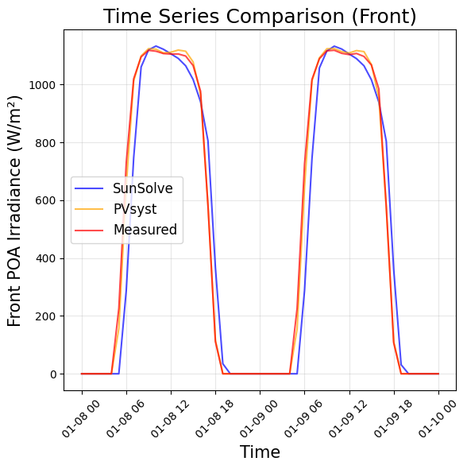
- Update the weather file to see if it got worse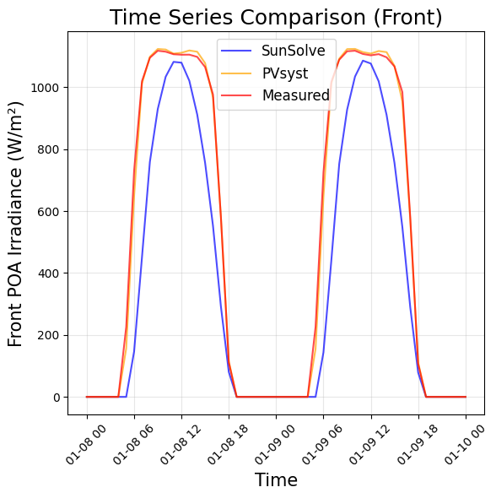
- So the problem comes from the weather file
- Try change the weather file of problematic file to old file
- 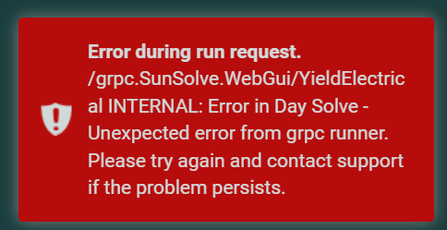
- May be because the solar position should be calculated instead of from weather
- Worked, but the weather became different
- "C:\Users\z5183876\OneDrive - UNSW\Documents\GitHub\25_09_02_Bomen_bifacial_gain_2021\Data\SunSolve Yield\Per inverter\2-1\0_mimic_PVsyst\25_10_07_old_weather.sim"
- 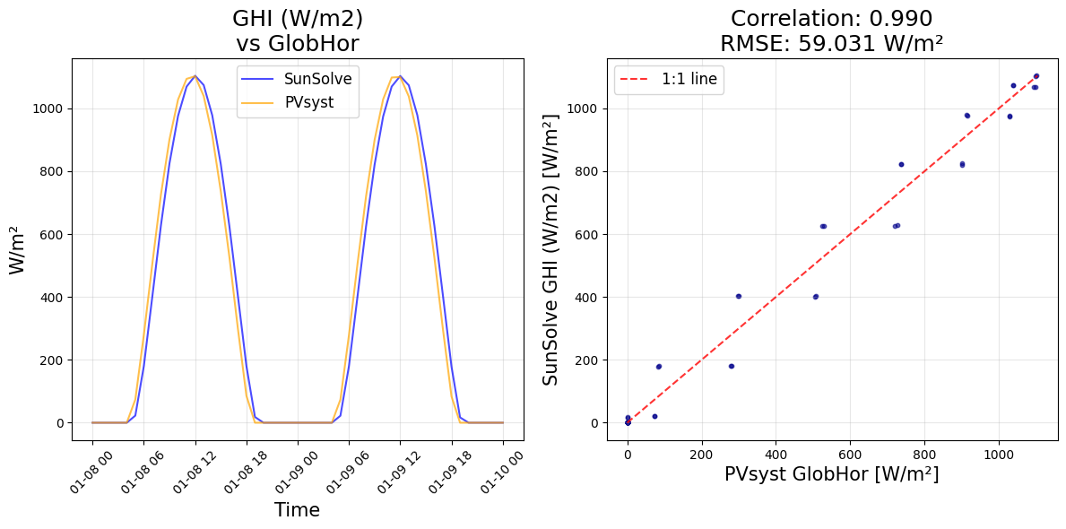
- 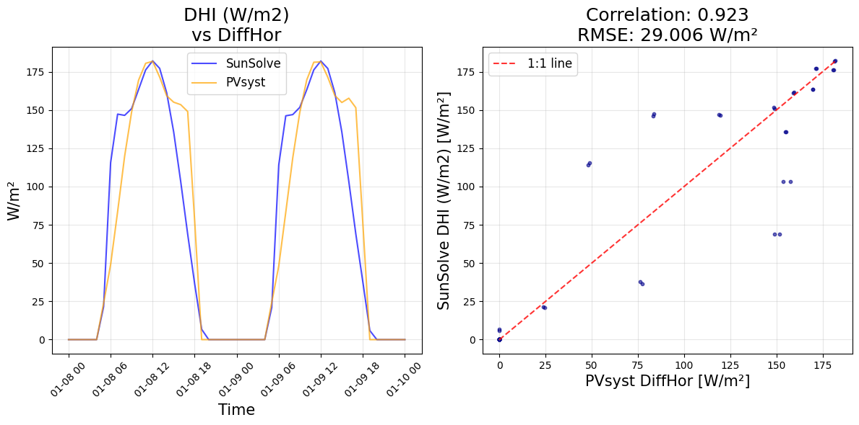
- 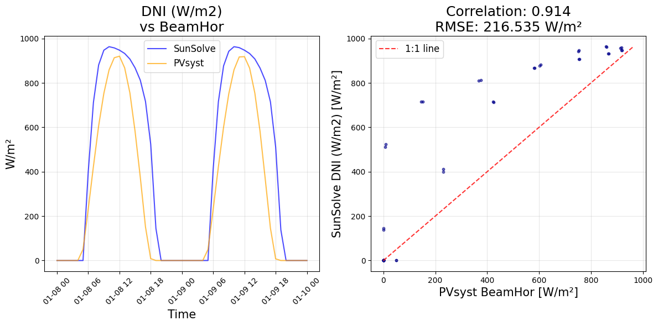
- 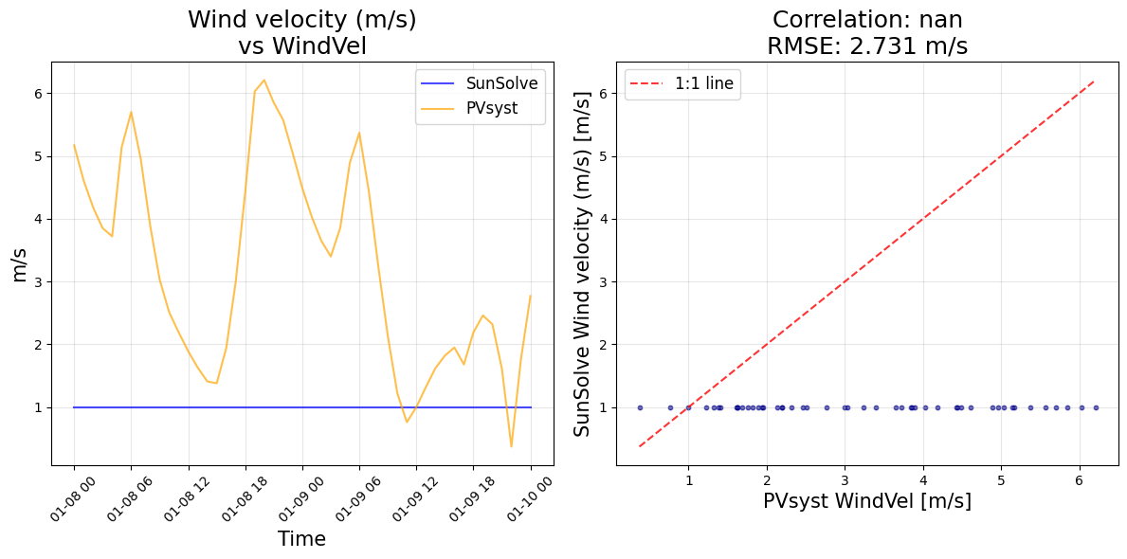
- The problem of different POA came from the weather file
- The old weather file was better
- But gave different DHI and DNI
- Weather data
  - Try same GHI and DHI with end (not DNI)

25-10-08
- Try to get a weather file that both gives an accurate simulation and same matching with weather data
- Bad dni as before
- Try weather with same ghi and dni end
- Bad dhi
- Try with dni and dhi, cannot
- Try ghi and dni ins
- Th best is ghi, dni with ins
- Record the results and model

25-10-09
- Modelled ended up using: "C:\Users\z5183876\OneDrive - UNSW\Documents\GitHub\25_09_02_Bomen_bifacial_gain_2021\Data\SunSolve Yield\Per inverter\2-1\0_mimic_PVsyst\25_10_08_ghidni_ins.sim"
- Try to improve the performance for Jan
  - Incident irradiance spectrum
  - Rear colour spectrum
  - IAM
  - Module frame
  - Improve T model
  - Remove vertical block
- Try to improve to get one model for all months that works for the whole year
- Try remove vertical block: no change
- Try use the spectrum calculation, improved CRMSE drop from 0.746 to 0.740

25-10-11
- Try to improve the performance for the Year (the 25_10_09_vb_spec)
  - Incident irradiance spectrum (done)
  - IAM
  - Module frame
    - In options
    - In PV module definition
  - Improve T model
  - Remove vertical block (done)
  - Transpositional model for diffuse light
  - Rear colour spectrum monthly albedo
  - Monthly soiling
- Try:
- Try to improve the performance for the Year
  - Incident irradiance spectrum (done)
  - IAM
  - Module frame (failed)
    - In options
    - In PV module definition
  - Improve T model
  - Remove vertical block (done)
  - Transpositional model for diffuse light
  - Rear colour spectrum monthly albedo
  - Spectrum for module current
- Cannot run the model: problem comes from the frame
- Try the default frame setting to see if it works
- No it does not
- Try different diffuse light model
- Try to improve the performance for the Year : 0.766 (worse)
  - Incident irradiance spectrum (done)
  - IAM
  - Module frame (failed)
    - In options
    - In PV module definition
  - Improve T model
  - Remove vertical block (done)
  - Transpositional model for diffuse light: isotropic
  - Rear colour spectrum monthly albedo
  - Spectrum for module current
- Try to improve the performance for the Year : 1.10
  - Incident irradiance spectrum (done)
  - IAM
  - Module frame (failed)
    - In options
    - In PV module definition
  - Improve T model
  - Remove vertical block (done)
  - Transpositional model for diffuse light: Hay
  - Rear colour spectrum monthly albedo
  - Spectrum for module current
- Try to improve the performance for the Year : 0.740
  - Incident irradiance spectrum (done)
  - IAM
  - Module frame (failed)
    - In options
    - In PV module definition
  - Improve T model
  - Remove vertical block (done)
  - Transpositional model for diffuse light: Perez 1990
  - Rear colour spectrum monthly albedo
  - Spectrum for module current
- Try to improve the performance for the Year : 0.748
  - Incident irradiance spectrum (done)
  - IAM
  - Module frame (failed)
    - In options
    - In PV module definition
  - Improve T model
  - Remove vertical block (done)
  - Transpositional model for diffuse light: Perez 1987
  - Rear colour spectrum monthly albedo
  - Spectrum for module current
- Try to improve the performance for the Year: 0.740
  - Incident irradiance spectrum (done)
  - IAM
  - Module frame (failed)
    - In options
    - In PV module definition
  - Improve T model
  - Remove vertical block (done)
  - Transpositional model for diffuse light: Perez SAM
  - Rear colour spectrum monthly albedo
  - Spectrum for module current
- Try to improve the performance for the Year: 0.739
  - Incident irradiance spectrum (done)
  - IAM: from material (done)
  - Module frame (failed)
    - In options
    - In PV module definition
  - Improve T model
  - Remove vertical block (done)
  - Transpositional model for diffuse light: Perez (1990) (done)
  - Rear colour spectrum monthly albedo
  - Spectrum for module current
- Try to improve the performance for the Year: 0.737
  - Incident irradiance spectrum (done)
  - IAM: from material (done)
  - Module frame (failed)
    - In options
    - In PV module definition
  - Improve T model
  - Remove vertical block (done)
  - Transpositional model for diffuse light: Perez (1990) (done)
  - Rear colour spectrum monthly albedo
  - Spectrum for module current: typical c-Si front and rear (done)
- Optimise monthly for all months other than the T model
- Jan: 0.261
  - Options
    - Incident light spectrum (enabled) (optimised)
    - Module frames enable (failed)
    - Block vertical gap (disabled) (done)
    - Diffuse light: Perez 1990 (optimised)
  - Systems
    - Albedo monthly
    - Thermal
  - Module
    - EQE (c-Si) (optimised)
    - Frames (failed)
    - IAM (material calculated) (optimised)
- Sunsolve: 0.739
  - Options
    - Incident light spectrum (enabled) (optimised)
    - Module frames enable (failed)
    - Block vertical gap (disabled) (done)
    - Diffuse light: Perez 1990 (optimised)
  - Systems
    - Albedo monthly
    - Thermal
  - Module
    - EQE (c-Si) (optimised)
    - Frames (failed)
    - IAM (material calculated) (optimised)
  - Python: optimise for individual month
- Sunsolve: 0.681
  - Options
    - Incident light spectrum (enabled) (optimised)
    - Module frames enable (failed)
    - Block vertical gap (disabled) (done)
    - Diffuse light: Perez 1990 (optimised)
  - Systems
    - Albedo monthly with spectrum
    - Thermal: Faiman
  - Module
    - EQE (c-Si) (optimised)
    - Frames (failed)
    - IAM (material calculated) (optimised)
  - Python: optimise for individual month (done)
- Sunsolve: 0.681
  - Options
    - Incident light spectrum (enabled) (optimised)
    - Module frames enable (failed)
    - Block vertical gap (disabled) (done)
    - Diffuse light: Perez 1990 (optimised)
  - Systems
    - Albedo monthly with spectrum
    - Thermal: PLV 2022, default
    - Mounting structure
  - Module
    - EQE (c-Si) (optimised)
    - Frames (failed)
    - IAM (material calculated) (optimised)
  - Python: optimise for individual month (done)
- Sunsolve: 0.684
  - Options
    - Incident light spectrum (enabled) (optimised)
    - Module frames enable (failed)
    - Block vertical gap (disabled) (done)
    - Diffuse light: Perez 1990 (optimised)
  - Systems
    - Albedo monthly with spectrum
    - Thermal: PLV 2022
      - Transient
        - Mmod=11.38 kg/m3 (from datasheet)
        - Cm=833J/K (default)
    - Mounting structure
  - Module
    - EQE (c-Si) (optimised)
    - Frames (failed)
    - IAM (material calculated) (optimised)
  - Python: optimise for individual month (done)
- Sunsolve: 0.683
  - Options
    - Incident light spectrum (enabled) (optimised)
    - Module frames enable (failed)
    - Block vertical gap (disabled) (done)
    - Diffuse light: Perez 1990 (optimised)
  - Systems
    - Albedo monthly with spectrum
    - Thermal: PLV 2022
      - Transient
        - Mmod=11.38 kg/m3 (from datasheet)
        - Cm=700 J/K
    - Mounting structure
  - Module
    - EQE (c-Si) (optimised)
    - Frames (failed)
    - IAM (material calculated) (optimised)
  - Python: optimise for individual month (done)
- Sunsolve: 0.677
  - Options
    - Incident light spectrum (enabled) (optimised)
    - Module frames enable (failed)
    - Block vertical gap (disabled) (done)
    - Diffuse light: Perez 1990 (optimised)
  - Systems
    - Albedo monthly with spectrum
    - Thermal: PLV 2022
      - Transient (disabled)
        - Mmod=11.38 kg/m3 (from datasheet)
        - Cm=400 J/K
      - Include radiation to sky: emissivity 0.9
    - Mounting structure
  - Module
    - EQE (c-Si) (optimised)
    - Frames (failed)
    - IAM (material calculated) (optimised)
  - Python: optimise for individual month (done)
- Sunsolve: 0.677
  - Options
    - Incident light spectrum (enabled) (optimised)
    - Module frames enable (failed)
    - Block vertical gap (disabled) (done)
    - Diffuse light: Perez 1990 (optimised)
  - Systems
    - Albedo monthly with spectrum
    - Thermal: PLV 2022
      - Transient (disabled)
        - Mmod=11.38 kg/m3 (from datasheet)
        - Cm=400 J/K
      - Include radiation to sky: emissivity 0.8
    - Mounting structure
  - Module
    - EQE (c-Si) (optimised)
    - Frames (failed)
    - IAM (material calculated) (optimised)
  - Python: optimise for individual month (done)
- Sunsolve: 0.677
  - Options
    - Incident light spectrum (enabled) (optimised)
    - Module frames enable (failed)
    - Block vertical gap (disabled) (done)
    - Diffuse light: Perez 1990 (optimised)
  - Systems
    - Albedo monthly with spectrum
    - Thermal: PLV 2022
      - Transient (disabled)
        - Mmod=11.38 kg/m3 (from datasheet)
        - Cm=400 J/K
      - Include radiation to sky: emissivity 0.9
      - Include heat flow to ground (default, const): 0.677
    - Mounting structure
  - Module
    - EQE (c-Si) (optimised)
    - Frames (failed)
    - IAM (material calculated) (optimised)
  - Python: optimise for individual month (done)
- Sunsolve: 0.676 (25_10_11 file)
  - Options
    - Incident light spectrum (enabled) (optimised)
    - Module frames enable (failed)
    - Block vertical gap (disabled) (done)
    - Diffuse light: Perez 1990 (optimised)
  - Systems
    - Albedo monthly with spectrum
    - Thermal: PLV 2022 (optimised)
      - Transient (disabled)
        - Mmod=11.38 kg/m3 (from datasheet)
        - Cm=400 J/K
      - Include radiation to sky: emissivity 0.9 (optimised)
      - Include heat flow to ground (15, Tamb) (optimised)
    - Mounting structure
  - Module
    - EQE (c-Si) (optimised)
    - Frames (failed)
    - IAM (material calculated) (optimised)
  - Python: optimise for individual month (done)
- The next step is to break it down to monthly files

25-10-12
- Figure out the colour
- Change the color to see which one is better
- Jan:
  - 0.204, soil,
  - 0.204, veg
  - 0.204, const

25-10-14
- Figure out the matching for PVsyst
- Set up python environment for bifacial gain project (done)
- Try dni ghi and end to see if better match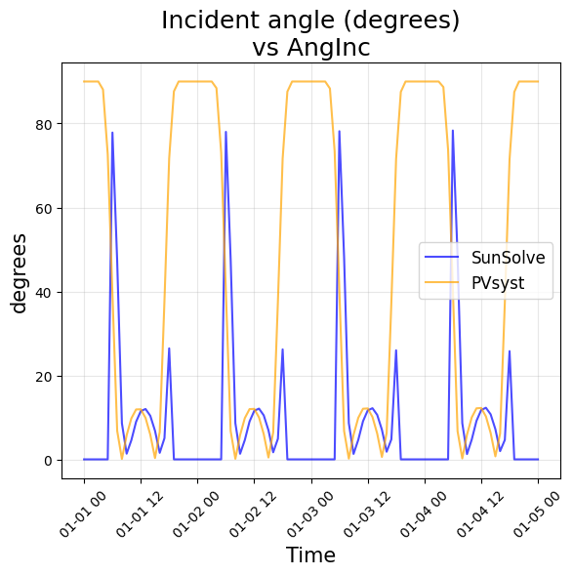
- Got worse, do start
- Got better
- Try to improve this model: 0.710
  - Options
    - Incident light spectrum
    - Module frames enable
    - Block vertical gap (disabled)
    - Diffuse light: Perez 1990
  - Systems
    - Albedo monthly with spectrum
    - Thermal: PLV 2022
      - Transient (disabled)
        - Mmod=11.38 kg/m3
        - Cm=400 J/K
      - Include radiation to sky: emissivity 0.9
      - Include heat flow to ground (15, Tamb)
    - Mounting structure
  - Module
    - EQE (c-Si)
    - Frames
    - IAM (material calculated)
  - Python: optimise for individual month (done)

25-10-15
- Problem: suddenly, this does not work 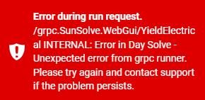
- Try to go back to the PVsyst mimic file to see if it works, no
- Nothing I can do
  - Email Sunsolve
  - With
    - Screenshot
    - File
- Email sent, nothing can be done before I hear back from them

25-10-16
- Optimise the temperature model
  - Enable transient (got worse)
    - 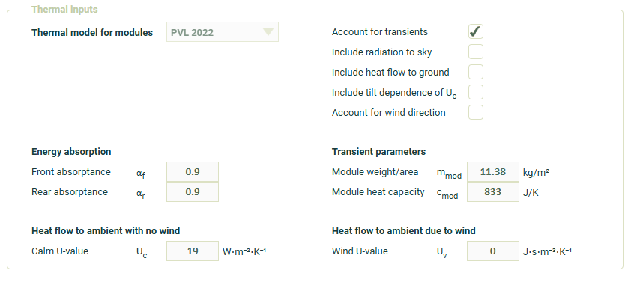
    - 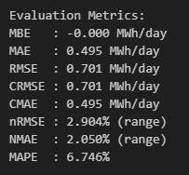
  - Enable radiation to sky
    - 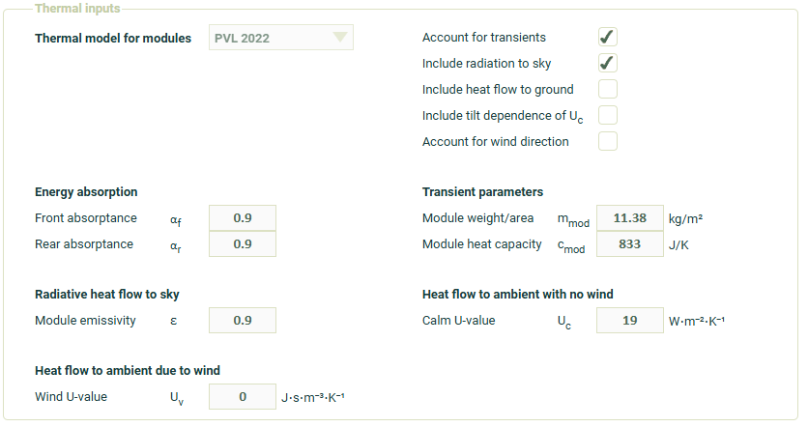
    - 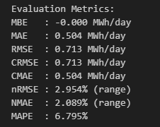
  - Eable heat flow to ground
    - 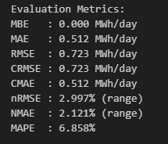
    - 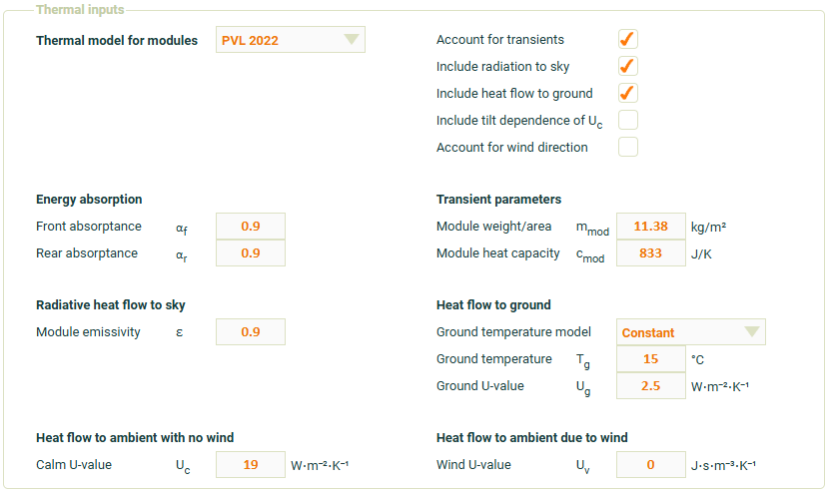
  - Enable radiation to the floor
    - T ground constant
    - T ground ambient
      - 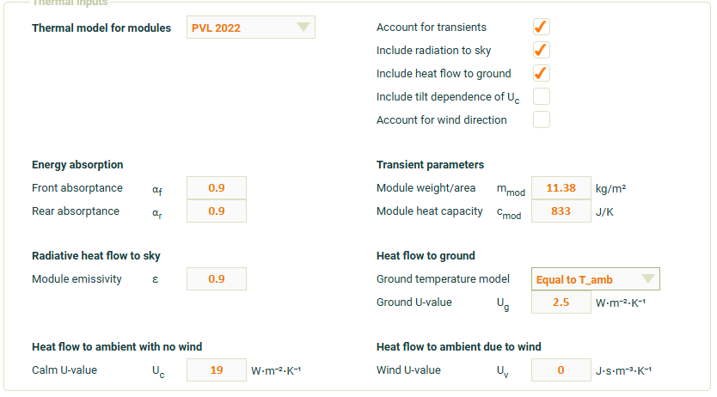
      - 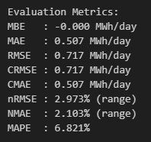
  - Try without transient
    - 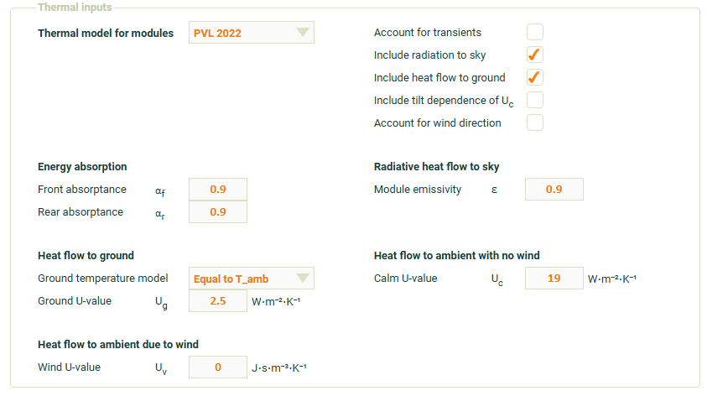
  - Try with smaller c
    - 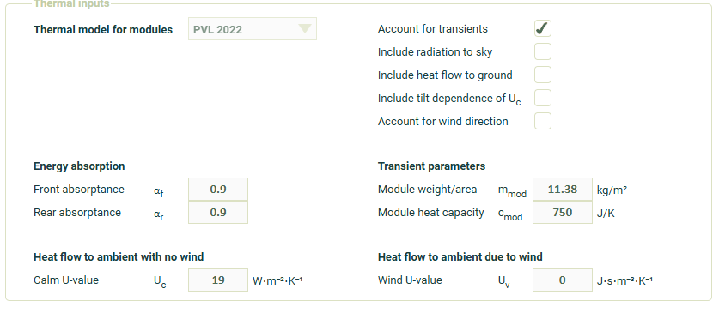
    - The results show that the transient will make it worse, even though reducing the cmod will make it match better, it still worse than without transient at all
    - 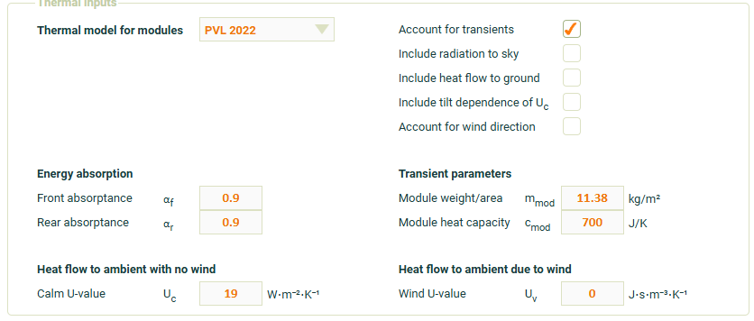
    - 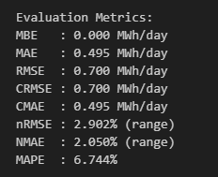
    - Try the radiation to the sky
    - 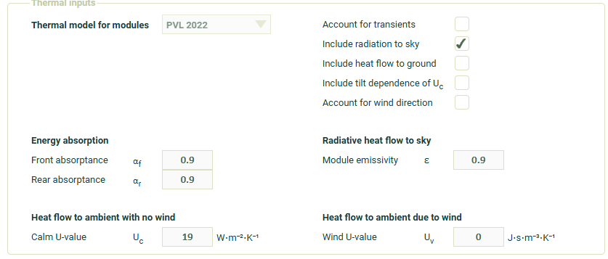
    - 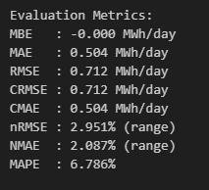
    - Try smaller emissivity
    - 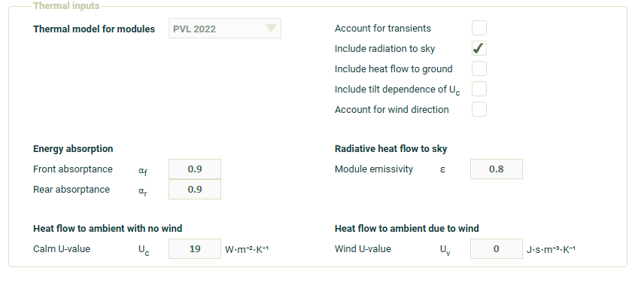
    - Got better but still worse than not including it
    - 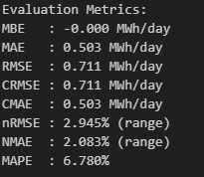
    - Heat flow to ground
      - T ground 15 C
        - 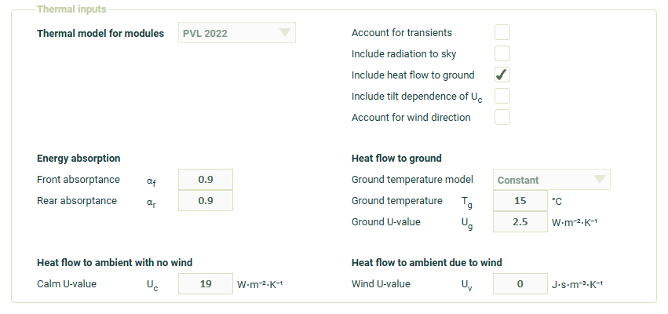
        - 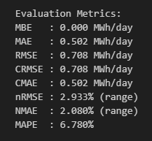
      - T ground ambient T
        - 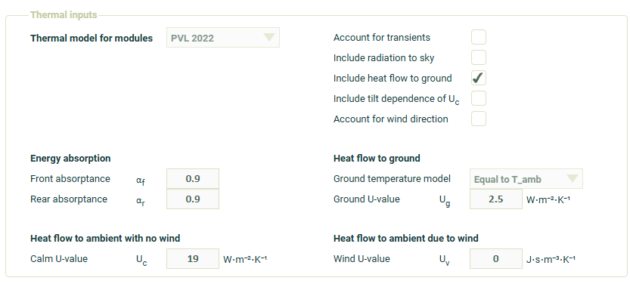
        - 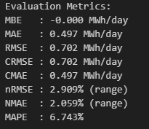
        - Try with different U see if we can beat 0.698
        - U=2
          - 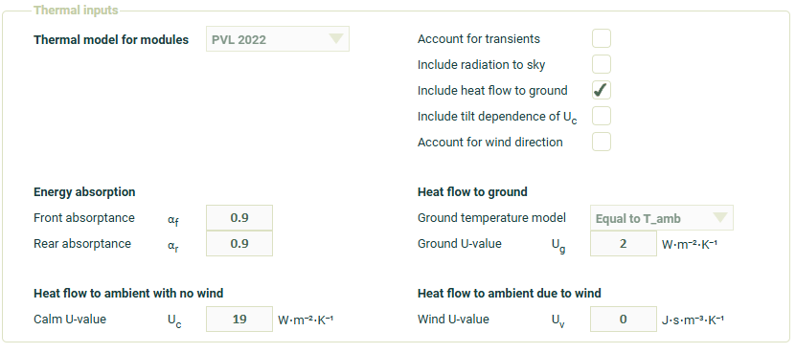
          - 
          - It decreases with U
          - It works the best with U=0, which means no heat flow
          - So the best option is to remove it
        - U=3
    - Try the dependence on tilt for U
      - 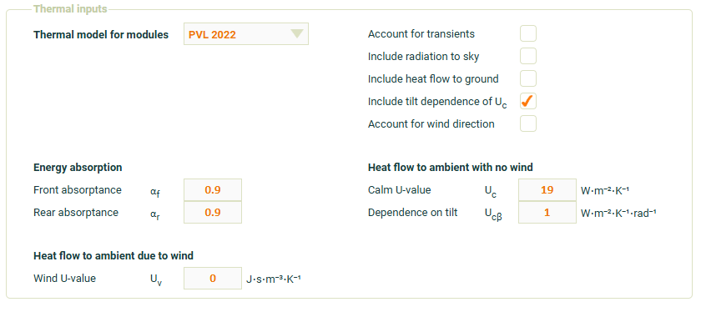
      - 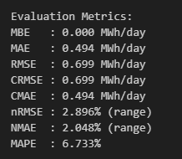
      - Try 0.5 to see if there is anything changed
        - 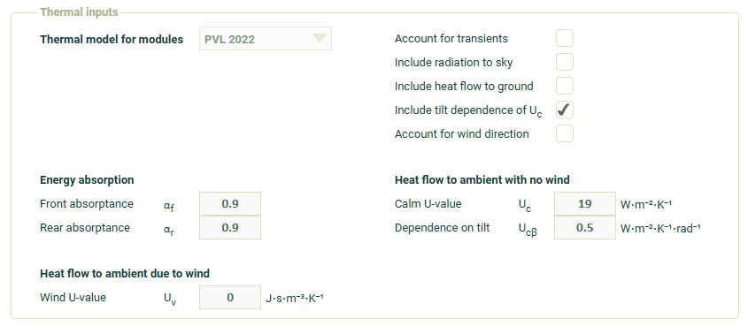
        - 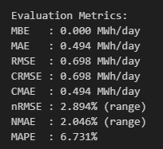
      - Just remove it
  - Optimise the U values
    - Uv=1
      - 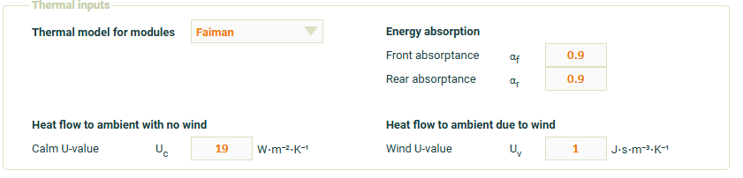
      - 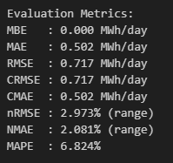
      - Uv keep as zero
    - Uc=20
      - 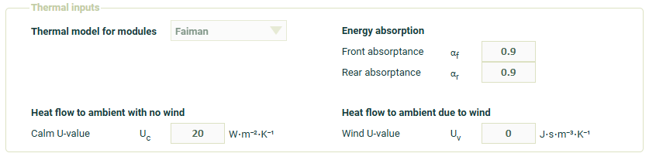
      - 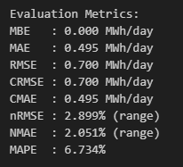
    - Uc=18
      - 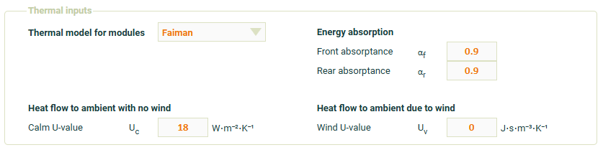
      - 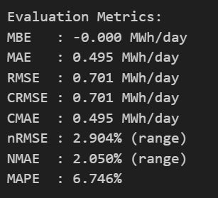
    - OK, the best option for thermal model is just to keep it as it is
- Now let us try to optimise monthly
- The historical data only shows June being soil
- For each month
  - Update the dates
  - Update the albedo
  - Optimise
    - Veg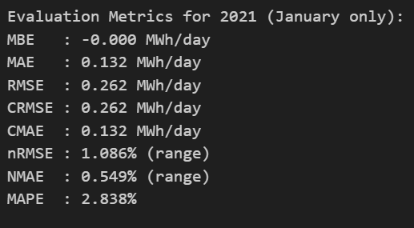
    - Soil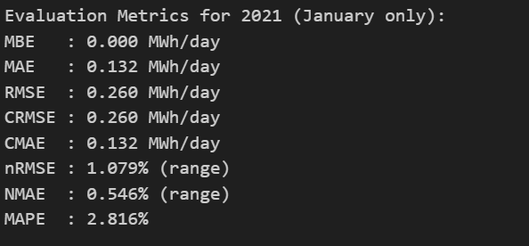
    - custom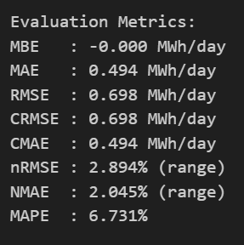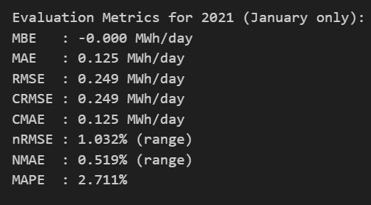
- Jan
  - Update the dates
  - Update the albedo
  - Optimise
    - Veg
    - Soil
  - custom
- Feb
  - Update date
  - Update albedo: 0.200
  - Update python month
  - Optimise spec
    - Veg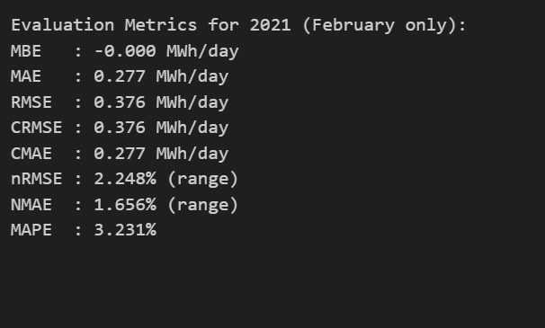
    - Soil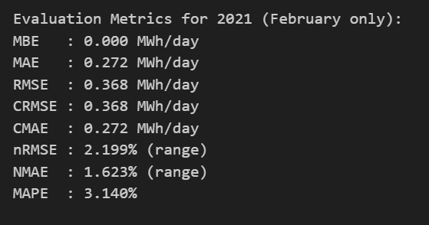
    - const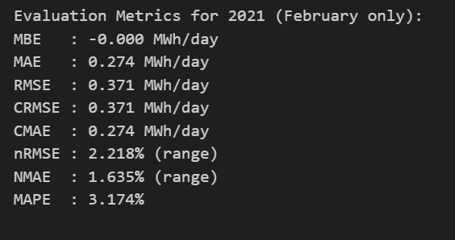
- March
  - Update date
  - Update albedo
  - Update python
  - Optimise
    - Veg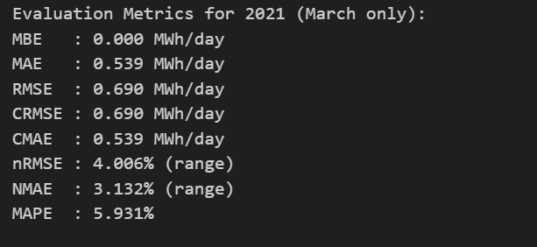
    - Soil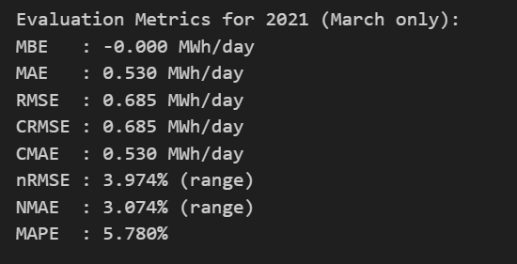
    - const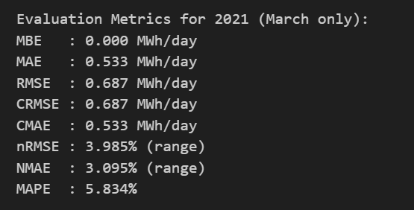
- April
  - Update date
  - Update albedo
  - Run
  - Save
  - Update Python
  - Update
    - Veg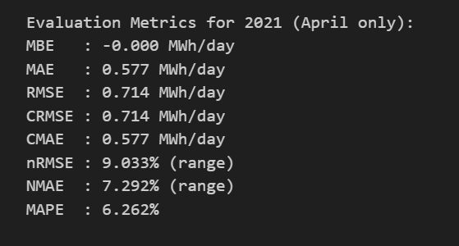
    - Soil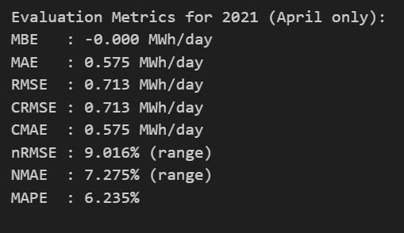
    - const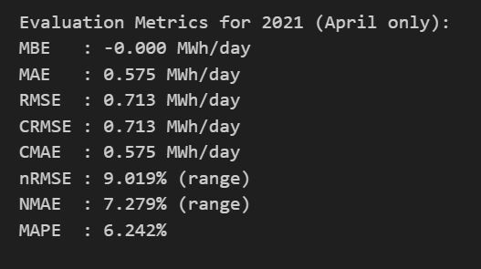
    - Soil is the best
- May
  - Update date
  - Update albedo
  - Run
  - Save
  - Update Python
  - Optimise
    - Veg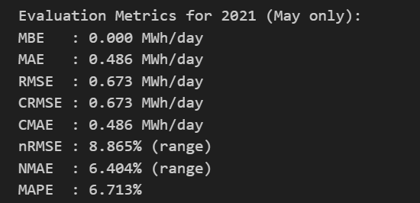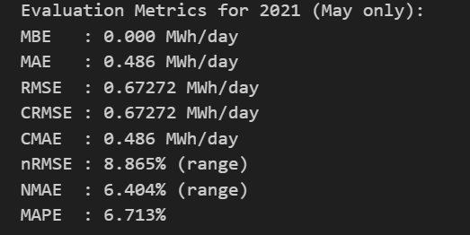
    - Soil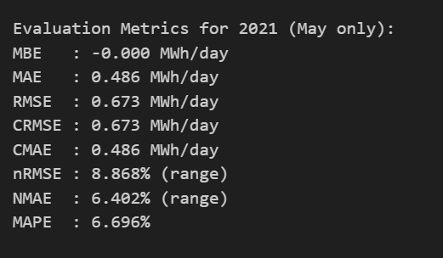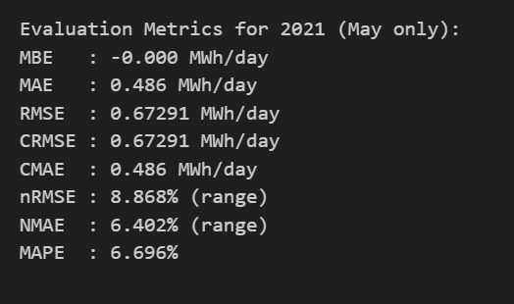
    - const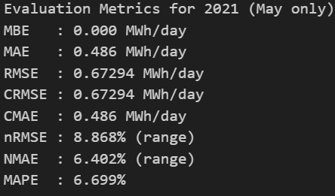
- June
  - Update date
  - Albedo
  - Python
  - Optimise
    - Veg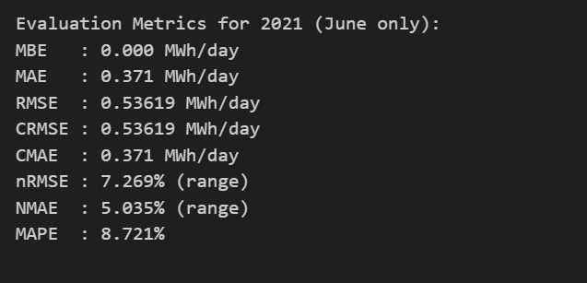
    - Soil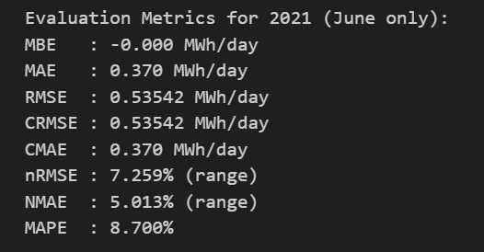
    - const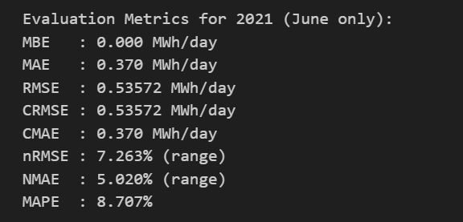
- July
  - Date
  - Albedo
  - Python
  - Optimisation
    - Soil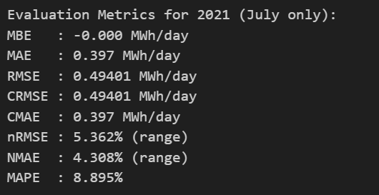
    - Veg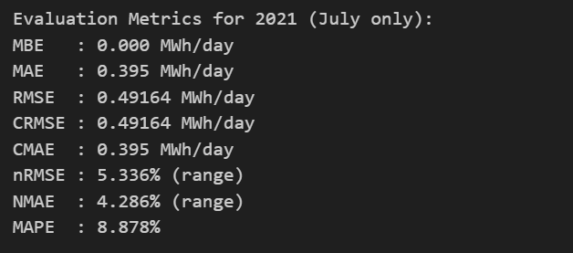
    - Cons: to save rays, stop running const for now
- August
  - Date
  - Albedo
  - Python
  - Optimisation
    - Veg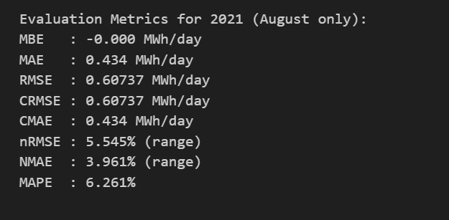
    - soil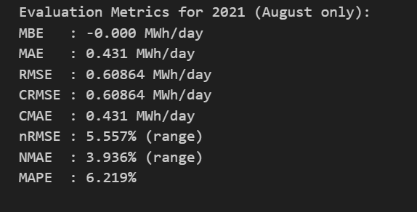
- Sept
  - Date
  - Albedo
  - Python
  - Optimisation
    - soil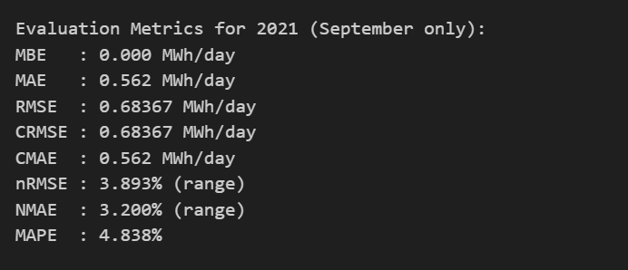
    - veg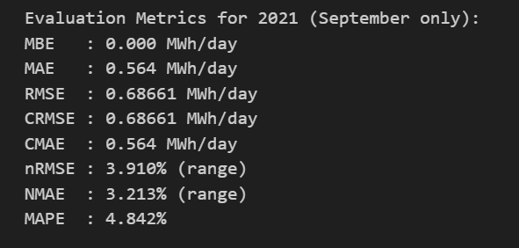
- Oct
  - Date
  - Albedo
  - Python
  - Optimisation
    - veg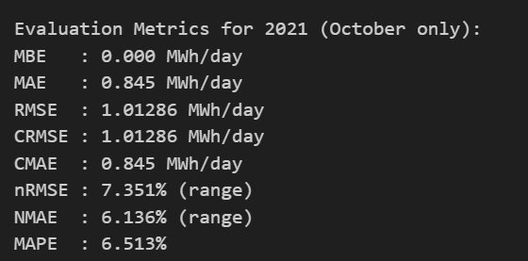
    - soil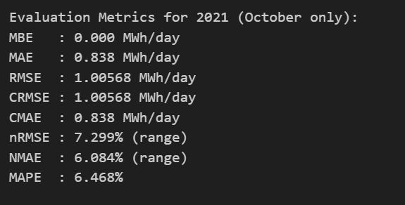
    - 
- Nov
  - Date
  - Albedo
  - Python
  - Optimisation
    - soil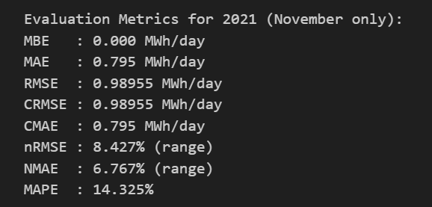
    - veg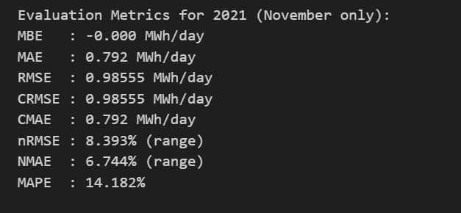
- Nov
  - Date
  - Albedo
  - Python
  - Optimisation
    - veg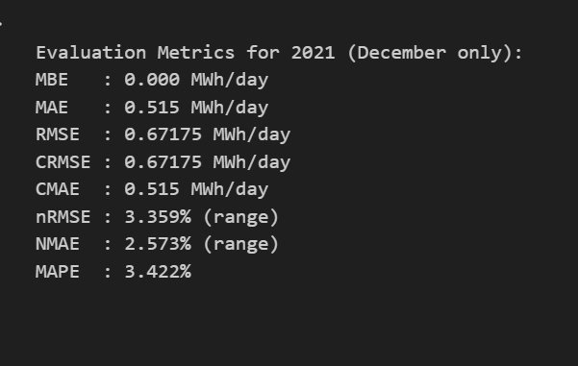
    - soil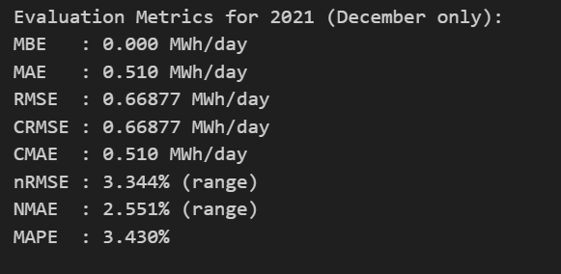

25-10-20
- Try to ensure the scale factor of PVsyst and SunSolve works
- Ensure the PVsyst works
  - Claude: ask workflow
    - Init
    - prompt
  - Based in the explanation to see if it is as expected
  - Update the workflow
  - Run the analysis for inverter 2-1
- The file C:\Users\z5183876\OneDrive - UNSW\Documents\GitHub\25_09_02_Bomen_bifacial_gain_2021\Code\batch_pvsyst_evaluation_inv.py is wrong
- It did clipping first then scaled
- Study the code
- The scale->clip file works
- Run on the old code to see how it changes
- The results of clip then scale
- 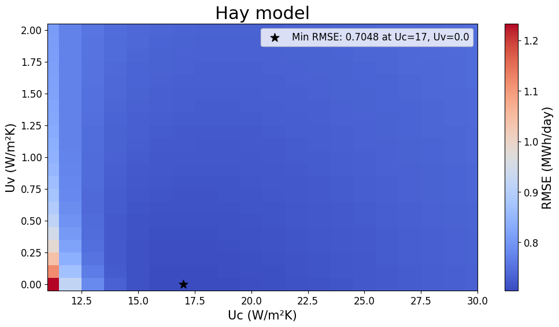
- 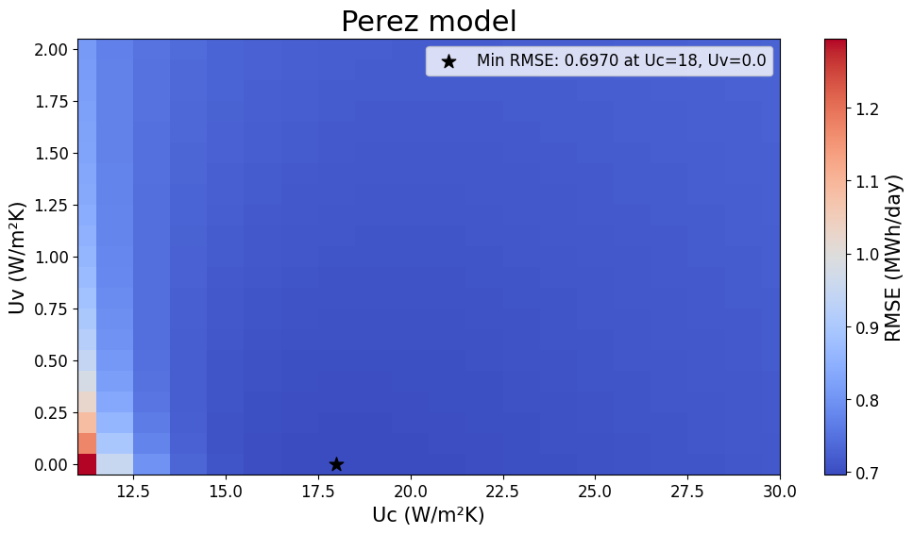
- The results of scale then clipped
- Run python file
- Check if the results changed
- The results itself changed, it is just because the scaling was too small and the clipping idd not click in
- Try to ensure the sunsolve has the clipping as well
- Finished
- Now both SunSolve Yield and PVsyst has the same clipping process
- Check the filtering of the data
- Update the PVsyst notebook
- Check if the results is identical
- The problem: the notebook for 2-1 looks confusing
  - The heatmap shows 0.679 MWh/day but the plot shows 0.56 MWh/day
  - The daily plot looks strange, it seems to fill the nan with zero
- Goal, make the MBE(scale->clip->resample) to 0 for
  - PVsyst notebook
  - SunSolve Yield notebook
  - PVsyst python

25-10-21
- Goal, make the MBE(scale->clip->resample) to 0 for
  - PVsyst notebook
  - SunSolve Yield notebook
  - PVsyst python
- Let us start with PVsyst notebook (done)
  - Ensure the code run (done)
  - Remove the extensive md cells (done)
  - Check with days before filtering (done)
    - Is the scaling based on the daily energy? Yes, it is
    - The plot is without filtering
    - But the optimisation and calculation are all after filtering
    - Fix to make them both consistent
    - Is it optimised scaled or not for RMSE, no
    - Is the plotting scaled or not scaled?
    - Update the code to clip based on excel
  - Check with days after filtering (done)
- Working PVsyst notebook
- Check if PVsyst
- Git
  - Add git ignore zip (done)
- Check if PVsyst file works (done), it is working correctly
- Check if SunSolve file works
  - Comparison between PVsyst and SunSolve (no need)
  - Comparison between Sunsolve and measured data (checked out)
- What I have done: ensure the scale->clip->resample->compare process works and consistent across all files
- What to do next:
  - Need an argument for the date alignment
  - Maintenance-free and a close match with manual inspection (you can just say that)
  - For now: say filters when we observe that the power data follows the measured POA
  - Next step: repeat the experiment to optimise Sunsolve yield model

25-10-22
- Another problem I realised is that SunSolve Yield is single albedo but the Pvsyst is monthly albedo
- Today, build one with monthly albedo using existing file to mimic PVsyst
- Each file
  - Update date
  - Update albedo value as a constant
- Now, update to exclude mounting systems
  - Open each sim file of the old folder on Sunsolve
    - Turn off transparent mounting
    - Rerun the simulation
    - Save the simulation file
    - Save the csv file
- I need to change too much to the mounting system
- For each file
  - Change the month
  - Change the albedo
  - Rerun the simulation
  - Save the simulation file
  - Save the csv file
- Next step is to enable the incident light spectrum
- For each file from mounting month
  - Enable the spectrum from always AM1.5G to calculate
  - Enable EQE in the modules
  - Update albedo to soil
    - Run the simulation
    - Save the simulation file
    - Save the csv file
  - Update albedo to vegetation
    - Run
    - Save sim
    - Save csv

25-10-23
- Finished mounting
- Next step is the gaps between modules
- For each monthly file in mounting folder
  - Remove the gap blocks
  - Run
    - Save sim
    - Save csv
- The problem with the module frame is that the module frame does not seems to work
  - My estimation was that the vertical gap is smaller than the module frame dimension, the module does not understand the dimension includes the module frame
  - The plan is to try to fix that regarding the module frame
    - Add the module frame in the module file
    - Enable the module frame in options
    - Update the module thickness
    - Try to see if it works
    - Worked
  - Double check, save the sim file that worked. Email to ask Keith if I need to increase the gaps to account for the farme or not?
  - Do an experiment to make frame very big to see where it expands to
  - The experiment shows that it expands inward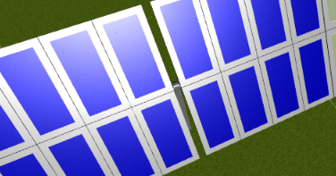
- Let us try to update a procedure to simulate for the module frame
- For each monthly files in the gap folder
  - Change the module to the ones with frame
  - Enable the frame in the options
  - Run the simulation
  - Save the sim file
  - Save the csv file
- Do another experiment to include the IAM
- For each monthly file in the gap folder
  - Calculate the module to the one with the calculated IAM
  - Run the simulation
  - Save the sim
  - Save the CSV file
- Do another experiment to include spectrum
  - Data generation, for each monthly file in the IAM folder
    - Change the module to include EQE
    - Change the incident spectrum from AM1.5 to calculate
    - Change the background to soil
      - Save sim
      - Save csv
    - Change the background to vegetation
      - Save sim
      - Save csv
    - Change the background to constant
      - Save sim
      - Save csv
  - Model optimisation: there are 3 to the power 12 choices
  - Up to spectrum vegetation Jan

