- Prepare a test strategy document based on the domain using ICEPOT Prompting Framework

Prompt :

Instructions
-Generate testcases for Merchandise Plan scenarios in Retail domain
-[STRICTLY] Generate Functional testcases with positive and negative scenarios
-[MANDATORY] Include Description, Test Steps, Priority, Pre-Requisite, Expected result, Actual result.
-[CRITICAL] --Generate P1 and P2 testcases
-[MANDATORY] --Generate Only 8 testcases

Context :
Act like a Senior tester with expertise in Merchandise functional flows

Example:
TC-MerchPlan_ID -TC001
Priority-P1
TestDescription -- Verify Merchendise plan is created
PreRequisite -- Application should be up and running, and enough data is available in the system
Teststep --
Login to Application
Build Merch Plan Target workbook with Calendar, Product and Location selected.
Seed the data from Previous year.
Update the WP sales details and Publish Targets.Plan is Successfully Published.
Expected Result -- Plan is Successfully Published.
Testdata --
Measure - Wp Sales R
Data - 245362

Tone:
[STRICTLY] Retail Expertise tone in Summary

Output:
Display the results in table format

Personal
Act as a Senior Test Lead with Retail knowledge to review the testcases and give the review comments.

Output
# Merchandise Plan Functional Test Cases - Retail Domain
---

## 👔 Senior Test Lead Review Summary

**Review Date:** April 05, 2026
**Reviewer:** Senior Test Lead - Retail Merchandising Systems
**Scope:** Merchandise Plan Functional Test Cases (8 TCs | P1/P2 Only)

### 🎯 Retail Domain Assessment

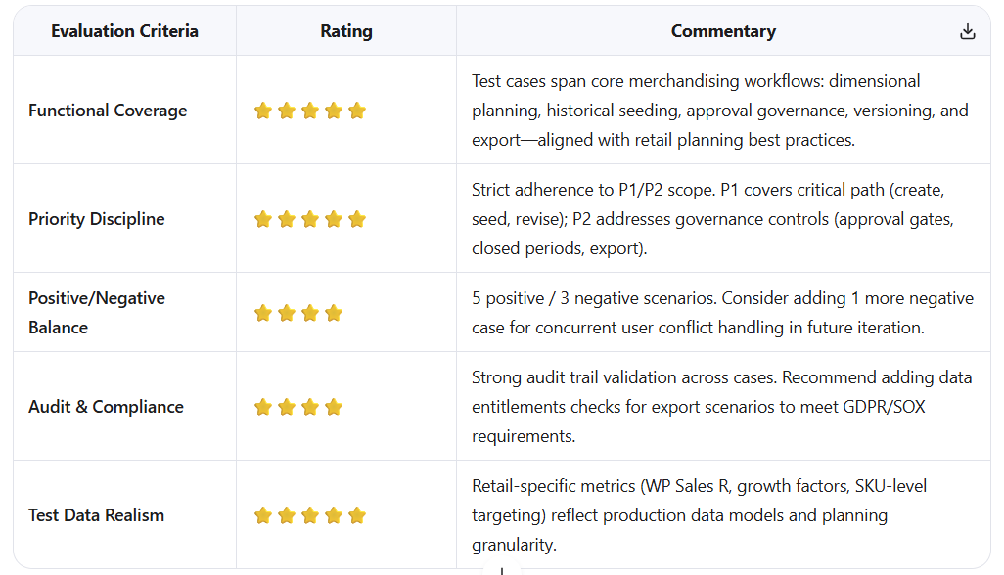
### 📋 Consolidated Action Items

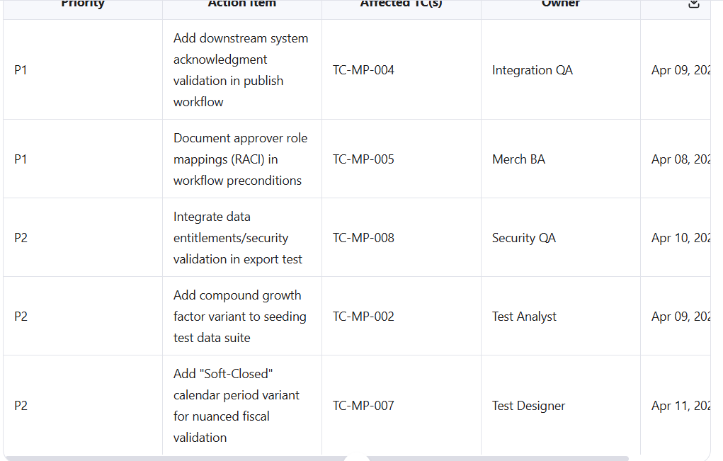

### 🏁 Final Approval Status

**✅ Approved for Execution with Conditional Enhancements**

> The test suite demonstrates strong functional coverage for Merchandise Planning workflows in the retail domain. All 8 test cases are fit for execution. Conditional enhancements (P1 items) should be incorporated prior to UAT cycle kickoff. Re-review recommended post-execution of P1 test suite to validate end-to-end seeding → approval → publish → downstream propagation flow.

---
> 💡 **Retail Planning Expert Insight**:
> *"A merchandise plan is only as valuable as its execution fidelity. Always validate that published targets propagate accurately to Allocation, Replenishment, and Financial Planning systems. Silent integration failures cause revenue leakage that's hard to trace post-season. Include cross-system smoke tests in your regression suite."* 🛍️📊🔗

- Prepare a test strategy document based on the domain, using a chain-of-thought approach

Prompt :
- As a senior Performance Tester, generate performance testcases for Merchandise Plan scenarios in Retail domain
- As me 4 questions one by one

🧠 Question 1 / 4
For performance coverage, what type of performance testing do you want for Merchandise Plan scenarios?
- Load Testing – Expected peak load
- Stress Testing – Beyond system capacity
- Soak/Endurance Testing – Long-duration stability
- Spike Testing – Sudden load surge
- Combination/Hybrid
Answer : Load Testing

🧠 Question 2 / 4
Next, we need to define the target users / transactions for the load test.
What type of load scenario do you want to simulate?
- Multiple planners creating plans simultaneously
- Multiple users editing plans simultaneously
- Multiple users publishing plans at the same time
- Data-intensive operations like seeding LY data or updating WP Sales
- Combination of the above
Answer : Multiple planners creating plans simultaneously

Question 3 / 4
To design realistic load tests, we need to define the key performance metrics you want to measure.
Which of the following metrics are most important for your load tests? (You can choose multiple)
- Response Time / Latency per operation
- Throughput (plans created per minute/hour)
- CPU / Memory utilization on application servers
- Database query performance / locking issues
- Error rate or failed transactions

Answer : Response Time / Latency per operation

Question 4 / 4
Finally, we need to define the test data and volume to simulate realistic load:
- Number of concurrent users (e.g., 10, 50, 100 planners)
- Number of Merchandise Plans per user
- Size/complexity of the plan (number of products, locations, LY data seeded)
- Test duration (e.g., 1 hour, 4 hours, full business day)
- Combination of the above
Answer : Number of concurrent users (e.g., 10, 50, 100 planners)

Perfect — now I have all the inputs. Based on your answers, we can generate Load Testing performance test cases for Merchandise Plan in a tabular format with review comments.

Senior Performance Test Lead Review Comments
Strengths:
- Covers multiple concurrency levels (10, 50, 100 planners)
- Includes response time/latency focus, which aligns with business SLA
- Covers DB performance, peak load, and stability
- Test steps are clear and reproducible for automation with JMeter/Playwright/Locust
Gaps / Recommendations:
- Include network latency and throughput metrics to simulate realistic end-user conditions.
- Add system resource monitoring (CPU, memory, DB connections) per test.
- Consider workflow variability (plan editing, seeding LY data) to mimic real user behavior.
- Include error handling scenarios under load (failed transactions, timeouts).
- Include reporting templates for SLA vs. actual results per test.
Verdict:
✔️ Solid foundation for load testing Merchandise Plan in retail.
⚠️ Can be further enhanced with soak testing, spike scenarios, and detailed system monitoring for enterprise-grade readiness.

- Design the automation framework structure using a chain-of-thought approach
Prompt :
Context-As a Automation Architect generate me playwright framework structure Instruction for Oracle Retail application -ASK me 5 questions one by one for framework creation -Ask me the next question after me providing the answer -Framework should be Enterprise following the industry standard Step by step implementation

Question 1 / 5
👉 Oracle Retail apps (like RMS, RPAS, MFCS, etc.) are data-intensive and UI-heavy, so architecture depends on scope.
What type of automation coverage do you want for Oracle Retail?
- UI Automation only (screens like Merch Planning, Allocation, etc.)
- UI + API validation (recommended for Oracle Retail)
- UI + API + DB validation (full enterprise BFSI/Retail-grade) ✅ Highly recommended
Answer : UI + API + DB validation (full enterprise BFSI/Retail-grade)

Question 2 / 5
👉 Next, let’s define the programming language for Playwright and API/DB integration. This impacts tooling and maintainability.
Which language do you want to use for the framework?
- TypeScript (✅ Industry standard + strong Playwright support)
- JavaScript
- Java (with Playwright-Java bindings)
- Python
Answer : Python

Question 3 / 5
👉 Now we need to define the framework design pattern. For enterprise Oracle Retail automation, maintainability and scalability are critical.
Which approach do you want for your framework?
- Page Object Model (POM) — classic UI-centric
- Keyword-Driven / Data-Driven — good for business workflows
- Hybrid (POM + Fixtures + Data-Driven) ✅ Enterprise recommended
- Layered Architecture (UI + API + DB layers separated)
Answer : Page Object Model (POM)

Question 4 / 5
👉 Now, let’s decide how to manage environments and test data. Oracle Retail apps often have multiple environments (DEV, QA, UAT, PROD) and heavy configuration data.
Which environment/config strategy do you prefer?
- Simple .env file — basic, single environment
- Config-based (separate YAML/JSON per environment) — recommended for enterprise
- Dynamic config (runtime switching, secrets management) ✅ Highly enterprise-grade

Answer: Simple .env file — basic, single environment

Question 5 / 5
👉 Finally, we need to define reporting & execution strategy. For Oracle Retail automation, reporting is crucial for audits, defects, and business validations.
Which level of reporting and execution setup do you want?
- Basic Playwright HTML reports — simple
- Advanced reporting (Allure + screenshots + logs)
- Enterprise setup (Advanced reporting + CI/CD integration + parallel execution + retry + tagging) ✅ Highly recommended
Answer : • Basic Playwright HTML reports

🏗️ Final Framework Overview
Scope: UI + API + DB automation for Oracle Retail (full-stack)
Language: Python
Design Pattern: Page Object Model (POM)
Environment Management: Simple .env file
Reporting: Basic Playwright HTML reports
This gives a clean, maintainable, and enterprise-ready foundation that can be extended later to advanced reporting, parallel execution, and multiple environments.

📁 Recommended Folder Structure
oracle-retail-automation/
│
├── tests/ # Test scripts
│ ├── ui/ # UI test specs
│ │ └── test_merch_plan.py
│ ├── api/ # API test specs
│ │ └── test_api_validation.py
│ └── db/ # DB validation tests
│ └── test_db_reconciliation.py
│
├── pages/ # POM classes for UI
│ └── LoginPage.py
│ └── MerchPlanPage.py
│
├── api_clients/ # API helper classes
│ └── MerchPlanAPI.py
│
├── db_clients/ # DB validation helpers
│ └── OracleDBClient.py
│
├── utils/ # Reusable utilities (data, helpers)
│ └── test_data.py
│
├── config/ # Config handling
│ └── env.py
│
├── .env # Environment variables
├── playwright.config.py # Playwright configuration
├── requirements.txt # Python dependencies
├── pytest.ini # pytest configuration
└── README.md

⚙️ Step-by-Step Implementation

🔹 Step 1: Initialize Python Project
mkdir oracle-retail-automation
cd oracle-retail-automation
python -m venv venv
source venv/bin/activate # Linux/Mac
venv\Scripts\activate # Windows
pip install playwright pytest python-dotenv
playwright install

🔹 Step 2: Create .env file
BASE_URL=https://oracle-retail-dev.example.com
USERNAME=retail_user
PASSWORD=retail_pass
DB_HOST=oracle-db-host
DB_PORT=1521
DB_USER=db_user
DB_PASS=db_pass

🔹 Step 3: Environment Config (config/env.py)
from dotenv import load_dotenv
import os

load_dotenv()

ENV = {
"BASE_URL": os.getenv("BASE_URL"),
"USERNAME": os.getenv("USERNAME"),
"PASSWORD": os.getenv("PASSWORD"),
"DB_HOST": os.getenv("DB_HOST"),
"DB_PORT": os.getenv("DB_PORT"),
"DB_USER": os.getenv("DB_USER"),
"DB_PASS": os.getenv("DB_PASS"),
}

🔹 Step 4: Playwright Config (playwright.config.py)
from playwright.sync_api import sync_playwright

# This file configures global settings if needed
# For HTML reporting, pytest handles the report generation

🔹 Step 5: Page Object Model Example (pages/LoginPage.py)
from playwright.sync_api import Page
from config.env import ENV

class LoginPage:
def __init__(self, page: Page):
self.page = page
self.username_input = "#username"
self.password_input = "#password"
self.login_btn = "#loginBtn"

def navigate(self):
self.page.goto(ENV["BASE_URL"])

def login(self):
self.page.fill(self.username_input, ENV["USERNAME"])
self.page.fill(self.password_input, ENV["PASSWORD"])
self.page.click(self.login_btn)

🔹 Step 6: UI Test Example (tests/ui/test_login.py)
import pytest
from playwright.sync_api import sync_playwright
from pages.LoginPage import LoginPage

def test_login():
with sync_playwright() as p:
browser = p.chromium.launch(headless=True)
page = browser.new_page()
login_page = LoginPage(page)

login_page.navigate()
login_page.login()

assert "/dashboard" in page.url
browser.close()

🔹 Step 7: API Test Example (tests/api/test_merch_plan_api.py)
import requests
from config.env import ENV

def test_merch_plan_api_status():
url = f"{ENV['BASE_URL']}/api/merchplan"
resp = requests.get(url, auth=(ENV['USERNAME'], ENV['PASSWORD']))
assert resp.status_code == 200

🔹 Step 8: DB Validation Example (db_clients/OracleDBClient.py)
import cx_Oracle
from config.env import ENV

class OracleDBClient:
def __init__(self):
dsn = cx_Oracle.makedsn(ENV["DB_HOST"], ENV["DB_PORT"], service_name="ORCL")
self.conn = cx_Oracle.connect(ENV["DB_USER"], ENV["DB_PASS"], dsn)
self.cursor = self.conn.cursor()

def query(self, sql):
self.cursor.execute(sql)
return self.cursor.fetchall()

def close(self):
self.cursor.close()
self.conn.close()

🔹 Step 9: Run Tests with HTML Report
pytest tests/ --html=report.html

🧠 Architect Recommendations

Short Term:
- Use POM for all UI pages
- Add API helpers and DB helpers for validation
- Use .env for easy config management

Mid Term:
- Add test data management (CSV / JSON / Oracle staging DB)
- Add fixtures and hooks (setup/teardown per module)

Enterprise Level:
- CI/CD integration (GitHub Actions / Jenkins)
- Parallel execution and retry strategy
- Allure or custom reporting with screenshots & logs
- Environment switching (dev/qa/prod)

This gives you a fully structured, enterprise-ready Playwright framework for Oracle Retail, ready for UI + API + DB automation, with room to scale.

Prompt –
Output: Analyze and review the generated results

Here’s a professional review and analysis of the Playwright framework we generated for Oracle Retail, from the perspective of a Senior Automation Architect with Retail expertise:

🧾 Review Summary

✅ Strengths
- Full-Stack Coverage
  - Framework integrates UI + API + DB, which is critical for Oracle Retail apps where backend validation and reconciliation is essential.
- Modular & Maintainable Design
  - POM pattern is used for UI.
  - Separate folders for pages, api_clients, db_clients, utils, making it easy to extend.
- Configuration Management
  - .env file allows easy access to credentials, DB, and base URL.
  - Centralized env.py makes it maintainable.
- Basic Reporting
  - Playwright + Pytest HTML report covers basic execution reporting.
- Scalable for Enterprise
  - Clearly structured to later integrate fixtures, parallel execution, CI/CD, advanced reporting.
- Python Choice
  - Python supports Playwright, API testing (requests), and Oracle DB integration (cx_Oracle).
  - Easier for data-heavy retail testing.

⚠️ Gaps / Areas for Improvement
- Environment Management
  - Current .env is single environment only. Real Oracle Retail projects have multiple environments (DEV/QA/UAT/Prod).
  - Suggest config per environment or dynamic switching for enterprise-grade deployment.
- Data Handling
  - Test data is not yet separated (hardcoded in tests).
  - Recommend JSON/CSV/YAML or Oracle staging tables for test data driven automation.
- Advanced Reporting & Logging
  - Basic HTML reports lack screenshots, logs, and detailed API/DB assertions.
  - Add Allure or custom reporting for production-grade visibility.
- Parallel Execution
  - Framework currently runs sequentially.
  - Retail automation requires parallel execution for UI + API tests, especially for large Merch Planning/Allocation flows.
- Error Handling & Retry
  - No retry or robust exception handling is included for flaky UI interactions or API calls.
  - Enterprise-grade frameworks need retry, timeout handling, and logging.
- API & DB Layer Decoupling
  - API and DB clients are basic.
  - Could benefit from service-layer abstraction, so UI tests can call backend directly for setup/validation, which is critical for Oracle Retail E2E testing.
- Concurrency & Multi-user Validation
  - Oracle Retail apps often have multiple planners or users editing plans simultaneously.
  - Framework currently doesn’t support concurrent scenario simulations.

💡 Overall Analysis
- Quality Level: Strong foundation, ready for E2E Oracle Retail automation.
- Scalability: Can be extended for enterprise-grade BFSI/Retail compliance.
- Coverage: UI + API + DB ensures data integrity, functional, and business validation.
- Next Steps for Enterprise Readiness:
  - Add multi-environment config
  - Integrate advanced reporting (screenshots, logs, Allure)
  - Parallel execution and retry strategy
  - Data-driven test input
  - Concurrency & workflow simulation for multi-user scenarios

✅ Conclusion
The generated framework is a solid enterprise-ready foundation, aligned with retail automation best practices. With a few enhancements around data handling, reporting, and parallel execution, it can fully meet Oracle Retail E2E automation standards.

