WEEK 1 TASK REPORT

Equipment Setup and Shot Planning
Photography Internship | Planning a Simple Indoor Portrait Photoshoot

Report details | Information
Student / Intern name | [Enter your full name]
Programme / Platform | Yuva Intern
Task | Week 1 — Equipment Setup and Shot Planning
Scenario | Indoor portrait photoshoot with a simple, professional look
Date of submission | [Enter date]

1. Introduction and Objective
This report presents a practical plan for an indoor portrait photoshoot. The purpose is to identify the equipment needed, arrange the camera and lighting safely, explain the reasons for the setup, and prepare an annotated shot list. The proposed session is designed for one subject against a plain background. It can be completed in a small room using a camera or a good smartphone, available light, and a few simple accessories. The plan prioritises clear images, consistent lighting, a tidy frame, and safe movement around the set.
The main objective is to plan before shooting rather than choosing equipment and compositions at random. A shot list helps the photographer know what to capture, which angle to use, and what visual purpose each photograph serves. The floor plan also makes the positions of the subject, camera, light source, reflector, and background easy to understand.

2. Photoshoot Concept and Creative Direction
Element | Plan
Theme | Natural, friendly, polished indoor portrait
Subject | One person; obtain permission before taking or sharing photographs
Location | Quiet indoor room with a plain wall or neutral cloth backdrop
Visual style | Soft light, natural skin tones, uncluttered background, relaxed expressions
Colour palette | Neutral background with simple, non-distracting clothing
Deliverables | A mix of wide, medium, close-up, profile, and creative detail portraits
Estimated session | Approximately 60–90 minutes, including setup and checks

3. Detailed Equipment Checklist
Equipment | Quantity / option | Purpose and notes | Check before shooting
Camera | 1 camera or smartphone | Captures the photographs. Use the highest suitable image quality. | Battery charged; lens clean; storage available.
Lens | Portrait lens if available; otherwise standard lens | A 50–85 mm equivalent is useful for flattering portraits; a phone's main camera also works. | Clean glass; check autofocus.
Tripod | 1, optional but recommended | Keeps framing steady and allows consistent compositions. | Leg locks secure; place on level floor.
Memory card / storage | 1 card or sufficient phone storage | Stores images and prevents interruptions. | Check free space; carry spare if possible.
Main light (key light) | 1 softbox/LED light, or window light | The main source illuminating the face. Soft light creates gentle shadows. | Check power, brightness, and stability.
Reflector / white board | 1 | Bounces light back into shadow areas and reduces contrast. | Place securely; avoid blocking the subject.
Background | Plain wall or backdrop cloth | Creates a clean, consistent background. | Remove wrinkles and distracting objects.
Light stand / clamp | As required | Holds a light or backdrop in position. | Tighten locks; do not overload.
Diffuser | 1, optional | Softens strong window or lamp light. | Keep fabric away from hot bulbs.
Power extension / charger | As required | Keeps powered lights ready. | Inspect cables; route away from walking areas.
Gaffer tape / cable ties | 1 roll / a few ties | Secures cables and reduces trip hazards. | Tape cables to the edge of the room.
Spare batteries / power bank | As required | Prevents loss of shooting time. | Charge before the session.
Props and stool | Optional | Adds variety to poses and gives the subject a comfortable position. | Check stability and keep props minimal.
Cleaning cloth | 1 | Removes fingerprints and dust from the lens. | Use a suitable lens cloth.
Notebook / shot list | 1 copy or phone note | Tracks completed shots, pose notes, and retakes. | Keep accessible but out of the frame.

4. Proposed Layout / Floor Plan
The camera is positioned in front of the subject, with enough distance to frame the portrait without crowding the subject. The key light is placed approximately 45 degrees to one side of the subject and slightly above eye level, angled down gently. A white reflector on the opposite side returns some light into the shadows. The subject stands a short distance away from the background so that shadows on the wall are reduced. An optional background light can be used only if it is available and safe.
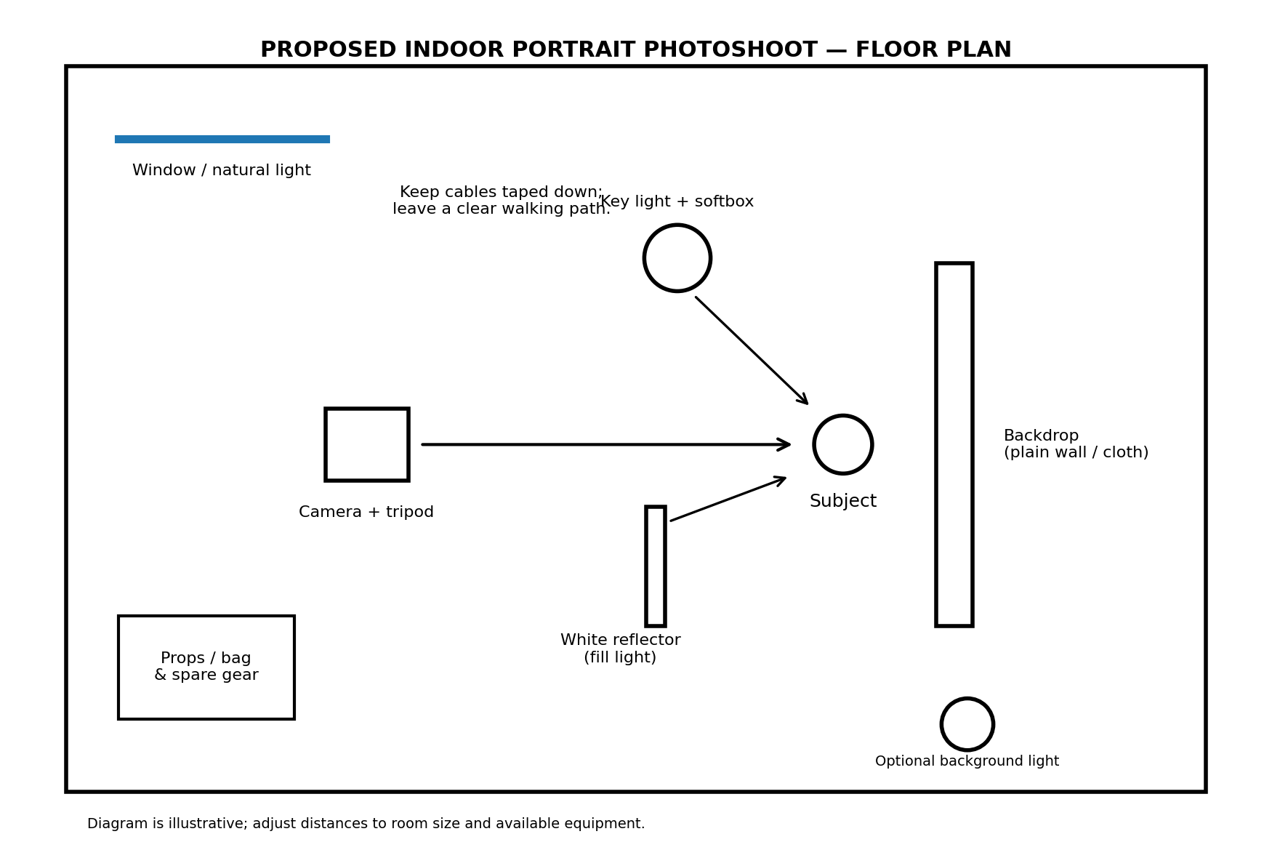
Safety notes: keep a clear path between the camera and subject; tape down loose cables; keep liquids away from electrical equipment; secure stands and backdrop supports; and do not place lights where they can fall or overheat. If using window light, avoid direct harsh sunlight when a softer position is available.

5. Lighting Setup and Reasoning
Setup choice | How it will be used | Reason for the choice
Key light | Place the soft light about 45° to the subject's face and slightly above eye level. | Creates shape and gentle shadows instead of flat, harsh illumination.
Fill using reflector | Place a white reflector opposite the key light, just outside the frame. | Brightens the shadow side naturally without needing a second powered light.
Background distance | Keep the subject about 1–2 metres from the background if the room permits. | Helps separate the subject from the background and reduces hard wall shadows.
Window light alternative | Position the subject facing or turned slightly toward a large window; use a curtain as diffusion if safe. | Makes use of available light and keeps the setup inexpensive.
White balance | Use one consistent lighting type where possible; set white balance or leave it on auto and check results. | Avoids inconsistent colour casts between images.
Exposure and focus | Take test frames; check highlights, shadows, and eye focus before the full set. | Prevents avoidable retakes and keeps the subject's eyes sharp.
Optional background light | Use a low-power light aimed at the backdrop only if available. | Can add separation, but it is not essential for this simple shoot.

6. Camera and Preparation Settings
For a camera, begin with a low ISO such as 100–400 when the light allows, and adjust exposure after test shots. For a single-person portrait, an aperture around f/2.8–f/5.6 can work depending on the lens and how much of the face must remain sharp. Choose a shutter speed fast enough to prevent movement blur; around 1/125 second or faster is a useful starting point for a still subject when handheld. These are starting points, not fixed rules. Use autofocus on the nearer eye and review the image at full size. With a smartphone, clean the lens, tap the eye/face to focus, avoid digital zoom where possible, and use portrait mode only if its edge detection looks natural.
Before the subject arrives, clear the area, check the background, charge devices, format or clear storage only after backing up any needed files, test each light, and take a few test photographs. Ask the subject which poses feel comfortable and obtain consent before publishing.

7. Complete Annotated Shot List
Shot | Framing / angle | Pose and composition | Lighting / camera notes | Purpose
1. Establishing portrait | Wide shot; eye level | Subject near the centre with some room around them; include the clean setting. | Key light at 45°; check the full background and edges of frame. | Introduces the subject and setting.
2. Classic head-and-shoulders | Medium close-up; eye level | Shoulders turned slightly; face toward camera; relaxed expression. | Focus on nearer eye; keep background uncluttered. | Main profile or portfolio portrait.
3. Close-up expression | Tight headshot; eye level | Frame from upper shoulders; natural smile or neutral expression. | Soft light; inspect highlights on forehead and nose. | Shows facial expression and detail.
4. Three-quarter pose | Medium shot; camera slightly to one side | Subject turns body about 30–45° while looking toward camera. | Keep light on the face; avoid a distracting wall shadow. | Adds variety and a flattering shape.
5. Profile portrait | Close or medium; side angle | Subject looks to the side, with space in front of the gaze. | Place key light to shape the profile; check nose and chin shadows. | Creates a more thoughtful, editorial image.
6. Seated portrait | Medium or three-quarter shot | Subject sits upright on a stable stool, hands resting naturally. | Camera near eye level; keep feet and stool placement tidy. | Adds a relaxed, approachable option.
7. Candid / looking away | Medium shot; slight angle | Subject looks toward the window or off-camera; capture a natural moment. | Use continuous light or window light; take several frames. | Creates a less posed, storytelling photograph.
8. Environmental portrait | Wide shot; eye level | Include a small amount of the room while keeping the subject dominant. | Check background lines and remove clutter. | Shows context and a sense of place.
9. Detail shot | Close-up of hands or a meaningful prop | Hands hold a simple prop or rest naturally; keep composition intentional. | Use the same light direction; focus carefully. | Adds a supporting image to the set.
10. Creative composition | Medium shot; subject placed to one side | Use negative space on one side; subject looks into the open space. | Keep exposure consistent; check that empty space is clean. | Leaves space for a title or graphic if needed.
11. Backlit / rim-light attempt | Medium shot; light behind/side if safe | Subject slightly separated from background; face still visible. | Only use an available safe light; expose for the face and avoid flare. | Tests a more dramatic look.
12. Final best portrait | Repeat the strongest framing | Ask the subject to choose a comfortable pose and expression. | Review focus, exposure, hair/clothing, and background before final frames. | Produces the primary final image.

8. Shot Execution Workflow
- Confirm the concept, location, time, clothing, and subject's consent.
- Prepare the room and background; remove clutter and check available light.
- Set up the camera/tripod first, then place the key light and reflector.
- Take test photographs and adjust exposure, light direction, and subject-to-background distance.
- Capture the shot list in order, marking completed shots and noting retakes.
- Review images during the session for focus, closed eyes, distracting objects, and awkward cropping.
- Back up the photographs to a second location before deleting or editing originals.
- Select the strongest images and make restrained edits to exposure, contrast, crop, and colour.

9. Risk Management and Contingency Plan
Possible issue | Prevention / response
Low or changing light | Move closer to a window, increase the light output, or adjust ISO/shutter speed while checking image quality.
Harsh shadows | Move the key light closer and soften it; reposition the subject or add a white reflector.
Background clutter | Check all four edges of the frame and remove unnecessary objects before shooting.
Camera shake or blur | Use a tripod, a faster shutter speed, and stable posture; check focus after test shots.
Battery or storage problem | Charge devices and check free storage in advance; carry a charger or spare battery.
Trip hazard | Tape cables down, keep bags out of walkways, and secure stands.
Subject discomfort | Offer pose choices, take breaks, explain the shot, and respect any request not to use a photograph.
Equipment unavailable | Use a smartphone, window light, a plain wall, and a white card/board as a simple alternative.

10. Quality-Control Checklist
☐ Lens clean and camera/phone battery charged.
☐ Enough storage or memory-card space available.
☐ Background is clean, straight, and free from distracting objects.
☐ Lights and stands are stable; cables are safely routed.
☐ Test frame has correct exposure and natural colour.
☐ Eyes are in focus and subject is comfortable.
☐ Shot list is followed and missing shots are identified.
☐ Images are backed up and selected files are named clearly.

11. Conclusion
This plan demonstrates how careful preparation supports a successful portrait photoshoot. The equipment checklist ensures that essential items are ready, the floor plan shows a practical arrangement, and the lighting explanation connects each setup decision to the intended visual result. The shot list provides a clear sequence of varied compositions, from a wide establishing portrait to close-ups and creative frames. The plan is flexible: a dedicated camera and studio lights can be used if available, but a smartphone, window light, reflector, and plain background can also produce useful results. During the shoot, safety, consent, focus, and consistent lighting should remain priorities.

12. Submission Notes
Before submitting, replace the bracketed name and date on the cover page. If you actually used different equipment or a different location, edit the checklist and floor plan to match your real setup. Add your own photographs or a photograph of your arranged setup if you have them. The GitHub URL field shown on the platform is described as compulsory only for technical/software-related tasks; this photography task appears non-technical, so it can generally be left blank unless the platform gives you different instructions.

