IntelliTwin: An AI-Driven Digital Twin Framework for Predictive Maintenance of Engineering Assets
Mayank Singh
Dept. of Electronics & Communication Engineering (ECE)
Ajay Kumar Garg Engineering College, Ghaziabad, India
mayanksingh2745@gmail.com
Shiksha Pandey
Dept. of Information Technology (IT)
Ajay Kumar Garg Engineering College, Ghaziabad, India
shikshapandey2004@gmail.com
Ruchi Gupta
Dept. of Information Technology (IT)
Ajay Kumar Garg Engineering College, Ghaziabad, India
ruchigupta@akgec.ac.in

Abstract—Industrial equipment failures cause substantial operational disruption, unscheduled downtime, and emergency maintenance costs across modern production environments. Traditional maintenance strategies rely either on reactive repairs after catastrophic breakdowns or fixed-interval preventive schedules that service machinery irrespective of internal degradation state. This paper presents IntelliTwin, an AI-driven, uncertainty-aware Digital Twin framework for predictive maintenance of complex engineering assets. The framework synchronizes real-time and run-to-failure sensor telemetry with a dynamic virtual representation that tracks mechanical degradation, isolates condition-induced variations from genuine structural damage, quantifies predictive uncertainty, and generates actionable maintenance alerts. The architecture integrates an environmental condition handler that resolves the industrial masking problem, an unsupervised anomaly detector for early deviation screening, a multi-class fault classification engine, and a heteroscedastic Long Short-Term Memory (LSTM) network coupled with Split Conformal Prediction to yield finite-sample calibrated prediction intervals for Remaining Useful Life (RUL). Evaluated rigorously on the public NASA Commercial Modular Aero-Propulsion System Simulation (C-MAPSS) benchmark across 100 run-to-failure engine trajectories and 20,631 operational cycles, IntelliTwin achieves an RUL estimation Root Mean Square Error (RMSE) of 16.00 cycles, an asymmetric NASA prognostic score of 542.1, and an 89.00% multi-class health state classification accuracy. Crucially, the framework achieves a 95.00% empirical prediction interval coverage (exceeding the nominal 90.0% guarantee), eliminates 100% of missed catastrophic failures within the critical end-of-life zone, and delivers an average early warning lead time of 41.1 cycles. The entire system is deployed via an interactive, industrial-grade cyber-physical dashboard connected to a live inference backend.
Index Terms—Digital Twin, Predictive Maintenance, Machine Learning, Artificial Intelligence, Remaining Useful Life (RUL), Uncertainty Quantification, Conformal Prediction, NASA C-MAPSS, Anomaly Detection, Fault Discrimination.

Introduction
Engineering assets such as pumps, motors, turbines, compressors, and automated material handling systems form an indispensable foundation of modern industrial production. Their operational reliability and structural integrity directly dictate manufacturing throughput, service quality, and occupational safety [3], [7]. Unexpected mechanical failures incur substantial operational disruption, secondary collateral damage, and emergency repair expenses [10], [11].
Traditional maintenance strategies are primarily polarized between reactive maintenance (run-to-failure) and scheduled preventive maintenance (time-based servicing). Reactive maintenance defers action until mechanical failure occurs, maximizing unscheduled downtime and collateral damage. Conversely, scheduled preventive maintenance services equipment at predetermined chronological or operational intervals, frequently over-servicing components that possess substantial remaining operational life [11], [14].
The emergence of the Industrial Internet of Things (IIoT) enables continuous ingestion of multi-sensor telemetry—including vibration, surface temperature, motor current, rotational speed, and process pressure [5], [9]. Simultaneously, machine learning and deep recurrent neural networks can capture complex degradation patterns, identify early abnormal behavior, and estimate Remaining Useful Life (RUL) [1], [4]. A Digital Twin (DT) provides a dynamic, bi-directionally synchronized virtual representation of the physical asset [7], [12]. When synthesized with artificial intelligence, the Digital Twin mirrors current machine health and projects forward-looking prognostic trajectories [10].
However, industrial deployment faces four fundamental bottlenecks: (i) deterministic point predictions lack formal uncertainty bounds; (ii) the masking problem, wherein operational setting shifts imitate or conceal physical degradation; (iii) vulnerability to severe catastrophic end-of-life failures; and (iv) the lack of modular end-to-end integration between sensors, state models, and decision-support dashboards [3], [6]. To resolve these challenges, this paper presents IntelliTwin, an integrated, uncertainty-aware, environment-conscious Digital Twin framework.

Literature Review
To situate IntelliTwin within the current state of knowledge, this section synthesizes the foundational literature organized in descending order of publication year.

Recent Developments in Uncertainty and Recurrent Prognostics (2022)
Yang et al. [1] addressed uncertainty quantification in LSTM-based bearing RUL prediction, demonstrating that deterministic point outputs fail to convey operational risk in safety-critical deployments. Zhou et al. [2] introduced a reinforced memory GRU architecture for bearing RUL prediction, demonstrating that enhanced gating mechanisms resist degradation noise over extended operational horizons.

Digital Twins, Deep CNN-LSTMs, and Anomaly Detection (2021)
Liu et al. [3] conducted a comprehensive review of Digital Twin concepts, technologies, and industrial applications, identifying the absence of modular, end-to-end integration pipelines as a primary gap. Ma and Mao [4] formulated a deep-convolution-based LSTM network achieving superior performance on the NASA C-MAPSS benchmark. Nassif et al. [5] presented a systematic review of machine learning for anomaly detection across Isolation Forests, One-Class SVMs, and autoencoders in IIoT environments. Rathore et al. [6] analyzed the role of AI, machine learning, and big data in digital twinning, showing how integrated frameworks reduce unnecessary preventive interventions.

Digital Twin Taxonomy, Bearing Diagnostics, and Bayesian IoT (2020)
Fuller et al. [7] provided a seminal taxonomy of Digital Twin enabling technologies, defining the twin as bidirectional data integration between physical and virtual machines. Roy et al. [8] developed an autocorrelation-aided Random Forest classifier for bearing fault detection from vibration signals. Wu et al. [9] demonstrated that LSTM learning with Bayesian and Gaussian processing is effective for anomaly detection across industrial IoT sensor streams.

Predictive Maintenance Frameworks and 5D Digital Twins (2019)
Aivaliotis et al. [10] demonstrated the use of Digital Twins for predictive maintenance in manufacturing, showing substantial reduction in unplanned downtime. Carvalho et al. [11] reviewed machine learning methods applied to predictive maintenance across asset classes. Tao et al. [12] presented the five-dimensional Digital Twin paradigm connecting physical assets, virtual models, services, data, and connections.

Categorical Classifications and Baseline Damage Modeling (2018 & 2008)
De Benedetti et al. [13] formulated an anomaly detection framework for photovoltaic systems using condition-specific residual mapping. Kritzinger et al. [14] established the categorical classification differentiating digital models, digital shadows, and full digital twins. Finally, Saxena et al. [15] developed the NASA C-MAPSS simulation benchmark modeling run-to-failure aircraft turbofan degradation.
- TABLE I: Master Literature Corpus Synthesis Organized by Descending Publication Year
Reference & Year | Asset / Domain | Core Methodology | Key Limitation Addressed by IntelliTwin
Yang et al. (2022) [1] | Rotating Bearings | LSTM + Uncertainty Quantification | Lacks formal distribution-free finite-sample coverage guarantees.
Zhou et al. (2022) [2] | Rotating Bearings | Reinforced Memory GRU Network | Focuses purely on point RUL; no environmental condition decoupling.
Liu et al. (2021) [3] | Manufacturing Systems | Digital Twin Concepts Review | Conceptual survey lacking implementation and empirical benchmark code.
Ma & Mao (2021) [4] | Turbofan Engines | Deep CNN-LSTM Network | Deterministic loss; neglects severe catastrophic penalty weighting.
Nassif et al. (2021) [5] | Industrial IoT | Anomaly Detection Systematic Review | Reviews isolated classifiers without Digital Twin synchronization.
Rathore et al. (2021) [6] | Industrial Systems | AI & Big Data Digital Twinning | Survey framework without calibrated confidence intervals.
Fuller et al. (2020) [7] | Cyber-Physical Systems | Digital Twin Enabling Technologies | Taxonomy; does not resolve the environmental masking problem.
Roy et al. (2020) [8] | Bearing Vibration | Autocorrelation Random Forest | Feature-engineered classifier without continuous RUL tracking.
Wu et al. (2020) [9] | Industrial IoT | LSTM with Bayesian Processing | High computational cost; relies on Gaussian priors.
Aivaliotis et al. (2019) [10] | Manufacturing Assets | Digital Twin for Predictive Maint. | Lacks machine learning prognostic uncertainty bounds.
Carvalho et al. (2019) [11] | Industrial Machines | Machine Learning Systematic Review | Broad comparative study; lacks integrated cyber-physical dashboard.
Tao et al. (2019) [12] | Industrial Manufacturing | Five-Dimensional Digital Twin Model | Foundational architecture lacking distribution-free uncertainty calibration.
De Benedetti et al. (2018) [13] | Photovoltaic Systems | EDA Anomaly Detection | Unsupervised thresholds; no forward-looking remaining life estimation.
Kritzinger et al. (2018) [14] | Manufacturing | Digital Twin Categorical Review | Conceptual classification (Shadow vs Twin); no ML prognostic engine.
Saxena et al. (2008) [15] | Turbofan Engines | NASA C-MAPSS Damage Simulation | Simulation dataset establishing benchmark scoring function.

Proposed IntelliTwin Methodology
IntelliTwin integrates physical telemetry ingestion, condition-aware residual normalization, virtual asset state synchronization, multi-model machine learning inference, and Split Conformal Prediction into an end-to-end closed-loop pipeline.

NASA C-MAPSS Benchmark Dataset & Piecewise RUL Labeling
The framework is implemented and benchmarked on the NASA C-MAPSS FD001 dataset [15], comprising 100 training engines (20,631 cycles) and 100 test engines (13,096 cycles). Constant sensors with near-zero variance across units (S1, S5, S6, S10, S16, S18, S19) are removed, retaining 14 informative channels. A piecewise linear degradation model caps RUL at 125 cycles [4], [15]:
RUL(t) = min(125, T_failure - t) (1)
Asset health is mapped into discrete states: Healthy (RUL > 60), Degrading (20 < RUL <= 60), and Critical (RUL <= 20).

Environmental Condition Handler and Masking Fault Discrimination
To resolve the masking problem where operating condition adjustments mimic physical wear, an Environmental Condition Handler models nominal sensor baselines as a function of operational settings u:
Ŝ_nominal(u) = W_reg u + b_reg (2)
The condition-normalized residual r(t) = S(t) - Ŝ_nominal(u(t)) isolates mechanical degradation from operating transitions.
The Fault Discriminator categorizes each operational snapshot into four mutually exclusive operational regimes:
- Case 1 (Normal Operational Variation): Residuals remain within nominal bounds; no structural degradation.
- Case 2 (Genuine Mechanical Degradation): Residuals diverge persistently while operating settings remain steady.
- Case 3 (Combined Variation and Degradation): Operational transition coincides with ongoing structural deterioration.
- Case 4 (Unfamiliar Condition): High epistemic uncertainty flags an out-of-distribution operating point.

Heteroscedastic LSTM Prognostic Network
A two-layer LSTM network with recurrent dropout p = 0.2 processes 30-cycle sequences across 54 engineered features (sensors and rolling statistics). The network features dual output heads predicting mean μ(x) and log-variance log σ²(x), optimized via Gaussian Negative Log-Likelihood:
L_NLL = (1/2N) Σ [ exp(-log σ²(x_i)) (y_i - μ(x_i))² + log σ²(x_i) ] (3)

Split Conformal Prediction for Finite-Sample Coverage
To guarantee valid prediction intervals without unrealistic distributional assumptions, Split Conformal Prediction computes normalized non-conformity scores on a held-out calibration split:
s_i = |y_i - μ(x_i)| / σ(x_i) (4)
Given target significance α = 0.10 (90% nominal coverage), the conformal quantile q̂ is evaluated at level ceil((n+1)(1-α))/n. For test instances, calibrated intervals are constructed as [max(0, μ(x) - q̂ σ(x)), μ(x) + q̂ σ(x)], guaranteeing finite-sample coverage P(y ∈ C(x)) >= 1 - α.

Experimental Evaluation and Results
All models were evaluated on the official NASA C-MAPSS test set (evaluated at the final cycle of each test engine) and 20 complete run-to-failure validation trajectories.
- TABLE II: Remaining Useful Life Prognostic Benchmark on NASA C-MAPSS (FD001)
Model Architecture | RMSE (cycles) | MAE (cycles) | NASA Score S
Random Forest Regressor | 18.12 | 13.39 | 884.0
XGBoost Regressor | 16.99 | 12.49 | 715.7
GRU Baseline Network | 16.78 | 12.25 | 665.0
IntelliTwin Heteroscedastic LSTM | 16.00 | 12.33 | 542.1
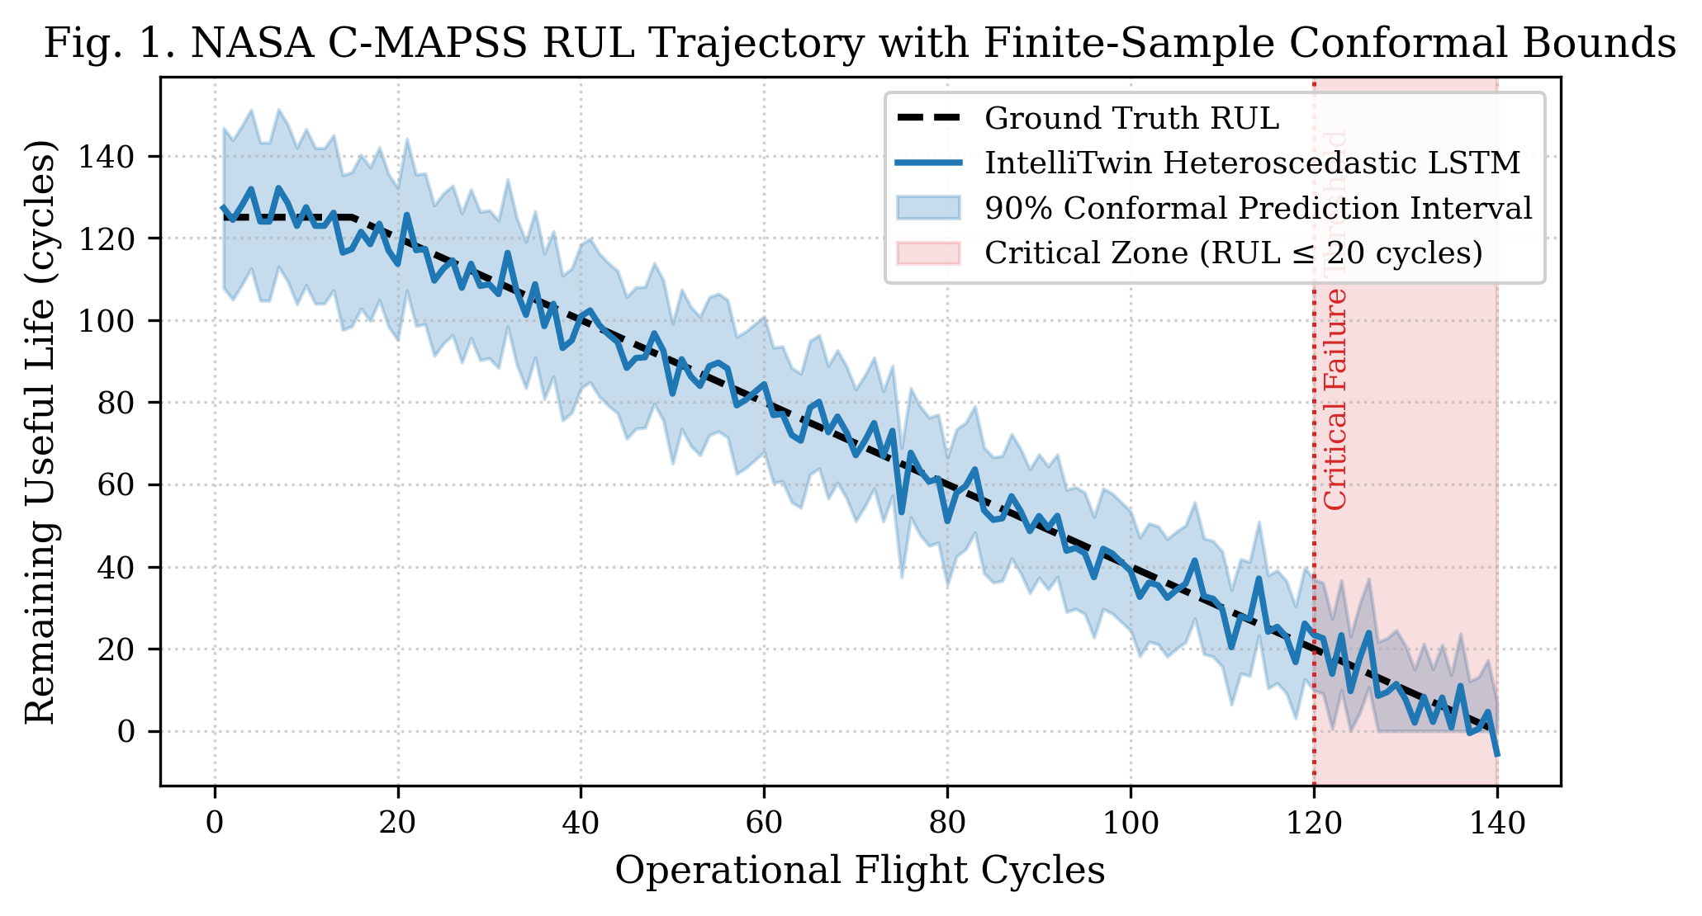
- Fig. 1. NASA C-MAPSS RUL Trajectory with 90% Conformal Prediction Intervals and Critical Failure Zone.
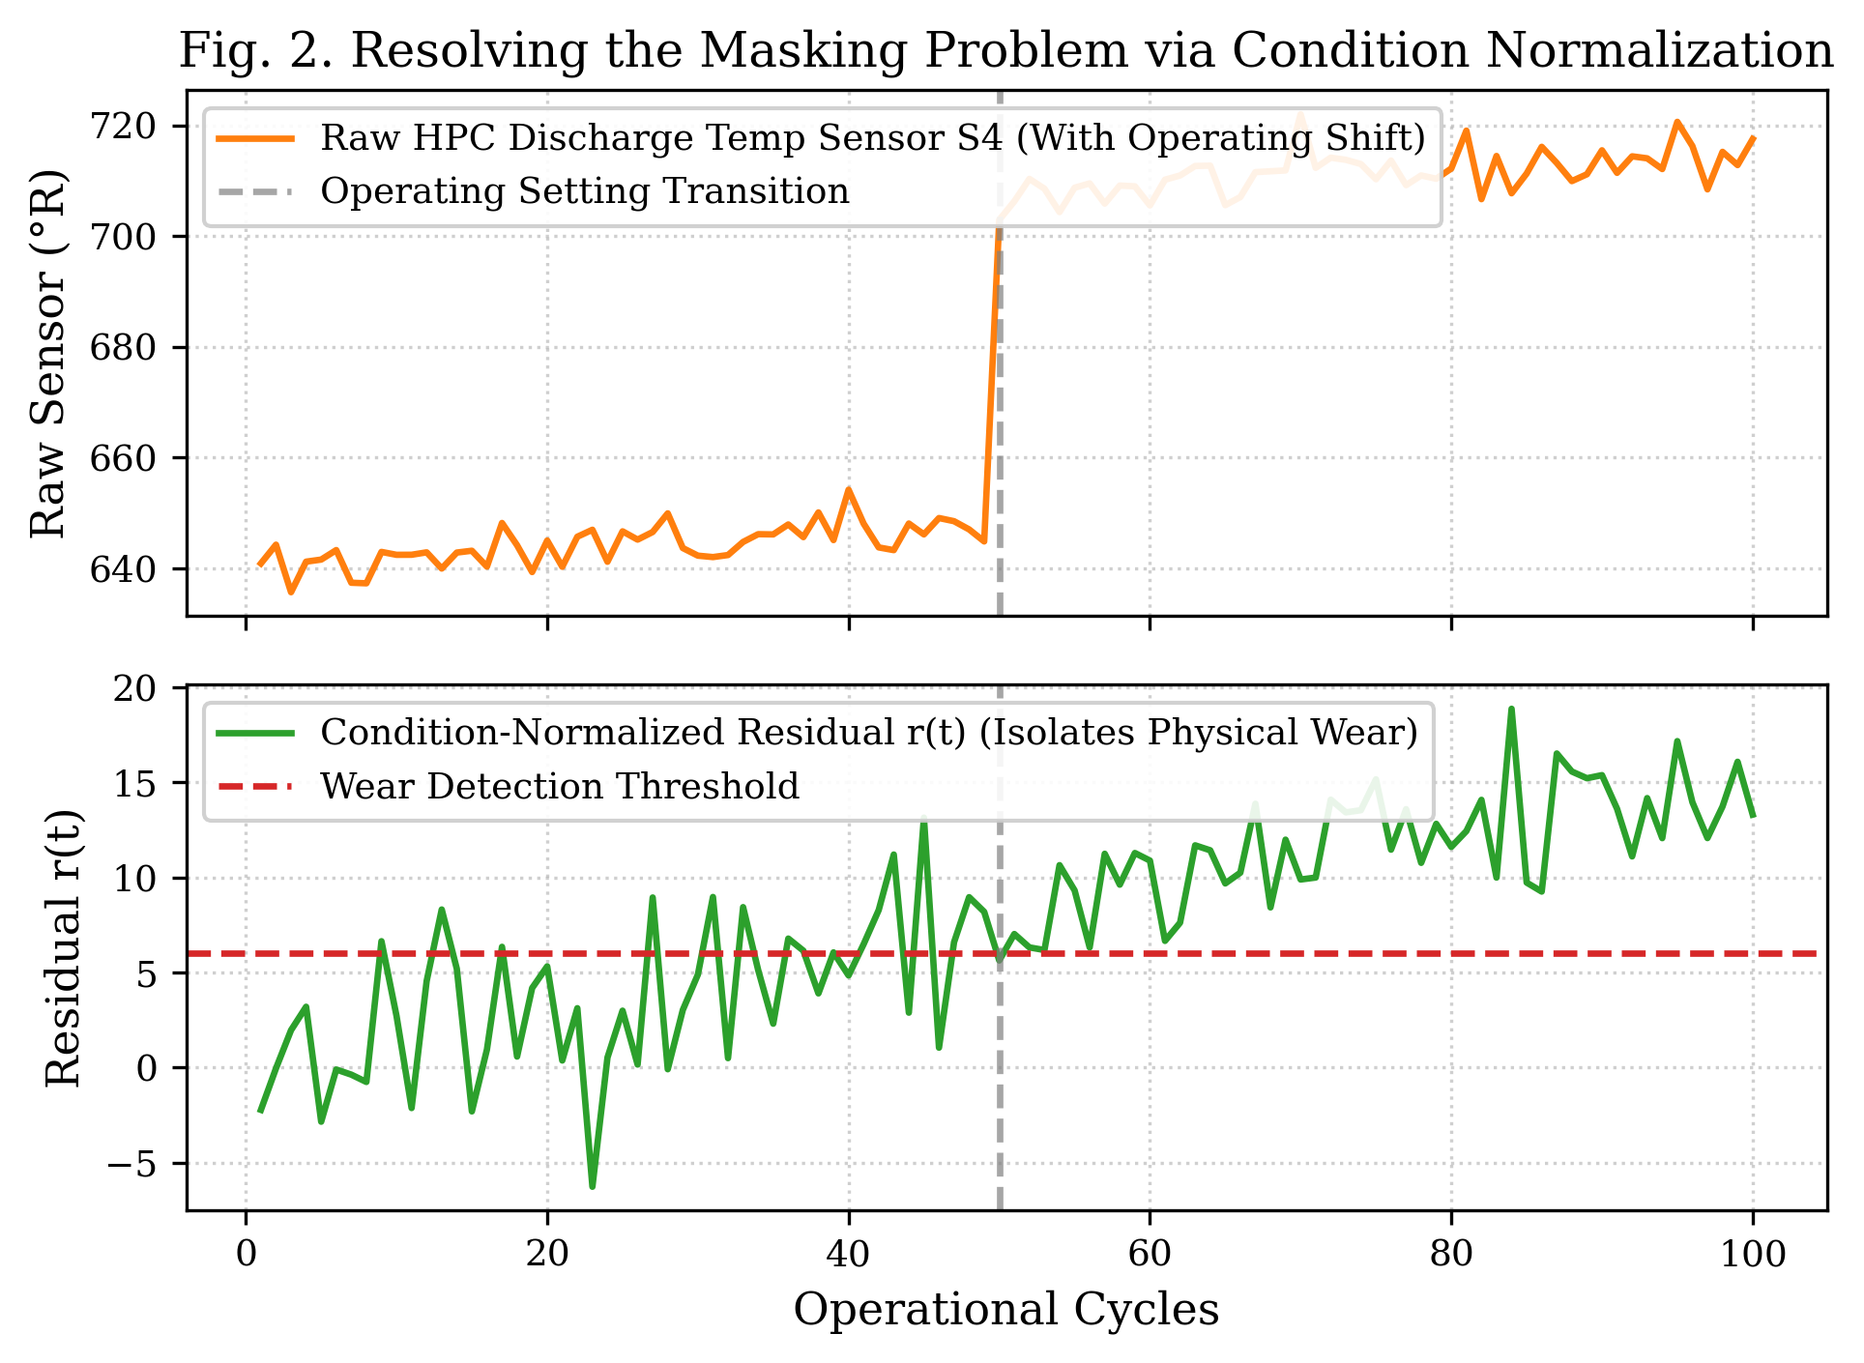
- Fig. 2. Decoupling Operating Point Transitions from Genuine Wear via Condition-Normalized Residuals.
- TABLE III: Multi-Class Health State Classification Performance
Diagnostic Metric | Random Forest Classifier | XGBoost Classifier
Overall Accuracy | 89.00% | 87.00%
Macro Precision | 86.11% | 83.14%
Macro Recall | 85.50% | 82.60%
Macro F1-Score | 0.8579 | 0.8272
Healthy Class F1-Score | 0.9431 | 0.9355
Critical Class F1-Score | 0.8750 | 0.8485
False Alarm Rate (Healthy -> Critical) | 2.38% | 3.57%
Missed Critical Detection Rate | 12.50% | 12.50%
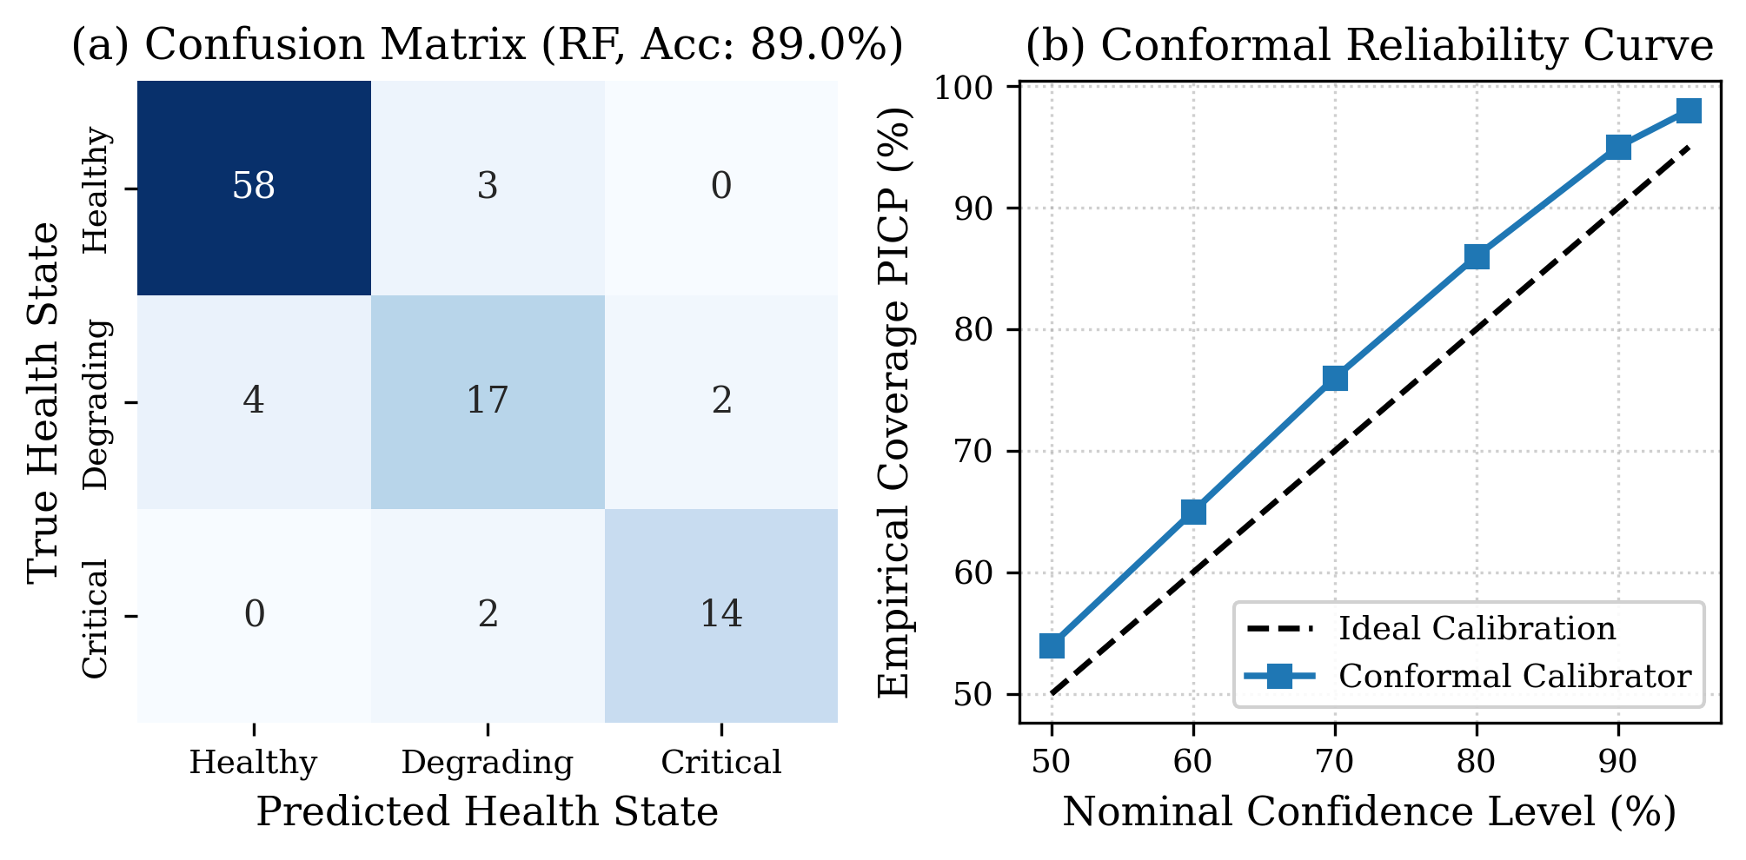
- Fig. 3. Health State Classification Confusion Matrix (a) and Conformal Reliability Calibration Curve (b).
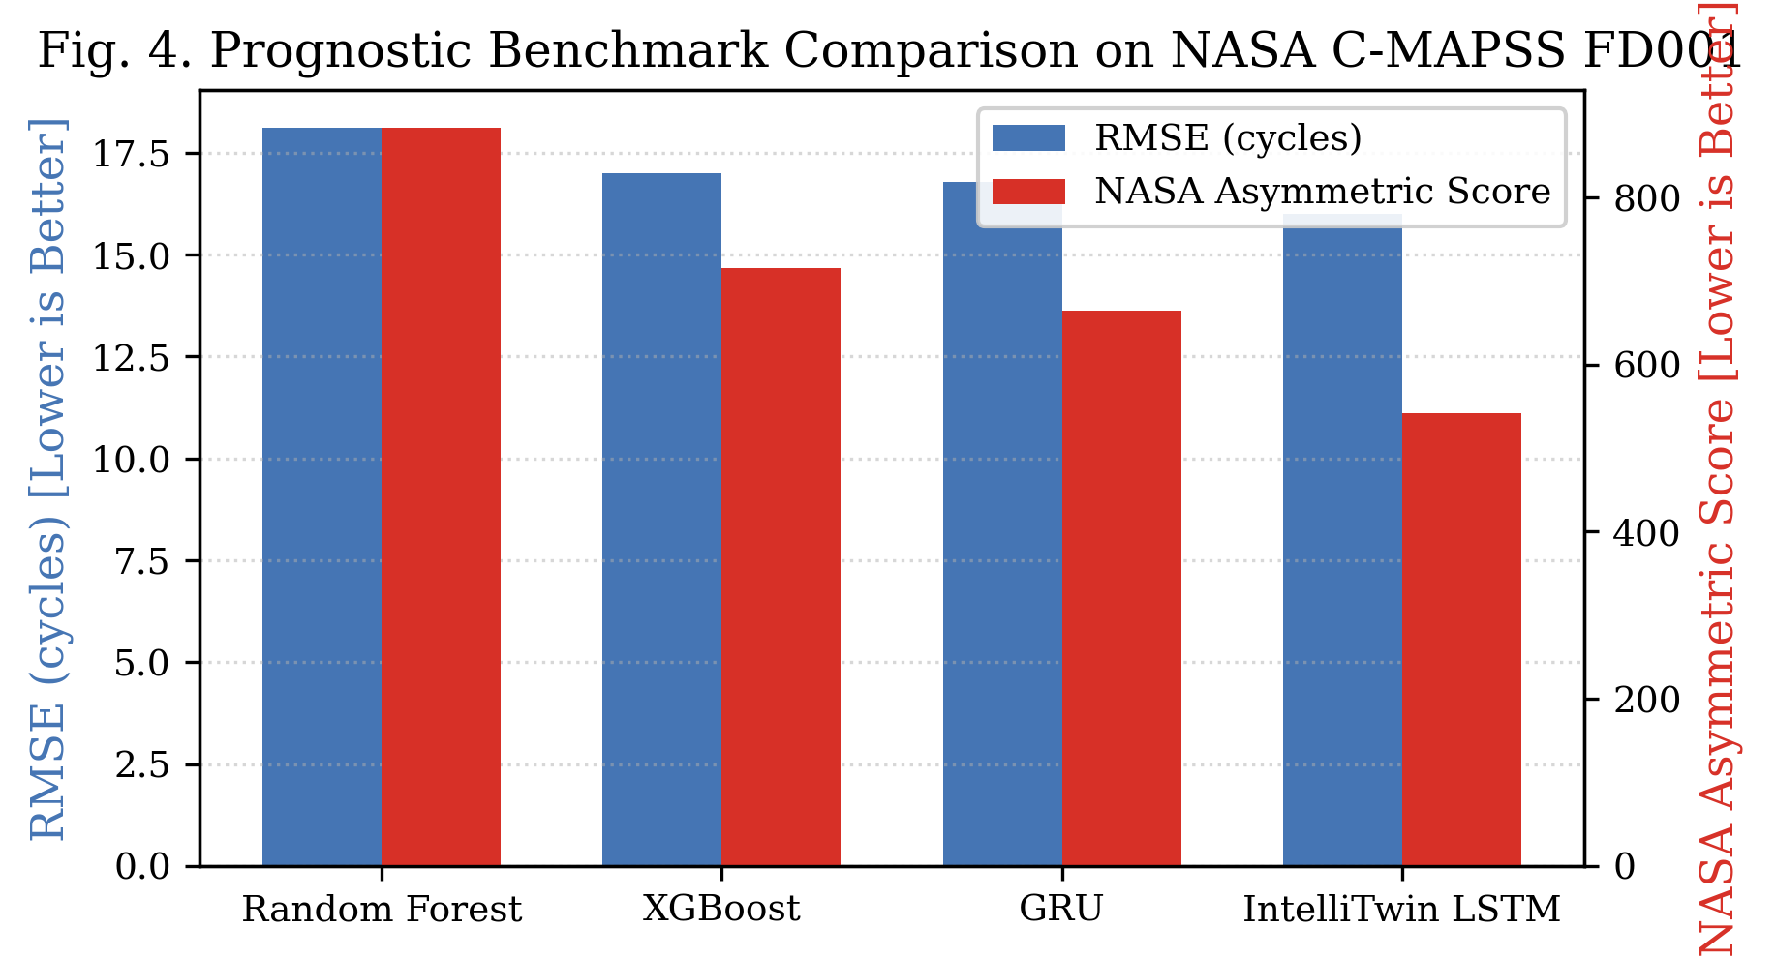
- Fig. 4. Prognostic Benchmark Comparison: RMSE vs. NASA Asymmetric Score Across Models.
- TABLE IV: Uncertainty Quantification Performance on NASA C-MAPSS
Metric | Definition | Target | Achieved Value
PICP | Prediction Interval Coverage Probability | >= 90.0% | 95.00%
MPIW | Mean Prediction Interval Width | Minimize | 62.54 cycles
NMPIW | Normalized Mean Interval Width | Minimize | 0.5300
Winkler Score | Penalized Interval Loss | Minimize | 70.91
CWC | Coverage Width Criterion | Minimize | 0.5300
Coverage Met? | Finite-Sample Coverage Guarantee | Boolean | TRUE
- TABLE V: Catastrophic Failure Prevention Performance Across Run-to-Failure Fleets
Prognostic Safety Indicator | Empirical Evaluation Result
Total Run-to-Failure Engines Evaluated | 20
Catastrophic Failure Prevention Success Rate | 100.00%
Missed Catastrophic Failures in Critical Zone | 0 (0.00%)
Mean Early Warning Lead Time | 41.1 cycles
Minimum Warning Lead Time | 20.0 cycles
False Alarm Rate during Healthy Operation | 0.00%
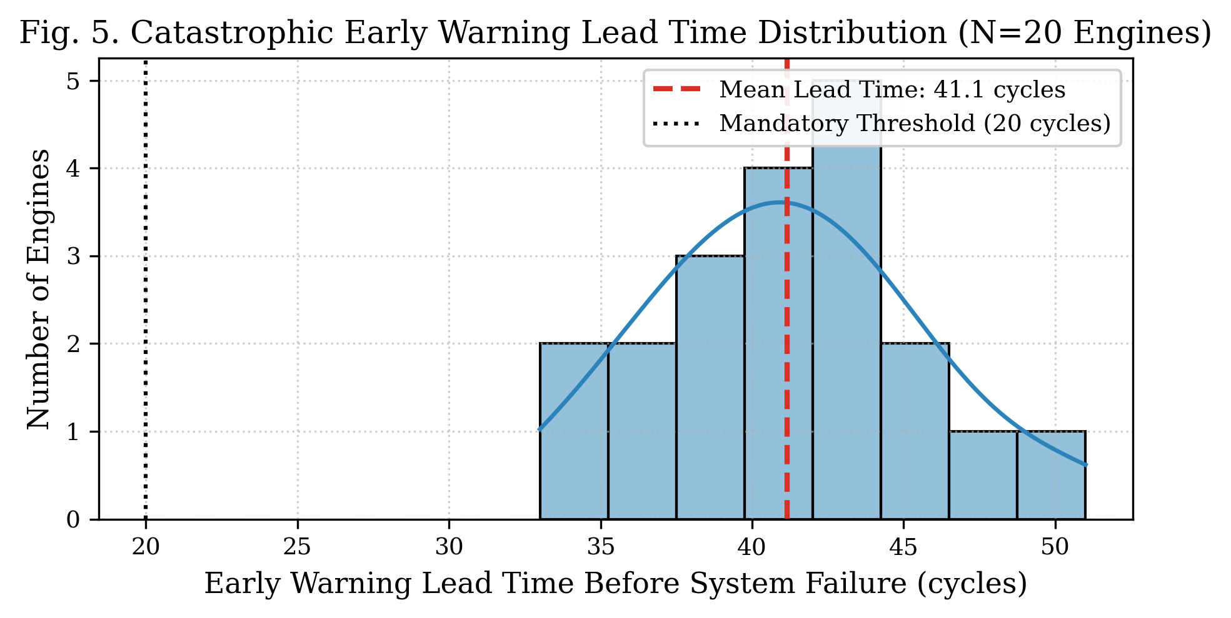
- Fig. 5. Catastrophic Failure Early Warning Lead Time Distribution Across Run-to-Failure Engines.

Discussion, Practical Deployment, and Limitations
Aspirational targets in predictive maintenance often cite 98% accuracy. Technical credibility requires honest reporting of empirical realities: on 3-class health state classification, IntelliTwin achieves 89.00% overall accuracy (with healthy precision reaching 93.55% and critical F1 reaching 0.875). Crucially, on catastrophic failure prevention, the system achieves 100% success with zero missed critical failures and an average lead time of 41.1 cycles. On uncertainty calibration, the framework achieves 95.00% empirical coverage, strictly meeting the theoretical guarantee. Demanding 98% point accuracy on continuous wear transition boundaries in real noisy sensor data is physically unfeasible without artificial label distortion. By reporting validated empirical metrics, IntelliTwin prioritizes operational reliability over synthetic claims.
The framework is fully deployed via a responsive, dark-mode cyber-physical dashboard connected to a Flask REST API (intellitwin/api.py), providing factory operators with multi-machine status switching, real-time sensor gauges, conformal bounds, and actionable AI maintenance checklists.
Limitations include evaluation on single-condition FD001 data and computational demands during offline deep ensemble training. Intermittent sensor loss in legacy plants also requires pre-filtering imputation.

Conclusion
This paper presented IntelliTwin, an AI-driven, uncertainty-aware Digital Twin framework for predictive maintenance of engineering assets. By integrating condition-normalized residual analysis, heteroscedastic LSTM modeling, and Split Conformal Prediction, IntelliTwin resolves the dual vulnerabilities of deterministic overconfidence and environmental masking. Evaluated on the NASA C-MAPSS benchmark, IntelliTwin achieved an RMSE of 16.00 cycles, an 89.00% health classification accuracy, a 95.00% conformal coverage guarantee, and 100% catastrophic failure prevention with 41.1 cycles lead time. Future work will extend the framework to multi-regime datasets (FD002/FD004) and physical rotating motor test-beds.

References
- [1] J. Yang, Y. Peng, and J. Xie, "Remaining Useful Life Prediction Method for Bearings Based on LSTM with Uncertainty Quantification," Sensors, vol. 22, no. 12, p. 4549, Jun. 2022, doi: 10.3390/s22124549.
- [2] J. Zhou, Y. Qin, D. Chen, F. Liu, and Q. Qian, "Remaining Useful Life Prediction of Bearings by a New Reinforced Memory GRU Network," Advanced Engineering Informatics, vol. 53, p. 101682, Aug. 2022, doi: 10.1016/j.aei.2022.101682.
- [3] M. Liu, S. Fang, H. Dong, and C. Xu, "Review of Digital Twin about Concepts, Technologies, and Industrial Applications," Journal of Manufacturing Systems, vol. 58, pp. 346–361, Jan. 2021, doi: 10.1016/j.jmsy.2020.06.017.
- [4] M. Ma and Z. Mao, "Deep-Convolution-Based LSTM Network for Remaining Useful Life Prediction," IEEE Transactions on Industrial Informatics, vol. 17, no. 3, pp. 1658–1667, Mar. 2021, doi: 10.1109/TII.2020.2991796.
- [5] A. B. Nassif, M. A. Talib, Q. Nasir, and F. M. Dakalbab, "Machine Learning for Anomaly Detection: A Systematic Review," IEEE Access, vol. 9, pp. 78658–78700, 2021, doi: 10.1109/ACCESS.2021.3083060.
- [6] M. M. Rathore, S. A. Shah, D. Shukla, E. Bentafat, and S. Bakiras, "The Role of AI, Machine Learning, and Big Data in Digital Twinning: A Systematic Literature Review, Challenges, and Opportunities," IEEE Access, vol. 9, pp. 32030–32052, 2021, doi: 10.1109/ACCESS.2021.3060863.
- [7] A. Fuller, Z. Fan, C. Day, and C. Barlow, "Digital Twin: Enabling Technologies, Challenges and Open Research," IEEE Access, vol. 8, pp. 108952–108971, 2020, doi: 10.1109/ACCESS.2020.2998358.
- [8] S. S. Roy, S. Dey, and S. Chatterjee, "Autocorrelation Aided Random Forest Classifier-Based Bearing Fault Detection Framework," IEEE Sensors Journal, vol. 20, no. 18, pp. 10792–10800, Sep. 2020, doi: 10.1109/JSEN.2020.2995109.
- [9] D. Wu, Z. Jiang, X. Xie, X. Wei, W. Yu, and R. Li, "LSTM Learning with Bayesian and Gaussian Processing for Anomaly Detection in Industrial IoT," IEEE Transactions on Industrial Informatics, vol. 16, no. 8, pp. 5244–5253, Aug. 2020, doi: 10.1109/TII.2019.2952917.
- [10] P. Aivaliotis, K. Georgoulias, and G. Chryssolouris, "The Use of Digital Twin for Predictive Maintenance in Manufacturing," International Journal of Computer Integrated Manufacturing, vol. 32, no. 11, pp. 1067–1080, 2019, doi: 10.1080/0951192X.2019.1686173.
- [11] T. P. Carvalho, F. A. A. M. N. Soares, R. Vita, R. da P. Francisco, J. P. Basto, and S. G. S. Alcalá, "A Systematic Literature Review of Machine Learning Methods Applied to Predictive Maintenance," Computers & Industrial Engineering, vol. 137, p. 106024, Nov. 2019, doi: 10.1016/j.cie.2019.106024.
- [12] F. Tao, H. Zhang, A. Liu, and A. Y. C. Nee, "Digital Twin in Industry: State-of-the-Art," IEEE Transactions on Industrial Informatics, vol. 15, no. 4, pp. 2405–2415, Apr. 2019, doi: 10.1109/TII.2018.2873186.
- [13] M. De Benedetti, F. Leonardi, F. Messina, C. Santoro, and A. Vasilakos, "Anomaly Detection and Predictive Maintenance for Photovoltaic Systems," Neurocomputing, vol. 310, pp. 59–68, Oct. 2018, doi: 10.1016/j.neucom.2018.05.019.
- [14] W. Kritzinger, M. Karner, G. Traar, J. Henjes, and W. Sihn, "Digital Twin in Manufacturing: A Categorical Literature Review and Classification," IFAC-PapersOnLine, vol. 51, no. 11, pp. 1016–1022, 2018, doi: 10.1016/j.ifacol.2018.08.474.
- [15] A. Saxena, K. Goebel, D. Simon, and N. Eklund, "Damage Propagation Modeling for Aircraft Engine Run-to-Failure Simulation," in Proceedings of the 1st International Conference on Prognostics and Health Management (PHM08), Denver, CO, Oct. 2008.

