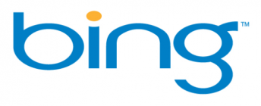



Wisdom IT Solutions LLC



Submitted to: Adel Group Of Companies
(www.adelgroup.com)
Prepared by: Wisdom

February 28th, 2018
This material contained in our response and any material or information disclosed during discussions of the proposal represents the proprietary, confidential information pertaining to Wisdom IT Solution’s services, methodologies and methods. Other products and brand names may be trademarks or registered trademarks of their respective owners.
By accepting this response, client agrees that the information in this proposal will not be disclosed outside the Organization and will not be duplicated, used, or disclosed for any purpose other than to evaluate this proposal. This proposal is a subject to a mutually approved agreement or contract specifying full terms and conditions.

“If We Do Not Achieve it in 90 Days We Will Do It For Free”

Private & Confidential
Date: February 28th, 2018
We are pleased to submit our proposal to www.adelgroup.com for the service of Online marketing. Our proposal is underscored by the deep expertise and qualifications of our team to provide the services required by client.
Our proposal is formatted to specifically address the requirements identified during web analysis and case study. The proposal includes detailed descriptions of our approach and methodology to provide you with high-quality deliverables and results.
We look forward to the opportunity of developing a professional relationship with you by working on this project.
We welcome comments and feedback and would be pleased to make any modifications to this proposal to ensure your requirements are fully met. Please direct any questions or comments regarding our proposal to me directly at +971 55 7521538
Office Address:
Office No 1005, Damac Smart Heights, TeCom, Dubai Internet City Dubai.
Tel.: 04 3883913
http://wistech.biz/seodubai/

Sincerely,

Naseem Aslam,
Sales Manager
Wisdom IT Solutions LLC

Mobile: +971 55 7521538
Email: naseem@wistech.biz

Table of Contents

Introduction
SEO & SEO Process (How Do We Do It?)
Our Happy Clients
Adel Group Of Companies –SEO & AdWords Proposal
Basic Web Audit
Recommended Keywords
Adwords Keywords
Why Wisdom for your Online marketing?
Breakdown of Payment
Deliverables
Terms of Services or Guarantees
Signup
UAE Contact Information

What You Will Get???

Introduction
It’s not ordinary SEO, we create business driven strategies for you.

Wisdom IT Solution L.L.C is pleased to submit search engine optimization proposal for www.adelgroup.com. Our proposal will describe the program element, services, terms and conditions and schedule for SEO program.
We have designed our workflow for your website in way that your website will surely appear on the first page of search engines for competitive keywords that will actually draw relevant traffic for your website (conditions apply). Here is how you get business from our SEO?

Being one of the best SEO companies’ our work flow starts from the optimization of the website which includes

- Design Check
- Keywords Check
- On-page Optimization Check
- Content Check
- Off-Page Optimization Check

On-Page Optimization Check
Keywords Check
Design Check

Off-Page Optimization Check
Content Check

Benefits of SEO & SEO Process (How Do We Do It?)

Brief Overview of Our Full SEO Process - 800Wisdom

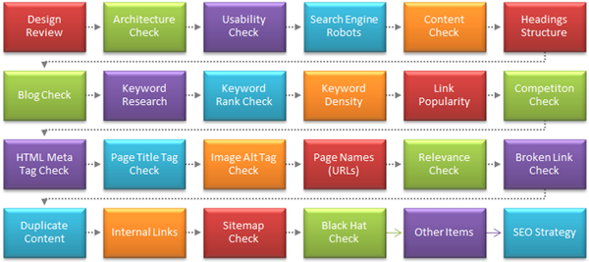

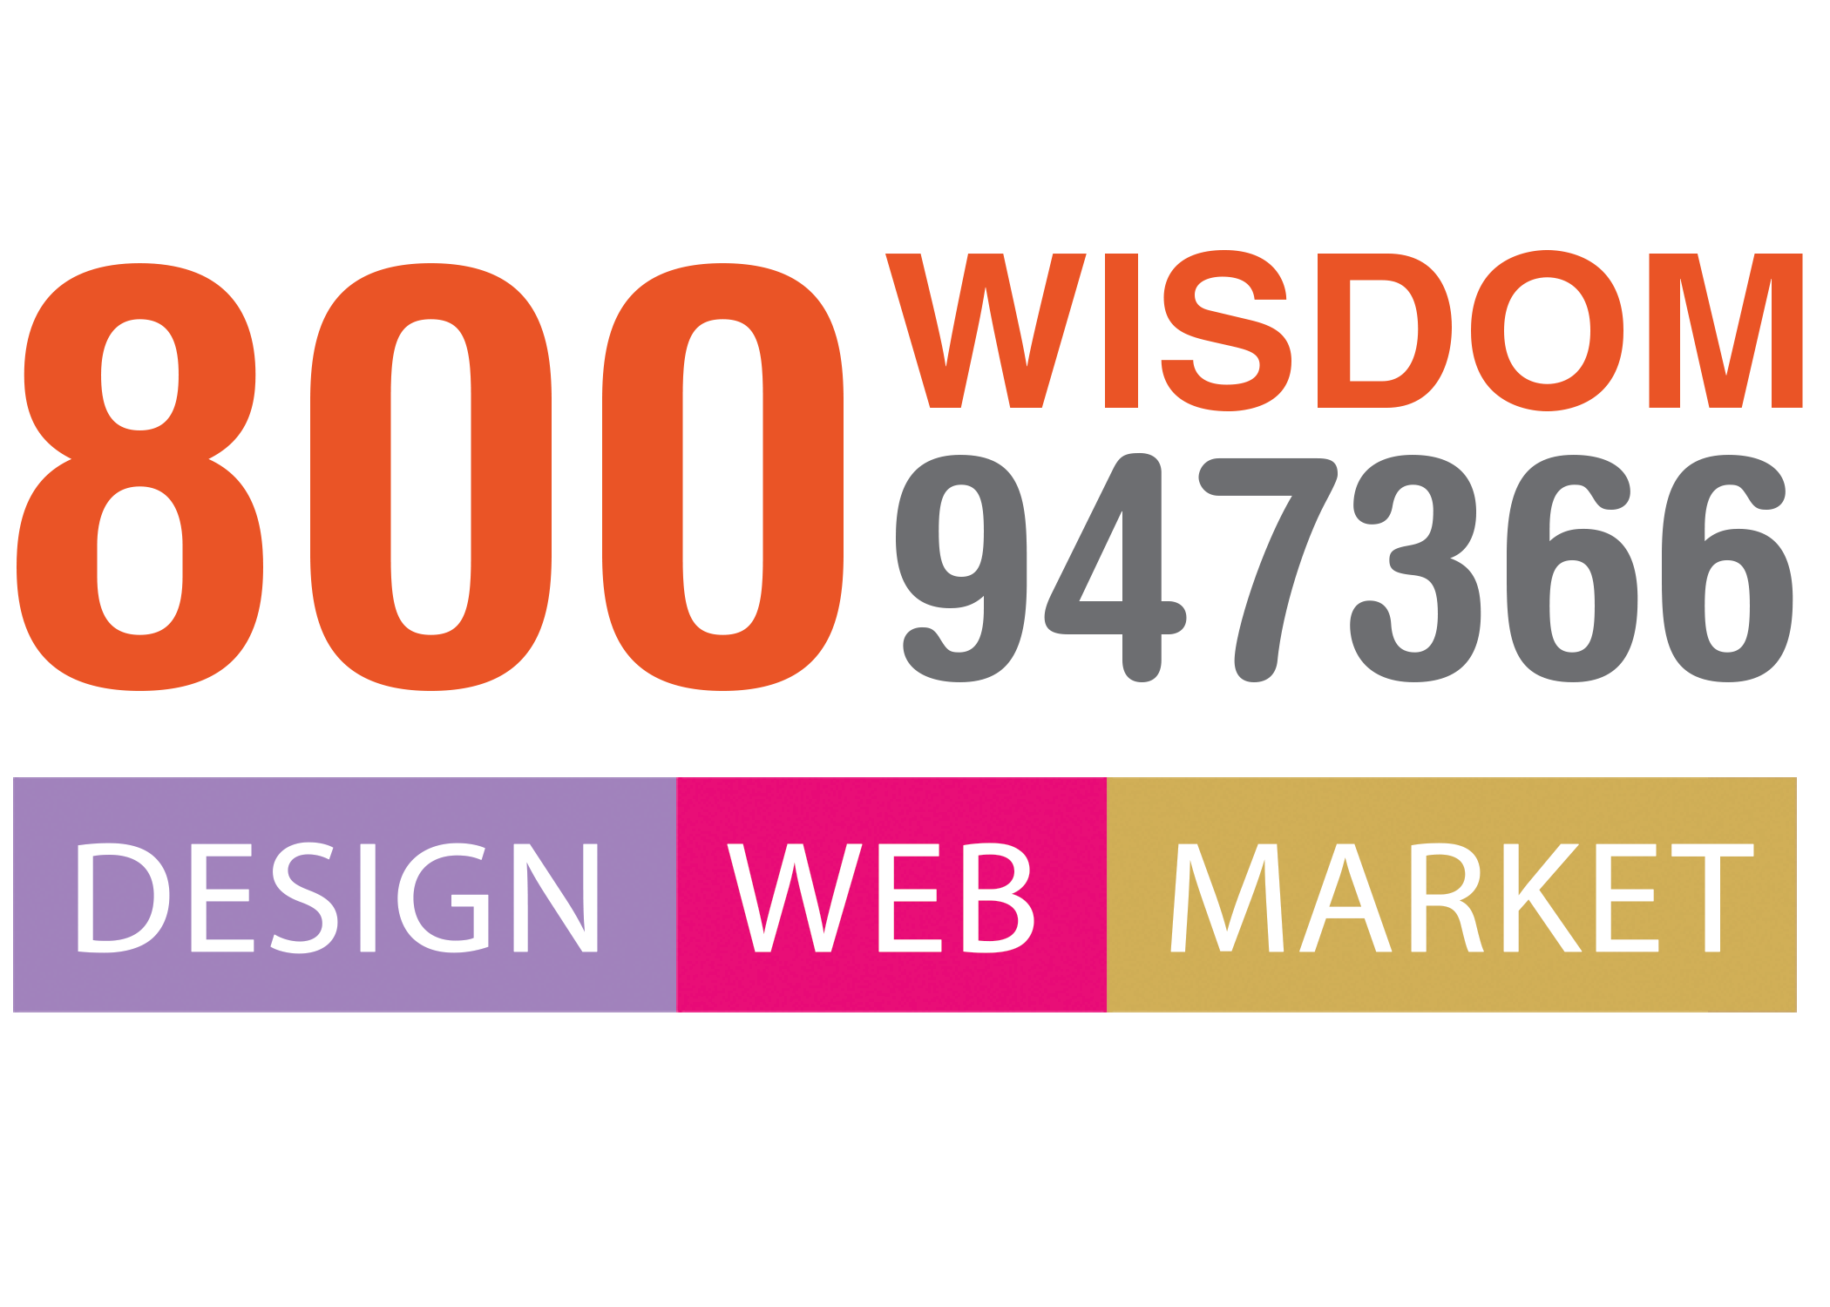


Our Happy Clients

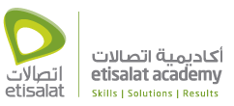









Adel Group Of Companies – Description (SEO)
- Upload 10 key index able phrases that you choose to market your business.
- Analyze your competition.
- Examine the structure and content of your Web site.
- Create and upload search-engine friendly Meta data.
- Provide a comprehensive SEO analysis of your site.
- Deliver support to discuss the present and future of your Website.
- Submit your site to up to 100 search engines and directories.
- Submission of Press Releases
- Submission of Articles to Web 2.0 Properties
- Google & Yahoo Site Maps Creation & Submission
- Both IN-Page and Off-Page SEO
- Competitor Analysis, and Regular steps to increase PR of Site
- Monitor traffic using the latest SEO technology.
- Site Map Submissions to Google
- Robot.txt Optimization - Social Bookmarking
- Content Optimization

Monthly Web Audit

- Competition Analysis & Re-Adjustment of On-Page Optimization
- Keyword Ranking Report
- Link Analysis Report
-Web Traffic Report
Min. 1 Year Contract

Adel Group Of Companies – Google AdWords
- Complete Google Adwords account and Campaign Creation
- Maintenance, Consultation and Reporting
- Keywords Suggestions

Why Wisdom for Your SEO?

The reason you will hire us - and stay with us

Wisdom IT Solutions L.L.C, You are getting everything you want from digital marketing. From visitors to customers, we plan a journey for you.

We have comprehensive, authoritative and easy to understand practical advices for you to get more sales from your digital marketing campaigns and SEO experience.

You get more audience,You have more sales

 | Professionalism
 | We have a full solution for your every ‘how-to’ question in the area of digital marketing.
 | Statistics
 | Statistics, facts and figures, audience and current reports.
 | Software
 | We use latest software online and offline to measure every activity on your website.
 | Reports
 | Monthly reporting with the list of indexed keywords with their rankings.
 | Consultation
 | One hour optional monthly consultation on how to improve digital media marketing.


What do you get?

- Your website listed with popular search engines.
- More audience and visitors.
- More interaction and communication.
- Monthly consultation on conversion.
- Best Solutions for every digital media marketing problem.
- Intelligent briefing on every action for SEO.
- Monthly proper reporting.
Breakdown of Payment
- No Setup or Hidden Charges

- We will sign up a 12 months contract, no setup, startup or hidden charges. One month advance payment will be made before starting the project and rest every month. More keywords will give you more traffic.

- After full analysis of the project on the basis of given keywords the final price for the project is mentioned below in quotation, Payable in monthly or quarterly cheques in advance.

Deliverables
- Monthly Report
- Google Analytics
- 1 Hour Monthly Consultancy

Terms of Services or Guarantees
By using our services, viewing, accessing or otherwise using any of the services or information created, collected, compiled or submitted to Wisdom, you agree to be bound by the following Terms and Conditions of Service.

- Wisdom IT Solutions L.L.C does not practice or tolerate spam in any shape or form. We do not communicate your e-mail address or contact information to any third-party organizations.
- We understand the importance of your privacy. We will always be careful with you information and never willfully disclose it to anyone without your knowledge.
- Every client must agree with our Terms of service and privacy policy on signing up.

10% keywords achieved | 90 Days Minimum
30% keywords achieved | 180 Days Minimum
60% keywords achieved | 365 Days Minimum

- If we do not achieve it in 90 Days we will do it free till we achieve the results.
- This guarantee is applicable if
- Your website is not penalized by Google
- No changes made to Structure and Contents of Website

# | Package 1 | AED / Month | Package 2 | AED / Month
1 | Search Engine Optimization – 10-15 Keywords (One Year contract) | 1500 | Search Engine Optimization – Up to 30 Keywords (One Year contract) | 2200
2 | AdWords Maintenance, Consultation & Reporting ( Handling Only) | 1200 | Google AdWords (handling & budget up to 3000 per month only) | 4500
3 | Social Media Facebook & Instagram (2posts per week designing & uploading) | 1500 | Social Media Facebook & Instagram (3posts per week designing & uploading) | 2000
4 | - Photography 25-30 ( per month single session )  - Additional 60/per image ( minimum 20 images in single session ) | 1200 | - Photography upto 60 IMAGES/month  (single session)  - Additional 60/per image (minimum 20 images in single session) | 2000
 | Total | 5400 |  | 10500

Payment terms and keyword setup is very easy and simple, the next steps are even simplest. There are following simple steps of SEO contract signup procedure.

- Made advance payment
- 24 hours and your project is up and running.

Signup
Client | Name:  Designation:  Date:  Signature:  Stamp:

 | Name:  Designation:  Date:  Signature:  Stamp:

UAE Contact Information
Wisdom IT Solutions L.L.C
Department of Search Engine Optimization ( SEO )

- Address: Office-1005, Damac Smart Heights, Tecom, Dubai Internet City, Dubai, UAE.
- Telephone: +971 4 388 3913

Sales Manager
Contact: 00971 557521538
Email: naseem@wistech.biz

Sales Executive: Tayyaba Babar
Contact: 00971 58 2259563
Email: sales@wistech.biz



