What is Procure-web?

Procure-Web is a marketplace for business to business (B2B) only transactions. It has been designed from the ground up to provide a seamless interaction and exchange of usable data between Clients and Providers in order to achieve all procurement department needs.

Procure-web gives you as a Provider, equal opportunities against the competition. Normally, Clients will have a reduced pool of known suppliers (either from internal or external references) and leave out most of the potential good Providers that can give better pricing with the same quality and time; think of Procure-Web as a supercharged Yellow pages with Linked-in profile!

Procure-web guarantees to our Clients that the provider's’ documentation and references have been checked prior to them being listed, activity licence are updated and the people responding on the other side do work for that company. Frequent field audits also verify both Clients and Providers. Clients also have the added benefit of choosing their supplier based on past ratings leading to better selection of the Provider for a job; also having at their fingertips complete company profiles including portfolios with previous work helps in the way of selection.

Procure-Web model of functionality is based on subscription to the site, which gives access to all the benefits. There is no money transacted inside Procure-Web (no fees or commissions will be charged). Procure-Web is not a monolithic and strict model, all the functionalities can be improved through feedback to ensure the optimum service to all our customers is achieved, we strive for greatness.

Providers guidelines of use:
- Register and upload all documentation required, you can also upload certificates that will be beneficial for your future clients to know about (ISO, API, etc…)
- Select the package to subscribe. This will be a recurring monthly cost and ruled as per the T&C in the website that you have agreed upon registration. There will be a XX day grace period of free use (within the limitations of your selected package in the amount of transactions) and after that the first monthly charge will be made to the preferred mode of payment. This XX day grace period will commence once the registration is approved
- Expect phone calls and emails to clarify any issues in your application, this will be done within 1-5 working days (depending on the load of our consultants with other clients registering)
- Once registration will be approved, a username and password will be issued linked to the email provided initially.
- Log-in for the first time will direct you to the page of your company profile that you can add more data like: documents, pictures, portfolios, contacts, hours of operation, zones/cities of operation, social media links, videos, etc… for the future clients. This will be a complete profile of your company accessible to any client. You can view your profile clicking on “My Profile” on the top right corner
- The password update section will need to be approved (after a confirmation) that It was actually issued by an authorized person, expect a call regarding this change.
- You must also add Specific Services that you can provide (within the limitations of your trading licence) in order to have better visibility when clients look for services. (Be generic and also specific so the number of hits increase)
- You can create “Job Alerts” accessing the button on the top right corner, besides “My Profile” to add keywords of what clients post, a daily/weekly/monthly summary can be emailed, also a push notification can be setup so your organization gets notified immediately on any job posting of interest
- Once all this is done, you can navigate to “JOBS” tab, which are the posted jobs by clients; these jobs are open to all providers to see. To sort out what you are looking for, just search your keywords (even partial keywords work in the search). Only open jobs will be posted, client names will be shown along with the cost, terms, location and budget (if any)
- If there is a job of interest for your organization click on it and see the summary notes, cost, attached documents, etc… You can apply (quote) with the button and upload your summary, scanned quotation with all T&C for the job and submit. The Client will be notified and after their process and time has been satisfied, they will select the provider using our information of ratings and your quotation.
- If at any point the client will need additional clarification on the quotation, they can contact directly the pre-selected providers
- If you have been selected as the provider for the job you will be notified and the time will start running for your project
- Under your profile in the “My Jobs” section, you will be able to change the state of your project (in %); once a number is selected it cannot be turned back. This will be also reflecting in the client side to monitor the progress of all their projects. Once your deliveries are finalized, you may turn the job to “closed”
- Under “My Jobs” and under each project, you can view all the documents that have been exchanged initially (scope, quotation). We are working to have a centralized document and communication repository to easily access all the related documents for a finalized project; this should serve as a backup of your own organization’s system.

Clients guidelines of use:
- Register and upload all documentation required, you can also upload certificates that will be beneficial for your future Providers to know about (ISO, API, etc…)
- All clients have a Setup Fee access to all the platform features. This is a one-time fee and only applicable to be listed in the platform, no other fees will be applicable.
- Expect phone calls and emails to clarify any issues in your application, this will be done within 1-5 working days (depending on the load of our consultants with other potential clients registering)
- Once registration will be approved, a username and password will be issued linked to the email provided initially
- Log-in for the first time will direct you to the page of your company profile that you can modify to add your company picture placeholder or Logo, update contact details and location for future reference.
- The password update section will need to be approved (after a confirmation) that It was actually issued by an authorized person, expect a call regarding this change
- Providers can be contacted directly without the need of posting a job for all to see, this can be done by searching for the provider and then sending a message. This is not the preferred way as the more suppliers bid for the work, better rates can be achieved from more potential suppliers
- To post a job, simply navigate on your left side to “Post a Job”, fill in the required information and upload necessary files for potential suppliers to have all the information required to provide an accurate quote
- Once posted, all Providers will be advised on your requirements and they will be working to provide the best quotes. Potential providers will quote and post through the platform their quotations, they will be only available for your eyes only
- No other clients are able to see how many suppliers have bid on your work, and once the work is assigned, it will disappear from the public list and only you and the supplier will be able to see the project and all documents
- Once all quotes reviewed, you can select the supplier at your convenience which will immediately get a notification that they have been selected
- Your current projects/jobs will be under “My Jobs” and will not be viewed anymore to the rest of suppliers, protecting your information as well as your supplier. You can monitor the progress of it and refer to any files that were used originally by your company and the selected supplier
- Under “My Jobs” you can view all the applicants, if the position has been filled and the current progress (as an input from the supplier)
- A supplier can be added to “My Favourites” for quicker reference/use in the future
- In case the Providers do not provide proper quotations but the supplier is accidentally selected, this can be reversed in the same My Jobs section just below the title of the job, it can also be duplicated, deleted and edited
- Once job is 100% done, it can be closed from the Client and Provider side. It is then enabled the option for the Client to comment and rate the Provider on the overall satisfaction on the job provided in the terms of cost, time, communication, efficiency, professionalism, accurateness, etc… This is essential for the platform to be useful for your organization and other for the future, as this data (the whole evaluation) is gathered for further processing in reports

Workflow
Access www.procure-web.com, then click on Sign-up
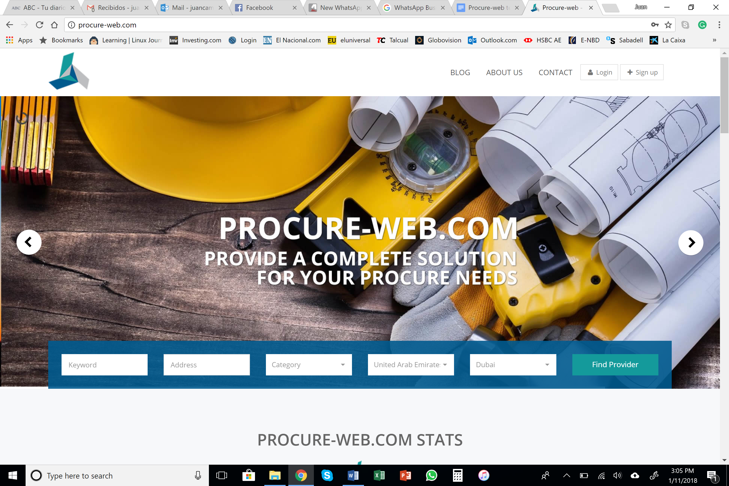

Select which type of customer, Buyer (Customer), information required:
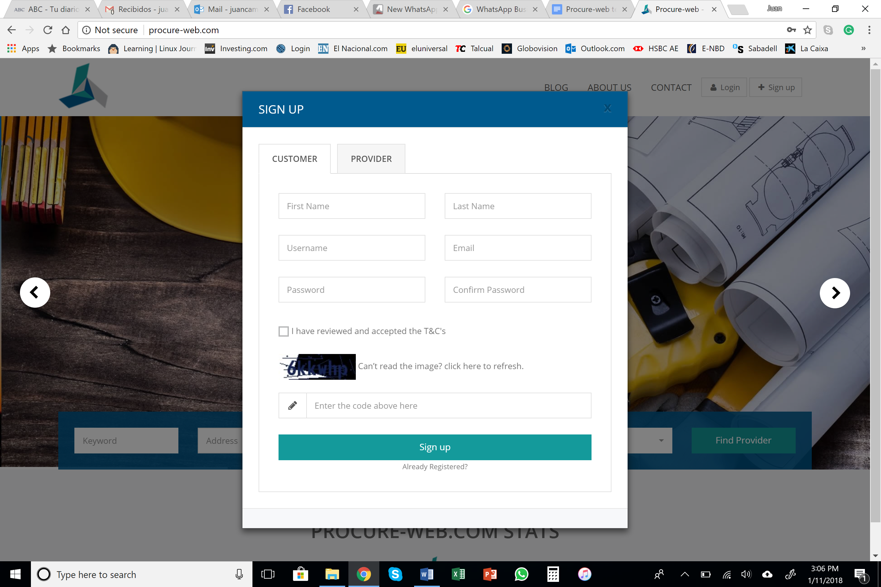

After applying, the customer information will need to be verified in the backend
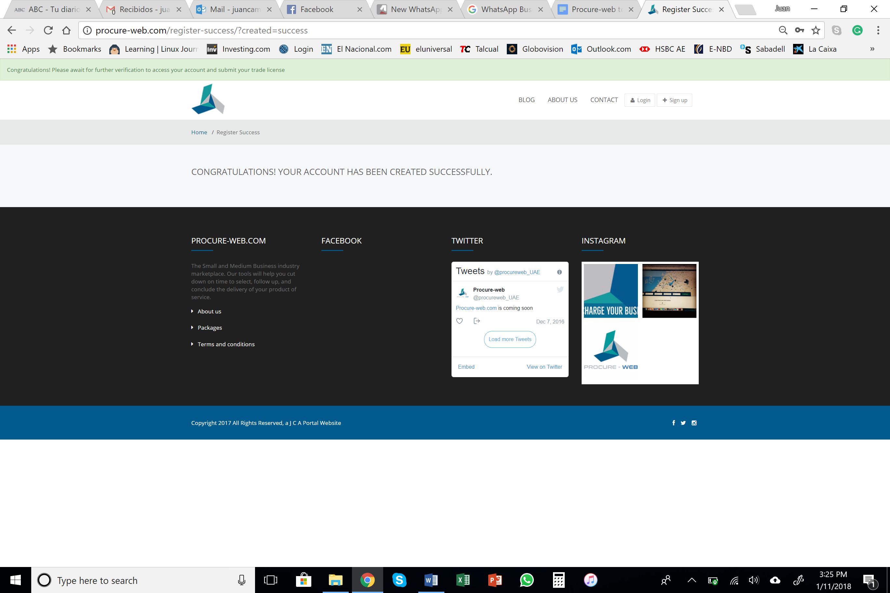
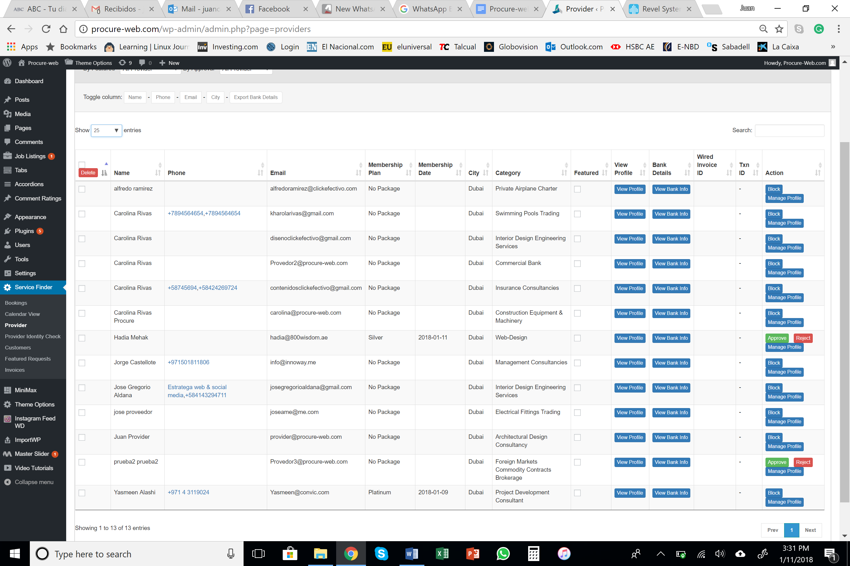

Once able to log-in, the Buyer will be able to access their profile and can post a job and can view in “My Jobs” other active jobs (either with assigned applicants or already in progress or closed.
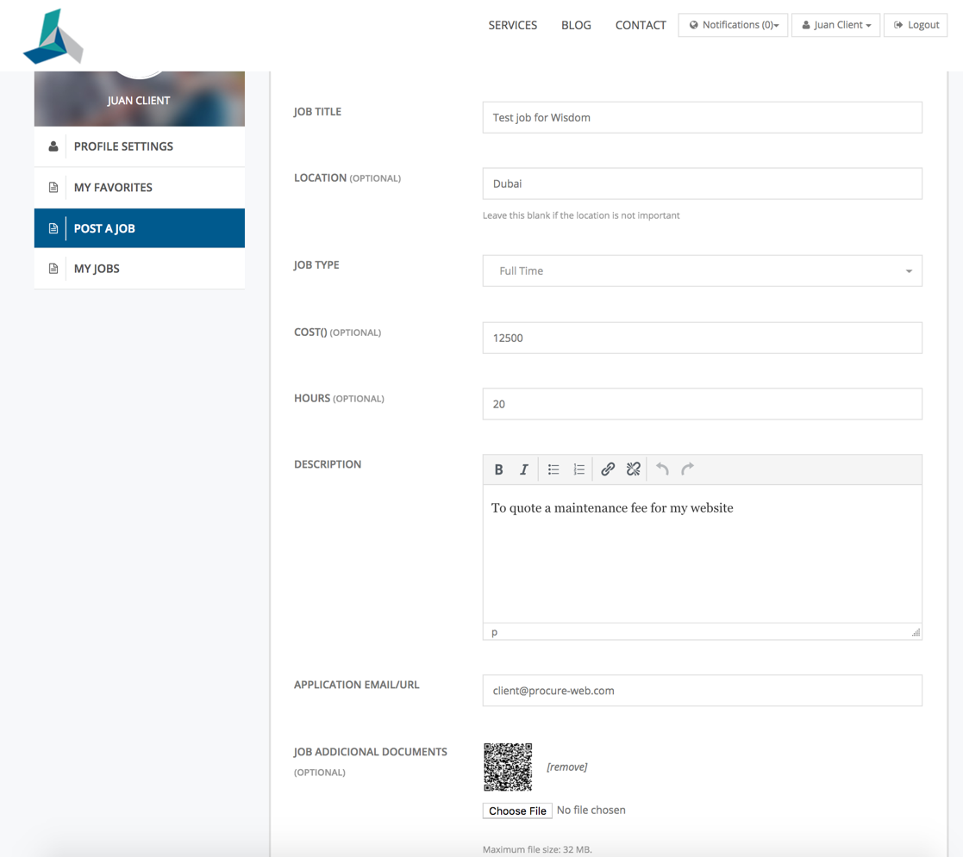
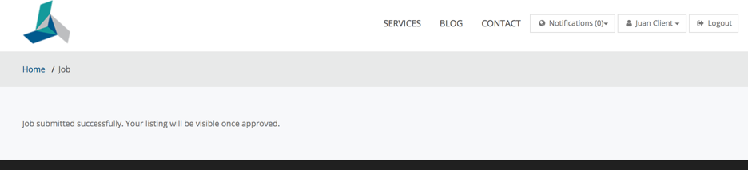
After the job description is filled, it must be approved by ADMIN in the backend before it is listed
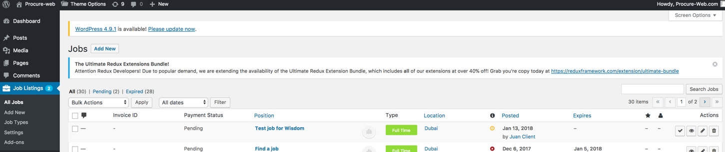
In the jobs section, the buyer can edit, mark filled, duplicate or delete the jobs. Automatically all jobs expire after 30 days and will be removed from the jobs section (for other providers to see) unless a request is sent to ADMIN to keep it alive
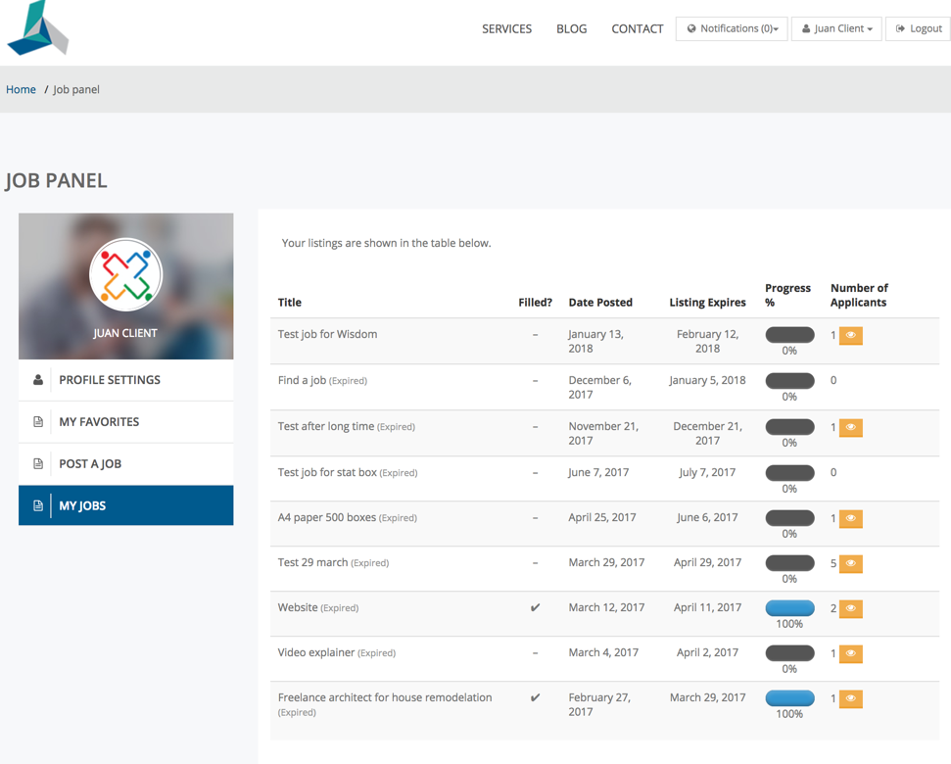
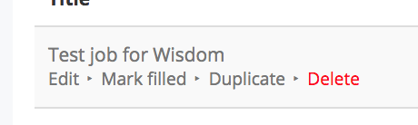

On the top menu “Services”, client can view all suppliers, can view the profile, rating and can send a direct RFQ or message
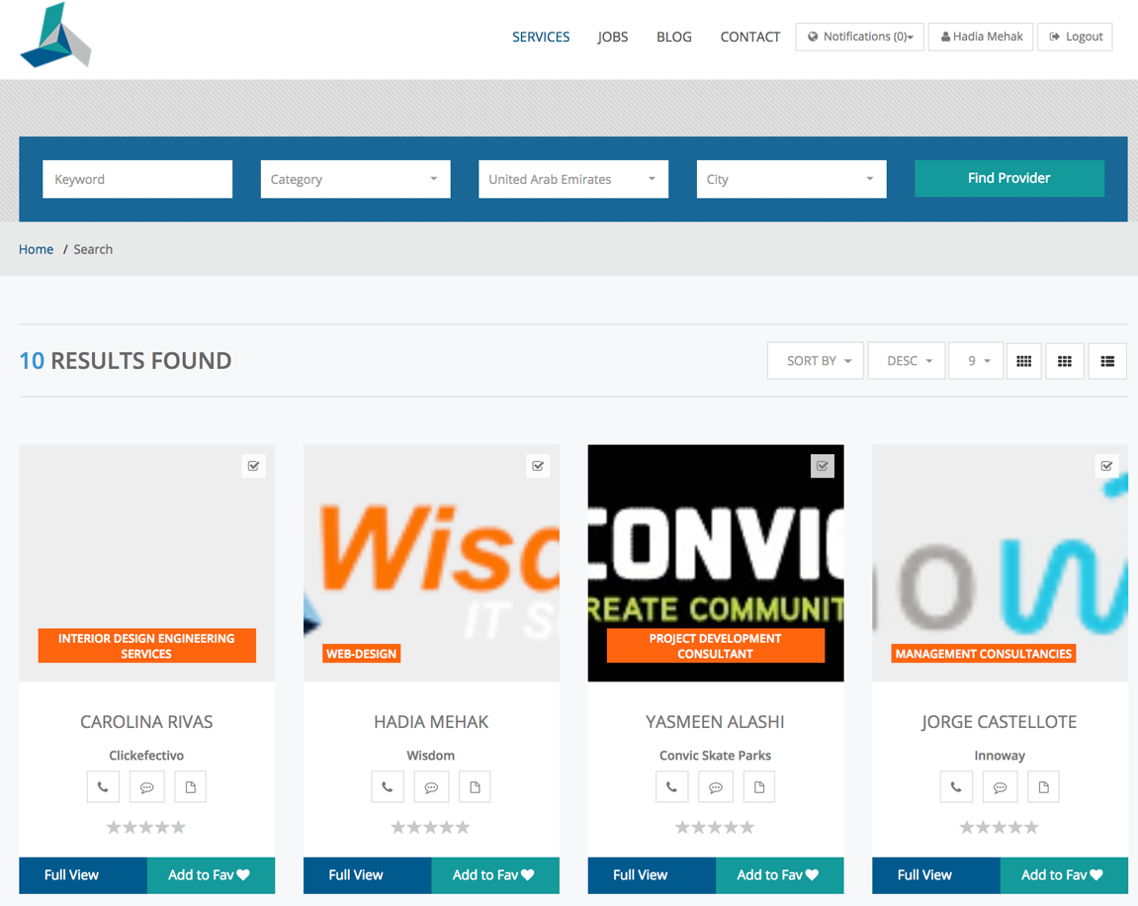
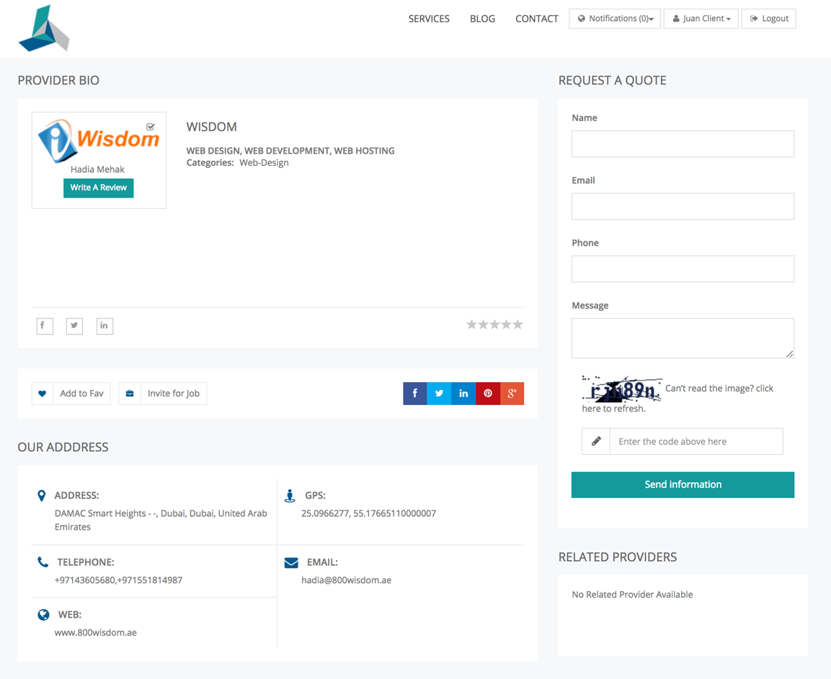

When suppliers bid for the job, a notification will be sent to the buyer. They can access the quotation and check the Supplier profile, send a message (in case of any discrepancy or clarification) and once the price, scope etc is agreed, the button “Hire me” can be pressed. This will notify the supplier that they have been selected.
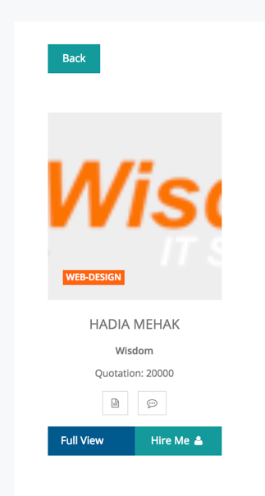

SUPPLIER
Sign-up as supplier (information required):
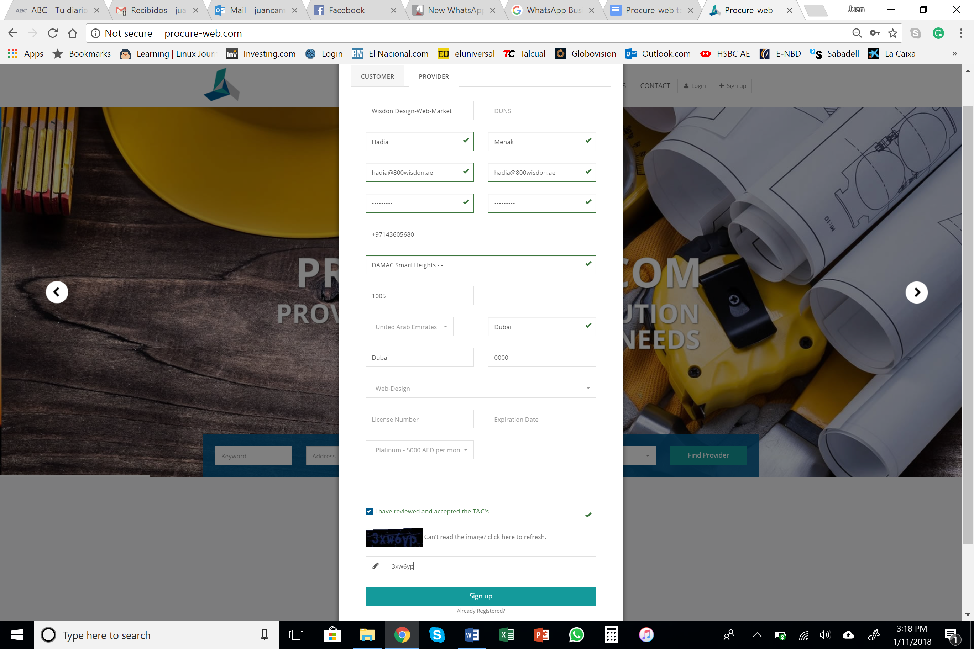


After this, a notification will be sent to info@procure-web.com and an alert will appear in the backend to approve the client registration. For Suppliers, the registration is a two-step process


In case the Client/Supplier wants to log-in before their account is approved, this pop-up will appear:
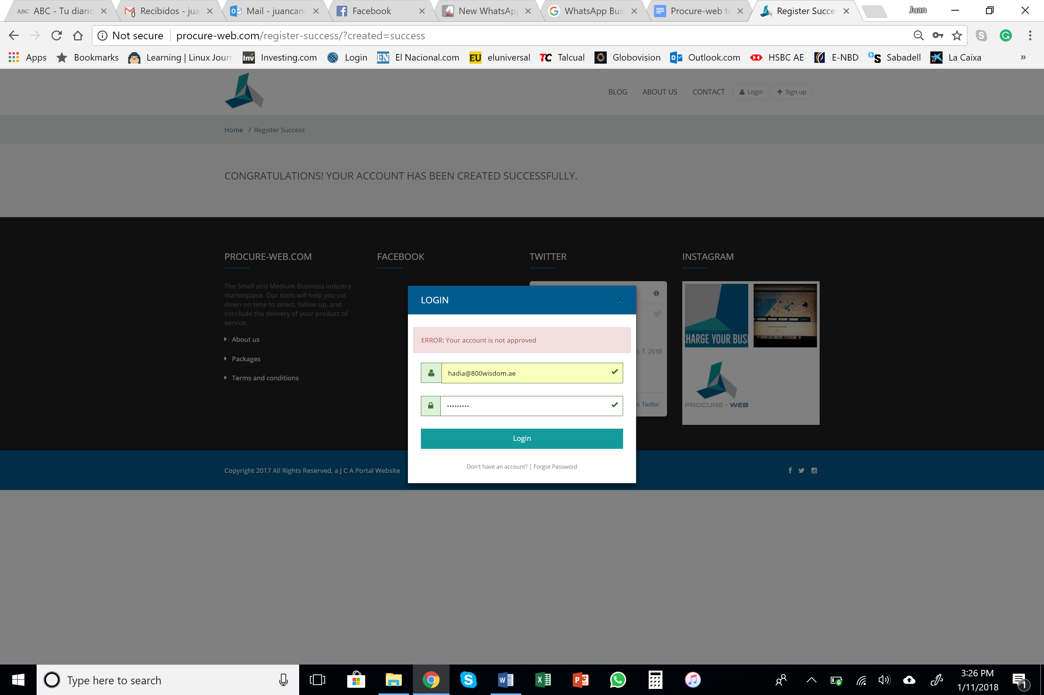

Once initial registration has been approved, the Provider must log-in again for the Trade License upload, no other feature is available for the user.
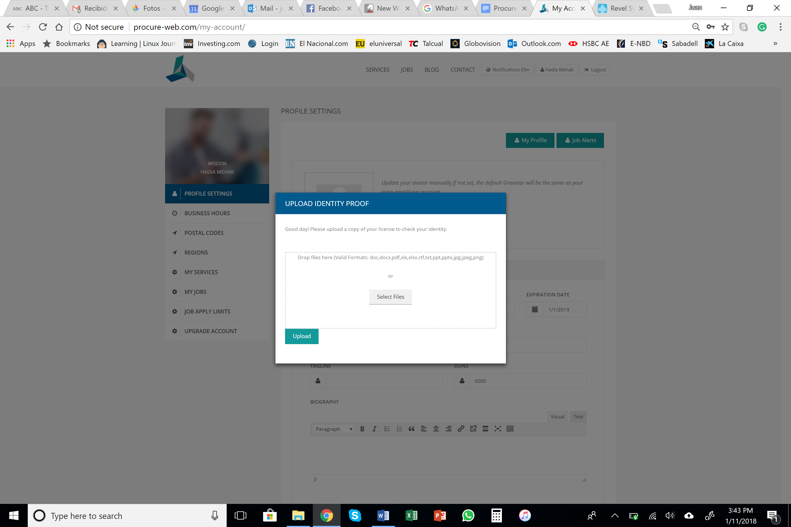

In the backend, the identity must be approved in order for the user to have full access.
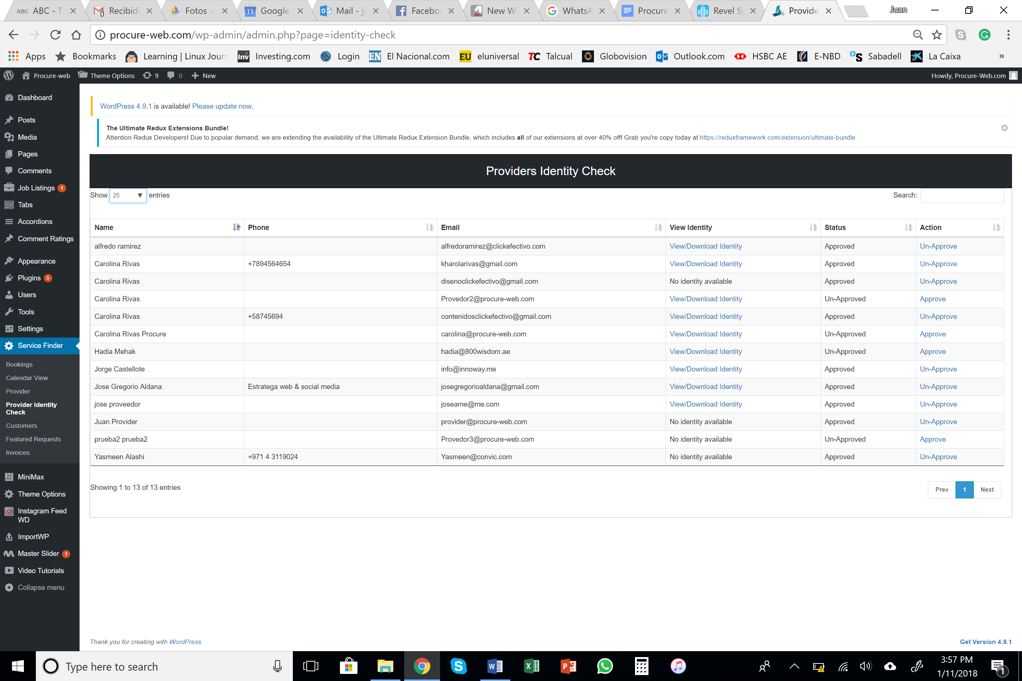

Once identity is verified, then the supplier can log-in and complete all the fields available in the profile, only the ones until now were mandatory, the rest are optional but they are there to provide as much information to the client on the supplier. The Trade License details are private and not shared with any other person, they are only required for verification and only Procure-Web personnel can see it
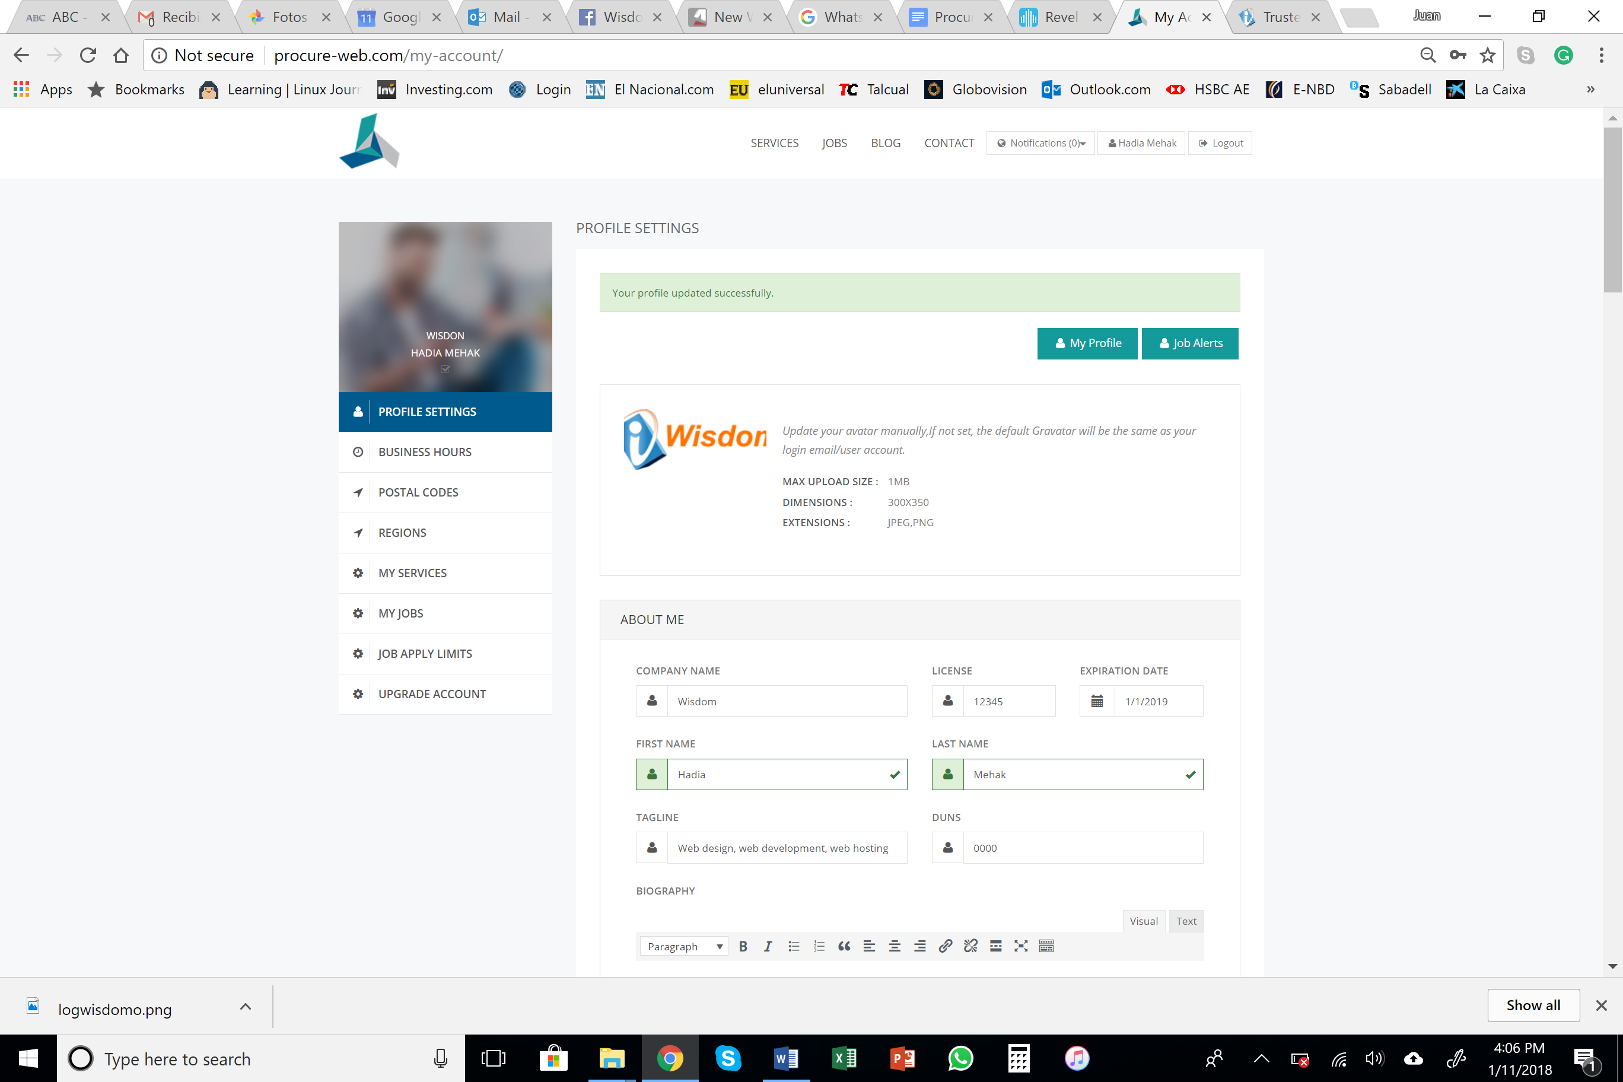

In JOBS menu, you can access all RFQ that have been put out to quote. From a particular Job, you can create alerts that will advise you by email, whenever there is a similar job posted (depending on the key-words used)
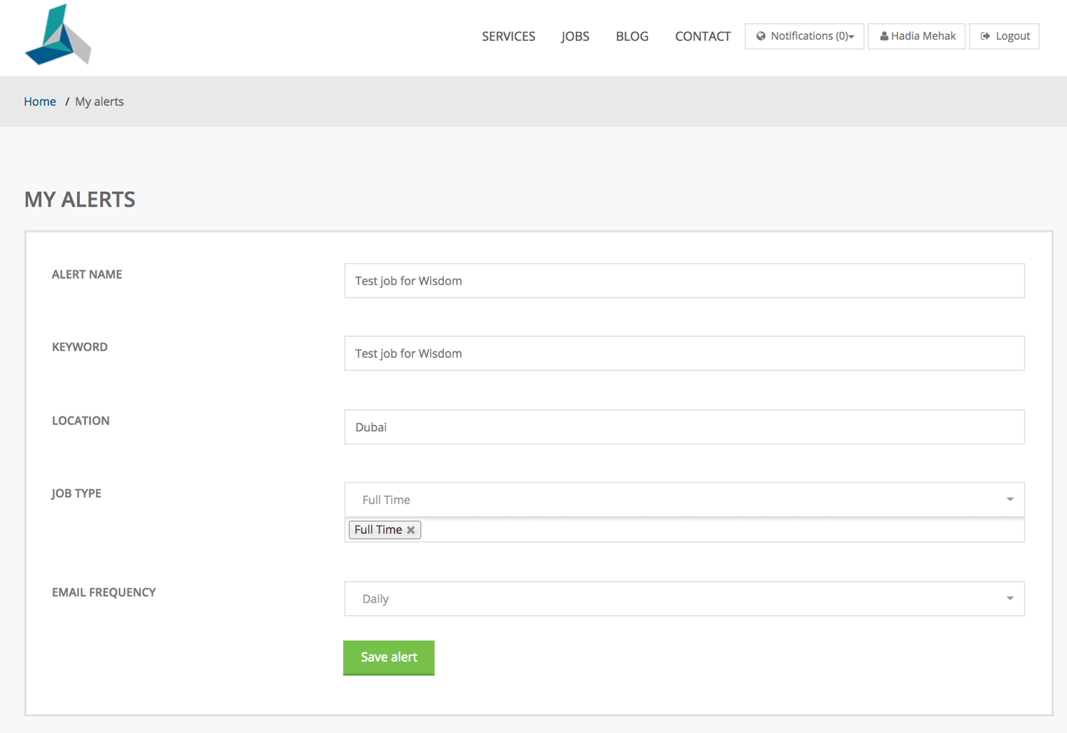

When applying for a job, the buyer will be informed that someone has send a quotation. During the bidding process, the client details are not disclosed to any supplier, only the work details.
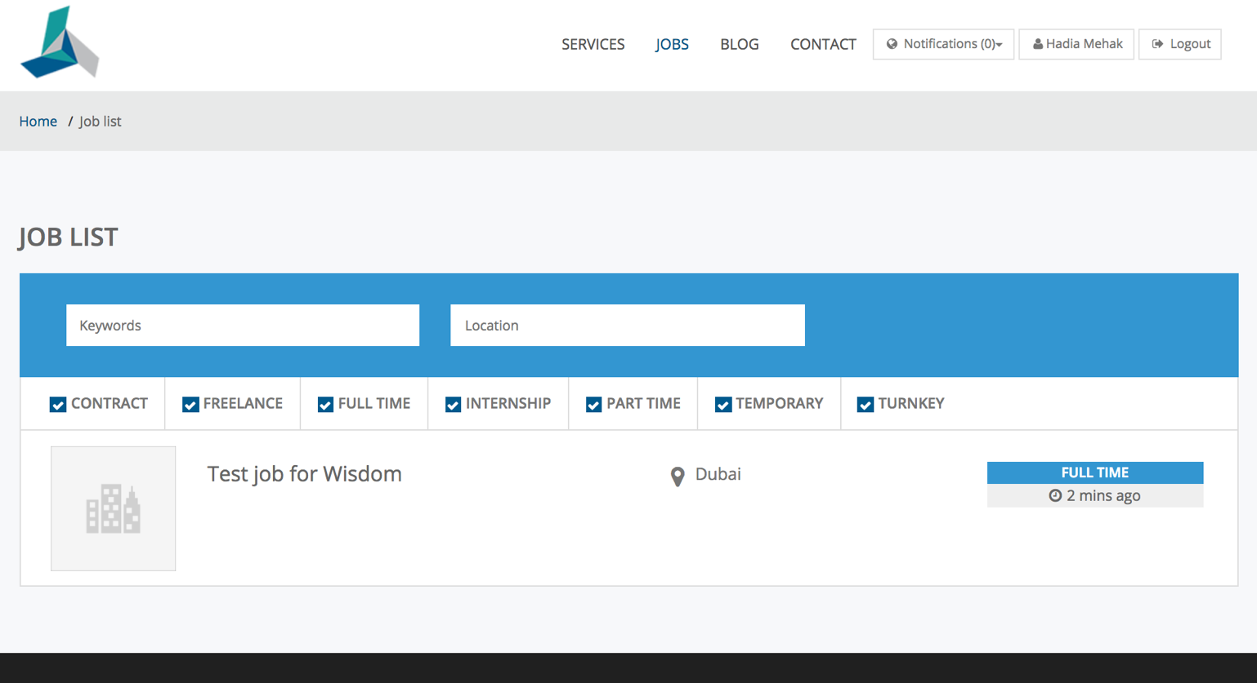
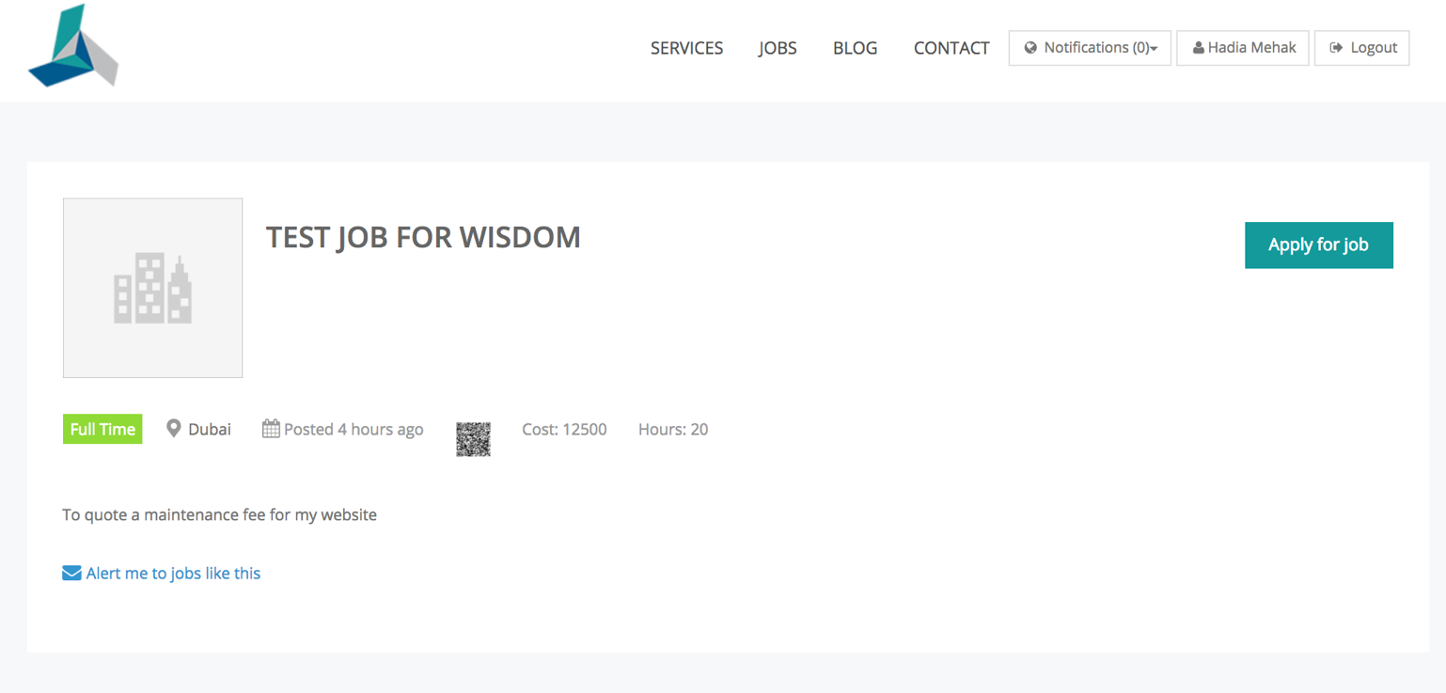
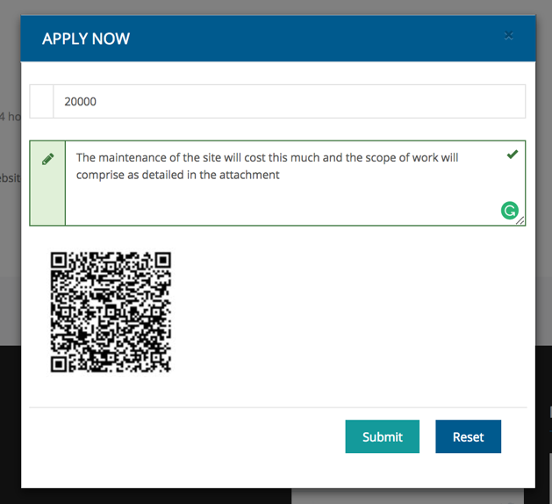

After the client/buyer has selected your company, you will receive a notification and the job in the job list will turn to “Filled”
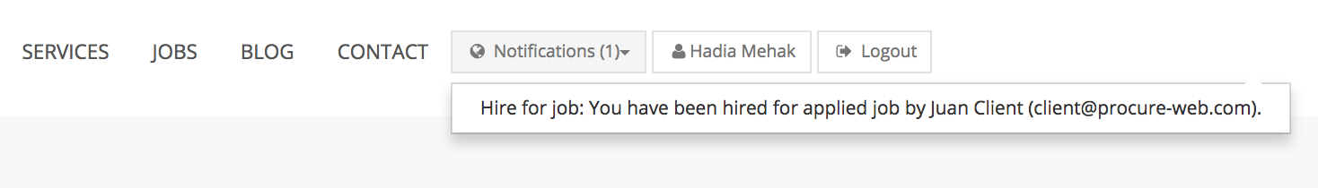
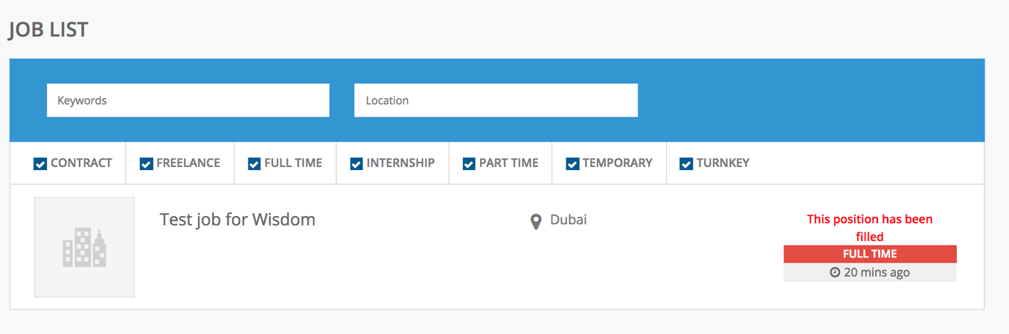

You can access the jobs details in “My Jobs” section and update the progress of the job until its completion, this will in turn ask the client to post the review and star rating on your job
