URGENT: GDPR
- Email templates for members and non-members attached.
- For members: Once they click the [button here], pop-up window with the following categories appear, they select accordingly. All categories must have an answer either thumbs up or down, they cannot proceed if they have missed to answer a category.



Please select the emails you wish to receive from us:

Events


Weekly E-Newsletter

Special Offers and Announcements
Save & Close

- For non-members: If they click [SUBSCRIBE], pop-up window with the following message will appear


You are now subscribed to receive email updates, special offers and announcements from the BBG
Close

If they click the [UNSUBSCRIBE], pop-up window with the following message will appear

We’re sorry to see you go. You are now unsubscribed from our mailing list.
Close

- Admin to be able to re-send this email, in case they did not receive
- Import contacts from the attached spreadsheet, deleting duplicates
- To be sent out to entire database on Tuesday 22 May, 10am

- From the Back-end: Add Manage Contacts in the box shown below
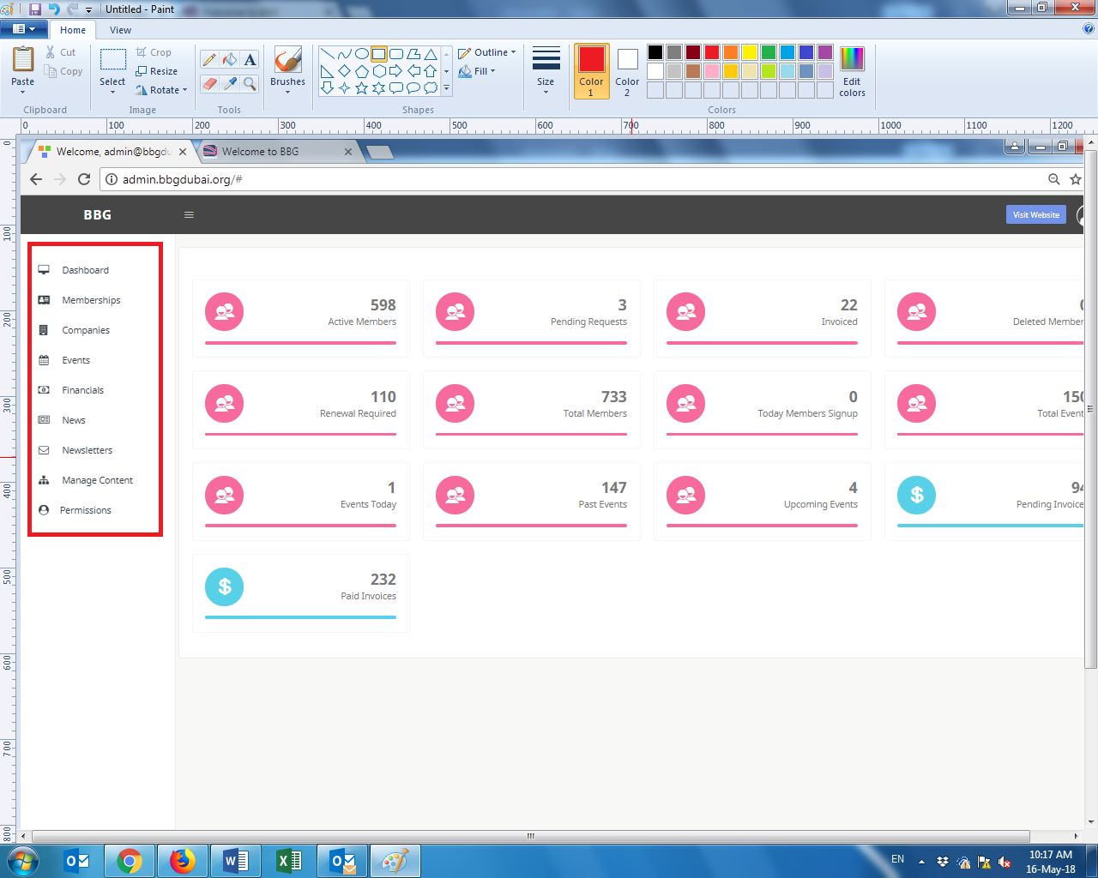
Manage Contacts page will be similar to http://admin.bbgdubai.org/members but we will only need the following search fields on top:
- First name
- Last Name
- Company Name
- Email Address
- Type – Member or Non-Member
- Category with drop down options of
  - Your Membership
  - Events
  - Weekly E-Newsletter
  - Special Offers & Announcements
  - Unsubscribed from all categories
- Export button – able to export (1) full list (2) per category
The display list will have the following columns
First Name | Last Name | Company Name | Email Address | Type (Member or Non member) | View  Resend Email  Delete
View will have the list of subscribed categories
- From the Front-end: As previously requested, remove Associates. Replace this with Email subscriptions
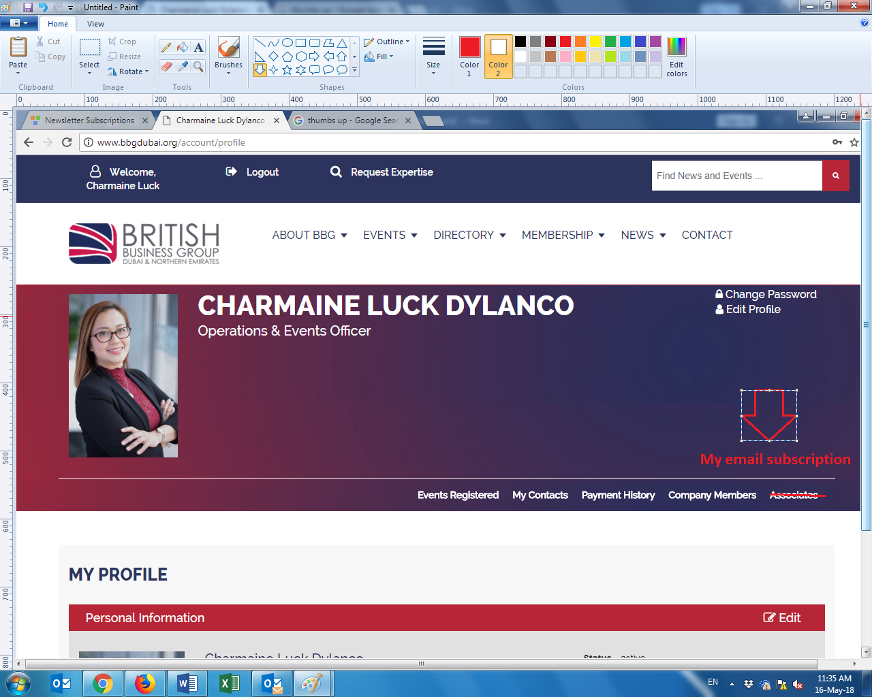
Page will have:
Edit my email subscriptions:
- Your Membership – Subscribe / Unsubscribe
- Events – Subscribe / Unsubscribe
- Weekly E-Newsletter – Subscribe / Unsubscribe
- Special Offers & Announcements – Subscribe / Unsubscribe
- For new members after sending the initial email on 22 May – Admin needs to be able to send Members Email Template from the system
- For non-members who click on Subscribe from the front-end a pop-up message will appear saying
“I would like to receive emails from the British Business Group
Dubai & Northern Emirates’”
Confirm
Close

Once ‘Confirm’ is clicked, 2nd pop-up window below.


You are now subscribed to receive email updates, special offers and announcements from the BBG
Close

