**app/views/layouts/application.html.erb:**

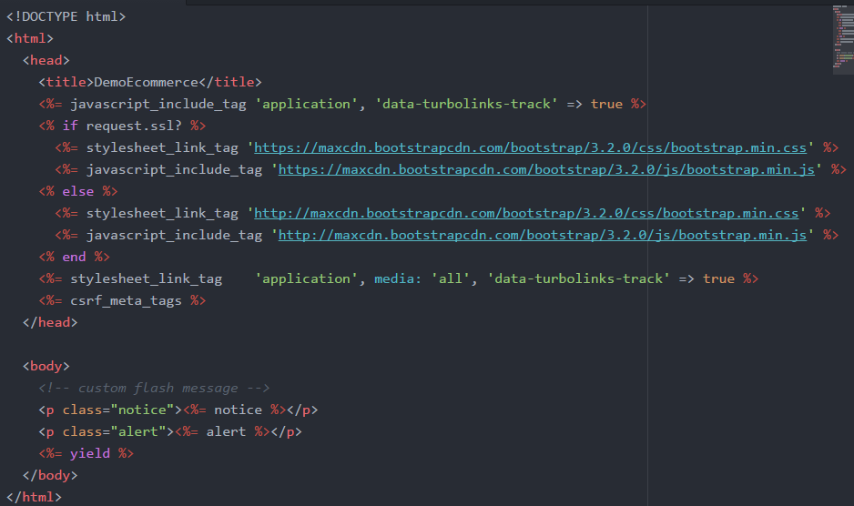

**app/views/products/index.html.slim:**

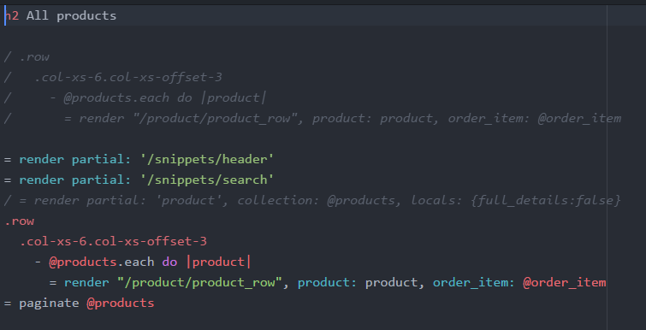

**app/views/snippets/_header.html.slim:**

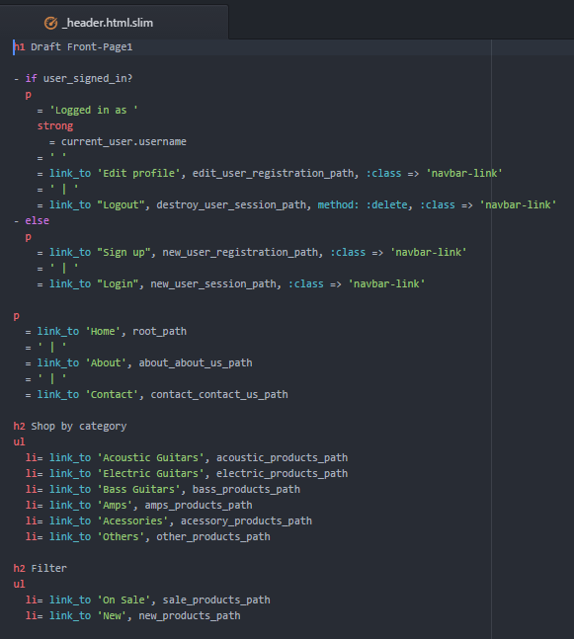

**app/views/snippets/_search.html.slim:**

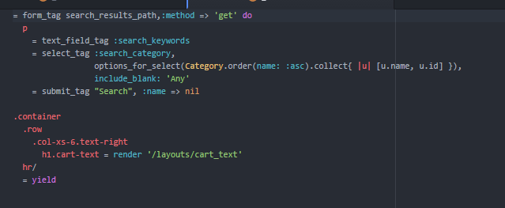

**app/views/products/_product_row.html.erb:**

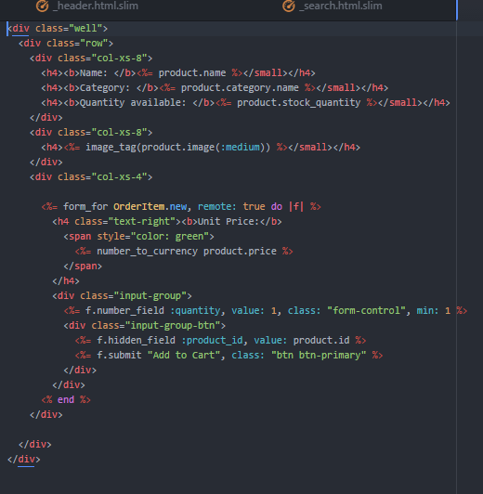

**config/routes.erb:**

