|  |
| --- |
| Software Engineering of Distributed Systems, KTH |
| Design an Agent Platform conformant to FIPA Specifications |
| Distributed AI and Intelligent Agents, Project 2007 |

|  |
| --- |
| Shanbo LI, Sike Huang  2007-12-10 |

## Complete design of your Agent Platform using GAIA AOSE Methodology

### Role Model

|  |  |  |
| --- | --- | --- |
| Role | | Register |
| Description | | It acts as a register and gives AIDs to agents |
| Protocols and Activities | | GenerateAID |
| Permissions | |  |
|  | reads | new AgentRequire |
|  | generates | AID |
| Responsibilities | |  |
|  | Liveness | GenerateAID = AgentLocalName@*hap_name* |
|  | Safety | true |

|  |  |  |
| --- | --- | --- |
| Role | | Modifier |
| Description | | It acts as a modifier and edit agent description |
| Protocols and Activities | | UpdateAgentDescription |
| Permissions | |  |
|  | reads | AID |
|  | generates | description |
| Responsibilities | |  |
|  | Liveness | newDescription = Description·update |
|  | Safety | true |

|  |  |  |
| --- | --- | --- |
| Role | | YellopageServiceProvier |
| Description | | It behaves like a yellow page |
| Protocols and Activities | | Register, Search, Subscribe |
| Permissions | |  |
|  | reads | agentDescription |
|  | generates | searchResult |
| Responsibilities | |  |
|  | Liveness | GenerateResult = SearchRegistedAgent·filterAgentDescription |
|  | Safety | true |

### Interaction Model

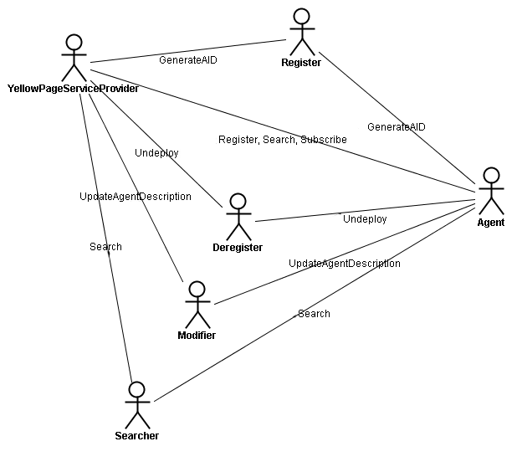

We introduce a normal agent besides DF and AMS, since an agent communicates with both AMS and DF. YellowPageServiceProvider obtains its AID from Register, and asks Modifier to update its description as Directory Facilitator. A normal agent in the agent system registers to the YellowPageServiceProvide, more it can search other agents based on description or subscribe the notification to certain descriptions, if a agent searches another agent using a AID, the call directly goes to the Searcher, the agent obtains its AID from Register and it can update its description via Modifier.

### Agent Model

AMSAgent

1

1

1

1

Register Deregister Modifier Searcher

Agent Management System agent plays four different roles, register, deregister, modifier and searcher. Register registers an agent with its local name to agent platform, and gives the agent a global unique identifier. Deregister deregisters an agent and releases its global unique identifier assigned previously. Modifier modifies the agent description and agent service description. Searcher matches the requesting description to current stored ones.

DFAgent

*

YelloPageServiceProvier

DFAgent plays only one role, which is the YellowPageServiceProvider.

### Service Model

|  |  |  |  |  |
| --- | --- | --- | --- | --- |
| Service | Inputs | Outputs | Pre-condition | Post-condition |
| GenerateAID |  | *AID* | *no same localName* | *true* |
| UpdateAgentDescription | *AID* | *Description* | *AID ≠ nil* | *true* |
| Register | *AID* |  | *true* | *true* |
| Search | *ServiceDescription* | *SearchResult* | *true* | *true* |
| Subscribe | *ServiceDescription* | *SubscribeResult* | *true* | *true* |

### Acquaintance Model

AMSAgent

DFAgent

AMSAgent and DFAgent negotiate with each other directly if necessary.

## Represent agent interaction protocols in UML.

### Level 1: Representing the Overall Protocol

### 2.1.1. Templates

A template is a parameterized model element whose parameters are bound at model time. We consider four templates from FIPA interaction protocol specifications, which are:

* FIPA Request Interaction Protocol
  + <http://www.fipa.org/specs/fipa00026/SC00026H.html>
  + The FIPA Request Interaction Protocol (IP) allows one agent to request another to perform some action. The Participant processes the request and makes a decision whether to accept or refuse the request. If a refuse decision is made, then “refused” becomes true and the Participant communicates a refuse. Otherwise, “agreed” becomes true.
* FIPA Subscribe Interaction Protocol
  + <http://www.fipa.org/specs/fipa00035/SC00035H.html>
  + The Initiator begins the interaction with a subscribe message containing the reference of the objects in which they are interested. The Participant processes the subscribe message and makes a decision whether to accept or refuse the query request. If the Participant makes a refuse decision, then “refused” becomes true and the Participant communicates a refuse. Otherwise, ”agreed” becomes true.
* FIPA Query Interaction Protocol
  + <http://www.fipa.org/specs/fipa00027/SC00027H.html>
  + The Initiator requests the Participant to perform some kind of inform action using one of two query communicative acts, query-if or query-ref (see [FIPA00037]). The query-if communication is used when the Initiator wants to query whether a particular proposition is true or false and the query-ref communication is used when the Initiator wants to query for some identified objects. The Participant processes the query-if or query-ref and makes a decision whether to accept or refuse the query request. If the Participant makes a refuse decision, then “refused” becomes true and the Participant communicates a refuse. Otherwise, “agreed” becomes true.
* FIPA Propose Interaction Protocol
  + <http://www.fipa.org/specs/fipa00036/SC00036H.html>
  + The Initiator sends a propose message to the Participant indicating that it will perform some action if the Participant agrees. The Participant responds by either accepting or rejecting the proposal, communicating this with the accept-proposal or reject-proposal communicative act, accordingly. Completion of this IP with an accept-proposal act (see [FIPA00037]) would typically be followed by the performance by the Initiator of the proposed action and then the return of a status response.

### 2.2.2. Packages

**Packages for Agent Management System**













**Packages for Directory Facilitator**









### 2.2 Level 2: Representing Interactions among agents

**Interaction between AMS and Agent**

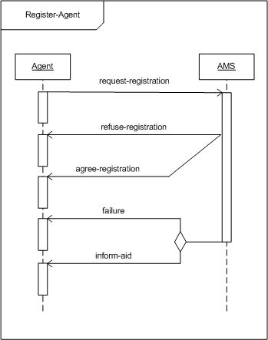

AMS: Register-Agent

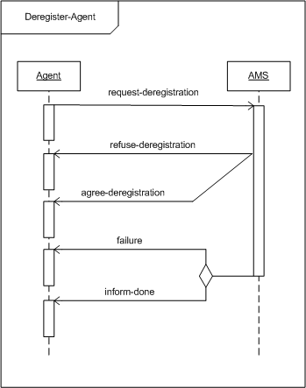

AMS: Deregister-Agent

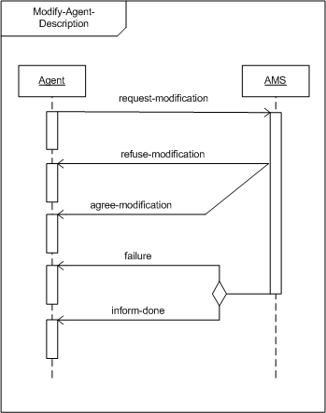

AMS: Modify-Agent-Description

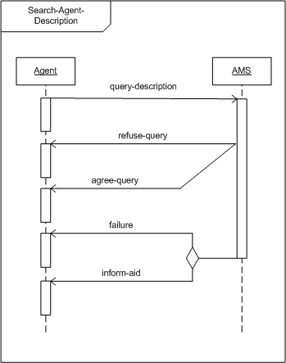

AMS: Search-Agent-Description

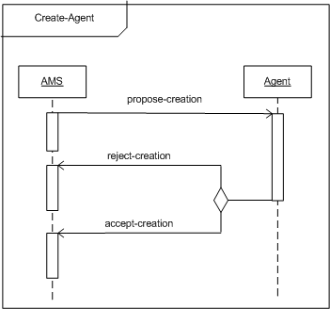

AMS: Create-Agent

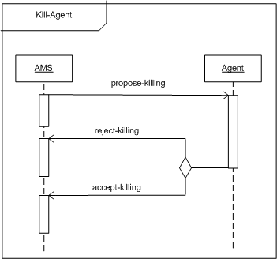

AMS: Kill-Agent

**Interaction between DF and Agent**

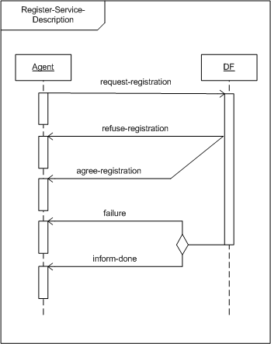

DF: Register-Service-Description

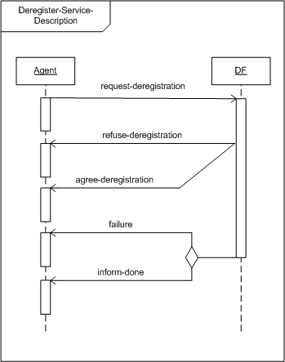

DF: Deregister-Service-Description

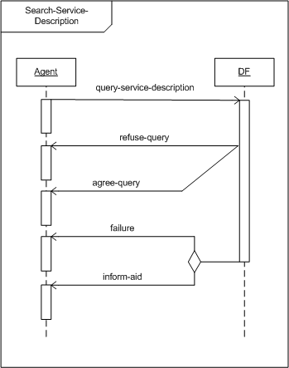

DF: Serach-Service-Description

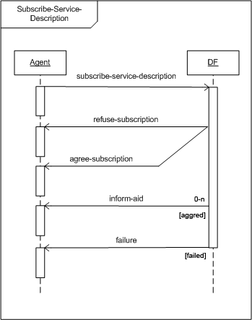

DF: Subscribe-Service-Description

### 2.2 Level 2: AMS agent representation using State-chart diagrams

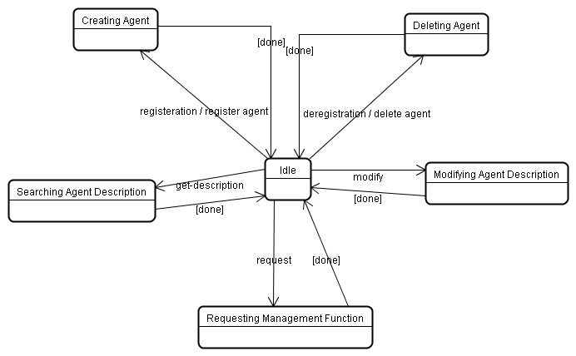

One of the most important state AMS agent has is creating agent, where each agent registers with AMS in order to obtain an AID which is then retained by AMS as a directory of all agents present within the Agent Platform and their current state. Agent descriptions can be modified under restriction of authorization by the AMS. Deregistration causes AMS into the state of deleting agent, where the AID of that agent is removed and can be made available to other agents who should request it. Agent descriptions are maintained in the state of modifying agent description and retrieved by requesting the action get-description. And The AMS can request that an agent performs a specific management function, such as to terminate its execution, and has the authority to enforce the operation if the request is ignored.

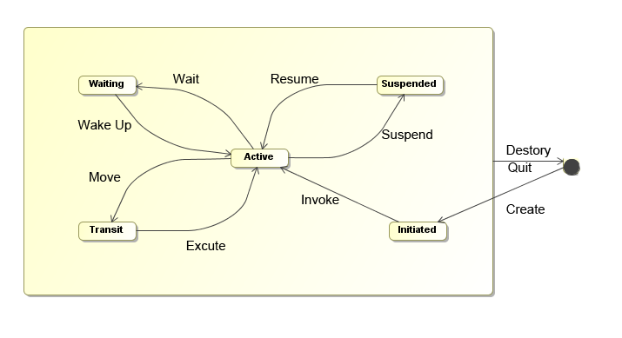

Since AMS itself is an agent, it can be in one of several states, according to Agent Platform Life Cycle in FIFA specification. The states are initiated – the agent object is built; active – the agent object is registered; suspended – the agent object is stopped; waiting – the agent object is blocked; deleted – the agent is dead and transit – agent is migrating to the new location.

## Use role-based modeling method to model FIPA specified roles for Agent Platform

### 3.1. Capture Use Cases

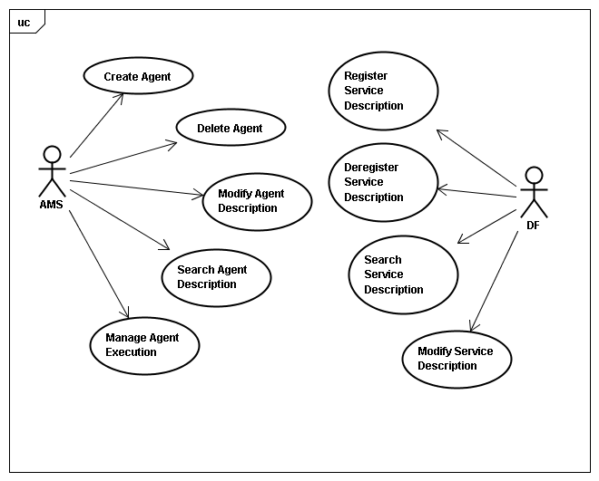

We consider two actors, Agent Management System and Directory Facilitator. AMS includes five use cases: Create Agent and Delete Agent take care of registering and deregistering agent in the agent platform; Agent descriptions are maintained by Use case Modify Agent Description; Agent descriptions can be returned by Search Agent Description; Manage Agent Execution enforces specific management function on an agent. On the other hand, DF keeps track of all service description by four different use cases as listed in the figure.

### 3.2. Identify Roles

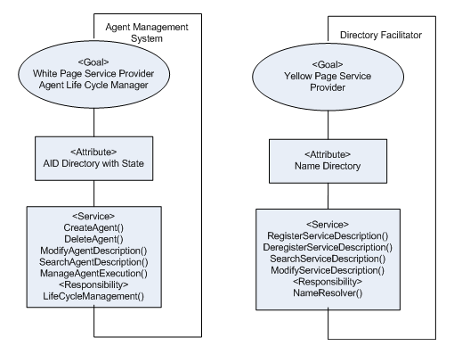

Two roles are identified from the use cases, Agent Management System and Directory Facilitator. Agent Management System provides white pager service and manages the agent life cycle, while Directory Facilitator offers yellow page service and resolves the naming.

### 3.3 Construct Role Organizations

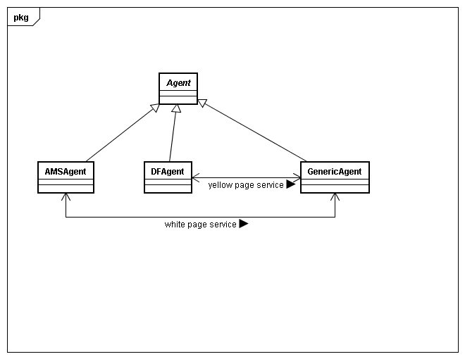

We introduce a new role called Agent, which is the superset. AMSAgent and DFAgent are two specialized roles inherited from Agent, and GenericAgent is a concrete agent deduced from Agent, which takes other responsibilities other than AMS and DF.

### 3.4 Bind Roles to Agents

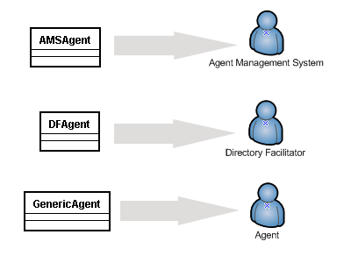

AMSAgent plays the role of Agent Mangement System; DFAgent plays the role of Directory Facilitator; GenericAgent plays the role of Agent.

### 3.5 Class Design

**AMSAgent / Agent Management System**

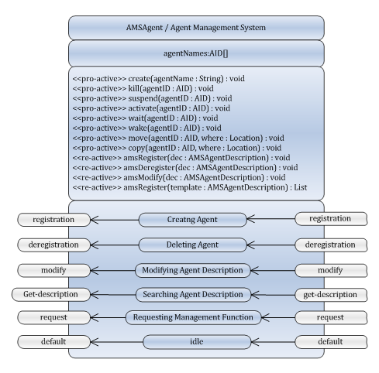

**DFAgent / Directory Facilitator**

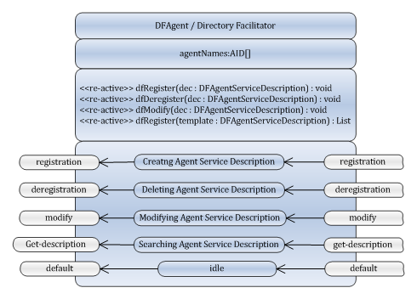

## Re-modeling the above using MESSAGE UML.

## Assume your agent platform is distributed over two machines, thus you need mobility and cloning et al services to maintain your agent platform