

**WEB DEVELOPMENT**

**INTRODUCTION**

The web development event is being conducted by Elan & nVision 2023, IIT Hyderabad. This three-day technical event will focus on developing original and cutting-edge web pages, a productive backend, and seamless interaction with the business world's twist. This competition is a fantastic chance for students to mix artistic expression with technology, acquire confidence, and triumph over other participants in the web design race. Participating in this event will help you to please grumpy clients and unlock the creative developer within you.

**STRUCTURE**

This event is an online event with proper judging criteria and starts from 18/02/2023 (Saturday) and is three days long. All submissions must be made online and must follow the necessary standards, which will be specified alongside the problem statement. There will be offline presentations during the fest dates where every team which has made a submission will present their working website and its features in front of a panel of judges. The winners will be revealed about two days after the presentations are over.

**TIMELINE**

|  |  |
| --- | --- |
| **MILESTONE** | **DATE** |
| Registration Start Date | 11th January, 2023 |
| Registration End Date | 15th February, 2023 |
| Event Date | 17th January, 2023 |
| Event Time | 11:00 A.M. |

**PROBLEM STATEMENT**

Each team must create a website with a functioning frontend and backend strictly during the event using non-proprietary frameworks/libraries which closely follow the given problem statement and theme, which shall be revealed soon.

**JUDGING CRITERIA**

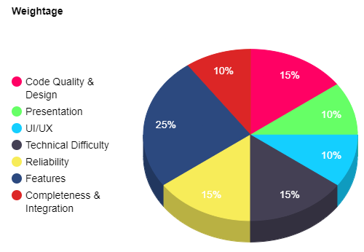

**SUBMISSIONS**

* Teams are required to submit their code via a private GitHub repository which will be shared with the team members at the start of the event. All the project code should be pushed to the main branch of the repository within the deadline, which is 72 hours from the start of the event.
* All the teams should submit pre-built release versions of their websites/web apps for all major platforms that clients may use.  
  Example: website hosted on Heroku / GitHub Pages / Netlify.
* The submitted GitHub repository must contain a README.md file in the root directory containing detailed instructions on how to build the written software on a Linux machine running Ubuntu 20.04/22.04 LTS and containing relevant explanations on all web development tools and decisions made.
* In case frameworks such as React or Vue are used, the GitHub repository should contain the source React code and not the built-minified HTML CSS.

**RULES AND REGULATIONS**

* Teams should strictly not use any proprietary software in their code. All APIs/SDKs/Libraries/Frameworks used while developing your project should be open-source.
* Each team can submit only one entry for the event. Participation in the event is subject to a “per-team” basis, i.e., one person is not allowed to be part of more than one team.
* Any intellectual property developed during and within the scope of the hackathon must be open-source and licensed under one of the licenses referenced in [Open Source Licenses & Standards](https://opensource.org/licenses).
* Teams are required to give an interactive demonstration of the project in front of a panel of judges, who may ask questions specific to either the implementation or usability of your project.
* Teams can have a maximum of 4 members.
* All decisions taken by the organizers and judges will be final and binding.
* In case of a tie at any prize-winning position, team entry gets the least priority. In between two teams, the team submitting early gets the position ahead.
* Use of pre-made templates or code written before the event is strictly prohibited. Use of small blocks of code (that can be found on the internet) to implement a particular functionality is permitted (cite them appropriately in the README.md file).
* Any commits made after the deadline will be ignored.
* Any team found to be cheating, interfering with another team, or the competition in any form will be punished with severe point deductions and/or immediate disqualification.
* Your first commit should be an HTML boilerplate with empty CSS and JS files attached. All further commits will be closely monitored. Any submission with irregularities in commit history will lead to disqualification.

**CERTIFICATES AND PRIZES**

* The top three teams will receive prizes worth Rs. __20000___.
* The prize money will be awarded via NEFT and processed within 30 working days.
* The winners will be notified via email sent from [elan@iith.ac.in](mailto:elan@iith.ac.in).
* E-certificate of Participants will be given to all the participants who have made a valid submission within the deadline.
* E-certificate of Excellence will be given to the top 3 teams.

**CONTACT DETAILS**

Organizer Name: Priyesh Jain Organizer Name: Prabhat Pensalwar

Mobile Number: 7987497614 Mobile Number: 9405975702