Guru Nanak’s Canvas
By Karminder Singh Dhillon | Asia Samachar | Part 1 of 12
Source: https://asiasamachar.com/2021/05/05/guru-nanaks-canvas/

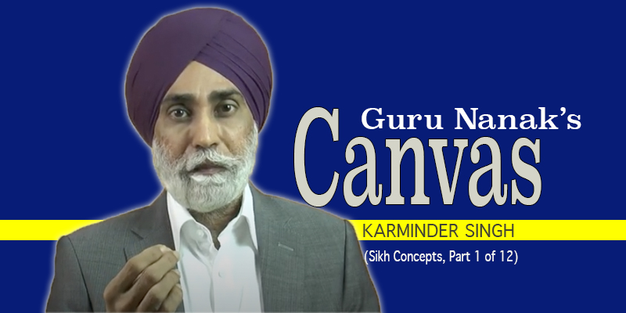
By Karminder Singh | Sikhi Concepts | Part 1 of 12 [→ https://youtu.be/jW5fPKS59go] |
If Sikhi was a portrait, then Guru Nanak would be its artist. Our mind is then the canvas on which the painting of Guru Nanak’s Sikhi would be created.
This is a narrative of the portrait of Sikhi. More specifically, it’s a story of the canvas, on which the portrait of Sikhi is brought to life.
When Guru Nanak wanted to create a portrait of Sikhi in 1469, he realized that the canvas on which he intended to paint it – posed a challenge. It posed a problem.
The canvas on which he wanted to create that image of Godly spirituality was neither clean nor blank.
The canvas – that was the human MIND – was already painted on with a thousand images.
How does one paint on a canvas that is already painted? And already contains a thousand images? How does one paint on a canvas that does not have any empty space left?
CLICK HERE [→ https://youtu.be/jW5fPKS59go] FOR THE VIDEO (SIKH CONCEPTS PART 1)
Guru Nanak discovered that the human mind – that was the spiritual canvas of the people of his times – had images of heaven and hell, 8.4 million life forms to be lived after death, soldiers of death, angels of death, and the cycle of births and deaths (Ava Gaun) and reincarnation.
The existing canvas had images of salvation after death, judgement after death by dharam raj, reports of our deeds to dharam raj by Chitar Gupat. The canvas also had images of punishment, of accounting of our deeds after death, and of our deceased ancestors. The existing canvas further had images of pre-ordained stuff carried over from our past lives, and unfinished activities being carried into our after lives.
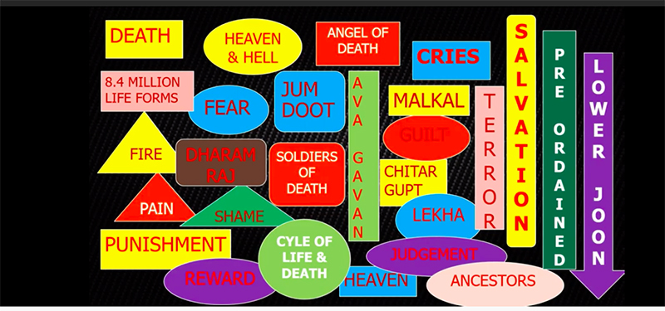
It was a canvas that was painted full to the brim. And so much more. There was virtually no space on the canvas that was left unpainted.
Then, there was something else. The existing canvas had a focus on Death. It was a canvas that had an OBSESSION with life after death and a FIXATION with the afterlife.
The existing canvas had a PREOCCUPATION with securing a good and comfortable Afterlife. A life that no one had seen. A life that no one had experienced. A life that no one really knew anything about. A life that no one knew if it even existed in the first place.
The Potrait that Guru Nanak painted was different. It was Starkly different. It was one whose focus was NOT on death, but on Life and on Living.
It was one whose emphasis was on the Here and the Now. Not on life after death.
But there was a major challenge. The canvas that was the human mind was already painted on. So essentially what Guru Nanak had to do, and did – was to Paint Over an Existing Canvas. Paint over an already painted canvas that was the human mind.
The Portrait of spirituality of Guru Nanak focused on Life and Living in the Here and Now. It was painted over an almost 4,000-year-old one that was OBSESSED with life after death. This was the uniqueness of Guru Nanak’s portrait.
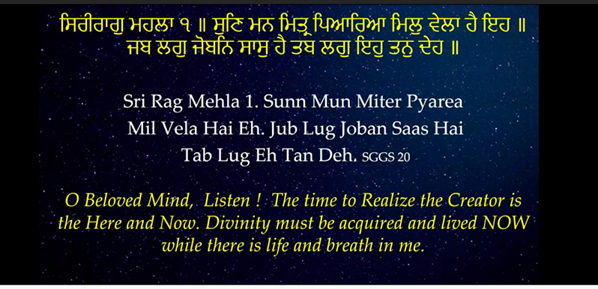
Guru Nanak establishes this primary principle on page 20 of the Sri Guru Granth Sahib (SGGS).
ਸਿਰੀਰਾਗੁ ਮਹਲਾ ੧ ॥ ਸੁਣਿ ਮਨ ਮਿਤ੍ਰ ਪਿਆਰਿਆ ਮਿਲੁ ਵੇਲਾ ਹੈ ਇਹ ॥ ਜਬ ਲਗੁ ਜੋਬਨਿ ਸਾਸੁ ਹੈ ਤਬ ਲਗੁ ਇਹੁ ਤਨੁ ਦੇਹ ॥
Sri Rag Mehla 1. Sunn Mun Miter Pyariya Mil Veyla Hai Eh. Jub Lug Joban Saas Hai Tub Lug Eh Tun Deh. (SGGS, 20)
This is the meaning of the verse: O Beloved Mind, Listen! The time to Realize the Creator is the Here and Now. Divinity must be acquired and lived NOW while there is life and breath in me.
The Spirituality of Guru Nanak is for the HERE and NOW.
Bhai Gurdas ji puts it this way.
ਨਾਨਕ ਨਿਰਮਲ ਪੰਥ ਚਲਾਇਆ ॥
Nanak Nirmal Panth Chaleya.
The spirituality of Guru Nanak was nirmal. It was unique. It was nirmal because it did not have the contaminants of the existing beliefs. It was nirmal because it was free from the impurities of the old canvas. Free from the FOCUS of the old canvas which was the afterlife.
Above all, it was nirmal because it presented a spirituality to be lived – NOT for some unknown and unknowable FUTURE – but lived in the PRESENT – lived in the Here and Now.
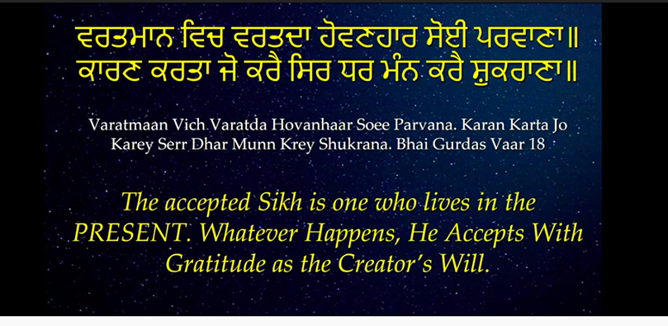
Bhai Gurdas ji writes of the spirituality of Sikhi.
ਵਰਤਮਾਨ ਵਿਚ ਵਰਤਦਾ ਹੋਵਣਹਾਰ ਸੋਈ ਪਰਵਾਣਾ॥ ਕਾਰਣ ਕਰਤਾ ਜੋ ਕਰੈ ਸਿਰ ਧਰ ਮੰਨ ਕਰੈ ਸ਼ੁਕਰਾਣਾ॥
Varthman Vich Vartda Hovannhar Soyi Parvanna. Karann Karta Jo Krey Sir Dhar Munn Krey Shukranna.
The Meaning of the verse is: The accepted Sikh of Guru Nanak is one who lives in the PRESENT. Whatever Happens in the Here and Now, He Accepts with Gratitude as the Creator’s Will.
So this LIVING in the PRESENT, this Living in the HERE and NOW was the UNIQUENESS of Sikhi. This was the Nirmalta of Sikhi.
In doing so, the entire foundation of spirituality had been turned on its head by Guru Nanak. This required an entirely NEW CANVAS. There was a need for NEW concepts. There was a need to DISCARD the concepts of the Old Canvas.
THEN WHY – you may ask – are ALL the concepts of the old canvas mentioned in the SGGS. IF the old canvas had indeed been painted over, why is the old portrait still visible within the pages of the SGGS?
Well, the canvas is not a physical canvas. A physical canvas can be destroyed. It can be crushed and discarded. It can be painted over. Once painted over, the original colors and images are no longer visible. But the canvas we are talking about is a MENTAL canvas. It’s a canvas that exists in our MINDS. It’s a canvas that sits as our MIND-SET.
Believe it or not, even though Guru Nanak’s sikhi has been with us for more than five and a half centuries – a large percentage of us Sikhs are still walking around with that old canvas within our spiritual psyches. A vast majority of our granthis, ragis, parcharaks, clergy, our thinkers, our intellectuals, our writers – subscribe to the old canvas, hold on to the old canvas and believe and accept the old canvas.
A vast majority of us SIKHS are SIKHS on the exterior. Unique in our looks. But our MINDSETS are framed by the 4,000 year-old Canvas.
It’s a mental canvas we are talking about. And we are talking about painting over a mental canvas.
The manner of painting over it that was employed by Guru Nanak – is novel, innovative and marvelous. It’s a manner that speaks of Guru Nanak’s spiritual genius, his inner wisdom and his devotional enlightenment. It’s called REDEFINING.
Guru Nanak painted over the 4,000 year-old canvas by REDEFINING EVERYTHING that was on it. It was REVOLUTIONARY redefining. All the existing concepts are REDEFINED. Each one of them is given new meanings. They are mentioned by Guru Nanak and in Gurbani, because people identified spirituality with those concepts. Removing them from the canvas was not an option.
These concepts had been INGRAINED within the deepest recesses of the human mind. They have been carved within the deepest portions of the spiritual psyche. They had settled within the inner depths of the human conscience and the human soul.
REDEFINING was the way. The appropriate and correct way. This was the only way to provide people with a NEW MINDSET. Guru Nanak re-defined them all. He gave NEW meanings to EVERYTHING that existed on the Old Canvas – meanings to fit HIS canvas of life and the here and the now. The defining is revolutionary.
And if you are asking where exactly are the REDEFINED meanings of these concepts recorded – the answer is: within the pages of the SGGS.
It’s a voluminous text. Massive by any standards. It is a wholesome text. A complete text. Any and every concept that is used in the text is defined WITHIN the text. Any and all concepts that are borrowed from the pre-existing canvas are re-defined.
So the question is plain.
When we want to understand Gurbani, to interpret it or translate it, then do we resort to the 4-thousand-year old dictionary that was discarded by Guru Nanak, or use that dictionary that is embedded within the pages of the SGGS itself?
It may seem like a rhetorical question. But the reason it has to be asked is simple. Virtually all our Gurbani translations use the 4,000 year-old discarded dictionary to explain the concepts of Gurbani as used within the SGGS.
The outcome is that, by and large, Sikhs have reverted Sikhi to the old canvas.
WHY LIVE THE DISCARDED CANVAS?
And the question is: WHY are SIKHS Living the Discarded Canvas? Why are Sikhs living the old canvas and accepting the old canvas as Sikhi? Why have we Reverted to it?
Why has this Old and Discarded canvas become our spiritual canvas?
Now There can be three reasons for this.
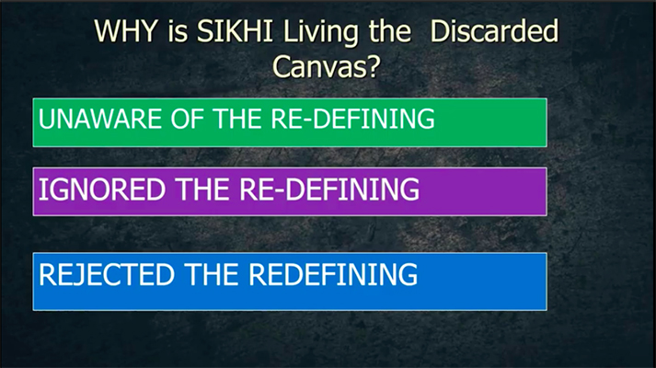
There are of course dire consequences of such a state of affairs.
One glaring one is that While all of us Sikhs are Living Physically in the 21st C. A vast majority of us are living in 1468 in the Spiritual sense. In other words, for a vast majority of us, Guru Nanak has yet to be born into our lives. For a vast majority of us, Guru Nanak’s portrait of Sikhi has NOT been REPAINTED over our old canvas. We are still living the old canvas and thinking (wrongly of course) that the old canvas is what Guru Nanak’s sikhi really is.
So, how do we know if we are living the old canvas?
We can ask ourselves if the Sikhi we practice is one of FEAR. Fear of god, fear of guru, fear of pain, fear of sorrow and fear of all things negative.
We can ask if our spirituality is one of making deals with God or Guru – that we will make so many offerings, so many langgars and so many akhand paths IF and AFTER our demands are met.
We can ask if our spirituality is one of BEGGING, of constantly asking for this and that, of rubbing our noses to plead to be given this and that.
We can ask ourselves if our spirituality is a spirituality on BEHALF – where we ask our clergy – granthis to do our ardas asking for this and that, the pathis to do our paaths for us upon payment.
We can ask if our Spirituality is driven by concerns of LIFE AFTER DEATH, of heaven and hell, of 8.4 mill life forms, and of reincarnation.
We can ask if our Spirituality is one of RITUALS
We can ask if our Spirituality is one in which we expect MIRACLES to take place.
If the answer to any of the above questions is yes, then we need to know that these are the pillars of the discarded canvas. These are foundation blocks of the 4-thousand-year old canvas.
A vast majority of the practices in our gurdwaras, a good deal of Sikhi that is preached in our gurdwaras by our clergy, and a good deal of Sikhi stuff on the social media and our published literature is based on the 4-thousand-year-old and discarded canvas.
PILLARS OF GURU NANAK’S CANVAS
The pillars of Guru Nanak’s canvas are starkly different.
Spirituality of FEAR is replaced by the Spirituality of Joy, Bliss and Love. Gurbani calls it SOHELA, VIGAS OR ANAND.
Spirituality of making deals with god and guru is replaced by the Spirituality of CONTENTMENT. Gurbani calls it Santokh.
Spirituality of getting clergy to do it on our behalf is replaced by the Spirituality of KIRET, spirituality our own effort. Apey Beej Apey Hi Khah (ਆਪੇ ਬੀਜਿ ਆਪੇ ਹੀ ਖਾਹੁ ॥ SGGS, 4).
Spirituality of outsourcing to the clergy is replaced by Spirituality of SELF, by the self for the SELF. Apan Hathi Apna Apey Hi Kaaj Swareay (ਆਪਣ ਹਥੀ ਆਪਣਾ ਆਪੇ ਹੀ ਕਾਜੁ ਸਵਾਰੀਐ ॥੨੦॥ SGGS, 474). Guru Nanak forbade us from having a clergy class.
Spirituality that is driven by concerns of life after death is replaced by the Spirituality of HERE & NOW
Spirituality of Rituals is from the Old canvas. In Guru Nanak’s canvas it is replaced by Spirituality of Enlightenment.
Spirituality of expecting miracles of the old canvas is discarded. In its place Guru Nanak puts the Spirituality of HUKM – of abiding in His will. Hukm Rajayi Chalna (ਹੁਕਮਿ ਰਜਾਈ ਚਲਣਾ, SGGS, 1)
Guru Nanak’s spirituality tells us to stop waiting for miracles to happen. And to BECOME the miracle that we seek, in the HERE and NOW. Sikhi is the Spirituality of BECOMING. Becoming DIVINE.
WHAT WENT WRONG?
Now the question you might want to ask is this: How did Sikhi revert to the discarded Canvas? Especially when it comes to understanding Gurbani within the SGGS?
The answer is this. The Canvas of Sikhi that Guru Nanak gave us within the SGGS got lost in translation. This is how it happened.
We had the 4,000-year-old Canvas. In Guru Nanak’s Sikhi terms, it’s the canvas of DISCARDED beliefs.
It was discarded from within the messages of the Sri Guru Granth Sahib. The method of discarding it was through Revolutionary Redefining of existing concepts and the introduction of NEW CONCEPTS.
Then came the translations. The first one was done by a group of Benares based vedantic intellectuals. It was called the Freedkoti Translation – named after the royal household that sponsored it. Virtually all subsequent translations – in Punjabi and English – were based on this Fareedkoti Teeka.
What the translations have done is this. They have fallen back on the concepts within the discarded canvas. And inserted them right back into Gurbani – THROUGH the translations.
Now, we know that Sikhs – in the last 300 years especially – have lost the ability to understand Gurbani on their own. All of us need translations. Given the Fareedkoti Translation, our understanding of Gurbani has been infiltrated with the old discarded canvas. Our understanding is adulterated by the concepts of the discarded canvas.
Then we have dozens of writings that we call “classical texts” which are primarily sakhis and stories about the lives of our Gurus that ingrain the concepts from the REJECTED canvas. Texts such as Gurbilas, Suraj Parkash and the Janam Sakhis.
We have in these classical texts, what are essentially tall tales disguised as sakhis about our Gurus acting and living very much in accordance with the 4-thousand-year-old canvas.
For example, we have fake sakhis of Gurus constructing a well with 84 steps to represent the 8.4 million life forms, concocted Sakhis of Gurus talking to wolves which were reincarnated Sikhs, and feel good Sakhis of Gurus pulling out Sikhs from the fires of hell by their long hair.
Such corruption – conducted, condoned, accepted and preached over long periods of time has this effect. The Canvas of Guru Nanak, the canvas of Sikhi of Guru Nanak got discarded. The RE-PAINTED canvas was the one that got discarded. In its place the old canvas has gotten re-established within the psyche of the Sikh. THE OLD CANVAS HAS BECOME OUR SIKHI OF TODAY.
A vast majority of Sikhs make claims that Sikhs believe in heaven and hell, believe in reincarnation, believe in 8.4 million, believe in judgement day, believe in dhram raj etc – all of which are from the old canvas.
Our clergy, granthis, ragis, kathakars, preachers and writers not just hold on to the old canvas, they preach the old canvas on grounds that it is MENTIONED in the SGGS. Mention is equated to acceptance. Without understanding the context. And without understanding the REDEFINING.
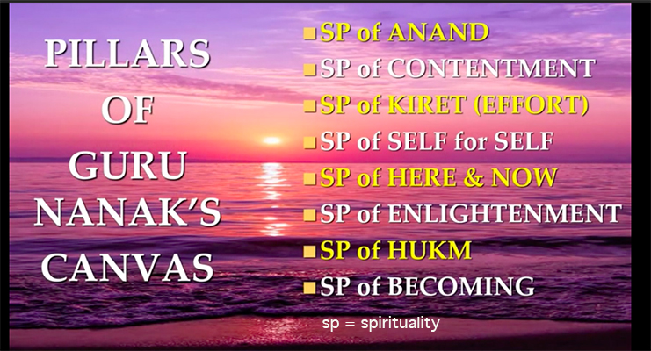
The outcome is stark indeed. What we have done is that we have brought ourselves to the Same Junction that Guru Nanak stood in 1469.
And we have chosen to travel the road he chose NOT to take. We are travelling the road he TOLD us NEVER to travel. We are travelling the road he discarded.
What’s worse, we are travelling the discarded road claiming that he – Guru Nanak – told us to travel this discarded road because he MENTIONED it in Gurbani.
We have reverted to the DISCARDED canvas. We have returned to the old canvas. We have regressed to the 4-thousand-year old canvas. We have lapsed to the REJECTED canvas.
And this is because we have ignored the fact that all the existing concepts in the discarded canvas are REDEFINED. We ignored the fact that Guru Nanak gave them new meanings – to FIT HIS CANVAS of life and the here and the now.
But what are the re-defined meanings of these concepts? Concepts such as Death, After Life, Heaven and Hell. Concepts such as 8.4 million, Ava gaun, Reincarnation. And concepts such as Jum Doot, Chitar Gupat, Dargah and Dharam raj.
This 12-part series of videos titled SIKHI CONCEPTS, will attempt to provide the new, redefined, and Gurbani meanings of these concepts as outlined within the 1429 pages of the SGGS.
The next video [→ https://youtu.be/GdpMMT_f55o] – Part 2 of 12 – will deal with the concept of DEATH. Death as Redefined within the Canvas of Guru Nanak.
SIKHI CONCEPTS SERIES BY DR KARMINDER SINGH DHILLON: COMPLETE LINKS TO VIDEOS & LECTURE NOTES
MASTER LINK: Complete links to videos and lecture notes [→ https://asiasamachar.com/2021/07/03/sikhi-concepts-complete-links-videos-lecture-notes/]
PART 1: GURU NANAK’S CANVAS: Video [→ https://youtu.be/jW5fPKS59go] | Lecture Notes [→ https://asiasamachar.com/2021/05/05/guru-nanaks-canvas/]
PART 2: DEATH: Video [→ https://youtu.be/GdpMMT_f55o] | Lecture Notes [→ https://asiasamachar.com/2021/05/13/death/]
PART 3: AFTER LIFE: Video [→ https://youtu.be/KTosh6sUe8c] | Lecture Notes [→ https://asiasamachar.com/2021/05/28/after-life/]
PART 4: CHAURASI LAKH (8.4 MILLION): Video [→ https://youtu.be/xU2-FGcA7eY] | Lecture Notes [→ https://asiasamachar.com/2021/06/05/chaurasi-lakh/]
PART 5: REINCARNATION: Video [→ https://youtu.be/IsrVhGUIIt0] | Lecture Notes [→ https://asiasamachar.com/2021/06/16/reincarnation/]
PART 6: HEAVEN & HELL: Video [→ https://youtu.be/99GZpXPC1Ok] | Lecture Notes [→ https://asiasamachar.com/2021/06/22/heaven-hell/]
PART 7: SALVATION (MUKTI): Video [→ https://youtu.be/3IugplCX4MM] | Lecture Notes [→ https://asiasamachar.com/2021/06/26/salvation/]
PART 8: COURT OF JUDGEMENT (DARGAH): Video [→ https://youtu.be/2g6eW8qxa8w] | Lecture Notes [→ https://asiasamachar.com/2021/07/01/dargah-court-of-judgement/]
PART 9: DHRM RAJ: Video [→ https://youtu.be/y6_xSqg5i9g] | Lecture Notes [→ https://asiasamachar.com/2021/02/27/36844/]
PART 10: JUM DOOT & CHITR GUPT: Video [→ https://youtu.be/oCmAjm4oSRg] | Lecture Notes [→ https://asiasamachar.com/2021/03/13/37103/]
PART 11: ANCESTORS: Video [→ https://youtu.be/J2ohetid6ZU] | Lecture Notes [→ https://asiasamachar.com/2021/03/26/35742/]
PART 12: APPLYING THE CANVAS: Video [→ https://youtu.be/jN2MMtuRRLo] | Lecture Notes [→ https://asiasamachar.com/2021/04/17/37691/]
Sikh thinker, writer and parcharak Karminder Singh Dhillon, PhD (Boston), is a retired Malaysian civil servant. He is the joint-editor of The Sikh Bulletin and author of The Hijacking of Sikhi. He can be contacted at dhillon99@gmail.com.
* This is the opinion of the writer, organisation or publication and does not necessarily represent the views of Asia Samachar.
RELATED STORY:
Hijacking Sikhi [→ https://asiasamachar.com/2020/12/19/35472/] (Asia Samachar, 19 Dec 2020)
Karminder talks about what shaped his thinking, and his latest books on Sikhi [→ https://asiasamachar.com/2020/11/20/34900/] (Asia Samachar, 20 Nov 2020)
ASIA SAMACHAR is an online newspaper [→ http://asiasamachar.com/] for Sikhs / Punjabis in Southeast Asia and beyond. Facebook [→ https://www.facebook.com/asiasamachar/] | WhatsApp +6017-335-1399 | Email: editor@asiasamachar.com | Twitter [→ https://twitter.com/AsiaSamachar] | Instagram [→ https://www.instagram.com/asiasamachar/] | Obituary announcements, click here [→ http://asiasamachar.com/2017/07/30/obituary-announcement-at-asia-samachar/] |
RELATED ARTICLES [→ #]MORE FROM AUTHOR [→ #]

