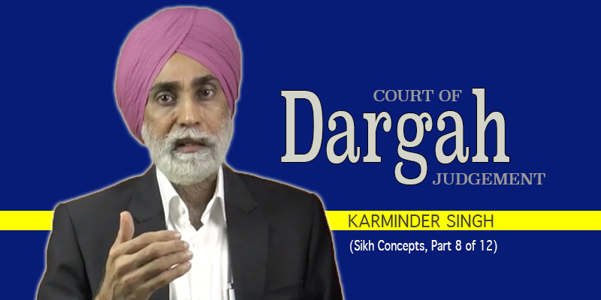
Our premise in these series of videos has been that Guru Nanak’s Portrait of Sikhi was Painted Over an existing canvas – one that had existed for thousands of years prior to Guru Nanak.
What we mean by PAINTING OVER is that Guru Nanak RE-DEFINED all the spiritual concepts of that pre-existing canvas to suit the spirituality of Gurbani. So while all the concepts of the old canvas are MENTIONED in the SGGS, they have been given NEW Meanings.
And IF we intend to appreciate the Sikhi of Guru Nanak, we will need to understand the NEW meanings or REDEFINED meanings of the concepts – as contained within the Sri Guru Granth Sahib.
In today’s video, we will look at the concept of the Court of Judgement, or Dargah as it’s known in Punjabi.
Let’s begin with Dargah and what is advocated about it by the 4,000-year-old Canvas.
According to its beliefs, Dargah is the Court of Judgement. The Sanskrit equivalent of Dargah is Sanyumni. This is the word that appears in the texts that are based on the 4K year old Canvas – Sanyumni.
Dargah is presided by Dhrm Raj and the one who prosecutes the soul of the deceased person is Chitargupt.
Dargah is the place where judgement is pronounced on the departed soul. Good souls are sent to heaven to obtain salvation, some bad ones are ordered to serve their sentences in one of the 21 hells, and other bad ones are condemned to their journey of avagaun or reincarnation. The court of judgment – Dargah – sets the exact path and order of 8.4 million reincarnations for the departed soul. How many life forms and which comes first and which next.
This narrative is presented as a religious FACT, and religious TRUTH. And believed by millions. And accepted by millions more.
What is most chilling really is that this narrative of Dargah – as drawn from the texts of the old canvas – is the one that is presented by our clergy – our granthis and parcharaks in our gurdwaras AS Sikhi beliefs. As Gurmat beliefs. As beliefs supported by Gurbani.
The outcome is that – the narrative that is held within the psyche of a vast majority of Sikhs is NOT the narrative of Gurbani, but that of the 4K year old canvas. And this vast majority of Sikhs mistakenly think and accept and believe the narrative of the 4K Old canvas to be the narrative of Gurbani.
Nothing can be further than the truth.
So what is the narrative of Dargah within Gurbani? We can develop the basic principles by examining some verses that discourse the concept.
Before we do that, it will help if we looked at two primary principles of Sikhi, Gurmat and Gurbani. Principle one pertains to the PRIMACY of HUKM and principle two is that SIKHI is for the HERE and NOW and Gurbani therefore concerns itself with the LIFE THAT WE ARE LIVING in the HERE and NOW.
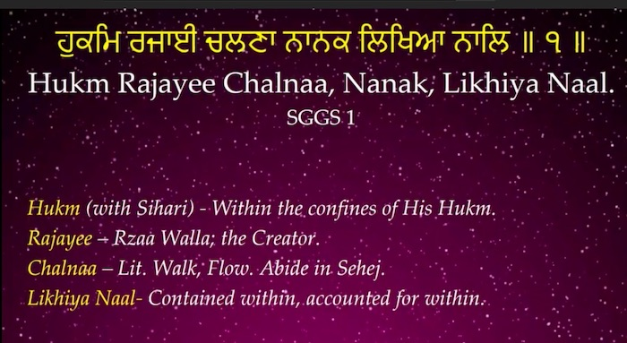
The primacy of Hukm in Sikhi is laid out in this verse of Guru Nanak on Page 1 of the SGGS:
ਹੁਕਮਿ ਰਜਾਈ ਚਲਣਾ ਨਾਨਕ ਲਿਖਿਆ ਨਾਲਿ ॥ ੧ ॥
Hukm Rajayee Chalnaa, Nanak, Likhiya Naal.
Hukm (with Sihari) means Within the confines of His Hukm. Rajayee – translates as Rzaa Walla; meaning the Creator. Chalnaa – Lit means to Walk, Flow. Abide in Sehej. Then we have the phrase Likhiya Naal. The word Lekha means an accounting. So Likhya Naal means – the Hukm is contained within, accounted for within.
The meaning of the verse is Nanak, The Way to Realize the Creator Within Is to Remain Within the Confines of, and Abide in Sehej (Chalna) Of His Hukm, As Contained Within Me.
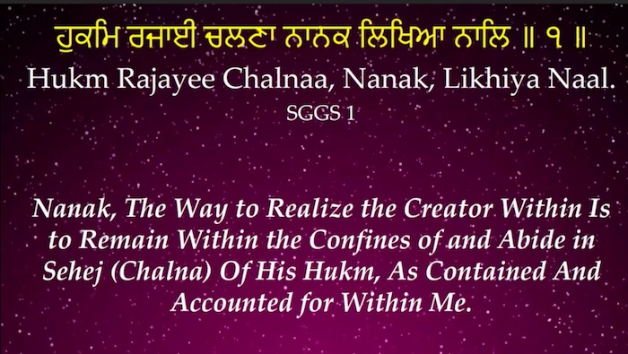
So that’s the first primary principle of Sikh – the Primacy of the Hukm.
The principle of Sikhi being a spirituality of the Here and Now, of the PRESENT life is contained within this verse of Bhai Gurdas.
ਵਰਤਮਾਨ ਵਿਚ ਵਰਤਦਾ ਹੋਵਣਹਾਰ ਸੋਈ ਪਰਵਾਣਾ॥ ਕਾਰਣ ਕਰਤਾ ਜੋ ਕਰੈ ਸਿਰ ਧਰ ਮੰਨ ਕਰੈ ਸ਼ੁਕਰਾਣਾ॥
Varatmaan Vich Varatda Hovanhaar Soee Parvana. Karan Karta Jo Karey Serr Dhar Munn Krey Shukrana. Bhai Gurdas Vaar 18.
Meaning: The accepted Sikh is one who lives successfully in the PRESENT. Whatever the Creator does, he accepts with gratitude as His hukm.
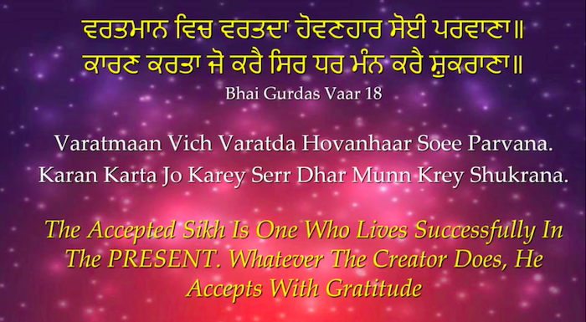
When we put these two principles together, then we get a narrative that can be summarized as follows.
One, The Hukmi is the Creator. Second, the Creator is Within. Third, If the Creator is Within, then His Court is also Within.
We know in temporal life; a Court is only good when the Judge presides. And the Court is where the Judge is. If a judge decides to sit under a tree and conduct the business of his court – then that’s his court. If a King holds court in a cave – then that is where his court is. If a judge decides to set up court on the beach – then that’s where the court is.
The court is where the Judge is, where the King is.
Guru Nanak tells us the Creator is Within. So His Court has to be Within. And there can be no court higher than the Creator’s court.
Fourth, If the Court is Within, then the Judgement is Within.
And finally, all of the above happens in the HERE and the NOW.
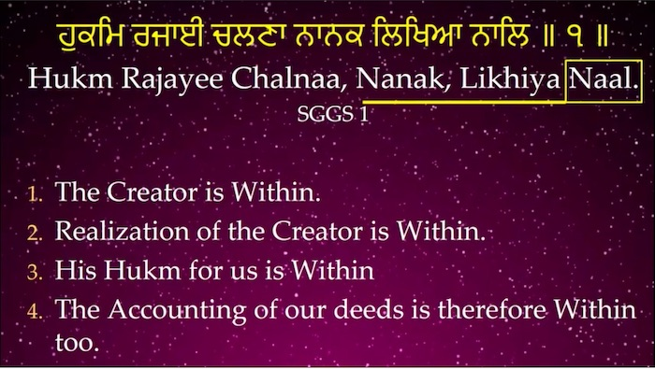
In order for the above principles to settle into our psyche, lets return to the seminal verse of Guru Nanak from page one of the SGGS ਹੁਕਮਿ ਰਜਾਈ ਚਲਣਾ ਨਾਨਕ ਲਿਖਿਆ ਨਾਲਿ ॥ ੧ ॥ Hukm Rajayee Chalnaa, Nanak, Likhiya Naal.
Guru Nanak is giving us some very profound messages in this verse. Every word of this verse is revolutionary. Every word carries a concept of spirituality that did NOT exist in the pre-1469 period.
Guru Nanak is saying the Creator is Within ਨਾਲਿ Naal. Since the Creator is within and realization of the Creator is within; it follows that His Hukm for us is in operation within ਨਾਨਕ ਲਿਖਿਆ ਨਾਲਿ Nanak, Likhiya Naal. It cannot be that the Creator is within us but that His Hukm is not, or that His Hukm is Without.
Four points are thus discernable from the verses thus far and worth noting. First, the Creator is Within. Second, Realization of the Creator is Within. Third, His Hukm for us is therefore Within (The Creator cannot be Within us sans His Hukm, minus His Hukm). The fourth consequential point is that the accounting of our deeds is therefore Within too.
Pre-existing and pre-1468 notions of judgement IN THE AFTER LIFE by external “entities” such as Dharam-raj, Chitargupat, Lekha etc. are thus REJECTED. They are then REDEFINED in Gurbani as processes that occurs WITHIN and in the Here and Now.
But where is the direct evidence from within Gurbani that the Court is Within?
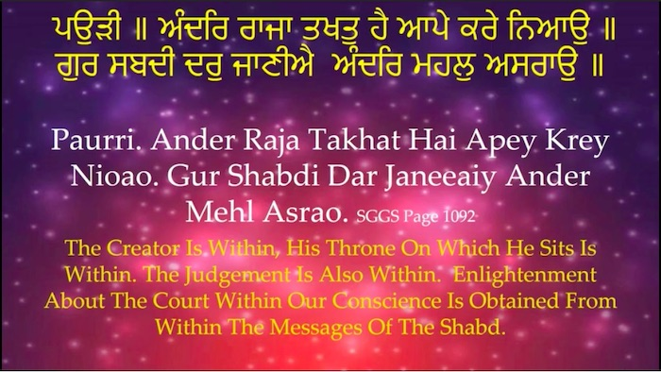
This is a verse from page 1092 of the SGGS.
ਅੰਦਰਿ ਰਾਜਾ ਤਖਤੁ ਹੈ ਆਪੇ ਕਰੇ ਨਿਆਉ ॥ ਗੁਰ ਸਬਦੀ ਦਰੁ ਜਾਣੀਐ ਅੰਦਰਿ ਮਹਲੁ ਅਸਰਾਉ ॥
Ander Raja Takhat Hai Apey Krey Nioao. Gur Shabdi Dar Janeeaiy Ander Mehl Asrao.
Guru Amardas ji is saying. The King is Within ਅੰਦਰਿ ਰਾਜਾ Ander Raja. His Throne on which he sits is Within ਅੰਦਰਿ ਰਾਜਾ ਤਖਤੁ ਹੈ Ander Raja Takhat Hai the Justice, the law, the rules, the judgement is also Within ਅੰਦਰਿ ਰਾਜਾ ਤਖਤੁ ਹੈ ਆਪੇ ਕਰੇ ਨਿਆਉ Ander Raja Takhat Hai Apey Krey Nioao.
How do we get enlightened about this Court Within? How do we find the door, the access to this Court Within? The answer is in the next verse ਗੁਰ ਸਬਦੀ ਦਰੁ ਜਾਣੀਐ Gur Shabdi Dar Janeeaiy. Dar means door, it means passage way, it means access. Through the messages of the Shabd Guru.
Enlightenment about the Court within, within which the Creator Reigns, sits on the throne, and executes judgement within ਅੰਦਰਿ ਮਹਲੁ ਅਸਰਾਉ Ander Mehl Asrao is to be obtained from within the messages of the shabd ਗੁਰ ਸਬਦੀ ਦਰੁ ਜਾਣੀਐ ਅੰਦਰਿ ਮਹਲੁ ਅਸਰਾਉ Gur Shabdi Dar Janeeaiy Ander Mehl Asrao.
The phrase ਅੰਦਰਿ ਮਹਲੁ ਅਸਰਾਉ Ander Mehl Asrao means Within the Conscience. It is our CONSCIENCE that is the DARGAH. It is the Conscience that is the court.
Keep in mind that all of Gurbani’s concepts are grounded in the HERE and NOW. In our present life. ਵਰਤਮਾਨ ਵਿਚ ਵਰਤਦਾ ਹੋਵਣਹਾਰ ਸੋਈ ਪਰਵਾਣਾ॥ Varatmaan Vich Varatda Hovanhaar Soee Parvana.
Similarly, the concepts of Dargah and Judgement in Dargah are grounded in the HERE and NOW.
In that context then, the phrase ਅੰਦਰਿ ਮਹਲੁ ਅਸਰਾਉ Ander Mehl Asrao means Within the Conscience. It is our CONSCIENCE that is the DARGAH. It is the Conscience that makes judgements about our thoughts, speech, acts and deeds. These are instant judgements in the here and now.
The meaning of the verse then is this: The Creator is Within, His Throne on which he sits is Within. The Justice, the law, the rules, the judgement is also Within. Enlightenment about the Court within Our Conscience is obtained from within the messages of the shabd.
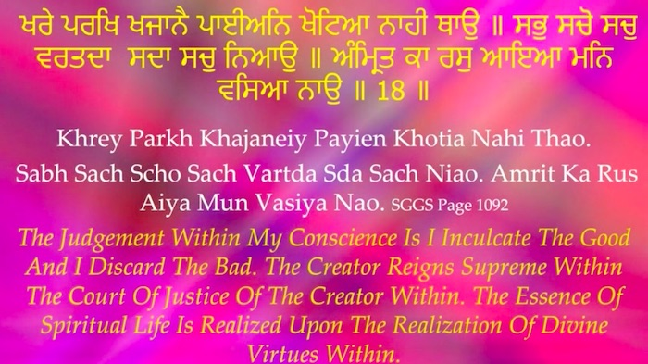
The verses that follow are:
ਖਰੇ ਪਰਖਿ ਖਜਾਨੈ ਪਾਈਅਨਿ ਖੋਟਿਆ ਨਾਹੀ ਥਾਉ ॥ ਸਭੁ ਸਚੋ ਸਚੁ ਵਰਤਦਾ ਸਦਾ ਸਚੁ ਨਿਆਉ ॥
Khrey Parkh Khajaneiy Payien Khotia Nahi Thao. Sabh Sach Scho Sach Vartda Sda Sach Niao. Amrit Ka Rus Aiya Mun Vasiya Nao. SGGS Page 1092
What happens in the Court or Dargah that is our Conscience – is that judgement or evaluation takes place – in the HERE and NOW. The word ਪਰਖਿ means just that – evaluation and judgement.
What is the ਪਰਖਿ Parkh about? What is the judgement within our Conscience? Guru ji says – ਖਰੇ ਪਰਖਿ ਖਜਾਨੈ ਪਾਈਅਨਿ ਖੋਟਿਆ ਨਾਹੀ ਥਾਉ Khrey Parkh Khajaneiy Payien Khotia Nahi Thao – To accept the good and to reject the bad. To provide space and acceptance to upright thoughts, to worthy speech and to virtuous deeds – ਖਰੇ ਪਰਖਿ ਖਜਾਨੈ ਪਾਈਅਨਿ Khrey Parkh Khajaneiy Payien and to reject and toss out the fake ਖੋਟਿਆ ਨਾਹੀ ਥਾਉ Khotia Nahi Tha.
The voice of our Conscience Within is the Voice of the Creator Within.
ਅੰਦਰਿ ਰਾਜਾ ਤਖਤੁ ਹੈ ਆਪੇ ਕਰੇ ਨਿਆਉ
Ander Raja Takhat Hai Apey Krey Nioao.
He Himself is the Voice of our Conscience Within.
The voice of our Conscience Within is the Judgement of our thoughts, deeds and actions that takes place all the time in the HERE and NOW, in our PRESENT life. The Conscience is the Court. The Conscience is the Dargah WITHIN.
Then Patshah says in the next verse:
ਸਭੁ ਸਚੋ ਸਚੁ ਵਰਤਦਾ ਸਦਾ ਸਚੁ ਨਿਆਉ
Sabh Sach Scho Sach Vartda Sda Sach Niao.
This verse tells us of the character and quality of the ਪਰਖਿ Parakh or evaluation or judgement that takes place within our Conscience as the voice of the Creator within. The character is ਸਦਾ ਸਚੁ ਨਿਆਉ Sda Sach Niao. Niyao means Justice. Sda means permanent, without exceptions. Sach means eternal, of the eternal creator.
The judgement that is of the voice of the Conscience Within pertains to the Justice of the Eternal Creator. Why? Because the voice of our Conscience Within is the Voice of the Creator Within.
And what is the outcome of such realization? What is the outcome of the realization that The Creator is Within, that His Throne on which he sits is Within, that His court is within, that the Justice, the law, the rules, and the judgement is also Within?
The outcome is in the final verse ਅੰਮ੍ਰਿਤ ਕਾ ਰਸੁ ਆਇਆ ਮਨਿ ਵਸਿਆ ਨਾਉ ॥ Amrit Ka Rus Aiya Mun Vasiya Nao. Amrit comes from two words A + Mrit. Mrit means death and A negates it. It therefore means the absence of death, the absence of spiritual death. In other words, SPIRITUAL LIFE.
ਅੰਮ੍ਰਿਤ ਕਾ ਰਸੁ ਆਇਆ Амрит Ка Рус Айя означает: суть духовной жизни пробуждается.
The translation of the verse is: The Judgement Within My Conscience Is I Inculcate the Good and I Discard the Bad. The Creator Reigns Supreme Within the Court of Justice of the Creator Within. The Essence of Spiritual Life Is Realized Upon the Realization of Divine Virtues Within.
Putting it all together then, the message of the verse is: The judgement within our Conscience is of essence.
The good and the bad, the truth and the falsity, the real and the unreal – I judge within my Conscience on the basis of ਗੁਰ ਸਬਦੀ ਦਰੁ ਜਾਣੀਐ Gur Shabdi Dar Janeeaiy.
I inculcate the good ਖਰੇ ਪਰਖਿ ਖਜਾਨੈ ਪਾਈਅਨਿ Khrey Parkh Khajaneiy Payien. I discard the bad ਖੋਟਿਆ ਨਾਹੀ ਥਾਉ Khotia Nahi Thao. The essence of Spiritual life is realized upon the realization of Divine virtues within.
What all the above means is that Guru Amardas ji is telling us that for Divinity to come into existance within our minds in the HERE and NOW– we need to appreciate that the Creator is Within, His Court or Dargah is within, and so is the Judgement which comes through the voice of the conscience which is the voice of the Creator within.
On the other hand, if we accept that the Dargah is an external entity in the After Life, and that the judgement is done by an entity out there –also in our afterlife – then the essence of it will NOT be DIVINITY, but fear, anxiety, worry and dread. These are not the building blocks of spirituality in the Here and Now.
The fourth Guru Ramdas ji has these set of very profound verses on page 591 of the SGGS.
ਜਿਸੁ ਕੈ ਘਰਿ ਦੀਬਾਨੁ ਹਰਿ ਹੋਵੈ ਤਿਸ ਕੀ ਮੁਠੀ ਵਿਚਿ ਜਗਤੁ ਸਭੁ ਆਇਆ ॥ ਤਿਸ ਕਉ ਤਲਕੀ ਕਿਸੈ ਦੀ ਨਾਹੀ ਹਰਿ ਦੀਬਾਨਿ ਸਭਿ ਆਣਿ ਪੈਰੀ ਪਾਇਆ ॥
Jis Kaiy Ghar Diban Har Hoveiy Tis Ki Muthi Vich Jagt Sabh Aiya. Tis Kao Talki Kiseiy Di Nahi Har Diban Sabh Aann Pairi Paya.
The first verse is ਜਿਸੁ ਕੈ ਘਰਿ ਦੀਬਾਨੁ ਹਰਿ ਹੋਵੈ Jis Kaiy Ghar Diban Har Hoveiy. Diban is Court. And ਘਰਿ Ghar with a sihari is Within – within the mind, within the conscience.
So in the first verse Guru Ramdas ji is saying The Court of the Omnipresent Creator is Within ਜਿਸੁ ਕੈ ਘਰਿ ਦੀਬਾਨੁ ਹਰਿ ਹੋਵੈ Jis Kaiy Ghar Diban Har Hoveiy.
Then Patshah says ਤਿਸ ਕੀ ਮੁਠੀ ਵਿਚਿ ਜਗਤੁ ਸਭੁ ਆਇਆ Tis Ki Muthi Vich Jagt Sabh Aiya. Realization of such puts the Entirety of our life into the Creator’s hand – into the Creator’s Hukm or will.
The second verse speaks of the outcome of such a realization ਤਿਸ ਕਉ ਤਲਕੀ ਕਿਸੈ ਦੀ ਨਾਹੀ ਹਰਿ ਦੀਬਾਨਿ ਸਭਿ ਆਣਿ ਪੈਰੀ ਪਾਇਆ Tis Kao Talki Kiseiy Di Nahi Har Diban Sabh Aann Pairi Paya. The phrase ਤਲਕੀ ਕਿਸੈ ਦੀ ਨਾਹੀ Tis Kao Talki Kiseiy Di Nahi means the subjugation of none, the fear of none, the dread of none.
So the outcome of Realization that the Court of the Omnipresent Creator is within is the REMOVAL of subjugation to any OTHER entity. Any entity other than the Creator within.
The message is crystal clear – A Sikh of the SGGS, a Sikh of Gurbani does not subject himself or herself to any COURT, any Diban, any Dargah that is under the jurisdiction of any entity OTHER than the Creator Within.
This single verse alone is sufficient to discard all the external entities such as the Dargah of the afterlife, Dhrm raj, Chitargupt etc. A Sikh is NOT subject to any such concocted entities.
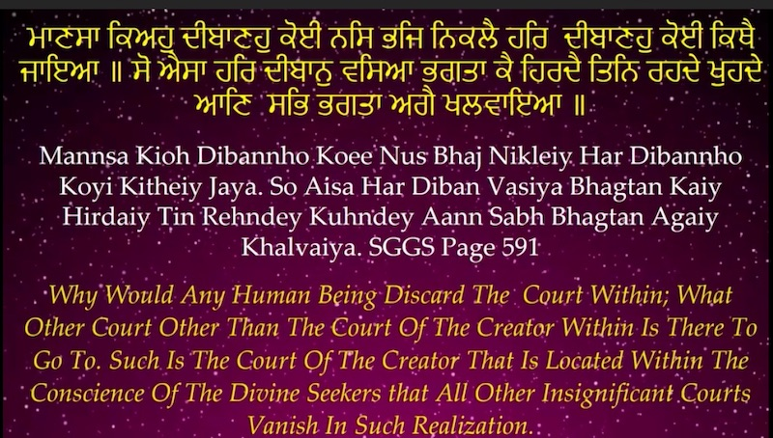
In the next verse Guru Ramdas ji says
ਮਾਣਸਾ ਕਿਅਹੁ ਦੀਬਾਣਹੁ ਕੋਈ ਨਸਿ ਭਜਿ ਨਿਕਲੈ ਹਰਿ ਦੀਬਾਣਹੁ ਕੋਈ ਕਿਥੈ ਜਾਇਆ ॥
Mannsa Kioh Dibannho Koee Nus Bhaj Nikleiy Har Dibannho Koyi Kitheiy Jaya.
Meaning: Why would any human being ਮਾਣਸਾ Mannsa Har Dibannho Koyi Kitheiy Jaya discard such a Court, such a Diban ਕਿਅਹੁ ਦੀਬਾਣਹੁ ਕੋਈ ਨਸਿ ਭਜਿ ਨਿਕਲੈ Kioh Dibannho Koee Nus Bhaj Nikleiy and what other court other than the Court of the Creator Within is there to go to ਹਰਿ ਦੀਬਾਣਹੁ ਕੋਈ ਕਿਥੈ ਜਾਇਆ Har Dibannho Koyi Kitheiy Jaya?
Then in the next verse Guruji says:
ਸੋ ਐਸਾ ਹਰਿ ਦੀਬਾਨੁ ਵਸਿਆ ਭਗਤਾ ਕੈ ਹਿਰਦੈ ਤਿਨਿ ਰਹਦੇ ਖੁਹਦੇ ਆਣਿ ਸਭਿ ਭਗਤਾ ਅਗੈ ਖਲਵਾਇਆ ॥
So Aisa Har Diban Vasiya Bhagtan Kaiy Hirdaiy Tin Rehndey Kuhndey Aann Sabh Bhagtan Agaiy Khalvaiya.
Meaning Such is the court of the Creator ਸੋ ਐਸਾ ਹਰਿ ਦੀਬਾਨੁ So Aisa Har Diban Tin Aann. Such is the court of the Creator that is located within the conscience ਵਸਿਆ ਭਗਤਾ ਕੈ ਹਿਰਦੈ Vasiya Bhagtan Kaiy Hirdaiy. The Court is within the Conscience. So much so that all other insignificant courts ਰਹਦੇ ਖੁਹਦੇ Rehndey Kuhndey vanish in such realization ਸਭਿ ਭਗਤਾ ਅਗੈ ਖਲਵਾਇਆ Sabh Bhagtan Agaiy Khalvaiya.
The message is crystal clear. Once Realization of the Court of the Creator Within comes, settles in, and becomes a reality of our Spirituality in the HERE and NOW – all other courts become insignificant, become inconsequential, become irrelevant. Guru ji uses the words ਰਹਦੇ ਖੁਹਦੇ ਦੀਬਾਨੁ Rehndey Kuhndey Diban in comparison to ਹਰਿ ਦੀਬਾਨੁ Har Diban. The idiom ਰਹਦੇ ਖੁਹਦੇ Rehndey Kuhndey means trivial, petty, frivolous and irrelevant remnants.
To a Sikh of Gurbani, the so called Dargah, or Court of judgement in the afterlife is as frivolous as it is irrelevant.
The meaning of the verse is: Why would any human being discard the Court within; What other court other than the Court of the Creator Within is there to go to. Such is the court of the Creator that is located within the conscience of Divine Seekers (Bhagats) that all other insignificant courts vanish in such realization.
In essence then pyareo, what Gurbani has done is to Liberate us from the entire pre 1468 Canvas. To free us from the debilitating and crippling fear of the clergy concocted concepts of the 4K year old canvas.
Life is difficult enough without having to believe that the entire universe is just waiting to consign us to an eternal hell. And that is exactly what the 4K year old Canvas and our clergy want us to believe. That we are given an infinitely miniscule span for our life and that what awaits us in the afterlife is a terrifying judgment in a petrifying court, at the hands of of a horrifying judge who is just waiting to confine us into 21 hells for eternity for some petty wrongdoings and have us to go through 8.4 million life forms of cats, rats, bats and cockroaches.
This is the fear from which Guru Nanak and Gurbani seek to liberate us from. There is no court of judgement, no Dargah, no kacheri, no saynyamni in the afterlife. The only court is the one within us. In the here and now.
The court of judgement is our conscience. Every thought, every word, every action of ours is judged right within us, in the very instant, and a judgement delivered by our conscience right there and there. We have to listen to our conscience. We have to silence the background noises in our mind that tell us to ignore our conscience. We have to refrain our attempts to silence our conscience. Instead, we have to empower our conscience. Gurbani is the source of this empowerment. The messages of Gurbani are the nourishment for our conscience. The voice of our conscience is the voice of the creator within us. Gurbani tells us to seat the Creator Within – on His Throne Within – In His Court Within – which is our Conscience.
ਅੰਦਰਿ ਰਾਜਾ ਤਖਤੁ ਹੈ ਆਪੇ ਕਰੇ ਨਿਆਉ ॥ ਗੁਰ ਸਬਦੀ ਦਰੁ ਜਾਣੀਐ ਅੰਦਰਿ ਮਹਲੁ ਅਸਰਾਉ ॥
Ander Raja Takhat Hai Apey Krey Nioao. Gur Shabdi Dar Janeeaiy Ander Mehl Asrao.
The King is Within ਅੰਦਰਿ ਰਾਜਾ Ander Raja His Throne on which he sits is Within ਅੰਦਰਿ ਰਾਜਾ ਤਖਤੁ ਹੈ Ander Raja Takhat Hai. The Justice, the law, the rules, the judgement is also Within ਅੰਦਰਿ ਰਾਜਾ ਤਖਤੁ ਹੈ ਆਪੇ ਕਰੇ ਨਿਆਉ Ander Raja Takhat Hai Apey Krey Nioao.
When You Stop Fearing the Dargah of the After Life, You Start to Listen to the Dargah Within in the Here and Now
When You Discard the concocted notion of Dargah in the Afterlife. You Acquire the Gurbani Notion of Dargah Within us in the Here and Now.
You start to listen to the Voice of your Conscience as the Voice of the Creator Within, When You Stop Chasing the Spirituality of Life After Death. You Start Living the Spirituality of Here and Now. And You Allow the Spirituality of HUKM to live within You
When You Discard the Gurbani Discarded Narratives of the 4K years Old Canvas, You start living the Truths of Gurbani.
The next video will examine the concepts of Dhrm Raj. It will attempt to provide the new, redefined, and Gurbani meanings as outlined within the 1429 pages of the SGGS.

