Assignment #2-Group Project

Poster Presentation of Sikhism

Diana S. Bright

Neil Brown

Gianina Bocsanu

Nursing 350, School of Nursing,
University of British Columbia
Tutor: Mrs. C. Pikios
Due: June 24, 2002

Abstract

A poster presentation is made of the development of the Sikh religion and its history in Canada. A visit to a Sikh Temple and interviews with adherents, explore the cultural and religious beliefs. Aspects of health care may be affected by cultural differences. If health care personnel are aware of these differences, provision may be made to give medical care while also respecting the Sikhs’ beliefs and cultural values.

Contents
Introduction………………………………………………......……....p. 5
- The History of Sikhism…………………………......…. p. 6
- The Sikhs in Canada………………………………......…p 31
- Welcome to the Sikh Temple………………………........p.36
  - Entering Gurdwara……………………………….p.37
  - Prayers and Music………………………………..p 39
  - The Guru Granth Sahib…………………………..p.41
  - Food……………………………………………...p. 43
  - Five Symbols of the Baptized Sikh………………p.44
  - Mr. Lail………………………………………….. p.46
- Sikh Family Life ……………………………………......p 47
  - Marriage………………………………………….p 48
  - Family Structure……………………………….…p 49
  - Family Planning………………………………….p 51
  - Food Practices……………………………………p 51
  - Health Care Practices…………………………….p 52
  - Birth………………………………………………p 52
  - Changing Times…………………………………..p 53
  - Work……………………………………………...p 54
  - RCMP Sikh photo………………………………..p. 55
  - Summary…………………………………………p. 56
- Implications for Health Care…………………………….p. 57
  - Illness and Health………………………………....p 58
  - Hospitalization…………………………………….p 58
e) Community ties………………………………….....p 59
f) Euthanasia……………………………………........p 59
VI Information Gathering………………………………......….p 61
VI References…………………………………….......…….…p. 63
VII Appendix #1 Interview Questions…..………….......……p. 65

Introduction:

To provide health care that is optimal, there is a need to respect different customs and beliefs of people. Incorporating the differences into health care planning, gives the patient a feeling of respect, encourages cooperation with treatment, provides a culturally safe environment, and a happier working environment. The history of the Sikh religion (including the ten Gurus), their belief in one God, and their beliefs in regard to hospitalization, illness and death, are the major areas covered in this paper.
This poster presentation on the Sikh religion is based on information garnered from various websites, interviews with several people, and visits to a Sikh temple. We cannot thank Mrs. Cindy Grewal, and Mr. Amrak Singh Lail, and members of the Penticton Sikh Temple enough for all their assistance.

The

History

of the

Sikhs

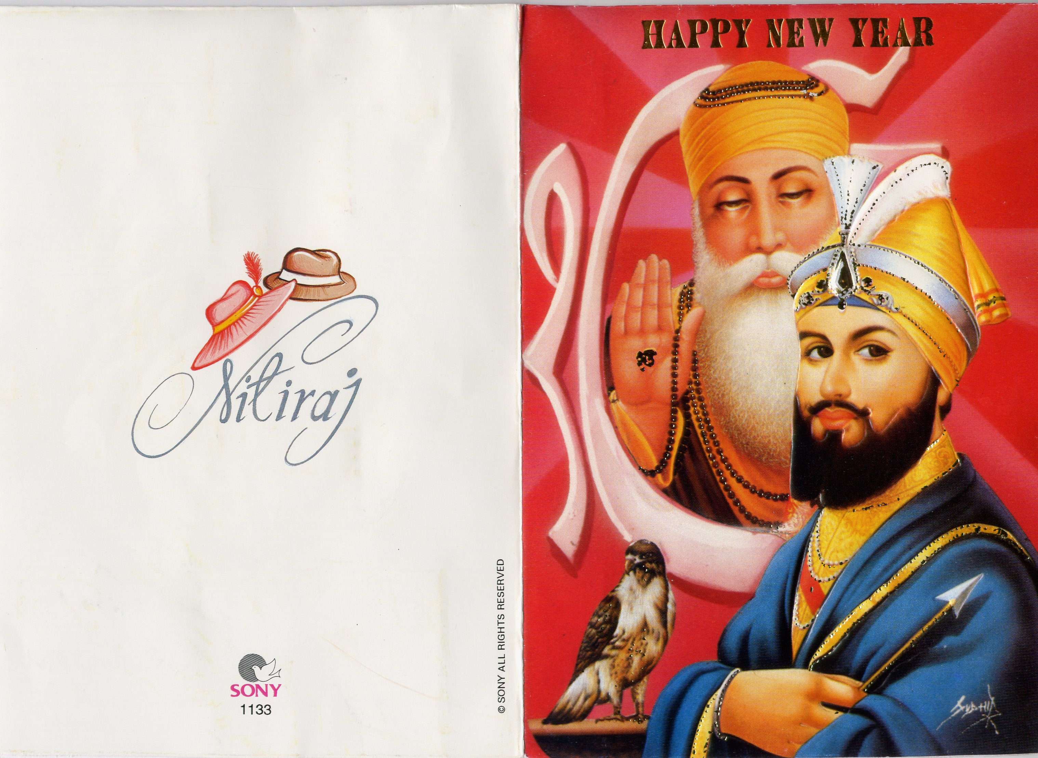
Greeting card provided by Cindy Grewal

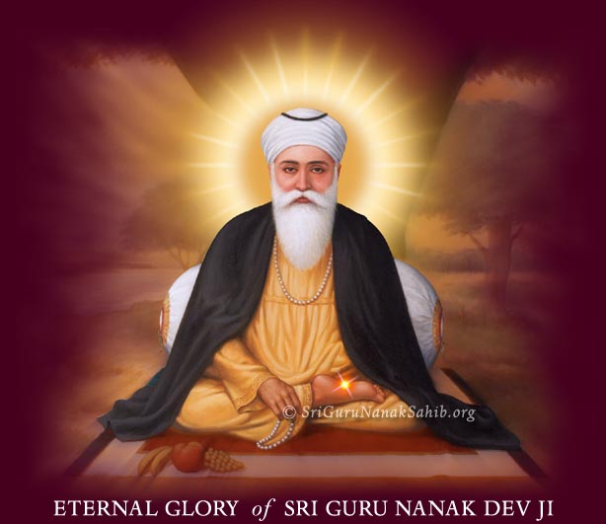
Sikhism

“Guru Nanak Dev Ji was the Enlightener
Who dispelled delusion and brought
Awareness.

Being the Guru he was one with God.
It is impossible to make an estimate of his
Greatness as a person,
For the Guru is not a person.

He is Light.

The Guru's glories are infinite and
Therefore unfathomable and inexpressible.
No one can estimate the Guru's greatness,
Only pay homage to the Guru by
Expressing his glories as seen in the play
Of his phenomenal life.” www.sikh-info.com

Just as Guru Nanak was the Enlightener, the visit to the Sikh temple in Penticton, B.C. was enlightening and educational. While we were able to see how their spiritual and religious beliefs influence their perceptions of health and illness, the history of the religion itself is very deep and structured.
The word Sikh comes from the Sanskrit word 'shishya' which means disciple. Sikhs are the disciples of their ten Gurus. The ten gurus, in the order in which they served as Gurus with their birth year in brackets are: Guru Nanak Dev Ji (1469), Guru Angad Dev Ji (1504), Guru Amar Das Ji (1479), Guru Ram Das Ji (1534), Guru Arjun Dev Ji (1563), Guru Hargobind Sahib Ji (1595), Guru Har Rai Ji (1630), Guru Har Krishan Ji (1656), Guru Tegh Bahadur Ji (1621), and Guru Gobind Singh Ji (1666). It was the foundation laid by these men as well as the installation of the Sri Guru Granth Sahib as a permanent Guru that helped to develop over 20 million Sikhs in the world today, with the vast majority living in the north Indian state of Punjab. The Sri Guru Granth Sahib is The Sikh Scripture and is also called the Eleventh Guru, as all Sikh's view it as a form of a person. It was the Tenth Guru, Guru Gobind Singh who conferred it as perpetual Gurudom on October 3, 1708.
www.sikhworld.co.uk 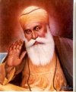
Guru Nanak Dev Ji, the founder of the Sikh faith was the son of an official with a small holding of land in a village northwest of Lahore, India. His father's wish was for him to train as an accountant so that he could get a job in the court of the Muslim governor of the district. But Guru Nanak Dev Ji had little interest in his school text books and instead engaged in long discourses with holy men both Hindu and Muslim, who turned up at his village. He disappointed his parents greatly as he would not attend to family business and spent what ever money they gave him towards the poor. When he grew up to be a young man, they arranged a marriage for him. For a short time he devoted himself to the care of his wife and two sons.
However, the search for truth became overwhelming for Guru Nanak Dev Ji, and he entered the court of Akal Purkh (God) who sent him out to spread his word. For a period of three days, Guru Ji went missing and was presumed drowned. On that third day he appeared and began his mission with a simple message, 'There is no Hindu, there is no Mussulman.' His message was simple: “In Gods eyes, all are equal.” He had a following of people dissenting both from Hinduism and Islam, and it was up to his nine successors to mold that following into a distinct community with its own language, religious beliefs, institutions and traditions.
Guru Nanak Dev Ji had two sons, but did not choose one of them to succeed as Guru and instead chose a faithful disciple and named him Guru Angad Dev Ji. www.sikhworld.co.uk 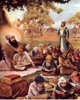The Second Guru created the Gurmukhi language which was then used to compile the hymns of his master. Angad Dev Ji also set up centers of teaching and organized the Sikh's into a tight community. For the Third Guru, Angad Dev Ji went the way of Nanak and chose disciple Amar Das Ji. www.sikhworld.co.uk  Guru Amar Das Ji then appointed his son-in-law Ram Das Ji to become the Fourth Guru. 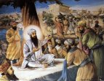 www.sikhworld.co.uk Guru Ram Das Ji started the construction of the Harminder Sahib (Golden Temple). His son Guru Arjun Dev Ji 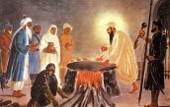 www.sikhworld.co.uk invested it with the special sanctity it has for the Sikhs today. He also took many steps to make Sikhism a faith distinct from Hinduism and Islam. Of the other major accomplishments, he compiled the Adi Granth by collecting the writings of the preceding Guru's and those of Hindu and Muslim saints and adding them to his own hymns. At that point, the Adi Granth was the sacred scriptures of the Sikh's, later to become the Sri Guru Granth Sahib. Unfortunately (or perhaps fortunately), Guru Arjun Dev Ji greatest contribution to the Sikh faith was his life. Moghal Emperor Jahangir was upset by the Guru growing influence amongst his people. He was arrested on a frivolous charge and subjected to severe torture which resulted in Guru Ji's death.
Guru Arjun Dev Ji's son, Hargobind Sahib succeeded him as the Sixth Guru. 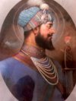 www.sikhworld.co.uk He changed the direction of the community by organising all of them into an army to fight the imperial forces. Four battles were fought, with Guru Ji winning all four of them. 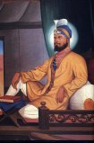 www.sikhworld.co.uk Guru Har Rai Ji and Gur Har Krishan Ji www.sikhworld.co.uk 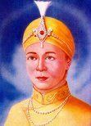followed him as the Seventh and Eighth Guru's. The final transformation of the Sikh's came with the Tenth Guru, Guru Gobind Singh Ji. www.sikhworld.co.uk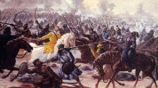In 1675 the young Gobind's father, the Ninth Guru, Guru Tegh Bahudar 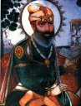www.sikhworld.co.uk was besieged by Hindu Brahmin who pleaded with Guru Ji to help them from the onslaught of the Muslim rulers who were forcing all Hindu's to convert to Islam. Guru Tegh Bahudar travelled to Delhi to meet the emperor, where he too, was ordered to accept the Islam faith or face death. The Ninth Guru wrote some words on some paper and tied it around his neck with string. He was indeed executed, but the paper read, “I gave my head, but not my faith.”
“When a Sikh has died, relatives and friends are informed so that they may join the funeral ceremony on the date it is scheduled for the cremation. In foreign countries (like Canada, for example), a date and time is given by the crematorium authorities. Once all parties have arrived for the funeral, the corpse is bathed then dressed in clean clothes with the five symbols of the Khalsa, and then placed in a wooden frame. The people form a procession and sing hymns as they carry the body to the cremation ground.” (Fletcher, 1994) A motorcade is formed in the western hemisphere and they drive to the crematorium. Once the body reaches the cremation-place, the Kirtan Sohila is recited, for it is of special significance at this time. The Guru says:
“This same call goes to all homes every day; So remember that Lord who calls, O Nanak; The day draws ever nearer for each one of us.
Then the Ardas, or General Prayer is recited -- this seeks a blessing for the departed person. The nearest relation to the deceased lights the funeral pyre, electricity or gas, whichever is being used for the cremation. The ashes that are collected should be disposed of by throwing them into running water or into the sea. No memorials or monuments may be erected at the place where the last remains of the deceased were disposed of. Upon the completion of the cremation, the relatives and friends return to the house of the deceased where they bathe and generally start a Sadharan Path for the benefit of the dead and his family. This consists of a complete reading of the Scripture and is done by the relatives and friends of the family. Usually, both in the morning and in the evening, Kirtan (Sikh worship) and Katha are performed. It is important to remember that the passing of a Sikh is no cause of grief or sorrow, for that would mean submitting to the will of God. It is strongly believed that those who have led pure lives are not in any way afraid of death. The path, or reading, of the Holy Scripture should be completed within nine days. On the tenth day, relatives and friends of the family gather for the “Bhog” ceremony, at which the singing of hymns and the last five pages of Sri Guru Granth Sahib are read. After this ceremony, the composition “Ramkali Sadd,” (page 923 of Sri Guru Granth Sahib) is recited for the benefit of the family of the deceased. Emphasizing the remembrance of God's name as the means of consolation for the bereaved family is something the Guru's have always felt is important. Langar, or free food, is sometimes served following the reading, but this is not always the case. Presents are occasionally distributed to the grandchildren and donations are announced for charities or religious organizations. Dastar-bandi, or turban tying, is another small ceremony held to mark the occasion of a deceased loved one. The eldest member of the family is declared as the new Head of the family and given a turban ceremoniously. This is a token of his new responsibility for looking after the family and estate of the deceased person. He is now regarded as the new chief of the family, responsible for the care of the children and other dependents of the family. In reference to religion and the healing process, Sikhism believes in a just and merciful God. God does not on His own cause suffering: “The Creator takes no blame to Himself.” All things work under His law; He does not undermine His own law by making exceptions. Man sows the seed of action and gets the fruit accordingly. According to the Sikh's, God is like a supreme judge who deals with people according to their desserts. It is also His privilege to pardon an erring but repenting soul. In regard to illness, a deep study of the problem of pain makes us feel that pain has a good and useful purpose to serve. Pain draws out great kindness and compassion in this hard world. Pain is also a test, an ordeal, to assess man's conviction and courage. Guru Nanak believes that “Pain is a remedy, and pleasure the disease.” Of course, physical pain is a measure of ill-health, like an alarm-bell. When one feels physical pain, they will either self-medicate or consult their doctor. So why not do the same for spiritual pain? The Sikhs believe that God gives us a timely warning through our conscience. Their Guru is the doctor for these pains.
As far as specific illnesses go, the Sikhs have rules corresponding to the ways of the Guru's. It is
believed that anything done to improve one's health, is
like improving the person and their soul. Therefore, drugs, blood transfusions, and vaccines are acceptable. However, only if the drug is to improve health may it be used. Recreational drugs like alcohol and marijuana are strictly prohibited. Organ transplants and biopsies are also allowed, as they are done with the intention of improving one's health. Should a Sikh lose a limb, the cremation of that lost limb is desirable, much like cremation is performed when one dies. The termination of life is interpreted in different ways. The general concept of death according to the Sikh's is that death is the extinction of the body and the sense-organs. Sikh Guru's believe that death is the forgetting of God. The First Guru, Guru Nanak says that “If I remember Him, I live; when I forget Him, I am dead.” This forgetfulness of God allows man to enter the cycle of birth and death. The Sikh's are true believers that “physical death is neither painful nor terrible. It only makes sense that all must die as the physical frame is subject to decay. However, dying is like an art. The feeling of joy at the prospect of a coming death is normal. It is thought that to know the art of true dying, one must have known the art of true living. True living is dying to self while true dying is the privilege of the brave who die for an approved cause. A 'True' devotee welcomes death as a friend because he looks forward to a union with the Supreme Being. Pointless dying, for no cause at all, helps no one.“ (Fletcher, 1994)

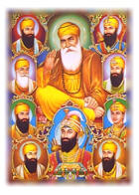
The Ten Gurus
www.sikhworld.co.uk

The Sikhs in Canada
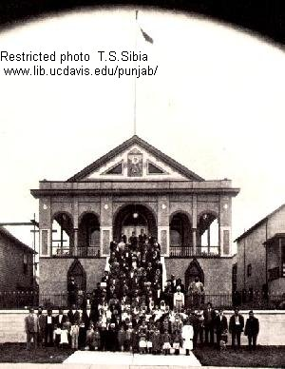

Vancouver Sikh Temple, 1936 built in 1908.

“The history of Sikhs in Canada dates back to 1897, when the first Sikhs visiting Canada were soldiers of the British Army. It was their passing through Canada on their way back to India that enabled them to tell other British Army Sikh Soldiers in Honk Kong, Shanghai, and Singapore about the opportunities in Canada. In 1904, the first Sri Guru Granth Sahib was brought to Vancouver, providing the Sikhs with something to worship and promoted them to congregate regularly for worship, using their houses for this purpose. Although the Anti-Hindu riot occurred in Bellingham, Washington, it is significant to note that in 1907 approximately 500 men assaulted boarding houses and mills. The riot began as an attack on two East Indian workers and then escalated to a rock throwing lynching. The next day, 300 Hindus fled Bellingham in fear.
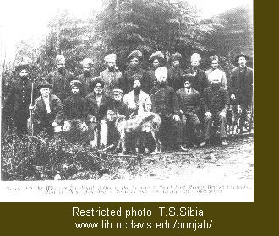Photo taken in Port Moody, 1907 www.lib.ucdavis.edu/punjab/
In 1908, the first Gurdwara Sahib, or temple, was officially opened in Vancouver. 1970 saw a new Gurdwara built, with the land costing $100,000. It was unfortunate, however, to lose the earlier historic Sikh monument. By the early 1920's the Sikh population of BC was just over 1,000. By the late 1920's and early 1930's, children of the immigrants were attending school regularly. Education was certainly a huge opportunity for all of them. Despite improved education and acceptance (although minimal), Canadian citizenship was not granted until 1947.” www.lib.ucdavis.ecu/punjab/  www.lib.ucdavis.edu/ punjab/
Monument in Vancourver, B.C.to first Sikh soldiers. Photo 1997
After overcoming many battles with the Government, including the right to bring in their parents, siblings and other relatives, now 400,000 Sikhs have earned the right to call Canada their home. They have worked hard, saved, paid taxes, bought property, invested wisely, prayed and waited for change. The only answer given by all Sikhs when asked why they have overcome all obstacles they have faced in this country: “We are hard workers.”

Welcome

to the



Sikh
Temple

Please, before entering Gurdwara,
remove your shoes www.sears.ca
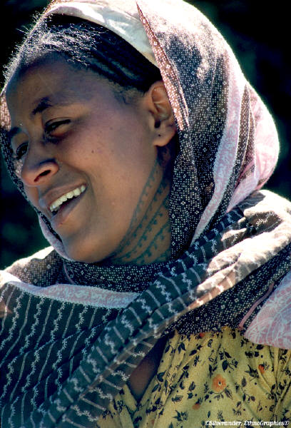
cover your head with a scarf
or a turban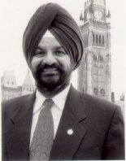 Mr. Mali-1st turbaned MP
MS Clip Artand wash your hands.
Ladies, it is preferred that you wear a skirt or dress, rather than slacks. Do not bring in any tobacco or alcohol into Gurdwara.

Then,
Walk down the center aisle and bow before the Guru Granth Sahib and put a small donation in the collection box.
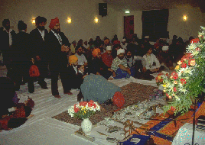 http://faithnet.freeserve.co.uk
Sit cross-legged on the carpet:
Men sit on the right side of the room and Women and small children on the left side.
All people are equal, so no person is placed higher than another.
(Do not sit with your feet out in front of you towards Guru Granth Sahib-that would be disrespectful.)

Someone will bring you food that has been blessed: raisins, cardamom seeds, almonds, MSClipart and something sweet. This is sacred food-please do not throw it away.
Listen to the hymns sung by ragis 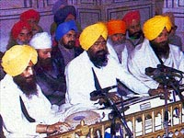 called Kirtan at
http://www.sikh-religion.com/JapGurGopal.mp3
http://www.sikh-religion.com/JapGurGopal.mp3 or watch videos at this website http://www.sikhvideos.org/guru-nanak.htm and hear the prayers, and the scripture recited by the Granthi (reader of scripture) or by the sangat (congregation member).
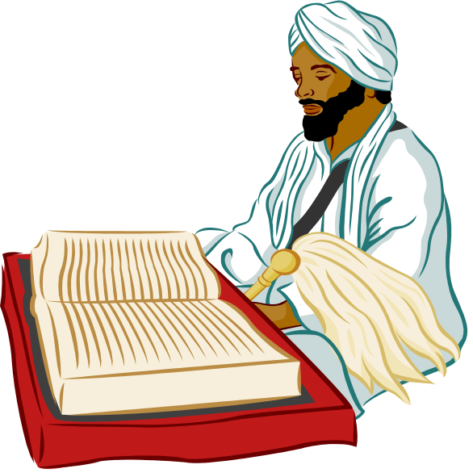MS Clipart

Karah Prasad (flatbread made of flour and clarified butter and sugar) will be given out at the services.
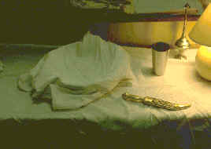
http://www.faithnet.freeserve.co.uk

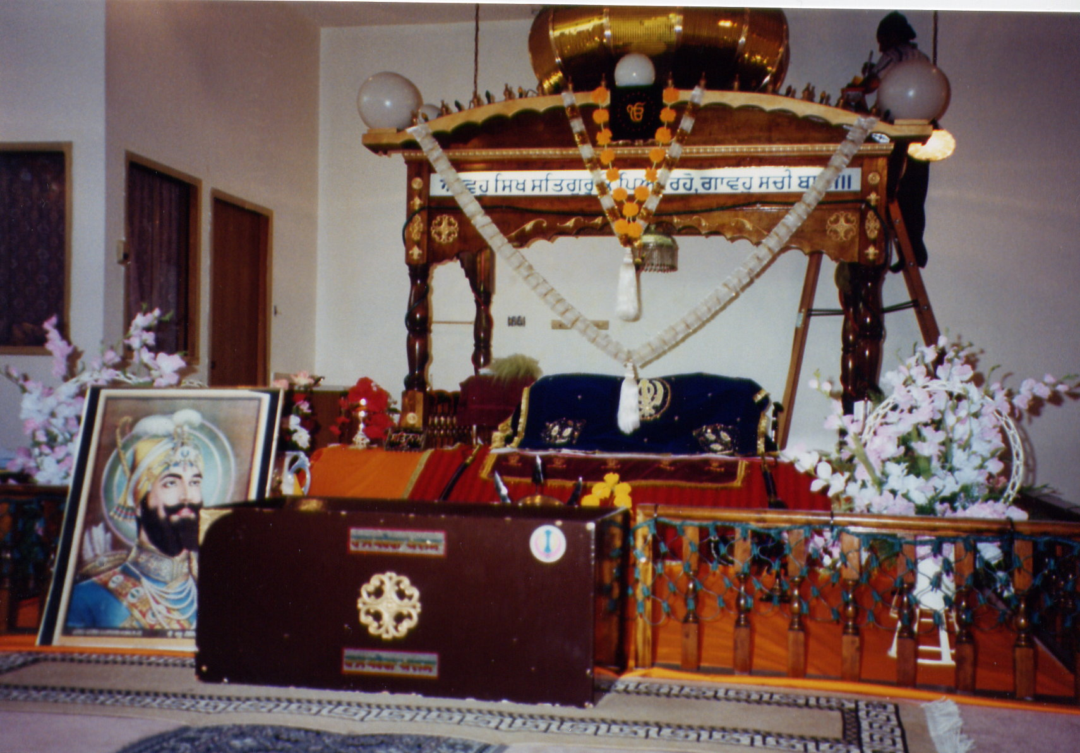

Gurdwara and Guru Granth Sahib
Photo by D.S. Bright June 2002

SRI GURU GRANTH SAHIB

THE BOOK OF

HOLY WRITINGS

The 11th Guru

Guru Granth Sahib is the book of holy writings of six of the gurus and
thirty-six other holy men. It is the last, living Guru. It contains all the thoughts and teachings of the Sikh faith.

Guru Granth Sahib is covered with a cloth called a Rumala.
MS Clip ArtA chauri is waved over Guru Granth Sahib to keep the flies away.

Above it are suspended a canopy and scriptures, and a golden dome which is the crown of Guru Granth Sahib.

The Guru Granth Sahib is placed on a raised platform. Readings from
Guru Granth Sahib are read during services or marriage ceremonies.
At night Guru Granth Sahib is wrapped up carefully and placed in a safe place.

Are you hungry or thirsty?
Langar (free food) is available downstairs in the communal kitchen.
There is chapatti (flatbread), curried peas and carrots, yogurt, and chick peas, and a very sour pickle. Cold water is provided
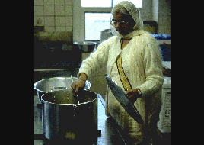
to drink. All the food is served on a

Preparing Langar in the kitchen.
http://www.faithnet.freeserve.co.uk/gurdwara.htm

metal plate, in accordance with what the Guru said to do.
The temple is open at all times, and anyone can enter and get langar and a place to sleep, if need be.
“The Sikhs may be divided into two types viz., 1_Sahjdharis, who do not grow long hair and do not adopt the discipline of five Ks. . . and 2_Singhs or Khalsa or Keshadharis”(Kohli,p.92) who are baptized.
The Baptized Sikh is one who adheres closely to the tenets of the Gurus. He or she will wear the five symbols of the faith:

Kesh—long uncut hair

Kanga—a comb Amolak Singh, produced these pictures
http://www.sikhworld.co.uk

Kacha—undergarments 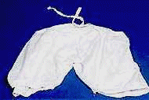

Kirpan—a ceremonial dagger 
Kara—a steel bangle


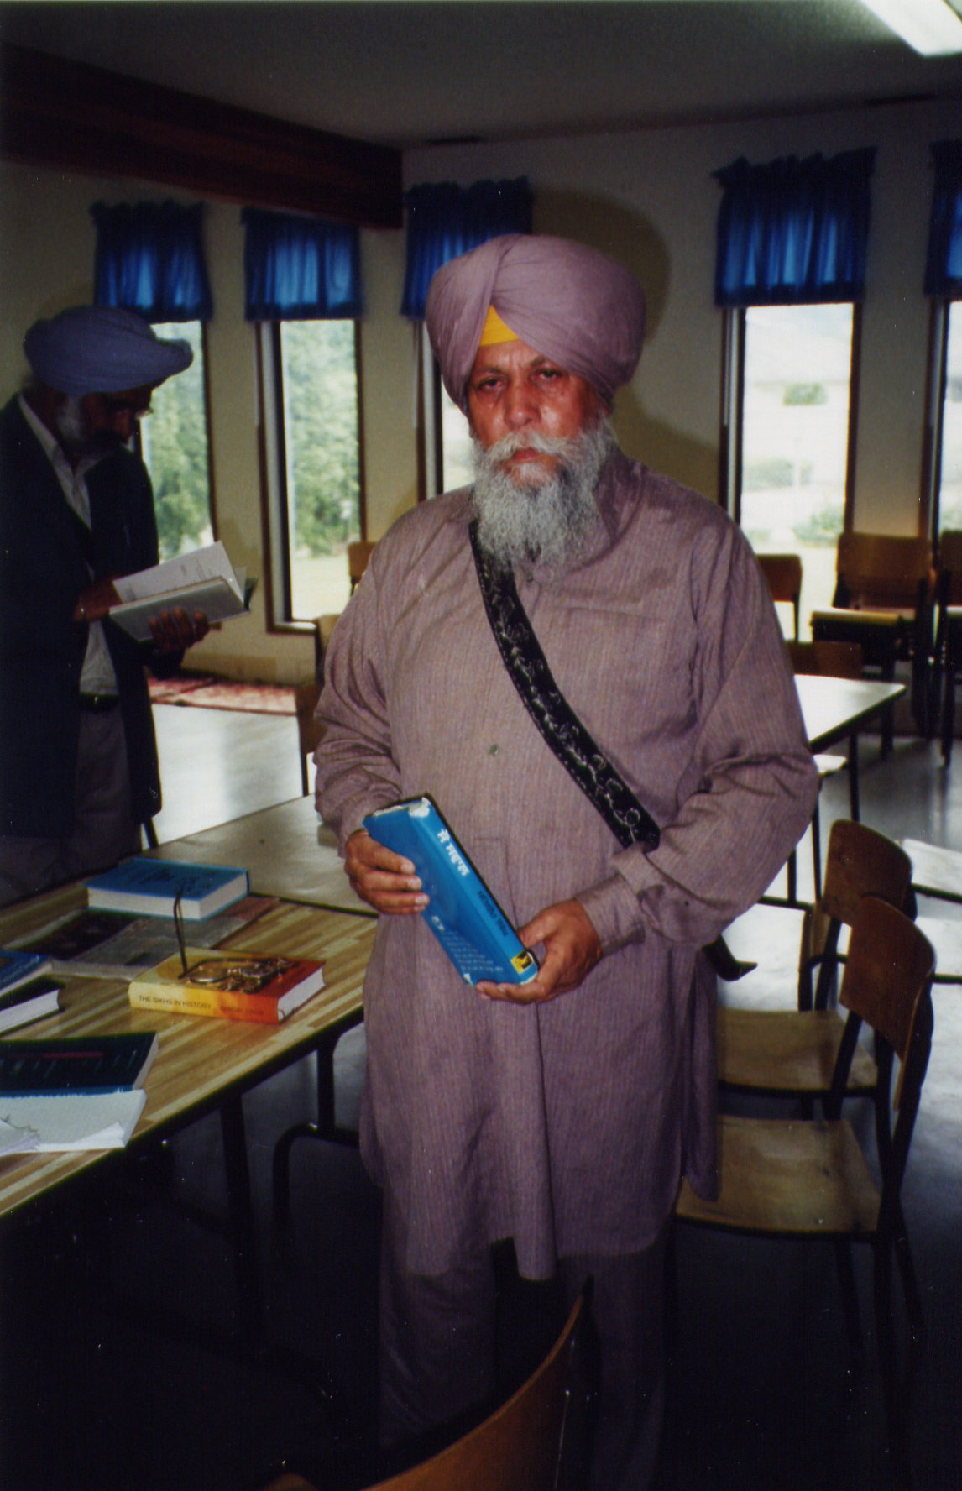

Mr. Amrak Singh Lail, June 2002
Penticton Sikh Temple
Photo by D.S. Bright

Sikh

Family

Life

Family Life

Marriage
Traditionally, marriages are arranged by the parents. However if either the young man or young woman does not want to marry the person who is introduced, the marriage is not forced upon him or her. Parents must provide a dowry for their daughter. If the dowry is poor, then the bride may face chastisement by her in-laws, as not being worthy for their son. The girl’s parents try to find a man who is educated and has a good job, so that their daughter is well-provided for. 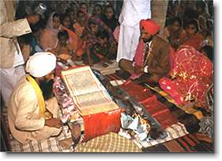www.sikhmatrimonials.com/s/SikhWedding
The marriage ceremony takes place in the temple, or gurdwara. The families of the bride and groom sit close by, and scripture is read from the Guru Granth Sahib and prayers are said. Marriage is seen as a union of two souls. After the prayers, the groom and bride hold a scarf or sheet of cloth and, with the groom in front, walk around the Guru Granth Sahib four times.
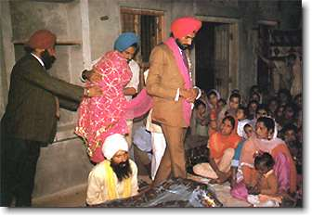 www.sikhmatrimonials.com/s/SikhWedding
Usually a marriage ceremony lasts three or four hours and is followed by a reception. If any alcohol is to be served, then the reception is held at another hall. If no liquor or tobacco is used, then the reception may be held in the hall of the Sikh Temple. (Grewal, C.)
Family Structure in Sikh Religion
Family as a social unit is very important for South Asian families and respectively for Sikh religion. The extended family is comprised by parents and children, grandparents, brothers, sisters, and their families. Those extended families provide an economic and emotional support for individuals. The lifestyle is collective rather than individualistic and continues same even after immigrating to Canada. Family prospers together and earnings are shared even though, sometimes, only one family member is responsible for family’s finances (eldest son or grandmother). (Waxler-Morrison. 1990. p. 150)
Women have the responsibility to take care of ill family members but health care decisions are made based on opinions and support from all family members and, at times, community members (friends, neighbors). Women, in their home country or in Canada, are very supportive of one another taking over duties as caregivers, babysitters, etc.
Man is considered head of the family, major decision-maker and provider. The eldest son in the family is expected to take care of aging parents. In home country this is done relatively easy as large families can share daily responsibilities. In Canada, a young couple may find it hard to do this as usually both of them have to work outside home. Nursing home is considered as last resort for aging parents. (Waxler-Morrison, 1990 p.151)
Within the extended family, elderly have authority and respect. They help to raise grandchildren and counsel the young. Also, they play an important role in arranging marriages. The dowry system, the giving of gifts by the bride’s family to the bridegroom, is still practiced. This can range from jewelry, to household items, appliances, even a car or apartment. Extended families are still favoring marriages with partners from home country as they see a better chance of stability and survival if the partner has a more traditional background. (Waxler-Morrison, 1990 p.151)
The strong cultural pressure on the couple to stay together makes separation and divorce extremely rare in traditional society. The separation is possible in case of physical abuse but initiation of divorce is more likely done by the husband.
Young children are dependent on parents and are not encouraged to attend summer camps or other activities with Canadian children. Also, they do not follow same fixed schedules (bedtime, mealtimes, etc). as Canadian children. Physical punishment (spanking) is a common form of discipline for bad behavior. Teenagers are more strictly controlled by their families than are Canadian teenagers. Parents want children to be well-educated and a high priority is placed on schooling. It can be very upsetting for parents to realize the differences between Canadian school system and the traditional one: children encouraged to voice their opinions, classes conducted in a more relaxed and liberal atmosphere, etc.

Family Planning

Family size is often decided by the husband and, although the number of children is smaller in families living in Canada, sons remain favorites to daughters. The childbirth of baby boy is reason for celebration by the whole family and friends. Pregnancy is considered a normal, healthy state. Women may avoid seeing a physician during pregnancy unless there is serious problem (e.g. abnormality). Other reasons for avoiding health services could be language, being uncomfortable discussing childbirth with strangers, etc. Throughout pregnancy women continue to work as usual, although they may avoid lifting heavy objects. Diet remains the same with only a slight increase in foods like yogurt, butter and milk (cooling foods). (Waxler-Morrison, 1990, p. 171)
Canadian hospital delivery can be stressful event especially for a woman who has previously had children in her home country and is not familiar with western practices. The preference is usually for a natural delivery although forceps and Caesarian section are accepted when properly explained by the physician. During the postpartum period women receive lots of support from family members. Visitors may bring gifts or cash for the child. Women prefer to breast feed unless they are required to return to work in which case they may choose to bottle-feed.

Food Practices
In Canada, eating same foods as in their home country is relatively easy since ingredients are available in stores. Many Sikhs are vegetarians although there are no religious restrictions. The preferred foods are lentils, milk, buttermilk, seasonal vegetables, and fruit. There is no strict definition of hot foods or cool foods. Meat, eggs, and nuts belong to the first category, and butter, milk, yogurt, and some fruit belong to the second category. Hot and cold foods are very important for the health of Sikh people and eating a non balanced diet can cause illness.

Health care practices
In regards to seeking healthcare in Canada, in traditional families, the old ways of making health decisions may persist at least in the initial phase. Families prefer to choose a physician who speaks their language and who is familiar with their culture. The physician is greatly respected and trusted by family members and is expected to prescribe medication.
Birth
During pregnancy prayers may be said to ask for a healthy child, but no special preparations or diet is followed. The birth of a son is greeted with great rejoicing. A daughter’s birth may be greeted with tears. In olden days, daughters may have been the victims of infanticide—especially among poor families who could not afford the dowries for their daughters. When the umbilicus of a baby boy dries and falls off, it is saved as a memento. Often the baby boy will have a chain placed around his middle. The chain will often have a charm or a coin attached so that there is a jingle as he walks. This is supposed to provide protection from evil or provide good luck to the baby boy. Baby girls do not have their umbilicus saved, nor do they have chains placed around them. The babies have a naming ceremony at the temple on the thirteenth day, and the mother bakes Kara Prasad, a flatbread that is then blessed, to be distributed after the ceremony. Every boy is given the name Singh, for he should be brave like a lion. Every girl receives the name Kaur, for she is a princess. “(Grewal, C.)
Small children are mostly cared for by their mother or aunt or grandmother. The children may be told Sakhis, or short stories. 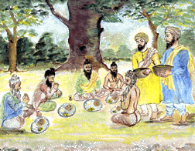http://www.sikhnet.com/s/sakhis

Changing Times
As children grow, there is conflict with the old ways and the new ways. Because of the need for women to work, many have now decided to bottle feed their babies rather than breast feed, as it is more convenient. In school, the children may face teasing from other children if they have long hair, or if they wear turbans. 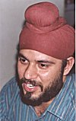 http://www.kamat.com/kalranga/sikhism/
In the Sikh religion, sex before marriage is strictly forbidden, as is dating. However, the young people want to have boyfriends and girlfriends and date, just as their school friends do.
Religious requirements conflict with other rules of Canadian society. Recently a Quebec court upheld a twelve-year-old’s right to wear a Kirpan, a ceremonial dagger, to school. http://www.world-sikh.org/home.htm
The school had forbidden all knives, but the Kirpan was considered an essential part of his belief as one of the five signs of the baptized Sikh.
The family elders may also be upset that the young people are dating or drinking alcohol or smoking, and chastise their son and daughter-in-law. Criticism may also be levied at those who do not encourage the younger generation to go to Punjabi school to learn to read and write Punjabi, or to attend the services at the Sikh Temple.

Work
When the Sikhs first come to Canada, they must often take jobs that do not require English in order to provide for their families. They may work as farmers, or in garment factories, or as housekeepers. Friends in the Sikh community help them find work. As their English improves then they can get more skilled jobs. As the children are educated, they enter all avenues of the labor force i.e. there are Sikh educators, real estate agents, politicians, doctors, nurses, engineers, and police officers. (Grewal, C.)

http://www.world-sikh.org/home.htm

Summary
For the Sikhs, the work ethic and economic activities are located within a religious and socio-cultural context. The work an individual does is part of "being a good Sikh." Sikhs are not afraid of hard physical work, and they will take whatever job they can get until they can find a better one. Since late 1800 they worked hard, saved, paid taxes, bought property, invested wisely, prayed and waited for things to change. When older Sikhs give advice to a new immigrant from India, most of them say that newcomers should try to fit in with other Canadian people, in fashion, hairstyles and attitudes. They should adapt to Canadian ways like other Canadians and leave the problems of India behind them. At the same time, they advise to never forget India. Their other advice is to work hard and save money, be honest and help members of the community, as they did in the early days. They stress the value of learning English, and most of them advise getting a good education. Socializing outside of their own group is very important for new immigrants, since that will help them to gain greater acceptance. Overall, immigrants should try to adopt a flexible lifestyle, avoid living in isolation and mix with other Canadian people. (Waxler-Morrison, 1990 (pp141-180)
Canadians are also adjusting to other cultures. The Canadian government has put forth legislation to ensure Religious observances are allowed in the Charter of Rights. http://www.world-sikh.org/news/press_releases/01-11-07.htm

Implications for
Health-Care

Illness and Health
When someone has an upset stomach, he may drink an herbal tea to settle it. If a doctor is needed, he may prefer one with whom he can communicate. If hospitalization is necessary, the hospital staff may be able to accommodate the person’s needs by asking what their preferences are. A diet choice may be offered of vegetarian dishes or meals with meat from the hospital menu, or food may be brought in from home if it does not conflict with prescribed treatment. Although there are no restrictions with receiving medications or operations or blood transfusions, if a limb is amputated, the Sikhs prefer that it is cremated. Hospital staff should be aware of the importance of the religious symbols of the Sikh religion and not insist on their removal unless absolutely necessary for treatment. Explaining and negotiating procedures and the reasons may reduce conflict with the patient. Interpreters should be called in from the staff list, or from the patient’s spouse. Children should not be used as interpreters as the parents may not want to discuss sensitive matters or problems in front of their children, (Waxler-Morrison, et al. 1990 p.254) or the children may not understand how to interpret certain things or technical procedures.
Family support for the ill person is part of the Sikh culture. Having family members present day and night may interfere with normal hospital procedure, so if possible, a private room should be provided for the patient so that other patients are not bothered. A lounge where the family can go during provision of personal care would also be useful so that normal hospital traffic is not impeded by extra people waiting in the hallways.
Being aware of Sikh women in the community who are new to Canada and who live in rural areas, is the first step to providing health care to them. It was found that “Indian women in Canada. . . have a high incidence of low birthweight babies” (Lynam, J. et al. 1997). How can communities best serve them with prenatal and perinatal care?
Although daughters are valued more now, (Lyman, J. 1997) with the birth of a girl baby, nurses should be aware of potential for depression of the mother and the rejection of the baby. The nurse may also keep the umbilicus if it dries and falls off for the mother to keep as a memento.
If the patient is dying, provisions should be made for the prayers and readings of scripture by the family and temple members.
Because new immigrants are removed from familiar surroundings and families and language, mental problems may arise. The doctors and nurses should be aware of the patient’s background and help by providing links to community support.
Social workers may also be required to promote understanding with problems that arise from children who do not follow the traditional values and their parents’ directives.
Euthanasia is an extremely controversial subject. While some see acts of assisted suicide as granting someone mercy from pain and suffering, others view it as just simply murder. Some European countries, like The Netherlands and Belgium, have legalized euthanasia, the first countries to do so. Perhaps more will continue to do so, but whoever they are will be in complete opposite opinion of the Sikh's. The Gurus regarded suffering as a result of man's Karma. Not having the moral courage to bear suffering without lament is inexcusable. Baptized Sikhs should pray for the grace of God to enable one to put up with pain in a spirit of resignation and surrender. Euthanasia is something that will never be accepted into Sikhism. Sickness and suffering is countered with medical attention and pain alleviation. Leprosariums and hospitals were established by Guru Arjan and Guru Har Rai. Just as euthanasia is prohibited, suicide is also rejected by the faith. It is believed to be interference in God's plan. History shows that many Sikh's faced torture and eventually death by tyrant leaders, even though they could have found relief through suicide. In short, birth and death are prerogatives of God--it is of no business of man to oppose the Divine Will.
In Sikhism, sex is prohibited unless the couple are married. In fact, dating is also virtually unheard of, as the union of two people is only allowed when the appropriate time has come for an arranged marriage to take place. As a nurse or pharmacist, it may be important to remember Sikh couples are married, and nothing else. Homosexuality is also something that is not accepted. If it were present in a family, it would not be recognized, just ignored.
Meat and alcohol are prohibited throughout a baptized Sikh's life. Unnecessary killing or causing suffering to animals for the sake of providing food to humans is to be avoided. Eating meat only for the satisfaction of one's taste or appetite is not good. It is extremely interesting to note that the Gurus did not like the taboo placed on meat when more important things like control over desires or passion were ignored. They felt it to be much more imperative to kill the evil that pollutes the mind rather than abstain from meat. Impurities of the mind should be removed first, and then food may be labelled as pure or impure. However, meat and alcohol are strictly forbidden for baptized Sikhs. On page 1103 of the Adi Granth, Kabir says: “You kill life and call it an act of religion. Then what is irreligion?” This statement is very powerful and applies directly to the events of September 11.

Information Gathering
I tried to telephone the Penticton Sikh Temple to set up an appointment to visit. However the person answering did not speak English and hung up. Then I approached a Sikh co-worker, Cindy Grewal, who said she would go with us to the Sikh temple and explain what was happening. Neil and I agreed to meet Cindy in the hospital parking lot on Saturday morning. We drove together to the temple.
Cindy instructed us to put scarves on our heads, and remove our shoes, and then wash our hands, and to make a small donation to the collection box. We climbed the stairs to the Gurdwara, or place of worship. Cindy answered many questions. She also provided Neil and I with a handout that she had found on Sikhism on the hospital’s Mox library under Religion. She said that it would provide us with the information we required and it was quite accurate. (I had not even been aware that our MOX library contained such information.)
Then Cindy took us to the communal kitchen where we met several gentlemen: Parminder Chhina and his son, Ryan, and an elderly man who was a baptized Sikh, Amrak Singh Lail. As his English was very limited, Cindy acted as interpreter. He answered our questions at length. The other men listened to him with great interest. One said to Neil, “Good question!” Mr. Lail telephoned someone to bring us books about the Sikh religion, and loaned them to us.
Neil and I seemed to garner equal attention and respect—perhaps because he was male and perhaps because I am older? It would be interesting to see what the reaction would have been if we had been the same age.
The men asked if we would like to eat, and took us to get food. Another man refilled our plates as soon as they were becoming empty. We were given such a warm welcome! Mr. Lail also allowed me to take his photograph.
Information was also obtained from the internet. There were many excellent sites that provided very interesting information, and music, and even sermons in Punjabi.
I was amazed to learn how many of the beliefs in the Sikh religion were similar to Christian beliefs. Sikhs believe in only one God, they practice monogamy, they believe in life after death, and they believe that their holy book, the Guru Granth Sahib, is the Living Word of God, much as Christians believe The Holy Bible is the Word of God.
The Penticton Sikh Temple had tables and chairs in their kitchen. Mr. Lail said that in some temples there are no tables and chairs—everyone sits on the carpet. In some cases the people of the temples have had heated discussions and then separated to form a temple which is more in keeping with their beliefs. The temples that have no tables and chairs are indicative of orthodox followers of the Sikh religion. Very few of the people that we saw in the temple were baptized Sikhs. The majority had cut their hair, and the men wore Western clothes. The women dressed in traditional Sikh suits of matching pants, long tunic, and scarf.
I asked Cindy questions afterwards, in a quiet setting. She told me things about difficulties she had encountered in adjusting to Canadian life, how lonely it was being away from her friends and extended family, and health care issues, that she may not have felt comfortable speaking about in front of others.
When gathering information it is important to remember that the setting, or the atmosphere, should be conducive to discussion and free from distractions. However, in a temple, much can be learned by listening and observing, and asking appropriate questions about what one sees and hears. Also if one is open and sincere and interested in learning about another’s culture and religion, the answers will likely be given openly and sincerely

References

a) Websites:

http://photon.bu.edu/~rajwi/sikhism/mansukh1.html

http://www.faithnet.freeserve.co.uk/gurdwara.htm

http://www.kamat.com/kalranga/sikhism/

http://www.lib.ucdavis.edu/punjab/

http://www.sikh-religion.com/Jap/gurGopal.mp3

http://www.sikhs.org/gurmukhi.htm

http://www.srigurugranthsahib.org/

http://www.world-sikh.org/home.htm

References:

American Psychological Association (1994). Publication Manual of the American
Psychological Association Fourth Edition. Washington, DC.
Fletcher, Rev. Gordon. (1994). Religious Practices-Sikhism. Magic Office *Live * Drawers-Files
MOX Library, Interior Health Authority, Kelowna.

Kohli, Surindar, Singh.(1995). Sikhism and Major World Religions. Amritsar. Singh Brothers
Lynam,Judith, Gum, Balbir, Dhari, Ranjit. (2000). Exploring Perinatal Health in Indo-Canadian
Women. The Canadian Nurse, 96(4), 18-24.
Macauliffe, Max Arthur. (1909). The Sikh Religion Its Gurus, Sacred writings and
Authors. Volumes 1 to 6. New Delhi. D.K. Publishers Distributors (P) Ltd.
Waxler-Morrison, N. and Anderson, J., and Richardson, E. Chapter 7 The South Asians. Cross-
Cultural Caring: A Handbook for Health Professionals in Western Canada (1990).
Vancouver, B.C. University of British Columbia Press.

Interviews:
Dhoot, S.
Grewal, Cindy. Cindy is married with two teenage sons. She works as a Long Term Care Aide at
the Penticton Regional Hospital Extended Care Unit.
Lail, Amrak Singh. Caretaker/Reader in the Penticton Sikh Temple.

Appendix #1

Interview Questions

1. What is Sikhism?

2. What are customs that are followed in the Temple?

a) Seating?
b) Roles of men and women as priests?
c) Covering heads?
d) Music?

3. What is the name of the holy book?

4. Why is there a kitchen in here?

5. What are signs of a baptized Sikh for men and for women?

6. Are there any foods that are forbidden?

7. Are there foods that are considered sacred?

8. How have Sikhs adapted to Canada in clothing, holy days, foods, customs?

Birth

1. Are there any special things pregnant women do to ensure a healthy baby?

2. Are there any special things a woman does when she is in labour to ease the pain of

contractions, e.g. relax, scream, drink special teas, water, foods

3. Does a family prefer having sons or daughters? Has this changed by being in

Canada?

4. Are there any special things one does after the baby is born?

a) eat special foods?

b) say certain prayers?
- Bathing or massage?
- Circumcision?
- Umbilicus?
- Breast or bottle?
- Resting or going back to work?
- Naming the baby—special ceremony?
--- named after relatives or not?

i) What role do the grandparents have e.g. advice, help, caring for mother after birth?

Marriage:

- Are marriages still arranged, now that you live in Canada?

- How are they arranged?

- What role does the wife have with her family and her husband’s family?

- Is there much divorce among the Sikhs? Why or why not?

- What happens in the marriage ceremony?

Elderly

1. Who cares for the elderly?

a) Do they enter nursing homes? What would be the conditions?
- If a couple have no sons, who would care for them in their old age?
- What roles do the elderly have as advisors, providing child care, decision making?
- How do the older people view the way you have changed since coming to Canada in following/not following the customs that they hold dear?
Social and political
- Why did you come to Canada?
- What problems have you encountered with:
  - language
  - finding work
  - adjusting to money differences
  - adjusting to transportation differences
  - clothing
  - prejudice or harassment?
  - leaving India?
  - conflict of cultures e.g. youth and dating
  - wearing the ceremonial dagger or turban

Health and Illness
- What do you do to stay healthy?
- Do you smoke or drink alcohol?
- What do you do when you are ill e.g. with influenza
- Do you have any restrictions with medical procedures like biopsies, surgery, blood transfusions, or amputations?

e) What are the attitudes towards homosexuality and sex?
- When someone is dying, what do you do? e.g. prayers, family visits

