**ASSIGNMENT _2 MongoDB**

**Atlanta Population**

1. use db.zipcodes.find() to filter results to only the results where city is ATLANTA and state is GA.

db.zipcodes.find({$and :[{city:"ATLANTA"},{state:"GA"}]})

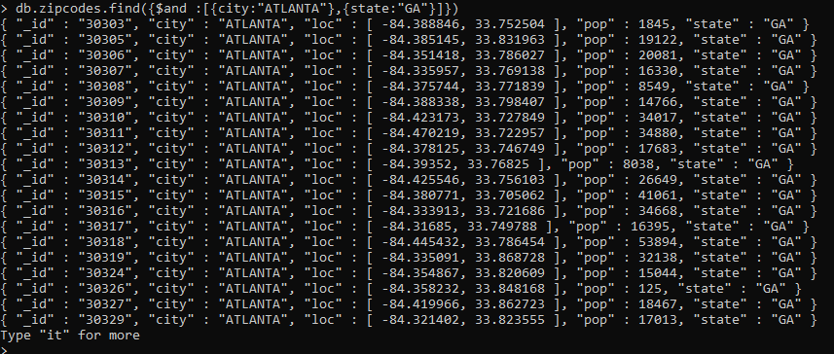

2. use db.zipcodes.aggregate with $match to do the same as above.

db.zipcodes.aggregate([{$match:{$and:[{city:"ATLANTA"},{state:"GA"}]}}])

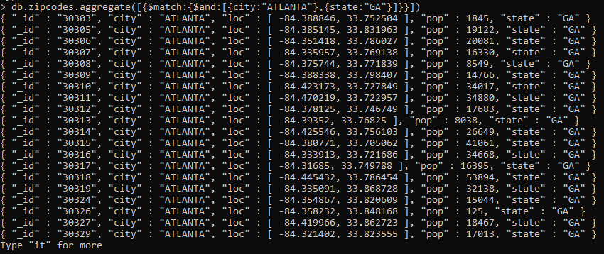

3. use $group to count the number of zip codes in Atlanta.

db.zipcodes.aggregate([{$match:{city:"ATLANTA",},},{$group:{_id:"$city",count:{$sum:1},},},]);



4. use $group to find the total population in Atlanta.

db.zipcodes.aggregate([{$match:{city:"ATLANTA",},},{$group:{_id:"$city","Total Population":{$sum: "$pop"},},},]);



Populations By State

1. use aggregate to calculate the total population for each state

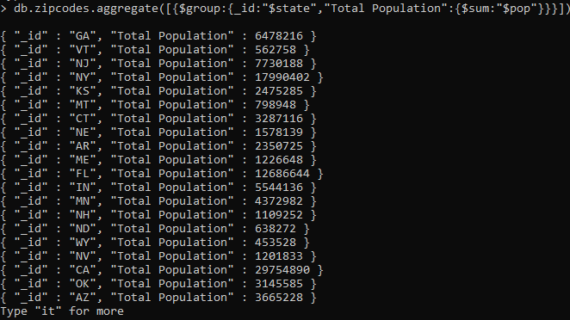

2. sort the results by population, highest first

db.zipcodes.aggregate([{$group:{_id: "$state","Total Population":{ $sum:"$pop"},},},{$sort: {"Total Population":-1,},},]);

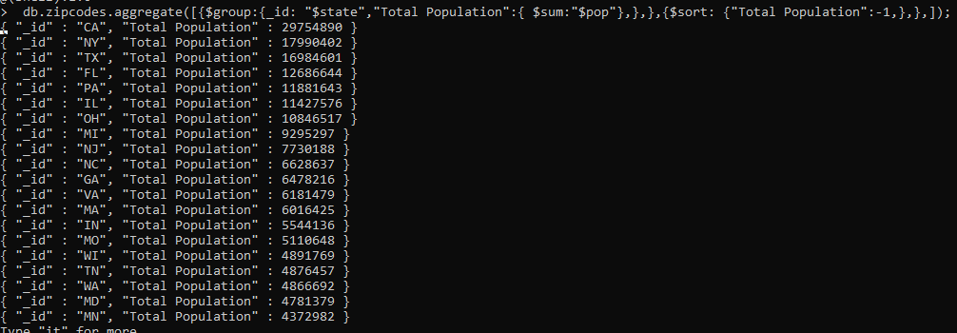

3. limit the results to just the first 3 results. What are the top 3 states in population?

db.zipcodes.aggregate([{$group: {_id: "$state","Total Population":{$sum:"$pop"},},},{$sort:{"Total Population":-1,},},{$limit: 3,},]);



Populations by City

1. use aggregate to calculate the total population for each city (you have to use city/state combination). You can use a combination for the _id of the $group: { city: '$city', state: '$state' }

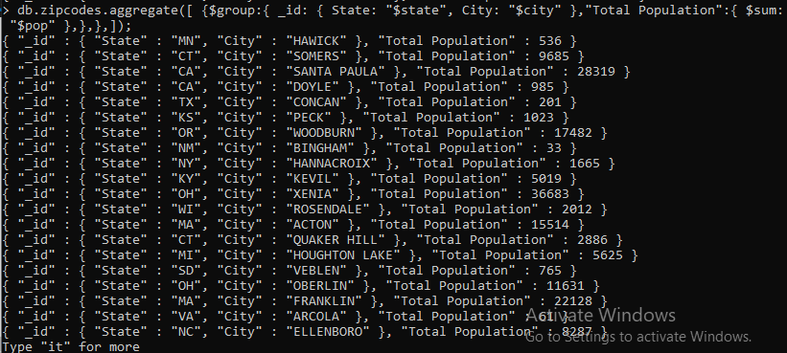

2. sort the results by population, highest first

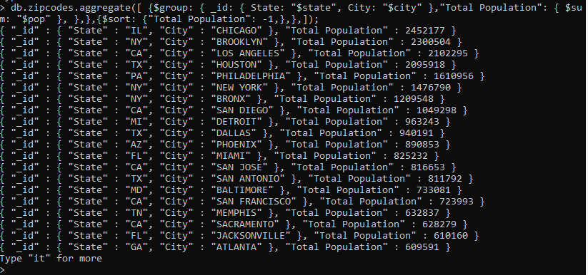

3. limit the results to just the first 3 results. What are the top 3 cities in population?

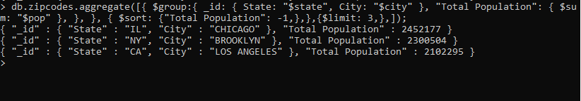

4. What are the top 3 cities in population in Texas?

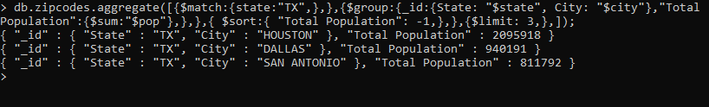

Bonus

1. Write a query to get the average city population for each state.

db.zipcodes.aggregate([{$group:{_id:"$state","Average Population":{$avg:"$pop"}}}])

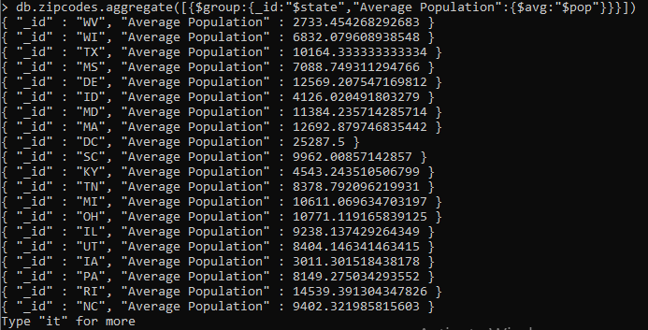

2. What are the top 3 states in terms of average city population?

