**ASSIGNMENT_3**

1. Write a MongoDB query to display all the documents in the collection restaurants.



2. Write a MongoDB query to display the fields restaurant_id, name, borough and cuisine for all the documents in the collection restaurant.

db.addresses.find({},{"restaurant_id":1,"name":1,"cuisine":1,"borough":1})

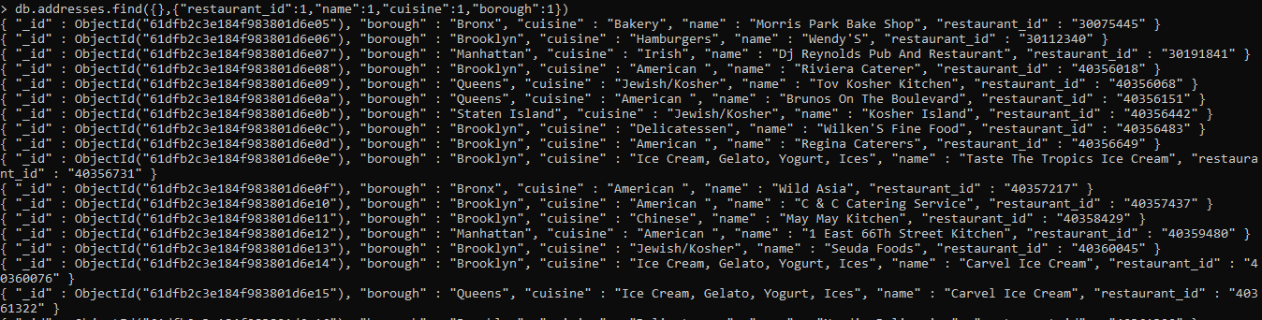

3. Write a MongoDB query to display the fields restaurant_id, name, borough and cuisine, but exclude the field _id for all the documents in the collection restaurant.

db.addresses.find({},{"restaurant_id":1,"name":1,"cuisine":1,"borough":1,"_id":0})

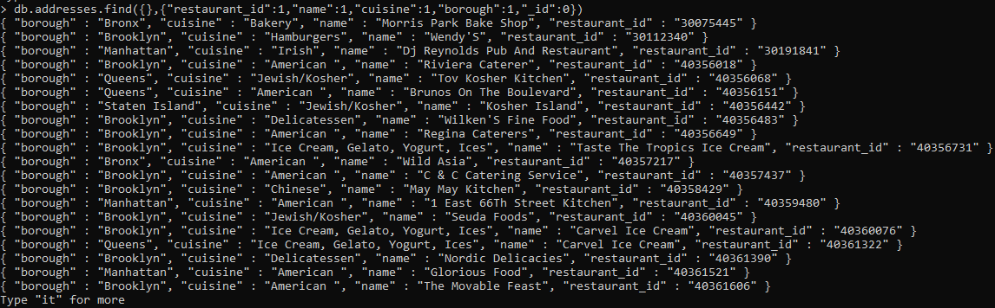

4. Write a MongoDB query to display the fields restaurant_id, name, borough and zip code, but exclude the field _id for all the documents in the collection restaurant.

db.addresses.find({},{"restaurant_id":1,"name":1,"address.zipcode":1,"borough":1,"_id":0})

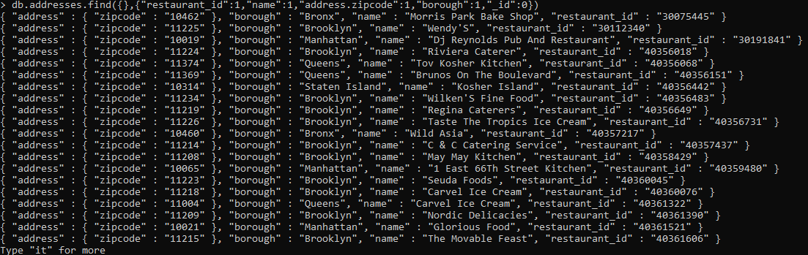

5. Write a MongoDB query to display the first 5 restaurant which is in the borough Bronx.

db.addresses.aggregate([{$match:{"borough":"Bronx"}},{$limit:5}])

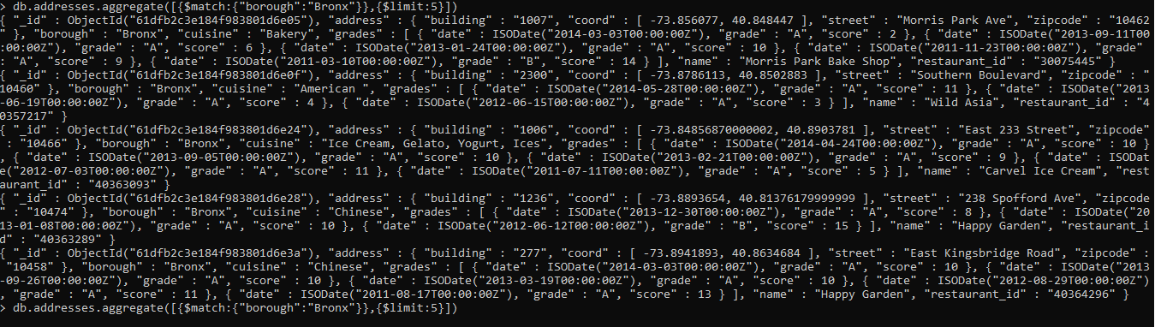

6. Write a MongoDB query to display all the restaurant which is in the borough Bronx.

db.addresses.aggregate([{$match:{"borough":"Bronx"}}])

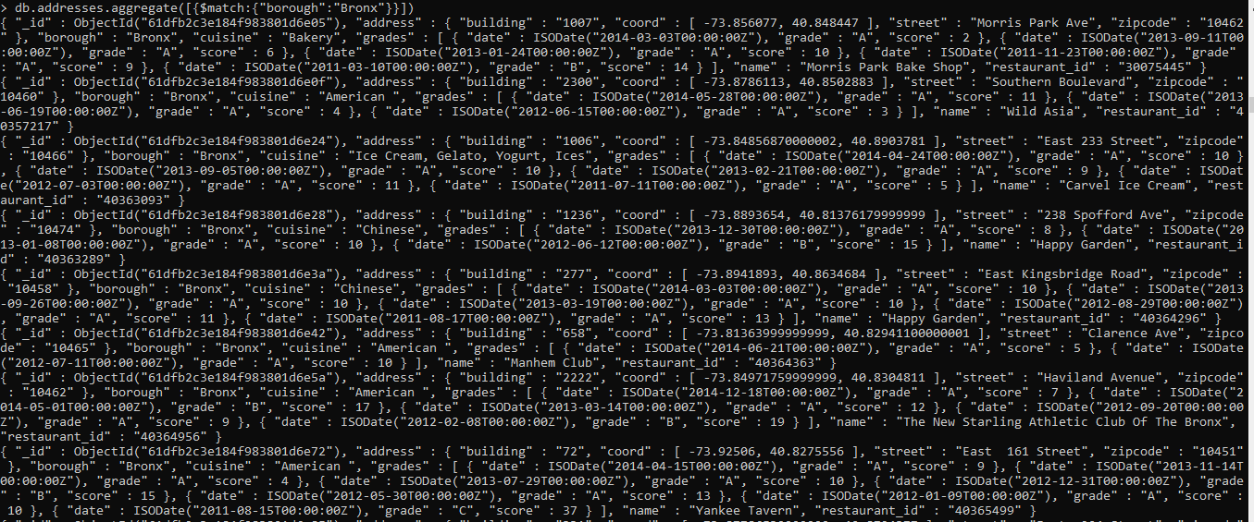

7. Write a MongoDB query to display the next 5 restaurants after skipping first 5 which are in the borough Bronx.

db.addresses.aggregate([{$match:{"borough":"Bronx"}},{$skip:5},{$limit:5}])

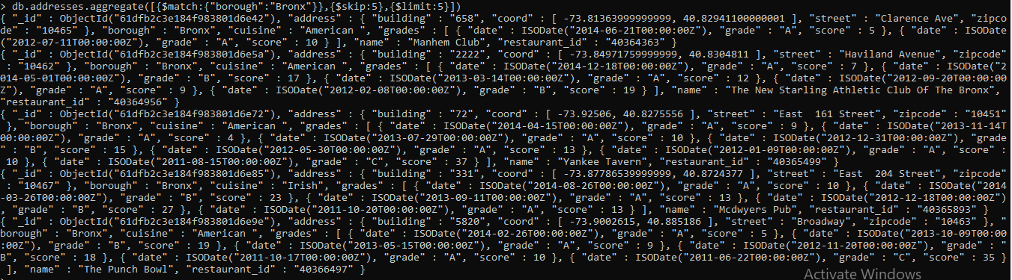

8. Write a MongoDB query to find the restaurants who achieved a score more than 90.

db.addresses.aggregate([{$match:{"grades.score":{$gt:90}}}])

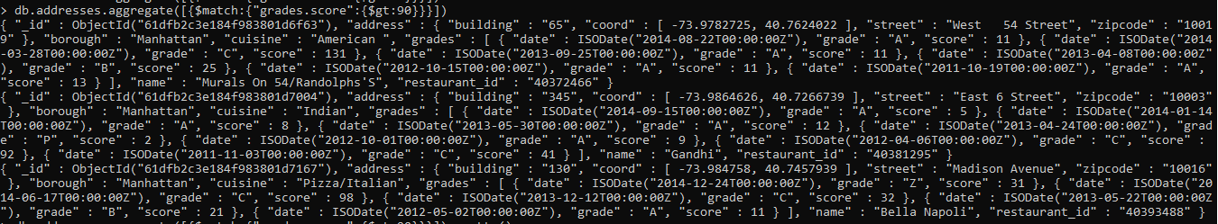

9. Write a MongoDB query to find the restaurants that achieved a score, more than 80 but less than 100.

db.addresses.aggregate([{$match:{"grades.score":{$gt:80, $lt:100}}}])

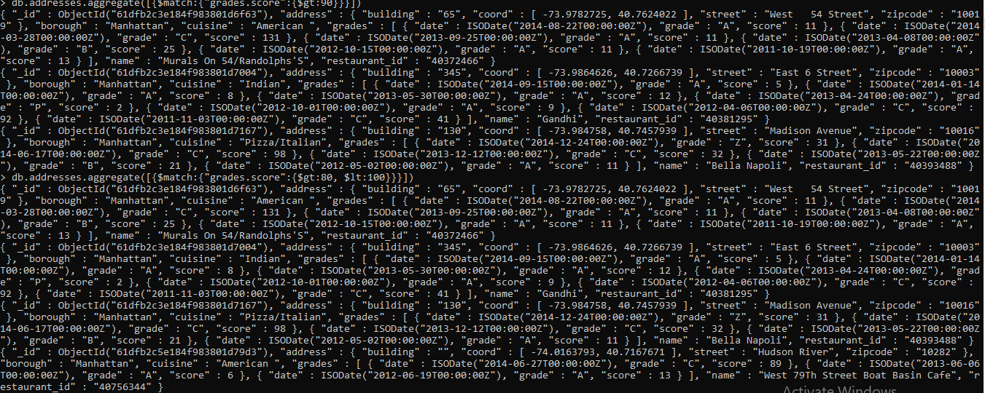

10. Write a MongoDB query to find the restaurants which locate in latitude value less than -95.754168.

db.addresses.aggregate([{$match:{"address.coord.0":{$lt:-95.754168}}}])

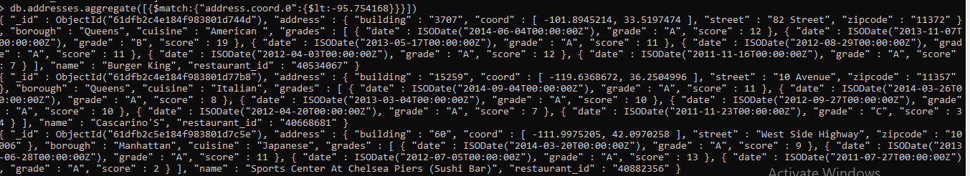

11. Write a MongoDB query to find the restaurants that do not prepare any cuisine of 'American' and their grade score more than 70 and latitude less than -65.754168.

db.addresses.find({$and : [{"cuisine" : {$ne : "American "}}, {"address.coord.0" : {$lt : -65.754168}}, {"grades.score" : {$gt : 70}}]})

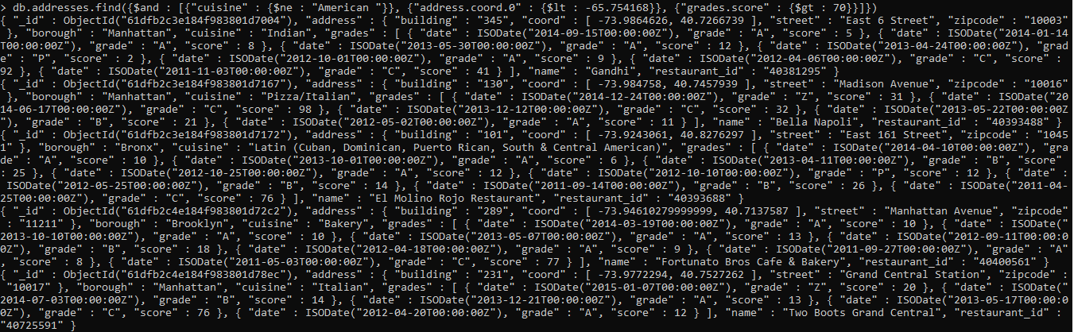

12. Write a MongoDB query to find the restaurants which do not prepare any cuisine of 'American' and achieved a score more than 70 and located in the longitude less than -65.754168.

db.addresses.find({"cuisine":{$ne:"American"},"grades.score":{$gt: 70},"address.coord":{$lt :-65.754168}});

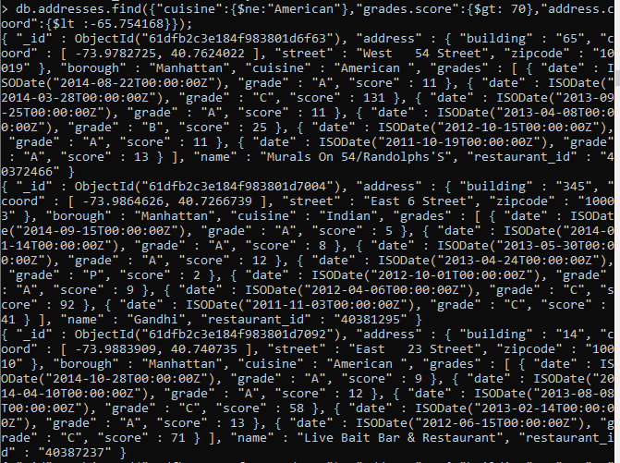

13. Write a MongoDB query to find the restaurants which do not prepare any cuisine of 'American ' and achieved a grade point 'A' not belongs to the borough Brooklyn. The document must be displayed according to the cuisine in descending order.

db.addresses.find({$and:[{cuisine:{$ne:"American"}},{"grades.grade":"A"},{"borough":{$ne:"Brooklyn"}}]}).sort({cuisine:-1})

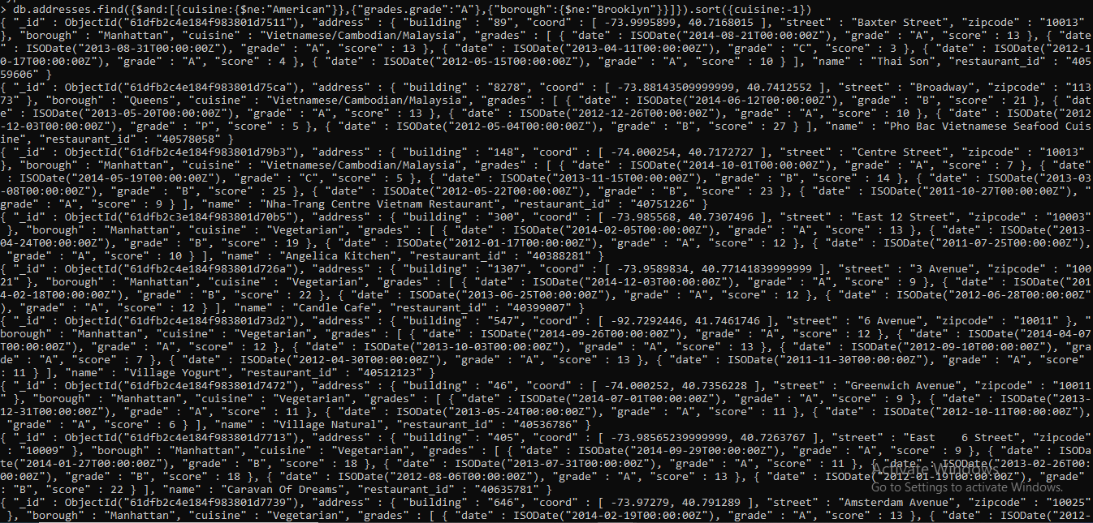

14. Write a MongoDB query to find the restaurant Id, name, borough and cuisine for those restaurants which contain 'Wil' as first three letters for its name.

db.addresses.aggregate([{$match:{name: /^Wil/}},{$project:{name:1,restaurant_id:1,borough:1,cuisine:1}}])

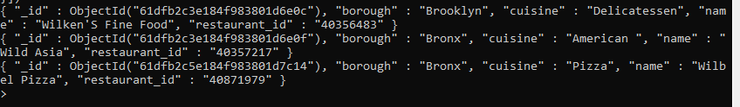

15. Write a MongoDB query to find the restaurant Id, name, borough and cuisine for those restaurants which contain 'ces' as last three letters for its name

db.addresses.aggregate([{$match:{name: /ces$/}},{$project:{name:1,restaurant_id:1,borough:1,cuisine:1}}])

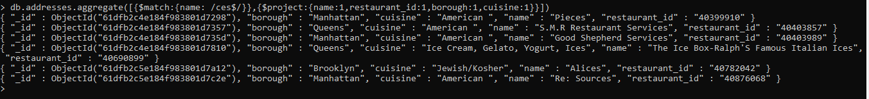

16. Write a MongoDB query to find the restaurant Id, name, borough and cuisine for those restaurants which contain 'Reg' as three letters somewhere in its name.

db.addresses.aggregate([{$match:{name: /Reg/}},{$project:{name:1,restaurant_id:1,borough:1,cuisine:1}}])

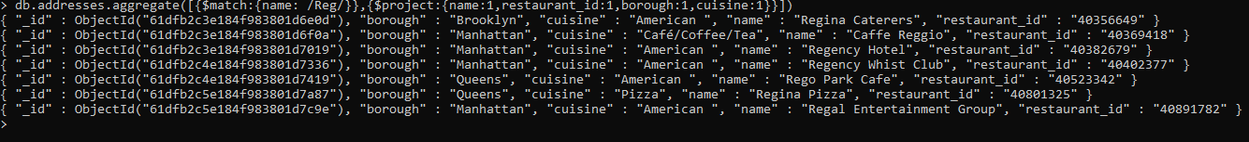

17. Write a MongoDB query to find the restaurants which belong to the borough Bronx and prepared either American or Chinese dish.

db.addresses.aggregate([{$match:{$or:[{cuisine:"American"},{cuisine:"Chinese"}]}},{$project:{name:1,restaurant_id:1,borough:1,cuisine:1}}])

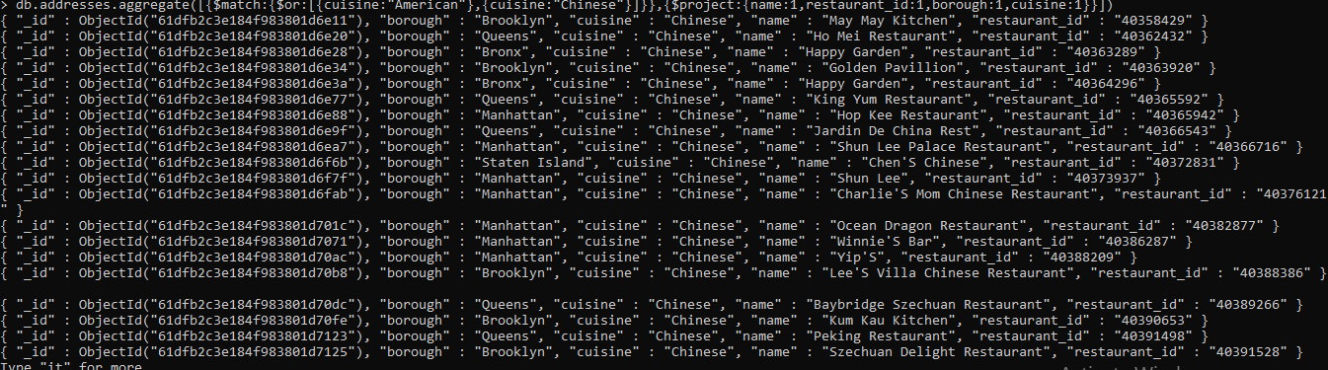

18. Write a MongoDB query to find the restaurant Id, name, borough and cuisine for those restaurants which belong to the borough Staten Island or Queens or Bronxor Brooklyn.

db.addresses.aggregate([{$match:{$or:[{borough:"Staten Island"},{borough:"Queens"},{borough:"Bronx"},{borough:"Brooklyn"}]}},{$project:{name:1,restaurant_id:1,borough:1,cuisine:1}}])

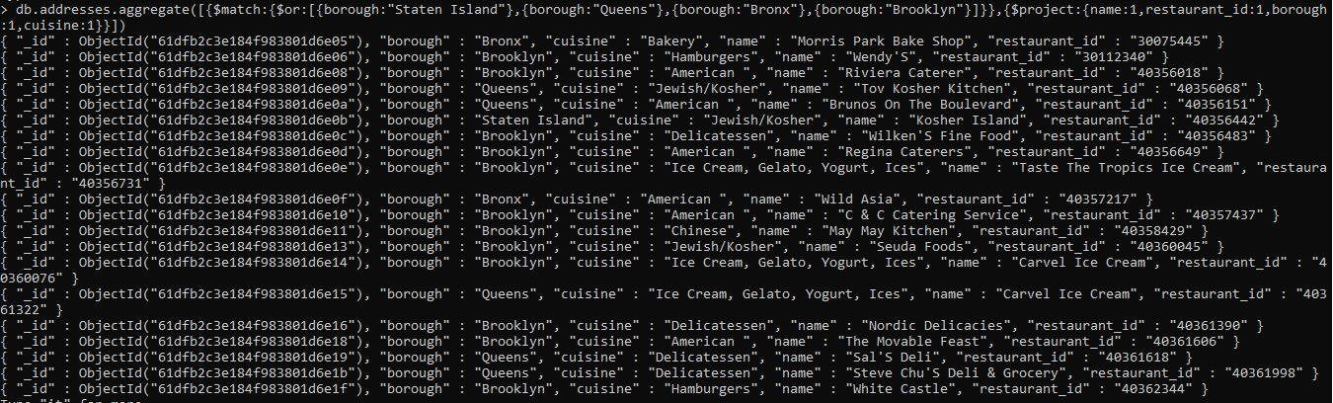

19. Write a MongoDB query to find the restaurant Id, name, borough and cuisine for those restaurants which are not belonging to the borough Staten Island or Queens or Bronxor Brooklyn.

db.addresses.aggregate([{$match:{$or:[{borough:{$nin:["Staten Islan","Queens","Bronx","Brooklyn"]}}]}},{$project:{name:1,restaurant_id:1,borough:1,cuisine:1}}])

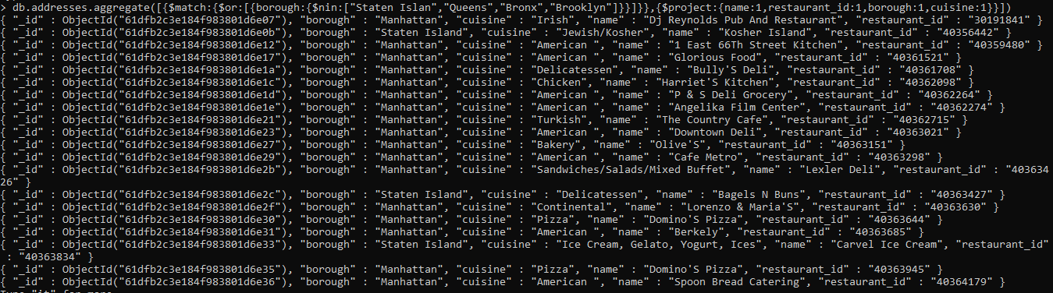

20. Write a MongoDB query to find the restaurant Id, name, borough and cuisine for those restaurants which achieved a score which is not more than 10.

db.addresses.aggregate([{$match:{"grades.score":{$lt:10}}},{$project:{name:1,restaurant_id:1,borough:1,cuisine:1}}])

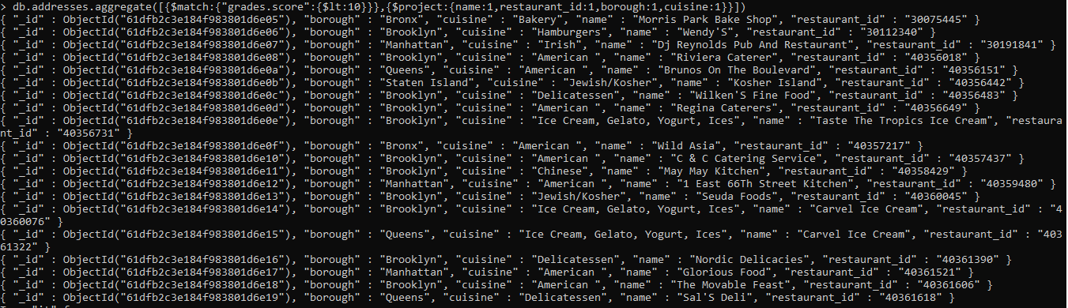

21. Write a MongoDB query to find the restaurant Id, name, borough and cuisine for those restaurants which prepared dish except 'American' and 'Chinees' or restaurant's name begins with letter 'Wil'.

db.addresses.find({$or:[{name:/^Wil/},{"$and":[{"cuisine":{$ne :"American"}},{"cuisine":{$ne :"Chinees"}}]}]},{"restaurant_id" : 1,"name":1,"borough":1,"cuisine":1});

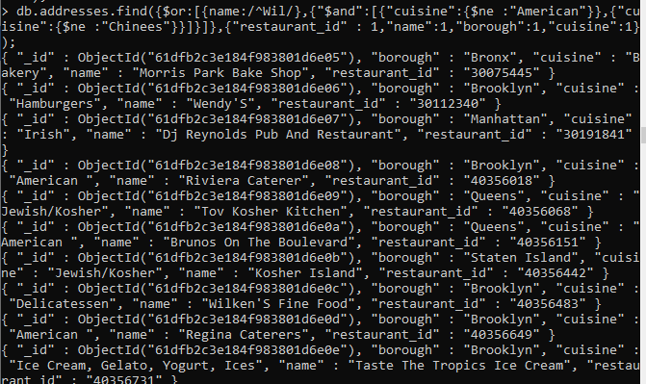

22. Write a MongoDB query to find the restaurant Id, name, and grades for those restaurants which achieved a grade of "A" and scored 11 on an ISODate "2014-08-11T00:00:00Z" among many of survey dates..

db.addresses.aggregate([{$match:{grades: {date: ISODate("2014-08-11T00:00:00Z"), grade:"A", score:11}}},{$project:{restaurant_restaurant_id:1, name:1, grades:1}}])



23. Write a MongoDB query to find the restaurant Id, name and grades for those restaurants where the 2nd element of grades array contains a grade of "A" and score 9 on an ISODate "2014-08-11T00:00:00Z"

db.addresses.aggregate([{$match:{"grades.1": {date: ISODate("2014-08-11T00:00:00Z"), grade:"A", score:9}}},{$project:{restaurarestaurant_id:1, name:1, grades:1}}])

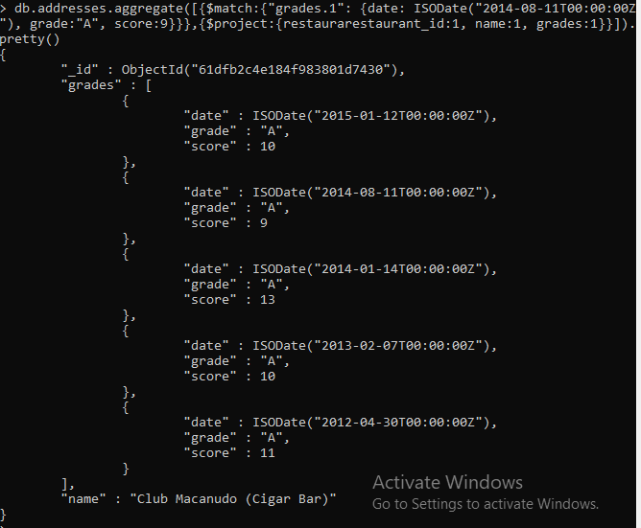

24. Write a MongoDB query to find the restaurant Id, name, address and geographical location for those restaurants where 2nd element of coord array contains a value which is more than 42 and upto 52..

db.addresses.aggregate([{$match:{"address.coord.1": {$gte:42, $lte:52}}},{$project:{restaurant_id:1, name:1,address:1, coord:1}}])

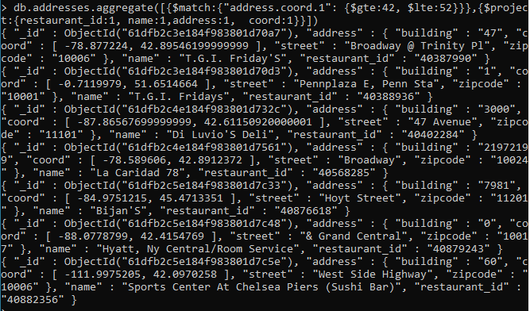

25. Write a MongoDB query to arrange the name of the restaurants in ascending order along with all the columns.

db.addresses.find({}).sort( {name: 1})

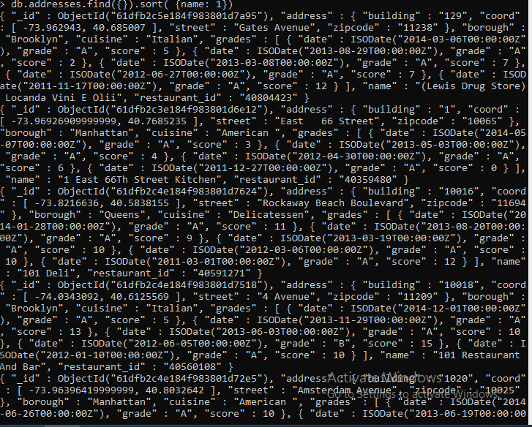

26. Write a MongoDB query to arrange the name of the restaurants in descending along with all the columns.

db.addresses.find({}).sort( {name:-1})

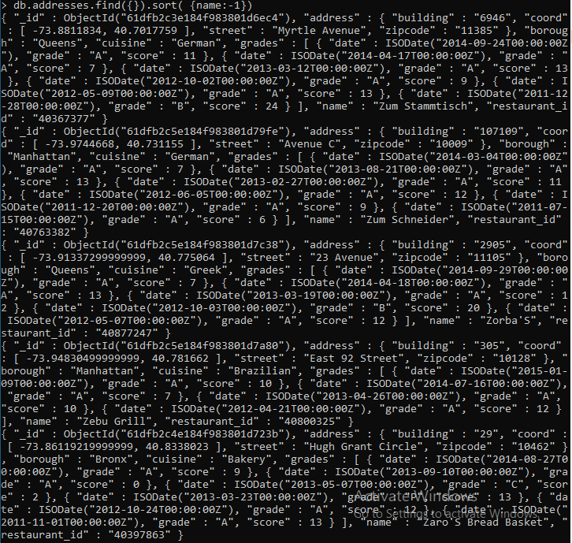

27. Write a MongoDB query to arranged the name of the cuisine in ascending order and for that same cuisine borough should be in descending order.

db.addresses.find({}, {_id:0,name:1,cuisine:1, borough:1}).sort({cuisine: 1, borough: -1})

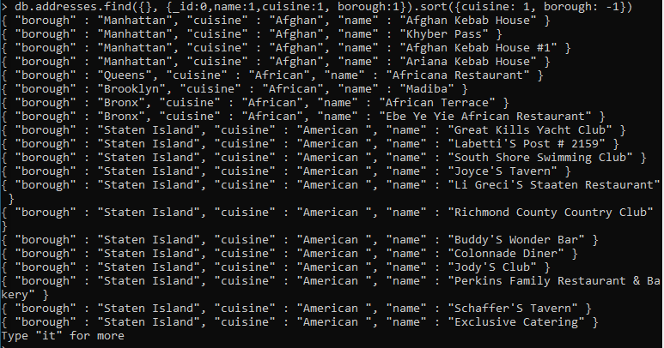

28. Write a MongoDB query to know whether all the addresses contains the street or not.

db.addresses.aggregate([{$match:{"address.street":{$exists:true}}}]).pretty()

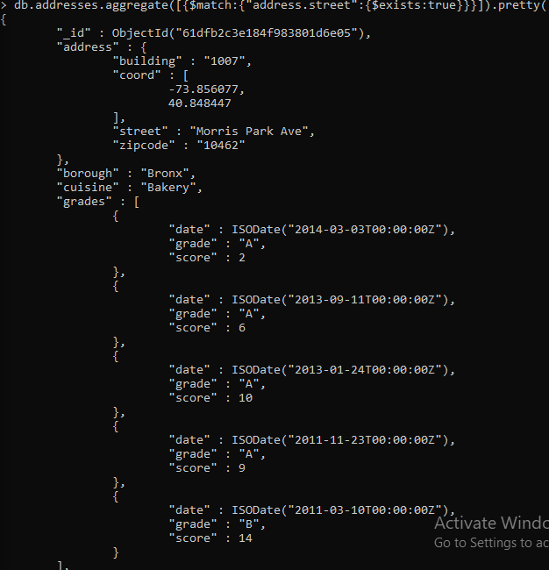

29. Write a MongoDB query which will select all documents in the restaurants collection where the coord field value is Double.

db.addresses.find({"address.coord":{$type :1}});

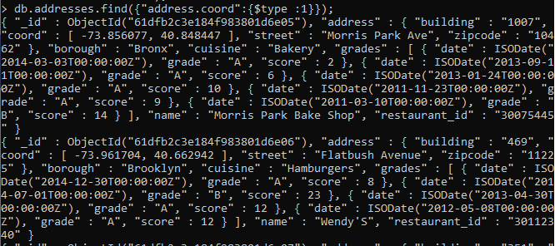

30. Write a MongoDB query which will select the restaurant Id, name and grades for those restaurants which returns 0 as a remainder after dividing the score by 7.

db.addresses.aggregate([{$match:{"grades.score":{$mod:[7,0]}}},{$project:{restaurant_id:1, name:1, grades:1}}])

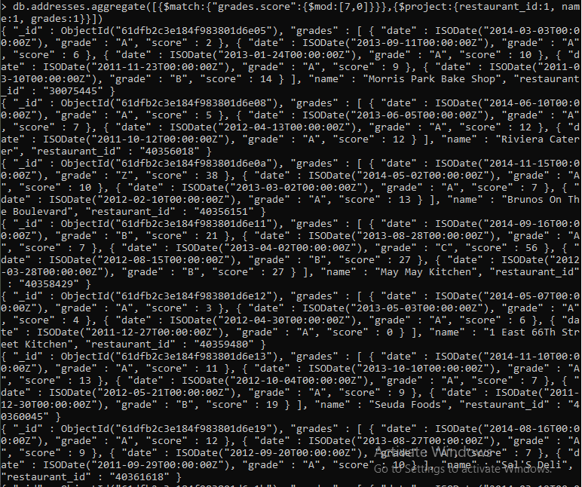

31. Write a MongoDB query to find the restaurant name, borough, longitude and attitude and cuisine for those restaurants which contains 'mon' as three letters somewhere in its name.

db.addresses.aggregate([{$match:{name: /mon/}},{$project:{_id:0,name:1, borough:1,"address.coord.0":1,"address.coord.1":1,cuisine:1}}])

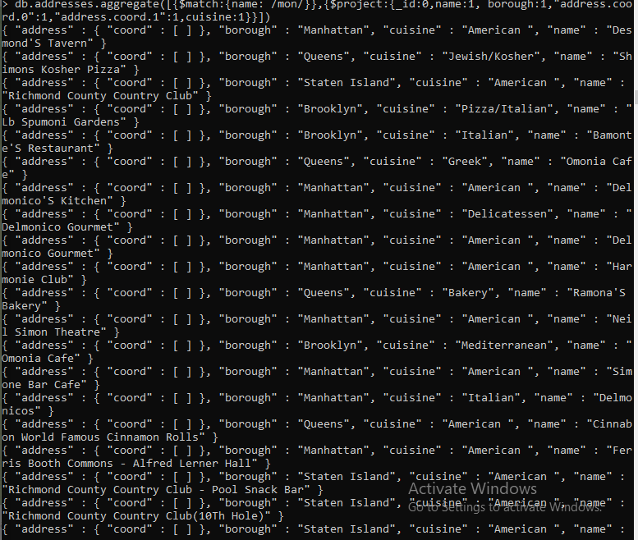

32. Write a MongoDB query to find the restaurant name, borough, longitude and latitude and cuisine for those restaurants which contain 'Mad' as first three letters of its name.

db.addresses.aggregate([{$match:{name: /^Mad/}},{$project:{_id:0,name:1, borough:1,"address.coord.0":1,"address.coord.1":1,cuisine:1}}])

