

MATHEMATICS DIVISION

INSTITUTE OF MATHEMATICAL SCIENCES AND PHYSICS

College of Arts and Sciences

University of the Philippines Los Baños

A MATHEMATICAL MODEL OF AMERICAN FOULBROOD TRANSMISSION THROUGH DRIFTING BEHAVIOUR OF EUROPEAN HONEYBEES (APIS MELLIFERA L.)

**Kieffer Patani Santos**

A SPECIAL PROBLEM SUBMITTED IN PARTIAL FULFILLMENT

OF THE REQUIREMENTS FOR THE DEGREE OF

BACHELOR OF SCIENCE IN APPLIED MATHEMATICS

June 2024

The special problem attached hereto, entitled

**“A MATHEMATICAL MODEL OF AMERICAN FOULBROOD TRANSMISSION THROUGH DRIFTING BEHAVIOUR OF EUROPEAN HONEYBEES (APIS MELLIFERA L.)”,**

prepared and submitted by **KIEFFER PATANI SANTOS** in partial fulfillment of the requirements for the degree of BACHELOR OF SCIENCE IN APPLIED MATHEMATICS is hereby accepted.

**DR. EDUARDO O. JATULAN**

Special Problem Adviser

_____________________________

(Date Signed)

**DR. MARK LEXTER D. DE LARA**

Head

Mathematics Division,

Institute of Mathematical Sciences and Physics

_____________________________

(Date Signed)

Permission is given for the following people to have access to this special problem:

|  |  |
| --- | --- |
| Available to the general public | Yes |
| Available only after consultation with author/SP adviser | No |
| Available only to those bound by confidentiality agreement | No |

# BIOGRAPHICAL SKETCH

Born on August 30, 2001, in Makati City, Kieffer P. Santos is the eldest child of Antonio P. Santos and Ruth P. Santos, and sibling to Seymour P. Santos, Calahan P. Santos, and Austein P. Santos. Growing up, he received his primary education at Golden Lampstand Grade School in San Pedro, Laguna, followed by his secondary education at Immaculate Heart of Mary School, also in San Pedro. In September 2020, Kieffer embarked on his academic journey at the University of the Philippines Los Baños (UPLB), where he pursued a degree in BS Applied Mathematics. With a keen interest in mathematical applications, Kieffer is committed to leveraging his education to contribute meaningfully to his field and beyond.

KIEFFER P. SANTOS

# ACKNOWLEDGEMENT

I would like to express my heartfelt gratitude to several individuals who have contributed to my academic journey and the completion of this degree.

First and foremost, I extend my deepest appreciation to my parents, Antonio P. Santos and Ruth P. Santos, for their support and efforts throughout my education.

I am also grateful to my siblings, Seymour P. Santos, Calahan P. Santos, and Austein P. Santos, for their constant encouragement and understanding.

Additionally, I would like to thank the faculty and staff of Golden Lampstand Grade School and Immaculate Heart of Mary School for their dedication to nurturing my academic growth during my formative years.

Also, I am indebted to the University of the Philippines Los Baños (UPLB) for providing me with the opportunity to pursue my passion in Applied Mathematics and for fostering an enriching learning environment. I am particularly grateful to my special problem adviser, Sir Eduardo O. Jatulan, whose guidance, expertise, and mentorship have been invaluable in shaping my academic and personal development.

Furthermore, I would like to express my appreciation to my dear applied math friends Rhencis, Axl, JB, Chen, and others, whose camaraderie and encouragement have provided invaluable assistance throughout my academic journey. Their presence has made the challenges more manageable and the successes more meaningful.

I am deeply grateful to my dormmates Joshua and Kurt, whose friendship and companionship have significantly enriched my university experience. In particular, I want to express special appreciation to my best friend Joshua, whose dependable support and brotherhood have been a constant source of joy and strength throughout my academic journey. Their companionship has truly enriched my university experience, creating lasting memories and a sense of belonging that I will always cherish.

Finally, I extend my deepest gratitude to Denise, my girlfriend, whose unwavering love, understanding, and encouragement have been the cornerstone of my academic journey. Her steadfast support has not only been a source of inspiration but also a driving force behind my achievements.

Each of these individuals and institutions has played a significant role in shaping my academic and personal development, and for that, I am truly grateful.

To the ALMIGHTY FATHER, thank you for the guidance you gave me and to my prayers that you answered. I love you all.

# ABSTRACT

KIEFFER P. SANTOS, University of the Philippines Los Baños, June 2024

**A MATHEMATICAL MODEL OF INTER-COLONY SPREAD OF AMERICAN FOULBROOD IN EUROPEAN HONEYBEES (APIS MELLIFERA L.)**

**Major Professor: Eduardo** **O. Jatulan**

American Foulbrood (AFB) poses a significant threat to European honeybee colonies worldwide, impacting bee health and apiary productivity. This study aims to deepen our comprehension of the inter-colony transmission dynamics of AFB among European honeybee colonies by developing a comprehensive compartmental model. Incorporating influential factors such as bee drifting between colonies, the model offers a nuanced exploration of disease ecology in honeybee communities. The research highlights that while a source colony initiates infection, the receiving colony exhibits a higher peak of infected bees, elevating the risk of disease transmission to neighboring colonies. The findings suggest that bee drifting may delay the onset of infection in broods within a colony but will not mitigate its severity. Furthermore, simulations indicate that a combination of lower drift rates and higher rejection rates delays the onset of brood infection in the receiving colony while accelerating it in the source colony. Additionally, infected broods are found to have a more significant impact on colony health than infected adult bees, warranting further study. The simulations show that lower contamination caused by these two factors—hygienic behavior of adult bees and beekeeper cleaning habits—significantly delays the onset of brood infection, emphasizing their critical role in managing AFB outbreaks. This research significantly advances our understanding of disease ecology in honeybee populations, crucial for sustainable beekeeping practices and honeybee population preservation.

**Mathematics Subject Classification (2020):** 92-10, 92B05, 92D25, 92D30, 92D50

**Keywords:** American Foulbrood (AFB), European honeybees (*Apis mellifera L.*), epidemiology, population dynamics

# INTRODUCTION

American Foulbrood (AFB), caused by *Paenibacillus larvae*, is a devastating disease primarily targeting the brood of honeybee colonies, especially during the pre-pupal and pupal stages. Characteristic symptoms include sunken cappings and a foul smell, with the disease spreading through robbing, drifting bees, and human activities [1, 6, 18]. The infection process begins when larvae ingest spores, which germinate and proliferate within their midgut, leading to larval death [6]. The resilience of AFB spores, which can remain viable for over 50 years, underscores the necessity for preventive measures and prompt action [6]. The transmission of AFB among bee colonies also occurs through extracted honey supers, transfer of brood and honey frames, and other contaminated hive parts [18]. Additionally, factors such as robbing, drift, and the introduction of infected queens and package bees can facilitate the spread of AFB within and between apiaries [18]. It is important to note that AFB infections do not stem from just a single bacterial spore; instead, it typically takes millions of spores to successfully infect larvae within a colony [18]. This means that with an insufficient load of spores, drifting behavior will not significantly contribute to the spread of AFB [10]. In natural environments, robbing typically occurs during periods of food scarcity. However, in this study, we assume sufficient food availability, thus excluding robbing as a significant factor in AFB transmission.

Globally, AFB remains a significant threat to apiculture, with outbreaks leading to substantial economic losses for beekeepers [1]. In the Philippines, AFB has been found to widely infect colonies of *Apis mellifera* (European honeybee), leading to considerable concern among apiculturists. This disease not only devastates European honeybee colonies but also poses a risk to the native *Apis cerana* (Asian honeybee), which, although somewhat resistant, can still suffer from outbreaks under certain conditions. Recent studies have delved into understanding the disease dynamics in honeybee populations. Datta et al. [5] studied the 2010 AFB epidemic on Jersey Island using a spatial SIR model with an owner network, applying a Markov chain Monte Carlo (MCMC) scheme to determine parameters and infection times. They found that both distance- and owner-based transmissions contributed to AFB spread. Validation with a stochastic SIR model showed consistent infection levels. Their analysis indicated that earlier inspections reduced epidemic size and increased the likelihood of AFB eradication. Meanwhile, Jatulan et al. [11] developed a mathematical model to analyze the intra-colony spread of AFB in European honeybees. Their compartmental (SI framework) model predicted that untreated AFB infection leads to colony collapse. They identified infection thresholds based on equilibrium states' stability and emphasized the number of infected cell combs as a key factor driving disease spread. Betti et al. [2] developed a mathematical model to predict colony fate by linking disease spread dynamics with colony demographics, highlighting the critical roles of transmission and disease-induced death rates. Interestingly, increased disease severity might enhance colony survival, whereas early infection, especially within 20 days before winter, significantly harms colony health. Their model identifies hive bee recruitment age as an early survival indicator and notes that infectious diseases pose greater threats to colonies than environmental hazards like pesticides. Gavina et al. [9] examined the strategic placement of eusocial bee colonies to address forager competition and suboptimal crop pollination due to limited nectar and pollen sources. They suggested that optimal beehive distribution could mitigate these issues. Using linear programming, they developed models that considered factors like beekeeper preferences, colony numbers, colony strength, plant cluster carrying capacity, and apiary spatial orientation. Betti and Shaw [3] created a multi-scale mathematical model to address inter-colony disease spread in honeybee populations. They found that increased forager and drone drift accelerates disease transmission, highlighting the importance of effective guarding behavior. Their study also identifies specific behaviors in certain conditions, suggesting further research into extending the model to entire apiaries and exploring the evolutionary aspects of honeybee behavior. Goodwin et al. [10] investigated the role of drifting honey bees in spreading American foulbrood (AFB) infections, finding that drifting bees from lightly infected colonies do not significantly contribute to AFB transmission. Instead, the study suggests that factors such as robbing may play a more significant role in the spread of the disease, highlighting the importance of thorough inspection techniques for managing and preventing AFB outbreaks. But Šekulja et al. [23] examined the drifting behavior of honey bees and its role in spreading AFB. It found that while drifting was common and did not differ significantly between infected and healthy colonies, bees from infected colonies carried higher levels of *Paenibacillus larvae* spores. This suggests that drifting contributes to the spread of AFB, particularly during the orientation flights of young bees. Additionally, Khoury et al. [13] focused on forager death rates' impact on colony failure, and Prado et al. [15] explored honeybee lifespan dynamics. Given the findings of Goodwin et al. and Šekulja et al. that drifting behavior contributes to the spread of AFB, this paper will focus on understanding and mitigating drifting as a key factor in disease management. By examining the mechanisms and impacts of drifting, we aim to develop strategies to control AFB spread, thereby improving the health and sustainability of honey bee populations.

The primary objective of this study is to develop a compartmental model (SI model) to investigate the dynamics of inter-colony spread of AFB in European honeybee populations, aiming to incorporate key factors such as drifting rate, effectiveness of drifting bees in integrating into other colonies, and return rate of unsuccessful drifting bees into the model to comprehensively capture AFB transmission dynamics between honeybee colonies. To the best of our knowledge, this represents the first mathematical model addressing inter-colony AFB transmission. Through analysis and numerical simulations, the study seeks to identify factors influencing the spread of AFB and assess the accuracy and effectiveness of the model. The significance of the study lies in its comprehensive analysis of AFB transmission dynamics, providing insights crucial for devising effective disease management strategies and safeguarding the economic viability of beekeeping operations. Additionally, the study's implications extend to biodiversity conservation, public health, and scientific research, highlighting its importance in addressing a pressing threat to honeybee populations and the ecosystems they support. While the study focuses on understanding the influence of factors like colony density, bee movement, behaviour, and health on AFB transmission dynamics and offers insights into long-term AFB exposure effects and critical control points for mitigating epidemics, it acknowledges limitations inherent in mathematical modeling, including simplifications and data availability constraints, which may affect the accuracy and generalizability of findings to real-world scenarios. Therefore, it's important to exercise prudence when applying the findings of this study to practical beekeeping and disease management practices.

# METHODOLOGY

## Main Assumptions

In this model, we assume that the two colonies are maintained within a controlled environment where food resources are abundant and consistently available, thereby eliminating the possibility of robbing behavior among the bees. This controlled setting ensures that competition for resources does not influence bee behavior, focusing the study on other dynamics. Additionally, it is presumed that there are sufficient spores present for an infected adult bee to effectively transmit American Foulbrood (AFB) within and between colonies. Due to the continuous interaction within the hive, we do not differentiate between house bees and forager bees, treating them collectively as adult bees. This simplification allows for a more streamlined model, focusing on the overall dynamics of the adult bee population without needing to account for the specific roles of individual bees. Brood can become infected through two primary pathways: either through feeding by spore-carrying adult bees or when eggs are laid in an infected cell comb. The queen's egg-laying rate is assumed to be dependent on the adult honeybee population, reflecting the natural regulation of reproduction based on colony size and health. Furthermore, we assume that 30% of the adult bee population comprises potential foragers capable of drifting. In this model, guard bees do not kill the drifting foragers but instead reject them. Rejected drifters face two possible outcomes: they may either return to their original colony or become lost within the model's dynamics, failing to reintegrate into any colony.

## Mathematical Model

This mathematical model builds upon the model presented in Jatulan et al.’s paper [11] by incorporating an inter-colony interaction. Specifically, it focuses on modeling two colonies, designated as Colony 1 and Colony 2, to illustrate how different behaviours impact disease transmission between colonies, specifically the drifting behaviour. The mathematical model for Colony 1 is given by the following system:

|  |  |
| --- | --- |
|  | (1) |
|  | (2) |
|  | (3) |
|  | (4) |
|  | (5) |
|  | (6) |

The dynamics of Colony 2 exhibit similarities to Colony 1, albeit with distinct subscripts of the state variables and parameters , , , , , and . The dynamics of Colony 2 are governed by the following system:

|  |  |
| --- | --- |
|  | (7) |
|  | (8) |
|  | (9) |
|  | (10) |
|  | (11) |
|  | (12) |

The drifting component's dynamics are governed through the following system:

|  |  |
| --- | --- |
|  | (13) |
|  | (14) |
|  | (15) |
|  | (16) |

From the equations, the following terms , are the number of eggs that a queen can produce per day, , and are the probability that a brood will come into contact with spore-carrier adult bees. Additionally, represents the number of broods that can be infected by spore-carrier adult bees per day. The parameters introduced, not originally in Jatulan et al.’s paper [11], include and , representing the drifting rate of honey bees times the percentage of their foragers; and , indicating the rejection rate of drifting honey bees not accepted by the other colony; and finally and , signifying the return rate of drifting adult bees to their original colony upon failure to integrate into the other colony.

The other key parameters that are in Jatulan et al.’s paper [11], together with the new added ones are presented in **Table 1**.

Table 1. Significant parameters utilized in the model.

|  |  |  |  |
| --- | --- | --- | --- |
| **Parameters** | **Description** | **[Range], Default Value** | **Reference** |
|  | The queen’s maximum laying rate per day | , | [11, 12, 17] |
|  | A coefficient that influences the rate at which the term approaches as the number of adult bees in a colony gets large [13] |  | [11, 13] |
|  | The rate at which broods are infected by colony spore-carrying adult bees | , | [11] |
|  | The rate at which adult bees become infected by the infected cell | , | [11] |
|  | The rate at which adult bees become infected upon contact with spore-carrier adult bees | , | [11] |
|  | The rate at which broods become immune with the spores |  | [11], calculated from [14] |
|  | The rate at which immune broods become adult bees |  | calculated from [14] |
|  | The death rate of infected broods | variable, | [11, 14] |
|  | The rate at which a diseased dead brood is cleaned by adult bees | variable, | [11, 14] |
|  | The maximum number of cells in the colony |  | [11] |
|  | The percentage of clean cell combs that will be contaminated by AFB spores |  | [11] |
|  | The death rate of adult bees (both spore-carrier and spore-free) |  | [11] |
|  | The rate at which honeybees drift multiplied by the percentage of foraging honeybees | , , * | calculated from [20] and [23] |
|  | The rejection rate of drifting honeybees that are not accepted by the receiving colony |  | [19] |
|  | The rate at which drifting adult bees return to their original colony after failing to integrate into the other colony | , | [14, 15] |

*the subscript representing the two colonies.

*~1% drift rate [23] x ~30% are foragers [20]

In the model, we examined 16 state variables (see **Table 2**), with parameter details provided in the previous table, **Table 1**. We applied the Susceptible-Infectious (SI) framework to depict the transmission of American foulbrood (AFB) among broods and adult bees between colonies.

Table 2. Description of the state variables.

|  |  |
| --- | --- |
| **Variables** | **Description** |
|  | The number of infected broods in colony 1 |
|  | The number of healthy broods in colony 1 before hours old ( depends on the susceptibility of bees) |
|  | The number of healthy broods in colony 1 beyond hours old |
|  | The number of infected cell combs in colony 1 (due to diseased dead brood) |
|  | The number of adult bees with AFB spores in colony 1 |
|  | The number of adult bees without AFB spores in colony 1 |
|  | The number of infected broods in colony 1 |
|  | The number of healthy broods in colony 2 before hours old ( depends on the susceptibility of bees) |
|  | The number of healthy broods in colony 2 beyond hours old |
|  | The number of infected cell combs in colony 2 (due to diseased dead brood) |
|  | The number of adult bees with AFB spores in colony 2 |
|  | The number of adult bees without AFB spores in colony 2 |
|  | The number of infected adult bees from colony 2 that drift into colony 1 |
|  | The number of adult bees from colony 2 that drift into colony 1 |
|  | The number of infected adult bees from colony 1 that drift into colony 2 |
|  | The number of adult bees from colony 1 that drift into colony 2 |

To be able to come up with equations, it is important to identify the relationships among the established variables and parameters. **Figure 1** depicts the intra-colony transmission flow diagram of AFB. The intra-colony behaviour mirrors that described in Jatulan et al.’s paper [11], with supplementary parameters outlining inter-colony behaviour that **Figure 2** illustrates.

|  |
| --- |
| **(a)** |
| **(b)** |

Figure 1. Compartmental diagram illustrating the interaction of honeybees and the spread of AFB within Colony 1 (a) and Colony 2 (b). Red arrows represent infection, while blue arrows denote transitions between states (refer to Table 2 for the definitions of state variables).

|  |
| --- |
| **(a)** |
| **(b)** |

Figure 2. Diagram illustrating inter-colony honeybee behaviour between the two colonies. Subfigure (a) depicts the drifting behaviour dynamics, while (b) illustrates infection dynamics. In (a), dark blue arrows represent honeybees leaving their colony to drift to the other colony, while orange arrows indicate the return movement of foreign honeybees either back to their original colony or outside the two colonies.

Upon merging all the diagrams, the resulting comprehensive diagram is displayed in **Figure 3**. **Figure 3** provides an overview of the complete mathematical model depicting the spread of AFB through drifting behaviour, constituting the primary focus of this study.

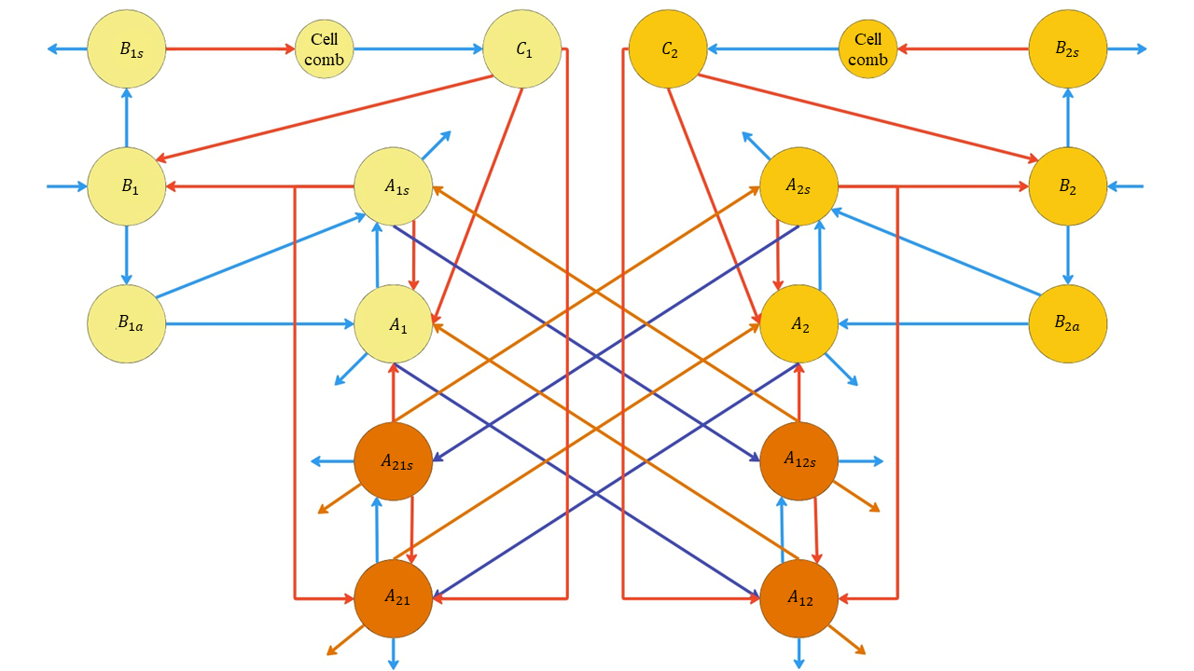

Figure 3. The resulting comprehensive model diagram depicting the AFB transmission dynamics.

Lastly, Table 3 provides explanations for the terms utilized in each equation, enhancing clarity and facilitating a better understanding of the dynamics involved.

Table 3. Explanation of terms used in equations.

|  |  |  |
| --- | --- | --- |
| **Terms** | **Relevant Equation** | **Description** |
|  | Eqn (1), (2), (7), (8) | The number of broods infected daily through contact with spore-carrying adult bees |
|  | Eqn (1), (2), (7), (8) | The number of broods infected daily when laid in infected cells. The expression ​represents the probability that a brood will be laid in an infected cell. |
| ; | Eqn (1), (7) | The number of cells infected after an infected brood die. |
|  | Eqn (2), (3), (8), (9) | The number of young broods that develop resistance to AFB spores. This means the broods will survive even if they carry spores. However, immunity to spores does not make the broods spore-free; they can still be spore carriers. |
|  | Eqn (3), (9) | The number of broods that mature into adult bees each day. Broods that survive AFB may still carry spores when they become adult bees. |
| ; | Eqn (4), (10) | The number of cell combs that can be contaminated by adult bees during the cleaning or removal of diseased dead brood. |
| ; | Eqn (5), (11) | The number of broods that develop into spore-carrier adult bees after acquiring resistance. |
| ; | Eqn (6), (12) | The daily number of broods that develop into spore-free adult bees. |
| ;; ; | Eqn (5), (6), (11), (12), (13), (14), (15), (16) | The number of adult bees that become spore carriers upon contacting infected cells. Here, represents the probability that a spore-free adult bee will come into contact with an infected cell. |
| ; ; ; | Eqn (5), (11), (13), (14), (15), (16) | The number of spore-free adult bees that become spore carriers upon contact with spore-carrier adult bees. The number of spore-carrier bees indirectly affects the spread of spores in the storage area, as per the main assumptions. |
| ; ; ; ; ; ; ; | Eqn (5), (6), (11), (12), (13), (14), (15), (16) | The mortality rate of adult honeybees due to natural causes. |
| ; ; ; | Eqn (5), (6), (11), (12), (13), (14), (15), (16) | The number of adult bees of appropriate age (forager bees) for leaving the colony that exhibit drifting behavior. |
| ; ; ; | Eqn (5), (6), (11), (12) | The number of adult bees that were initially rejected during drifting but return to their original colony. |
| ; ; ; | Eqn (13), (14), (15), (16) | This terms for example, is the simplified form of It represents the number of adult bees that initially drifted away but got rejected, accounting for those that successfully returned to their original colony and those that didn't or got lost within the model's dynamics. |

# RESULTS

This section presents the outcomes of the simulation and numerical experiments conducted with the proposed model. The results are depicted graphically to enhance clarity and aid visualization.

For the first result of inter-colony dynamics, we incorporated the drifting behaviour of honeybees into the model of the two healthy colonies. The parameters, , and for all is incorporated and the results are shown in the figure below.

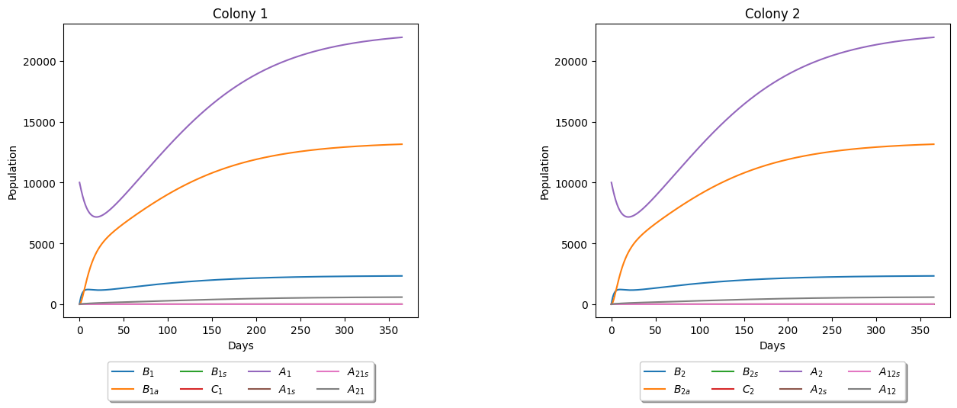

Figure 4. Dynamics of Two Healthy Colonies with Drifting Behavior. The parameters used are in Table 1. The initial conditions are also indicating that both are healthy.

The graph illustrated that when drifting occurs, the behavior of the colonies remains largely similar to when there is no drifting, albeit with the addition of foreign bees to the colony dynamics. Notably, there is only a marginal difference in the population of the original bees within the colony, but this is accompanied by the addition of the population of foreign bees. Based on the findings from **Figure 4**, we can also determine the percentage of honeybees that have drifted from the other colony, as further illustrated in **Figure 5**.

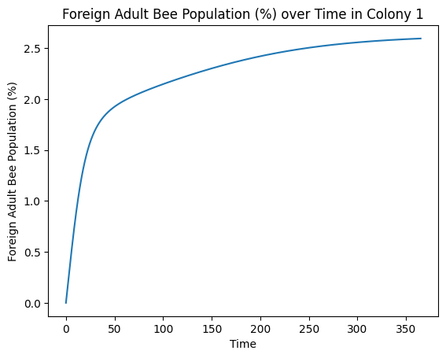

Figure 5. Percentage of drifted honeybees over time. This example from Colony 1 demonstrates behavior similar to that of Colony 2, as evidenced by the results in Figure 4. Therefore, we presented the results for Colony 1, recognizing their equivalence to those of Colony 2.

To further analyze the impact of drifting on the colony, we varied the drifting rate by adjusting the parameter as detailed in **Table 1**. Specifically, we conducted 10 simulations with drifting rates ranging from to for a healthy Colony 1. The resulting effects are depicted in **Figure 6**.

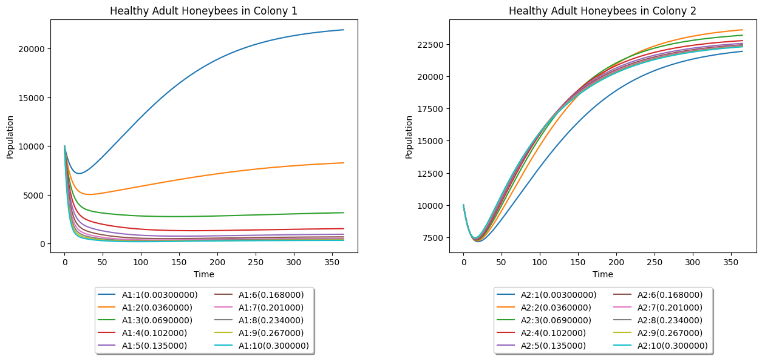

Figure 6. Effects of different values of drift rate to the healthy Colony 1.

From the graph above, we observed that as the drifting rate increases for a healthy Colony 1, it may result in a weakened colony, potentially leading to collapse, particularly at higher drift rates.

Now, we delved deeper into studying the parameters influencing the dynamics of a healthy colony in drifting. In the following heatmap, we varied both the drifting rates, and , of the two colonies.

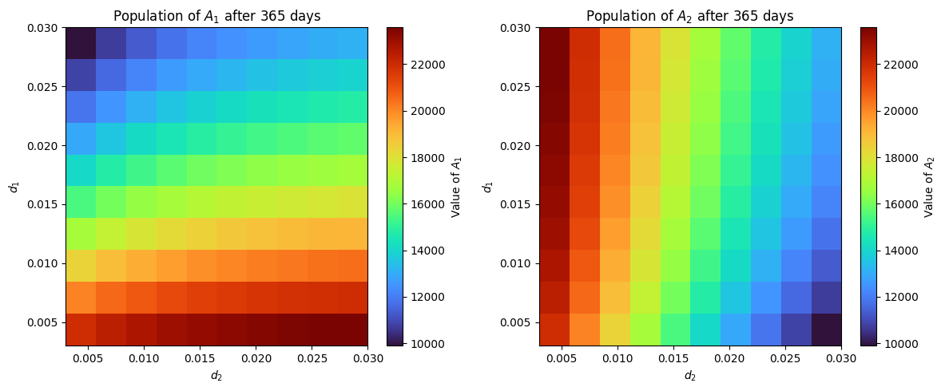

Figure 7. Dynamics of adult honeybees in two healthy colonies with varied drifting rates

The heatmap above illustrated the outcomes for the adult honey bee populations of Colony 1 and Colony 2, indicating whether they will survive or collapse as both their drifting rates are varied. From this analysis, we can conclude that both colonies will survive regardless of whether drifting is at 0% or 100%, as long as the percentage of forager bees (honeybees of an appropriate age capable of leaving the colony) in both colonies remains at 30%. If we include varying the percentage of forager bees and expand the range of from 0% to 100%, the resulting heatmap is displayed below.

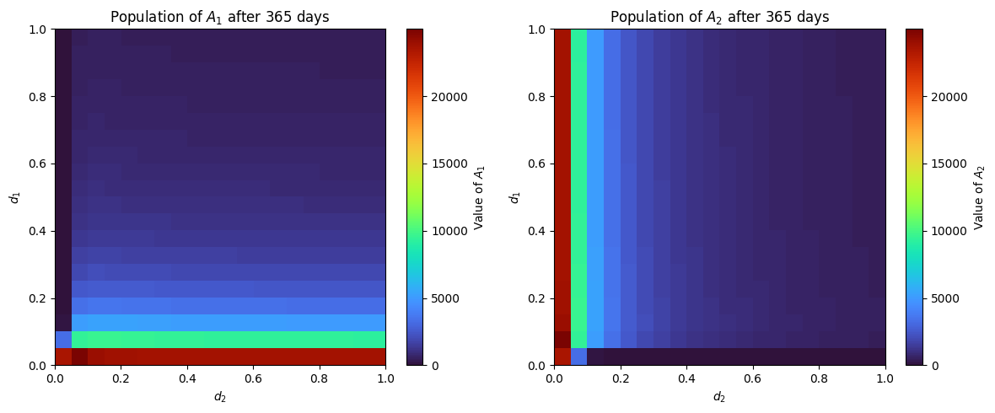

Figure 8. Dynamics of two colonies with varied drifting rates including the percentage of forager honeybees.

From the heatmap, we can identify points where colony collapse occurs. While there isn't a specific percentage of the total population that guarantees collapse, as colony losses are less frequently associated with collapse [7], we can set collapse as occurring when the percentage of the current population to the original initial population is less than 1% (1000). In the heatmap, areas with a deeper blue color indicate collapse.

Additionally, we analyzed the combined effects of drift rate ​and return rate ​ on Colony 2 to determine whether it will survive or collapse under varied parameters. By varying and and plotting this in a heatmap, it can visualize how these two parameters interact and influence each other within the context of honeybee behavior and colony dynamics. Their potential implications are:

* High , Low : This scenario suggests high levels of drift, where bees frequently leave their original colony but successfully integrate into new colonies. This could be due to weak guarding behavior in the receiving colony or aggression from resident bees, leading to the drifting bees either dying or becoming lost outside the two-colony system.
* Low , High : Here, while bees may initially show less inclination to drift, those that do are unsuccessful at integrating into other colonies. This may imply a less hospitable environment outside or strong guarding behavior by the receiving colony.
* High , High : This combination could indicate a dynamic in which bees frequently drift but struggle to integrate into new colonies, possibly suggesting an unhealthy colony or an inhospitable network of colonies.
* Low , Low : This scenario may suggest a stable colony environment with minimal drifting and few bees returning to their original colony, indicative of a well-connected network of colonies.

In the following figure, we analyzed the effect of varying both the drift rate and return rate in Colony 2.

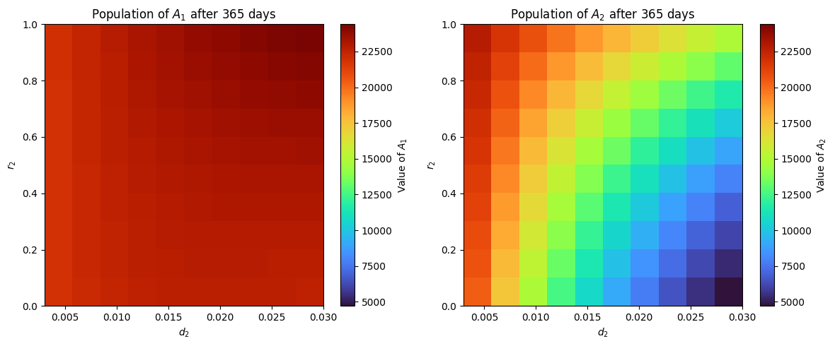

Figure 9. Effect of varying drift rate and return rate to the survival of the adult honeybees.

From the heatmap shown in **Figure 9**, we can see that adult honeybees in Colony 2 still survived, however it became weak, even when there is no return rate and has high drift rate in Colony 2. The colony survival under these parameter values is further illustrated in the figure below.

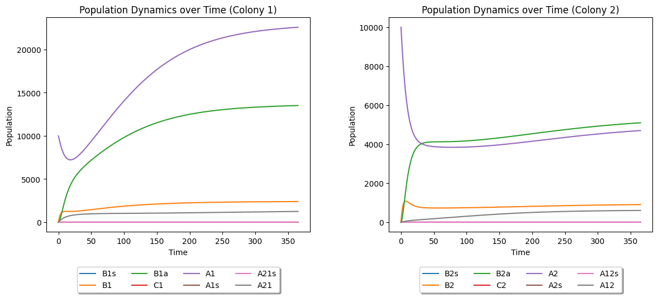

Figure 10. Inter-colony dynamics of the two healthy colony when and on Colony 2.

Finally, in this scenario, if we also vary the percentage of foragers and expand the range of from 0% to 100%, the survival of Colony 2 is depicted in the figure below.

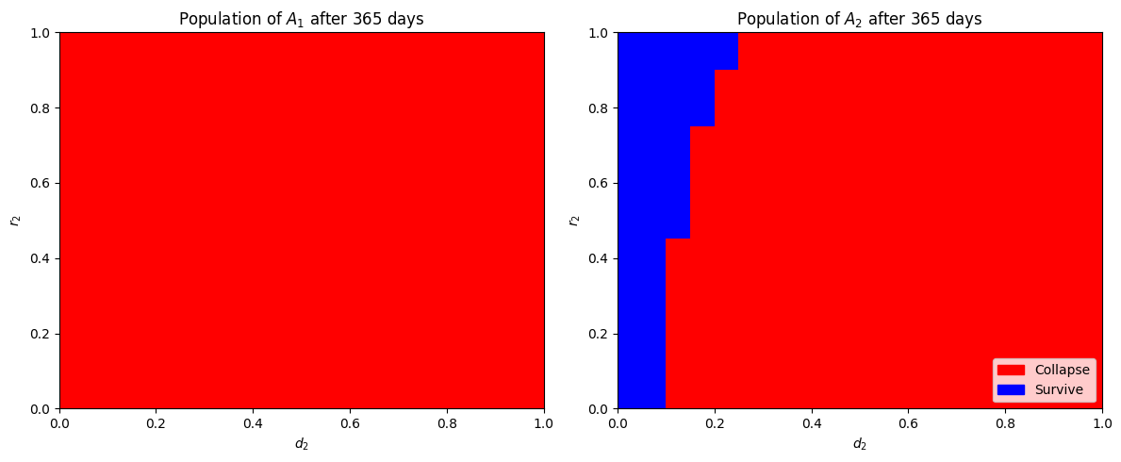

Figure 11. Colony 2 survival heatmap.

We can further explore various combinations of parameters to examine the survival or collapse of a healthy colony. However, we will now shift our focus to the primary objective of this study, which involves integrating AFB infection into the inter-colony dynamics. For the first simulation involving the AFB infection, we started by adding an infected adult to Colony 2. The results are shown in **Figure 12**.

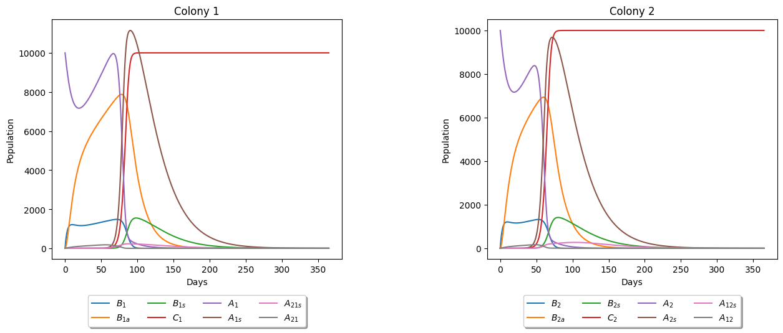

Figure 12. Dynamics of the two colonies with drifting infected adult honeybee from Colony 2. The parameters used here is also in Table 1. The initial conditions are , indicating the presence of an infected adult in Colony 2.

From the graphs above, it is evident that both colonies experience mortality between 250 to 300 days after the infection begins in Colony 2. Interestingly, despite the infection originating in Colony 2, the number of infected adult honeybees in Colony 1 peaks higher than that of Colony 2 over time, potentially increasing the risk of spreading the infection to other colonies when a portion of infected bees in Colony 1 drift to neighboring colonies beyond the two-colony system in the model. This result aligns with findings from Betti et al.'s paper [3], where the second colony in their study peaks slightly higher than the source colony. However, the peak we observed is more pronounced. Lastly, our results from Berkeley Madonna indicate that drifting may delay the onset of infection spread in broods of a colony compared to scenarios without drifting. However, despite this delay, both colonies will ultimately succumb to the infection. This finding aligns with the outcomes documented by Betti et al. [3]. The results we got from Berkeley Madonna are summarized in the table below.

Table 4. Day of First Brood Infection Onset.

|  |  |
| --- | --- |
| **Scenario** | **Day of First Brood Infection in Colony 2 (Source Colony)** |
| Infection without drifting | 38.9 days |
| Infection started with drifting at **1% on Colony 2** ( 0.003) | 39.44 days |
| Infection started with drifting at **10% on Colony 2** ( 0.03) | 44.94 days |
| Infection started with drifting at 5**0% on Colony 2** ( 0.15) | 105.72 days |
| Infection started with drifting at **1% on both colonies** ( 0.003) | 39.16 days |
| Infection started with drifting at **10% on both colonies** ( 0.03) | 41.54 days |
| Infection started with drifting at **50% on both colonies** ( 0.15) | 50.2 days |

We further explored intriguing scenarios, such as when Colony 2 is weaker than Colony 1, resulting in notable outcomes depicted in **Figure 13**.

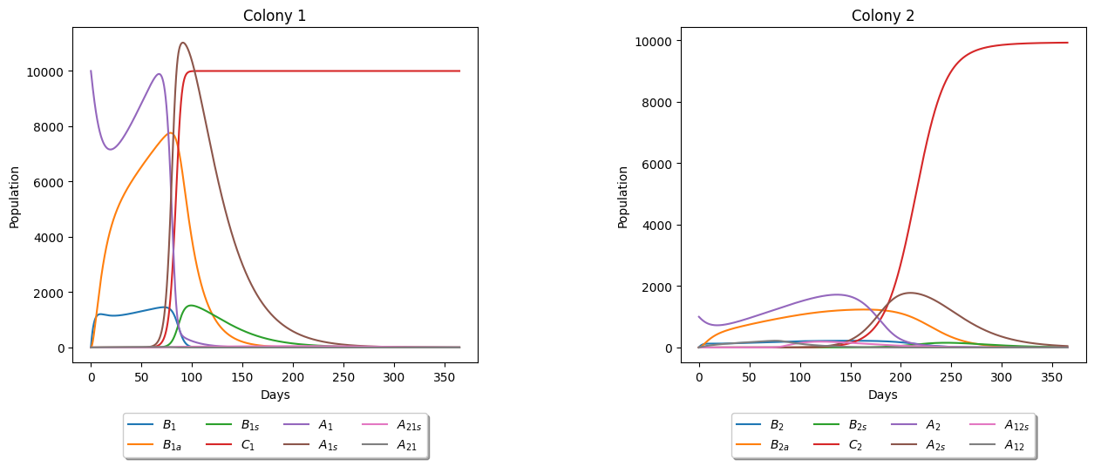

Figure 13. Dynamics of the two colonies with drifting infected adult honeybee from a weak Colony 2. Here, we set and. We also set the initial value of so that we weaken the Colony 2.

From the results, we observed that despite Colony 2 having the initial infected adult, Colony 1 is the first to collapse. This suggests that higher population density may accelerate the spread of AFB transmission within a colony. Further studies could explore whether population density serves as a critical factor in transmission dynamics.

We further investigated the dynamics using the model by varying important parameters that are likely to impact the trajectory of the system. Our initial exploration involves varying the parameter , which is detailed in **Table 1**, to observe its effects on the colony dynamics of both colonies, particularly with an infected adult honeybee present in Colony 2. The results are shown below.

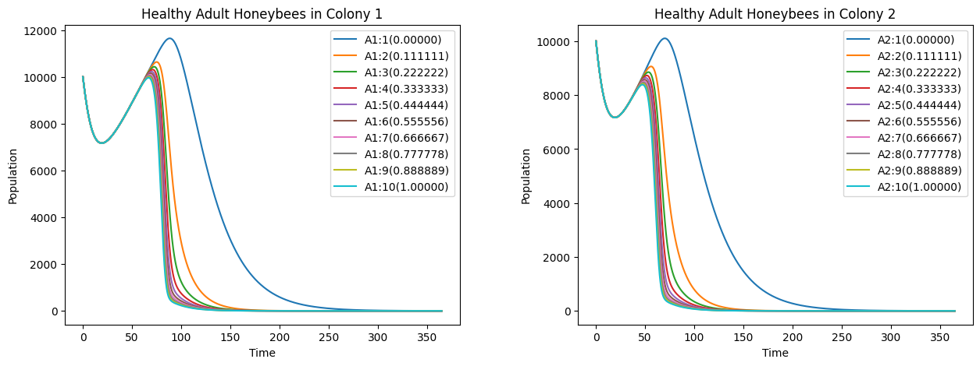

Figure 14. Effect of varying on adult honeybee dynamics with infected adult in Colony 2.

From the graphs depicted in **Figure 14**, we can see that for all values of from [0,1], the effect of  does not help much on the colony survival, specifically the adult honeybee population.

Now, let's examine its impact on the brood infection within the system. We can see the results in the following figure below.

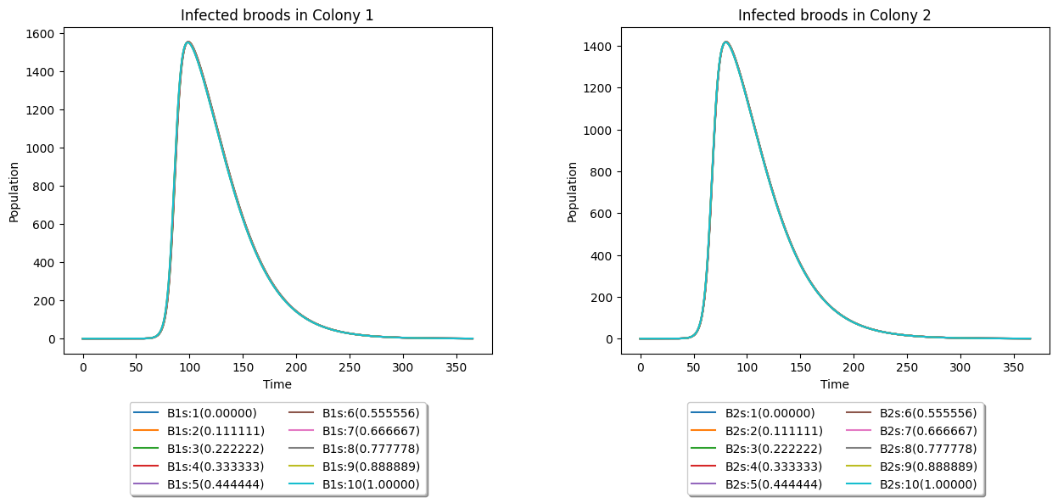

Figure 15. Effect of varying on brood dynamics with infected adult in Colony 2.

From the results above, it's evident that varying does not significantly influence the brood dynamics.

Next, we explored other infection rates for adult honeybees, like . Similar to , represents the rate at which adult bees become infected. The following figure showed how varying affects the adult honeybee population.

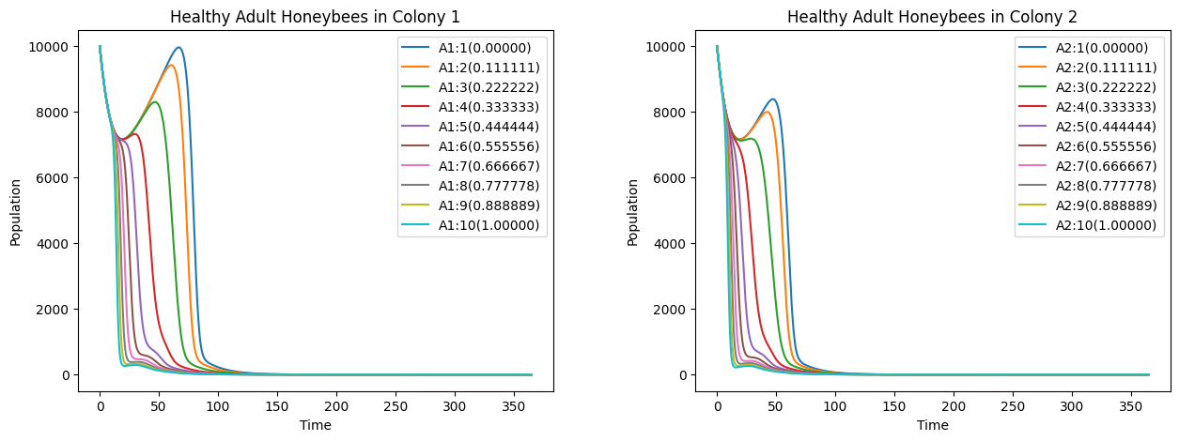

Figure 16. Effects of varying on adult honeybee dynamics with infected adult in Colony 2.

From **Figure 16**, any values from the simulations ranging [0,1] does not affect much on colony survival. It is observed that increasing values up to 1 only prolong the lifespan of adult honeybees before eventual mortality.

We further investigated the effect of varying into the brood infection now. The results can be seen from the figure below.

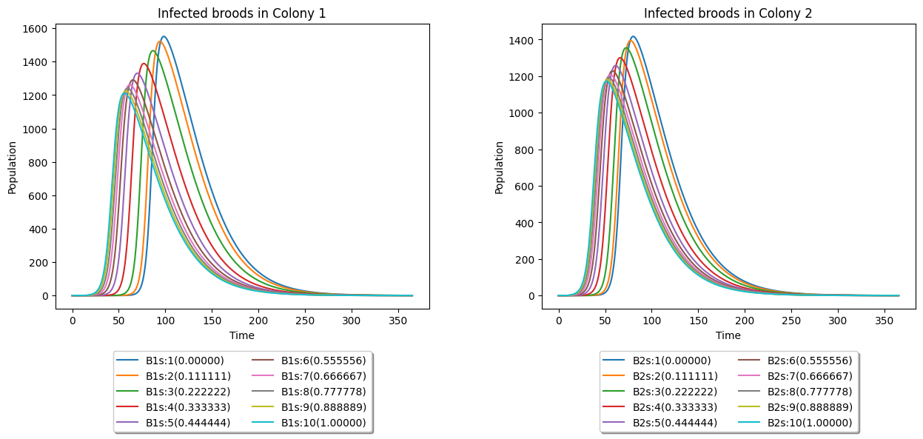

Figure 17. Effect of varying on brood dynamics with infected adult in Colony 2.

Based on the data presented in the figure above, it is apparent that infected broods will succumb to the infection across all values of within the range of [0,1]. Lower values of the parameter merely delay the eventual mortality of the infected broods.

Next, we explore another parameter related to infection rates: . Like the previous parameters, represents an infection rate, specifically concerning broods. We conducted experiments by varying , and the findings are presented below.

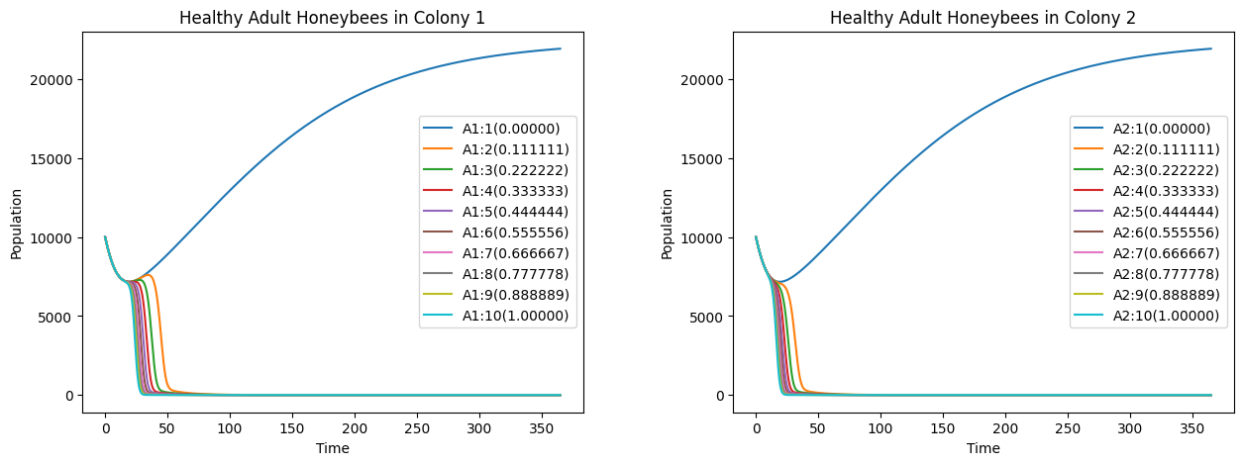

Figure 18. Effects of varying on adult honeybee dynamics with infected adult in Colony 2.

The findings from the graphs show a significant shift from the previous two parameters. We now observe a potential for adult honeybee survival when parameter is zero. Because of this, it is intriguing to also see what will happen to the brood dynamics. We can see the results from the following figure.

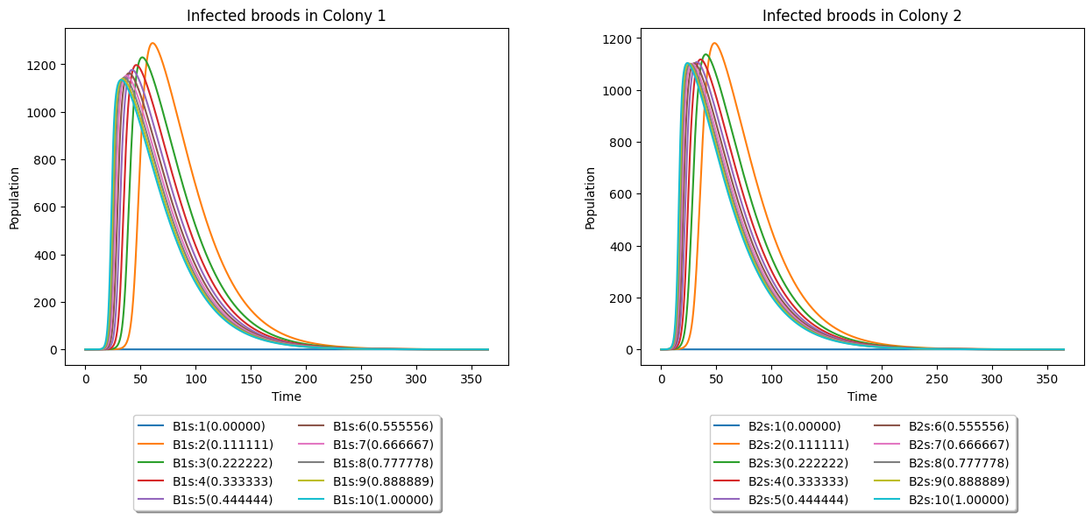

Figure 19. Effect of varying on brood dynamics with infected adult in Colony 2.

Correlating with the survival of adult honeybees, a notable observation arises when parameter , despite not being immediately apparent due to the graph displaying a flat line at 0. Both colonies in this scenario (varying ) exhibit survival without any infections. This finding holds significant implications, suggesting the critical importance of the infection rate among broods for colony survival and health. Consequently, it can be inferred that infected broods may constitute a more decisive factor in colony health and survival than infected adult honeybees. Further studies into these results is warranted.

Moving on from the infection rates parameters, we also studied the effects of varying on the adult honeybee population, which is the rejection rate of drifting honeybees from Colony 2 that are not accepted by the receiving colony, as discussed in **Table 1**. The results are shown below.

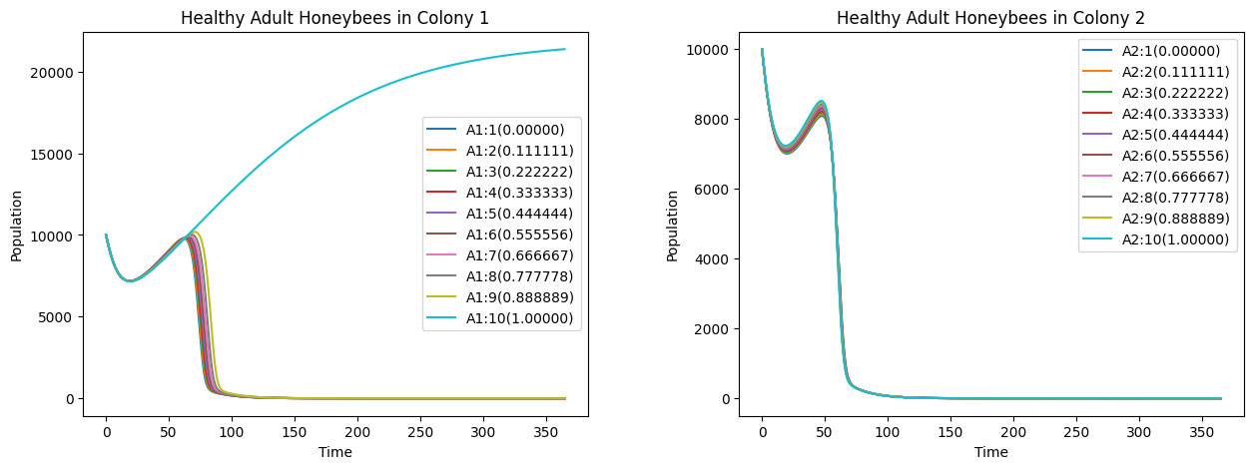

Figure 20. Effects of varying on adult honeybee dynamics with infected adult in Colony 2.

Based on the findings depicted in **Figure 20**, when Colony 1 consistently rejects all drifting adult honeybees from Colony 2, Colony 1 can survive without experiencing infection within its colony. Conversely Colony 2, where AFB infection initially originated, will still face colony collapse due to the presence of the disease.

Additionally, we investigated another parameter, , by conducting we vary the parameter to observe the effects of varying the rate at which diseased dead brood is cleaned by adult bees on the onset of the first brood infection. The results of these experiments are presented below.

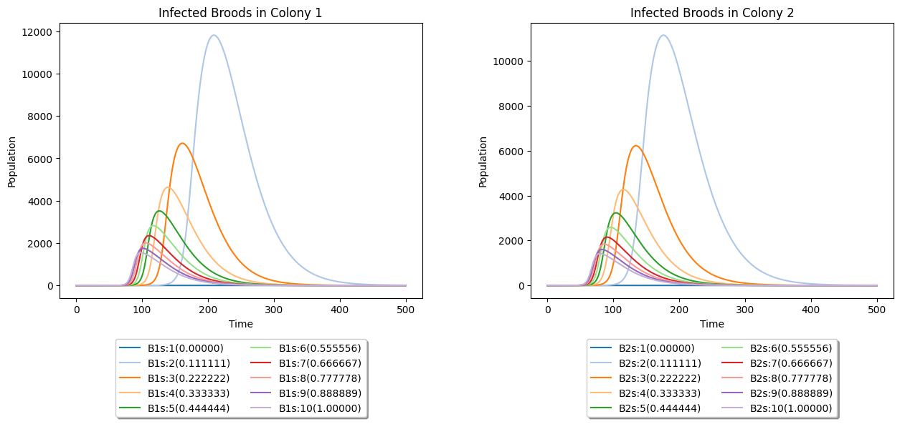

Figure 21. Effect of varying on brood dynamics with infected adult in Colony 2.

The observed graphs indicate that as the parameter decreases, the onset of the first brood infection decelerates, albeit with a higher peak population. Consequently, we conducted experiments with smaller values of this parameter and investigated their impact on the dynamics of adult honeybees. The findings are presented below.

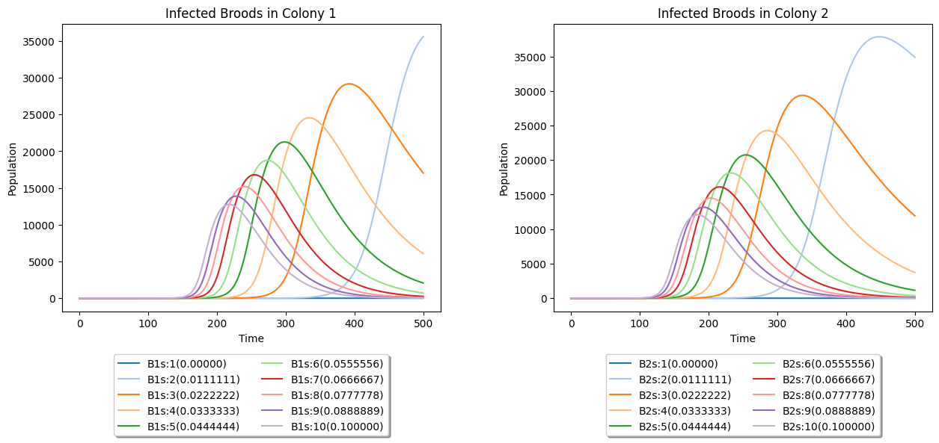

Figure 22. Effect of varying [0, 0.1] on brood dynamics with infected adult in Colony 2.

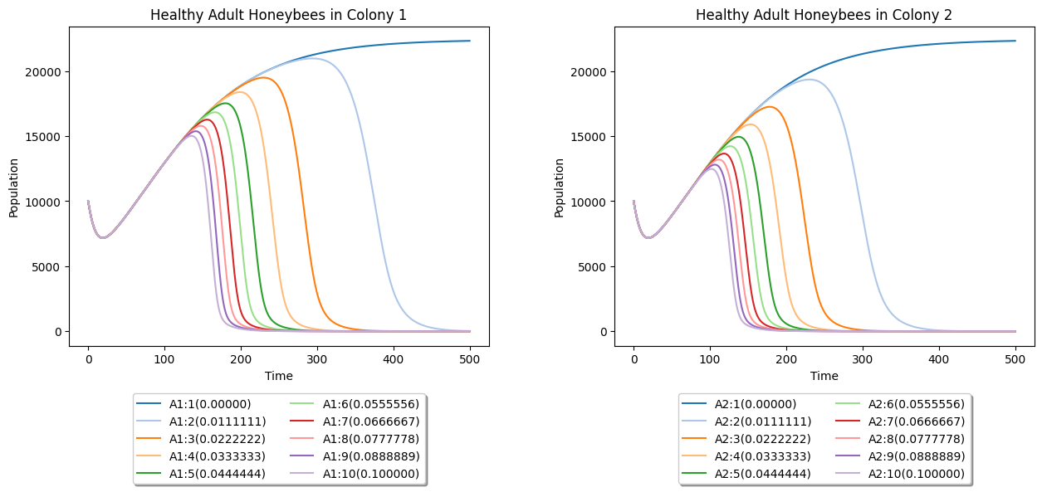

Figure 23. Effects of varying [0, 0.1] on adult honeybee dynamics with infected adult in Colony 2.

Further observations reveal that smaller values of lead to delayed onset of AFB infection; however, if left unaddressed, they result in more severe consequences in colony health.

Now, we proceeded to another important parameter, , which is the percentage of clean cell combs that will be contaminated by AFB spores (**Table 1**). The following results can be seen in the figures below.

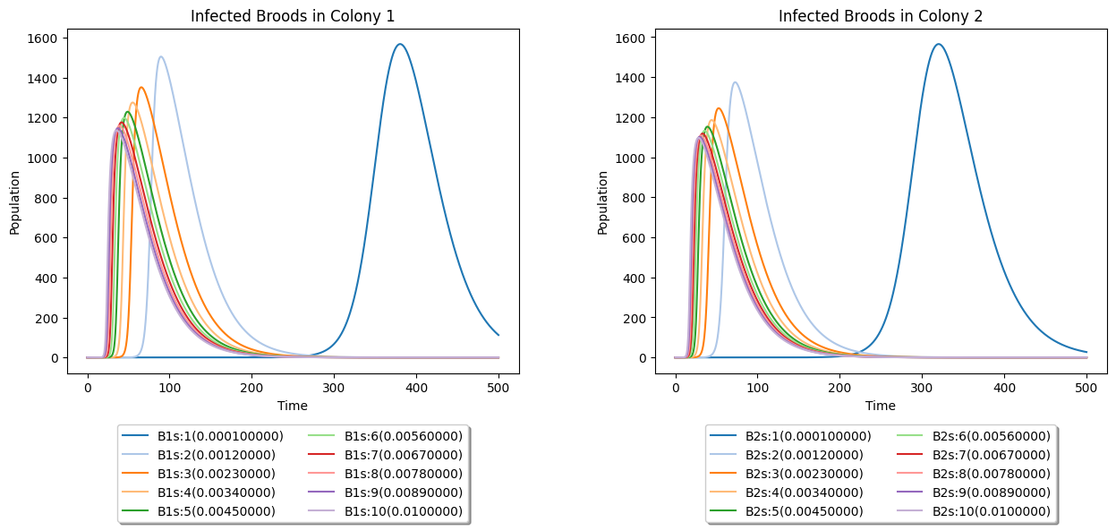

Figure 24. Effect of varying on brood dynamics with infected adult in Colony 2.

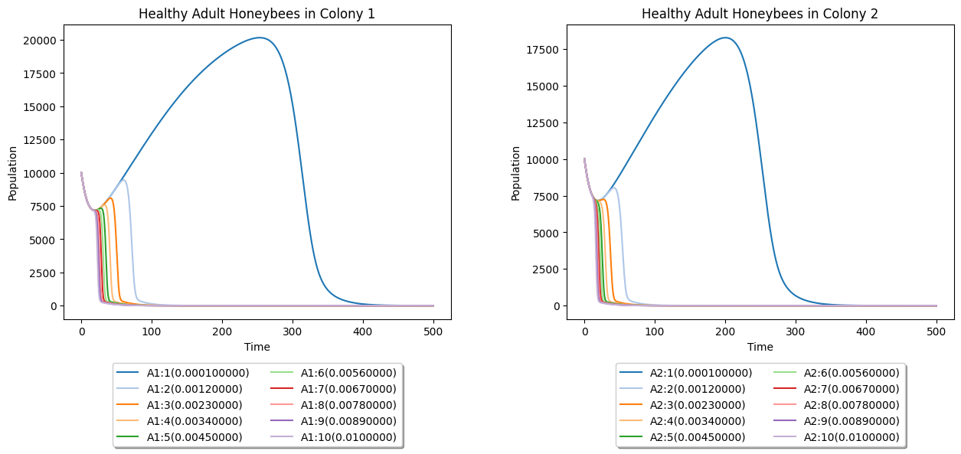

Figure 25. Effects of varying on adult honeybee dynamics with infected adult in Colony 2.

These results indicate that smaller values of also slow down the spread of infection within the colony. This suggests that apiary farmers may have more time to address the spread of AFB within their apiaries.

Based on these findings, we further explored the effects of different combinations of two parameters on brood infection onset using heat maps. Specifically, we varied both and , and the resulting heat map is depicted below.

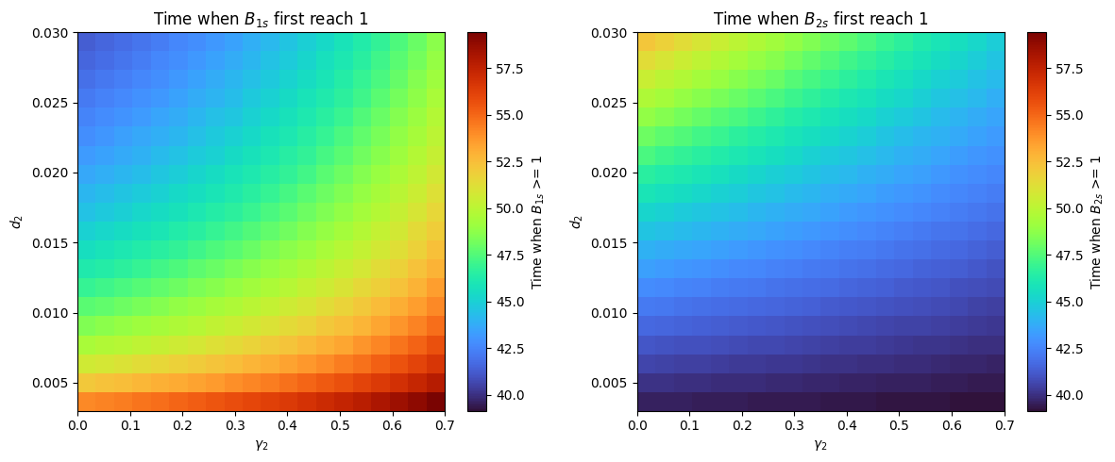

Figure 26. Effects of varying and on brood dynamics with infected adult in Colony 2.

Analyzing the heatmaps, we determined the relationship between different parameter combinations and the onset of the first brood infection in days. Notably, when is low and is high, the onset of brood infection occurs slower in Colony 1 but faster in Colony 2. This suggests that limited drifting in Colony 2 facilitates faster infection spread within their colony. Consequently, rejected adult drifters from Colony 2 have a higher likelihood of getting lost to another colony or returning to their own, accelerating the onset of infection.

Furthermore, we investigated the combined effects of two important parameters, and , on the onset of brood infection. The results are displayed in the heatmaps below.

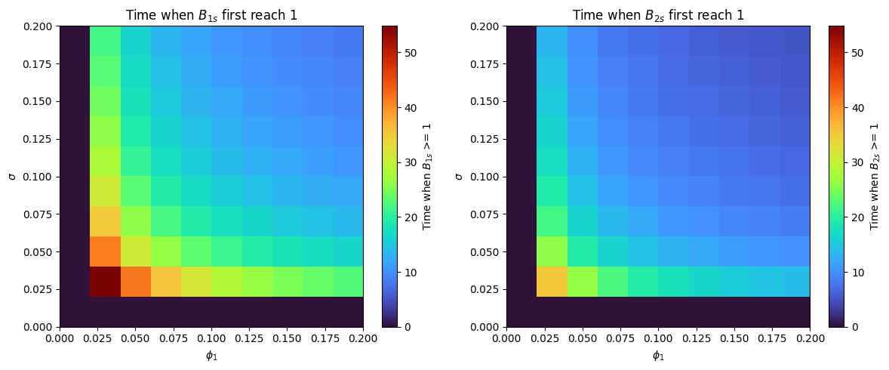

Figure 27. Effects of varying and on brood dynamics with infected adult in Colony 2.

The heatmaps above illustrate that lower values of both parameters lead to a slower onset of the first brood infection. This observation underscores the significant influence of these parameters on the timing and severity of AFB outbreaks, highlighting their importance in formulating effective disease control strategies for beekeeping practices.

Finally, the last simulation was the effect of varying the parameters, and . The importance of this relationship lies in how environmental contamination influences the likelihood and rate of infection transmission within the colony. A higher value means that more clean cell combs are contaminated, which in turn increases the exposure of adult bees to AFB spores and thus increases the likelihood of infection transmission, as captured by . The heatmap is shown below.

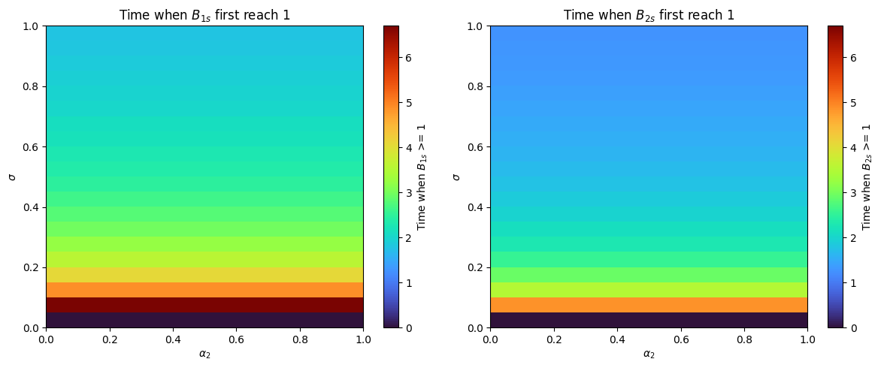

Figure 28. Effects of varying and on brood dynamics with infected adult in Colony 2.

From the heatmap above, we can see that does not really affect the first infection on broods. It is more important to look at , which denotes the percentage of clean cell combs contaminated by AFB spores, is particularly significant for assessing the vulnerability of honeybee colonies to AFB infection. A higher value of sigma indicates a greater likelihood of AFB contamination in the colony's brood cells, leading to more rapid and extensive spread of the disease.

The obtained results are further elaborated upon in the Discussion section of the paper.

# DISCUSSION

The findings from our simulations and numerical experiments provide significant insights into the dynamics of honeybee colonies, particularly concerning drifting behavior and the impact of American Foulbrood (AFB) infection. For the healthy colony part, our results show that while drifting behavior introduces only minor differences in the original bee populations under balanced conditions, increased drifting rates can significantly weaken healthy colonies, potentially leading to collapse. This underscores the importance of managing forager bee populations to mitigate the effects of drifting. Heatmap analyses reveal critical thresholds for drifting behavior, suggesting that high drifting rates () are detrimental, which highlights the need for effective apiary management practices, such as careful hive placement and orientation, to control bee drifting. The relationship between bee drifting and return rates () revealed that while high drifting rates with low return rates can lead to weakened colonies, maintaining balanced rates is essential for colony stability.

Furthermore, our simulation of AFB infection dynamics indicates that infection can spread rapidly and more severely in densely populated colonies, emphasizing the importance of early detection and intervention in these colonies. Interestingly, the findings suggest that bee drifting may delay the onset of infection in broods within a colony but will not reduce the severity of the infection. This indicates that while drifting can temporarily hinder the spread of disease, it does not affect the ultimate impact on colony health. Sensitivity analysis of infection rates reveals that brood infection rate () is particularly critical for colony survival than adult bee infection rates (, ), which could shift the focus towards more rigorous management of brood infections. Additionally, the study highlighted the importance of rejection rates () of drifting bees, showing that effective rejection can prevent the spread of AFB to healthy colonies, thus underscoring the role of colony defense mechanisms in disease management. Furthermore, it was found that lower values of () delay the onset of brood infection, but this comes with the trade-off of higher peak populations of infected broods, indicating a complex balance between immediate and long-term colony health. Higher contamination rates (𝜎) demonstrated a rapid increase in the spread of AFB, emphasizing the critical need for stringent hygiene practices within hives to prevent widespread infection. These findings pave the way for future research and practical applications, such as exploring environmental influences on drifting and infections, evaluating long-term apiary management impacts, and developing predictive models. Overall, our results enhance understanding of honeybee colony dynamics and offer insights to improve bee health and apiculture management.

# REFERENCES

1. American Foulbrood. Texas Apiary Inspection Service TAIS. (2017, May). https://txbeeinspection.tamu.edu/american-foulbrood/
2. Betti, M. I., Wahl, L. M., & Zamir, M. (2014). Effects of infection on Honey Bee Population Dynamics: A model. PLoS ONE, 9(10). https://doi.org/10.1371/journal.pone.0110237
3. Betti, M., & Shaw, K. (2021). A multi-scale model of disease transfer in honey bee colonies. Insects, 12(8), 700. https://doi.org/10.3390/insects12080700
4. Cervancia, C.R., Fajardo, A.C. Jr., Sabino, N.G., Jamora, R.M., Consignado, K.I., Flores, B.F.C. (2013). Prevalence of American Foul Brood (AFB) diseases of honey bee *Apis mellifera* (L.) in the Philippines and its pathogenicity to *Apis cerana* Fabricus. Philipp Ent. 27(1):75–90.
5. Datta, S., Bull, J. C., Budge, G. E., & Keeling, M. J. (2013). Modelling the spread of American Foulbrood in Honeybees. Journal of The Royal Society Interface, 10(88), 20130650. https://doi.org/10.1098/rsif.2013.0650
6. Established pests. Bee Aware. (2014, July). https://beeaware.org.au/archive-pest/american-foulbrood/#ad-image-0
7. Ferrier, P. (2018, October 1). Despite elevated loss rate since 2006, U.S. honey bee colony numbers are stable. USDA ERS - Despite Elevated Loss Rate Since 2006, U.S. Honey Bee Colony Numbers Are Stable. https://www.ers.usda.gov/amber-waves/2018/october/despite-elevated-loss-rate-since-2006-u-s-honey-bee-colony-numbers-are-stable/
8. Garvey, K. K. (2013, September 24). The foraging force of a honey bee colony. ANR Blogs. https://ucanr.edu/blogs/blogcore/postdetail.cfm?postnum=11592
9. Gavina, M. K., Rabajante, J. F., & Cervancia, C. R. (2014). Mathematical programming models for determining the optimal location of beehives. Bulletin of Mathematical Biology, 76(5), 997–1016. https://doi.org/10.1007/s11538-014-9943-9
10. Goodwin, R. M., Perry, J. H., & Ten Houten, A. (1994). The effect of drifting honey bees on the spread of American foulbrood infections. Journal of Apicultural Research, 33(4), 209-212. https://doi.org/10.1080/00218839.1994.11100873
11. Jatulan, E. O., Rabajante, J. F., Banaay, C. G., Fajardo, A. C., & Jose, E. C. (2015). A mathematical model of intra-colony spread of American Foulbrood in European honeybees (apis mellifera L.). PLOS ONE, 10(12). https://doi.org/10.1371/journal.pone.0143805
12. Katzav-Gozansky, T., Ibarra, F., Francke, W., Hefetz, A., & Soroker, V. (2001). Dufour’s gland secretion of the queen honeybee ( apis mellifera ): An egg discriminator pheromone or a queen signal? Behavioural Ecology and Sociobiology, 51(1), 76–86. https://doi.org/10.1007/s002650100406
13. Khoury, D. S., Myerscough, M. R., & Barron, A. B. (2011). A quantitative model of Honey Bee Colony Population Dynamics. PLoS ONE, 6(4). https://doi.org/10.1371/journal.pone.0018491
14. Laomettachit, T., Liangruksa, M., Termsaithong, T., Tangthanawatsakul, A., & Duangphakdee, O. (2021). A model of infection in honeybee colonies with social immunity. *PLOS ONE*, *16*(2). https://doi.org/10.1371/journal.pone.0247294
15. Prado, A., Requier, F., Crauser, D., Le Conte, Y., Bretagnolle, V., & Alaux, C. (2020). Honeybee lifespan: The critical role of pre-foraging stage. Royal Society Open Science, 7(11), 200998. https://doi.org/10.1098/rsos.200998
16. Randy. (2023, May 8). A study on Bee Drift and mite immigration: Part 1. Scientific Beekeeping. https://scientificbeekeeping.com/a-study-on-bee-drift-and-mite-immigration-part-1/#:~:text=the%20drone%20factor.-,HOW%20MUCH%20DRIFT%20IS%20THERE%20OF%20WORKER%20BEES%3F,hives%20%5B%5B13%5D%5D.
17. Schmus, B. (2022, October 27). The honey bee lifecycle. The Best Bees Company. https://bestbees.com/2022/08/08/bee-lifecycle/
18. Spread of AFB: The Management Agency, National American Foulbrood Pest Management Plan New Zealand. The Management Agency, National American Foulbrood Pest Management Plan New Zealand | Elimination of American Foulbrood (AFB) Disease in New Zealand. (2019, April 11). https://afb.org.nz/spread-of-afb/
19. Staughton, J. (2024, March 19). What happens to bees when they get lost?. Science ABC. https://www.scienceabc.com/nature/animals/what-happens-to-bees-when-they-get-lost.html
20. Van Der Steen, J. (2015, February). The Foraging Honey Bee. Waginengen; Plant Research International.
21. Wildflowermeadows. (2019, October 22). Drifting. Wildflower Meadows. https://wildflowermeadows.com/2019/10/drifting/?fbclid=IwAR1bdt9f_t3ocsow-a6RSkcIFk_YGo_zio-1A6s8mpt3OO-b98wQymae2yE#:~:text=Looking%20at%20a%20large%20apiary,the%20correct%20colony%20each%20time
22. Willingham, R., Klopchin, J., & Ellis, J. (2021, July 20). Eny-163/IN1064: Robbing behaviour in Honey Bees. Ask IFAS - Powered by EDIS. https://edis.ifas.ufl.edu/publication/IN1064
23. Šekulja, D., Pechhacker, H., & Licek, E. (2014). Drifting Behaviour of Honey Bees (Apis Mellifera Carnica Pollman, 1879) in the Epidemiology of American Foulbrood. Zbornik Veleučilišta u Rijeci, 2(1), 345–358. https://hrcak.srce.hr/en/file/443139