Grade Shop Calculator

Functional Requirements:
- Take in any amount for initial grade value
- Display current grade remaining
- Has a list of all grade shop items with values
- Checkbox for each shop item
- When you click on a checkbox it will dynamically change the remaining grade
- If after click there are items which cannot be purchased due to lack of grade, those will show up in red and the checkboxes will be grayed out

Design:
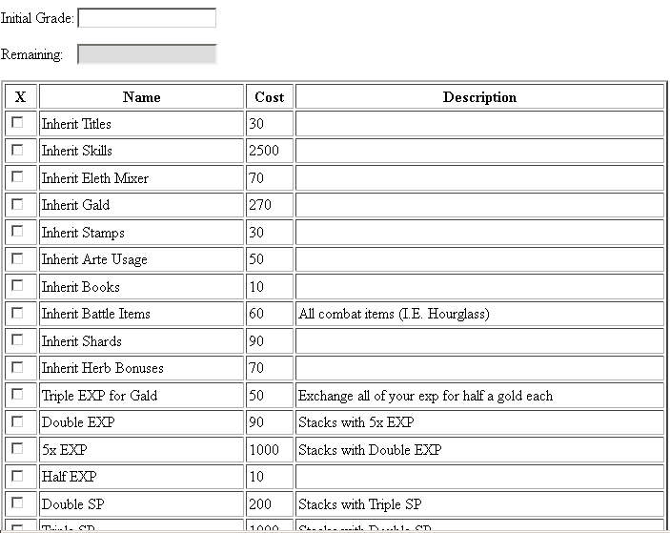

Pseduocode:
When a user clicks a checkbox
If the value would reduce the remaining grade to less than 0
Disable row
Disable checkbox
Highlight box in red
End function
Subtract cost from remaining
Highlight row in blue
Display remaining
For each row whose cost would take remaining grade below 0
Dsiable row

Classes:
Class | Properties | Behaviors
grade_shop | initial_grade  remaining_grade | disableRow  calculateGrade  checkPurchasableItems

