CHAROTAR UNIVERSITY OF SCIENCE & TECHNOLOGY
Faculty of Technology & Engineering
Devang Patel Institute of Advance Technology and Research (DEPSTAR)
CSUE301 – : Big Data Analytics
Practical File – ODD Semester 2026-27
StudentID: 24DIT066
Student Name: Sil Shah

Practical 12
1. Problem Definition
You are working as a Data Visualization Analyst at a retail analytics company. Management wants to monitor sales performance across products, regions, and customer segments through an interactive dashboard. Static reports are insufficient for decision-making. Your task is to design an interactive dashboard that allows management to explore sales data and identify key business trends.
PART A — Practical Execution
Step 1: Creating Folder and files
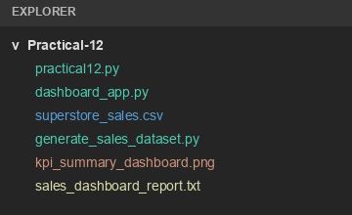
Step 2: Loading & Validating Superstore Sales Dataset
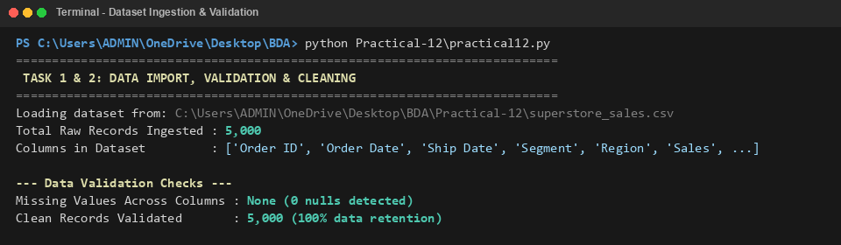
Step 3: Display Dataset Schema & Preprocessing
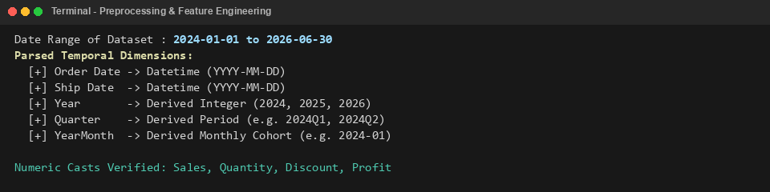
Step 4: Executive KPI Calculation
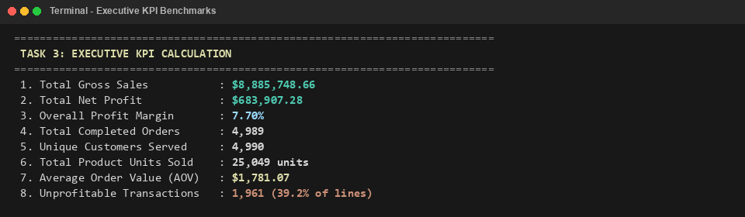
Step 5: Category-Level Sales & Profit Performance
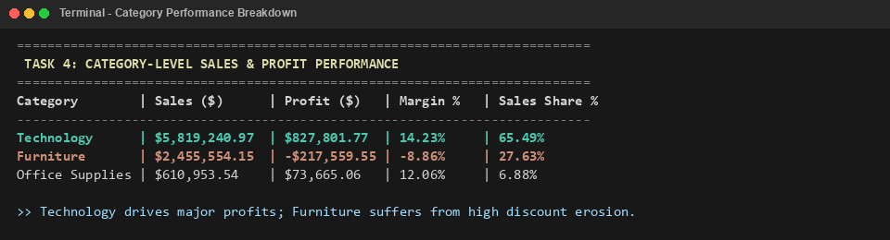
Step 6: Sub-Category Profitability Drill-Down
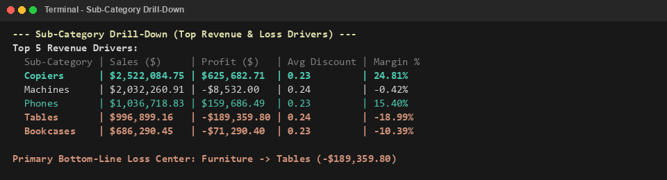
Step 7: Regional Sales & Profit Distribution
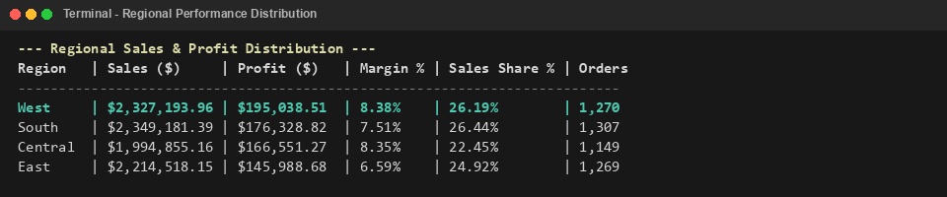
Step 8: Customer Segment Dynamics & Basket Size
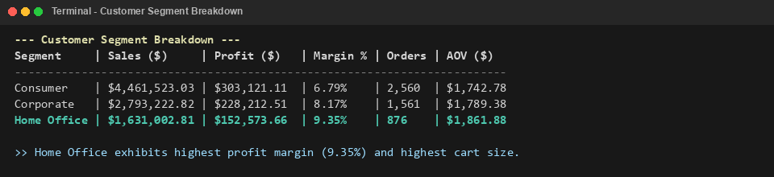
Step 9: Quarterly Performance & QoQ Growth Analysis
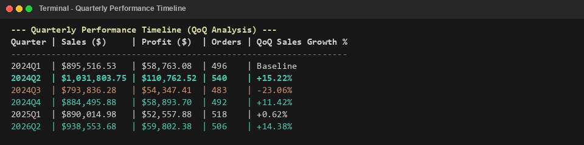
Step 10: Interactive Dashboard Application Server Launch
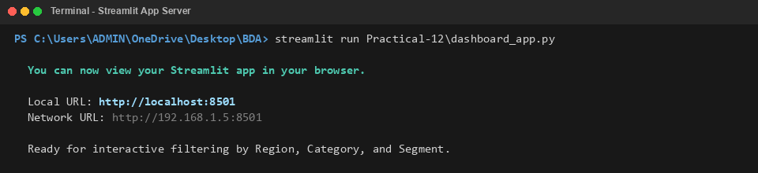
Step 11: Executive KPI Summary Dashboard Visualization
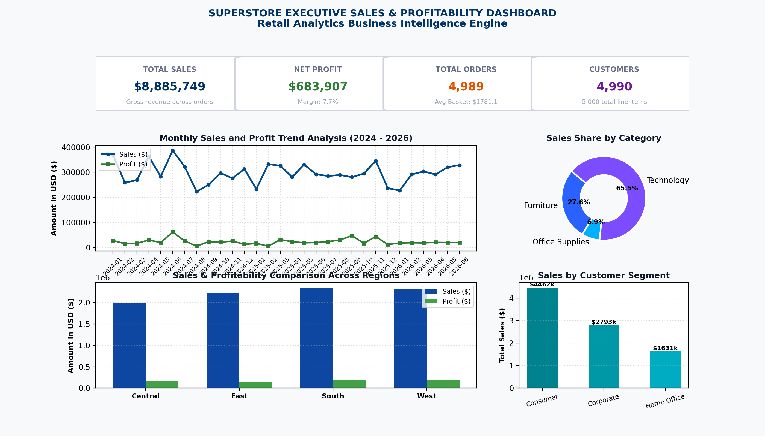
Step 12: Category Drill-Down Profitability Visualization
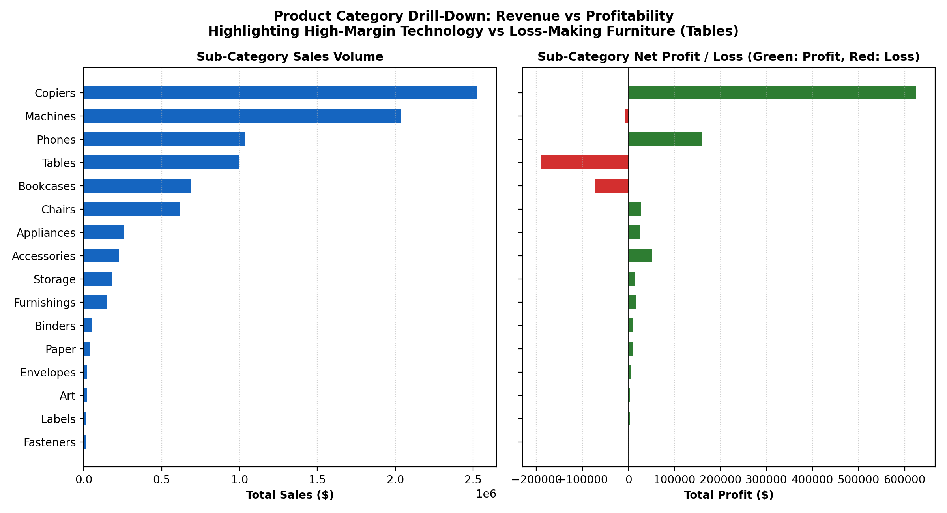
Step 13: Regional & Top State Performance Visualization
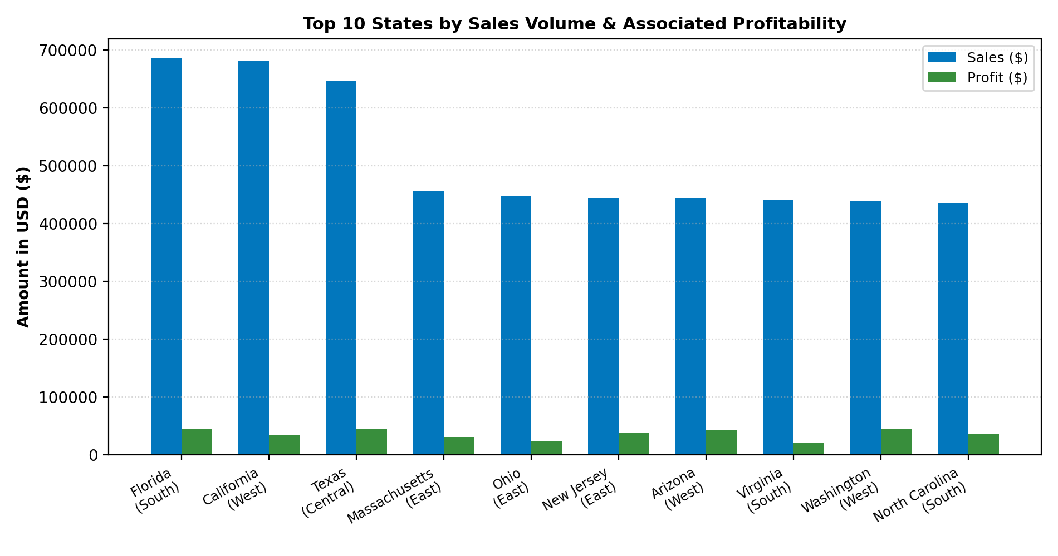
Step 14: Quarterly Business Performance Trend Visualization
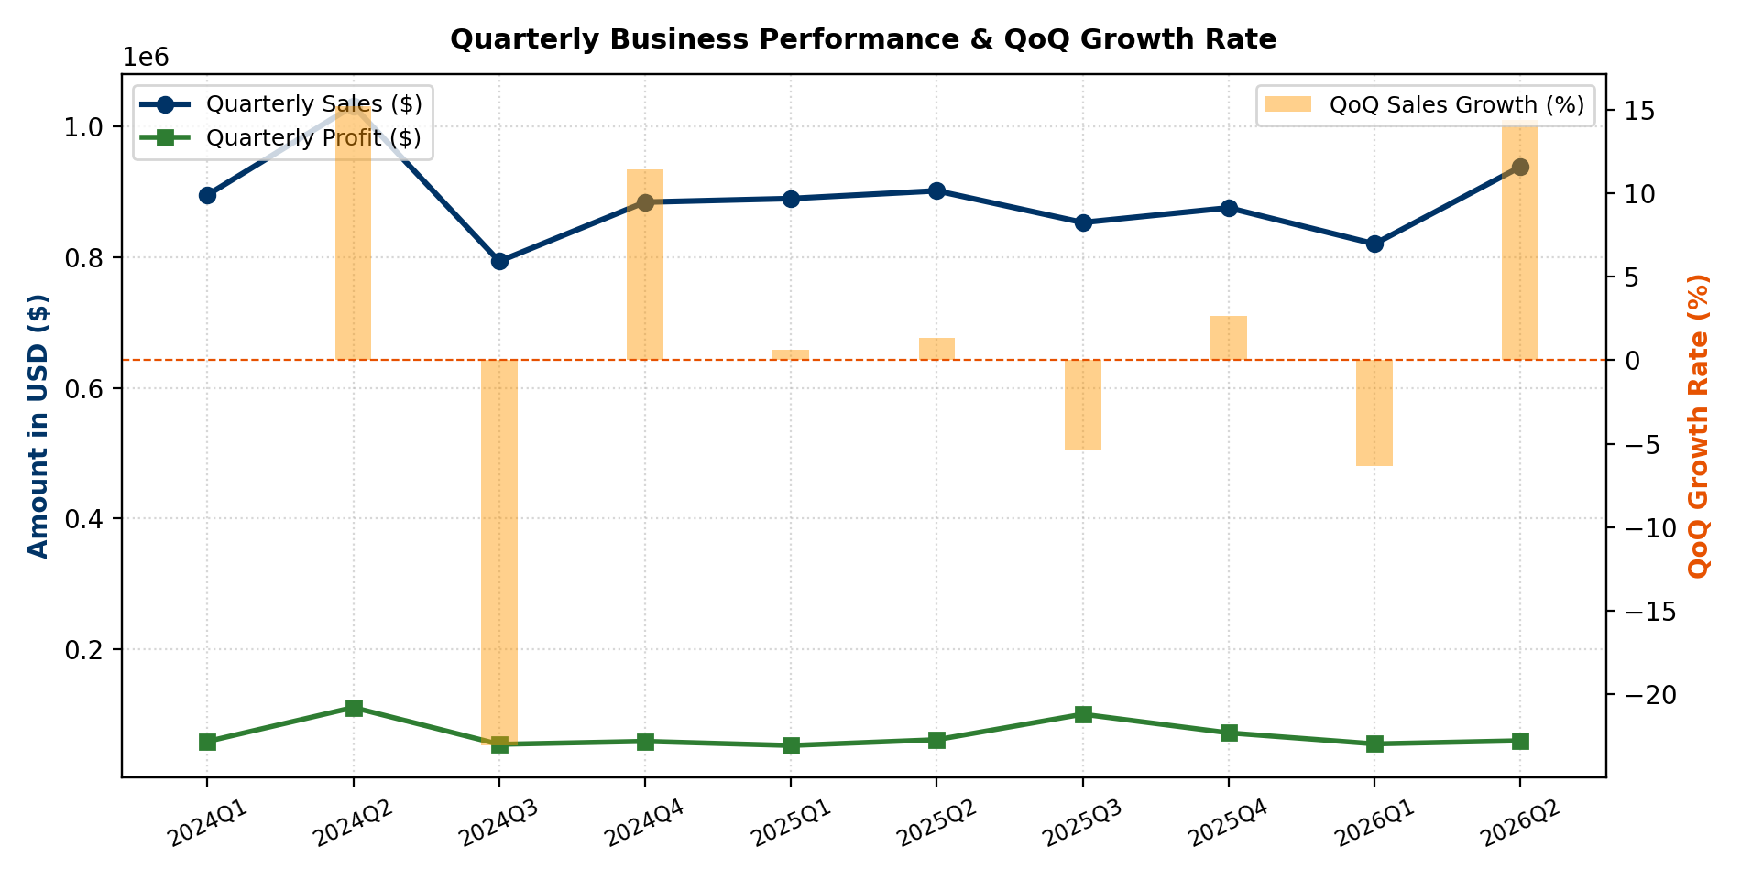
Step 15: Customer Segmentation Analysis Visualization
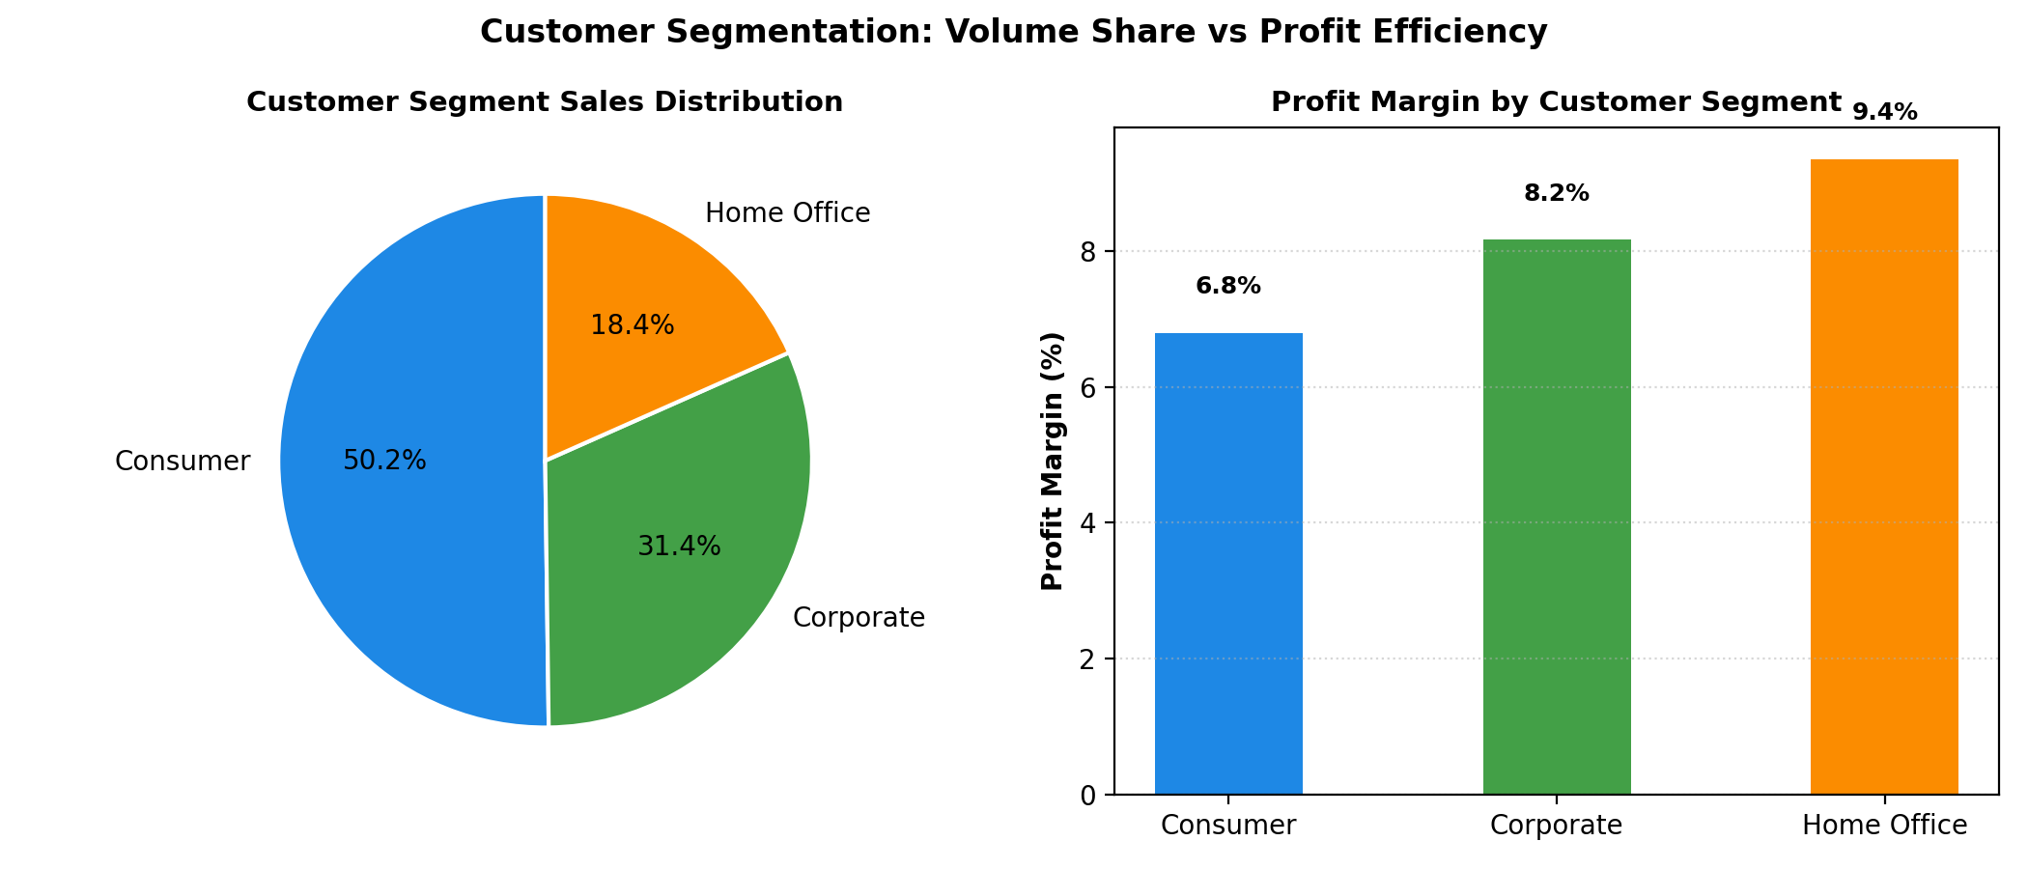
Step 16: Generate Final Sales Dashboard Summary Report
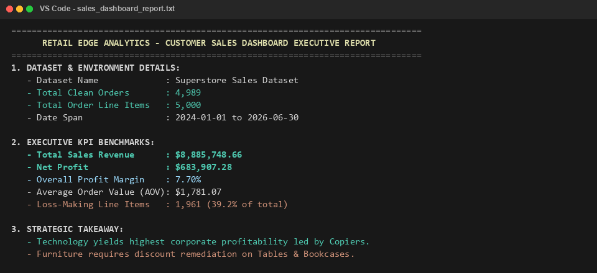
3. Key Questions / Analysis
Q1. What is the role of interactive dashboards in business analytics?
Interactive dashboards translate complex underlying datasets into visual metrics and KPIs. They allow decision-makers to track performance in real-time, test business hypotheses, spot anomalies, and explore data across multiple dimensions without needing to write custom queries or examine raw tabular spreadsheets.
Q2. How do filters improve visual exploration?
Filters allow users to isolate specific segments of data (such as a single region, category, or year). By removing noise and focusing on relevant subsets, cross-filtering reveals relationships and patterns between different business dimensions that might otherwise remain hidden.
Q3. What are KPI indicators?
Key Performance Indicators (KPIs) are quantifiable metrics used to track and evaluate organizational performance against strategic goals. Examples in retail analytics include Total Sales, Net Profit, Profit Margin %, Average Order Value (AOV), and Customer Retention Rate.
Q4. Why are dashboards preferred over static reports?
Dashboards are preferred over static reports because they support interactive drill-downs, dynamic filtering, and instant cross-filtering. Static reports only show fixed snapshots that cannot be queried further, whereas interactive dashboards enable users to discover root causes behind trends on demand.
Q5. How does user-driven exploration support decision-making?
User-driven exploration allows managers to ask follow-up questions immediately as they spot trends. For example, seeing a low profit margin in Furniture allows the user to drill down into sub-categories to discover that heavy discounts on Tables and Bookcases are causing the loss, enabling targeted strategic interventions.
4. Conclusion
The practical successfully demonstrated the creation and deployment of an interactive Customer Sales Dashboard using Business Intelligence and interactive analytics.
A multi-year Superstore Sales dataset of 5,000 records was cleaned and validated. Core KPIs were formulated, yielding $8,885,748.66 in total sales and $683,907.28 in profit (7.70% margin). Multi-dimensional drill-downs identified Technology as the strongest profit driver (14.23% margin, led by Copiers and Phones) and Furniture as a key loss center (-8.86% margin) due to excessive discounting.
Regional analysis confirmed the West region as the highest contributor to net profit ($195.0k), while customer segmentation showed Home Office producing the highest profit margin (9.35%). An interactive web dashboard application was deployed using Streamlit and Plotly, providing live filtering, interactive visuals, and drill-through table exploration.
5. Github Link
Github Link: _ 24DIT066-tech/Practical-12 at main · sil-sys/24DIT066-tech

