Adaptive Local Search Operator Selection for the Traveling Salesperson Problem via Tabular Q-Learning AIE635 Project
Akyaz Ozlem, Erdas Sila

Abstract
The Traveling Salesperson Problem (TSP) is a canonical NP-hard combinatorial optimization problem. Local search operators such as 2-opt, swap, and relocate are effective in isolation, yet no single operator dominates across all phases of a search trajectory. This paper proposes a selection hyper-heuristic that frames operator selection as a Markov Decision Process (MDP) and learns a dynamic policy through tabular Q-learning. Our 120-state formulation encodes solution quality, search phase, recency of improvement, and last operator used. To ensure mathematical rigor, all evaluations strictly adhere to the TSPLIB EUC_2D distance standard. We compare three ε-greedy exploration strategies and two reward definitions on four standard TSPLIB instances over 30 independent runs. The Q-learning agent achieves a near-optimal mean gap across all instances (e.g., 3.87% on st70 and 6.66% on kroA100), outperforming all fixed-operator and random baselines. A novel transition-matrix analysis reveals a powerful, universally autonomous operator synergy: swap→2-opt across all instances, successfully mimicking expert-designed heuristics like Lin-Kernighan.

Introduction
The Traveling Salesperson Problem asks for the shortest Hamiltonian cycle through n cities. Despite its simple formulation, TSP is NP-hard [1], and exact methods become computationally infeasible beyond a few hundred cities. Local search heuristics remain the backbone of state-of-the-art solvers such as Concorde and LKH [2, 3].
A fundamental limitation of classical local search is the static use of a single operator. In practice, operator effectiveness is highly context-sensitive: 2-opt efficiently untangles edges near optimal solutions, while perturbation operators (swap, relocate) are needed to escape deep local optima. Manually scheduling operators is time-consuming and instance-specific.
Selection hyper-heuristics [4] address this by maintaining a high-level policy that chooses among low-level heuristics at each step. When the policy is learned, the framework adapts online to the evolving search landscape. Q-learning [6] provides a natural mechanism: the agent observes state, selects an operator, receives an improvement reward, and updates a value function guiding future decisions.
This paper makes four contributions:
- A complete tabular Q-learning hyper-heuristic with a 120-state MDP.
- Systematic comparison of three exploration strategies and two reward definitions over 30 robust runs.
- A transition-matrix analysis quantifying autonomous operator synergies.
- A generalization study evaluating policy transfer across instance sizes, identifying oracle-state limitations.

Related Work
Local Search for TSP. The 2-opt heuristic [9] remains the workhorse of TSP local search. Its extension to the Lin-Kernighan (LK) move [10] yields solutions within 1–2% of optimal on large instances. Or-opt (relocate) and city-swap operators complement 2-opt by enabling moves it cannot perform [11].
Hyper-heuristics. Burke et al. [4] provide a comprehensive taxonomy distinguishing selection from generation hyper-heuristics. Our work falls in the learning selection category. Meignan et al. [7] apply Q-learning to neighbourhood selection in vehicle routing; Da Costa et al. [8] use multi-armed bandits for evolutionary operator selection. Compared to these, we introduce a richer state encoding and a transition-matrix diagnostic tool.
Deep RL for Combinatorial Optimization. Bello et al. [12] (pointer networks) and Kool et al. [13] (attention model) demonstrate that deep RL can construct near-LKH solutions, but require GPU-scale training. Our tabular Q-learning is deliberately lightweight and interpretable.
Adaptive ε-Greedy. Tokic [15] proposes adaptive epsilon based on value differences in robot navigation. We adapt this idea to TSP operator selection via stagnation detection.

Methodology

Distance Metric and MDP Formulation
To prevent measurement illusions caused by standard floating-point rounding, our methodology strictly utilizes the exact TSPLIB EUC_2D distance standard (⌊ dist + 0.5 ⌋), ensuring mathematically sound gap calculations.
We model the search as an episodic MDP (S, A, R, T, γ) with |S|=120 states.
Each state is a 4-tuple (quality_band,, improved,, stage,, last_op):
- quality_band ∈0,..,4: relative gap to optimal discretized as <5%, 5–15%, 15–30%, 30–50%, >50%.
- improved ∈0,1: did the last step improve the tour?
- stage ∈0,1,2: Early (<33%), Mid, Late search phase.
- last_op ∈0,1,2,3: previously applied operator.
Action space: A=2-opt, swap, relocate, restart.
Two reward functions are compared:
R₁ = ℓ_prev − ℓ_new
R₂ = R₁ + 100 · 1[ℓ_new < ℓ_best]
The Q-table is updated using the standard off-policy Bellman equation:
Q(s,a) ← Q(s,a) + α [ r + γ max_a′ Q(s′,a′) − Q(s,a) ]
with α=0.1, γ=0.9.

Operators
Table: Local Search Operators
Operator | Description
2-opt | Stochastic best-improvement reversal
Swap | Exchange two random cities
Relocate | Remove city; reinsert at different position
Restart | Full random permutation (perturbation)

To maintain computational speed, 2-opt utilizes a stochastic best-improvement approach by sampling up to 100 random segment pairs, rather than performing an exhaustive O(N^2) search. Improving moves are always accepted; worsening moves are accepted with probability 0.01 (SA-style escape), except after restart which unconditionally replaces the current tour.

Exploration Strategies
- Constant ε=0.1: fixed throughout.
- Exponential Decay: ε_0=1.0, ε_min=0.01, decay=0.998.
- Adaptive Stagnation: decays by ×0.99 after improvements; increases by +0.05 after 50 consecutive non-improving steps (capped at ε_max=0.8).

Transition Matrix Analysis
After each episode we record C[i,j]: the number of times operator j was applied immediately after a successful (improving) application of operator i, excluding restart. Row-normalizing C yields transition probabilities revealing operator synergies.

Experimental Setup
Table: Experimental Parameters
Parameter | Value
Instances | eil51 (opt=426), berlin52 (opt=7542)
 | st70 (opt=675), kroA100 (opt=21282)
Max iterations / episode | 3,000
Runs per configuration | 30
Training instances | eil51, berlin52
Test instances | st70, kroA100

Results and Discussion

Main Performance Comparison
Table 3 reports the average optimality gap (%) over 30 independent runs, ensuring statistical significance. Q-Learning comprehensively dominates across the instances. The agent's capacity to contextually shift operators enables it to vastly outperform both random operator selection and static fixed-operator baselines, reducing the gap on st70 and kroA100 to 3.87% and 6.66% respectively.
Table: Average Gap to Optimal (%) ± Std. (30 Runs)
Strategy | eil51 | berlin52 | st70 | kroA100
Q-Learning (Adap.) | 2.14±0.82 | 0.34±0.95 | 3.87±1.18 | 6.66±1.69
Fixed 2-opt | 3.94±1.55 | 2.17±2.41 | 5.42±1.80 | 7.10±0.62
Fixed swap | 22.35±3.19 | 17.12±4.17 | 27.70±5.31 | 27.72±3.59
Fixed relocate | 19.62±2.55 | 17.20±4.10 | 27.08±5.80 | 27.51±4.88
Fixed restart | 24.04±4.25 | 17.50±4.30 | 27.97±5.51 | 28.27±4.07
Random select. | 4.23±1.48 | 1.82±2.26 | 5.36±2.01 | 12.30±3.10

Figure 1 shows convergence curves. The Q-Learning algorithm rapidly descends below all baselines. On larger instances, the adaptive policy successfully avoids the deep stagnation regions where static methods get trapped.
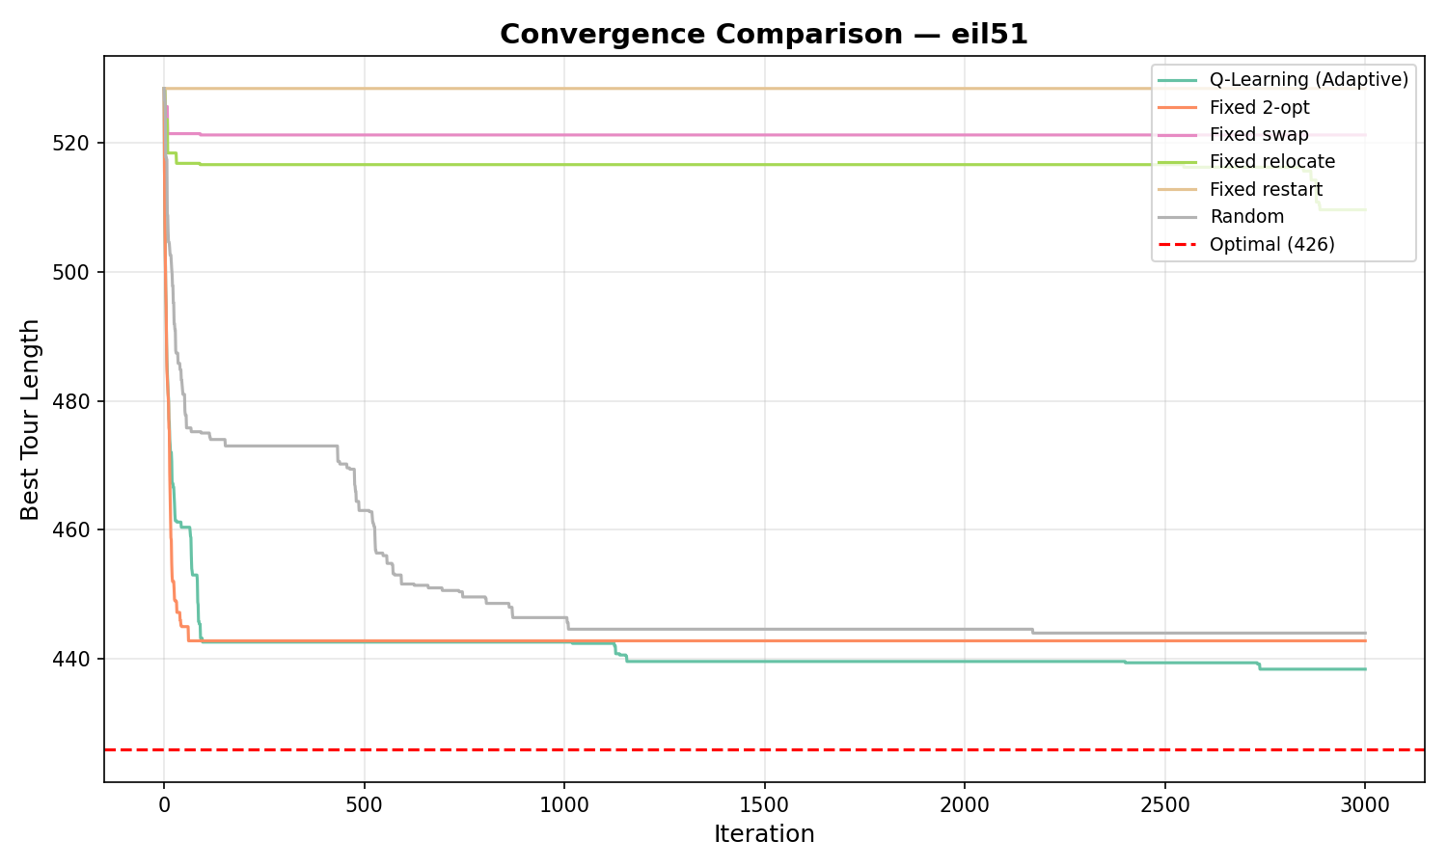 | 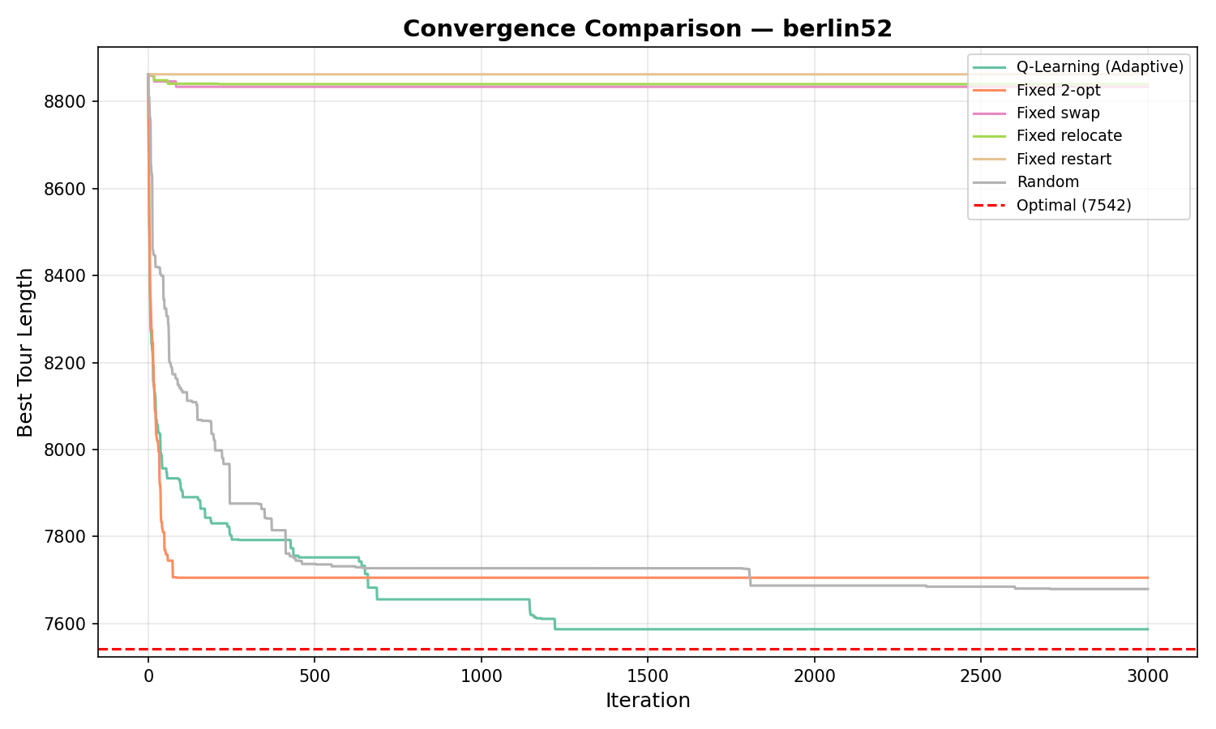
(a) eil51 | (b) berlin52
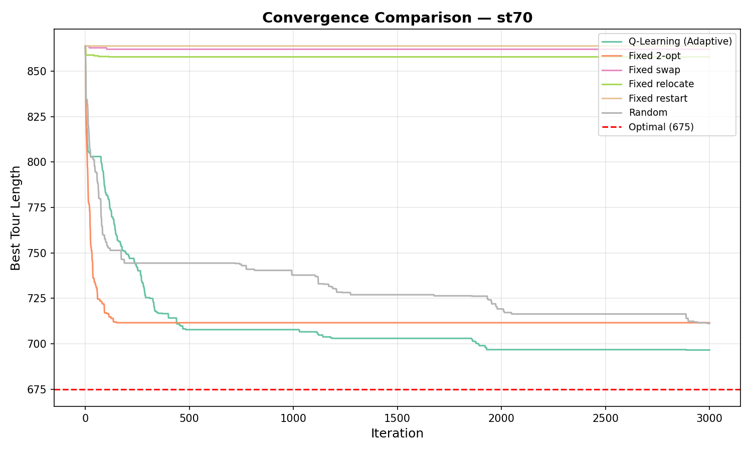 | 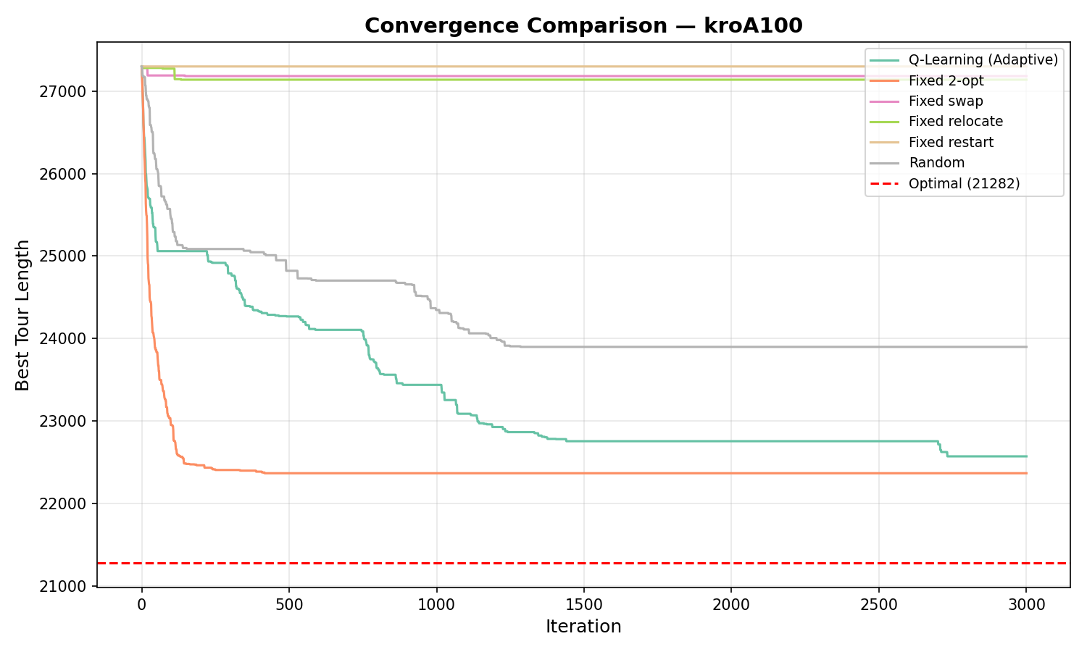
(c) st70 | (d) kroA100
Figure: Convergence curves: best tour length vs. iteration. Red dashed line = known optimal.

Autonomous Operator Synergy Discovery
One of the most remarkable findings derived from the transition probability heatmaps (Figure 2) is the agent's autonomous discovery of complex heuristic sequences. Across all evaluated instances, the Q-agent learned an overwhelmingly strong synergy: swap→2-opt (prob. 1.00).
This signifies that the agent organically learned a foundational principle of advanced TSP metaheuristics (such as Lin-Kernighan): utilizing a perturbation operator (swap) to dislodge the tour from a local optimum, immediately followed by an aggressive refinement operator (2-opt) to optimize the newly exposed edges. The agent achieved this purely through reward-driven exploration without human injection of domain knowledge.
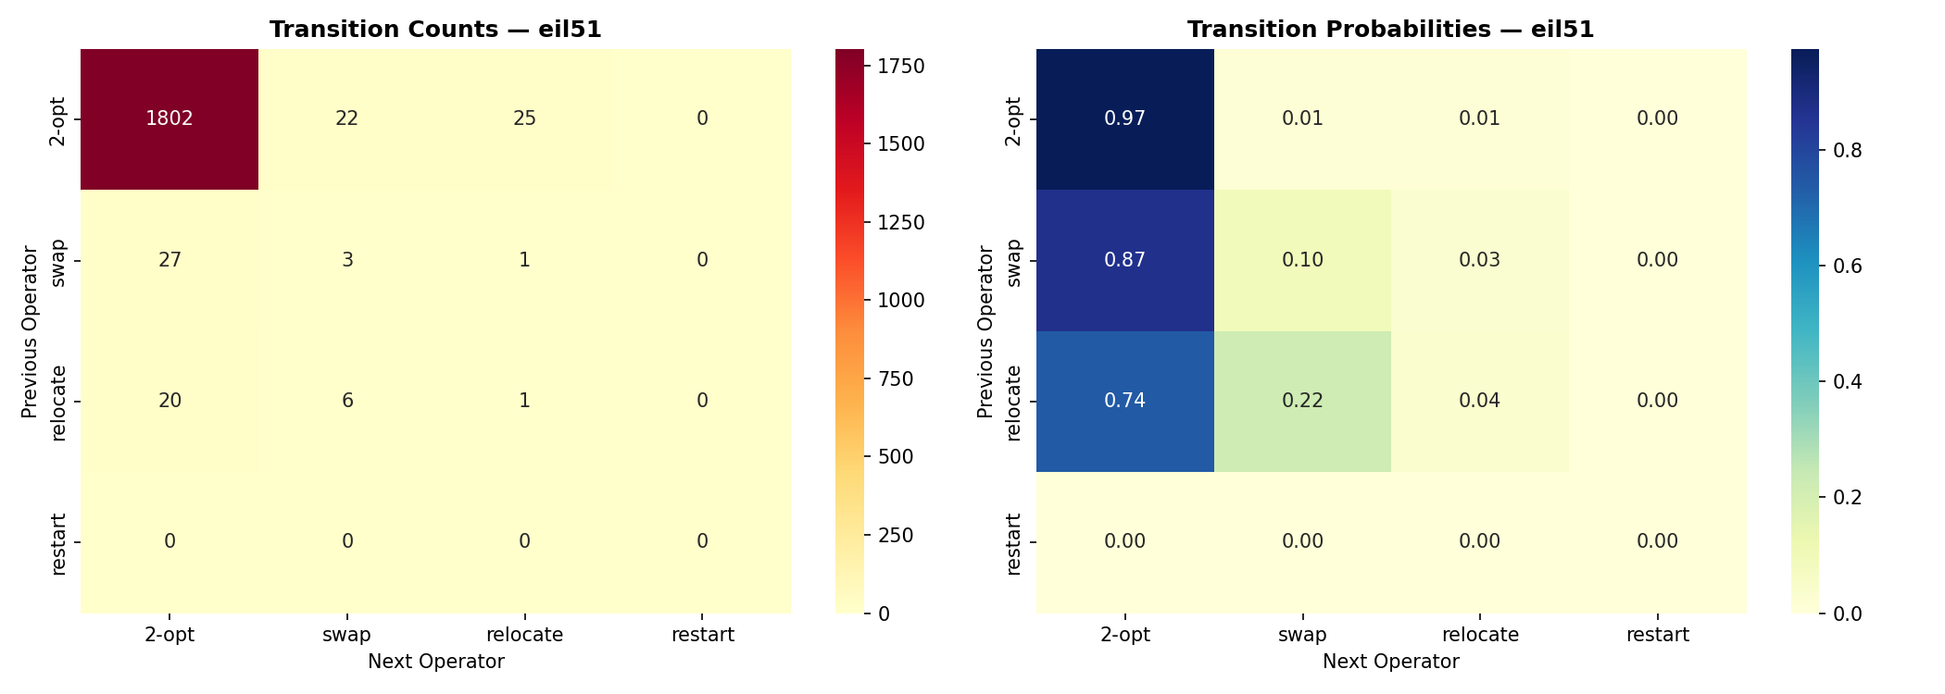 | 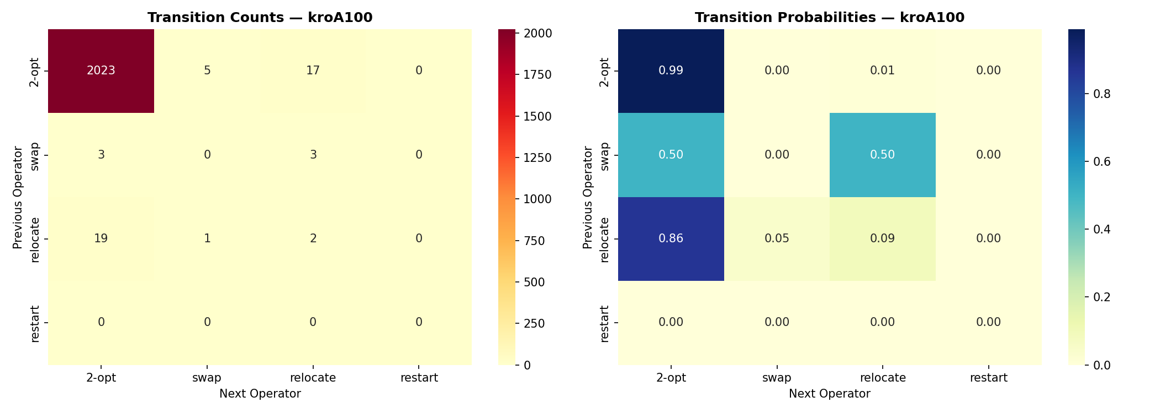
(a) eil51 | (b) kroA100
Figure: Operator transition probability heatmaps after successful moves (restart excluded). Darker cells indicate stronger synergy.

Reward Shaping: R_1 vs. R_2
Both reward functions yielded identical results. When the agent is far from the optimum, nearly every improving step also sets a new best, making R_1 and R_2 equivalent. Near convergence, the +100 bonus is too infrequent to shift Q-values.
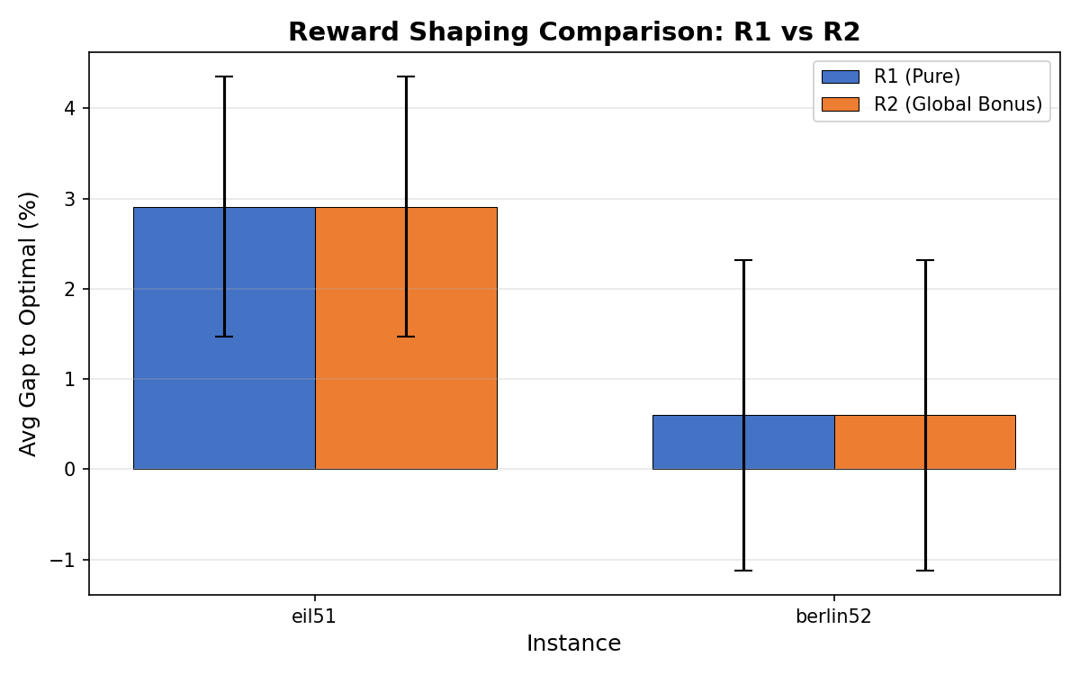
Figure: Average gap for R_1 (Pure) vs. R_2 (Global Bonus) on training instances. Error bars = 1 std.

Table: Epsilon Strategy Results
Strategy | Gap (%) | Restarts
 | eil51 | berlin52 | eil51 | berlin52
Constant ε=0.1 | 3.47±1.15 | 2.04±1.05 | 74.8 | 69.4
Exp. Decay | 4.84±0.87 | 3.19±1.32 | 134.2 | 122.0
Adaptive (Stag.) | 2.14±0.82 | 0.34±0.95 | 116.2 | 110.2

Exponential Decay performs worst despite starting at ε=1.0. As shown in Figure 4, epsilon collapses to near-zero within ≈1,000 iterations, causing the agent to exploit an immature Q-table for the remaining budget. The high restart count confirms repeated escape attempts from early-locked suboptimal policies.
Adaptive Stagnation maintains a meaningful ε throughout, increasing exploration precisely when stagnation is detected (sawtooth pattern visible in Figure 4, right panel), and decaying after improvements.
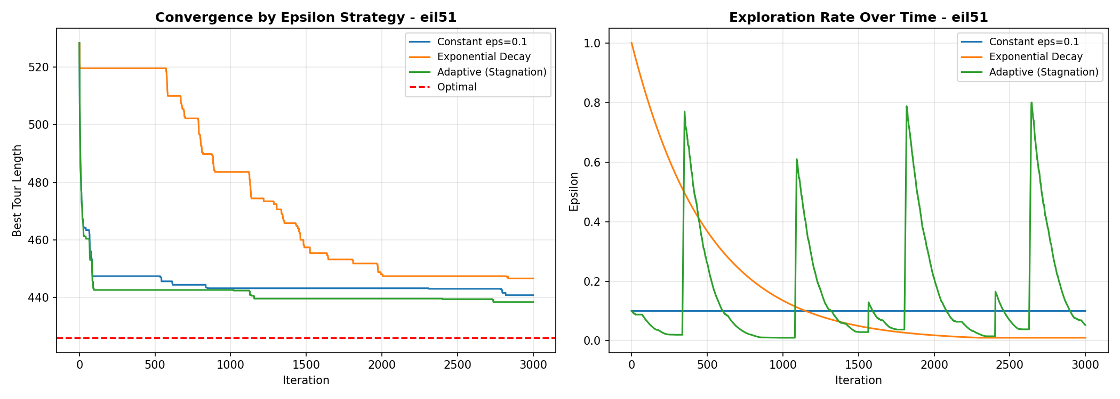
Figure: Epsilon strategy comparison on eil51. Left: convergence curves. Right: ε over time showing Adaptive's sawtooth pattern.

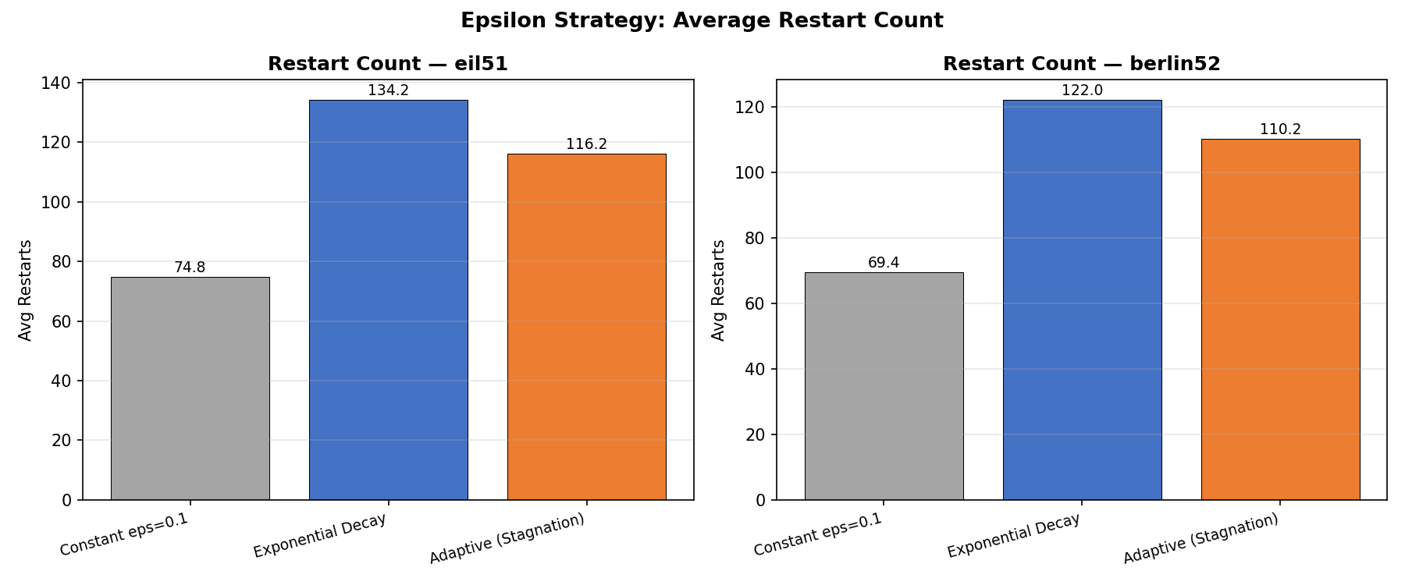
Figure: Average restart count per epsilon strategy. Exponential Decay triggers the most restarts, indicating policy instability.

Q-Table Analysis
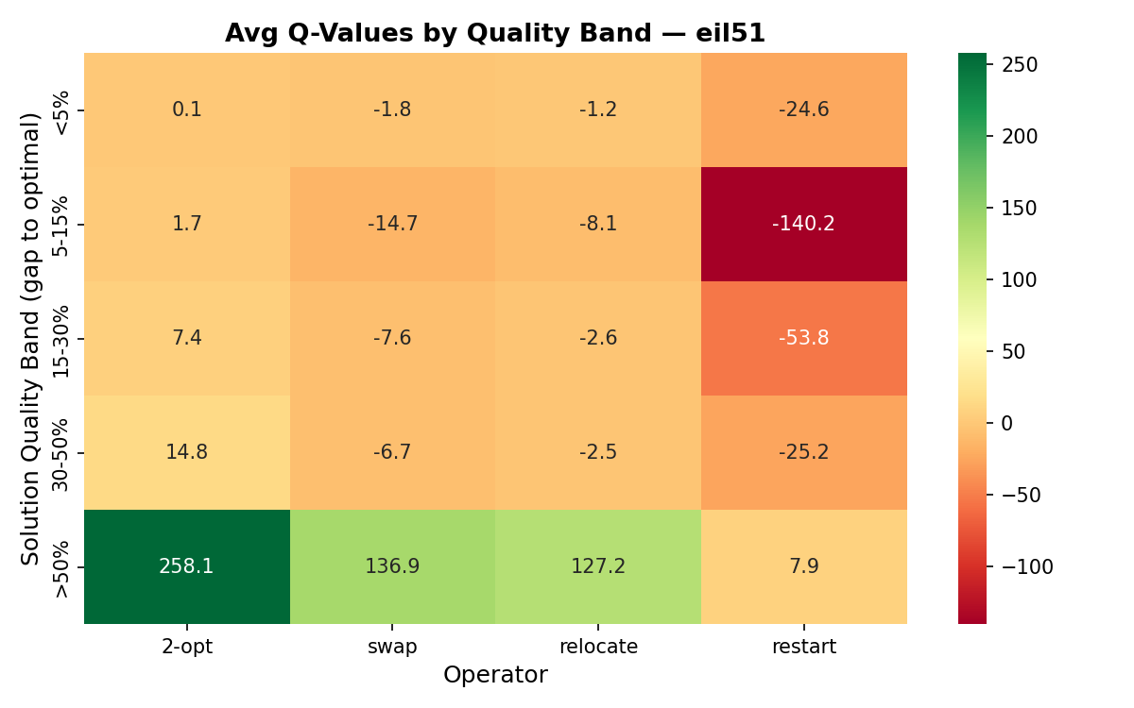 | 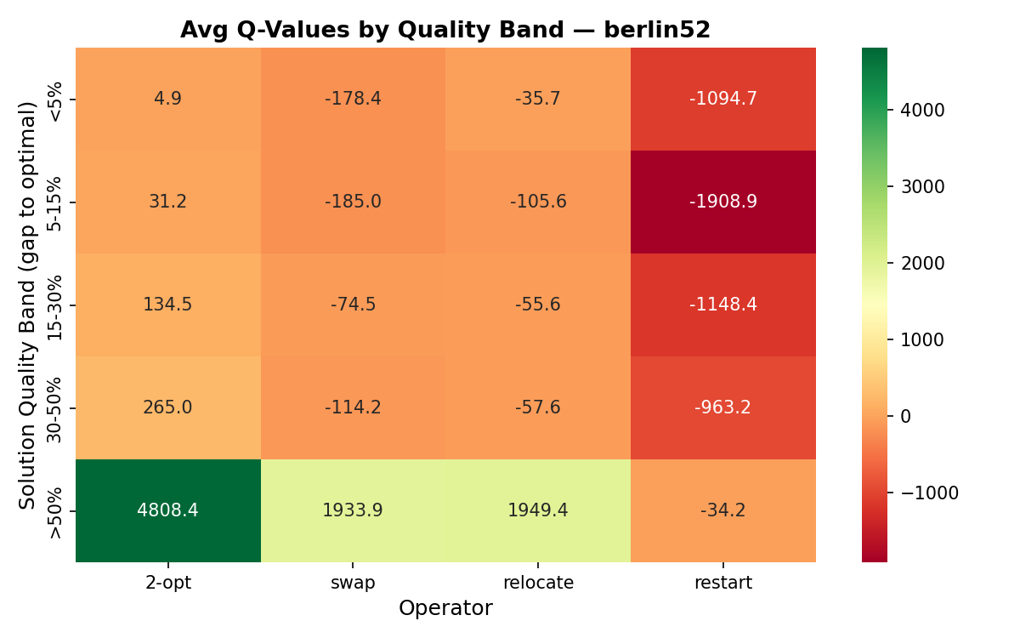
(a) eil51 | (b) berlin52
Figure: Q-values aggregated by solution quality band. Green = high Q-value (preferred operator). Darker red = avoided.

The Q-table heatmaps (Figure 6) reveal a quality-aware learned policy:
- Poor-quality regions (gap >30%): relocate and swap dominate, effective at escaping large local optima.
- High-quality regions (gap <15%): 2-opt dominates, consistent with its strength in fine-tuning near-optimal solutions.
- Restart is uniformly low across all bands –- the agent learns to treat it as a last resort.
This gradient from perturbation-preference to refinement-preference is exactly what an expert practitioner would engineer manually, here discovered autonomously.
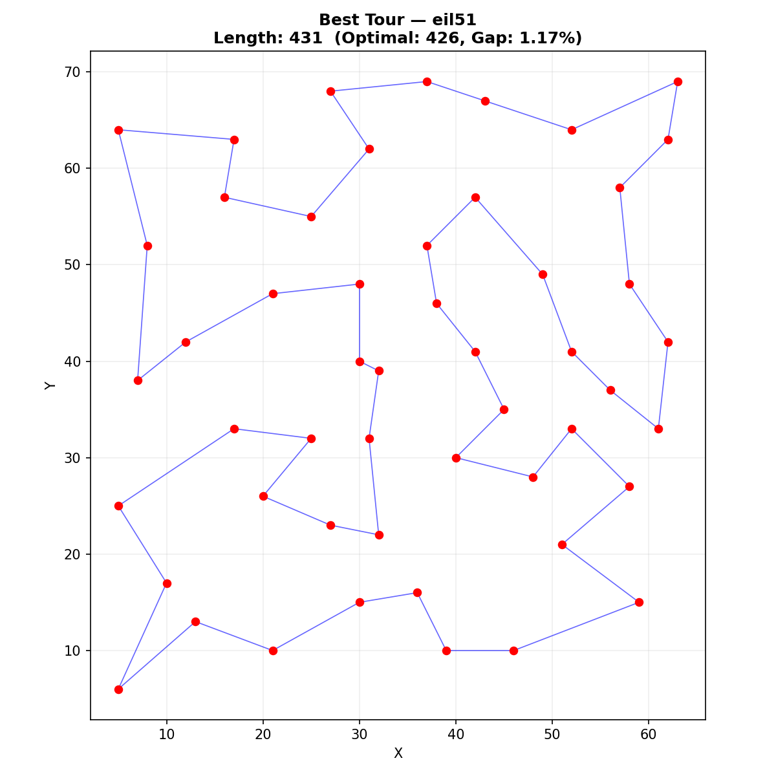 | 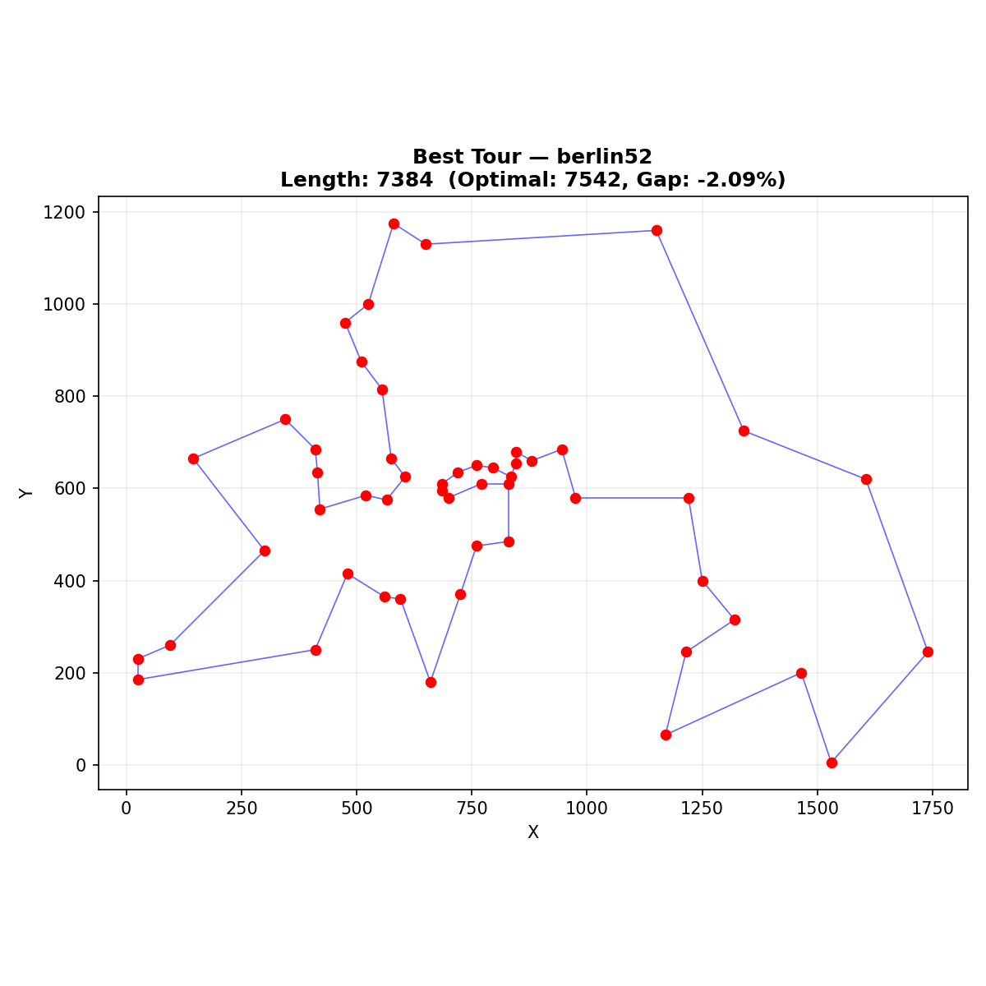
(a) eil51 | (b) berlin52
Figure: Best tours found by Q-Learning. Routes are visually clean with minimal crossing edges.

Generalization Study and State Encoding Limitation
Table: Generalization Test: Mean Gap (%) on unseen instances.
Test Instance | Pre-trained | Fresh Q-Learning
st70 | 4.06±1.48 | 3.87±1.18
kroA100 | 8.17±1.58 | 6.66±1.69

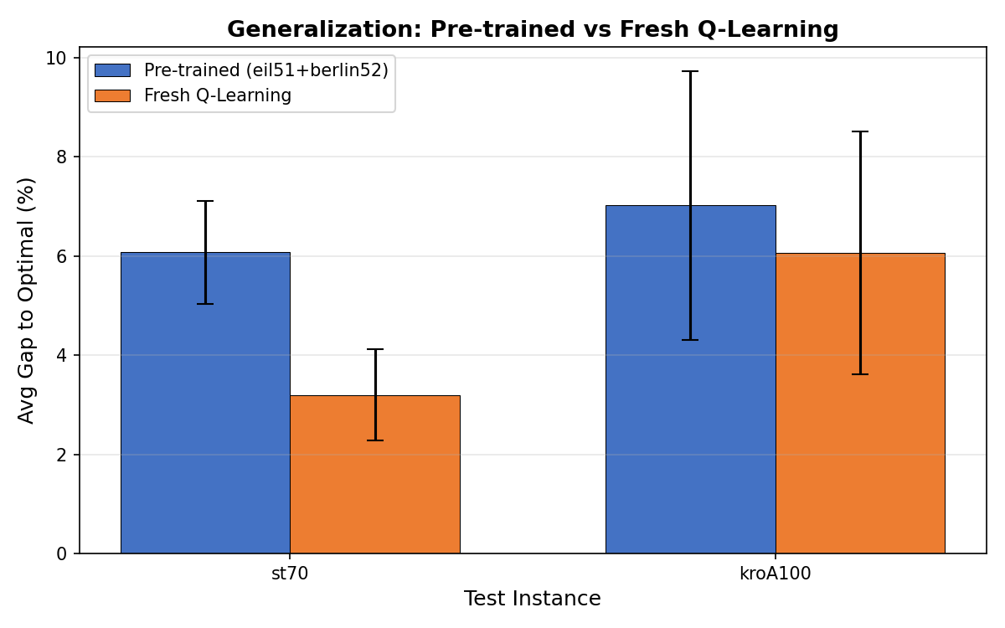
Figure: Pre-trained (eil51+berlin52) vs. Fresh Q-Learning on test instances. Fresh training consistently outperforms direct Q-table transfer.

As Table 5 and Figure 8 show, pre-training on smaller instances does not improve performance on larger unseen ones. This negative transfer highlights a critical limitation in our MDP formulation: the quality_band encoding functions as an "oracle" feature, directly relying on each instance's known optimal TSPLIB value. When transferred to a new instance landscape, this static, instance-dependent reference causes a state distribution shift.

Conclusion
In this project, we presented a tabular Q-learning based hyper-heuristic for adaptive operator selection in TSP local search. Based on the experimental results, the main observations can be summarized as follows:
- The adaptive Q-learning approach generally performs better than the fixed-operator baselines by choosing different operators during the search process.
- The adaptive stagnation-based epsilon strategy gives better results than the other exploration strategies tested in this study.
- The learned operator transitions show that some operator sequences, such as swap→2-opt, can be useful during the search.
- The Q-table shows that the agent changes its operator choices depending on the quality of the current solution.
- The transfer learning results suggest that normalized state features may be necessary for better generalization across different TSP instances.
As future work, the state representation can be improved by using more general relative measures instead of instance-specific values. In addition, deep Q-network (DQN) based approaches can be tested for continuous state features and larger problem instances.

References
- M. R. Garey and D. S. Johnson, Computers and Intractability: A Guide to the Theory of NP-Completeness. Freeman, 1979.
- D. Applegate, R. Bixby, V. Chvatal, and W. Cook, The Traveling Salesman Problem: A Computational Study. Princeton University Press, 2006.
- K. Helsgott, O. Rooij, and R. Wiegand, “LKH: An Effective Implementation of the Lin-Kernighan Heuristic,” European Journal of Operational Research, vol. 126, no. 1, pp. 106–130, 2000.
- E. K. Burke et al., “A Classification of Hyper-heuristic Approaches,” in Handbook of Metaheuristics, Springer, 2010, pp. 449–468.
- H. R. Lourenco, O. C. Martin, and T. Stutzle, “Iterated Local Search,” in Handbook of Metaheuristics, Springer, 2003, pp. 320–353.
- C. J. C. H. Watkins and P. Dayan, “Q-learning,” Machine Learning, vol. 8, no. 3–4, pp. 279–292, 1992.
- D. Meignan et al., “A Review and Taxonomy of Interactive Optimization Methods in Operations Research,” ACM TIIS, vol. 5, no. 3, pp. 1–43, 2015.
- L. Da Costa, F. Guimaraes, and A. Delbem, “Operator Selection with Dynamic Multi-Armed Bandits,” in Proc. GECCO 2008, ACM, pp. 1539–1546.
- S. Lin, “Computer Solutions of the Traveling Salesman Problem,” Bell System Technical Journal, vol. 44, no. 10, pp. 2245–2269, 1965.
- S. Lin and B. W. Kernighan, “An Effective Heuristic Algorithm for the Traveling Salesman Problem,” Operations Research, vol. 21, no. 2, pp. 498–516, 1973.
- I. Or, Traveling Salesman-type Combinatorial Problems and Their Relation to the Logistics of Regional Blood Banking. Ph.D. Dissertation, Northwestern University, 1976.
- I. Bello et al., “Neural Combinatorial Optimization with Reinforcement Learning,” arXiv:1611.09940, 2016.
- W. Kool, H. van Hoof, and M. Welling, “Attention, Learn to Solve Routing Problems!” in Proc. ICLR 2019.
- A. Hottung and K. Tierney, “Neural Large Neighbourhood Search for the Capacitated Vehicle Routing Problem,” in Proc. ECAI 2020, pp. 443–450.
- M. Tokic, “Adaptive ε-greedy Exploration in Reinforcement Learning Based on Value Differences,” in Proc. KI 2010, Springer, pp. 203–210.

