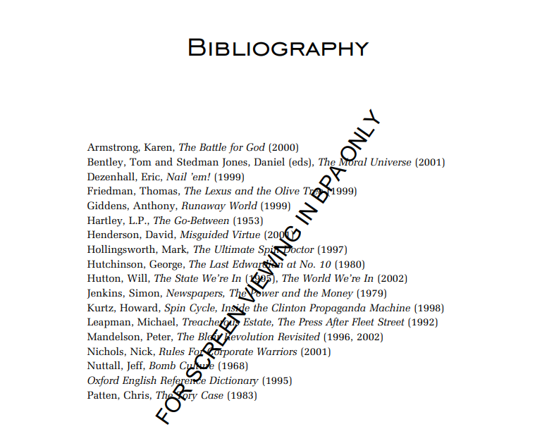

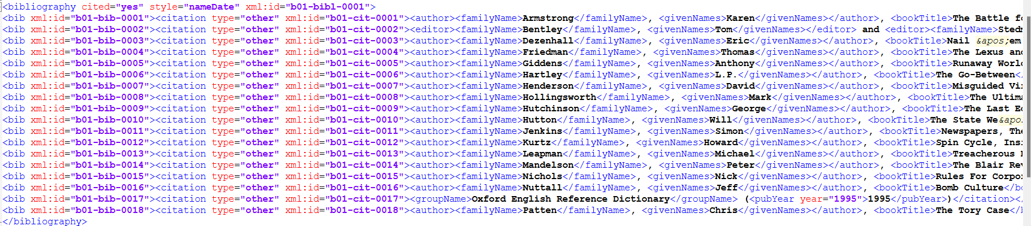

<bibliography cited="yes" style="nameDate" xml:id="b01-bibl-0001">

<bib xml:id="b01-bib-0001"><citation type="other" xml:id="b01-cit-0001"><author><familyName>Armstrong</familyName>, <givenNames>Karen</givenNames></author>, <bookTitle>The Battle for God</bookTitle> (<pubYear year="2000">2000</pubYear>)</citation></bib>

.

.

.

</bibliography>

1)



<bib xml:id="b01-bib-0001">

<citation type="other" xml:id="b01-cit-0001">

< author>

<familyName>Armstrong</familyName>, <givenNames>Karen</givenNames>

</author>

, <bookTitle>The Battle for God</bookTitle>

(<pubYear year="2000">2000</pubYear>)

</citation>

</bib>

<bib xml:id="b01-bib-0001"><citation type="other" xml:id="b01-cit-0001"><author><familyName>Armstrong</familyName>, <givenNames>Karen</givenNames></author>, <bookTitle>The Battle for God</bookTitle> (<pubYear year="2000">2000</pubYear>)</citation></bib>

2)



<bib xml:id="b01-bib-0002">

<citation type="other" xml:id="b01-cit-0002">

<editor>

<familyName>Bentley</familyName>

, <givenNames>Tom</givenNames>

</editor>

and

<editor>

<familyName>Stedman</familyName>

<givenNames>Jones</givenNames>

</editor>

, <editor>

<familyName>Daniel</familyName>

</editor>

(eds), <bookTitle>The Moral Universe</bookTitle>

(<pubYear year="2001">2001</pubYear>)

</citation>

</bib>

<bib xml:id="b01-bib-0002"><citation type="other" xml:id="b01-cit-0002"><editor><familyName>Bentley</familyName>, <givenNames>Tom</givenNames></editor> and <editor><familyName>Stedman</familyName> <givenNames>Jones</givenNames></editor>, <editor><familyName>Daniel</familyName></editor> (eds), <bookTitle>The Moral Universe</bookTitle> (<pubYear year="2001">2001</pubYear>)</citation></bib>

3)



<bib xml:id="b01-bib-0003">

<citation type="other" xml:id="b01-cit-0003">

<author>

<familyName>Dezenhall</familyName>

, <givenNames>Eric</givenNames>

</author>

, <bookTitle>Nail &apos;em!</bookTitle>

(<pubYear year="1999">1999</pubYear>)

</citation>

</bib>

<bib xml:id="b01-bib-0003"><citation type="other" xml:id="b01-cit-0003"><author><familyName>Dezenhall</familyName>, <givenNames>Eric</givenNames></author>, <bookTitle>Nail &apos;em!</bookTitle> (<pubYear year="1999">1999</pubYear>)</citation></bib>

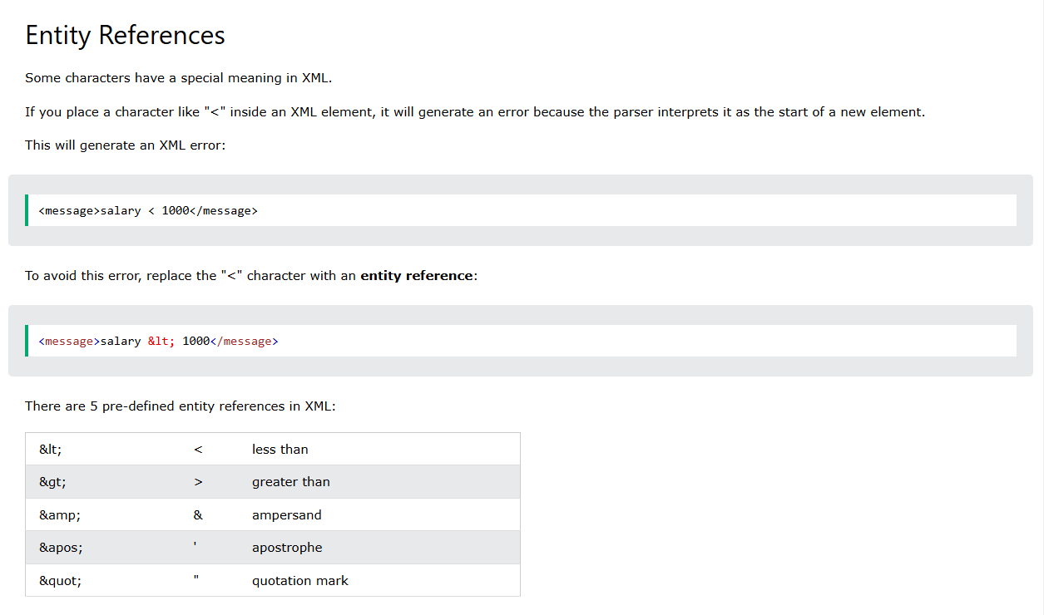

4)



<bib xml:id="b01-bib-0006">

<citation type="other" xml:id="b01-cit-0006">

<author>

<familyName>Hartley</familyName>

, <givenNames>L.P.</givenNames>

</author>

, <bookTitle>The Go-Between</bookTitle>

(<pubYear year="1953">1953</pubYear>)

</citation>

</bib>

<bib xml:id="b01-bib-0006"><citation type="other" xml:id="b01-cit-0006"><author><familyName>Hartley</familyName>, <givenNames>L.P.</givenNames></author>, <bookTitle>The Go-Between</bookTitle> (<pubYear year="1953">1953</pubYear>)</citation></bib>

5)



<bib xml:id="b01-bib-0010">

<citation type="other" xml:id="b01-cit-0010">

<author>

<familyName>Hutton</familyName>

, <givenNames>Will</givenNames>

</author>

, <bookTitle>The State We&apos;re In</bookTitle>

(<pubYear year="1995">1995</pubYear>)

, The World We&apos;re In (2002)

</citation>

</bib>

<bib xml:id="b01-bib-0010"><citation type="other" xml:id="b01-cit-0010"><author><familyName>Hutton</familyName>, <givenNames>Will</givenNames></author>, <bookTitle>The State We&apos;re In</bookTitle> (<pubYear year="1995">1995</pubYear>), The World We&apos;re In (2002)</citation></bib>

6)



<bib xml:id="b01-bib-0010">

<citation type="other" xml:id="b01-cit-0010">

<author>

<familyName>Hutton</familyName>

, <givenNames>Will</givenNames>

</author>

, <bookTitle>The State We&apos;re In</bookTitle>

(<pubYear year="1995">1995</pubYear>), The World We&apos;re In (2002)

</citation>

</bib>

<bib xml:id="b01-bib-0010"><citation type="other" xml:id="b01-cit-0010"><author><familyName>Hutton</familyName>, <givenNames>Will</givenNames></author>, <bookTitle>The State We&apos;re In</bookTitle> (<pubYear year="1995">1995</pubYear>), The World We&apos;re In (2002)</citation></bib>

7)



<bib xml:id="b01-bib-0014">

<citation type="other" xml:id="b01-cit-0014">

<author>

<familyName>Mandelson</familyName>

, <givenNames>Peter</givenNames>

</author>

, <bookTitle>The Blair Revolution Revisited</bookTitle> (1996, 2002)

</citation>

</bib>

<bib xml:id="b01-bib-0014"><citation type="other" xml:id="b01-cit-0014"><author><familyName>Mandelson</familyName>, <givenNames>Peter</givenNames></author>, <bookTitle>The Blair Revolution Revisited</bookTitle> (1996, 2002)</citation></bib>