kubectl.exe create secret generic secret1 --from-literal=key1=value1

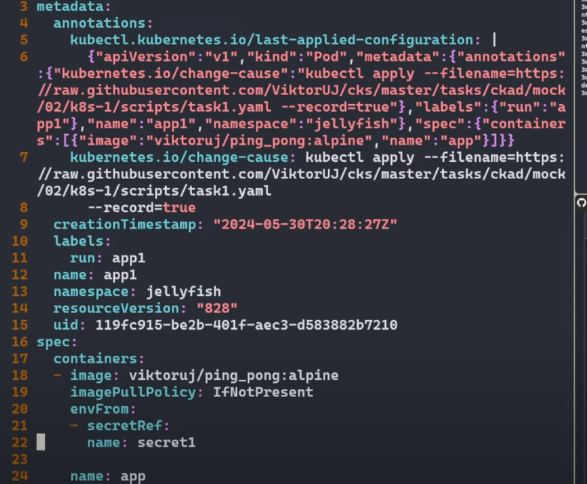

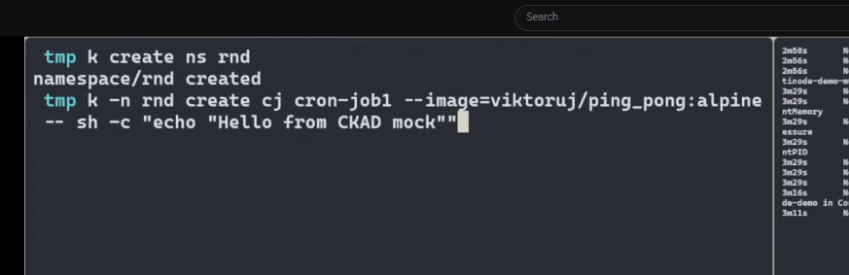

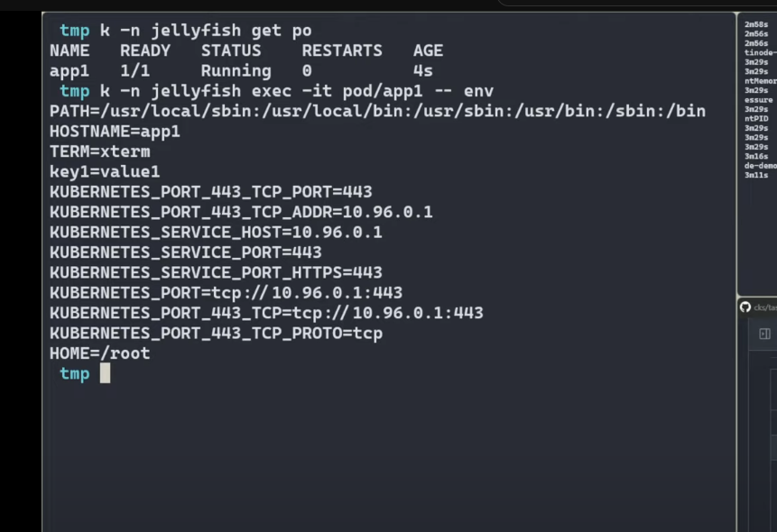

kubectl.exe -n rds create cj cron-job1 --image==victoruj/ping_pong:alpine $do --schedule="*/15 * * * *" -- sh -c "echo 'Hello

from CKAD'"

kubectl.exe explain cronjob.spec | head

GROUP: batch

KIND: CronJob

VERSION: v1

FIELD: spec <CronJobSpec>

DESCRIPTION:

Specification of the desired behavior of a cron job, including the schedule.

More info:

https://git.k8s.io/community/contributors/devel/sig-architecture/api-conventions.md#spec-and-status

anddre@DESKTOP-HGSL44O MINGW64 /e/gitrepo useful/kubectl

$ kubectl.exe explain configmap.spec | head

error: field "spec" does not exist

KIND: ConfigMap

VERSION: v1

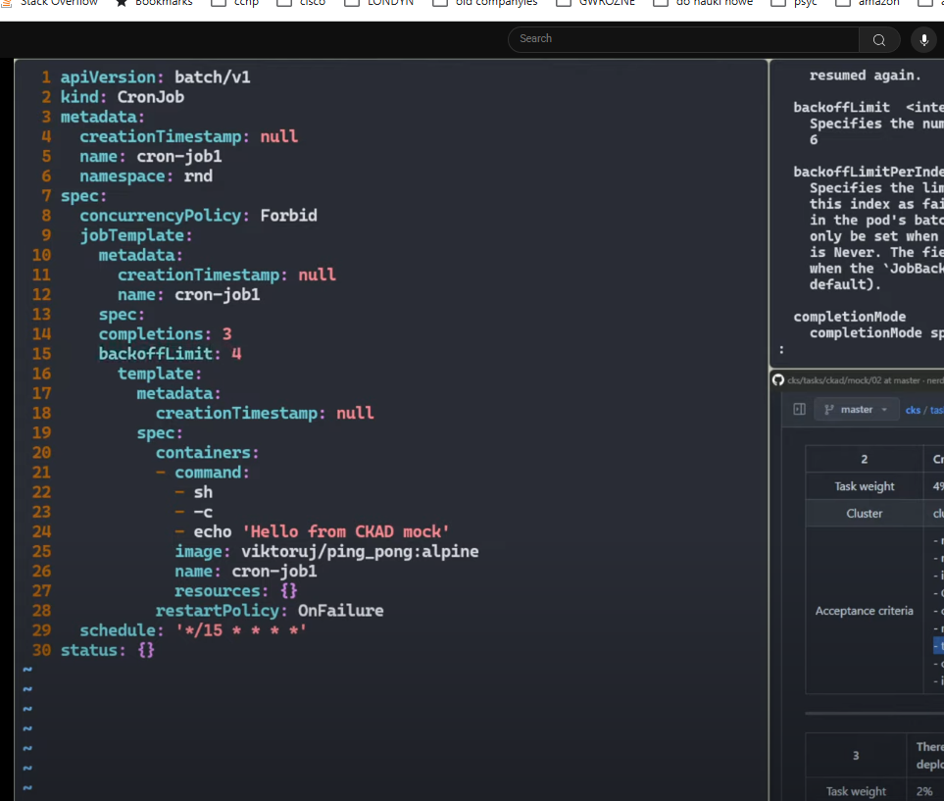

Kubectll get deploy

k-n barracuda history deploy

k -n barracuda rollout history deployment/mydeployment

Concept> storage> persistent volume  
