Setup

Using Setup.docx, setup application on your local machine.

It is advisable to start project from scratch and start adding models, components etc using Angular CLI.

Those who don’t want above, can copy the assignment and run “npm install” command inside SilicusDemo folder via CMD prompt.

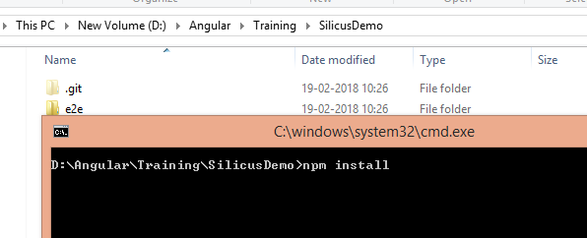

This will create node_modules folder and download all the modules – will take 5-10 minutes.

Please use the Reference UI Files folder for all the html/css/js.

Assignment

First go through the existing application and try running it.

Understand Forms, Services, Routing & Guards etc.

Small but important things, such as how header changes menu based on whether user is logged-in or he is admin or not. This is implemented using Subject in LoginService.

## Forms

1. Register New User (should call add employee api call)
2. Change Password (old password, new password and confirm password)
3. View All Employees (pagination is good to have)
4. View Employee
5. Update Employee

**Note** – Login Form is validated against hardcoded values - Please modify this to use Service data.  
Admin – Username = admin Password = test123  
Employee – username = employee Password = test123

## Services

For above mentioned forms, call the appropriate service methods it is all setup.  
Install json-server from npm

**Command –** npm install -g json-server

**Note** – For API data, you need to run Data Service locally like below

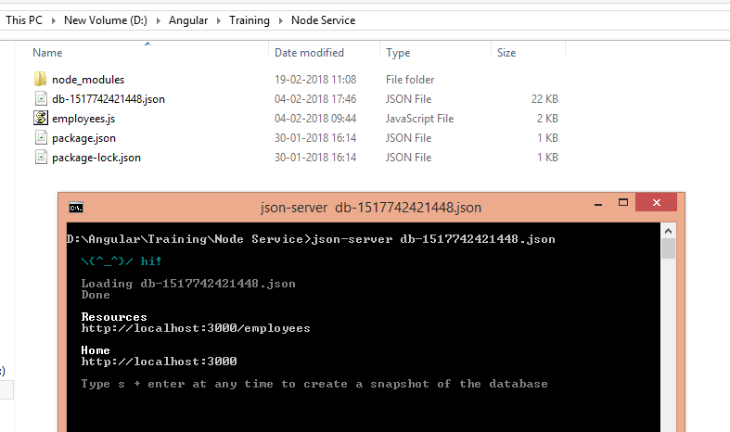

If you have added few employees and then you want to take snapshot, you can press s + enter to save changes to local file. Then you can run json-server <new-file.json>

## Routing

For all the forms added above, add the respective routes.

This includes

1. Routes configuration in App Module
2. Appropriate Guards
3. Router Links (e.g. <a routerLink="/register" routerLinkActive="active">Register Now</a>)

## Gaurds

AuthGaurd – ensures, we cannot access a particular a page without login and redirect to login page.

Implement similar page for Admin Only pages – e.g. View All Employees or View/update other employee by logged-in User.

Please feel to reach us @ [amarnath.pratapwar@silicus.com](mailto:amarnath.pratapwar@silicus.com) & [ajay.birari@silicus.com](mailto:ajay.birari@silicus.com)