**Install Nodejs (LTS version)**

<https://nodejs.org/en/>

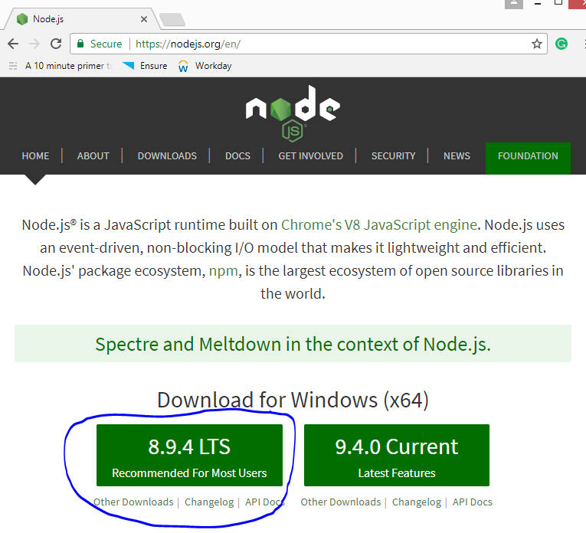

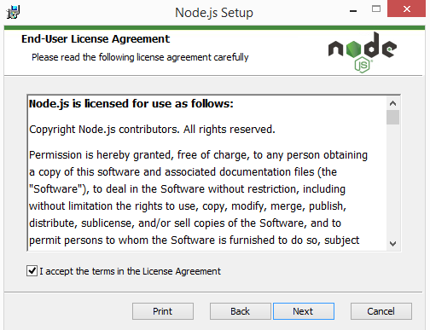

Next…Next… ...Finish

Note – version 8.9.4 at time preparing this document, it may increment in future.

It is recommended to install even if you already have it to update the nodejs + npm.

**Install Angular CLI**

Open Command prompt

npm install -g @angular/cli (for first time users)

OR

npm update -g @angular/cli (if already installed)

Version 1.6.6 was latest.

Note – It is recommended to run command prompt with administrative privileges to avoid errors.

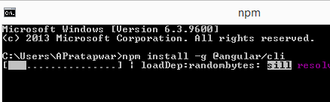

**Create new project**

Open command prompt and run command where you want to create folder

ng new SilicusAngularAssignment

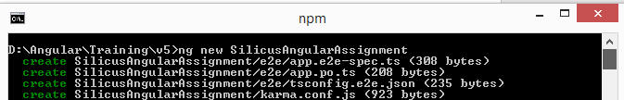

It will take some time to install all the packages by downloading it from registry.

You should see below log after successful completion

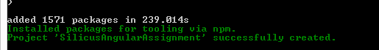

Test running app by below command

>cd SilicusAngularAssignment

>ng serve

Note - Default port is 4200, in case you want different port, use ng serve --port <port number> e.g. ng serve --port 5000, then you can access the site in browser using http://localhost:5000

**Code Editor**

You can use any editor of your choice, I have given example of atom

Download it from <https://atom.io/> and install

Also you may want to install packages like atom-typescript

Let’s Start Implementation