CSS142P Final Project Report
Campus Canteen Checkout Queue Simulation
Group 1
Members: Facultad, Josiah Jaravilla · Juanico, Jessie Jasper, E · Manlulu, Silas P. · Sarenas, Heherson
Date: September 2026

1. Executive Summary
The campus canteen's single checkout lane cannot keep up with lunch-rush demand: our discrete-event simulation shows it saturates completely (100% cashier utilization) and produces an average student wait of about 27.8 minutes, far above a reasonable 3-minute target. We modeled the checkout line as a discrete-event queuing system and compared the current one-cashier baseline against two staffing alternatives — two cashiers and three cashiers — using 30 independent replications per scenario.
Adding a second cashier (Alternative A) drops the average wait to about 1.5 minutes while keeping cashiers productively busy about 80% of the time. A third cashier (Alternative B) drives the wait down further to about 0.2 minutes, but utilization falls to about 53%, meaning the extra cashier is idle more than half the lunch rush. A sensitivity analysis with 15% higher arrival volume confirms the same ranking holds under heavier demand.
Recommendation: the canteen should open a second checkout lane during the 11:30 AM–1:00 PM lunch rush. It is the smallest staffing change that reliably meets the waiting-time target without paying for cashier idle time.

2. Problem and Decision Question
Problem: The canteen manager oversees daily lunch operations. During the lunch rush (11:30 AM–1:00 PM), students queue at a single checkout lane. Long queues cause student frustration, lost lunch time, and occasional late returns to afternoon classes.
Decision-maker: the canteen manager, who controls how many cashiers are staffed during the lunch rush.
Decision question: How many checkout cashiers (1, 2, or 3) are needed during the lunch rush to keep the average student waiting time at or below a 3-minute target, without leaving cashiers mostly idle?
System boundary: the model covers only the checkout/payment step, from the moment a student with a food tray joins the checkout line to the moment they finish paying and leave. Food selection, cooking, and food-preparation queues are outside the boundary.

3. System Boundary and Conceptual Model

3.1 Conceptual model (process flow)
Student arrives with tray → joins single FIFO queue → waits for the next free cashier → is served (scan items, pay, bag) → departs. When all cashiers are busy, arriving students wait in line; the queue has no capacity limit (students do not balk in this model).
- Entities: students (customers) with a completed food tray, ready to pay.
- Resources: checkout cashiers — 1 (baseline), 2 (Alt A), or 3 (Alt B). Each cashier serves one student at a time.
- Queue discipline: single first-in-first-out (FIFO) line feeding all open cashiers.
- Inputs: student interarrival times, per-student checkout service time.
- Outputs: waiting time per student, cashier utilization, number of students served.
- Sources of randomness: interarrival times (exponential) and service times (lognormal).
Text-based state diagram: ARRIVE → [cashier free?] —yes→ SERVICE → DEPART; [cashier free?] —no→ WAIT_IN_QUEUE → (cashier frees up) → SERVICE → DEPART.

3.2 Out of scope
- Food preparation and cooking time upstream of checkout.
- Seating availability after checkout.
- Cash register breakdowns or system downtime.
- Differences between cash and cashless payment methods.
- Meal periods outside the 11:30 AM–1:00 PM lunch rush.

4. Input Data and Assumptions
No confidential or personally identifiable data was used. All values below are documented synthetic assumptions grounded in typical canteen operating patterns, as permitted by the project guidelines when a formal timing study is not conducted.
Parameter | Value | Distribution | Source / justification
Lunch rush window | 90 min (11:30–1:00) | Fixed | Canteen's posted peak period
Mean interarrival time | 1.0 min (~60/hr) | Exponential | Documented synthetic estimate of typical single-line demand
Mean service time | 1.6 min | Lognormal (CV=0.5) | Reflects scan + payment + bagging; right-skewed for occasional slow transactions
Cashiers (Baseline / A / B) | 1 / 2 / 3 | Fixed | Current policy vs. two proposed staffing levels
Waiting-time target | 3.0 min | Decision threshold | Group-set threshold for acceptable lunch-period wait

Full parameter list with justifications is also provided in Data/input_assumptions.csv.

5. Simulation Method and Implementation
Method: discrete-event simulation, implemented in Python with the SimPy library. State changes only at two event types — a student arrival and a checkout completion — which matches SimPy's process/resource model directly and keeps the implementation transparent and auditable, unlike a continuous or purely analytical approach.
Implementation summary: each simulated student is a SimPy process that requests a unit of the shared 'cashiers' Resource (capacity = 1, 2, or 3 depending on scenario), waits until granted, is served for a random lognormal duration, then departs. Arrivals are generated by a separate process drawing exponential interarrival times. Key parameters (interarrival mean, service mean, CV, cashier count, arrival-rate multiplier) are exposed as function arguments so scenarios and the sensitivity analysis reuse the same code path. The model runs without unresolved errors and produces the reported measures directly (see Model/CSS142P_FinalProject.ipynb).
Performance measures and computation:
- Average waiting time (minutes): mean, over all served students in a run, of (service start time − arrival time).
- Cashier utilization (fraction): total cashier-minutes spent serving, divided by (number of cashiers × 90 simulated minutes), capped at 1.0.

6. Verification and Validation
Three documented checks were used to confirm the model behaves as intended:
Check | Result | Detail
Zero-demand edge case (interarrival → ∞) | PASS | 0 students served, 0 min average wait, as expected with no arrivals.
Light-traffic case vs. M/G/1 analytical formula | PASS | Simulated wait 0.489 min vs. Pollaczek–Khinchine analytical estimate 0.625 min (relative error 22%, consistent with finite-horizon sampling noise).
Monotonicity: more cashiers should not increase wait | PASS | Mean wait strictly decreases: 27.76 → 1.52 → 0.18 min as cashiers go from 1 to 3.

Full detail is in Results/verification_validation_checks.csv.

7. Experiment Design
Scenarios: one baseline (1 cashier) and two alternatives (2 cashiers, 3 cashiers), compared under identical arrival and service assumptions.
Replications: 30 independent replications per scenario, each with a distinct fixed seed (base seed 1000; seeds 1000–1029), so results are reproducible and comparisons are paired across the same random-number stream index.
Controlled variables held constant across scenarios: lunch-rush duration (90 min), mean interarrival time, service-time distribution and parameters, and the random seed list. Only the number of cashiers (and, in the sensitivity analysis, the arrival-rate multiplier) was varied.
Performance measures compared: average waiting time and cashier utilization (with number of students served tracked as a supporting measure).
Sensitivity analysis: all three scenarios were re-run with arrival rate increased by 15%, using the same seed list, to test whether the recommendation holds under heavier-than-assumed demand.

8. Results and Uncertainty Analysis

8.1 Baseline experiment (n = 30 per scenario)
Scenario | Avg. wait (min), 95% CI | Utilization, 95% CI | Students served
Baseline (1 cashier) | 27.76 [25.64, 29.87] | 1.00 [1.00, 1.00] | 89.1
Alt A (2 cashiers) | 1.52 [1.18, 1.86] | 0.80 [0.77, 0.83] | 90.2
Alt B (3 cashiers) | 0.18 [0.14, 0.22] | 0.53 [0.51, 0.56] | 90.6

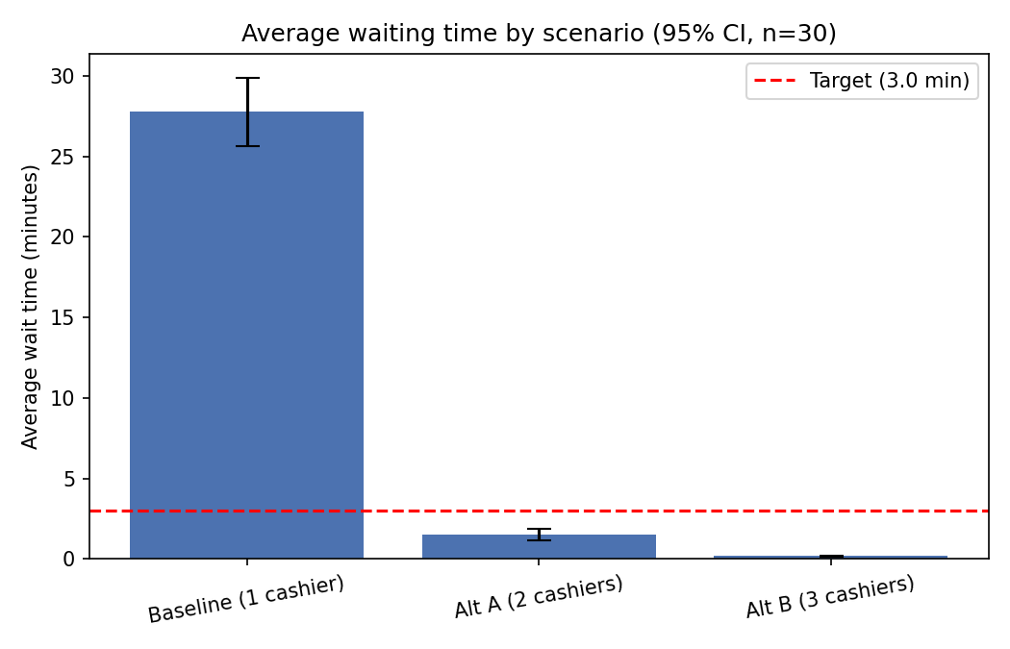
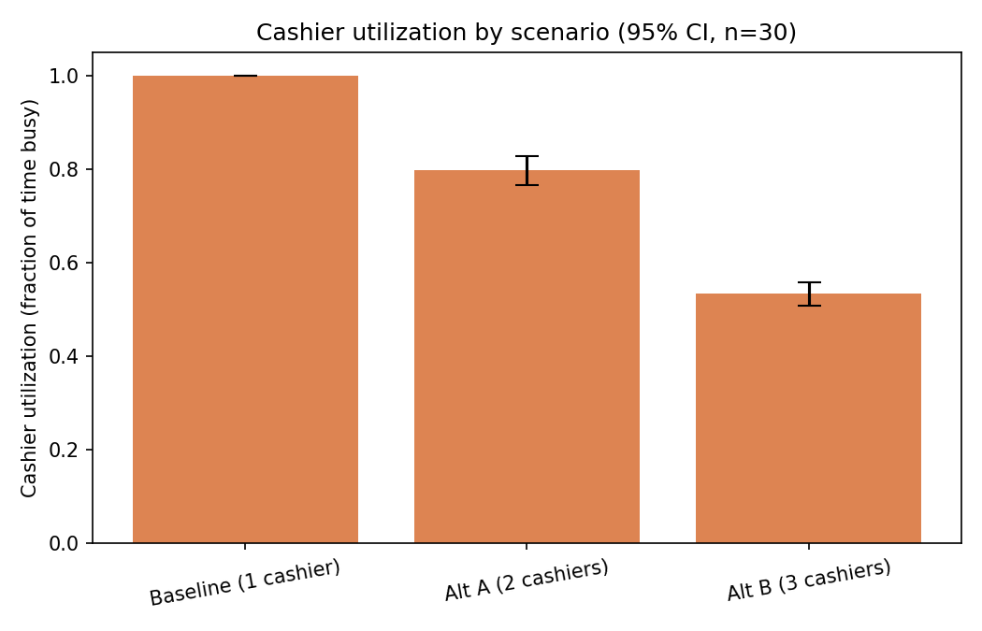

8.2 Sensitivity analysis (+15% arrival rate)
Scenario | Avg. wait (min) | Utilization
Baseline (1 cashier) | 33.78 | 1.00
Alt A (2 cashiers) | 2.57 | 0.90
Alt B (3 cashiers) | 0.32 | 0.61

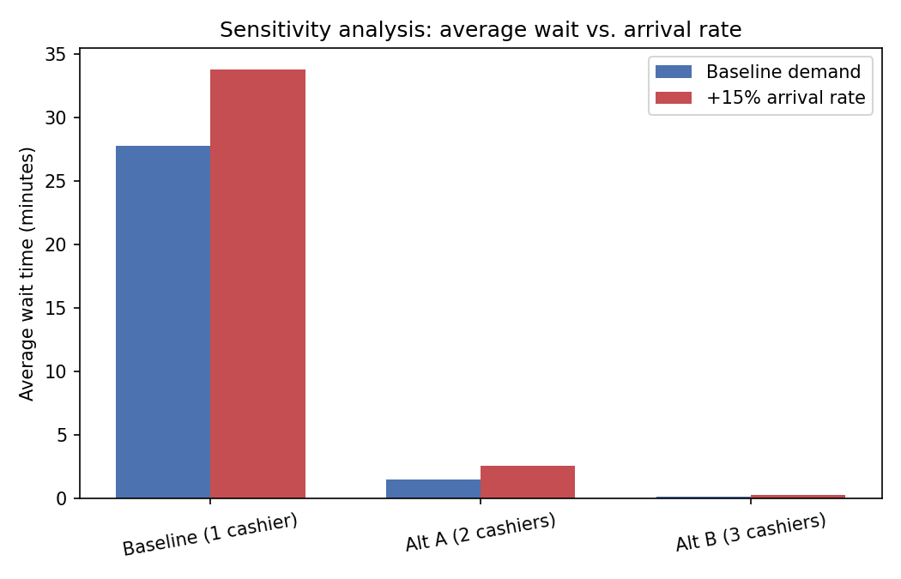
Interpretation: the baseline is unstable under either demand level — utilization pins at 100% and waiting time grows without bound over a longer rush. Alt A comfortably meets the 3-minute target at both demand levels while keeping utilization in a healthy 80–90% range. Alt B always meets the target with room to spare, but its utilization (53–61%) shows the third cashier is under-used most of the time. The 95% confidence intervals for average wait do not overlap between any two scenarios, so the ranking (Baseline worse than Alt A worse than Alt B) is statistically clear, not a sampling artifact.

9. Recommendation and Limitations
Recommendation: open a second checkout cashier lane during the 11:30 AM–1:00 PM lunch rush (Alternative A). It reduces average waiting time from about 28 minutes to about 1.5 minutes, meets the 3-minute target with margin even if demand rises 15%, and keeps both cashiers productively busy (~80–90% utilization) rather than paying for a third cashier that would sit idle nearly half the time.
When this recommendation applies: it assumes lunch-rush demand and service-time patterns similar to the documented assumptions in Section 4. If actual measured arrival rates or service times differ substantially, the model should be re-calibrated with real timing data before the staffing decision is finalized.
Limitations:
- Input parameters (arrival rate, service time) are documented synthetic estimates, not measured from the actual canteen; results should be validated against real timing data collected on-site.
- The model assumes no student balking or reneging (students never leave the line early), which may overstate waiting times at the most congested baseline scenario.
- A single FIFO queue is assumed; if the canteen instead uses parallel independent lines per cashier, results would differ slightly due to line-choice imbalance.
- Only checkout is modeled; if food-preparation delays are a binding constraint elsewhere in the system, adding cashiers alone may not fully resolve student wait times.
- The analysis does not include the direct labor cost of staffing an additional cashier, which the manager would need to weigh against the wait-time improvement.

10. References
SimPy Documentation. SimPy: Discrete-event simulation for Python. https://simpy.readthedocs.io/
Pollaczek, F., and Khinchine, A. Y. Classical results on the M/G/1 queue (Pollaczek–Khinchine formula), as presented in standard queuing theory references.
CSS142P Final Project Requirements and Guidelines (course document).

11. Appendices
Appendix A: full per-replication results are provided in Results/replication_raw_results.csv (30 replications × 3 scenarios, baseline demand).
Appendix B: complete scenario summary with 95% confidence intervals is in Results/scenario_summary_95ci.csv; sensitivity-analysis results are in Results/sensitivity_plus15pct_arrivals.csv.
Appendix C: the executable model, with all cells pre-run, is in Model/CSS142P_FinalProject.ipynb.

