**CHAPTER 1:**

**DENTAL SMART CARE**

1.0 INTRODUCTION

The need to constantly check the condition of one’s teeth has gradually grown since 90% of all adults have carious lesions. An early detection of these carious lesions has become an important aspect of maintaining dental health. It has been reported that with the advent of modern dentistry, the rate of caries growth has changed due to advances in dentistry and preventative care. This has triggered the need for many dental checkups across the globe. But with this there comes with it lots of fears due to the condition on the patients teeth or the accessibility to the dentists that has pushed many patients to retreat from having these dental trips. This has therefore pushed for the need of dental smart kits that can also be used at home or at the patient’s own comfort. The main aim of these kits is to enable the patients know if they have or are developing carious lesions. With this detection, patients can therefore seek for advice from dentists on how to have proper oral care. Considering patient friendly dry methods whereby teeth conditions can be scanned by a camera and with the incorporation of sound sensors, beeping sounds can help detect presence of carious lesions.

**1.1 OBJECTIVES**

***1.1.1 GENERAL OBJECTIVE***

The general objective of this work is to develop an optical imaging method of detecting dental caries.

***1.1.2 SPECIFIC OBJECTIVES***

* Use a commercial bore scope to acquire reflectance images of dental dummies for both healthy teeth and demineralized teeth.
* Develop an algorithm to Pre-process; (de-noise and remove uneven illumination )on the acquired images.
* Use the Pre-processed images to train Artificial Neural Network (ANN) for classification of healthy and demineralized teeth.
* Validate the trained neural network with a different set of images.

**CHAPTER 2:**

**2.0 THEORETICAL BACKGROUND**

**2.1.1 BACKGROUND ON HUMAN DENTAL SYSTEM**

**2.1.2 FORMATION OF IMAGES**

Images form when light from the source is reflected by the object to the observer.

**Reflectance is defined as the measure of the proportion of light or other radiation striking a surface which is reflected off it.**

**\*\*formula\*\***

Part of the light is absorbed by the object and part of it is reflected to the observer thus making it easier for the observer to see the image of the object. The intensity of light is like the brightness and it is measured as the rate at which light energy is delivered to a unit surface.

**2.1.3 IMAGE FORMATION ON DIGITAL CAMERAS.**

A charge coupled device (CCD) array of sensors is used to record digital images in the visible spectrum. It senses and converts images into electric signals. This is done by sampling a real image formed by a lens onto the sensor as shown below.

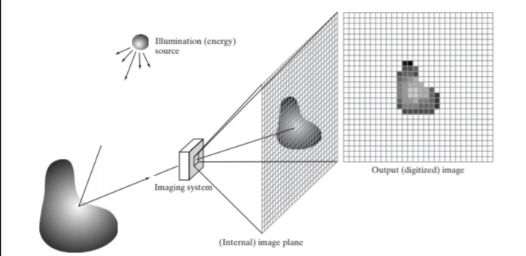

fig 2.1.4

***this is an example of the digital image acquisition process (a) Energy (“illumination”) source;***

***(b) An element of a scene; (c)Imaging system; (d) Projection of the scene onto the image plane; (e) Digitized image***

The CCD is actually in the shape of array or rectangular grid. It is like a matrix with each cell in the matrix containing a sensor that senses the intensity of a photon.

|  |  |  |  |
| --- | --- | --- | --- |
|  |  |  |  |
|  |  |  |  |
|  |  |  |  |
|  |  |  |  |

Each box contains a sensor to sense the intensity of the photon .

An image is defined as a 2D function of the CCD array that represents the intensity of light reflected from an object.

Charges stored on the CCD are converted to voltage one pixel at a time, with the help of additional circuits, the voltage is converted into digital information and then it is stored .

The no. of sensors represents the no. of pixels.

In physics, sound is a vibration that typically propagates an audible wave of pressure through a transmission medium such as gas, liquid or solid.

This project will require both the knowledge of image formation and how to perceive sound waves in order to get our device to produce a beeping sound in the case a carious lesion is detected.

In this case, we will require to use an electrical toothbrush , sound sensor and a bore scope that will be incorporated within the brush .

**CHAPTER 3:**

**3.0 METHODOLOGY**

*3. 1.1 COLLECTION OF DATA AND ANALYSIS.*

Carious lesions develop in different stages as stated by Susan Higham et al “ Caries Process and prevention Strategies : Demineralization / Remineralization”, this makes the depth of the caries a major deal in trying to detect them. Therefore a study will be done on dental learning facilities like ‘Dental dummies’. This will enable one to detect the different levels of carious lesions on a tooth.

Images of the carious lesions will be acquired by a commercial bore scope on the dental dummies for both healthy and demineralized teeth, thereafter an algorithm to Pre-process, de-noise and removing of uneven illumination will be developed. This algorithm will enable the use the Pre-processed images for training Neural Network which will enable the detection of dental caries .

In addition to this, it should be kept in mind that the light being shone on the carious lesions is strictly in the visible spectra.

***3.1.2 HOW IT WORKS.***

With the incorporation of a small CCD and a sound sensor within the electrical toothbrush, the patient is required to first of all ;

* Turn on the toothbrush
* Pass it around the mouth for scanning
* In the case carious lesions are detected, the sound sensor will immediately produce a beeping sound to alert the patient.

This process will enable the patient know that in as much as they are brushing their teeth, they have carious lesions in their teeth. This will further trigger the need for the patient to visit a nearby dental clinic for consultation purposes with the specialists. The initial stages of carious lesions are characterized by a partial dissolution of the tissue leaving a (2-5) micrometer thick mineralized surface layer and a subsurface lesion with a mineral loss of 30% to 50% extending into the enamel and dentin(Susan Higham et al “Caries Process and Prevention Strategies : Demineralization/Remineralization. The main goal is to stop the process at the “***white spot lesion stage”,*** when the intervention can still be non-surgical.

If the carious lesions advances to the outer enamel layer, it eventually becomes cavitated , at this point the lesion is non reversible hence the requirement of surgical intervention.

Beeping sounds indicate the presence of carious lesions .

Since the brush can be moved comfortably in the mouth, each tooth is most likely to be scanned and detected individually.

If no carious lesions are observed, no beeping sound would be produced so as to avoid giving the patient false alarms about the dental health.

**3.1.4 ADVANTAGES**

* ***privacy***

A patient is guaranteed privacy since this whole process can be done at their own place of comfort.

* ***Portability***

Given that this device can be moved about easily, this makes it easier for use by the patient.

* ***Efficiency***

Since the device will have an incorporated camera and sound sensor, the outcome given to the patient would be from a reliable source.

* ***Hygiene***

Since this device would be used by only a single person, each entitled to their own, hygiene is one major thing every individual would want to ensure is observed.

* ***safety***

This device would be absolutely safe and patient friendly since the light shone on the teeth would be of acceptable wavelengths only and their exposure to the patient would not bring any trouble to them.

**3.1.5 LIMITATIONS**

* ***cost***

A major thing that may affect the use of this device is the pricing which many people may opt to go for the normal much cheaper brushes instead of the smart care one.

* ***lack of desire to adapt to new dental technology***

Many people are already used to the old ways to detecting carious lesions that introducing smart care to them may not embraced with open arm

* ***misunderstanding of the new dental technology***

When new technology is introduced to people and not many of them have been educated on the advancement of the technology, misunderstanding it becomes so easy and hence embracing it becomes a whole other difficult thing.

**3.1.6 EXPECTED OUTCOME**

It would be expected that in the event a carious lesion is observed, a beeping sound would be produced by the sound sensor which will then inform the patient of the dental health. Sound teeth would not produce any beeping sound whereas demineralized teeth would produce the beeping sound

**CHAPTER 4:**

**4.0 LITERATURE REVIEW**

There are several methods currently being used by the General Dental Practitioners(GDP s)

1. Fluorescent Fiber Optic Trans illumination (FOTI)
2. Digital Fluorescent Fiber Optic Trans illumination (DIFOTI)
3. Fiber Optic Coupled Polarization Resolved Raman Spectroscopic System
4. Quantitative Light induced Fluorescence (QLF)
5. DIAGNOdent pen

**4.1 Fluorescent Fiber Optic Trans-illumination (FOTI).**

A study by Barnes, C. M.(2005). Dental hygiene participation in managing incipient and hidden caries. ***Dent Clin North Am, 49(4), 795-813, vi-vii*** and Davies, G.M. ,Worthington , H.V.,Clarkson, J.E .,Thomas , P.,&Davies, R.M (2001). The use of fiber optic trans illumination in general dental practice. ***British Dental Journal, 191(3),145-147,*** shows that FOTI is a visual technique that uses the principle of illumination of teeth to detect presence of caries. The demineralized areas of the tooth scatter more light than the sound parts.

The principle behind the working of FOTI is based on light scattering. Sound enamel is composed of densely packed modified hydroxyapatite crystals which give it a transparent structure hence the tooth color is greatly influenced by the underlying dentin shade.

When the enamel is disrupted in the presence of demineralization, the penetrating photons of light are scattered which results to an optical disruption. FOTI makes use of the optical properties of the enamel . The light shone through the teeth scatters and observed shadows may indicate the presence of caries since demineralized ares of the tooth scatter more light than the sound parts.

***4.1.1 For posterior approximal caries.***

Light probe position should be above the gingival margin of the tooth. The light source should be directly perpendicular to the approximal area to prevent direct observation of the beam of light and also to allow diffraction between demineralized and sound tooth structure.

Approximal decay will produce a dark shadow on the occlusal margin ridge.

***4.1.2 For anterior approximal carries.***

Light is shown on the buccal surface and should also be above the gingival margin.

***4.1.3 Advantage.***

**FOTI** can be used for detection of caries on all surfaces although it is more convenient for proximal lesions. It is also good for early detection of dental carries.

This system has it’s own limitations in as much as it has advantages;

***4.1.4 Limitations.***

* The system is subjective.

it’s analysis is done by the examiner who makes the judgment based on the appearance of scattering of light

* No data continuity

It is not possible to record the image seen for future reference.

* **FOTI** can only be used for coronal tooth surfaces and not below the gingival margin

**4.2 DIGITAL IMAGING FIBER OPTIC TRANS -ILLUMINATION (DiFOTI).**

This is a technique that builds on **FOTI** and also allows the recording of images of carious lesions during illumination.

It employs high intensity light and has an additional gray scale camera.

There are two types of cameras available for use with the DIFOTI**;**

***4.2.1 Proximal surface mouthpiece.***

This is used for detecting inter-proximal and smooth surface caries. Light is shown from either the buccal or lingual surface and the image recorded from from the opposite surface with the attached camera.(***pretty, maupome,2004)***

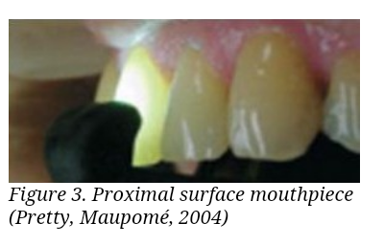

***fig 4.2.1***

***4.2.2 Occlusional surface mouthpiece.***

This is used for detecting caries on the Occlusional surface. The mouthpiece illuminates the tooth through both the buccal and lingual surfaces and captures the image from the top of the tooth.(***pretty, maupome,2004)***

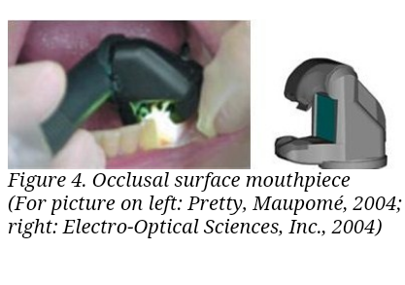

***fig 4.2.2***

**DiFOTI** technique has superior sensitivity compared to conventional radiology methods for the detection of approximal, occlusional and smooth surface caries. ***Fenis -le et al (1998) verified that 44% of the sites diagonised as having enamel or dental ccaries by FOTI actually became carious within 2.5 years.***

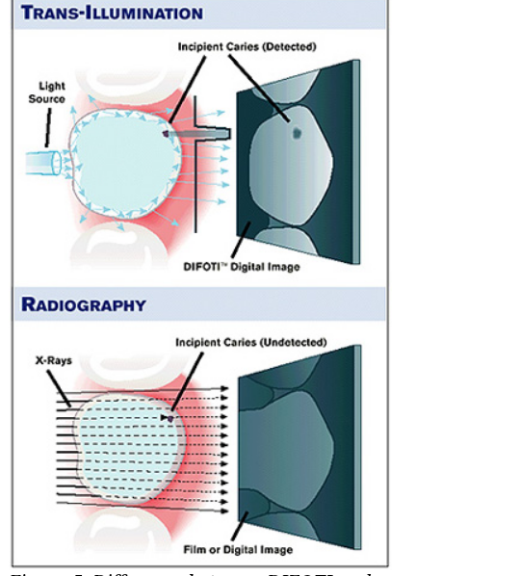

***Fig 4.2.3***

***Advantages.***

* The DIFOTItechnique is rapid since images are rapidly available following capture by the dentist. These images can be discussed with the patient then stored and reviewed at future visits.
* Given the visual approach of this technique, patients may be encouraged to take on a preventative approach as they are now aware and able to examine the demineralized enamel and the condition of their teeth.

* This modified method is a safe non-radiation technique for caries identification for pregnant women and cancer patients who receive high doses of radiation as opposed to X-rays.

***Limitations***

* ***image interpretation.***

There is a probable inaccuracy of white spot carious lesion.

* **DIFOTI** does not have the capability to determine the depth of the carious lesion.**(*Barnes, 2005)***

**4.3.0 EARLY DENTAL DETECTION USING A FIBER OPTIC COUPLED POLARIZATION RESOLVED RAMAN SPECTROSCOPIC SYSTEM.**

It was developed for simultaneous collection of orthogonally polarized Raman spectra in a single measurement.

Dental caries is a chronic infectious oral disease infecting people worldwide. current clinical practices is still largely limited to conventional visual and visuo- tactile tools such as sharp explorers and dental radio graphs. However these conventional methods which are aimed at detecting carious lesions were found to have low sensitivity in detecting early carious lesions.

Raman spectroscopy, a form of vibrational spectroscopy once not considered a viable optical modality for biomedical applications due to its slower speed and the need for powerful excitation sources is becoming increasingly important in bio-medical research for it’s high bio-chemical specificity.

In the non polarized Raman spectroscopy, carious lesions consistently exhibited stronger raman band intensity at 431/cm, 590/cm and 1043/cm compared with those in the raman spectra of sound enamel.

The raman band intensities changes in the spectra of carious lesions were proposed to be due to induced structural changes in the caries formation process.

Further investigations on early carious lesions was carried out with polarized raman micro-spectroscopy and it was found that early carious lesions can be differentiated from sound enamel by monitoring the change in polarization depolarization ratio of the most intense raman band of hydroxyapatite at 959/cm.

Polarized raman spectra of carious lesions exhibited a lower degree of raman polarization depolarization than those of sound enamel. Such decrease in the raman polarization depolarization detected in the raman spectra of carious lesion is believed to be due to structural changes in the enamel rods and/ or increased photon scattering resulting from larger pores within the carious lesion

**4.4.0 QUANTITATIVE LIGHT INDUCED FLORESCENCE.( QLF)**

*M H* ***Van der Veen ,E de Josselin de Jong,***

***Assessment of Oral Health 17, 144-162, 2000***

QLF is an non-destructive diagonistic method for the longitudinal assessment of dental caries lesions in time. When a tooth becomes carious, the florescence radiance at the location of the caries lesion decreases. The florescence loss in the lesion can be quantified in comparison to the florescence radiance level of sound enamel. Changes in florescence radiance loss is related to the mineral loss in the lesion

This caries detection system ***according to B Angmar- Mansson ,JJ Ten Bosch , Dentomaxillofacial Radiology 30(6), 298-307, 2001*** takes advantage of tooth florescence to record images that can be analyzed to obtain data on lesion area (***area in mm^2, lesion depth expressed in percentile florescence loss (delta F in %) and lesion volume (delta Q in mm^2) and bacteria activity in terms of percentile increase of red florescence (delta R)***

The inspector QLF-D bi-illumination 2+ camera system : both of these devices use blue light to illuminate teeth. This causes the tooth to florescence in green (also called auto-florescence ). The resulting QLF images show a higher contrast between sound and demineralized tooth tissue.

Besides the green auto florescence, the blue light can also generate red florescence which is believed to be caused by porphyrins that are as a result of metabolic process of specific bacterial strains. The intensity of the red florescence may also be related to other oral care issues such as gingivitis and halitosis.

A powerful feature of the QLF is the ability to follow tooth surfaces overtime( longitudinal monitoring). The software includes; automatic video repositioning that enables the acquisition of comparable QLF images of the same surface at different time points.

The software can also analyze and record images and thus provide an objective assessment of area of concern overtime.

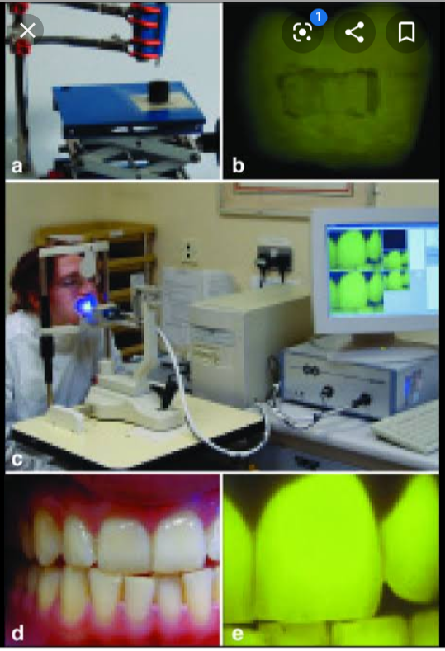

**Fig 4.4.0**

**4.5.0 DIAGNOdent.**

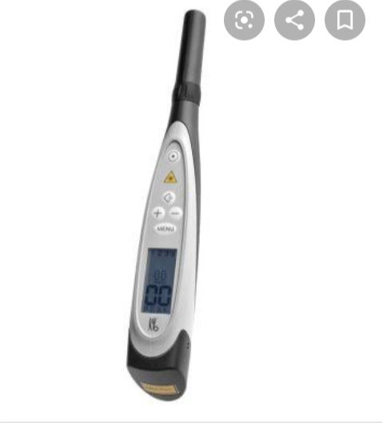

***Fig 4.5.0***

This is a caries detection aid. The DIAGNOdent pen will show you where the decay lies.

It works quickly and reliably. The laser fluorescence detector within the DIAGNOdent pen is a precise method for identifying tissue caries, proximal caries and periodontisis.

***4.5.1 How it works.***

It uses laser florescence to aid in the detection caries within the tooth structure. As the incident laser light is dispersed into the cite, carious tooth structure will exhibit florescence, proportionate to the degree of caries , resulting elevated scale readings on the display. Clean healthy teeth structure will exhibit little or no florescence and will result in very low scale reading on the display.