HTML and CSS notes (basic bullshit)

*Silas Jul Kierstein*

*I like to write/take notes whenever I learn some valuable information, not because I think I’m going to use the notes, but because that it forces me to process information.*

# HTML in a nutshell

*Hyper Text Markup Language:*

* Displays and format elements of a webpage/documents
* Only presentation
* No logic or programming like Java Script
* Building block of a web

To write HTML you need a web browser and a texteditor. Use a browser to open HTML-files and a texteditor to edit them. HTML files has the extension .html.

*Tag syntax:*

* <tagname>content</tagname>

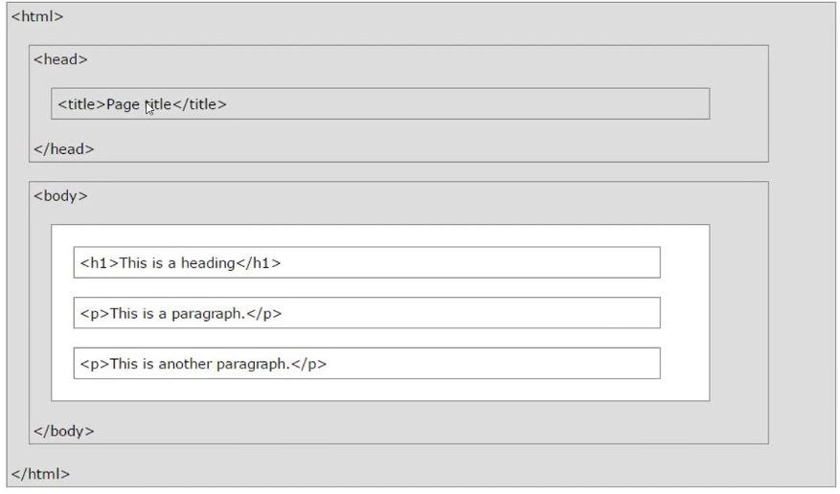

* Used to create structure
* Comments <!-- “developer note” -->
* **Headings:** <h1>XDDDD</h1> h1 can be replaced with h2, h3, h4, h5, h6 to change the heading size
* **Paragraphs:** <p>lorem10</p>
* **Bold/italic:** <p>Learning HTML is a lot of <strong>fun</strong> because it looks <em>very cool</em> just by default</p>
* **Link:** <a href=”a url or html.file”>

*Block- and inline elements:*

* **Margin:** space creating around elements by default (usually 1 em)
* **Block elements:** Start on a new line. Takes full available width.
  + <div>, <h1> - <h6>, <p>, <form>
* **Inline elements:** Doesn’t start on a new line. Takes the necessary width.
  + <span>, <img>, <a>
* **Lists:**

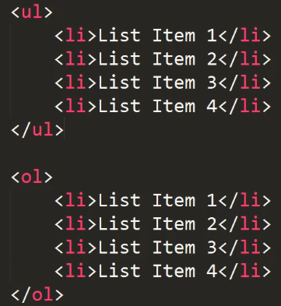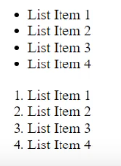

*Tag attributes:*

* Tags can have attributes to provide information regarding the element
* Key/value
* <tagname attributename=”attributevalue”>content</tagname>