Predicted shifts in the distribution of Atlantic reef building corals in face of climate change

Silas C. Principe1*, João Espíndola2, André Acosta2, and Tito M. C. Lotufo

1 Laboratório de Ecologia Recifal, Instituto Oceanográfico, Universidade de São Paulo, Brazil  
2 NHM

* Correspondence: [Silas C. Principe <[silasprincipe@yahoo.com.br](mailto:silasprincipe@yahoo.com.br)>](mailto:silasprincipe@yahoo.com.br)

# Introduction

This is a test of the introduction section

# Material and methods

This is a test of the material and methods section

# Results

## Latitudinal change

This is a test for the results section

Table 1 Performance of species distribution models for Mussismilia hispida, Montastraea cavernosa and Siderastrea obtained through four distinct algorithms (Generalized Additive Model - GAM; Boosted Regression Trees - BRT; Generalized Linear Models - GLM; Random Forest - RF). Values are the average of five runs of block cross-validation with ± standard deviation, for each algorithm. TSS is the True Skill Statistics and was used as the main metric. AUC is the Area Under the curve metric. TSS and AUC values range from 0 to 1 and specificity and sensitivity values range from 0 to 100. Models in bold are the algorithms that had the better performance for each species.

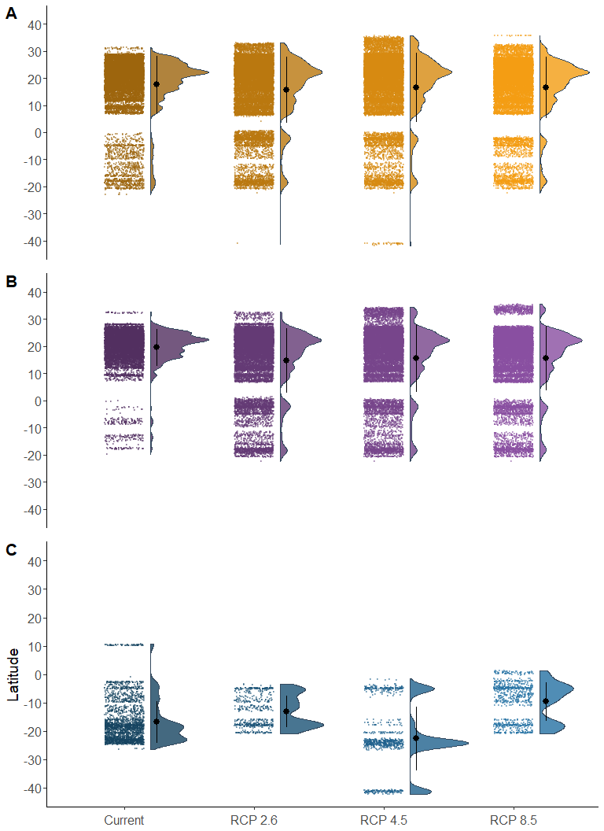

Figure 5: Test of caption for figures.

# Acknowledgments

# Data Accessibility

# Competing Interests

The authors declare no conflicts of interest.

# Author Contributions

SCP

# sessionInfo

capture.output(sessionInfo(), file="sessionInfo.txt")

# References