Predicted shifts in the distribution of Atlantic reef building corals in face of climate change

Silas C. Principe1,✉, João Espíndola1, André L. Acosta2, and Tito M. C. Lotufo1

1 Laboratório de Biologia Recifal, Instituto Oceanográfico, Universidade de São Paulo, São Paulo, Brazil.  
2 Instituto de Estudos Avançados, Universidade de São Paulo, São Paulo, Brazil.

✉ Correspondence: [Silas C. Principe <[silasprincipe@yahoo.com.br](mailto:silasprincipe@yahoo.com.br)>](mailto:silasprincipe@yahoo.com.br)

# Results

## Models performance and variables importance

The models performed well for all three species (Table 1). All algorithms achieved TSS scores higher than the established threshold of 0.7 in the cross-validation procedure and were thus included in the final ensemble. The BRT and RF algorithms achieved the highest TSS scores, except when applied for *Siderastrea*, for which the GLMs outperformed RFs. The GAMs consistently yielded low TSS values among the algorithms. The AUC (area under the curve) values were higher than the TSS values for all models, but this metric can be inflated and should be used with caution as a model performance metric.

Table 1 Performance of species distribution models for Mussismilia hispida, Montastraea cavernosa and Siderastrea obtained through four distinct algorithms (Generalized Additive Model - GAM; Boosted Regression Trees - BRT; Generalized Linear Models - GLM; Random Forest - RF). Values are the average of five runs of block cross-validation with ± standard deviation, for each algorithm. TSS is the True Skill Statistics and was used as the main metric. AUC is the Area Under the curve metric. TSS and AUC values range from 0 to 1 and specificity and sensitivity values range from 0 to 100. Models in bold are the algorithms that had the better performance for each species.

|  |  |  |  |  |  |
| --- | --- | --- | --- | --- | --- |
| Species | Model | TSS | AUC | Specificity | Sensitivity |
| M. hispida | GAM | 0.72 ± 0.17 | 0.86 ± 0.09 | 87.35 ± 8.26 | 84.49 ± 16.94 |
|  | GBM | 0.89 ± 0.1 | 0.96 ± 0.05 | 91.37 ± 8.81 | 97.57 ± 3.33 |
|  | GLM | 0.82 ± 0.18 | 0.92 ± 0.09 | 75 ± 42.28 | 90.89 ± 13.84 |
|  | RF | 0.89 ± 0.11 | 0.96 ± 0.05 | 91.03 ± 10.24 | 97.57 ± 3.33 |
| M. cavernosa | GAM | 0.74 ± 0.14 | 0.87 ± 0.07 | 58.14 ± 53.08 | 82.48 ± 19.73 |
|  | GBM | 0.83 ± 0.1 | 0.95 ± 0.04 | 93.57 ± 3.71 | 89.08 ± 10.49 |
|  | GLM | 0.8 ± 0.15 | 0.93 ± 0.08 | 89.78 ± 8.34 | 90.96 ± 10.24 |
|  | RF | 0.83 ± 0.09 | 0.96 ± 0.03 | 92.5 ± 3.42 | 90.33 ± 6.65 |
| Siderastrea | GAM | 0.75 ± 0.11 | 0.88 ± 0.06 | 58.34 ± 53.28 | 91.76 ± 7.65 |
|  | GBM | 0.82 ± 0.14 | 0.95 ± 0.04 | 85.42 ± 9.33 | 96.03 ± 6.93 |
|  | GLM | 0.82 ± 0.08 | 0.94 ± 0.03 | 73.81 ± 41.48 | 93.1 ± 4.99 |
|  | RF | 0.81 ± 0.13 | 0.95 ± 0.04 | 85.4 ± 10.38 | 96.06 ± 4.9 |

Our bootstrap analysis for detecting uncertainty in the predictions of models showed higher variations on the edges of the occurrence areas (Supplementary Figures 1, 2, and 3). Thus, the predictions are thought to be more reliable in the current range of the species than elsewhere. The "unalikeability", based on the binary ensembles, was less than 0.3 for all models/species. In general, the models were more often in disagreement on the edges of the presence points. As expected, the future predictions showed consistently higher uncertainty for all species when compared to the current period.

The most relevant variables for the models varied among species (Table 2). Salinity contributed the most to explaining the habitat suitability of *M. hispida* geographically expressed in the ensemble model. For *M. cavernosa* and *Siderastrea*, chlorophyll-a and temperature were the variables with the greatest importances. Calcite, the current velocity and the cloud cover showed minor importances for all species models.

Table 2 Importance of variables used to produce the ensemble models. Values are the mean importance obtained in a 20-fold permutation of variables. On each permutation, each variable is shuffled and a new prediction is generated. Then, a Pearson’s correlation between the original prediction and the ‘shuffled’ one is generated. Values of importance are given as 1-correlation. Highest values reveals a higher influence of the variable on the model. The most important variable for each species is in bold.

|  |  |  |  |
| --- | --- | --- | --- |
| Variable | M. hispida | M. cavernosa | Siderastrea |
| Calcite concentration - mean | 0.01 ± 0 | 0.02 ± 0 | 0.04 ± 0 |
| Chlorophyll-a concentration - maximum | 0.03 ± 0 | 0.21 ± 0.01 | 0.18 ± 0.01 |
| Cloud cover - maximum | 0.01 ± 0 | 0.03 ± 0 | 0.03 ± 0 |
| Nitrate concentration - mean | 0.07 ± 0.01 | 0.1 ± 0.01 | 0.11 ± 0.01 |
| Sea water pH - mean | 0.03 ± 0.01 | 0.1 ± 0 | 0.13 ± 0.01 |
| Phosphate concentration - maximum | 0.01 ± 0 | 0.07 ± 0 | 0.12 ± 0.01 |
| Salinity - mean | 0.49 ± 0.04 | 0.05 ± 0 | 0.05 ± 0 |
| Silicate concentration - mean | 0.03 ± 0 | 0.07 ± 0 | 0.17 ± 0.01 |
| Sea surface temperature - maximum | 0.04 ± 0.01 | 0.15 ± 0.01 | 0.23 ± 0.02 |
| Current velocity - mean | 0.01 ± 0 | 0.02 ± 0 | 0.03 ± 0 |
| Wind speed - mean | 0.19 ± 0.03 | 0.02 ± 0 | 0.03 ± 0 |
| Depth | 0.05 ± 0.01 | 0.05 ± 0 | 0.12 ± 0.01 |

## Distributions of reef builders

All species studied here will experience a reduction in the suitability of their habitats in the future (2100) in at least one scenario; however, increases in suitable areas were also projected in some regions. As expected, *M. hispida* showed the smallest suitable area among the three species (even considering suitable areas beyond its current range), while *Siderastrea* had the widest range of suitable areas. A summary of the current distributions and expected changes in the future scenarios is provided in Table 3. To better understand how the species are distributed in the present and in the future, we divided the Atlantic into three distinct regions, using the Marine Ecoregions of the World classification as a reference (Spalding et al., 2007). The first region was named the Southwestern Atlantic region and comprises the warm temperate southwestern Atlantic, tropical southwestern Atlantic, North Brazil Shelf and Magellanic provinces. The North Atlantic region includes the tropical northwestern Atlantic, the warm temperate northwestern Atlantic and the cold temperate northwestern Atlantic provinces. Finally, the Eastern Atlantic region comprises all provinces in the eastern part of our study area, including the islands not contained in the other provinces.

Table 3 Current and future projected area for three reef builders of the Atlantic obtained through species distribution models. Future projections are for three different scenarios of Relative Concentration Pathway (RCP 2.6, RCP 4.5 and RCP 8.5). Area (in Km²) is shown by regions (see results section for further information). Values in brackets are percentage of area change in future scenarios (positive, gain; negative, loss). Note that for *M. hispida*, the value in bold is the region that the species currently inhabit as it’s endemic from Brazil, but models were projected for the whole study area (other values).

|  |  |  |  |  |  |
| --- | --- | --- | --- | --- | --- |
| Species | Region | Current area | RCP 2.6 | RCP 4.5 | RCP 8.5 |
| M. hispida | Total | 375804.5 | 397166.4 (5.7%) | 367263.3 (-2.3%) | 421138.2 (12.1%) |
|  | Southwestern Atlantic | 143553.5 | 76236.3 (-46.9%) | 59275.4 (-58.7%) | 32315.5 (-77.5%) |
|  | North Atlantic | 208577.7 | 300164.7 (43.9%) | 286531.5 (37.4%) | 364790.7 (74.9%) |
|  | Eastern Atlantic | 23673.2 | 20765.3 (-12.3%) | 21456.3 (-9.4%) | 24031.8 (1.5%) |
| M. cavernosa | Total | 940249.7 | 1031157.5 (9.7%) | 959839.8 (2.1%) | 366477.7 (-61%) |
|  | Southwestern Atlantic | 160959.0 | 229539.4 (42.6%) | 184161.4 (14.4%) | 421.3 (-99.7%) |
|  | North Atlantic | 775797.4 | 778427.9 (0.3%) | 714256.4 (-7.9%) | 311318.7 (-59.9%) |
|  | Eastern Atlantic | 3493.3 | 23190.2 (563.8%) | 61422 (1658.3%) | 54737.7 (1466.9%) |
| Siderastrea | Total | 1052333.9 | 1061066.8 (0.8%) | 1069901.6 (1.7%) | 703062.4 (-33.2%) |
|  | Southwestern Atlantic | 183016.8 | 222550.8 (21.6%) | 189197.7 (3.4%) | 53055.8 (-71%) |
|  | North Atlantic | 865017.8 | 801640.6 (-7.3%) | 806538.8 (-6.8%) | 482744.2 (-44.2%) |
|  | Eastern Atlantic | 4299.3 | 36875.4 (757.7%) | 74165.2 (1625.1%) | 167262.5 (3790.5%) |

In the Southwestern Atlantic, which is the current range of distribution of *M. hispida*, suitable areas were projected from the north coast of Santa Catarina (27°S) to Maranhão state (0.8°S), with some gaps associated with river discharges (Figure 1). A major gap is associated with the discharge of the São Francisco River (10°S), one of the major rivers of Brazil. This gap was also evident in the ranges of *M. cavernosa* and *Siderastrea* (Figures 3 and 4, respectively). To the south, another gap is located near the areas influenced by the Doce River discharge along the coast of Espírito Santo state (approximately 19-20°S). Additionally, there is a discontinuity in the distribution associated with Guanabara Bay on the coast of Rio de Janeiro state (23°S). In northern Brazil, only two patches of suitable areas were projected, with the area farther north associated with the Parcel do Manuel Luis reef. Beyond the current distribution of the species, the model also identified suitable areas in the Caribbean region and on the coast of Morocco. Although the model projected suitable areas for *M. hispida* at depths over 100 m, the majority of suitable areas were shallower than 40 m (median = 21.2 m; Q1 = 42.4 m; Q3 = 8.2 m), which is in agreement with the actual biology of the species.

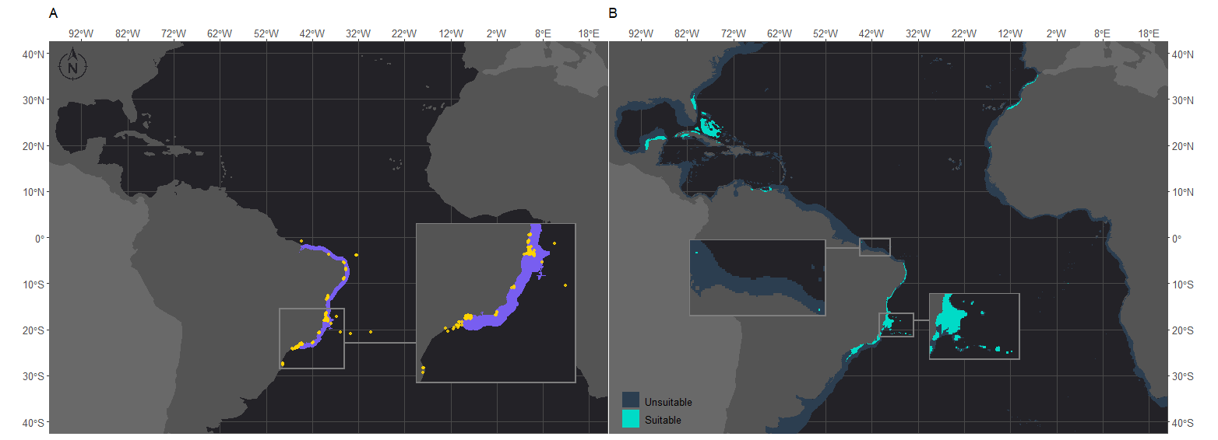

Figure 1 Projected habitat suitability of Mussismilia hispida in the Atlantic obtained through an ensemble modeling approach. Map (A) shows the presence points (in orange) used for training the model and shows (in purple) the expected range of M. hispida according to the IUCN. Map (B) presents the predicted habitat suitability for the current period. In both maps inset maps show the Abrolhos region, where M. hispida plays a key role as a habitat-forming species. In map (B), the left inset map highlights the patches of suitable areas in northern Brazil.

There were increases in the projected suitable areas for *M. hispida* in two future scenarios (RCP2.6 and RCP4.5; Figure 2). However, when considering only areas in the Southwestern Atlantic region, decreases are expected in all scenarios (Table 3 and Figure 2). Suitable areas for *M. hispida* will be lost all along the northeastern coast of Brazil and along its southern limit, regardless of the scenario. Additionally, the two patches on the coast of the Maranhão (0.8°S) and Ceará (3.6°S) states will be lost. Major losses of suitable areas will also occur in the Vitória-Trindade seamount chain and in the Abrolhos region; these losses would be critical in the RCP4.5 and RCP8.5 scenarios, with all suitable areas being lost.

New suitable areas are predicted in the southern and northern boundaries of the present distribution of *M. hispida* for all scenarios. In the RCP4.5 and RCP8.5 scenarios, the gain of new areas is diminished, but suitable areas are expected to occur far south of the current distribution region along the coast of Argentina (40°S to 42°S). Interestingly, some areas that would become suitable in RCP2.6 scenario are in regions of river discharge. New suitable areas would also occur in the denominated North Atlantic region. These projections do not consider the Amazon river mouth barrier, which currently limits the distribution of this species to the Brazilian coast. There was no evident change trend in the suitable area depth (RCP2.6: median = 20.1 m, RCP4.5: median = 16.8 m, RCP8.5: median = 17.3 m; Supplementary Table 2).

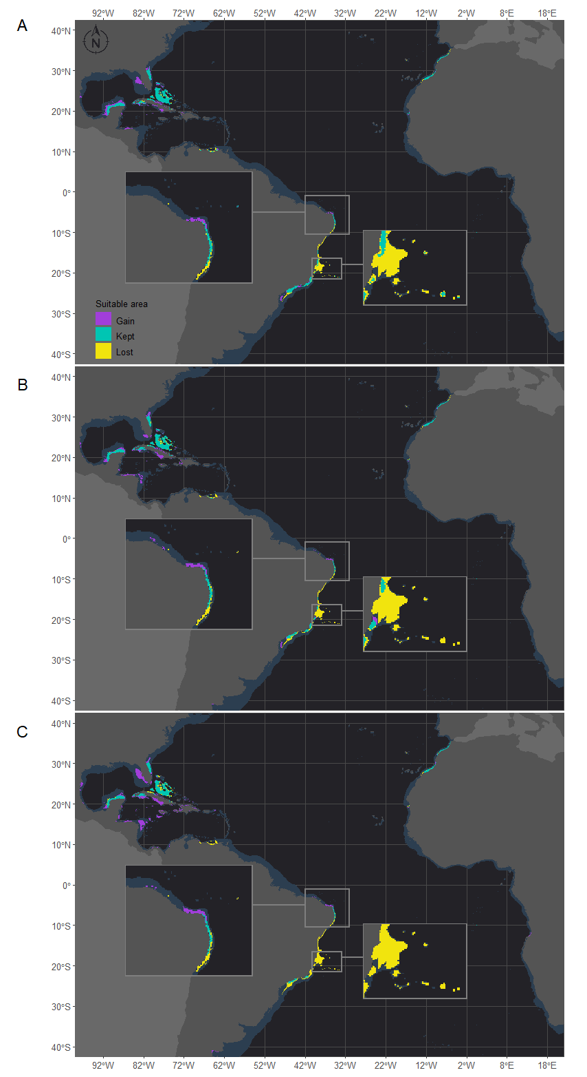

Figure 2 Projected habitat suitabilities for future relative concentration pathway (RCP) scenarios for Mussismilia hispida in the Atlantic Ocean, obtained through an ensemble modeling approach. The models were trained on present-day data of each species and projected for the (A) RCP2.6, (B) RCP4.5 and (C) RCP8.5 scenarios. Inset maps highlight changes in northern Brazil (top) and in the Abrolhos region (bottom).

*Montastraea cavernosa* and *Siderastrea* exhibited similar habitat suitability patterns in the current period, in agreement with their current distribution ranges (Figures 3 and 4, respectively). The majority of suitable areas for both species were distributed in the northeastern and north coast of Brazil, up to the coast of Maranhão state and in the North Atlantic. Suitable areas were also observed at similar depths, although the maximum depth of *M. cavernosa* was deeper than that of *Siderastrea* (*M. cavernosa* - median = 40.5 m, maximum = 194.6 m; *Siderastrea* - median = 37.6 m, maximum = 185.8 m). Despite these similarities, some differences in habitat suitability are evident. The predicted southern limit of the suitable areas for *M. cavernosa* was 22.4°S, but the *Siderastrea* distribution extended farther south, reaching Rio de Janeiro state (23°S). Additionally, adequate areas for *Siderastrea* were predicted on the Ascension, Cape Verde and São Tomé islands, but suitable areas for *M. cavernosa* were found only on São Tomé and Ascension (although the species is not currently found in the latter area). Another evident difference is the larger extent of suitable areas for *Siderastrea* in the Gulf of México and on the western side of Florida than that for *M. cavernosa*. However, *M. cavernosa* was the only species with suitable areas on Bermudas Island in the western Atlantic, thus having a higher northern limit than that of *Siderastrea* (approximately 32°N versus approximately 28°N for *Siderastrea*). Several areas that were considered to be within the ranges of both species according to the IUCN were not supported by our models as suitable areas.

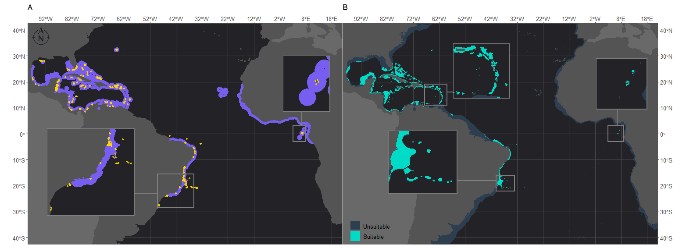

Figure 3 Projected habitat suitability for Montastraea cavernosa in the Atlantic Ocean obtained through an ensemble modeling approach. Map (A) shows the presence points (in orange) used for training the model and shows (in purple) the expected range of M. cavernosa according to the IUCN. Map (B) shows the predicted habitat suitability for the current period. In both maps, inset maps highlight the Abrolhos region (left) and São Tomé islands (right), and in map (B), the top inset highlights the Caribbean islands.

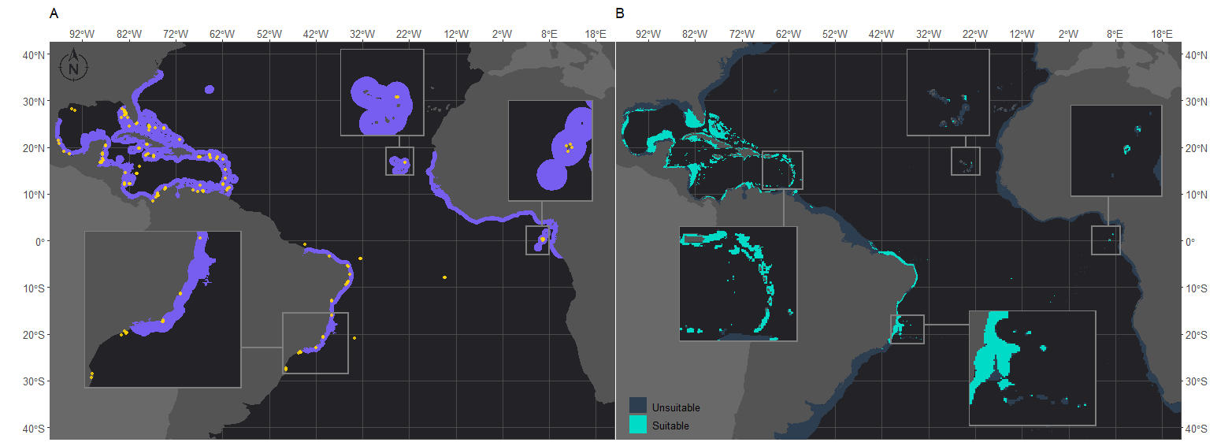

Figure 4 Projected habitat suitability for Siderastrea in the Atlantic, as obtained through an ensemble modeling approach. Map (A) shows the presence points (in orange) used for training the model and shows (in purple) the expected range of Siderastrea according to the IUCN. Map (B) shows the predicted habitat suitability for the current period. In both maps, inset maps highlight the Abrolhos region (left), Cape Verde (top) and São Tomé islands (right).

*Montastraea cavernosa* and *Siderastrea* are projected to experience net gains in suitable areas under the RCP2.6 and RCP4.5 scenarios, but the amounts vary between species, with *M. cavernosa* gaining more area than *Siderastrea* under both scenarios (Table 3). Along the Brazilian coast, areas to the south would become suitable for *M. cavernosa* under the RCP2.6 and RCP4.5 scenarios, consistent with poleward increases in suitable areas (Figure 5). None of those areas would maintain suitability in the RCP8.5 scenario. *Siderastrea* showed similar patterns of increases in suitable areas along the Brazilian coast (Figure 6); however, it showed a smaller southward expansion when compared to *M. cavernosa*. Additionally, increases in suitable areas were projected in the Abrolhos region under the RCP2.6 and RCP4.5 scenarios. In contrast to *M. cavernosa*, *Siderastrea* would still gain suitable areas under the RCP8.5 scenario. In the Northern Hemisphere, the models projected new suitable areas for both *M. cavernosa* and *Siderastrea* around their current occurrence ranges under the RCP2.6 and RCP4.5 scenarios but not in the RCP8.5 scenario (Figures 5 and 6, respectively). A poleward increase in suitable areas (to the north) was projected for *M. cavernosa* in the RCP4.5 and RCP8.5 scenarios and for *Siderastrea* in all scenarios. Areas around Bermuda Island would also become suitable for *Siderastrea* in the RCP4.5 and RCP8.5 scenarios. In the eastern Atlantic, there were consistent increases in suitable areas for *M. cavernosa* and *Siderastrea* under all scenarios in the region of Guinea, in portions of the Gulf of Guinea and its islands, on Cape Verde islands and on seamounts from approximately 3°S to 16°S. As for *M. hispida*, no evident change in depth of suitable areas was identified for both species (Supplementary Table 2).

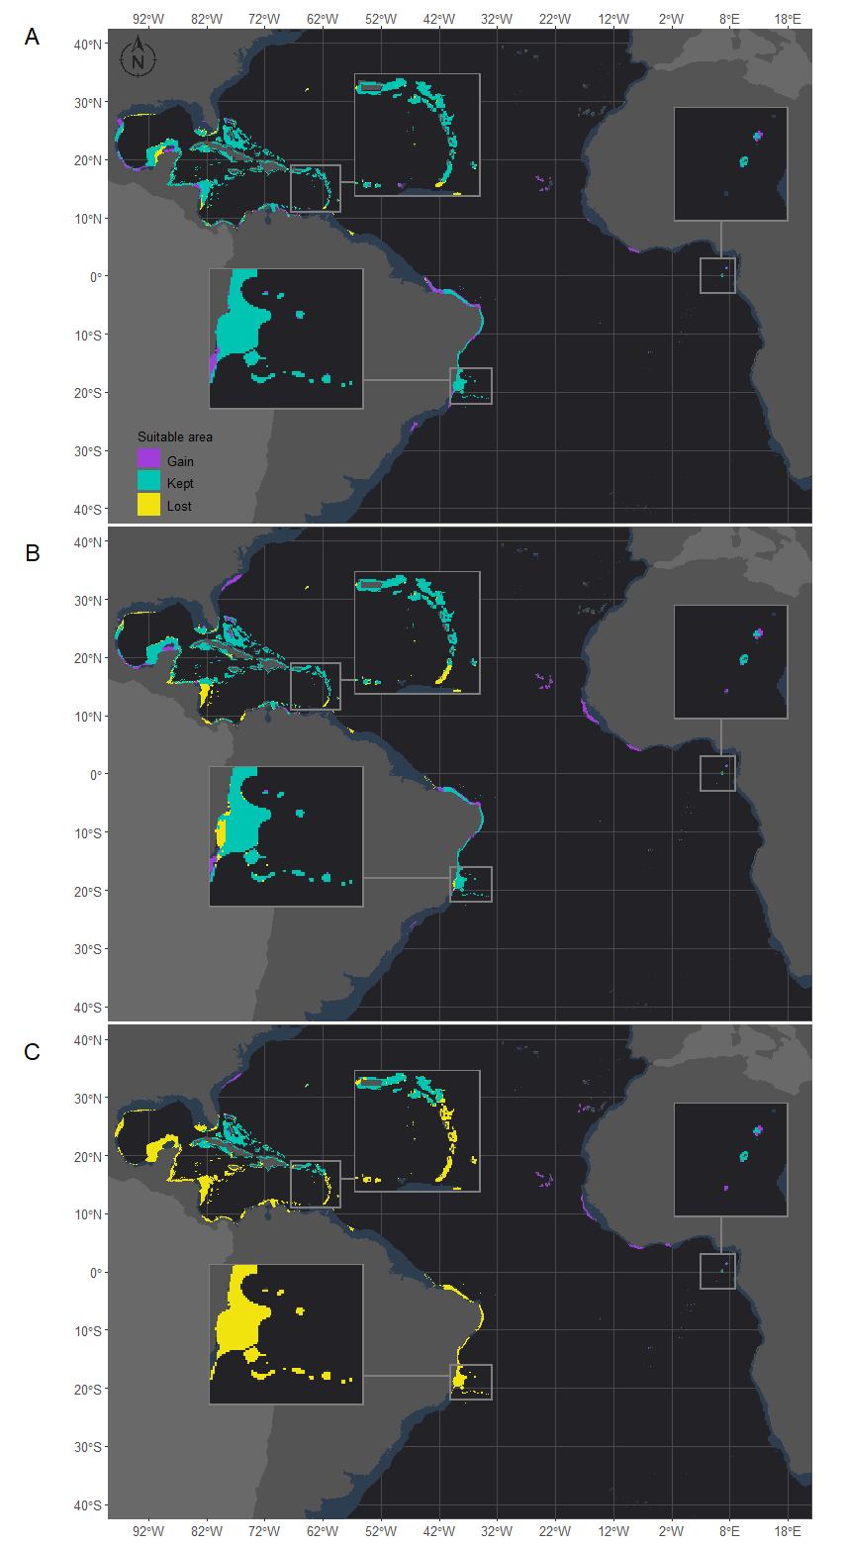

Figure 5 Projected habitat suitability for future relative concentration pathway (RCP) scenarios for Montastraea cavernosa in the Atlantic obtained through an ensemble modeling approach. Models were trained on present-day data of the species and projected for the (A) RCP2.6, (B) RCP4.5 and (C) RCP8.5 scenarios. Inset maps highlight the changes in the Caribbean region (bottom left), São Tomé islands (right) and in the Abrolhos region (bottom).

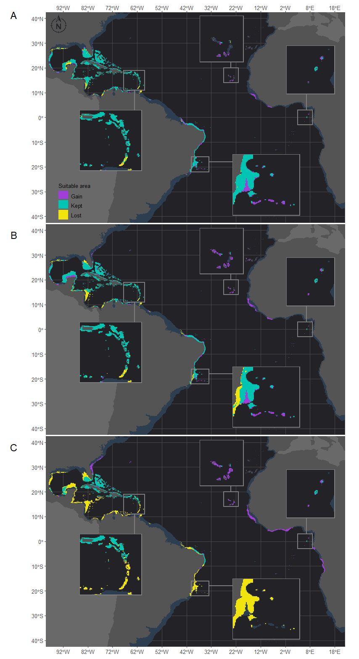

Figure 6 Projected habitat suitability under future relative concentration pathway (RCP) scenarios for Siderastrea in the Atlantic Ocean obtained through an ensemble modeling approach. The models were trained on present-day data of the species and projected for the (A) RCP2.6, (B) RCP4.5 and (C) RCP8.5 scenarios. Inset maps highlight changes in the Caribbean region (bottom left), Cape Verde islands (top), São Tomé islands (right) and Abrolhos region (bottom).

Despite the net gains in suitable areas under the RCP2.6 and RCP4.5 scenarios, both *M. cavernosa* and *Siderastrea* would lose suitable areas in regions that are currently adequate for the species. Additionally, in the RCP8.5 scenario, both species would experience net losses in suitable areas (Table 3). Along the Brazilian coast, *M. cavernosa* would lose suitable areas in its northern limit in the RCP2.6 and RCP4.5 scenarios and in the Abrolhos region in the RCP4.5 scenario (Figure 5). The RCP8.5 scenario is more drastic than the other two scenarios; *M. cavernosa* would vanish from the entire Brazilian coast, with the exception of Fernando de Noronha Island and most of the Caribbean and Gulf of Mexico. For *Siderastrea*, the loss of suitable areas along the Brazilian coast includes both the northern and southern limits; the most critical loss is projected under the RCP8.5 scenario, in which only the areas from 1.5°S to 11°S are retained. None of the areas in the eastern Atlantic were lost in any scenario for either species.

We also stacked the future projections for all species to analyze how climate change may affect the composition of species (Figure 7). This projection reflects the composition of suitable niches for this group of species and not the actual composition, as a given species may not occur in the full extent of its suitable modeled niche. The areas where the number of species would be reduced were consistent among the three scenarios. However, in the RCP8.5 scenario, the loss of species is higher in several areas and seems to be critical in the tropical North Atlantic and on the Brazilian coast. Areas in the Gulf of Mexico that are shared by *Siderastrea* and *M. cavernosa* would become dominated by *Siderastrea* in the RCP8.5 scenario. Additionally, in all scenarios, areas in the Caribbean and the Gulf of Mexico would completely lose suitability for both *Siderastrea* and *M. cavernosa*. On the Brazilian coast, losses of species are expected along the coastal extension in all scenarios, and this loss is critical in the RCP8.5 scenario. This is mainly due to the loss of suitable areas for *M. hispida* and *M. cavernosa* in this region. Under this scenario, major losses are concentrated in the Abrolhos region and the Vitória-Trindade seamount chain, which mainly reflects the reduction of suitable areas for *M. hispida*. In the RCP8.5 scenario, all species would be lost in the Abrolhos region; in northern Brazil, only *Siderastrea* would remain.

The areas where the number of species would increase differed between the RCP8.5 scenario and the other two scenarios, but there were consistent increases in the suitable habitat area in the Eastern Atlantic in all scenarios. In the RCP2.6 and RCP4.5 scenarios, areas along Georgia and South Carolina and in the Gulf of Mexico and Caribbean Sea would become adequate for *Siderastrea* and *M. cavernosa*. Some areas in the Yucatan Channel and in the Bahamas could also experience increases in the number of species due to the expansion of suitable areas for *M. hispida*. It is also important to note that some areas along the Caribbean, Gulf of México and around Florida that are predicted to keep at least one species are, in fact, areas where there is suitable habitat for *M. hispida; however*, this species is currently restricted to Brazil. Along the Brazilian coast, increases in the number of species are expected in the southern limits of the corals studied here under the RCP2.6 and RCP4.5 scenarios and in Northeast/North Brazil under all scenarios (but reduced in the RCP8.5 scenario). Compared to the current period, changes were predicted for almost all regions where suitable areas were projected for the modeled species.

A map with the current composition of suitable niches for the three species is provided in Supplementary Figure 4. An interactive version of the results section is available at <http://silasprincipe.github.io/reefbuilders>.

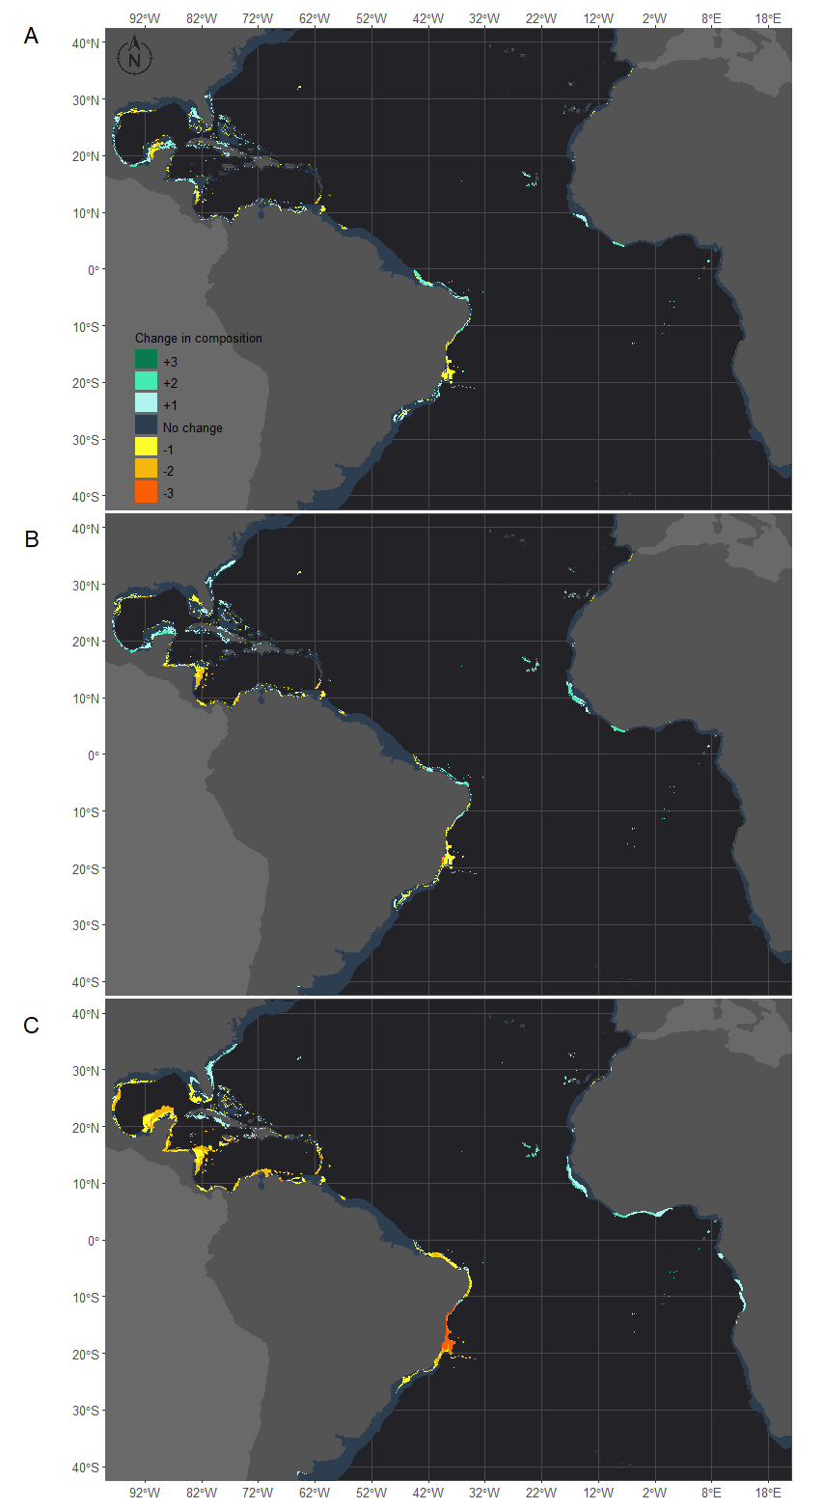

Figure 7 Future composition of adequate habitats for reef builder species in the western Atlantic obtained through species distribution models generated for three species: M. hispida, M. cavernosa and Siderastrea. Map (A) shows the number of species gained (positive values - green scale) or lost (negative values - yellow scale) in the RCP2.6 scenario in comparison to the current climate. The same is shown for the RCP4.5 (B) and RCP8.5 (C) scenarios. The dark gray depicts no change in the number of species.

## Session Info

sessionInfo()

## R version 3.6.2 (2019-12-12)  
## Platform: x86_64-w64-mingw32/x64 (64-bit)  
## Running under: Windows 10 x64 (build 18363)  
##   
## Matrix products: default  
##   
## locale:  
## [1] LC_COLLATE=Portuguese_Brazil.1252 LC_CTYPE=Portuguese_Brazil.1252   
## [3] LC_MONETARY=Portuguese_Brazil.1252 LC_NUMERIC=C   
## [5] LC_TIME=Portuguese_Brazil.1252   
##   
## attached base packages:  
## [1] grid parallel stats graphics grDevices utils datasets   
## [8] methods base   
##   
## other attached packages:  
## [1] patchwork_1.1.0 png_0.1-7 knitr_1.31   
## [4] biomod2_3.3-7.1 reshape_0.8.8 forcats_0.4.0   
## [7] stringr_1.4.0 purrr_0.3.3 readr_1.3.1   
## [10] tidyr_1.0.2 tibble_2.1.3 ggplot2_3.3.3   
## [13] tidyverse_1.3.0 blockCV_2.1.1 sf_0.9-3   
## [16] dplyr_0.8.3 dismo_1.1-4 adehabitatHS_0.3.15  
## [19] adehabitatHR_0.4.18 adehabitatLT_0.3.25 CircStats_0.2-6   
## [22] boot_1.3-23 MASS_7.3-51.5 deldir_0.1-25   
## [25] adehabitatMA_0.3.14 ade4_1.7-13 raster_3.0-7   
## [28] sp_1.3-2   
##   
## loaded via a namespace (and not attached):  
## [1] colorspace_1.4-1 ellipsis_0.3.0 class_7.3-15   
## [4] rgdal_1.4-8 fs_1.3.1 rstudioapi_0.10   
## [7] farver_2.0.3 hexbin_1.28.0 earth_5.1.2   
## [10] fansi_0.4.1 lubridate_1.7.4 xml2_1.2.2   
## [13] codetools_0.2-16 splines_3.6.2 Formula_1.2-3   
## [16] jsonlite_1.6 mda_0.4-10 pROC_1.16.1   
## [19] broom_0.5.4 dbplyr_1.4.2 compiler_3.6.2   
## [22] httr_1.4.1 backports_1.1.5 assertthat_0.2.1   
## [25] Matrix_1.2-18 cli_2.0.1 htmltools_0.4.0   
## [28] prettyunits_1.1.1 tools_3.6.2 gtable_0.3.0   
## [31] glue_1.3.1 Rcpp_1.0.3 PresenceAbsence_1.1.9  
## [34] cellranger_1.1.0 vctrs_0.2.2 nlme_3.1-142   
## [37] xfun_0.20 rvest_0.3.5 lifecycle_0.1.0   
## [40] zoo_1.8-7 scales_1.1.0 hms_0.5.3   
## [43] RColorBrewer_1.1-2 yaml_2.2.0 gridExtra_2.3   
## [46] TeachingDemos_2.10 rpart_4.1-15 latticeExtra_0.6-29   
## [49] stringi_1.4.4 highr_0.8 plotrix_3.7-7   
## [52] randomForest_4.6-14 e1071_1.7-3 rlang_0.4.3   
## [55] pkgconfig_2.0.3 evaluate_0.14 lattice_0.20-38   
## [58] tidyselect_0.2.5 gbm_2.1.5 plyr_1.8.5   
## [61] magrittr_1.5 R6_2.4.1 generics_0.0.2   
## [64] DBI_1.1.0 pillar_1.4.3 haven_2.2.0   
## [67] withr_2.1.2 units_0.6-5 survival_3.2-7   
## [70] abind_1.4-5 nnet_7.3-12 modelr_0.1.5   
## [73] crayon_1.3.4 KernSmooth_2.23-18 rmarkdown_2.6   
## [76] jpeg_0.1-8.1 progress_1.2.2 readxl_1.3.1   
## [79] plotmo_3.5.6 reprex_0.3.0 digest_0.6.23   
## [82] classInt_0.4-3 rasterVis_0.47 munsell_0.5.0   
## [85] viridisLite_0.3.0