## **Unit 1 Project: Cyberchef CTF**

### **Overview**

In this project, you will go through various [Capture the Flag (CTF)](https://en.wikipedia.org/wiki/Capture_the_flag_(cybersecurity)) challenges. CTF is a popular format for testing Cybersecurity knowledge and recreational problem solving.

For this CTF, most challenges will use **Cyberchef** and/or just **Google**. (You won't need to install any programs to solve the challenges!)

If this is your first experience with a CTF, here are some tips:

* The goal of the challenges is to either answer a question, decode/decrypt a message, and/or find a "flag" (which is like a code).
* The challenge name is almost always a hint.
  + Google the category along with the challenge name.
* Read the challenge description carefully.
  + Google the category/type of challenge along with the keywords in the description
* Is there a file?
  + The filename might be a hint.
  + File extension might be misleading (or there might not be one!).
  + Try comparing the extension type with its Magic Numbers!
* Any names mentioned?
  + Is this meaningful? Maybe it is the name of someone who has something to do with a certain type of cryptography or other cybersecurity concepts.

Challenge Types for This CTF will include **trivia**, **reconnaissance**, and **cryptography**.

* Make sure you download the [project1_images.zip](https://courses.codepath.org/course_files/cyb101/project_1/project1_images.zip) file. This folder contains any images needed for the challenges.

### **🎯 Goals**

By the end of this assignment you will be able to...

* Use your research (aka *Googling*), critial thinking, and problem solving skills to answer questions and help you solve CTF challenges.
* Use Cyberchef to solve CTF challenges.
* Start thinking about how these challenges might relate to real-world security 🤔

### **✉️ What You'll Turn In**

For this assignment, you'll be filling and submitting a copy of the [📄 **Project 1 Submission Template** (Google Doc)](https://docs.google.com/document/d/15iH6NxWFboG7t7F6m-C3U-2jt7E6nm0g03gOkAZftVQ/copy)

* Before proceeding, we recommend you **open it up now** and read over the requirements in the document.
* It might be easier to "fill-as-you-go" than try to fill it all out after you complete the project.

Required Challenges

*To receive full credit, you must...*

* Complete at least 6 out of the 11 challenges.
* Document your answers and process for solving the challenges.

Close Section

Stretch Challenges

*To receive bonus points, you can...*

* Complete at least 10 out of the 11 challenges (and document your answers.)

Close Section

*(For detailed project submission instructions, see* ***📬 Submitting Your Project*** *at the bottom of this page.)*

### **🧩 The Challenges**

#### **Trivia Challenges**

👥 **Challenge 1: Honesty is Best Policy**

**This aspect of the CIA triad is about ensuring that information is not altered accidentally or by entities unauthorized to make alterations.**

👥 **Challenge 2: Lots of Jobs!**

According to CyberSeek, which state has the highest numbers of cybersecurity job openings?

[CyberSeek.org](https://www.cyberseek.org/)

* Florida
* Virginia
* Texas
* California

👥 **Challenge 3: Hostage**

This kind of malicious software will encrypt the files on your harddrive and only provide a decryption key when you pay hackers a hefty fee, usually in cryptocurrency.

(Solution is a *type* of malicious software, *not* the name of one particular virus.)

#### **Reconnaissance Challenges**

👥 **Challenge 4: 11,185,272**

👥 **Challenge 5: Read Me**

👥 **Challenge 6: Three Even, Two Odd**

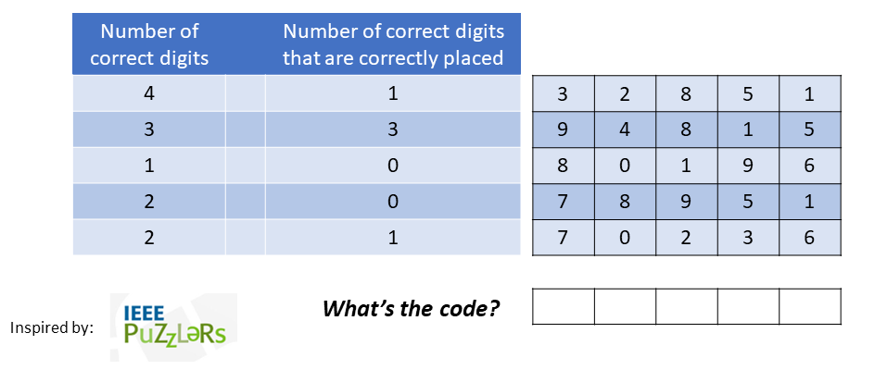

#### **Cryptography Challenges**

👥 **Challenge 7: Shifty**

👥 **Challenge 8: Encoded Message**

👥 **Challenge 9: Kasiski Who?**

👥 **Challenge 10: But are there eggs?**

👥 **EXTRA: Challenge 11: Arch EXIF!**

### **📘 Resources**

* [CyberChef](https://gchq.github.io/CyberChef/)
* [Project1_Images.zip](https://courses.codepath.org/course_files/cyb101/project_1/Project1_Images.zip)

**💡 Hints**

### **📬 Submitting Your Project**

* [📄 **Project 1 Submission Template** (Google Doc)](https://docs.google.com/document/d/15iH6NxWFboG7t7F6m-C3U-2jt7E6nm0g03gOkAZftVQ/copy)

✔ Am I Ready to Submit?

Check if you're **ready to submit** with the following questions:

* Did you complete all of the **Required Challenges**?
* Did you copy and fill out the [**Project 1 Submission Template**](https://docs.google.com/document/d/15iH6NxWFboG7t7F6m-C3U-2jt7E6nm0g03gOkAZftVQ/copy)?
  + It is important that you follow the same layout as the template so that we can easily access your work.
  + Be sure to check off each feature that is implemented in the **"Submission Checklist"** section
* Are any required images/GIFs correctly displaying in your document?
* Did you set your document to ***"Anyone with the link can Edit"***?

If you answered **yes** to **all** of these questions, you are ready to submit!

Look for the **"Submit"** button at the top of this page.

Close Section

📣 **Late Submissions**

* We highly encourage you submit your project in any state (even if it is not done) by the deadline: **Monday, February 27th at 11:59pm PST**.
* You can continue to work on your project with our **48-hour extension** in which your project will be graded once more once the extension deadline has passed.
* Don't forget to **resubmit through the course portal** with your **updated document link**!