T.C.
INFORMATION SYSTEMS ENGINEERING DEPARTMENT
DATA WAREHOUSING AND DATA MINING
PROJECT REPORT
Predictive Maintenance, Driver Behavior Profiling, and Bundle Sales Optimization for SIXT SE
Prepared by:
Satı Sıla Yolcu
Emre Hekimoğlu
Kaan Bilben

TABLE OF CONTENTS
TABLE OF CONTENTS 2
CHAPTER 1: CHOOSING, PROPOSING THREE PROBLEM(S) 3
1.1 introduction 3
1.2 general information about the chosen company 3
1.3 description of the problems 3
1.4 current situations 3
1.5 choose three problems carefully to use three different data mining methods 3
CHAPTER 2: REQUIREMENTS ANALYSES FOR EACH PROBLEM 5
2.1 what the users expect from the developed systems 5
2.2 which type of questions do they need answered by the systems 5
2.3 logical design of the databases — entity relationship diagram 5
2.4 architecture of the dimensions of cubics for OLAP 6
2.5 conceptual modeling of data warehouses 6
CHAPTER 3: ETL OPERATIONS AND KDD PROCESS 7
3.1 descriptions of the ETL operations 7
3.2 KDD process steps applied to this project 10
3.3 input data information 10
3.4 data pre-processing methods used 11
CHAPTER 4: THE FINDINGS OF THREE PROBLEMS AND BUSINESS IMPLICATIONS 12
4.1 choosing mining method for each problem 12
4.2 prediction and reporting 12
4.3 business implications and solutions offered to SIXT SE 16
REFERENCES 18

(Right-click the table above and choose “Update Field” in Microsoft Word to populate page numbers.)

CHAPTER 1: CHOOSING, PROPOSING THREE PROBLEM(S)

Introduction

The way people and things move around the world is changing. So it is very important for companies that use data-driven methods to make better decisions based on facts and data. This project is about using data to help a company that provides vehicle rental solutions and mobility services. We want to solve three problems for this company. We will use computer programs to look at old data and find useful information. These programs can help us group things together find rules about how things are related and put things into categories. We will use this information to help the company take care of its vehicles better understand how its drivers behave and make money from sales. The vehicle rental and mobility sector is where this company operates. We will look at data from this company to find useful information to optimize the companys maintenance strategies, for its the system analyzes driver behavior of its drivers and maximize the sales revenue of the company.

1.2 General information about the chosen company
- Company Name: SIXT SE
- Company Category: Mobility Service Provider
- Company Address: Zugspitzstraße 1, 82049 Pullach, Germany
- Company Business Information: Founded in 1912, SIXT is a leading international mobility service provider with a fleet of over 240,000 vehicles.
- Company Website: https://www.sixt.com/

description of the problems
SIXT faces three main operational challenges:

- Vehicle Failure Prediction: When machines fail unexpectedly customers get really upset. It costs a lot of money. The company wants to know if something is going to go with a vehicle before it happens.

- Driver Behavior: Some drivers are really rough, on vehicles, which makes them wear out faster. The company needs a way to understand how analyze driver behavior to improve vehicle longevity.

- Bundle Sales: Customers often buy things. The company wants to understand what people usually rent together so they can offer deals. They want to ensure that customers receive suitable product recommendations

1.4 current situations
SIXT does maintenance on a schedule right now. The current system assumes that all drivers contribute equally to vehicle wear and tear.When you book a vehicle on their website they suggest things you might want to buy but these suggestions are not based on what you have done before with SIXT. They do not look at what you have rented or bought from SIXT in the past to make these suggestions. SIXT treats all drivers the same. Does not look at how each driver actually uses their vehicles. This means that the maintenance schedule for SIXT vehicles is not based on how each vehicle's actually used. The suggestions you get from SIXT Vehicle booking options are standardized for all customers rather than being personalized, for you and what you have done with SIXT before.

1.5 choose three problems carefully to use three different data mining methods

- We want to figure out when a vehicle is going to fail. To do this we will use the Predictive Maintenance Dataset from AI4I 2020. We will apply the Decision Tree algorithm to the Predictive Maintenance Dataset to classify whether a vehicle is likely to fail. This will help predict potential vehicle failures more accurately.

- To understand how people drive we will look at the Eco-driving behavior dataset. We will use the k-Means clustering algorithm on the Eco-driving behavior dataset to group drivers into types. This enables the analysis of driver behavior profiles.

- We also want to know what people like to rent. To find this out we will use the Car Rental dataset. We will apply Association Rule mining to the Car Rental dataset to see which things are often bought together. This will support bundle sales optimization and improve customer satisfaction, find patterns in the Car Rental dataset.

CHAPTER 2: REQUIREMENTS ANALYSES FOR EACH PROBLEM

2.1 what the users expect from the developed systems

The main people who use these systems are the Fleet Operations team at SIXT the Customer Experience and Sales team and senior management who are in charge of controlling costs and increasing revenue. What they want from these systems is a little different but they all agree on three things: they want to detect potential problems before they become serious
happen they want to treat customers and vehicles in a more personal way and they want to see if the systems are actually saving or making them money.

- The Predictive Maintenance system is used by Fleet Operations. The people in charge of operations want this system to tell them which vehicles are likely to break down so they can schedule maintenance before it happens. They want the answer to be simple, like yes or no so they can put it right into the fleet dashboard.

- The Driver Behavior Profiling system is used by the Risk and Operations team. They want this system to group drivers into categories like good, average or bad based on how they drive, such as how fuel they use how they brake and how fast they go. This way they can charge the insurance premiums give the right vehicles to each driver and provide coaching to those who need it.

- The Bundle Sales Optimization system is used by the Sales and Marketing team. They want this system to show them which extra things people usually rent together like GPS or a child seat so they can suggest packages to customers when they are checking out and increase the amount they spend.

2.2 which type of questions do they need answered by the systems

- Predictive Maintenance: We need to figure out which vehicles in our fleet are going to break down. What things like torque and tool wear can tell us that a vehicle is going to fail? How accurate will our warning system be at telling us when something is about to go with the vehicles in our fleet?

- Driver Behavior Profiling: How different types of drivers do we have? What things can we look at to see if a driver is good or bad? For example do good drivers go slower or faster, than drivers? Which drivers should we talk to about driving efficiently or give a different vehicle to?

- Bundle Sales Optimization: What things do people usually buy together when they rent a vehicle from us? Are there some things that people always buy together that we can suggest to them when they are checking out? Does how much people spend have anything to do with how old they are?

2.3 logical design of the databases — entity relationship diagram
Because these problems are, from a vehicle company they are similar.The company provides mobility services. All three problems are related to vehicle rental. A combined logical schema is showed below in textual entity-relationship (ER) form. Each entity lists its primary key (PK) and foreign keys (FK).

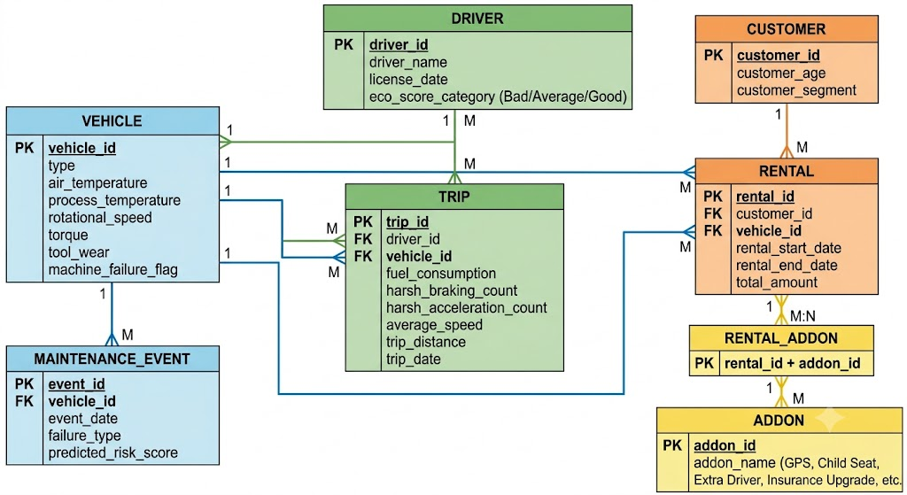

2.4 architecture of the dimensions of cubics for OLAP

For this project, no OLAP cube architecture with hierarchical dimensions was conducted. The three datasets used (AI4I 2020 Predictive Maintenance, Eco-driving Behavior, and Car Rental) are flat, transactional/operational datasets without attributes that can naturally be divided into sub-attributes (such as Year → Quarter → Month → Day, or Country → Region → City) that would validate a multidimensional cube with roll-up/drill-down dimension hierarchies.
Therefore, there is no hierarchical structure, and consequently no OLAP dimension architecture (cube) was designed for this project. The analysis uses fact and dimension tables to feed the data mining workflows. These workflows are described in Chapter 3.

2.5 conceptual modeling of data warehouses
A star schema for each business process. This star schema has one fact table in the middle. The fact table is surrounded by tables that describe the facts. These smaller tables names are dimension tables. They help us understand the facts in the fact table. We use a star schema, for each business process.
Star Schema 1 — Predictive Maintenance Process
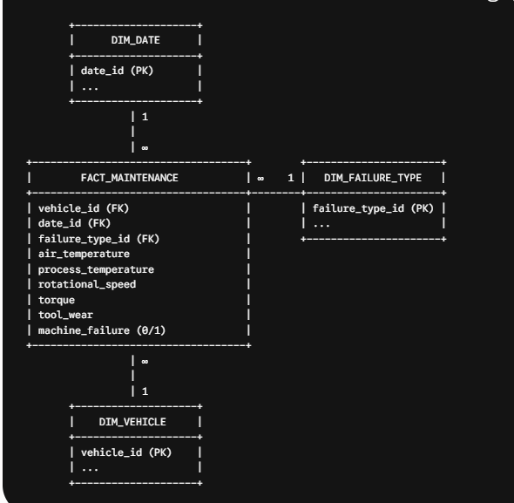
Star Schema 2 — Driver Behavior Process
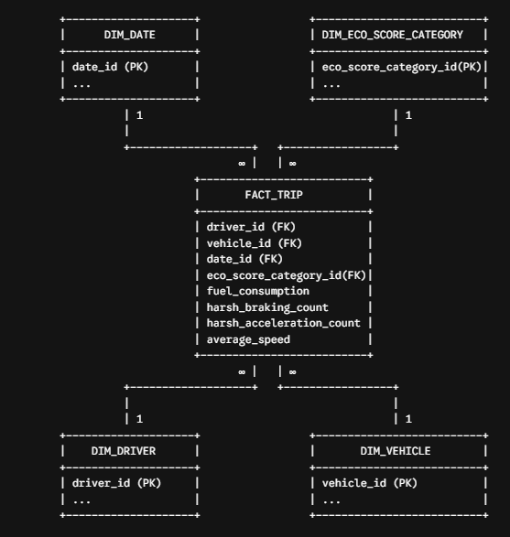

Star Schema 3 — Car Rental / Bundle Sales Process

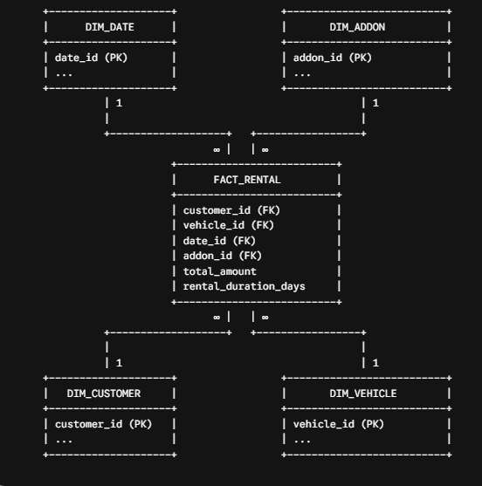

CHAPTER 3: ETL OPERATIONS AND KDD PROCESS

3.1 descriptions of the ETL operations
All three workflows were implemented in KNIME Analytics Platform. The general ETL pattern across the three problems consisted of: (1) extracting raw data with a CSV Reader node, (2) transforming/cleaning the data with nodes such as Column Filter, Missing Value, Number to String, Numeric Outliers, Normalizer, and Binner, and (3) loading the cleaned, structured data into the appropriate mining node (Decision Tree Learner, k-Means, or Association Rule Learner).
Problem 1 — Predictive Maintenance (Extract->>Transform ->> Load)
The pipeline starts with a CSV Reader node that reads the AI4I 2020 dataset. Removes irrelevant identifier columns (e.g. UDI, Product ID) which do not add to the prediction task. The Missing Value node deletes or imputes records with missing values, to ensure data quality. The cleaned table is then split with a Table Partitioner node (training/test split). The resulting table is fed into the Decision Tree Learner, whose model is applied with a Decision Tree Predictor, filtered with a Row Filter, and finally evaluated with a Scorer node outputting the confusion matrix and accuracy statistics.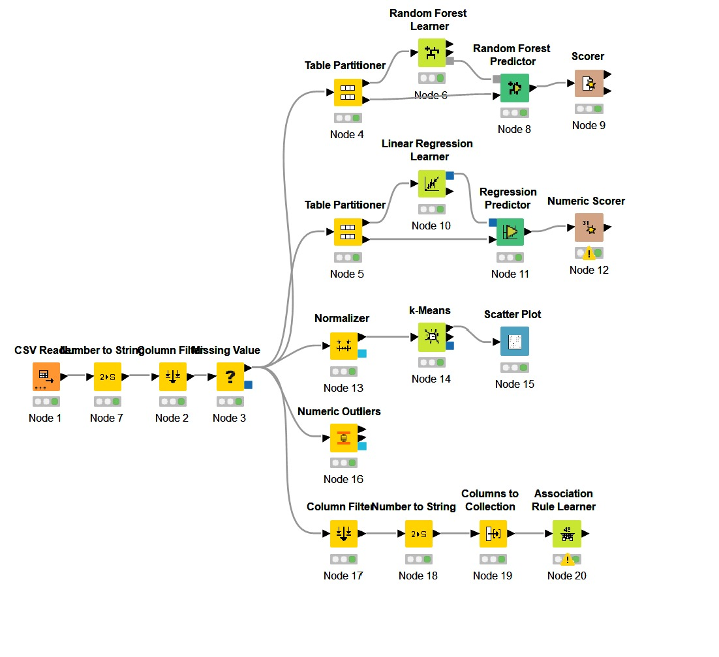
Figure 3.1 — Predictive Maintenance KNIME Workflow (CSV Reader → Column Filter → Missing Value → Table Partitioner → Decision Tree Learner/Predictor → Row Filter → Scorer)

Problem 2 — Eco-Driving / Driver Behavior (Extract ->> Transform ->> Load)
A CSV Reader node extracts the eco-driving behavior dataset. A Missing Value node handles incomplete telemetry rows. From this cleaned table, two parallel branches are built: (a) a Normalizer node scales numeric features (e.g., fuel consumption, braking counts) to a common [0,1] range before being passed to the k-Means node, whose cluster assignments are visualized with a Scatter Plot node; and (b) a Numeric Binner / Table Partitioner branch feeds a Decision Tree Learner/Predictor, used as a surrogate, human-readable model to explain which features (notably fuel_consumption) most strongly characterize each behavioral cluster, evaluated with a Scorer node.
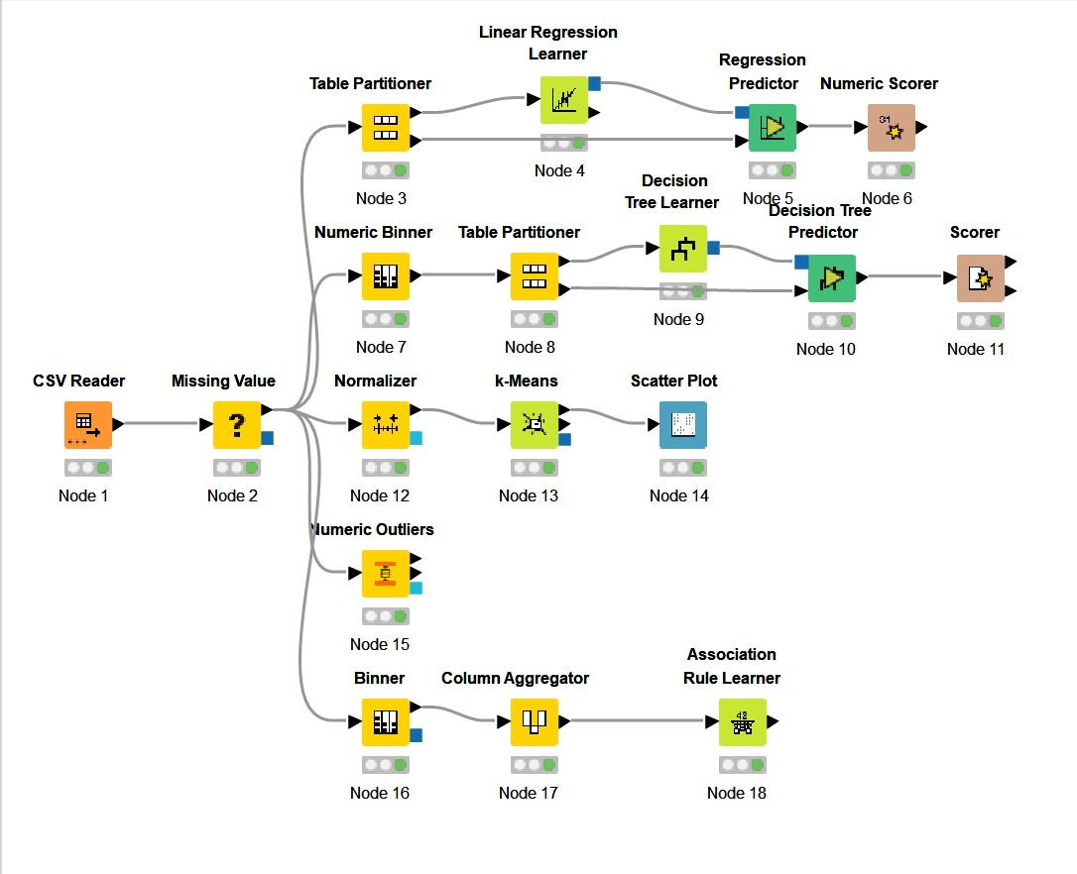
Figure 3.2 — Eco-Driving Behavior KNIME Workflow (CSV Reader → Missing Value → Normalizer → k-Means → Scatter Plot, with parallel Decision Tree explainability branch)

Problem 3 — Car Rental / Bundle Sales (Extract → Transform → Load)
A CSV Reader node extracts the car rental transactional dataset. A Column Filter and Missing Value node clean the table. To prepare the data for market-basket-style analysis a Binner node is used to discretize continuous variables (e.g. rental amount) into categorical bins in order to prepare the data for market-basket-style analysis. A Column Aggregator node is used to group item-level rental add-ons into a single transaction-style list per booking. This aggregated basket format table is fed into the Association Rule Learner node which mines the frequent itemsets and generates rules with Support, Confidence and Lift metrics. Furthermore, a Scatter Plot node was used in the exploratory analysis to visualize the relationship between Customer_Age and Total_Amount.

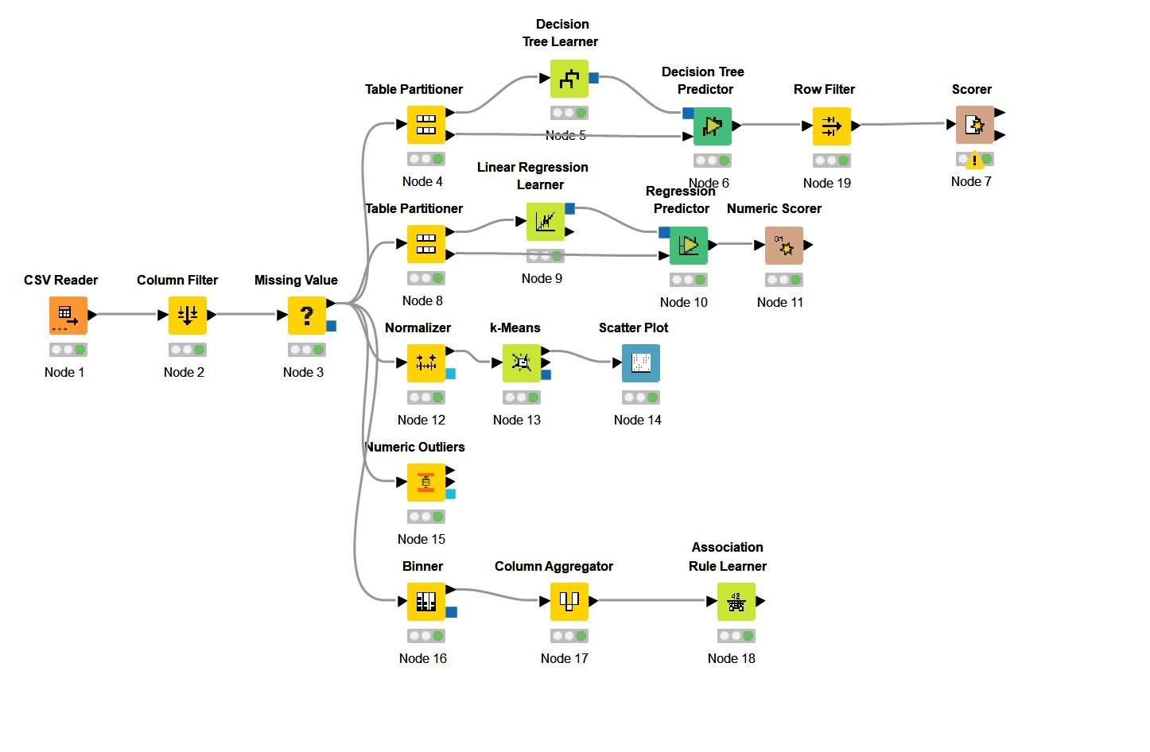
Figure 3.3 — Car Rental KNIME Workflow (CSV Reader → Column Filter → Missing Value → Binner → Column Aggregator → Association Rule Learner)

3.2 KDD process steps applied to this project
The same process of Knowledge Discovery in Databases (KDD) was followed in all the three problems, as follows: Input data → data pre-processing → data mining → post-processing → knowledge
- Data Cleaning: Missing values imputation/removal with the Missing Value node (all three datasets); Numeric outliers detection with the Numeric Outliers node (maintenance and eco-driving datasets).
- Data Integration: All datasets are taken as a whole from a single source – CSV extracts of operational facts tables (machine sensor logs, trip telemetry and rental transactions datasets correspondingly). No join operations were required due to that there are no multiple sources.
- Data Selection: The Column Filter node was used to remove the unnecessary columns that had no effect on data mining (for example, row ID and product ID).
- Data Transformation: Numerical data were scaled with the help of the Normalizer node (eco-driving k-Means branch), as well as binned/discretized with the help of the Binner/Numeric Binner nodes (maintenance and car rental branches).
- Data Mining: Patterns were found using Decision Tree (classification, Problem 1), k-Means (clustering, Problem 2), and Association Rule Learner/Apriori type algorithm (Problem 3). Pattern Evaluation: Found patterns were evaluated using Scorer node (confusion matrix, accuracy, Kappa) for classification, scatter plot for cluster separation (clustering), and support, confidence, lift (association rules).
- Knowledge Representation: Results were presented as a confusion matrix and decision tree (Problem 1), a scatter plot and decision tree explaining clusters (Problem 2), and as association rules table (Problem 3), all translated into business recommendations in Chapter 4.3.3 input data information

Dataset | Approx. # of Samples | Approx. # of Attributes | Class / Target Attribute
AI4I 2020 Predictive Maintenance | ~24,000 | 8–10 (air temperature, process temperature, rotational speed, torque, tool wear, type, etc.) | Machine failure (binary: 0 = No Failure, 1 = Failure)
Eco-Driving Behavior | ~24,000 trip records | 6–8 (fuel consumption, harsh braking count, harsh acceleration count, average speed, trip distance, etc.) | eco_score / driver category (Bad Driver, Average, Good Driver)
Car Rental | Several thousand transactions | 6–10 (customer age, total amount, rental duration, add-ons purchased, vehicle type, etc.) | None (unsupervised — basket of purchased add-ons)
(Exact sample/attribute counts should be filled in from your KNIME “Table” node row/column counters and adjusted to match your final dataset version.)

3.4 data pre-processing methods used
- Predictive Maintenance dataset: Irrelevant identifier columns were removed via Column Filter; missing sensor readings were handled with the Missing Value node (numeric mean/median imputation); the cleaned data was split into training and test partitions with Table Partitioner to allow unbiased model evaluation.
- Eco-driving dataset: Missing telemetry values were imputed using the Missing Value node; numeric features were normalized (min-max scaling) prior to k-Means, since clustering algorithms are sensitive to feature scale; Numeric Outliers detection was applied to reduce the influence of erroneous sensor spikes (e.g., implausible fuel consumption values) on the model.
- Car rental dataset: Missing values were removed/imputed; continuous variables were discretized (binned) using the Binner node so that the Association Rule Learner — which requires nominal/categorical “item” inputs — could treat amount ranges as discrete items; the Column Aggregator node converted individual rental line-items into a single basket (collection) per transaction, the required input format for association rule mining.

CHAPTER 4: THE FINDINGS OF THREE PROBLEMS AND BUSINESS IMPLICATIONS

4.1 choosing mining method for each problem

- Decision Tree (Classification) — Predictive Maintenance: A Decision Tree was selected because the target variable (machine failure) is binary and the business requires an interpretable, rule-based model that maintenance engineers can read directly (e.g., “if torque exceeds X and tool wear exceeds Y, predict failure”), rather than a black-box model. The dataset's mix of continuous sensor readings made it well suited to recursive partitioning.
- k-Means (Cluster Analysis) — Driver Behavior Profiling: k-Means was selected because there is no pre-labeled ground truth driver category; the business goal is to discover natural groupings of driving behavior from telemetry data. k-Means is computationally efficient and produces easily interpretable, centroid-based clusters, which were further explained using a surrogate Decision Tree to translate numeric clusters into human-readable rules (notably, the fuel_consumption threshold of ≈ 8.835 L/100km).
- Association Rule Mining (Apriori-style) — Bundle Sales Optimization: Association mining was selected because the bundle sales problem is fundamentally a market-basket analysis problem — identifying which items (add-ons) co-occur in the same transaction. The Association Rule Learner node natively computes Support, Confidence, and Lift, the standard metrics needed to evaluate candidate cross-sell rules.

4.2 prediction and reporting

Problem 1 — Predictive Maintenance Results
The Decision Tree model was tested on the held out test partition and resulted in an overall accuracy of 98.2%, correctly classifying 1964 of the 2000 test instances, with a Cohen's Kappa of 0.68.

Kappa of 0.68. 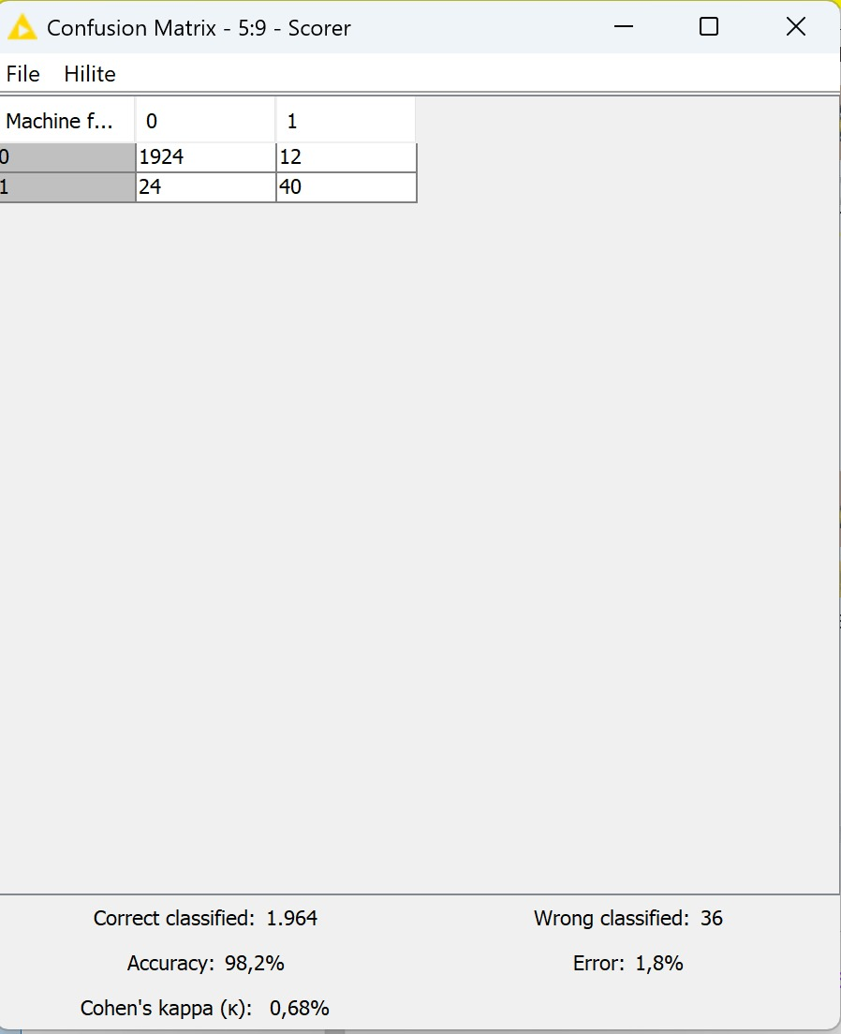
Figure 4.1 — Scorer Node Confusion Matrix Output for Machine Failure Classification (Accuracy 98.2%)
While the overall accuracy is high, it is worth noting that machine failure is a rare/imbalanced event in this dataset (only 64 of 2,000 test cases are actual failures), so the 24 false negatives (failures the model missed) are the most business-critical errors, as they represent breakdowns the predictive maintenance system would fail to flag in advance. This suggests that, in a production deployment, the decision threshold should be tuned to reduce false negatives even at the cost of some additional false positives (unnecessary inspections).

Problem 2 — Driver Behavior Profiling Results
The k-Means algorithm grouped drivers into three distinct behavioral clusters, subsequently labeled “Bad Driver,” “Average,” and “Good Driver” based on their eco-score characteristics. To make these clusters interpretable for the operations team, a surrogate Decision Tree was trained to predict the cluster label from the raw telemetry features. The resulting tree shows that fuel_consumption is the single strongest differentiator: drivers with fuel consumption ≤ 8.835 (normalized units) are split 65.7% “Average,” 17.0% “Bad Driver,” and 17.3% “Good Driver,” while drivers above this threshold are overwhelmingly classified as “Bad Driver” (75.6%), with virtually no “Good Driver” instances (0.2%) in that branch.
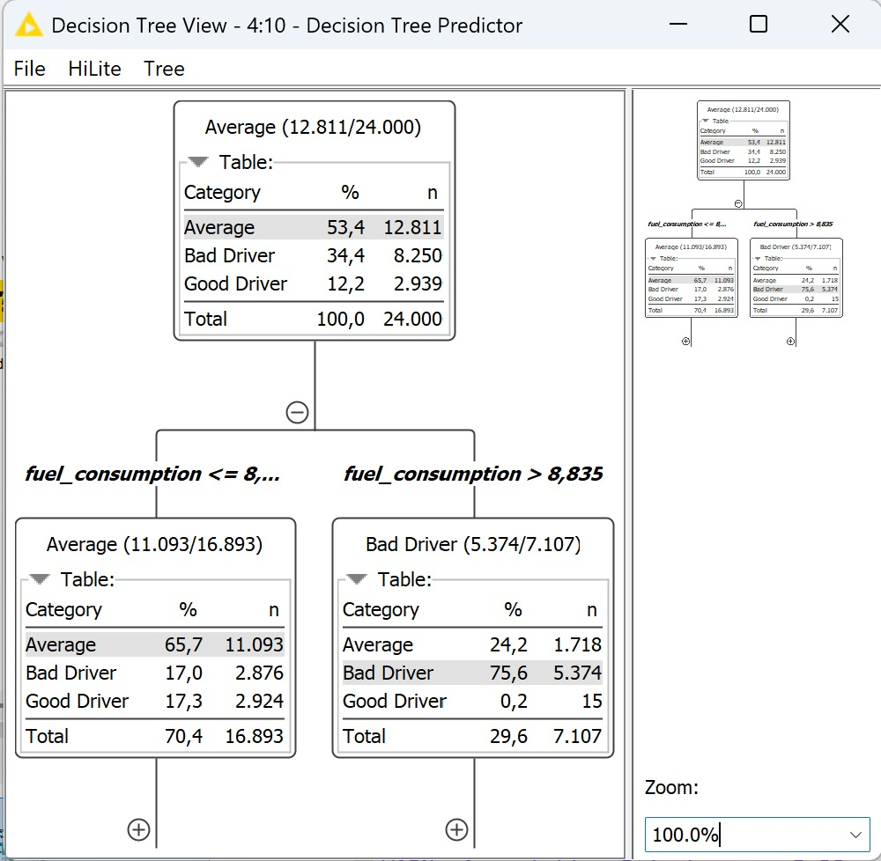
Figure 4.2 — Decision Tree View Explaining the k-Means Driver Behavior Clusters (Split on fuel_consumption)

The surrogate Decision Tree yielded an accuracy of 82.267% (4,936 correct and 1,064 wrong) in classification of the driver category based on the eco-scores generated by k-Means with a Cohen’s Kappa of 0.693 implying that there is moderate consistency in the relationship between fuel usage behavior and driver clusters discovered.
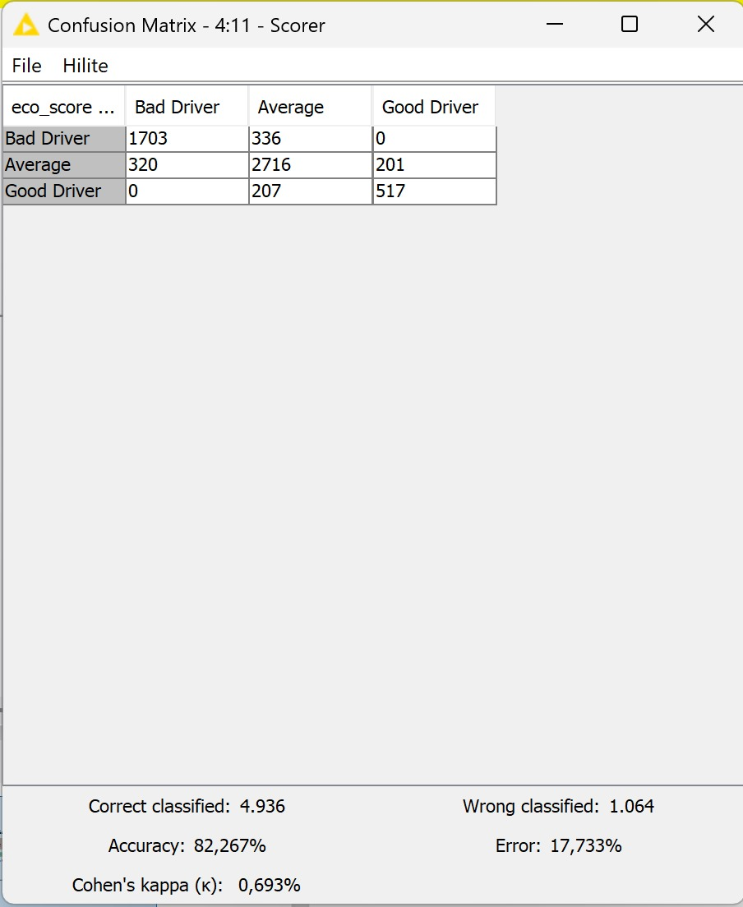
Figure 4.3 — Scorer Node Confusion Matrix for Eco-Score Driver Category (Accuracy 82.267%)
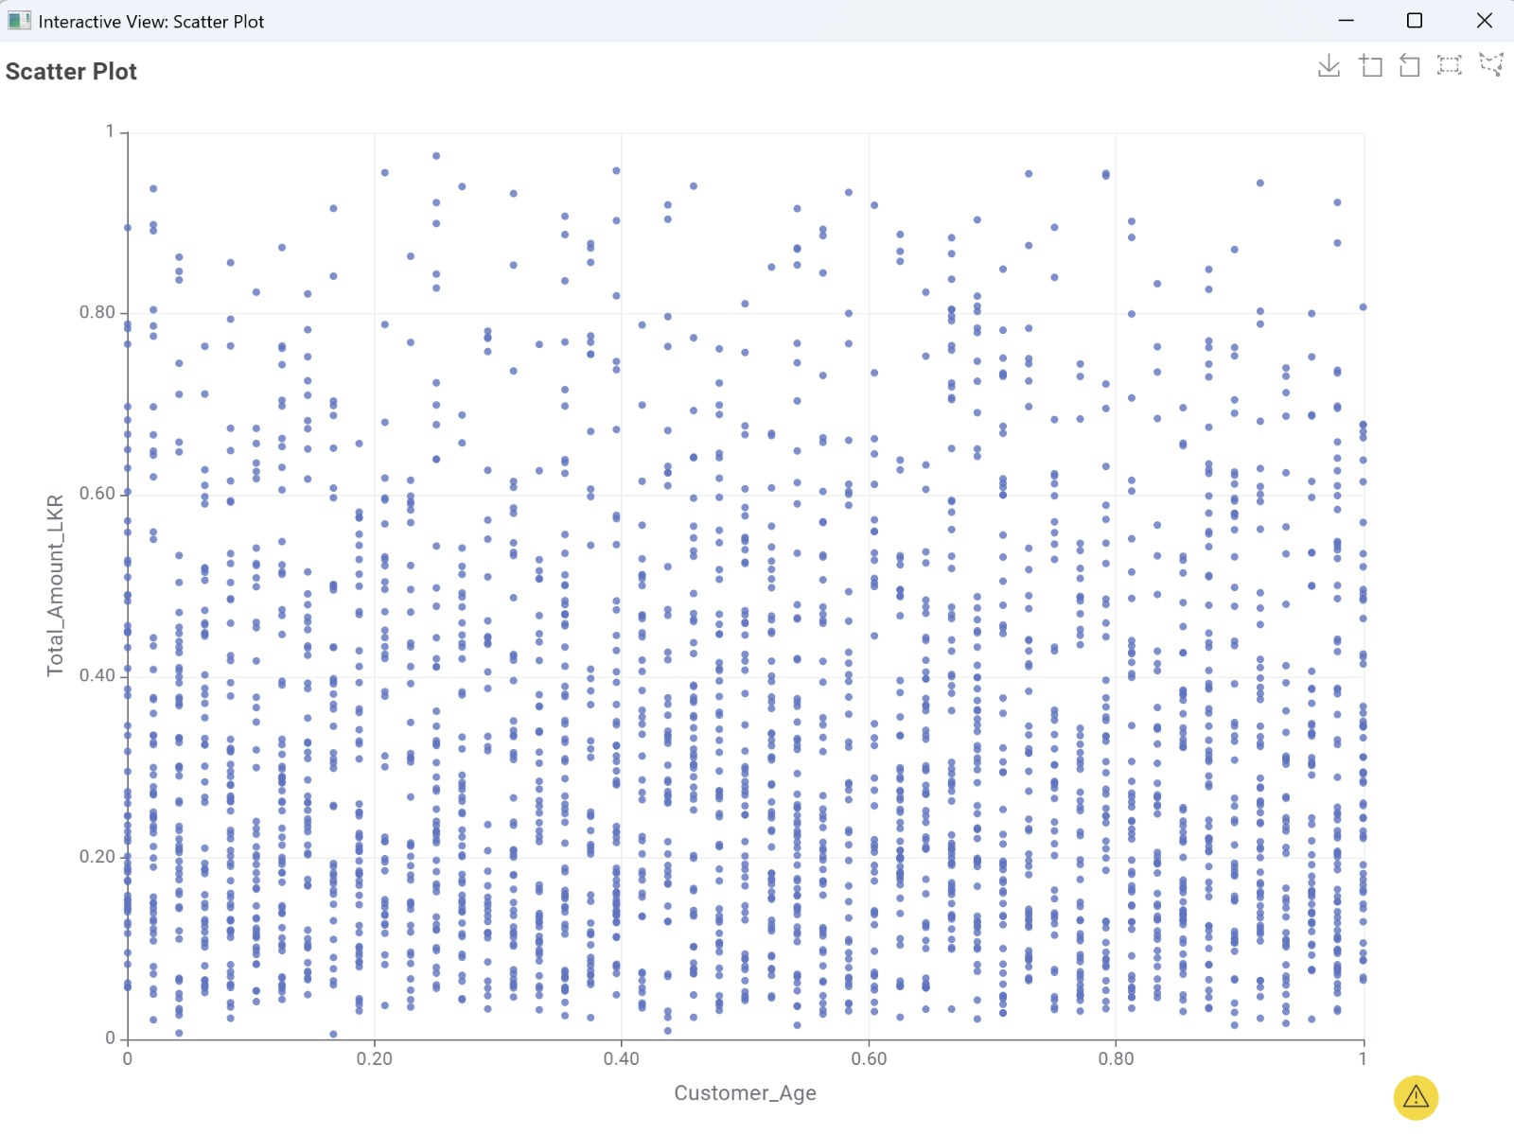
Figure 4.4 — Scatter Plot Visualization of Customer/Driver Data Distribution

Problem 3 — Bundle Sales / Association Rules Results

The Association Rule Learner node was applied in the analysis of car rental dataset in basket format after being transformed by Binner and Column Aggregator nodes using default settings of minimum support and confidence values. The node outputted zero qualifying rules (zero row results table for the Support, Confidence, Lift, Consequent, Implies, and Items columns) at this setting of threshold value.

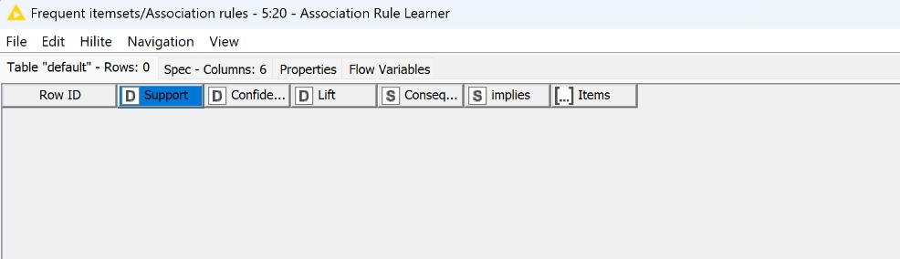
Figure 4.5 — Association Rule Learner Output Table (0 Rows Returned at Current Thresholds)

This non-event also serves as an event in itself: It’s informative as to whether any given bundle appears sufficiently often in the collection of transactions such that it can be counted as a frequent itemset (at the minimum support configured in this workflow). There are two likely business-implication-related conclusions that can be drawn from this null result: 1) the purchasing pattern of add-ons forSIXThis very fragmented, as no one add-on mix is disproportionately popular in booking patterns (operational intelligence that may itself be valuable); or 2) the minimum support selected for the analysis is excessively conservative for the number of transactions within the input data set. To address this, one could reduce minimum support values (perhaps from defaults like 10%-20% to 1%-5%), and run the process again to potentially uncover moderately commonbundle.

4.3 business implications and solutions offered to SIXT SE

- Predictive Maintenance: Based on 98.2% classification accuracy, SIXT may switch from preventive maintenance approach to predictive maintenance and focus only on the inspection of vehicles marked as problematic. Despite the false-negative rate, implementing this classification algorithm into an early-warning system can greatly help in minimizing unexpected breakdown costs and improve customer satisfaction.

- Driver Profiling: The difference between groups by fuel consumption provides SIXT with a rule to use easily ("high fuel consumption (~8.84) indicates the 'Bad Driver' status") to make decisions about risk-based insurance/deposits for car renters/corporate drivers as well as to provide targeted eco-driving trainings/vehicle reassignment to avoid excessive wear for those in the 'high fuel consumption-high wear' group and extend the lifespan of the vehicles.

- Bundle Sales Recommendation: As there are no associations found at the chosen threshold level, this information alone can be used to conclude that SIXT does not have any universal bundle to sell additional services together. The recommendation is to repeat the same analysis with a reduced value of support threshold and split customers into several segments first (based on age, for instance; using Customer_Age against Total_Amount scatterplot).

REFERENCES

Matzka, S. (2020). AI4I 2020 Predictive Maintenance Dataset [Data set]. UCI Machine Learning Repository / Kaggle. https://www.kaggle.com/datasets/stephanmatzka/predictive-maintenance-dataset-ai4i-2020

KNIME AG. (2024). KNIME Analytics Platform documentation. KNIME. https://docs.knime.com/

Han, J., Kamber, M., & Pei, J. (2012). Data mining: Concepts and techniques (3rd ed.). Morgan Kaufmann.

SIXT SE. (2024). About SIXT — Company information. SIXT.
https://www.sixt.com/

Kaggle. (2024). Car rental dataset [Data set]. Kaggle.
https://www.kaggle.com/

Kaggle. (2024). Eco-driving behavior dataset [Data set]. Kaggle. h

