

App Project Report

Fall,2025

Abstract
This project comprises the design and implementation of a web-based e-commerce website in the Home & Living product category. The primary intent of this project is to mimic a simple online shopping website to verify basic e-commerce functionality support on a website. The website is designed with PHP, HTML, CSS, and is based on a local web server setup with XAMPP on a MySQL database. From a functional perspective, users are enabled to log in with valid predefined values, view a list of products, search for products based on their category and price range, view specific product information, add items to an online ‘shopping basket,’ and finally, handle basket contents. Using sessions, authentication of users is maintained while visiting different pages of the website. Products' as well as users' data is stored in a relational database management system with dynamic retrieval of data. Test outcomes prove the website functions normally while being subjected to normal usage patterns. Based on these findings, the project cumulatively verifies practical application of web development techniques, integration with a database, storage of user data in a relational DBMS with sessions associated with a user’s visit to an e-commerce website.

1. Introduction
“The aim of this project will be to create an e-commerce website based on the Home & Living product type. The website will be designed to imitate the basic functionality of an actual e-commerce website, which means it will incorporate basic e-commerce functionalities."
The developed site enables users to log in using pre-defined log-in details, view an inventory of products stored in a database, search products, sort products, and display information on products. A user is able to add products to the shopping basket, edit the quantities, delete products, and see the total cost prior to closing their shopping session. Navigation of sites has been achieved using a menu system, while users' data has been managed with PHP sessions.
The objective of this project is to show the application of server-side programming, database-driven content management, and multi-page website design on a academic setting.

2. Literature Review
E-commerce applications and their use in modern web-based commerce were seen to be very important, and structured database design, authentication mechanisms, and navigation systems were noted to be very important components of an e-commerce site. PHP scripting language was still noted to be very popular at that time because of its flexibility and relational capabilities with MySQL.
Studies also bring out the relevance of search and filtering capabilities in enhancing the browsing experience for customers. Session handling methods can be employed to preserve the state of the customer over a number of web pages without the need for continuous authentication. Tools for local web developers, such as XAMPP, are often adopted for the development of web applications at the learning stage of institutions of higher learning.

3. Methodology
This section explains the development process, system structure, and technologies used in the project in sufficient detail to allow reproduction of the system by a trained individual.

3.1 Hardware Requirements
- A personal computer or laptop capable of running a local web server
- Sufficient processing power and memory to support Apache and MySQL services
- Adequate disk space for storing project files, images, and database data
- Internet connection for development resources and testing

3.2 Software Requirements
- XAMPP (Apache, PHP, MySQL)
- MySQL database managed via phpMyAdmin
- Visual Studio Code for code development
- Web browser for testing

3.3 System Architecture
The system follows a client–server architecture. The client interacts with the website through a web browser, while server-side processing is handled by PHP scripts executed on the Apache server. The MySQL database stores persistent data such as users, products, images, and basket records. PHP sessions are used to manage authentication and maintain user-specific data across pages.

3.4 E-R Diagram
The database design of the project is developed using a relational Entity-Relationship (E-R) Model that provides support for basic functionality of an e-commerce site. The E-R diagram is developed in a way that it aims at ensuring data integrity, avoiding redundant data, and specifying relation between system entities.
“Users” are the representation of system users who have been registered. They hold information related to the login credentials of the user. A user may have many basket entries. So, a one-to-many relationship exists between Users and Basket entities.
In entity "Products," data about the products is stored. This data includes product name, description, price, category, brand, and a URL for the primary image.
A product is identified uniquely in relation to its primary key. A product may have multiple images.To facilitate multiple images for a product, a new entity, Product_Images, has been employed. This entity establishes a relationship of one to many with the Products entity, enabling each product to contain extra images without replicating product details in the database, thus ensuring enhanced normalization of the database.
"Basket" is an entity that symbolizes a shopping basket and acts as a linking component between Users and Products. In this case, it holds the quantities chosen by a particular user for each product. The Basket table maintains multiple relationship connections to Users and Products via foreign key fields. This design helps each user store various products inside their basket.

In this case, it's apparent that the ER model describes an effective data structure system with an efficient way to handle data in the system, in addition to supporting user data management required in an e-commerce system.

3.5 Tools
- XAMPP for local server environment
- phpMyAdmin for database management
- Visual Studio Code as the development editor

3.6 Algorithms
The system utilizes a series of logical processes implemented using PHP and SQL queries to interact with users and manipulate data. These processes comprise the operational logic of the website.

User Authentication Logic:
The authentication mechanism checks the user credentials with the details stored in the database. Once validated, session variables are generated for the identification of the user during the entire browsing session. Authorization of pages is done by analyzing the session variables.
Product Search and Filtering Logic:
Product listing functions actively extract information from the database using criteria specified by the users. The search keys used to match products correspond to their name, description, or brand details. Product categories chosen, combined with price range specifications, serve to narrow down products listed for potential customers to see.

Basket Management Logic:
The functions regarding baskets are responsible for managing addition, update, and delete operations of products. While doing an addition of a product, it checks whether it already exists in the user's basket or not. If it exists, it will increase its count otherwise a new record is to be created in the basket. The records in the baskets belong to the logged-in user.
Total Price Calculation Logic:
The final price is determined server-side by adding the value of the individual lines in the shopping basket together. Each value is determined by the price of the product times the quantity chosen. Thus, no matter where the user clicks or what the user wants to refresh, the end result will be right and the same every time because all these algorithms work together to allow for a seamless e-commerce experience with integrity in its processes.

4. Results and Discussion
This section presents the results of the project under four categories.

4.1 Project Management
The project was developed in phases including database design, page development, user interface styling, and testing. The minor issues pertained to session handling and the formation of the queries. These were overcome by the process of testing and debugging. The work was done in the planned manner in the development process.

4.2 Final Product
The end result is a fully functional ecommerce site that is composed of multiple interrelated pages. The home page is designed for promotional activities, including promotional banners, feature products, and brand sections. The products page is designed for listing products that have search functionality. The shopping page is designed for product information presentation with functionality for adding products to a shopping basket. The summary page is designed for basket management.The implemented system aligns with the analysis and design objectives defined at the beginning of the Project.

4.3 Test Results
Testing was done in relation to login, searching, addition, and update operations related to basket addition, while total price calculations were also considered. Logs were kept in order to check whether there were expected and actual outcomes in both cases.

4.4 Limitations and Constraints
• The project is developed for learning purposes
• Product and user data are maintained by hand through the database
• The system uses the local server environment thus restricting real-time multi-user interaction

5. Future Considerations
Future enhancements can comprise adding an administrative interface for user and product management, improving current security features such as password encryption, designing a responsive interface for mobile browsing, and hosting the site on a remote hosting server. Other features can include sophisticated filtering and order processing systems.

6. Conclusion

This project has been able to successfully showcase the implementation of creating a Home & Living e-commerce website using the above-mentioned technologies of PHP, HTML, CSS, and MySQL. It can be said that some of the critical concepts learned in this course, such as handling databases, sessions, and creating a multi-page website, have been applied here through this very same project itself.

References

Apache Software Foundation. (2024). Apache HTTP Server documentation (Version 2.4). https://httpd.apache.org/docs/

Apache Friends. (2025). XAMPP: An easy to install Apache distribution containing MariaDB, PHP, and Perl. https://www.apachefriends.org/index.html

MySQL. (2024). MySQL 8.0 Reference Manual. Oracle Corporation. https://dev.mysql.com/doc/refman/8.0/en/

phpMyAdmin Team. (2025). phpMyAdmin documentation. https://www.phpmyadmin.net/docs/

PHP Group. (n.d.). PHP: Hypertext Preprocessor manual. https://www.php.net/docs.php

Trendyol. (2025). Trendyol official website. https://www.trendyol.com/

W3Schools. (2025). PHP MySQL Database. https://www.w3schools.com/php/php_mysql_intro.asp

Appendices
Appendix A: User Interfaces
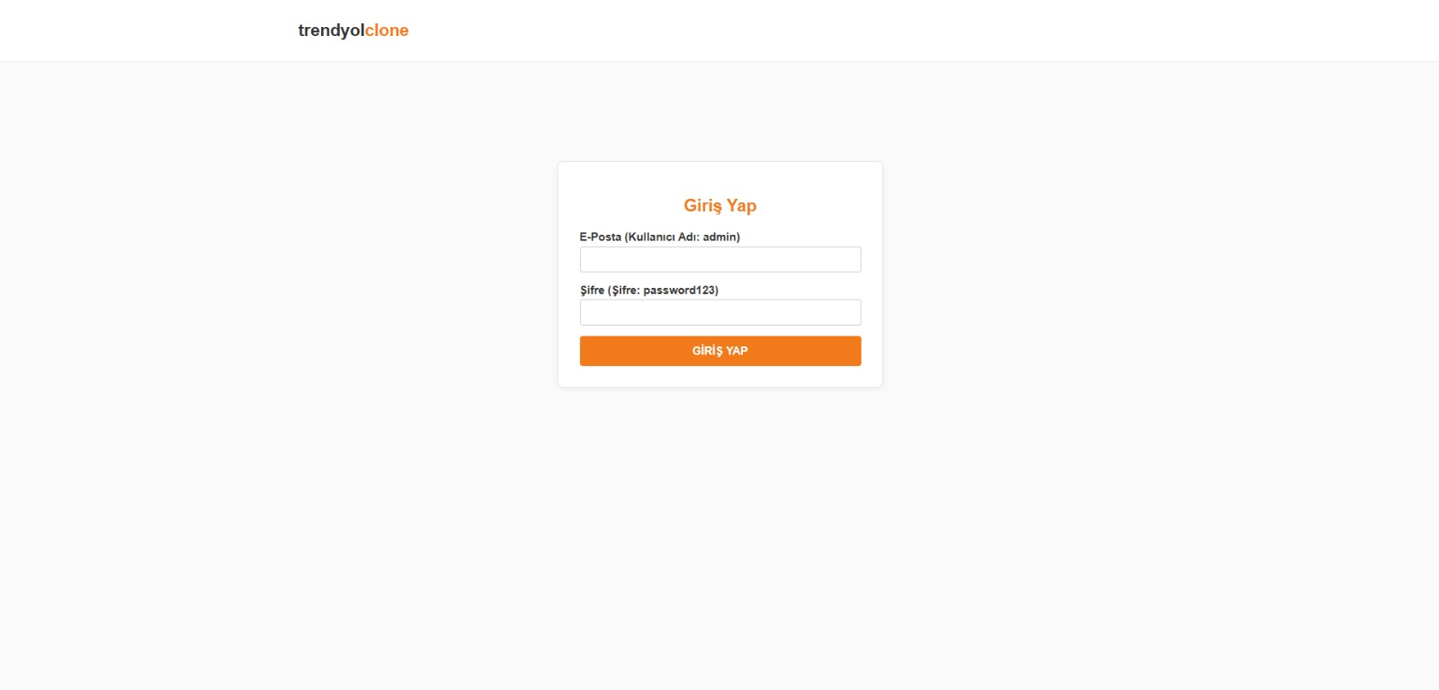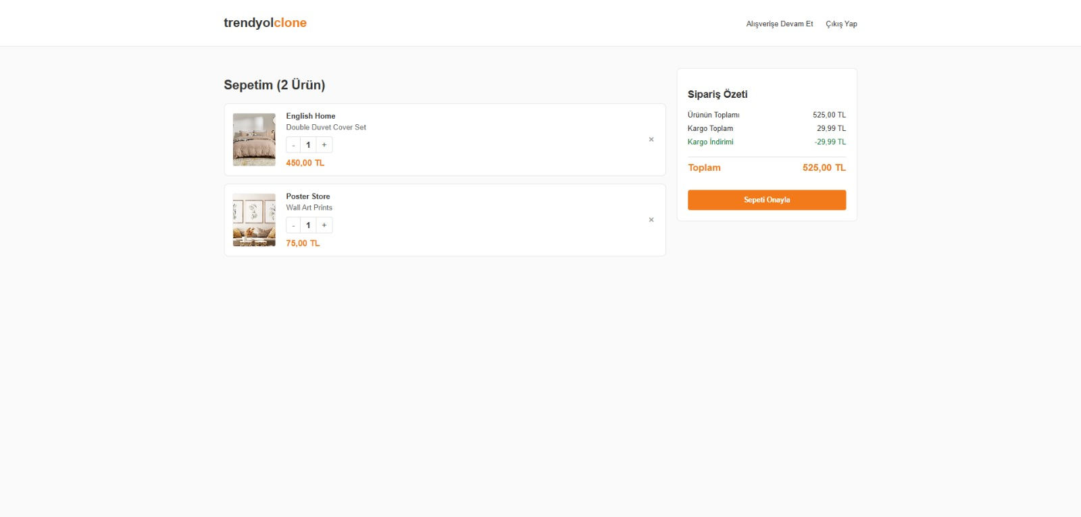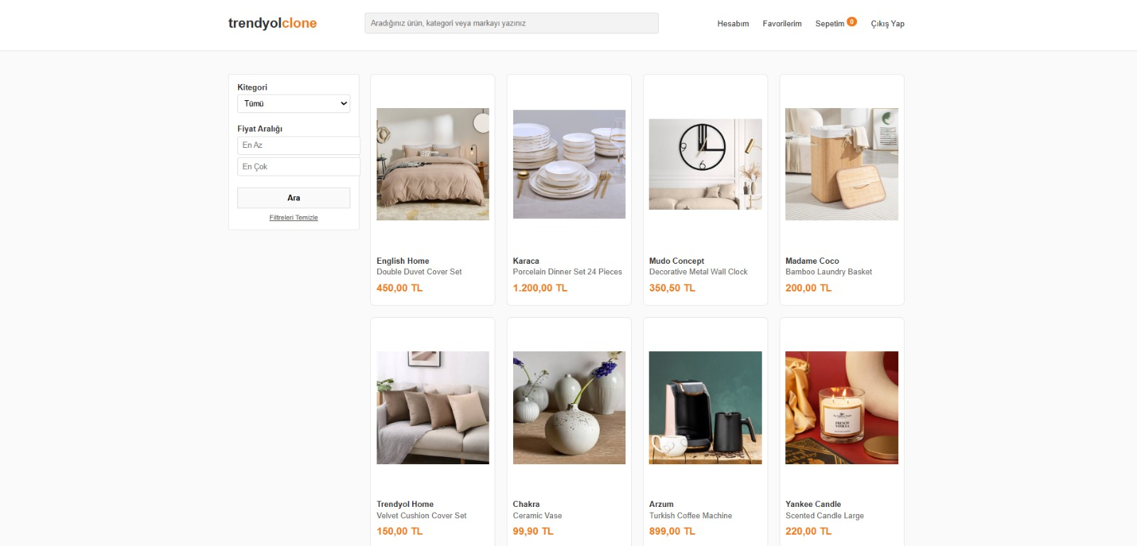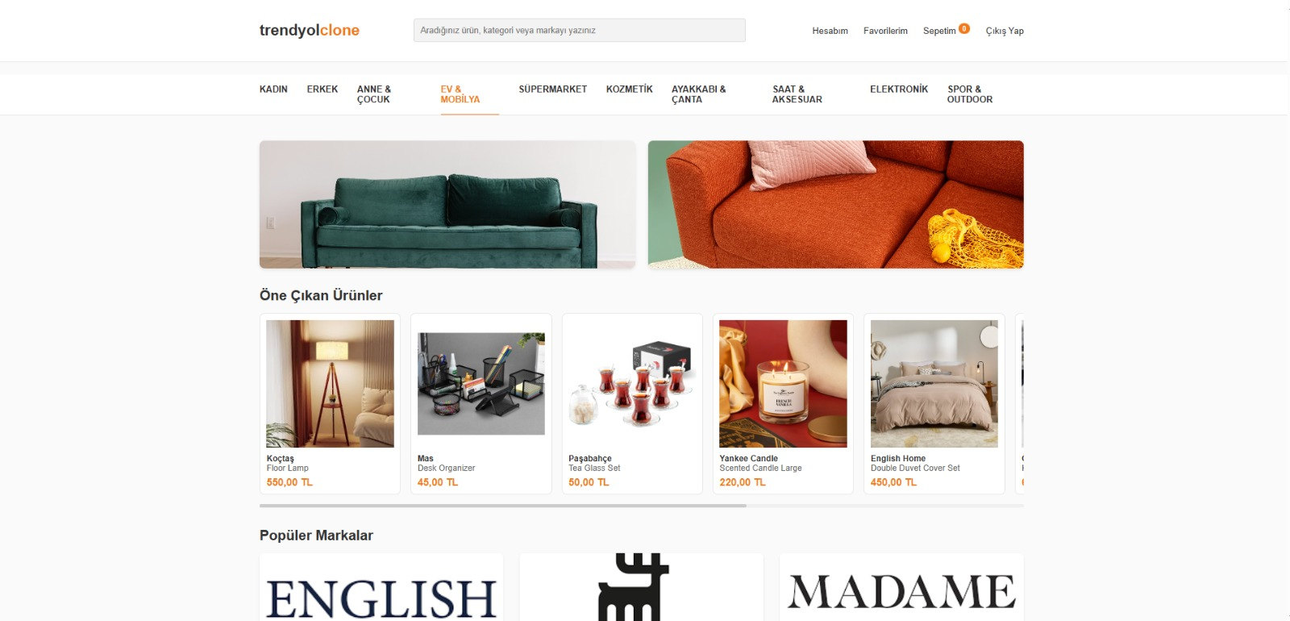

Appendix B: SQL Scripts
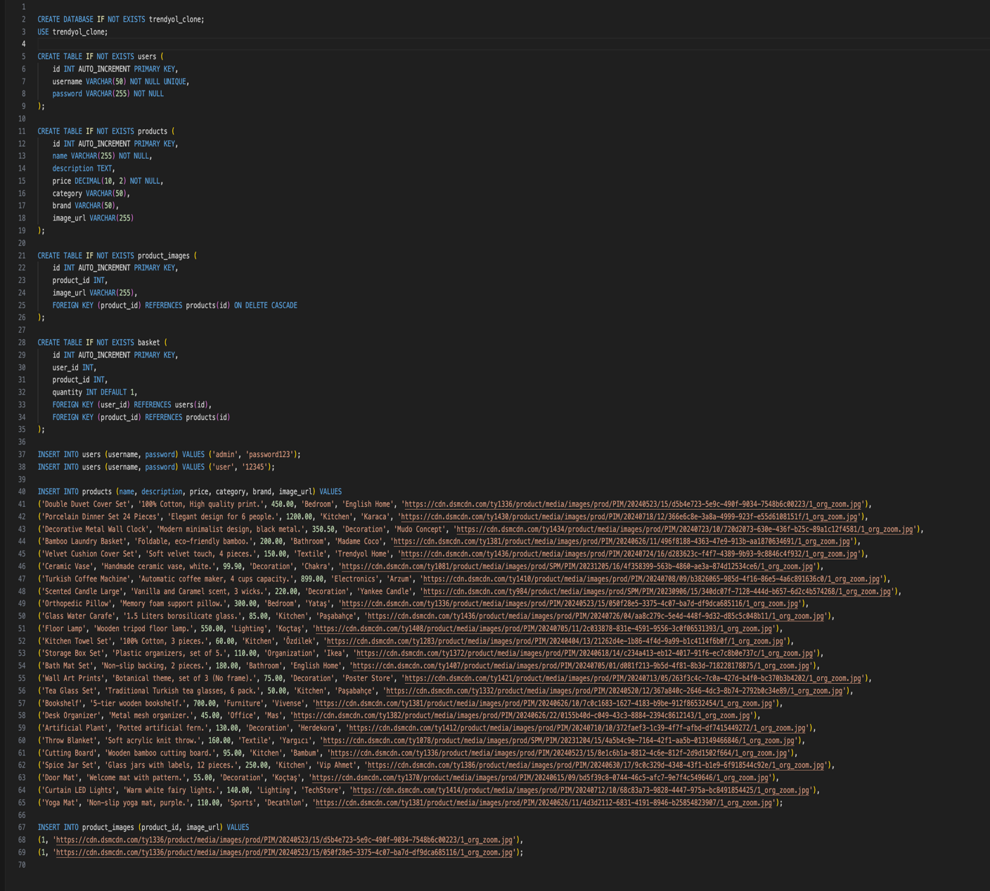

Appendix C: Class Diagram and E-R 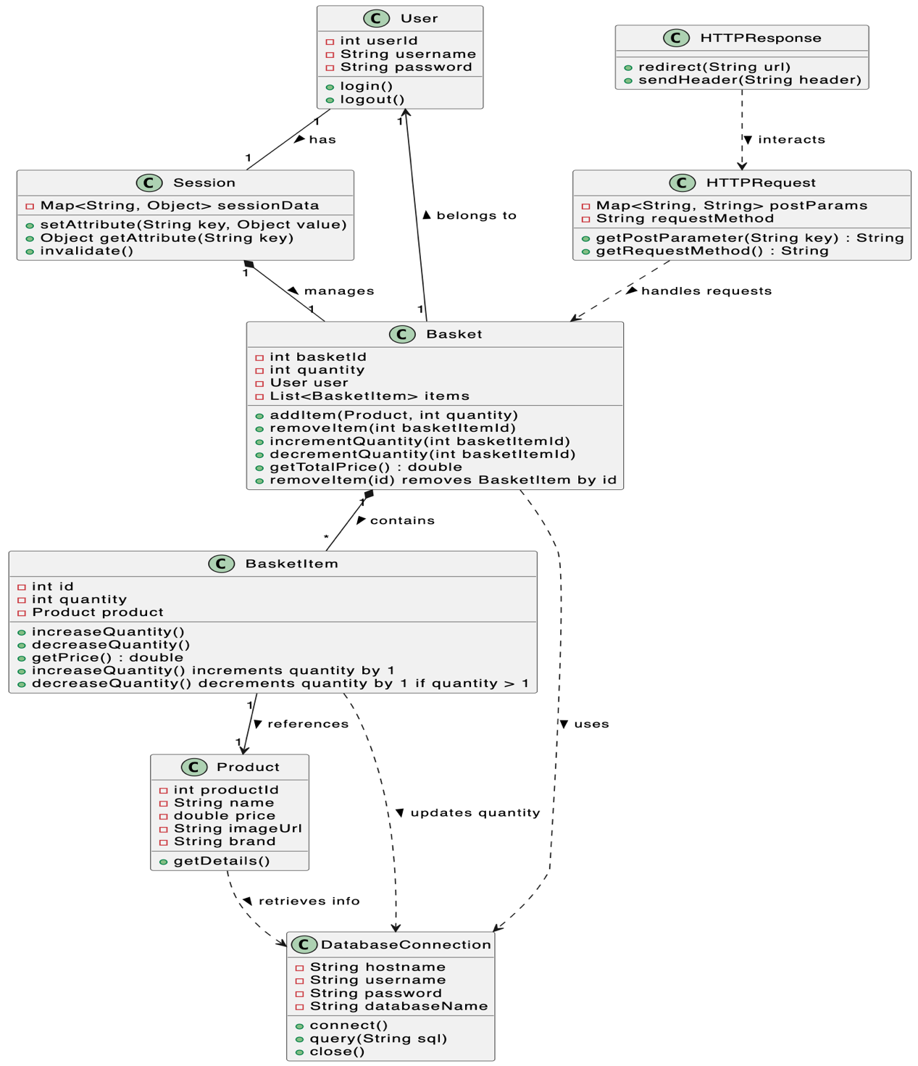

Appendix D: Test Log
