
The Birth of John the Baptizer
The Birth of John the Baptizer
Luke 1:5–25 Luke 1:57–64
Lesson Overview
Today’s Truth | God hears our prayers.
Objective | KNOW: The children will know that God hears their prayers.  DO: The children will talk with God.
Materials | - Quarter 1 Picture book, Bible, chalk  - Copies of the memory verse coloring page for the children to take home.  - Horn, gong, or drum  - Ball (Make a ball by tying wrappen (plastic bag) into knots many times, or fill an old sock with scrap material.)
Memory Verse | Luke 1:13 But the angel said to him: “Do not be afraid, Zechariah; your prayer has been heard. Your wife Elizabeth will bear you a son, and you are to give him the name John.”
Homework | Talk to God every day this week. You can talk to God anywhere at any time and He will hear you. You can talk to God when you are washing dishes, or when you are walking to visit your neighbours. Is God saying “yes”, “no”, or “wait”?

Detailed Lesson Plan
Song
Opening
Welcome
- Be sure the children know you are happy to see them!
- Introduce yourself and your helpers.
Sharing Time
What is something God has given you?
- (Give children time to share.)
Let's thank God for His gifts to us.
Prayer
- Let the children share praises and prayer requests.
- Keep a record of what the children are sharing so you can remember to thank God together for answered prayers.
- Spend time praying together. Let the children pray out loud if they volunteer. Do not force anyone to pray out loud.
Song
Words to Discuss
- On the blackboard, write the “Words to Discuss” from the list below.
Let's discuss some words to help us better understand the Bible story for today.
- Prayer: Talking to God. Where are some places we pray? What are some things we can be doing while we pray? Do we have to use a certain language or voice when we pray?
- Priest: Someone who makes sacrifices to God on behalf of others.
- Angels: Spiritual beings created by God to serve and worship Him. Often used by God as His messengers.
- Prophet: A man or woman God uses as His messenger.
Song
Bible Story / Lesson
Materials: Horn, gong, or drum
- Show the horn, gong or drum to the children.
- What do we use this for? (For calling people together for a meeting)
- When the horn is blown, does everyone always hear it? (No, they may be in the farm or they may be sleeping.)
- What is prayer? (It is talking to God.)
- When you pray or talk to God, do you have to ring a gong to get His attention? (No)
- God is always ready to listen to us. He is never sleeping or too busy to hear us.
- Today we will be learning about how God hears our prayers.
Introduce Truth
Our truth for today is: God hears our prayers.
This reminds me of a true story from the Bible.
Bible Story: Luke 1:5–25 Luke 1:57–64
[ We are going to spend a year learning about one book in the Bible, the Gospel of Luke. The Holy Spirit guided a man named Luke to write this book about Jesus and His teachings. Luke was a doctor and a follower of Jesus.
During this time in history, the land of Israel was part of the Roman Empire. The Jews dreamed of the day the promised Messiah (Christ) would come to save them and set them free. ]
[ The first story from the Gospel of Luke is about a priest named Zachariah. ]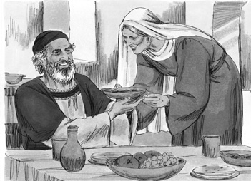
Picture 1–1

Luke 1:5-7 During the reign of Herod king of Judea, there lived a priest named Zechariah who belonged to the priestly division of Abijah, and he had a wife named Elizabeth, who was a descendant of Aaron. They were both righteous in the sight of God, following all the commandments and ordinances of the Lord blamelessly. But they did not have a child, because Elizabeth was barren, and they were both very old.
Luke 1:8-10 Now while Zechariah was serving as priest before God when his division was on duty, he was chosen by lot, according to the custom of the priesthood, to enter the holy place of the Lord and burn incense. Now the whole crowd of people were praying outside at the hour of the incense offering. 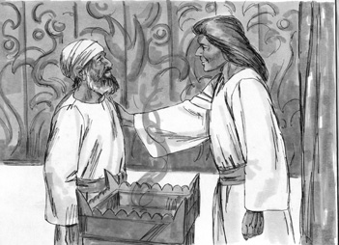
Picture 1–2

Luke 1:11-17 An angel of the Lord, standing on the right side of the altar of incense, appeared to him. And Zechariah, visibly shaken when he saw the angel, was seized with fear. But the angel said to him, “Do not be afraid, Zechariah, for your prayer has been heard, and your wife Elizabeth will bear you a son; you will name him John. Joy and gladness will come to you, and many will rejoice at his birth, for he will be great in the sight of the Lord. He must never drink wine or strong drink, and he will be filled with the Holy Spirit, even before his birth. He will turn many of the people of Israel to the Lord their God. And he will go as forerunner before the Lord in the spirit and power of Elijah, to turn the hearts of the fathers back to their children and the disobedient to the wisdom of the just, to make ready for the Lord a people prepared for him.”
Luke 1:18 Zechariah said to the angel, “How can I be sure of this? For I am an old man, and my wife is old as well.”
Luke 1:19-20 The angel answered him, “I am Gabriel, who stands in the presence of God, and I was sent to speak to you and to bring you this good news. And now, because you did not believe my words, which will be fulfilled in their time, you will be silent, unable to speak, until the day these things take place.”
Luke 1:21-22 Now the people were waiting for Zechariah, and they began to wonder why he was delayed in the holy place. When he came out, he was not able to speak to them. They realized that he had seen a vision in the holy place, because he was making signs to them and remained unable to speak.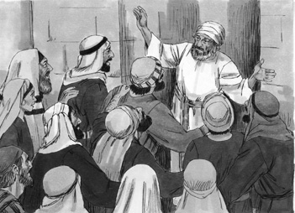
Picture 1–3

Luke 1:23-25 When his time of service was over, he went to his home. After some time his wife Elizabeth became pregnant, and for five months she kept herself in seclusion. She said, “This is what the Lord has done for me at the time when he has been gracious to me, to take away my disgrace among people.”
God hears our prayers.
Luke 1:57-58 Now the time came for Elizabeth to have her baby, and she gave birth to a son. Her neighbors and relatives heard that the Lord had shown great mercy to her, and they rejoiced with her.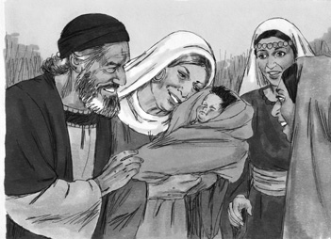
Picture 1–4

Luke 1:59-60 On the eighth day they came to circumcise the child, and they wanted to name him Zechariah after his father. But his mother replied, “No! He must be named John.”
Luke 1:61 They said to her, “But none of your relatives bears this name.”
Luke 1:62-64 So they made signs to the baby’s father, inquiring what he wanted to name his son. He asked for a writing tablet and wrote, “His name is John.” And they were all amazed. Immediately Zechariah’s mouth was opened and his tongue released, and he spoke, blessing God.
Application
God hears the prayers of His children. You become a child of God by asking Jesus to be your Lord and Saviour.
- Ask if there is anyone who would like to be a part of God’s family. Take time to counsel them after class.
If you are a part of God’s family, then God hears your prayers; just like He heard the prayers of Zechariah and Elizabeth. Sometimes God says “yes” to our prayers. Sometimes God says “no” to our prayers. Sometimes God says “wait” to our prayers. But God always answers the prayers of His children.
God hears our prayers.
Homework
This week: Talk to God every day this week. You can talk to God anywhere at any time and He will hear you. You can talk to God when you are washing dishes, or when you are walking to visit your neighbours. Is God saying “yes”, “no”, or “wait”?
Prayer / Song
Review Game
Throw the Ball at the Target on the Wall
Materials

- Make a target as shown on the blackboard or wall.
- Ball (Make a ball by tying wrappen (plastic bag) into knots many times, or fill an old sock with scrap material.)
- Draw a line on the floor for the children to stand behind.
How to Play
- Divide the class into 2 teams.
- The first team tries to answer the first question. The teacher can use this time to explain what the children do not seem to understand.
- The student on the team that answers the question correctly comes to the front and stands behind the line with their back facing the target. If the child only gets part of the question correct, the teacher can fill in the rest. The child can also ask for help from another child on his/her team. Help the child to succeed.
- The student then tries to throw the ball at the target.
- Wherever the ball hits shows how many points that team has.
- Record the points. The team with the most points wins.
- Be sure to clap for both sides. No name-calling. Encourage good sportsmanship.
Questions for Review Game
- What was the name of the priest in the first story of Luke? (Zechariah)
- What was the name of his wife? (Elizabeth)
- What problem did Zechariah and Elizabeth have? (They had no children.)
- How did they handle their problem? (They prayed to God.)
- Who visited Zechariah in the temple? (An angel)
- What was his message to Zechariah? (God had heard their prayers, they were going to have a baby.)
- What was Zechariah's reaction after receiving this message? (He doubted.)
- What happened to Zechariah when he doubted the angel's message? (He could not speak.)
- What name was to be given to Zechariah's son? (John)
- What was John supposed to do? (Lead people back to God, prepare the way for the kingdom of God)
- What was the main truth of our story today? ( God hears our prayers. )
Song
Memory Verse
Materials and Preparations
- Put a bookmark in Luke 1:13
- Write memory verse on the blackboard.
Luke 1:13 But the angel said to him: “Do not be afraid, Zechariah; your prayer has been heard. Your wife Elizabeth will bear you a son, and you are to give him the name John.”
Teach and Explain
Our memory verse is in the Gospel of Luke. That is in the New Testament, a part of the Bible.
- Read the verse from your Bible.
- Read the verse by yourself as you point to the words.
- Read the verse with the children as you point to the words.
- Explain the verse:
- Our memory verse comes from today’s Bible story.
- As you read the verse, circle the words shown below. Explain each of these words.
- Angel: An angel is a messenger from God.
- Prayer: Prayer is talking to God. We don’t need to use a different voice, or a different language. We should talk to God the way we talk to a good friend. What was Zechariah’s prayer? (That he and Elizabeth would have a baby.)
- Bear: This word means to give birth. The angel said that Elizabeth was going to have a baby boy. They were told to name the baby John.
- Read the verse again by yourself as you point to the words.
- Read the verse again with the children as you point to the words.
If you are a part of God’s family, then God hears your prayers just like He heard the prayers of Zechariah and Elizabeth. Sometimes God says “yes” to our prayers. Sometimes God says “no.” Sometimes God says “wait.” No matter the answer, God always hears our prayers.
Remember our truth for the day? Let’s all say it together:
God hears our prayers.
Memory Verse Review
Erase the Words of the Verse Written on the Blackboard
- Ask the children the first question.
- When a question is answered correctly, that child comes to the front and wipes away one or two words from the memory verse on the blackboard.
- The verse is said out loud together, making sure to say the missing words.
- Then the next question is asked.
- When that question is answered correctly, another child comes to the front and wipes more words from the memory verse on the chalkboard.
- The verse is said aloud again.
- Do this until all the words are gone and the children repeat the verse from memory.
Questions for Memory Verse
- Where is today's memory verse found? ( Luke 1:13 )
- Who delivered the message from God? (An angel)
- Who heard Zechariah's prayers? (God)
- What was going to happen? (Elizabeth was going to have a baby.)
- What were Zechariah and Elizabeth told to name the baby? (John)
Song
Closing and Homework
- Say the truth together:
God hears our prayers.
- Say the memory verse together:
Luke 1:13 But the angel said to him: “Do not be afraid, Zechariah; your prayer has been heard. Your wife Elizabeth will bear you a son, and you are to give him the name John.”
- Review the homework:
Talk to God every day this week. You can talk to God anywhere at any time and He will hear you. You can talk to God when you are washing dishes, or when you are walking to visit your neighbours. Is God saying “yes”, “no”, or “wait”?
- Give any needed announcements.
Closing Prayer
Thank God that He ALWAYS hears us when we talk to Him.
Ask God that the children will remember to talk to Him this week, and that their lives will be changed.
Colouring page to colour and take home!

God hears our prayers.
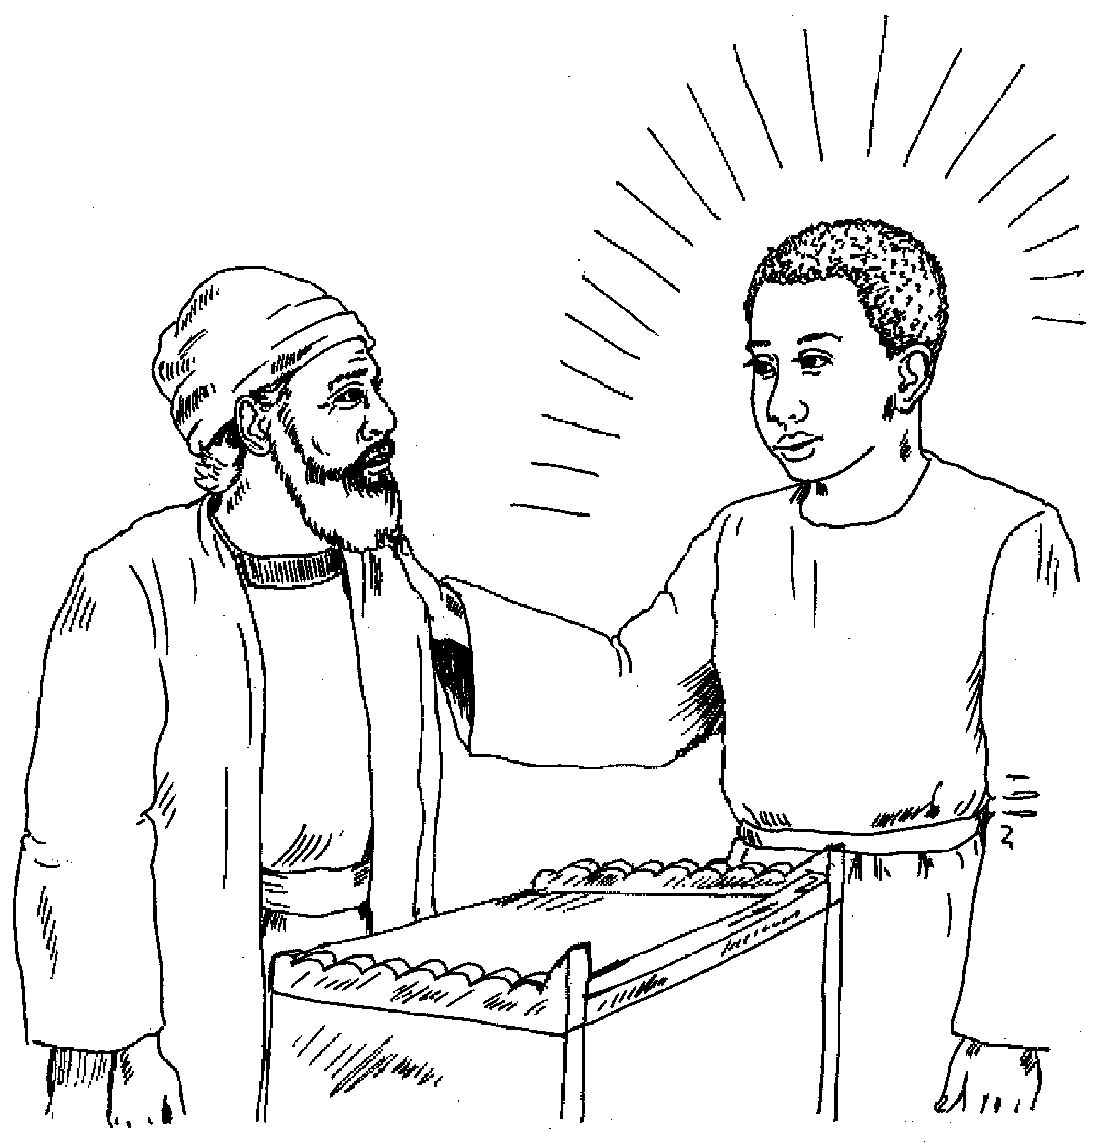
Luke 1:13 But the angel said to him: “Do not be afraid, Zechariah; your prayer has been heard. Your wife Elizabeth will bear you a son, and you are to give him the name John.”
God hears our prayers.
Luke 1:13 But the angel said to him: “Do not be afraid, Zechariah; your prayer has been heard. Your wife Elizabeth will bear you a son, and you are to give him the name John.”

