
Jesus Begins His Ministry
Jesus Begins His Ministry
Jesus Begins His Ministry
Luke 4:14–30
Lesson Overview
Today’s Truth | Jesus sets us free from sin and from the devil.  Jesus sets us free from sin and from the devil.
Objective | KNOW: The children will know that Jesus sets them free from sin and the devil.  DO: The children will have victory over sin this week.
Materials | - Quarter 1 Picture book, Bible, chalk  - Copies of the memory verse coloring page for the children to take home.  - Long banana leaf or something similar. Weave a stick into each end. Roll the leaf on both ends to look like a scroll. (See pictures 8-4 & 8-5.)  - Rope or twine, knife or scissors
Memory Verse | Luke 4:18-19 “The Spirit of the Lord is on me, because he has anointed me to preach good news to the poor. He has sent me to proclaim freedom for the prisoners and recovery of sight for the blind, to release the oppressed, to proclaim the year of the Lord’s favor.”  Luke 4:18-19 “The Spirit of the Lord is on me, because he has anointed me to preach good news to the poor. He has sent me to proclaim freedom for the prisoners and recovery of sight for the blind, to release the oppressed, to proclaim the year of the Lord’s favor.”
Homework | Think about a sin that you have had problems repenting, a sin that you keep doing over and over. Ask Jesus to help you overcome that sin this week.  Think about a sin that you have had problems repenting, a sin that you keep doing over and over. Ask Jesus to help you overcome that sin this week.

Detailed Lesson Plan
Song
Opening
Welcome
- Be sure the children know you are happy to see them!
- Introduce yourself and your helpers.
Sharing Time
- Say the truth from the previous lesson together:
God's Word helps us fight temptation.
God's Word helps us fight temptation.
- Say the memory verse from the previous lesson together:
Luke 4:8 Jesus answered him, “It is written, ‘ You are to worship the Lord your God and serve only him.’”
Luke 4:8 Jesus answered him, “It is written, ‘ You are to worship the Lord your God and serve only him.’”
- Review the homework from the previous lesson:
Did you remember the memory verse for when you are tempted to think, say or do things that displease God?
Did you remember the memory verse for when you are tempted to think, say or do things that displease God?
(Give children time to share.)
Did remembering the memory verse help you when you were tempted to sin?
Did remembering the memory verse help you when you were tempted to sin?
(Give children time to share.)
Prayer
- Let the children share praises and prayer requests.
- Keep a record of what the children are sharing so you can remember to thank God together for answered prayers.
- Spend time praying together. Let children pray out loud if they volunteer. Do not force anyone to pray out loud.
Song
Words to Discuss
On the blackboard, write the “Words to Discuss” from the list below.
Materials: Long banana leaf or something similar. Weave a stick into each end. Roll the leaf on both ends to look like a scroll. (See pictures 8-4 & 8-5.)
- Let's discuss some words to help us better understand the Bible story for today.
Let's discuss some words to help us better understand the Bible story for today.
- Sin: All the things we think, say and do that displease God.
Sin: All the things we think, say and do that displease God.
- Repent: To turn from sin and to turn towards God.
Repent: To turn from sin and to turn towards God.
- Devil: The chief of evil spirits. An enemy of God and man.
Devil: The chief of evil spirits. An enemy of God and man.
- Spirit: The breath and the power of God.
Spirit: The breath and the power of God.
- Synagogue: Jewish place of worship.
Synagogue: Jewish place of worship.
- Sabbath: Day of worship.
Sabbath: Day of worship.
- Scroll: A book written on paper that is rolled up.
Scroll: A book written on paper that is rolled up.
- Mob: An angry, violent crowd of people.
Mob: An angry, violent crowd of people.
Song
Bible Story / Lesson
Object Lesson: Getting all tied up.
Materials: Thread or thin twine that can be easily broken but has strength when more is added, knife or scissors with a paper attached that has “Jesus” written on it.
- Choose a volunteer.
- Have the child hold their wrists out to be tied together. Tie one strand of thread or twine around the volunteers' wrists. Ask the child to pull their wrists apart to break the thread. They should be able to break the thread.
When we sin, it is good to ask for forgiveness right away and to repent (change our direction). Then the sin is easily broken and it has no power in our life.
When we sin, it is good to ask for forgiveness right away and to repent (change our direction). Then the sin is easily broken and it has no power in our life.
- Tie the thread around the same child's wrists again but this time keep wrapping the thread around the child's wrists until he is not likely to break free.
- As you are wrapping the thread around the child's wrists, say,
“Sometimes we sin and don't ask for forgiveness and repent. Instead, we keep sinning and we become slaves to the sin. We become slaves to sin and the work of Satan to turn us away from God. This makes us poor in our spirits.”
“Sometimes we sin and don't ask for forgiveness and repent. Instead, we keep sinning and we become slaves to the sin. We become slaves to sin and the work of Satan to turn us away from God. This makes us poor in our spirits.”
- Ask the child to try to free himself from the thread. If you have wrapped it all around his arms well enough, he will not be able to break free.
- Show the knife or scissor.
This knife represents Jesus. Jesus is the only one who can free us from the power of sin and Satan in our lives.
This knife represents Jesus. Jesus is the only one who can free us from the power of sin and Satan in our lives.
- Cut off the thread from the child's wrists.
Jesus sets us free from sin and from the devil.
Jesus sets us free from sin and from the devil.
Introduce Truth
Our truth for today is: Jesus sets us free from sin and from the devil.
Our truth for today is: Jesus sets us free from sin and from the devil.
In the Bible story today, Jesus says that he has come to set us free.
In the Bible story today, Jesus says that he has come to set us free.
Bible Story: Luke 4:14–30
[ Jesus was about 30 years old when he began his ministry. In his home village, Nazareth, people thought he was just the son of Joseph, who was a descendant of King David and Abraham. ]
Luke 4:14-15 Then Jesus, in the power of the Spirit, returned to Galilee, and news about him spread throughout the surrounding countryside. He began to teach in their synagogues and was praised by all.
[ Jesus was about 30 years old when he began his ministry. In his home village, Nazareth, people thought he was just the son of Joseph, who was a descendant of King David and Abraham. ]
Luke 4:14-15 Then Jesus, in the power of the Spirit, returned to Galilee, and news about him spread throughout the surrounding countryside. He began to teach in their synagogues and was praised by all.
Luke 4:16-19 Now Jesus came to Nazareth, where he had been brought up, and went into the synagogue on the Sabbath day, as was his custom. He stood up to read, and the scroll of the prophet Isaiah was given to him. He unrolled the scroll and found the place where it was written, “ The Spirit of the Lord is upon me, because he has anointed me to proclaim good news to the poor. He has sent me to proclaim release to the captives and the regaining of sight to the blind, to set free those who are oppressed, to proclaim the year of the Lord’s favor.” 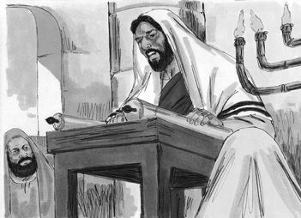
Picture 8–1

Luke 4:20-21 Then he rolled up the scroll, gave it back to the attendant, and sat down. The eyes of everyone in the synagogue were fixed on him. Then he began to tell them, “Today this scripture has been fulfilled even as you heard it being read.”
Luke 4:16-19 Now Jesus came to Nazareth, where he had been brought up, and went into the synagogue on the Sabbath day, as was his custom. He stood up to read, and the scroll of the prophet Isaiah was given to him. He unrolled the scroll and found the place where it was written, “ The Spirit of the Lord is upon me, because he has anointed me to proclaim good news to the poor. He has sent me to proclaim release to the captives and the regaining of sight to the blind, to set free those who are oppressed, to proclaim the year of the Lord’s favor.”
Luke 4:20-21 Then he rolled up the scroll, gave it back to the attendant, and sat down. The eyes of everyone in the synagogue were fixed on him. Then he began to tell them, “Today this scripture has been fulfilled even as you heard it being read.”
Luke 4:22 All were speaking well of him, and were amazed at the gracious words coming out of his mouth. They said, “Isn’t this Joseph’s son?”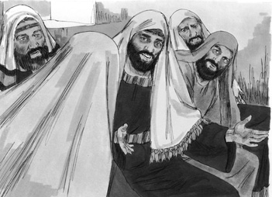
Picture 8–2

Luke 4:23 Jesus said to them, “No doubt you will quote to me the proverb, ‘Physician, heal yourself!’ and say, ‘What we have heard that you did in Capernaum, do here in your hometown too.’”
Luke 4:24-27 And he added, “I tell you the truth, no prophet is acceptable in his hometown. But in truth I tell you, there were many widows in Israel in Elijah’s days, when the sky was shut up three and a half years, and there was a great famine over all the land. Yet Elijah was sent to none of them, but only to a woman who was a widow at Zarephath in Sidon. And there were many lepers in Israel in the time of the prophet Elisha, yet none of them was cleansed except Naaman the Syrian.”
Luke 4:28 When they heard this, all the people in the synagogue were filled with rage.
Luke 4:22 All were speaking well of him, and were amazed at the gracious words coming out of his mouth. They said, “Isn’t this Joseph’s son?”
Luke 4:23 Jesus said to them, “No doubt you will quote to me the proverb, ‘Physician, heal yourself!’ and say, ‘What we have heard that you did in Capernaum, do here in your hometown too.’”
Luke 4:24-27 And he added, “I tell you the truth, no prophet is acceptable in his hometown. But in truth I tell you, there were many widows in Israel in Elijah’s days, when the sky was shut up three and a half years, and there was a great famine over all the land. Yet Elijah was sent to none of them, but only to a woman who was a widow at Zarephath in Sidon. And there were many lepers in Israel in the time of the prophet Elisha, yet none of them was cleansed except Naaman the Syrian.”
Luke 4:28 When they heard this, all the people in the synagogue were filled with rage.
Luke 4:29-30 They got up, forced him out of the town, and brought him to the brow of the hill on which their town was built, so that they could throw him down the cliff. But he passed through the crowd and went on his way.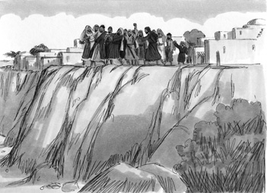
Picture 8–3

Luke 4:29-30 They got up, forced him out of the town, and brought him to the brow of the hill on which their town was built, so that they could throw him down the cliff. But he passed through the crowd and went on his way.
Application
Jesus said that he was the one sent by God to set the captives free. He was not talking about setting criminals free that are in prison for doing something bad. Jesus was saying that he came to set people free from the prison of sin. When we think, say and do things that displease God, we become slaves to that sin and the devil. We cannot free ourselves. We need help to get free. That is what Jesus can do for us.
Jesus said that he was the one sent by God to set the captives free. He was not talking about setting criminals free that are in prison for doing something bad. Jesus was saying that he came to set people free from the prison of sin. When we think, say and do things that displease God, we become slaves to that sin and the devil. We cannot free ourselves. We need help to get free. That is what Jesus can do for us.
Jesus sets us free from sin and from the devil.
Jesus sets us free from sin and from the devil.
Option: Use “Good News” picture book to present the gospel.
Have you accepted this Good News about Jesus? What have you done about it? How have you accepted it?
Have you accepted this Good News about Jesus? What have you done about it? How have you accepted it?
If you have already accepted the Good News about Jesus, do you really believe that he has set you free? Sin and the devil no longer have power over you.
If you have already accepted the Good News about Jesus, do you really believe that he has set you free? Sin and the devil no longer have power over you.
Homework
Think about a sin that you have had problems repenting, a sin that you keep doing over and over. Ask Jesus to help you overcome that sin this week.
Think about a sin that you have had problems repenting, a sin that you keep doing over and over. Ask Jesus to help you overcome that sin this week.
Prayer / Song
Review Game
Long Jump
Materials
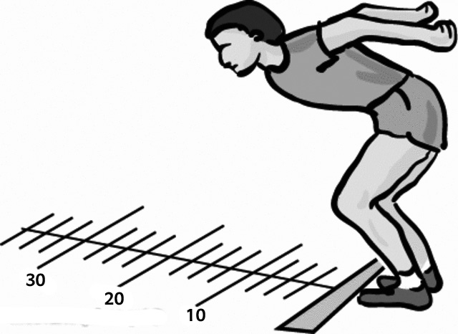
- Chalk
- Draw a starting line.
- Draw other lines from the starting line at different distances from the start.
- Give each distance a number with the easiest distance being 10 points then 20, 30, 40, 50 and so on.
How to Play
- Divide the class into 2 teams.
- When a child answers the question correctly, have that child come to the front and stand at the beginning line with their toes NOT crossing the line.
- Have them jump as far as they can from a standing position.
- Give points to that child's team depending on how far they jumped.
Questions for Review Game
- How old was Jesus when he began his ministry? (30 years old)
How old was Jesus when he began his ministry? (30 years old)
- Who did people think Jesus' father was? (Joseph)
Who did people think Jesus' father was? (Joseph)
- Whose power was with Jesus? (The Spirit of God)
Whose power was with Jesus? (The Spirit of God)
- Where did Jesus preach? (In the synagogue)
Where did Jesus preach? (In the synagogue)
- What kind of book did Jesus read from? (A scroll)
What kind of book did Jesus read from? (A scroll)
- The message that Jesus read was from what book of the Bible? (Isaiah)
The message that Jesus read was from what book of the Bible? (Isaiah)
- What was the main message that Jesus gave? (Jesus said that he had come to set us free from sin and from Satan.)
What was the main message that Jesus gave? (Jesus said that he had come to set us free from sin and from Satan.)
- What did Jesus say after he gave the scroll to the attendant? (The Scripture has come true before their very eyes.)
What did Jesus say after he gave the scroll to the attendant? (The Scripture has come true before their very eyes.)
- Why did the people become angry? (Jesus set himself up above them and their traditions.)
Why did the people become angry? (Jesus set himself up above them and their traditions.)
- What did the angry mob try to do? (Push Jesus off of a cliff)
What did the angry mob try to do? (Push Jesus off of a cliff)
- How did Jesus escape? (Slipping away through the crowd)
How did Jesus escape? (Slipping away through the crowd)
- What is the truth for today? ( Jesus sets us free from sin and from the devil. )
What is the truth for today? ( Jesus sets us free from sin and from the devil. )
Song
Memory Verse
Materials and Preparations
- Put a bookmark in Luke 4:18-19
- Write memory verse on the blackboard.
Luke 4:18-19 “The Spirit of the Lord is on me, because he has anointed me to preach good news to the poor. He has sent me to proclaim freedom for the prisoners and recovery of sight for the blind, to release the oppressed, to proclaim the year of the Lord’s favor.”
Luke 4:18-19 “The Spirit of the Lord is on me, because he has anointed me to preach good news to the poor. He has sent me to proclaim freedom for the prisoners and recovery of sight for the blind, to release the oppressed, to proclaim the year of the Lord’s favor.”
Teach and Explain
Today our memory verse is found in the Gospel of Luke. It goes with our story and truth for the day.
Today our memory verse is found in the Gospel of Luke. It goes with our story and truth for the day.
- Read the verse from your Bible.
- Read the verse by yourself as you point to the words.
- Read the verse with the children as you point to the words.
- Explain the verse:
- Our memory verse comes from today’s Bible story.
Our memory verse comes from today’s Bible story.
- As you read the verse, circle the words shown below. Explain each of these words.
- “The Spirit of the Lord”: The breath of God. The power of God.
“The Spirit of the Lord”: The breath of God. The power of God.
- Is on me: Jesus is the one talking here.
Is on me: Jesus is the one talking here.
- Because He has anointed me: God is the one who did the anointing. The word anointed means chosen.
Because He has anointed me: God is the one who did the anointing. The word anointed means chosen.
- To preach good news: The good news is that Jesus has come to set us free from the power of sin and the devil.
To preach good news: The good news is that Jesus has come to set us free from the power of sin and the devil.
- To the poor: Not the poor physically, but the poor spiritually. Before Jesus, we were poor spiritually. We had no power. Now Jesus gives us hope and power over sin and the devil.
To the poor: Not the poor physically, but the poor spiritually. Before Jesus, we were poor spiritually. We had no power. Now Jesus gives us hope and power over sin and the devil.
- Read the verse again by yourself as you point to the words.
- Read the verse again with the children as you point to the words.
Remember that sin is all the things we think, say and do that displease God. God chose Jesus to bring good news that He can save us. We are saved because of God and His love for us.
Remember that sin is all the things we think, say and do that displease God. God chose Jesus to bring good news that He can save us. We are saved because of God and His love for us.
Remember our truth for the day? Let’s all say it together:
Remember our truth for the day? Let’s all say it together:
Jesus sets us free from sin and from the devil.
Jesus sets us free from sin and from the devil.
Memory Verse Review
Erase the Words of the Verse Written on the Blackboard
How to Play
- Ask the children the first question.
- When a question is answered correctly, that child comes to the front and wipes away one or two words from the memory verse that is on the blackboard.
- The verse is said out loud together making sure to say the missing words.
- Then the next question is asked.
- When that question is answered correctly, another child comes to the front and wipes more words from the memory verse on the blackboard.
- The verse is said aloud again.
- Do this until all the words are gone and the children are able to repeat the verse from memory.
Questions for Memory Verse
- Where in the Bible is today's memory verse found? ( Luke 4:18-19 )
Where in the Bible is today's memory verse found? ( Luke 4:18-19 )
- Who was talking in this verse? (Jesus)
Who was talking in this verse? (Jesus)
- What did Jesus say was on him? (The Spirit of the Lord)
What did Jesus say was on him? (The Spirit of the Lord)
- What did the Spirit of the Lord allow Jesus to do? (Bring the good news to the poor)
What did the Spirit of the Lord allow Jesus to do? (Bring the good news to the poor)
Song
Closing and Homework
- Say the truth together:
Jesus sets us free from sin and from the devil.
Jesus sets us free from sin and from the devil.
- Say the memory verse together:
Luke 4:18-19 “The Spirit of the Lord is on me, because he has anointed me to preach good news to the poor. He has sent me to proclaim freedom for the prisoners and recovery of sight for the blind, to release the oppressed, to proclaim the year of the Lord’s favor.”
Luke 4:18-19 “The Spirit of the Lord is on me, because he has anointed me to preach good news to the poor. He has sent me to proclaim freedom for the prisoners and recovery of sight for the blind, to release the oppressed, to proclaim the year of the Lord’s favor.”
- Review the homework:
Think about a sin that you have had problems repenting, a sin that you keep doing over and over. Ask Jesus to help you overcome that sin this week.
Think about a sin that you have had problems repenting, a sin that you keep doing over and over. Ask Jesus to help you overcome that sin this week.
- Give any needed announcements.
Closing Prayer
Thank God that He sent Jesus to bring us good news and that we don't have to be poor spiritually anymore. With Jesus' help we are no longer slaves to sin and to the devil.
Ask God to help us remember to go to Jesus this week when we are feeling powerless against sin and against the devil. Jesus is the only one who can set us free.
Colouring page to colour and take home!

Jesus sets us free from sin and from the devil.
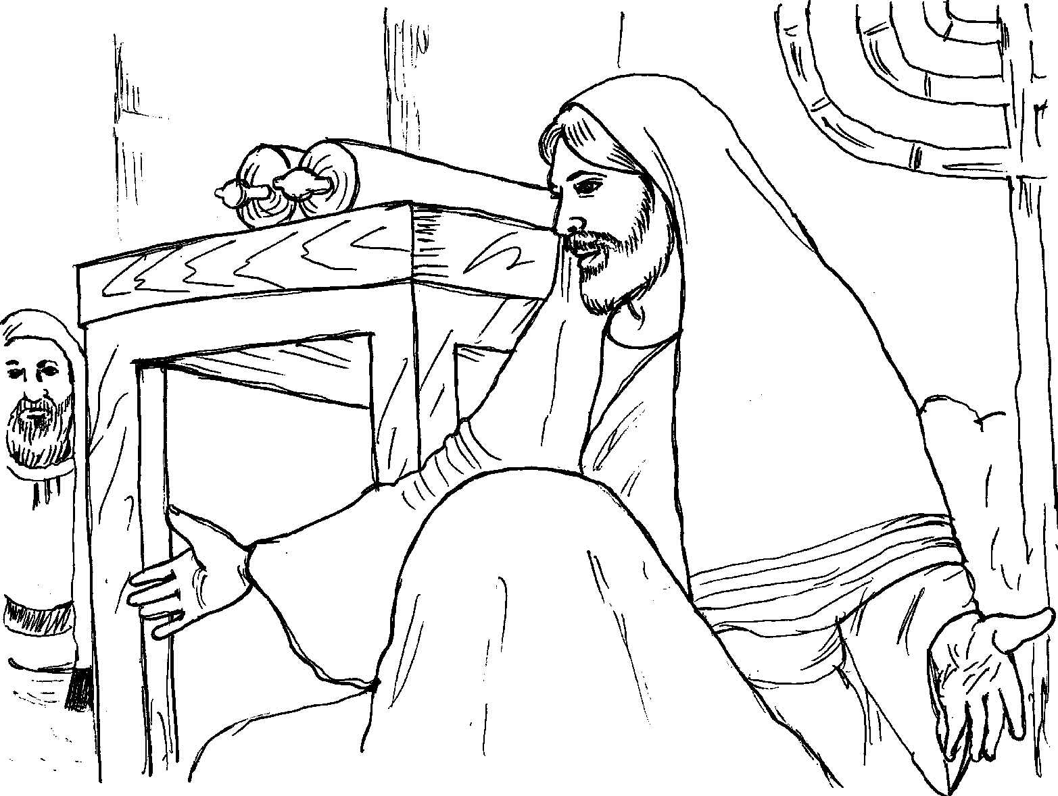

Luke 4:18-19 “The Spirit of the Lord is on me, because he has anointed me to preach good news to the poor. He has sent me to proclaim freedom for the prisoners and recovery of sight for the blind, to release the oppressed, to proclaim the year of the Lord’s favor.”
Jesus sets us free from sin and from the devil.

Luke 4:18-19 “The Spirit of the Lord is on me, because he has anointed me to preach good news to the poor. He has sent me to proclaim freedom for the prisoners and recovery of sight for the blind, to release the oppressed, to proclaim the year of the Lord’s favor.”

