
- An Angel Visits Mary
An Angel Visits Mary
An Angel Visits Mary
Luke 1:26–49
Lesson Overview
Today’s Truth | Nothing is impossible with God.  Nothing is impossible with God.
Objective | KNOW: The children will know that nothing is impossible with God.  DO: The children will pray to God about something, and they will be looking for His answer.
Materials | - Quarter 1 Picture book, Bible, chalk  - Copies of the memory verse coloring page for the children to take home.  - Written message, letter, envelope and/or phone  - Ball (Make a ball by tying wrappen (plastic bag) into knots many times, or fill an old sock with scrap material.)
Memory Verse | Luke 1:37 For nothing will be impossible with God.  Luke 1:37 For nothing will be impossible with God.
Homework | Talk to God every day this week. Talk to Him about a difficulty you have. You can talk to God anywhere at any time and He will hear you.  Talk to God every day this week. Talk to Him about a difficulty you have. You can talk to God anywhere at any time and He will hear you.

Detailed Lesson Plan
Song
Opening
Welcome
- Be sure the children know you are happy to see them!
- Introduce yourself and your helpers.
Sharing Time
- Say the truth from the previous lesson together:
God hears our prayers.
God hears our prayers.
- Say the memory verse from the previous lesson together:
Luke 1:13 But the angel said to him: “Do not be afraid, Zechariah; your prayer has been heard. Your wife Elizabeth will bear you a son, and you are to give him the name John.”
Luke 1:13 But the angel said to him: “Do not be afraid, Zechariah; your prayer has been heard. Your wife Elizabeth will bear you a son, and you are to give him the name John.”
- Review the homework from the previous lesson:
Did you remember to talk to God last week? When? Where? How?
Did you remember to talk to God last week? When? Where? How?
(Give children time to share.)
Prayer
- Let the children share praises and prayer requests.
- Keep a record of what the children are sharing so you can remember to thank God together for answered prayers.
- Spend time praying together. Let the children pray out loud if they volunteer. Do not force anyone to pray out loud.
Song
Words to Discuss
- On the blackboard, write the “Words to Discuss” from the list below.
- Let's discuss some words to help us better understand the Bible story for today.
Let's discuss some words to help us better understand the Bible story for today.
- Angels: Spiritual beings created by God to serve and worship Him. Often used by God as His messengers.
Angels: Spiritual beings created by God to serve and worship Him. Often used by God as His messengers.
- Prayer: Talking to God.
Prayer: Talking to God.
- Engaged: Promised to be married to a particular person.
Engaged: Promised to be married to a particular person.
- Marry: The joining of a man and woman where they become husband and wife.
Marry: The joining of a man and woman where they become husband and wife.
- Virgin: Someone who has never been with someone sexually.
Virgin: Someone who has never been with someone sexually.
Song
Bible Story / Lesson
Materials: Written message, letter, envelope and/or phone (Bring what ever you have to class. Can be one thing, all of the things or none of them)
- What are some ways that we send a message to people? (Through a trusted person, written message, phone, phone text.)
What are some ways that we send a message to people? (Through a trusted person, written message, phone, phone text.)
- If you sent a message to someone asking for help, what are the different ways they could respond to you? They could say “yes” and help right away. They could say “I am not able to help.” They could also say “I am not able to help now but maybe in the future.” There could even be the possibility of them not even answering us!
If you sent a message to someone asking for help, what are the different ways they could respond to you? They could say “yes” and help right away. They could say “I am not able to help.” They could also say “I am not able to help now but maybe in the future.” There could even be the possibility of them not even answering us!
- When we pray to God about our needs, He already knows them. He loves us and wants the best for us.
When we pray to God about our needs, He already knows them. He loves us and wants the best for us.
- God will always answer our prayers. Sometimes He says “yes”. Sometimes He says “no”. And sometimes He says “wait”.
God will always answer our prayers. Sometimes He says “yes”. Sometimes He says “no”. And sometimes He says “wait”.
- When God says “no” or “wait”, it is not because He is not able to do what we ask; but it is because He knows what is best. God can do anything He desires.
When God says “no” or “wait”, it is not because He is not able to do what we ask; but it is because He knows what is best. God can do anything He desires.
- Today we will be learning about how nothing is impossible with God.
Today we will be learning about how nothing is impossible with God.
Introduce Truth
Our truth for today is: Nothing is impossible with God.
Our truth for today is: Nothing is impossible with God.
This reminds me of a true story from the Bible.
This reminds me of a true story from the Bible.
Bible Story: Luke 1:26–49
Luke 1:26-28 In the sixth month of Elizabeth’s pregnancy, the angel Gabriel was sent by God to a town of Galilee called Nazareth, to a virgin engaged to a man whose name was Joseph, a descendant of David, and the virgin’s name was Mary. The angel came to her and said, “Greetings, favored one, the Lord is with you!”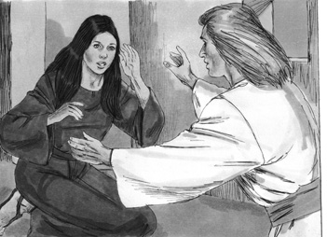
Picture 2–1

Luke 1:29-33 But she was greatly troubled by his words and began to wonder about the meaning of this greeting. So the angel said to her, “Do not be afraid, Mary, for you have found favor with God! Listen: You will become pregnant and give birth to a son, and you will name him Jesus. He will be great, and will be called the Son of the Most High, and the Lord God will give him the throne of his father David. He will reign over the house of Jacob forever, and his kingdom will never end.”
Luke 1:34 Mary said to the angel, “How will this be, since I have not had sexual relations with a man?”
Luke 1:35-36 The angel replied, “The Holy Spirit will come upon you, and the power of the Most High will overshadow you. Therefore the child to be born will be holy; he will be called the Son of God. “And look, your relative Elizabeth has also become pregnant with a son in her old age – although she was called barren, she is now in her sixth month!
Luke 1:38 So Mary said, “Yes, I am a servant of the Lord; let this happen to me according to your word.” Then the angel departed from her.
Luke 1:26-28 In the sixth month of Elizabeth’s pregnancy, the angel Gabriel was sent by God to a town of Galilee called Nazareth, to a virgin engaged to a man whose name was Joseph, a descendant of David, and the virgin’s name was Mary. The angel came to her and said, “Greetings, favored one, the Lord is with you!”
Luke 1:29-33 But she was greatly troubled by his words and began to wonder about the meaning of this greeting. So the angel said to her, “Do not be afraid, Mary, for you have found favor with God! Listen: You will become pregnant and give birth to a son, and you will name him Jesus. He will be great, and will be called the Son of the Most High, and the Lord God will give him the throne of his father David. He will reign over the house of Jacob forever, and his kingdom will never end.”
Luke 1:34 Mary said to the angel, “How will this be, since I have not had sexual relations with a man?”
Luke 1:35-36 The angel replied, “The Holy Spirit will come upon you, and the power of the Most High will overshadow you. Therefore the child to be born will be holy; he will be called the Son of God. “And look, your relative Elizabeth has also become pregnant with a son in her old age – although she was called barren, she is now in her sixth month!
Luke 1:38 So Mary said, “Yes, I am a servant of the Lord; let this happen to me according to your word.” Then the angel departed from her.
Luke 1:39-42 In those days Mary got up and went hurriedly into the hill country, to a town of Judah, and entered Zechariah’s house and greeted Elizabeth. When Elizabeth heard Mary’s greeting, the baby leaped in her womb, and Elizabeth was filled with the Holy Spirit. She exclaimed with a loud voice, “Blessed are you among women, and blessed is the child in your womb! 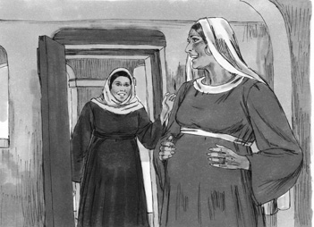
Picture 2–2

Luke 1:39-42 In those days Mary got up and went hurriedly into the hill country, to a town of Judah, and entered Zechariah’s house and greeted Elizabeth. When Elizabeth heard Mary’s greeting, the baby leaped in her womb, and Elizabeth was filled with the Holy Spirit. She exclaimed with a loud voice, “Blessed are you among women, and blessed is the child in your womb!
Luke 1:46-49 And Mary said, “My soul exalts the Lord, and my spirit has begun to rejoice in God my Savior, because he has looked upon the humble state of his servant. For from now on all generations will call me blessed, because he who is mighty has done great things for me, and holy is his name;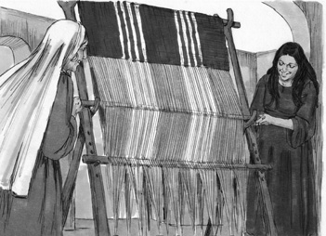
Picture 2–3

Luke 1:46-49 And Mary said, “My soul exalts the Lord, and my spirit has begun to rejoice in God my Savior, because he has looked upon the humble state of his servant. For from now on all generations will call me blessed, because he who is mighty has done great things for me, and holy is his name;
Nothing is impossible with God.
Nothing is impossible with God.
Application
Do you believe what the angel told Mary? God sent His Son to this world through Mary who was a virgin. He was sent to save people from their sins. Sin is all the things we think, say and do that displease God. Those sins separate us from God. Jesus came to die on the cross so that our sins can be forgiven and we can be in God’s family forever.
Do you believe what the angel told Mary? God sent His Son to this world through Mary who was a virgin. He was sent to save people from their sins. Sin is all the things we think, say and do that displease God. Those sins separate us from God. Jesus came to die on the cross so that our sins can be forgiven and we can be in God’s family forever.
All you have to do is accept Jesus as the One who came to save you from your sins. Ask Him to forgive you and to take control of your life. When we have problems in our life, remember that nothing is impossible with God. God formed a baby in a virgin’s body! Our God is a God of impossibilities. Are there difficulties in your life that seem to be impossible? We have a God who can do anything, so we can trust Him.
All you have to do is accept Jesus as the One who came to save you from your sins. Ask Him to forgive you and to take control of your life. When we have problems in our life, remember that nothing is impossible with God. God formed a baby in a virgin’s body! Our God is a God of impossibilities. Are there difficulties in your life that seem to be impossible? We have a God who can do anything, so we can trust Him.
Nothing is impossible with God.
Nothing is impossible with God.
Homework
This week: Talk to God every day this week. Talk to Him about a difficulty you have. You can talk to God anywhere at any time and He will hear you.
This week: Talk to God every day this week. Talk to Him about a difficulty you have. You can talk to God anywhere at any time and He will hear you.
Prayer / Song
Review Game
Throw the Ball at the Target on the Wall
Materials

- Make a target as shown on the blackboard or wall.
- Ball (Make a ball by tying wrappen (plastic bag) into knots many times, or fill an old sock with scrap material.)
- Draw a line on the floor for the children to stand behind.
How to Play
- Divide the class into 2 teams.
- The first team tries to answer the first question. The teacher can use this time to explain what the children do not seem to understand.
- The student on the team that answers the question correctly comes to the front and stands behind the line with their back facing the target. If the child only gets part of the question correct, the teacher can fill in the rest. The child can also ask for help from another child on his/her team. Help the child to succeed.
- The student then tries to throw the ball at the target.
- This time they throw the ball with their back turned to the target.
- Wherever the ball hits shows how many points that team has.
- Record the points. The team with the most points wins.
- Be sure to clap for both sides. No name-calling. Encourage good sportsmanship.
Questions for Review Game
- Mary lived in which town? (Nazareth)
Mary lived in which town? (Nazareth)
- To whom was Mary engaged? (Joseph)
To whom was Mary engaged? (Joseph)
- What is the name of the angel that appeared to Mary? (Gabriel)
What is the name of the angel that appeared to Mary? (Gabriel)
- What message did the angel give Mary? (She was going to have a baby.)
What message did the angel give Mary? (She was going to have a baby.)
- After Mary received the message, what question did she ask the angel? (“How can this be? I am a virgin.”)
After Mary received the message, what question did she ask the angel? (“How can this be? I am a virgin.”)
- How was it going to be possible for Mary to have a baby? (The Holy Spirit and the power of God would rest on her.)
How was it going to be possible for Mary to have a baby? (The Holy Spirit and the power of God would rest on her.)
- What name was she to give the baby? (Jesus)
What name was she to give the baby? (Jesus)
- What was her final response to the angel? (“I am the Lord's servant. May it be as you have said.”)
What was her final response to the angel? (“I am the Lord's servant. May it be as you have said.”)
- Who did Mary visit after the angel visited her? (Elizabeth)
Who did Mary visit after the angel visited her? (Elizabeth)
- What happened when Elizabeth heard Mary's greeting? (The baby moved in her.)
What happened when Elizabeth heard Mary's greeting? (The baby moved in her.)
- What did Elizabeth say to Mary? (“You are blessed among all women and blessed is the Child you will bear.”)
What did Elizabeth say to Mary? (“You are blessed among all women and blessed is the Child you will bear.”)
- What did Mary say? (“My heart praises the Lord because of the great things He has done for me.”)
What did Mary say? (“My heart praises the Lord because of the great things He has done for me.”)
- What is the truth of today's lesson? ( Nothing is impossible with God. )
What is the truth of today's lesson? ( Nothing is impossible with God. )
Song
Memory Verse
Materials and Preparations
- Put a bookmark in Luke 1:37
- Write memory verse on the blackboard.
Luke 1:37 For nothing will be impossible with God.
Luke 1:37 For nothing will be impossible with God.
Teach and Explain
Remember how God did the impossible when He gave Zechariah and Elizabeth a baby boy after many, many years? Then God did the impossible again with Mary. What did He do? (He made Mary to be pregnant with Jesus even though she was a virgin.)
Remember how God did the impossible when He gave Zechariah and Elizabeth a baby boy after many, many years? Then God did the impossible again with Mary. What did He do? (He made Mary to be pregnant with Jesus even though she was a virgin.)
- Read the verse from your Bible.
- Read the verse by yourself as you point to the words.
- Read the verse with the children as you point to the words.
- Explain the verse:
- Today’s verse is found in the Gospel of Luke. Remember, a man named Luke wrote this book in the Bible. He was a doctor and a friend of Paul. He wrote this book so we would know what Jesus did.
Today’s verse is found in the Gospel of Luke. Remember, a man named Luke wrote this book in the Bible. He was a doctor and a friend of Paul. He wrote this book so we would know what Jesus did.
- As you read the verse, circle the words shown below. Explain each of these words.
- Nothing: Not anything. Not one single thing.
Nothing: Not anything. Not one single thing.
- Impossible: Not able to be done.
Impossible: Not able to be done.
- With God: There is not one single thing that cannot be done when God is involved. God created everything, so He controls everything. He is the biggest and the best.
With God: There is not one single thing that cannot be done when God is involved. God created everything, so He controls everything. He is the biggest and the best.
- Read the verse again by yourself as you point to the words.
- Read the verse again with the children as you point to the words.
Try substituting the word “nothing” with other words. For example, say “ is healing me impossible for God?” or “Is solving a difficult family issue impossible for God?” (Each time you say the new sentence, have the children respond with, “No! God CAN do this!”) (Let the children try to create more sentences like the examples.)
Remember our truth for the day? Let’s all say it together:
Remember our truth for the day? Let’s all say it together:
Nothing is impossible with God.
Nothing is impossible with God.
Memory Verse Review
Erase the Words of the Verse Written on the Blackboard
How to Play
- Ask the children the first question.
- When a question is answered correctly, that child comes to the front and wipes away one or two words from the memory verse that is on the blackboard.
- The verse is said out loud together making sure to say the missing words.
- Then the next question is asked.
- When that question is answered correctly, another child comes to the front and wipes more words from the memory verse on the blackboard.
- The verse is said aloud again.
- Do this until all the words are gone and the children are able to repeat the verse from memory.
Questions for Memory Verse
- Where in the Bible is today's memory verse found? ( Luke 1:37 )
Where in the Bible is today's memory verse found? ( Luke 1:37 )
- Who was Luke? (A doctor who believed in Jesus and wrote the Book of Luke)
Who was Luke? (A doctor who believed in Jesus and wrote the Book of Luke)
- What does the word “nothing” mean? (Not one single thing)
What does the word “nothing” mean? (Not one single thing)
- What does the word “impossible” mean? (Not able to be done)
What does the word “impossible” mean? (Not able to be done)
Song
Closing and Homework
- Say the truth together:
Nothing is impossible with God.
Nothing is impossible with God.
- Say the memory verse together:
Luke 1:37 For nothing will be impossible with God.
Luke 1:37 For nothing will be impossible with God.
- Review the homework:
Talk to God every day this week. Talk to Him about a difficulty you have. You can talk to God anywhere at any time and He will hear you.
Talk to God every day this week. Talk to Him about a difficulty you have. You can talk to God anywhere at any time and He will hear you.
- Give any needed announcements.
Closing Prayer
Thank God that He hears us when we pray, and that He can do anything.
Ask God that the children will remember to talk to Him this week, and not to be afraid to ask God for help with difficult challenges and problems in their lives. Pray that their lives will be changed to be pleasing to God.
Colouring page to colour and take home!

Nothing is impossible with God.
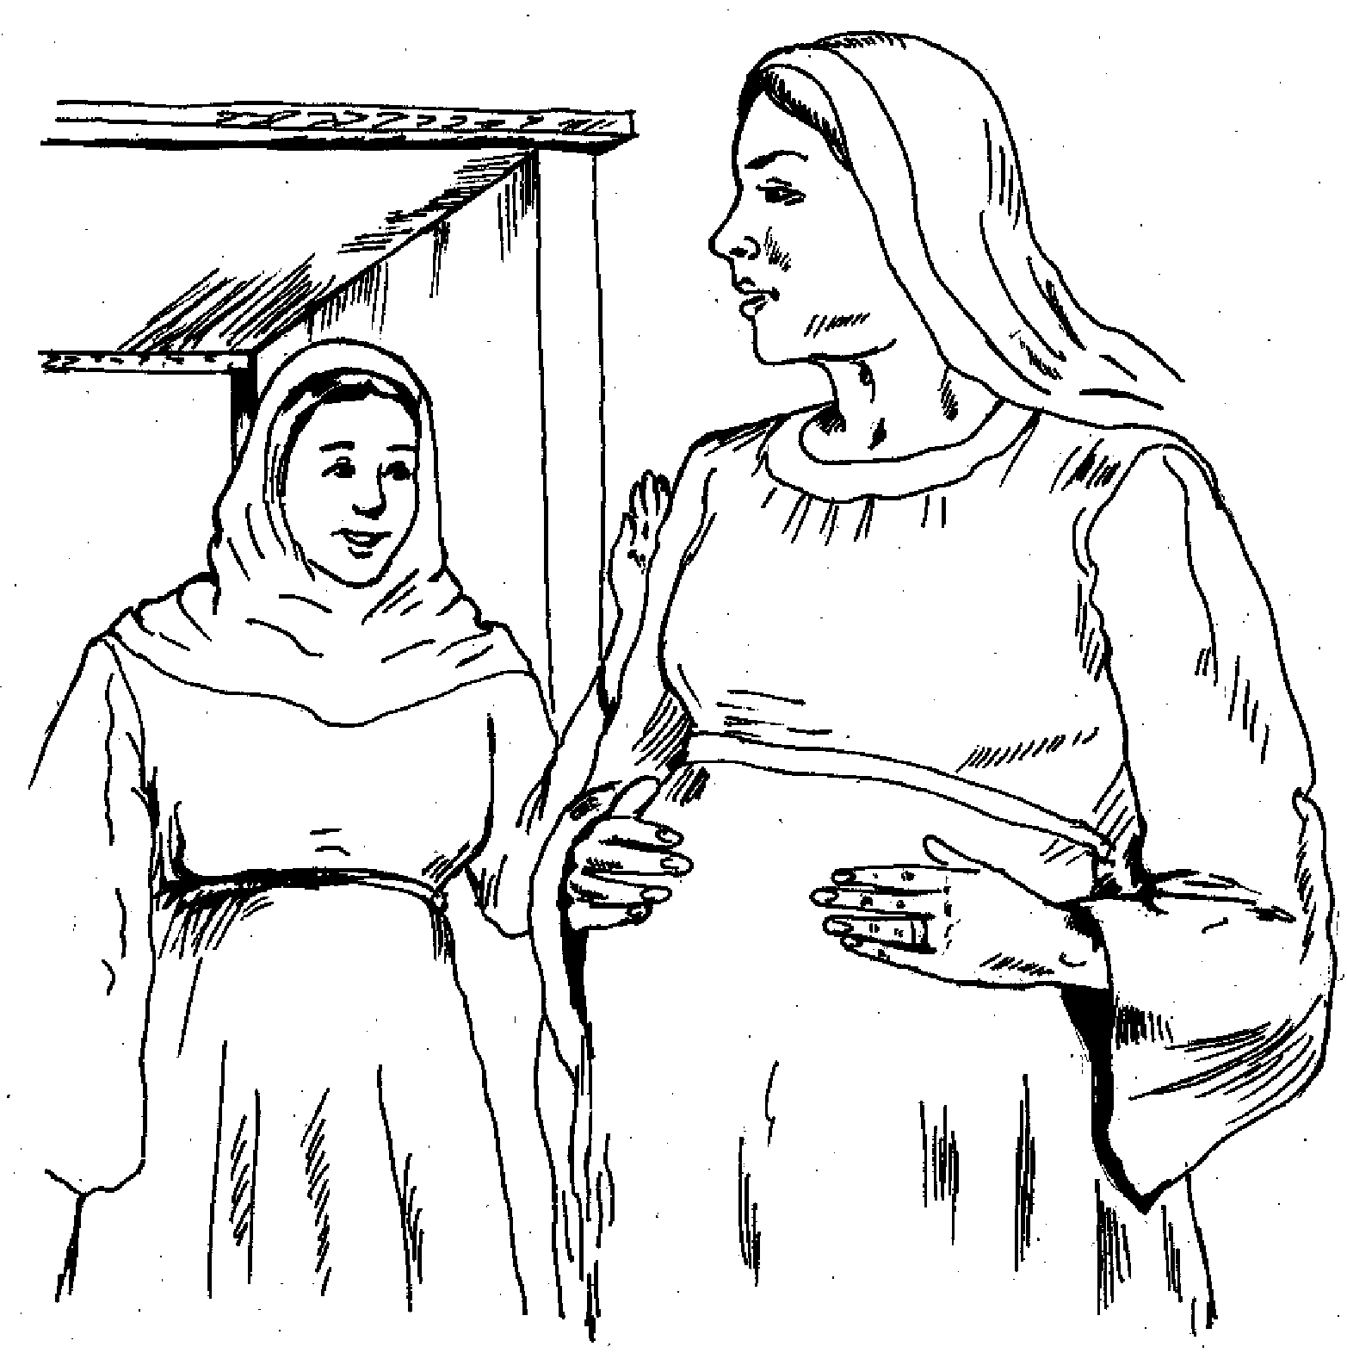

Luke 1:37 For nothing will be impossible with God.
Nothing is impossible with God.

Luke 1:37 For nothing will be impossible with God.

