3 | The Messiah is Born  The Messiah is Born | Luke 2:1-38

Lesson Overview
Today’s Truth | God ALWAYS keeps His promises.  God ALWAYS keeps His promises.
Objective | KNOW: The children will know that God always keeps his promises.  DO: The children will ask and trust God to forgive their sins.
Materials | - Picture book, Bible, chalk, copies of devotion page for children  - Ball (Make a ball by tying a wrappen into knots many times, or fill an old sock with scrap material.)
Memory Verse | Luke 2:10-11 But the angel said to them. “Do not be afraid. I bring you good news of great joy that will be for all the people. Today in the town of David a Saviour has been born to you; He is Christ the Lord.”  Luke 2:10-11 But the angel said to them. “Do not be afraid. I bring you good news of great joy that will be for all the people. Today in the town of David a Saviour has been born to you; He is Christ the Lord.”
Homework | Talk to God every day. Ask God to forgive your sins. Trust God to keep his promise to forgive you.  Talk to God every day. Ask God to forgive your sins. Trust God to keep his promise to forgive you.

Detailed Lesson Plan
Song
Opening
Welcome
- Be sure the children know you are happy to see them!
- Introduce yourself and your helpers.
Sharing Time
- Say the truth from Lesson 2 together:
Nothing is impossible with God.
Nothing is impossible with God.
- Say the memory verse from Lesson 2 together:
Luke 1:37 For nothing is impossible with God.
Luke 1:37 For nothing is impossible with God.
- Review the homework:
Did you talk to God everyday last week? Did you remember to ask God for help this week? How do you think God is answering your prayers? Is He saying “Yes,” “No,” or “Wait?” (Give children time to share.)
Did you talk to God everyday last week? Did you remember to ask God for help this week? How do you think God is answering your prayers? Is He saying “yes,” “no,” or “wait?” (Give children time to share.)
Prayer
- Let the children share praises and prayer requests.
- Keep a record of what the children are sharing so you can remember to thank God together for answered prayers.
- Spend time praying together. Let the children pray out loud if they volunteer. Do not force anyone to pray out loud.
Song
Words to Discuss
- On the blackboard, write the “Words to Discuss” from the list below.
- Let's discuss some words to help us better understand the Bible story for today.
Let's discuss some words to help us better understand the Bible story for today.
- Sin (Review): All the things we think, say and do that displease God.
Sin (Review): All the things we think, say and do that displease God.
- Emperor: An overall ruler or king.
Emperor: An overall ruler or king.
- Stable: A place that houses animals (house for sheep).
Stable: A place that houses animals, (house for sheep.)
- Manger: A long open box for the animals to eat out of (a box of salt for sheep).
Manger: A long open box for the animals to eat out of (a box for salt for sheep).
Song
Bible Story / Lesson
 | Have everyone stand. Explain that you want to see how long each child can hold his/her breath. When you clap your hands, the children hold their breath for as long as they can. When they have to breathe, they sit down. The last people standing are the winners. Try again a second time.  - What did everyone have to do eventually? (Breathe)  What did everyone have to do eventually? (Breathe)  - Even when we are asleep, our brains keep us breathing.  Even when we are asleep, our brains keep us breathing.  - This is a lot like God. Not that He has to breathe, but just like we all have to breathe because we are alive, God must keep His promises because He is God.  This is a lot like God. Not that He has to breathe, but just like we all have to breathe because we are alive, God must keep His promises because He is God.  - It is impossible for God to stop keeping His promises, just as it is impossible for us to hold our breath forever.  It is impossible for God to stop keeping His promises, just as it is impossible for us to hold our breath forever.  - Do you know anyone else in the whole universe who keeps all of their promises? Only God can!  Do you know anyone else in the whole universe who keeps all of their promises? Only God can!  - Today we will be learning about how God ALWAYS keeps His promises.  Today we will be learning about how God ALWAYS keeps His promises.

Introduce Truth
Our truth for today is: God ALWAYS keeps His promises.
Our truth for today is: God ALWAYS keeps His promises.
This reminds me of a true story from the Bible.
This reminds me of a true story from the Bible.
 Bible Story (Luke 2:1-38)
Picture | Story  [ Months had passed since the angel told Mary that she would have a baby. ]  Luke 2:1-3 In those days Caesar Augustus issued a decree that a census should be taken of the entire Roman world. (This was the first census that took place while Quirinius was governor of Syria.) And everyone went to his own town to register.  Luke 2:4-5 So Joseph also went up from the town of Nazareth in Galilee to Judea, to Bethlehem the town of David, because he belonged to the house and line of David. He went there to register with Mary, who was pledged to be married to him and was expecting a child.  [ Months had passed since the angel told Mary that she would have a baby. ]  Luke 2:1-3 In those days Caesar Augustus issued a decree that a census should be taken of the entire Roman world. (This was the first census that took place while Quirinius was governor of Syria.) And everyone went to his own town to register.  Luke 2:4-5 So Joseph also went up from the town of Nazareth in Galilee to Judea, to Bethlehem the town of David, because he belonged to the house and line of David. He went there to register with Mary, who was pledged to be married to him and was expecting a child.
3-1  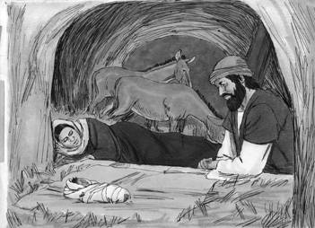 | Luke 2:6-7 While they were there, the time came for the baby to be born, and she gave birth to her firstborn, a son. She wrapped him in cloths and placed him in a manger, because there was no room for them in the inn.  Luke 2:6-7 While they were there, the time came for the baby to be born, and she gave birth to her firstborn, a son. She wrapped him in cloths and placed him in a manger, because there was no room for them in the inn.
3-2  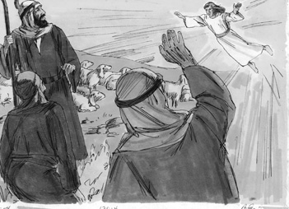 | Luke 2:8-12 And there were shepherds living out in the fields nearby, keeping watch over their flocks at night. An angel of the Lord appeared to them, and the glory of the Lord shone around them, and they were terrified. But the angel said to them, “Do not be afraid. I bring you good news of great joy that will be for all the people. Today in the town of David a Savior has been born to you; he is Christ the Lord. This will be a sign to you: You will find a baby wrapped in cloths and lying in a manger.”  Luke 2:13-14 Suddenly a great company of the heavenly host appeared with the angel, praising God and saying, “Glory to God in the highest, and on earth peace to men on whom his favor rests.”  Luke 2:8-12 And there were shepherds living out in the fields nearby, keeping watch over their flocks at night. An angel of the Lord appeared to them, and the glory of the Lord shone around them, and they were terrified. But the angel said to them, “Do not be afraid. I bring you good news of great joy that will be for all the people. Today in the town of David a Savior has been born to you; he is Christ the Lord. This will be a sign to you: You will find a baby wrapped in cloths and lying in a manger.”  Luke 2:13-14 Suddenly a great company of the heavenly host appeared with the angel, praising God and saying, “Glory to God in the highest, and on earth peace to men on whom his favor rests.”
3-3  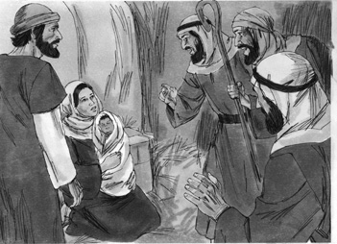 | Luke 2:15 When the angels had left them and gone into heaven, the shepherds said to one another, “Let’s go to Bethlehem and see this thing that has happened, which the Lord has told us about.”  Luke 2:16-20 So they hurried off and found Mary and Joseph, and the baby, who was lying in the manger. When they had seen him, they spread the word concerning what had been told them about this child, and all who heard it were amazed at what the shepherds said to them. But Mary treasured up all these things and pondered them in her heart. The shepherds returned, glorifying and praising God for all the things they had heard and seen, which were just as they had been told.  Luke 2:15 When the angels had left them and gone into heaven, the shepherds said to one another, “Let’s go to Bethlehem and see this thing that has happened, which the Lord has told us about.”  Luke 2:16-20 So they hurried off and found Mary and Joseph, and the baby, who was lying in the manger. When they had seen him, they spread the word concerning what had been told them about this child, and all who heard it were amazed at what the shepherds said to them. But Mary treasured up all these things and pondered them in her heart. The shepherds returned, glorifying and praising God for all the things they had heard and seen, which were just as they had been told.
3-4  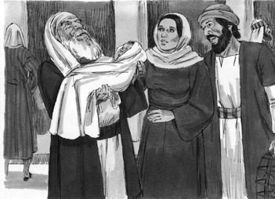 | Luke 2:21 On the eighth day, when it was time to circumcise him, he was named Jesus, the name the angel had given him before he had been conceived.  Luke 2:22-24 When the time of their purification according to the Law of Moses had been completed, Joseph and Mary took him to Jerusalem to present him to the Lord (as it is written in the Law of the Lord, “Every firstborn male is to be consecrated to the Lord”), and to offer a sacrifice in keeping with what is said in the Law of the Lord: “a pair of doves or two young pigeons.”  Luke 2:25-32 Now there was a man in Jerusalem called Simeon, who was righteous and devout. He was waiting for the consolation of Israel, and the Holy Spirit was upon him. It had been revealed to him by the Holy Spirit that he would not die before he had seen the Lord’s Christ. Moved by the Spirit, he went into the temple courts. When the parents brought in the child Jesus to do for him what the custom of the Law required, Simeon took him in his arms and praised God, saying: “Sovereign Lord, as you have promised, you now dismiss your servant in peace. For my eyes have seen your salvation, which you have prepared in the sight of all people, a light for revelation to the Gentiles and for glory to your people Israel.”  Luke 2:33-35 The child’s father and mother marveled at what was said about him. Then Simeon blessed them and said to Mary, his mother: “This child is destined to cause the falling and rising of many in Israel, and to be a sign that will be spoken against, so that the thoughts of many hearts will be revealed. And a sword will pierce your own soul too.”  Luke 2:21 On the eighth day, when it was time to circumcise him, he was named Jesus, the name the angel had given him before he had been conceived.  Luke 2:22-24 When the time of their purification according to the Law of Moses had been completed, Joseph and Mary took him to Jerusalem to present him to the Lord (as it is written in the Law of the Lord, “Every firstborn male is to be consecrated to the Lord”), and to offer a sacrifice in keeping with what is said in the Law of the Lord: “a pair of doves or two young pigeons.”  Luke 2:25-32 Now there was a man in Jerusalem called Simeon, who was righteous and devout. He was waiting for the consolation of Israel, and the Holy Spirit was upon him. It had been revealed to him by the Holy Spirit that he would not die before he had seen the Lord’s Christ. Moved by the Spirit, he went into the temple courts. When the parents brought in the child Jesus to do for him what the custom of the Law required, Simeon took him in his arms and praised God, saying: “Sovereign Lord, as you have promised, you now dismiss your servant in peace. For my eyes have seen your salvation, which you have prepared in the sight of all people, a light for revelation to the Gentiles and for glory to your people Israel.”  Luke 2:33-35 The child’s father and mother marveled at what was said about him. Then Simeon blessed them and said to Mary, his mother: “This child is destined to cause the falling and rising of many in Israel, and to be a sign that will be spoken against, so that the thoughts of many hearts will be revealed. And a sword will pierce your own soul too.”
 Application
The good news that the angels announced to the shepherds is the same good news for you today. The One who was promised by God to come and save you from the penalty of your sins has come. His name is Jesus. He died on the cross so that you can be in God's family forever. All you have to do is trust Him.
The good news that the angels announced to the shepherds is the same good news for you today. The One who was promised by God to come and save you from the penalty of your sin has come. His name is Jesus. He died on the cross so that you can be in God’s family forever. All you have to do is trust Him.
Homework
Are you trusting God to keep His promises? Have you trusted God to forgive you for your sins? Are you living the way He wants you to live? Ask Him to help you this week to live His way.
Are you trusting God to keep His promises? Have you trusted God to forgive you for your sins? Are you living the way He wants you to live? Ask Him to help you this week to live His way.
This week: Talk to God every day this next week. Ask God to forgive your sins. Trust God to keep His promise to forgive you and help you live His way.
This week: Talk to God every day this next week. Ask God to forgive your sins. Trust God to keep His promise to forgive you and help you live His way.
Prayer / Song
Review Game
Throw the Ball at the Target on the Wall under One Leg
Materials  - Make a target as shown on the blackboard or wall.  - Ball (Make a ball by tying wrappen into knots many times, or fill an old sock with scrap material.)  - Draw a line on the floor for the children to stand behind. | 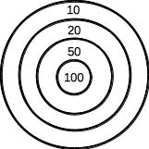
How to Play
- Divide the class into 2 teams.
- The first team tries to answer the first question. The teacher can use this time to explain what the children don’t seem to understand.
- The student on the team that answers the question correctly, comes to the front and stands behind the line with their back facing the target. If the child only gets part of the question right, the teacher can fill in the rest. That child can also ask for help from another child on his/her team. Help the child to succeed.
- That student then tries to throw the ball at the target. This time they throw the ball under one of their legs. (Have the child sit into a squat and have them throw the ball under one side of their legs.) Where the ball hits, shows how many points that team has.
- Record the points. The team with the most points wins.
- Be sure to clap for both sides. No name-calling. Encourage good sportsmanship.
Questions for Review Game
- What was the theme of today's lesson? (God ALWAYS keeps His promises.)
What was the theme of today’s lesson? (God ALWAYS keeps His promises.)
- What did the Emperor of Rome order the people to do? (Go to their town of birth to sign a roll book)
What did the Emperor of Rome order the people to do? (Go to their town of birth to sign a roll book)
- Where did Joseph and Mary go? (Bethlehem)
Where did Joseph and Mary go? (Bethlehem)
- Why did Joseph and Mary go to Bethlehem? (That is where Joseph was from.)
Why did Joseph and Mary go to Bethlehem? (That is where Joseph was from.)
- Where did they end up staying? (A stable)
Where did they end up staying? (A stable)
- Where did Mary put her baby after He was born? (A manger)
Where did Mary put her baby after He was born? (A manger)
- Why did Mary and Joseph name the baby Jesus? (The angel said that is what they were supposed to do.)
Why did Mary and Joseph name the baby Jesus? (The angel said that is what they were supposed to do.)
- Why did Mary and Joseph go to the temple? (The law said they had to give sacrifices for their baby.)
Why did Mary and Joseph go to the temple? (The law said they had to give sacrifices for their baby.)
- Who did Mary and Joseph see at the temple? (Simeon)
Who did Mary and Joseph see at the temple? (Simeon)
- What had the Holy Spirit promised Simeon? (He would not die until he saw the Messiah that God had promised.)
What had the Holy Spirit promised Simeon? (He would not die until he saw the Messiah that God had promised.)
- What did Simeon do when he saw Jesus? (He took Jesus into his arms and gave thanks to God.)
What did Simeon do when he saw Jesus? (He took Jesus into his arms and gave thanks to God.)
- Why did Simeon say that he could die in peace? (He had seen with his own eyes the Messiah that God had promised.)
Why did Simeon say that he could die in peace? (He had seen with his own eyes the Messiah that God had promised.)
Song
Memory Verse
Materials and Preparations
- Put a bookmark in Luke 2:10-11.
- Write memory verse on the blackboard.
Luke 2:10-11 But the angel said to them, “Do not be afraid. I bring you good news of great joy that will be for all the people. Today in the town of David a Saviour has been born to you; He is Christ the Lord.”
Luke 2:10-11 But the angel said to them, “Do not be afraid. I bring you good news of great joy that will be for all the people. Today in the town of David a Saviour has been born to you; He is Christ the Lord.”
Teach and Explain
Today our memory verse is found in the Gospel of Luke. It goes with our story and truth for the day.
Today our memory verse is found in the Gospel of Luke. It goes with our story and truth for the day.
- Read the verse from your Bible.
- Read the verse by yourself as you point to the words.
- Read the verse with the children as you point to the words.
- Explain the verse:
Today’s verse is found in the New Testament.
Today’s verse is found in the New Testament.
- As you read the verse, have the children underline the words shown below. Explain each underlined word.
- Angel: An angel is a messenger from God.
Angel: An angel is a messenger from God.
- For all the people: This angel appeared in order to bring good news, not just for the shepherds, but for everyone!
For all the people: This angel appeared in order to bring good news, not just for the shepherds, but for everyone!
- The town of David: The town of David is the place where King David had been born hundreds of years before. King David was Joseph’s forefather. Another name for this place is Bethlehem.
The town of David: The town of David is the place where King David has been born hundred of years before. King David was Joseph's forefather. Another name for this place is Bethlehem.
- Saviour: A Saviour is someone who comes to save someone. Jesus was born to save us from God’s anger against our sin.
Saviour: A Saviour is someone who comes to save someone. Jesus was born to save us from God's anger against our sin.
- Christ: “Christ” is another word for “Messiah”. God had promised hundreds of years before that a Messiah, or Deliverer, would come to save us.
Christ: “Christ” is another word for “Messiah”. God had promised hundred of years before that a Messiah, or Deliverer, would come save us.
- Lord: Not only is this child the promised Deliverer who saves us from the punishment of our sins, but He is the all-powerful Ruler over everything!
Lord: Not only is this child the promised Deliverer who saves us from the punishment of sins, but He is the all-powerful ruler over everything!
- Read the verse again by yourself as you point to the words.
- Read the verse again with the children as you point to the words.
God promised that He would send a Deliverer, someone who would be able to take the punishment for our sin so that we can be in God’s family forever.
God promised that He would send a Deliverer, someone who would be able to take the punishment for our sin so that we can be in God's family forever.
Remember our truth for the day? (Have everyone say it together.)
Remember our truth for the day? (Have everyone say it together.)
God ALWAYS keeps His promises.
God ALWAYS keeps His promises.
Memory Verse Review
Erase the Words of the Verse Written on the Blackboard
- Ask the children the first question.
- When a question is answered correctly, that child comes to the front and wipes one or two words from the memory verse on the blackboard.
- The verse is said out loud together making sure to say the missing words.
- Then the next question is asked.
- When that question is answered correctly, another child comes to the front and wipes more words from the memory verse on the blackboard.
- The verse is said aloud again.
- Do this until all the words are gone and the children repeat the verse from memory.
Questions for Memory Verse
- Where in the Bible is today's memory verse found? (Luke 2:10-11)
Where in the Bible is today’s memory verse found? (Luke 2:10-11)
- What is an angel? (A special being created by God, God's messenger to people, and helps people)
What is an angel? (A special being created by God, God’s messenger to people, and helps people)
- Who is the good news for? (Everyone)
Who is the good news for? (Everyone)
- Where was the Saviour born? (The town of David, Bethlehem)
Where was the Saviour born? (The town of David, Bethlehem)
- Who is the Saviour, Messiah, Deliverer, and Ruler over everything? (Jesus)
Who is the Saviour, Messiah, Deliverer and ruler over everything? (Jesus)
Song
Closing and Homework
- Say the truth together:
God ALWAYS keeps His promises.
God ALWAYS keeps His promises.
- Say the memory verse together:
Luke 2:10-11 But the angel said to them, “Do not be afraid. I bring you good news of great joy that will be for all the people. Today in the town of David a Saviour has been born to you; He is Christ the Lord.”
Luke 2:10-11 But the angel said to them, “Do not be afraid. I bring you good news of great joy that will be for all the people. Today in the town of David a Saviour has been born to you; He is Christ the Lord.”
- Review the homework:
God promises to forgive our sins if we ask Him. This week, ask God to forgive your sins every day! Be sure to also thank Him for forgiving your sins. Remember, sin is ANYTHING we do, think, or say that is not pleasing to God.
God promises to forgive our sins if we ask Him. This week, ask God to forgive your sins every day! Be sure to also thank Him for forgiving your sins. Remember, sin is ANYTHING we do, think, or say that is not pleasing to God.
- Give any needed announcements.
Closing Prayer
Thank God that He hears us when we pray and that He can do anything. Thank Him also that He ALWAYS keeps His promises and will forgive our sins.
Ask God to help the children remember to talk to Him this week and to ask for forgiveness often trusting that He will keep His promises. Pray that their lives will be changed to be pleasing to God.

Colouring page to colour and take home!

God ALWAYS keeps His promises
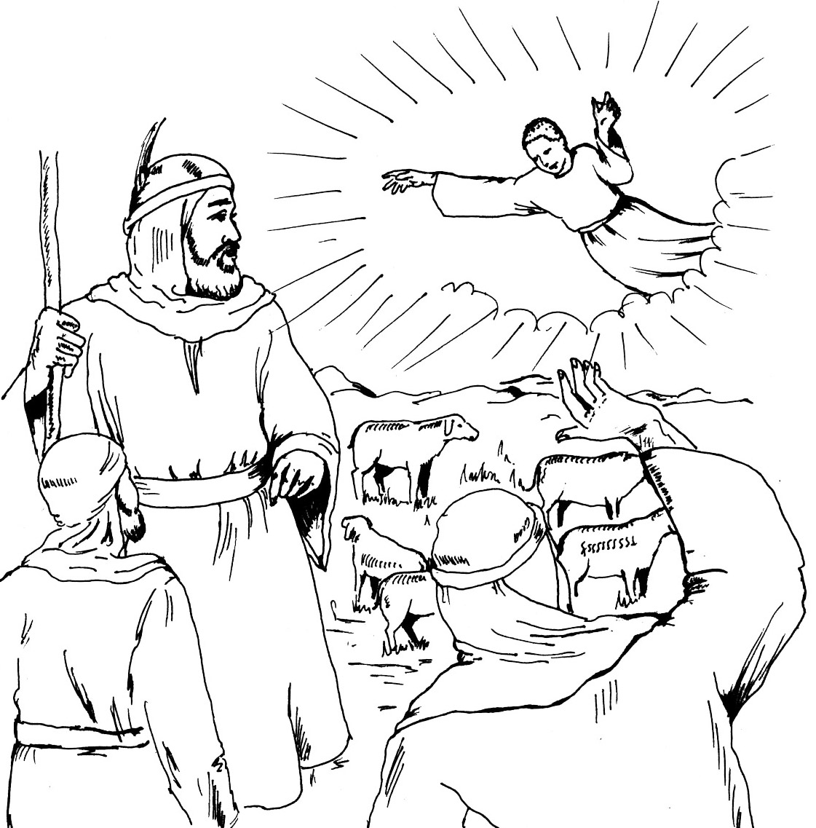
Luke 2:10-11 But the angel said to them, “Do not be afraid. I bring you good news of great joy that will be for all the people. Today in the town of David a Saviour has been born to you; He is Christ the Lord.”
God ALWAYS keeps His promises
Luke 2:10-11 But the angel said to them, “Do not be afraid. I bring you good news of great joy that will be for all the people. Today in the town of David a Saviour has been born to you; He is Christ the Lord.”

