4 | The Boy Jesus  The Boy Jesus | Luke 2:39-52

Lesson Overview
Today’s Truth | God’s way is the best way to grow.  God's way is the best way to grow.
Objective | KNOW: The children will know that they can please God as they are growing.  DO: The children will find ways that they can please God right now.
Materials | - Picture book, Bible, chalk, copies of devotion page for children  - A picture of yourself when you were small. (You can also use a picture of someone else.)  - Ball (Make a ball by tying wrappen into knots many times, or fill an old sock with scrap material.)
Memory Verse | Luke 2:52 And Jesus grew in wisdom and stature, and in favour with God and men.  Luke 2:52 And Jesus grew in wisdom and stature, and in favour with God and men.
Homework | Choose one new way you will try to grow well in this week. Ask God to help you.  Choose one new way you will try to grow well in this week. Ask God to help you.

Detailed Lesson Plan
Song
Opening
Welcome
- Be sure the children know you are happy to see them!
- Introduce yourself and your helpers.
Sharing Time
- Say the truth from Lesson 3 together:
God ALWAYS keeps His promises.
God ALWAYS keeps His promises.
- Say the memory verse from Lesson 3 together:
Luke 2:10-11 But the angel said to them. “Do not be afraid. I bring you good news of great joy that will be for all the people. Today in the town of David a Saviour has been born to you; He is Christ the Lord.”
Luke 2:10-11 But the angel said to them. “Do not be afraid. I bring you good news of great joy that will be for all the people. Today in the town of David a Saviour has been born to you; He is Christ the Lord.
- Review the homework:
Talk to God every day. Ask God to forgive your sins. Trust God to keep His promise to forgive you.
Talk to God every day. Ask God to forgive your sins. Trust God to keep His promise to forgive you.
Prayer
- Let the children share praises and prayer requests.
- Keep a record of what the children are sharing, so you can remember to thank God together for answered prayers.
- Spend time praying together: Let children pray out loud if they volunteer. Do not force anyone to pray out loud.
Song
Words to Discuss
- On the blackboard, write the “Words to Discuss” from the list below.
- Let's discuss some words to help us better understand the Bible story for today.
Let's discuss some words to help us better understand the Bible story for today.
- Jerusalem: The most important city in Israel for Jews because it was where the temple was built.
Jerusalem: The most important city in Israel for Jews because it was where the temple was built.
- Passover: A holiday where the Jews remember how God set them free from being slaves in Egypt.
Passover: A holiday where the Jews remember how God set them free from being slaves in Egypt.
- Temple: A Jewish religious building for worshiping God.
Temple: A Jewish religious building for worshiping God.
Bible Story / Lesson
 | Materials: A picture of yourself when you were small. (You can also use a picture of someone else.)  - Discuss different stages of human growth such as baby, toddler, child, teenager & adult.  Discuss different stages of human growth such as baby, toddler, child, teenager & adult.  - What things did you do as a baby or toddler that you don't do now?  What things did you do as a baby or toddler that you don't do now?  - Today we will be learning about how God's way is the best way to grow.  Today we will be learning about how God's way is the best way to grow.
Introduce Truth
Our truth for today is: God's way is the best way to grow.
Our truth for today is: God's way is the best way to grow.
This reminds me of a true story from the Bible.
This reminds me of a true story from the Bible.
 Bible Story (Luke 2:39-52)
Picture  4-1  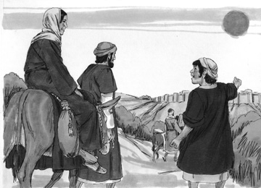 | Story  Luke 2:39-40 When Joseph and Mary had done everything required by the Law of the Lord, they returned to Galilee to their own town of Nazareth. And the child grew and became strong; he was filled with wisdom, and the grace of God was upon him.  Luke 2:41-45 Every year his parents went to Jerusalem for the Feast of the Passover. When he was twelve years old, they went up to the Feast, according to the custom. After the Feast was over, while his parents were returning home, the boy Jesus stayed behind in Jerusalem, but they were unaware of it. Thinking he was in their company, they traveled on for a day. Then they began looking for him among their relatives and friends. When they did not find him, they went back to Jerusalem to look for him.  Luke 2:39-40 When Joseph and Mary had done everything required by the Law of the Lord, they returned to Galilee to their own town of Nazareth. And the child grew and became strong; he was filled with wisdom, and the grace of God was upon him.  Luke 2:41-45 Every year his parents went to Jerusalem for the Feast of the Passover. When he was twelve years old, they went up to the Feast, according to the custom. After the Feast was over, while his parents were returning home, the boy Jesus stayed behind in Jerusalem, but they were unaware of it. Thinking he was in their company, they traveled on for a day. Then they began looking for him among their relatives and friends. When they did not find him, they went back to Jerusalem to look for him.
4-2  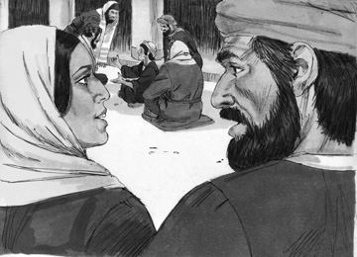 | Luke 2:46-47 After three days they found him in the temple courts, sitting among the teachers, listening to them and asking them questions. Everyone who heard him was amazed at his understanding and his answers.  Luke 2:46-47 After three days they found him in the temple courts, sitting among the teachers, listening to them and asking them questions. Everyone who heard him was amazed at his understanding and his answers.
4-3  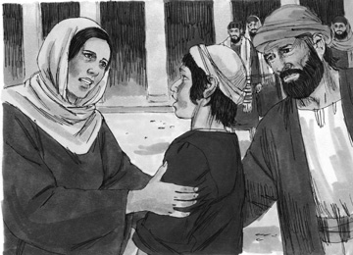 | Luke 2:48 When his parents saw him, they were astonished. His mother said to him, “Son, why have you treated us like this? Your father and I have been anxiously searching for you.”  Luke 2:49-50 “Why were you searching for me?” he asked. “Didn’t you know I had to be in my Father’s house?” But they did not understand what he was saying to them.  Luke 2:48 When his parents saw him, they were astonished. His mother said to him, “Son, why have you treated us like this? Your father and I have been anxiously searching for you.”  Luke 2:49-50 “Why were you searching for me?” he asked. “Didn’t you know I had to be in my Father’s house?” But they did not understand what he was saying to them.
4-4  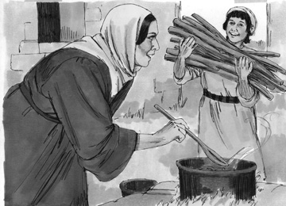 | Luke 2:51-52 Then he went down to Nazareth with them and was obedient to them. But his mother treasured all these things in her heart. And Jesus grew in wisdom and stature, and in favor with God and men.  Luke 2:51-52 Then he went down to Nazareth with them and was obedient to them. But his mother treasured all these things in her heart. And Jesus grew in wisdom and stature, and in favor with God and men.
 Application
We learn from this story that Jesus pleased God as he grew up to be a man. Luke 2:52 tells us that Jesus increased in wisdom and stature (or size), and in favour with God and men. God wants us to grow and change in good ways just like Jesus did.
We learn from this story that Jesus pleased God as he grew up to be a man. Luke 2:52 tells us that Jesus increased in wisdom and stature (or size), and in favour with God and men. God wants us to grow and change in good ways just like Jesus did.
Last week we learned that it is important to ask God to forgive our sins. When we become part of God's family, it is important to grow.
Last week we learned that it is important to ask God to forgive our sins. When we become part of God's family, it is important to grow.
We grow in wisdom by reading our Bibles and praying everyday. We also grow in wisdom by listening in church and at school.
We grow in wisdom by reading our Bibles and praying everyday. We also grow in wisdom by listening in church and at school.
We grow in stature (or physically) by having healthy habits such as: eating healthy foods, drinking plenty of water, getting enough sleep and exercising.
We grow in stature (or physically) by having healthy habits such as: eating healthy foods, drinking plenty of water, getting enough sleep and exercising.
We grow in favour with God and men by being kind and helpful to those around us.
We grow in favour with God and men by being kind and helpful to those around us.
Someday you will change from a child into an adult. Let's ask God to help you make that change, into adulthood, in a way that will be pleasing to HIM the way Jesus did.
Someday you will change from a child into an adult. Let's ask God to help you make that change, into adulthood, in a way that will be pleasing to HIM the way Jesus did.
God’s way is the best way to grow.
God’s way is the best way to grow.
Homework
This week: Ask God to help you to grow well in His ways. Maybe you need to read your Bible and pray everyday or try harder to learn well in school and in church. Maybe you need to listen to your mother when she tells you to eat more than just the things you like to eat. Maybe you need to work hard at whatever you are asked to do without complaining, so that your family will be pleased with you.
This week: Ask God to help you to grow well in His ways. Maybe you need to read your Bible and pray everyday or try harder to learn well in school and in church. Maybe you need to listen to your mother when she tells you to eat more than just the things you like to eat. Maybe you need to work hard at whatever you are asked to do without complaining, so that your family will be pleased with you.
Choose one of these things right now that you will work on doing better this week.
Choose one of these things right now that you will work on doing better this week.
Prayer / Song
Review Game
Throw the Ball at the Target on the Wall with Legs Spread Out and Back turned to the Target
Materials  - Make a target as shown on the blackboard or wall.  - Ball (Make a ball by tying wrappen into knots many times, or fill an old sock with scrap material.)  - Draw a line on the floor for the children to stand behind. | 
How to Play
- Divide the class into 2 teams.
- The first team tries to answer the first question. The teacher can use this time to explain what the children don’t seem to understand.
- The student on that team that answers the question correctly, comes to the front and stands behind the line. If the child only gets part of the question right, the teacher can fill in the rest. That child can also ask for help from another child on his/her team. Help the child to have success.
- The student then tries to throw the ball at the target. This time the student will stand with their back to the target, and throw the ball under spread out legs. Wherever the ball hits, shows how many points that team has.
- Record the points. The team with the most points wins.
- Be sure to clap for both sides. No name-calling. Encourage good sportsmanship.
Questions for Review Game
- In what town did Jesus grow up? (Nazareth)
In what town did Jesus grow up? (Nazareth)
- Where did Mary and Joseph go each year to celebrate the Passover? (Jerusalem)
Where did Mary and Joseph go each year to celebrate the Passover? (Jerusalem)
- How long did Mary and Joseph travel before they noticed that the boy Jesus was not with them? (One day)
How long did Mary and Joseph travel before they noticed that the boy Jesus was not with them? (One day)
- What did Mary and Joseph do when they couldn't find Jesus traveling with their group? (They went back to Jerusalem.)
What did Mary and Joseph do when they couldn't find Jesus traveling with their group? (They went back to Jerusalem.)
- How many days did Mary and Joseph look for the boy Jesus before they found him? (Three)
How many days did Mary and Joseph look for the boy Jesus before they found him? (Three)
- Where did Mary and Joseph find the boy Jesus? (At the temple)
Where did Mary and Joseph find the boy Jesus? (At the temple)
- What did Jesus say to his parents when they said they were worried when they couldn't find Him? (They should have known that he would have been at his Father's house.)
What did Jesus say to His parents when they said that they were worried when they couldn't find Him? (They should have known that he would have been at his Father's house.)
- How was Jesus to His parents when they all returned home? (Always obedient)
How was Jesus to His parents when they all returned home? (Always obedient)
- What was the truth of today's lesson? (God's way is the best way to grow.)
What was the truth of today's lesson? (God's way is the best way to grow.)
- How can you grow in wisdom? (By reading our Bibles and praying everyday. We also grow in wisdom by listening in church and at school.)
How can you grow in wisdom? (By reading our Bibles and praying everyday. We also grow in wisdom by listening in church and at school.)
- How can you grow in stature (or physically)? (By having healthy habits such as: eating healthy foods, drinking plenty of water, getting enough sleep and exercising.)
How can you grow in stature (or physically)? (By having healthy habits such as: eating healthy foods, drinking plenty of water, getting enough sleep and exercising.)
- How can you grow in favour with God and men? (By being kind and helpful to those around us.)
How can you grow in favour with God and men? (By being kind and helpful to those around us.)
Song
Memory Verse
Materials and Preparations
- IDEA: Think of motions that the children can do to help learn this verse.
- Put a bookmark in Luke 2:52.
- Write out the memory verse on the blackboard.
Luke 2:52 And Jesus grew in wisdom and stature, and in favor with God and men.
Luke 2:52 And Jesus grew in wisdom and stature, and in favour with God and men.
Teach and Explain
Today our memory verse is found in the Gospel of Luke. It goes with our story and truth for the day.
Today our memory verse is found in the Gospel of Luke. It goes with our story and truth for the day.
- Read the verse from your Bible.
- Read the verse by yourself as you point to the words.
- Read the verse with the children as you point to the words.
- Explain the verse:
Today’s verse is found in the New Testament. All our memory verses will be from the book of Luke.
Today’s verse is found in the New Testament. All our memory verses will be from the book of Luke.
- As you read the verse, have the children underline the words shown below. Explain each underlined word.
- Wisdom: having knowledge AND making good choices. Wisdom comes from having both knowledge AND using that knowledge to make good choices. Jesus grew in his knowledge and used his knowledge to make correct choices.
Wisdom: having knowledge AND making good choices. Wisdom comes from having both knowledge AND using that knowledge to make good choices. Jesus grew in his knowledge and used his knowledge to make correct choices.
- Stature: growing in physical height and in reputation with others. Jesus grew physically from a child to a man. He also grew to have a good reputation.
Stature: growing in physical height and in reputation with others. Jesus grew physically from a child to a man. He also grew to have a good reputation.
- Favour: respect and approval by others. Jesus grew in a way that made others around him to respect and approve of him in his character and manner of living.
Favour: respect and approval by others. Jesus grew in a way that made others around him to respect and approve of him in his character and manner of living.
- Read the verse again by yourself as you point to the words.
- Read the verse again with the children as you point to the words.
Growing well in your mind and body, and finding favor with God and men is God's way of growing. You need to grow like Jesus.
Growing well in your mind and body, and finding favor with God and men is God's way of growing. You need to grow like Jesus.
Remember our truth for the day? (Have everyone say it together.)
Remember our truth for the day? (Have everyone say it together.)
God's way is the best way to grow.
God's way is the best way to grow.
Memory Verse Review
Erase the Words of the Verse Written on the Blackboard
- Ask the children the first question.
- When a question is answered correctly, that child comes to the front and wipes away one or two words from the memory verse on the blackboard.
- The verse is said out loud together making sure to say the missing words.
- Then the next question is asked.
- When that question is answered correctly, another child comes to the front and wipes more words from the memory verse on the blackboard.
- The verse is said aloud again.
- Do this until all the words are gone and the children repeat the verse from memory.
Questions for Memory Verse
- Where in the Bible is today's memory verse found? (Luke 2:52)
Where in the Bible is today's memory verse found? (Luke 2:52)
- Was Jesus your age at one time? (Yes)
Was Jesus your age at one time? (Yes)
- How did Jesus grow in wisdom? (By learning from his parents, teachers, and religious leaders.)
How did Jesus grow in wisdom? (By learning from his parents, teachers, and religious leaders.)
- What does it mean that Jesus grew in stature? (Jesus grew physically.)
What does it mean that Jesus grew in stature? (Jesus grew physically.)
- Who did Jesus grow in favour with? (God)
Who did Jesus grow in favour with? (God)
- Who else did Jesus grow in favour with? (Men)
Who else did Jesus grow in favour with? (Men)
- What does it mean that Jesus grew in favour with God and men? (Jesus did things in his life that pleased them.)
What does it mean that Jesus grew in favour with God and men? (Jesus did things in his life that pleased them.)
- What is the truth for today? (God's way is the best way to grow.)
What is the truth for today? (God's way is the best way to grow.)
Song
Closing and Homework
- Say the truth together:
God's way is the best way to grow.
God's way is the best way to grow.
- Say the memory verse together:
Luke 2:52 And Jesus grew in wisdom and stature, and in favor with God and men.
Luke 2:52 And Jesus grew in wisdom and stature, and in favor with God and men.
- Review the homework:
Ask God this week to help you to grow well in ways that please God and men. Be ready to share stories next week!
Ask God this week to help you to grow well in ways that please God and men. Be ready to share stories next week!
- Give any needed announcements.
Closing Prayer
Thank God that He knows the best ways to grow, and that He promises to help us grow.
Ask God that the children will remember to ask Him this week to help them do things that please God and others. Pray that their lives will be changed.

Colouring page to colour and take home!

God's way is the best way to grow

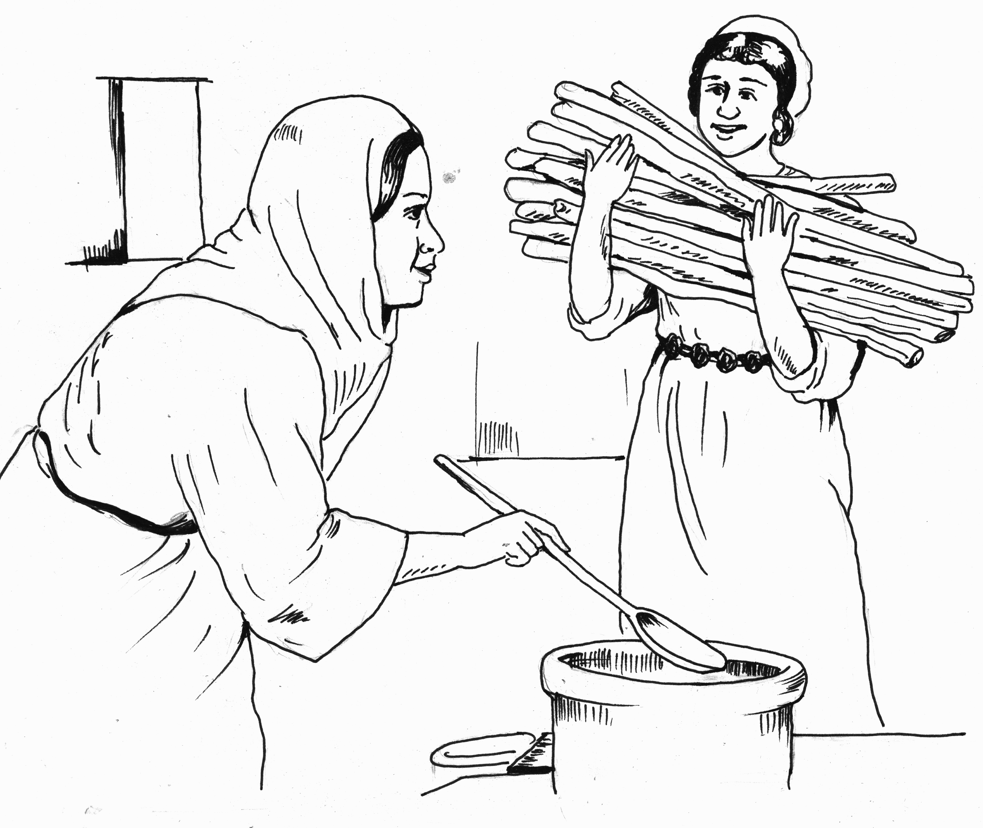

Luke 2:52 And Jesus grew in wisdom and stature, and in favor with God and men.
God's way is the best way to grow

Luke 2:52 And Jesus grew in wisdom and stature, and in favor with God and men.

