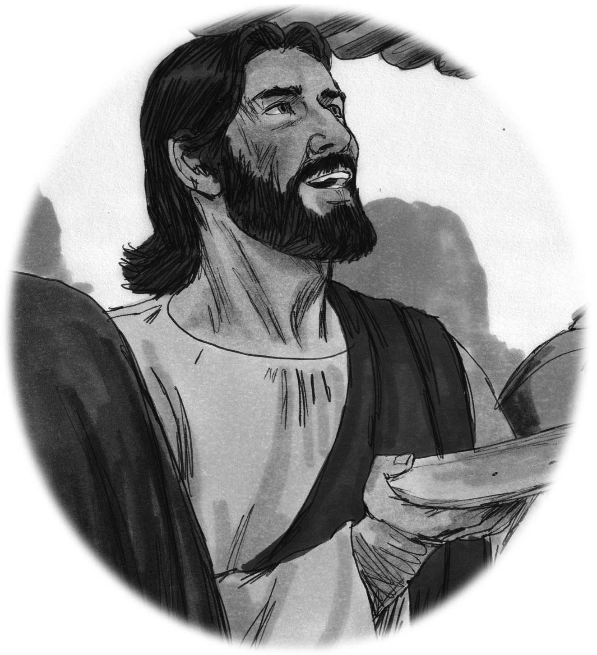
Lessons from Luke
Teacher’s Guide – Quarter 4

Chris and Karen Jackson, editors

Chris Jackson
BP 1299
Yaounde
Cameroon

2022

Adapted from the original work, “Lessons from Luke, 2nd Edition,” copyright Chris Jackson, licensed under a Creative Commons Attribution-NonCommercial-ShareAlike 4.0 International License (CC-BY-NC-SA).

English Scripture text: the NET Bible® http://netbible.com copyright ©1996, 2019 used with permission from Biblical Studies Press, L.L.C. All rights reserved

Bible illustrations by Jim Padgett, courtesy of Sweet Publishing, Fr. Worth (Texas); licensed for use under the Creative Commons BY-SA. https://creativecommons.org/licenses/by-sa/3.0/

The following illustrations were produced by Marx Tawe, Bamenda, North West Region, Cameroon: Covers, 9-2, 9-3; 10-2; 15-1 to 15-5; 16-1 to 16-4; 17-1 to 17-5; 18-1 to 18-2; 24-1 to 24-3; 31-1 to 31-3; 33-1 to 33-4; 36-1 to 36-3 and the coloring pages.
(for copyright questions concerning illustrations, contact Chris Jackson: chris_jackson@sil.org.)

2022 Chris Jackson
This work is licensed under the Creative Commons Attribution-NonCommercial-ShareAlike 4.0 International License. To view a copy of this license, visit http://creativecommons.org/licenses/by-nc-sa/4.0/deed.en_US.

Quarter 4 Table of Contents

No. | Title | Truth | Story
40 | Jesus Enters Jerusalem and Clears the Temple | A true disciple makes Jesus their King. | Luke 19:28–48
41 | The Widow's Gift | A true disciple of Jesus gives what they have with all their heart. | Luke 21:1–38
42 | The Passover Approaches | A true disciple of Jesus resists Satan. | Luke 22:1–13
43 | The Last Supper | A true disciple remembers Jesus' sacrifice. | Luke 22:13–40
44 | Jesus is Arrested | A true disciple of Jesus submits to God's will. | Luke 22:39–55
45 | Peter Denies Jesus | A true disciple of Jesus has a sorry heart when they sin. | Luke 22:54–62
46 | Review Lesson | Review Lessons 40-45
47 | Jesus's Trial | Jesus was wrongly judged, but he did not fight. | Luke 22:63–23:25
48 | The Crucifixion | Jesus suffered and died for us. | Luke 23:24–27  Luke 23:32–49
49 | Jesus Lives Again! | All of Jesus' words are true. | Luke 23:50–24:12
50 | On the Road to Emmaus | Jesus helps us know the truth. | Luke 24:10–35
51 | Jesus Appears to Believers and Returns to Heaven | Jesus is truly alive! | Luke 24:35–53
52 | Review Lesson | Review Lessons 47-51


- Jesus Enters Jerusalem and Clears the Temple
Jesus Enters Jerusalem and Clears the Temple
Luke 19:28–48
Lesson Overview
Today’s Truth | A true disciple makes Jesus their King.
Objective | KNOW: The children will know that Jesus is the one and only king!  DO: The children this week will find something that they are hanging onto that does not make Jesus king of their life. The children will then give Jesus total control over the things they are hanging onto.
Materials | - Quarter 4 Picture book, Bible, chalk  - Copies of the memory verse coloring page for the children to take home.  - A coat, cloak, or robe  - Ball (Make a ball by tying wrappen (plastic bag) into knots many times, or fill an old sock with scrap material.)
Memory Verse | Luke 19:38 Blessed is the king who comes in the name of the Lord! Peace in heaven and glory in the highest!
Homework | This week, identify something you don't want to give up that keeps Jesus from being King of your life. Are you afraid, or angry, or bitter against someone? Do you have a bad habit, or some sin that you are holding onto? Pray about this, ask God for forgiveness and freedom. Then give him control of whatever it is. Then you will start to experience the peace that comes when God is the truly the king of your life.

Detailed Lesson Plan
Song
Opening
Welcome
- Be sure the children know you are happy to see them!
- Introduce yourself and your helpers.
Sharing Time
- Does anyone remember a truth from any lesson?
(Give children time to share.)
- Does anyone remember a memory verse from any lesson?
(Give children time to share.)
Prayer
- Let the children share praises and prayer requests.
- Keep a record of what the children are sharing so you can remember to thank God together for answered prayers.
- Spend time praying together. Let children pray out loud if they volunteer. Do not force anyone to pray out loud.
Song
Words to Discuss
- On the blackboard, write the “Words to Discuss” from the list below.
- Let's discuss some words to help us better understand the Bible story for today.
- Colt: A young male horse.
- Cloaks: A garment to wear outside.
- Miracle: A surprise or event with no scientific explanation.
- Glory in the Highest: Giving praise to the Lord.
Song
Bible Story / Lesson
Object Lesson: Coats
Materials: A coat, cloak, or robe
- What do you use this for?
(Allow children to respond.)
- Do you place the coat on the ground?
(Allow children to respond.)
- Listen to today's story and see what people did with their coats.
- Today we will be learning that Jesus is the King!
Introduce Truth
Our truth for today is: A true disciple makes Jesus their King.
This reminds me of a true story from the Bible.
Bible Story: Luke 19:28–48
Luke 19:28-31 After Jesus had said this, he went on ahead, going up to Jerusalem. As he approached Bethphage and Bethany at the hill called the Mount of Olives, he sent two of his disciples, saying to them, “Go to the village ahead of you, and as you enter it, you will find a colt tied there, which no one has ever ridden. Untie it and bring it here. If anyone asks you, ‘Why are you untying it?’ tell him, ‘The Lord needs it.’”
Picture 40–1
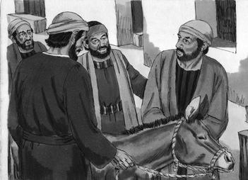
Luke 19:32-33 Those who were sent ahead went and found it just as he had told them. As they were untying the colt, its owners asked them, “Why are you untying the colt?”
Luke 19:34 They replied, “The Lord needs it.”
Luke 19:35-36 They brought it to Jesus, threw their cloaks on the colt and put Jesus on it. As he went along, people spread their cloaks on the road.
Picture 40–2
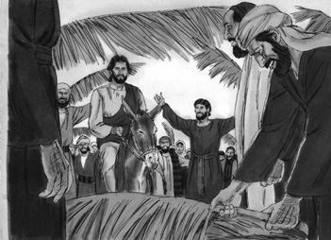
Luke 19:37-38 When he came near the place where the road goes down the Mount of Olives, the whole crowd of disciples began joyfully to praise God in loud voices for all the miracles they had seen: “Blessed is the king who comes in the name of the Lord!” “Peace in heaven and glory in the highest!”
Luke 19:39 Some of the Pharisees in the crowd said to Jesus, “Teacher, rebuke your disciples!”
Luke 19:40 “I tell you,” he replied, “if they keep quiet, the stones will cry out.”
Luke 19:45-46 Then he entered the temple area and began driving out those who were selling. “It is written,” he said to them, “‘My house will be a house of prayer’; but you have made it ‘a den of robbers.’”
Picture 40–3
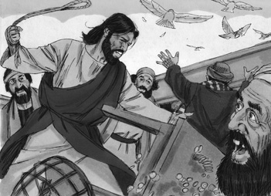
Luke 19:47-48 Every day he was teaching at the temple. But the chief priests, the teachers of the law and the leaders among the people were trying to kill him. Yet they could not find any way to do it, because all the people hung on his words.
Application
Who is the king of your life? Are you the leader of your life?
Jesus should be the one in charge of your life. Make him king.
What things do you want him to be in control of?
A true disciple makes Jesus their King.
Homework
This week, identify something you don't want to give up that keeps Jesus from being King of your life. Are you afraid, or angry, or bitter against someone? Do you have a bad habit, or some sin that you are holding onto? Pray about this, ask God for forgiveness and freedom. Then give him control of whatever it is. Then you will start to experience the peace that comes when God is the truly the king of your life.
Prayer / Song
Review Game
Throw the Ball at the Target on the Wall
Materials

- Make a target as shown on the blackboard or wall.
- Ball (Make a ball by tying wrappen (plastic bag) into knots many times, or fill an old sock with scrap material.)
- Draw a line on the floor for the children to stand behind.
How to Play
- Divide the class into 2 teams.
- The first team tries to answer the first question. The teacher can use this time to explain what the children do not seem to understand.
- The student on the team that answers the question correctly comes to the front and stands behind the line with their back facing the target. If the child only gets part of the question correct, the teacher can fill in the rest. The child can also ask for help from another child on his/her team. Help the child to succeed.
- The student then tries to throw the ball at the target.
- Wherever the ball hits shows how many points that team has.
- Record the points. The team with the most points wins.
- Be sure to clap for both sides. No name-calling. Encourage good sportsmanship.
Questions for Review Game
- Where did Jesus tell the disciples to go in the beginning of the Bible story? (To a village down from the Mount of Olives)
- What did Jesus want them to do? (Untie a colt that had never been ridden, and bring it to him)
- If anyone was to ask what the disciples were doing, what were they to say? (The Lord needed the colt.)
- What did the disciples lay over the colt when they brought it to Jesus? (Their garments)
- What did the crowd do when they saw Jesus on the road ahead? (They spread out their coats on the road ahead of Jesus.)
- As Jesus was walking past the crowd, what did they do? (They began to shout and sing, praising God.)
- What did the Pharisees in the crowd say when they heard all the praising? (“Teacher, rebuke your followers for saying things like that!”)
- Jesus said to the Pharisees that if the people stopped praising, who would then begin to start praising? (The stones in the road)
- When Jesus entered into the temple, who did he drive out? (All of the merchants)
- Why did Jesus drive out all of the merchants who were in the temple? (They were selling in the temple, and not worshiping.)
- As Jesus began teaching in the temple, what were the religious leaders planning? (Ways to kill Jesus)
- Why did the religious leaders stop planning ways to kill Jesus? (All the people listening to Jesus were hanging onto every word he was saying.)
Song
Memory Verse
Materials and Preparations
- Put a bookmark in Luke 19:38
- Write memory verse on the blackboard.
Luke 19:38 Blessed is the king who comes in the name of the Lord! Peace in heaven and glory in the highest!
Teach and Explain
Our memory verse is in the Gospel of Luke. That is in the New Testament, a part of the Bible.
- Read the verse from your Bible.
- Read the verse by yourself as you point to the words.
- Read the verse with the children as you point to the words.
- Explain the verse:
- Our memory verse comes from today’s Bible story.
- As you read the verse, circle the words shown below. Explain each of these words.
- Blessed: The people who were laying down their cloaks for the Lord were shouting this to him. By saying “blessed”, they are saying that Jesus is the holy one, sent from heaven.
- King: To say Jesus is King, the crowds are saying that Jesus is their King over all. He is higher than any King living on earth.
- Peace in heaven: The people are saying they know true peace is found in heaven where God reigns as king. They Jesus is on earth telling the good news to others, healing the sick and telling people they can be forgiven of their sins. The people in the crowd know that Jesus has been sent to earth and they are giving praise to him and to heaven.
- Glory in the Highest: The crowds are giving praise to the Lord just like the angels did when Jesus was born. Do you do this? Do you give the Lord all of your praise?
- Read the verse again by yourself as you point to the words.
- Read the verse again with the children as you point to the words.
The people who were shouting this verse to the Lord, were saying that Jesus is their King! He was sent from heaven, and he is the only true King. Can you say the same thing? Are you happy that God sent Jesus, His son, to die for us? We also need to shout for joy to the Lord.
Remember our truth for the day? Let’s all say it together:
A true disciple makes Jesus their King.
Memory Verse Review
Children Repeat the Verse by Playing “Ping Pong”
- Divide the class into 2 teams.
- Team 1 will say the first word of the verse.
- Team 2 will say the second word. The two teams will go back and forth saying one word, until the verse is finished.
- Ask the children the first question.
- When a question is answered correctly, that child chooses which side to start, and how many words each team will say as they go back and forth.
- The verse is said out loud together with the teams taking turns.
- Then the next question is asked.
- When that question is answered correctly, another child chooses which side to start.
- The verse is said aloud again with the teams taking turns.
- Do this until all the questions are asked.
Questions for Memory Verse
- Where in the Bible is today's memory verse found? ( Luke 19:38 )
- Who is speaking the words of this verse? (The crowd of people watching Jesus)
- Why are they saying these words? (They are praising God for his miracles.)
- Who is the King that we should be saying these words to? (Jesus!)
- What does it mean to “come in the name of the Lord”? (To come representing the Lord)
Song
Closing and Homework
- Say the truth together:
A true disciple makes Jesus their King.
- Say the memory verse together:
Luke 19:38 Blessed is the king who comes in the name of the Lord! Peace in heaven and glory in the highest!
- Review the homework:
This week, identify something you don't want to give up that keeps Jesus from being King of your life. Are you afraid, or angry, or bitter against someone? Do you have a bad habit, or some sin that you are holding onto? Pray about this, ask God for forgiveness and freedom. Then give him control of whatever it is. Then you will start to experience the peace that comes when God is the truly the king of your life.
- Give any needed announcements.
Closing Prayer
Thank God that Jesus is the King!
Ask God that the children will remember to find something that they are hanging onto, and pray that Jesus would become the King of their lives.
Colouring page to colour and take home!

A true disciple makes Jesus their King.

Luke 19:38 Blessed is the king who comes in the name of the Lord! Peace in heaven and glory in the highest!
A true disciple makes Jesus their King.

Luke 19:38 Blessed is the king who comes in the name of the Lord! Peace in heaven and glory in the highest!

- The Widow's Gift
The Widow's Gift
Luke 21:1–38
Lesson Overview
Today’s Truth | A true disciple of Jesus gives what they have with all their heart.
Objective | KNOW: The children will know that to be a true disciple one must give everything they are to God.  DO: The children will give a gift to someone this week from their heart.
Materials | - Quarter 4 Picture book, Bible, chalk  - Copies of the memory verse coloring page for the children to take home.  - Offering basket  - Coins  - Basket or hat to hold pieces of paper.  - 10 small strips of paper. Write different amounts of points on each. (Have numbers as low as 1 and numbers as high as 100.)
Memory Verse | Luke 21:3-4 “I tell you the truth,” he said, “this poor widow has put in more than all the others. All these people gave their gifts out of their wealth; but she out of her poverty put in all she had to live.”
Homework | Give a gift to someone this week from your heart.

Detailed Lesson Plan
Song
Opening
Welcome
- Be sure the children know you are happy to see them!
- Introduce yourself and your helpers.
Sharing Time
- Say the truth from the previous lesson together:
A true disciple makes Jesus their King.
- Say the memory verse from the previous lesson together:
Luke 19:38 Blessed is the king who comes in the name of the Lord! Peace in heaven and glory in the highest!
- Review the homework from the previous lesson:
You were to find something that you were hanging onto that did not make Jesus the King in your life. Did you give Jesus control of that thing? What was it?
(Give children time to share.)
Prayer
- Let the children share praises and prayer requests.
- Keep a record of what the children are sharing so you can remember to thank God together for answered prayers.
- Spend time praying together. Let children pray out loud if they volunteer. Do not force anyone to pray out loud.
Song
Words to Discuss
- On the blackboard, write the “Words to Discuss” from the list below.
- Let's discuss some words to help us better understand the Bible story for today.
- Widow: A woman who has lost her husband to death.
- Copper Coins: A piece of hard metal that is used for money.
- Temple: A building made for worship.
- Treasury: A place that holds money.
Song
Bible Story / Lesson
Object Lesson: Acting out ways to give
Materials: Offering basket, coins
- Have two children act out two different ways to give.
- One child will be the “rich” person: Have several coins or bills. Have the child count out their money and show everyone that they have a lot. Then they should choose one or two pieces of money to be placed in the offering basket.
- One child will be the “poor” person: Have one or two small coins. Have the child show that the small amount of money is all that they have. Then they should give all that they have into the offering basket.
- Which of these offerings is more pleasing to God?
(Allow children to respond.)
- Today we will be learning that a true disciple gives what they have with all of their heart.
Introduce Truth
Our truth for today is: A true disciple of Jesus gives what they have with all their heart.
This reminds me of a true story from the Bible.
Bible Story: Luke 21:1–38
Luke 21:37-38 Each day Jesus was teaching at the temple, and each evening he went out to spend the night on the hill called the Mount of Olives, and all the people came early in the morning to hear him at the temple.
Luke 21:1 As he looked up, Jesus saw the rich putting their gifts into the temple treasury.
Picture 41–1
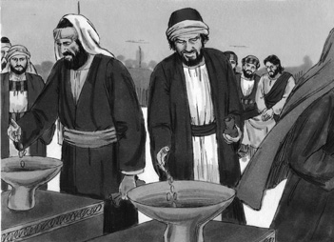

Luke 21:2-4 He also saw a poor widow put in two very small copper coins. “I tell you the truth,” he said, “this poor widow has put in more than all the others. All these people gave their gifts out of their wealth; but she out of her poverty put in all she had to live on.”
Picture 41–2
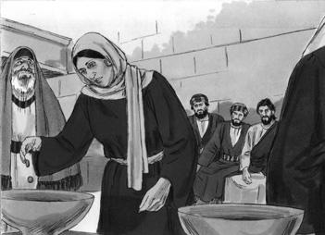
Luke 21:5-6 Some of his disciples were remarking about how the temple was adorned with beautiful stones and with gifts dedicated to God. But Jesus said, “As for what you see here, the time will come when not one stone will be left on another; every one of them will be thrown down.”
Picture 41–3
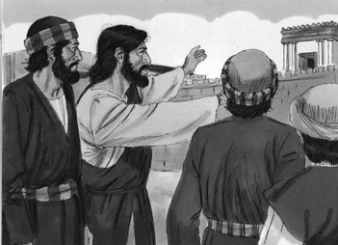
Luke 21:7 “Teacher,” they asked, “when will these things happen? And what will be the sign that they are about to take place?”
Luke 21:8-9 He replied: “Watch out that you are not deceived. For many will come in my name, claiming, ‘I am he,’ and, ‘The time is near.’ Do not follow them. When you hear of wars and revolutions, do not be frightened. These things must happen first, but the end will not come right away.”
Luke 21:10-11 Then he said to them: “Nation will rise against nation, and kingdom against kingdom. There will be great earthquakes, famines and pestilences in various places, and fearful events and great signs from heaven.
Luke 21:12-19 “But before all this, they will lay hands on you and persecute you. They will deliver you to synagogues and prisons, and you will be brought before kings and governors, and all on account of my name. This will result in your being witnesses to them. But make up your mind not to worry beforehand how you will defend yourselves. For I will give you words and wisdom that none of your adversaries will be able to resist or contradict. You will be betrayed even by parents, brothers, relatives and friends, and they will put some of you to death. All men will hate you because of me. But not a hair of your head will perish. By standing firm you will gain life.
Luke 21:31-33 Even so, when you see these things happening, you know that the kingdom of God is near. “I tell you the truth, this generation will certainly not pass away until all these things have happened. Heaven and earth will pass away, but my words will never pass away.
Application
Your gift should be motivated from your heart. No gift is too small. The widow gave her heart before the Lord.
A true disciple of Jesus gives what they have with all their heart.
Homework
This week: Give a gift to someone this week from your heart.
Prayer / Song
Review Game
Choose a Number out of the Basket
Materials
- Basket or hat to hold pieces of paper.
- 10 small strips of paper. Write different amounts of points on each. (Have numbers as low as 1 and numbers as high as 100.)
How to Play
- Divide the class into 2 teams.
- The first team tries to answer the first question. The teacher can use this time to explain what the children don’t seem to understand.
- The student on that team that answers the question correctly comes to the front and grabs a piece of paper from the basket or hat. (Make sure that the basket is held high enough so the student does not see which piece of paper they are grabbing.)
- The student then opens up the paper and the number that is on the piece of paper is the score that the team gets.
- Record the points. The team with the most points wins.
- Be sure to clap for both sides. No name-calling. Encourage good sportsmanship.
Questions for Review Game
- After Jesus was finished teaching in the Temple, where would he go to sleep? (Mount of Olives)
- One day when Jesus was in the Temple, what was he watching the people do? (Put their money in the treasury)
- Why were people putting money into the treasury? (They were supporting the temple.)
- First, Jesus watched the rich people put money into the collection box, who came after the rich? (A poor widow)
- How much money did she put into the collection box? (Two pennies)
- Was Jesus upset because she put in so little money? (No)
- Why was Jesus so pleased about the poor widow, and not with the wealthy? (She put in all that she had, while the wealthy only gave a tiny part of what they had.)
- What is the truth for today? ( A true disciple of Jesus gives what they have with all their heart. )
Song
Memory Verse
Materials and Preparations
- Put a bookmark in Luke 21:3-4
- Write memory verse on the blackboard.
Luke 21:3-4 “I tell you the truth,” he said, “this poor widow has put in more than all the others. All these people gave their gifts out of their wealth; but she out of her poverty put in all she had to live.”
Teach and Explain
Our memory verse is in the Gospel of Luke. That is in the New Testament, a part of the Bible.
- Read the verse from your Bible.
- Read the verse by yourself as you point to the words.
- Read the verse with the children as you point to the words.
- Explain the verse:
- Our memory verse comes from today’s Bible story.
- As you read the verse, circle the words shown below. Explain each of these words.
- Gifts: The gifts that people were giving to the temple, was money to help the temple pay for the things that they need to run every day. Jesus wants all of us to give.
- Wealth: People who had a lot of money were giving to the temple. Even though the people had a lot of money, they were only giving a little amount of money to the temple. They were being selfish and giving little.
- Poverty: The poor widow who gave a few coins, was all that she had. She gave everything to the temple, so that they could use it for the Lord. Jesus wants us to give everything that we are to him. We are to not give a little bit of ourselves to him, we are to give everything, and that might mean we have to give all of our money to the Lord.
- Read the verse again by yourself as you point to the words.
- Read the verse again with the children as you point to the words.
Remember our truth for the day? Let’s all say it together:
A true disciple of Jesus gives what they have with all their heart.
Memory Verse Review
Children Repeat the Verse by Playing “Ping Pong”
- Divide the class into 2 teams.
- Team 1 will say the first word of the verse.
- Team 2 will say the second word. The two teams will go back and forth saying one word, until the verse is finished.
- Ask the children the first question.
- When a question is answered correctly, that child chooses which side to start, and how many words each team will say as they go back and forth.
- The verse is said out loud together with the teams taking turns.
- Then the next question is asked.
- When that question is answered correctly, another child chooses which side to start.
- The verse is said aloud again with the teams taking turns.
- Do this until all the questions are asked.
Questions for Memory Verse
- Where in the Bible is today's memory verse found? ( Luke 21:3-4 )
- Who is speaking the words of this verse? (Jesus)
- Who did Jesus say gave the greatest gift? (The poor widow)
- What did the widow give to the church? (All that she had)
Song
Closing and Homework
- Say the truth together:
A true disciple of Jesus gives what they have with all their heart.
- Say the memory verse together:
Luke 21:3-4 “I tell you the truth,” he said, “this poor widow has put in more than all the others. All these people gave their gifts out of their wealth; but she out of her poverty put in all she had to live.”
- Review the homework:
Give a gift to someone this week from your heart.
- Give any needed announcements.
Closing Prayer
Thank God that He is the one who will be with us to the end.
Ask God that the children will remember to give a gift to someone.
Colouring page to colour and take home!
A true disciple of Jesus gives what they have with all their heart.

Luke 21:3-4 “I tell you the truth,” he said, “this poor widow has put in more than all the others. All these people gave their gifts out of their wealth; but she out of her poverty put in all she had to live.”
A true disciple of Jesus gives what they have with all their heart.

Luke 21:3-4 “I tell you the truth,” he said, “this poor widow has put in more than all the others. All these people gave their gifts out of their wealth; but she out of her poverty put in all she had to live.”

- The Passover Approaches
The Passover Approaches
Luke 22:1–13
Lesson Overview
Today’s Truth | A true disciple of Jesus resists Satan.
Objective | KNOW: The children will know that a true disciple resists Satan, and resists sin.  DO: The children will do something right when they feel they want to do something wrong. They will share what they did next week.
Materials | - Quarter 4 Picture book, Bible, chalk  - Copies of the memory verse coloring page for the children to take home.
Memory Verse | Luke 22:3-4 Then Satan entered Judas, called Iscariot, one of the twelve. And Judas went to the chief priests and the officers of the temple guard and discussed with them how he might betray Jesus.
Homework | This week, do something right when you feel you want to do something wrong. Next week you will tell about it.

Detailed Lesson Plan
Song
Opening
Welcome
- Be sure the children know you are happy to see them!
- Introduce yourself and your helpers.
Sharing Time
- Say the truth from the previous lesson together:
A true disciple of Jesus gives what they have with all their heart.
- Say the memory verse from the previous lesson together:
Luke 21:3-4 “I tell you the truth,” he said, “this poor widow has put in more than all the others. All these people gave their gifts out of their wealth; but she out of her poverty put in all she had to live.”
- Review the homework from the previous lesson:
The homework was to give a gift to someone from your heart. What did you do? Who did you give the gift to?
(Give children time to share.)
Prayer
- Let the children share praises and prayer requests.
- Keep a record of what the children are sharing so you can remember to thank God together for answered prayers.
- Spend time praying together. Let children pray out loud if they volunteer. Do not force anyone to pray out loud.
Song
Words to Discuss
- On the blackboard, write the “Words to Discuss” from the list below.
- Let's discuss some words to help us better understand the Bible story for today.
- Feast of Unleavened Bread/Passover: A celebration that celebrates the freedom of the Israelites from the Egyptians.
- Chief Priests: Teachers who were in charge in the temples.
- Teachers of the Law: An expert in the Law of Moses.
- Satan: The devil.
Song
Bible Story / Lesson
Object Lesson: Children act out a skit about “giving in” and “resisting”
- Have one child be a “shop keeper.”
- Have two children come into the shop. When the shop keeper is not looking, one friend encourages the other to steal something. The child will “give in” to the pressure of their friend, and steal something.
- Have the children act out the skit again, but this time, the child will not “give in” to the pressure of their friend. They will tell their friend that stealing is wrong, and they will not steal anything.
- Today we will be learning that a true disciple of Jesus resists Satan.
Introduce Truth
Our truth for today is: A true disciple of Jesus resists Satan.
This reminds me of a true story from the Bible.
Bible Story: Luke 22:1–13
Luke 22:1-2 Now the Feast of Unleavened Bread, called the Passover, was approaching, and the chief priests and the teachers of the law were looking for some way to get rid of Jesus, for they were afraid of the people.
Luke 22:3-6 Then Satan entered Judas, called Iscariot, one of the Twelve. And Judas went to the chief priests and the officers of the temple guard and discussed with them how he might betray Jesus. They were delighted and agreed to give him money. He consented, and watched for an opportunity to hand Jesus over to them when no crowd was present.
Picture 42–1
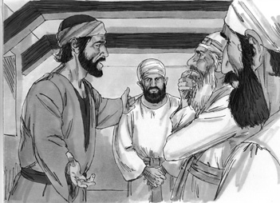

Luke 22:7-8 Then came the day of Unleavened Bread on which the Passover lamb had to be sacrificed. Jesus sent Peter and John, saying, “Go and make preparations for us to eat the Passover.”
Picture 42–2
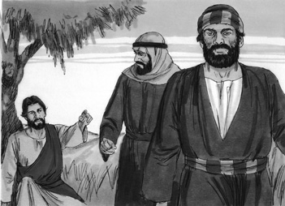
Luke 22:9 “Where do you want us to prepare for it?” they asked.
Luke 22:10-12 He replied, “As you enter the city, a man carrying a jar of water will meet you. Follow him to the house that he enters, and say to the owner of the house, ‘The Teacher asks: Where is the guest room, where I may eat the Passover with my disciples?’ He will show you a large upper room, all furnished. Make preparations there.”
Luke 22:13 They left and found things just as Jesus had told them. So they prepared the Passover.
Picture 42-3
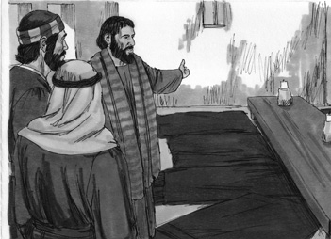

Application
When you are tempted, you feel the pull or desire to do something that you know is wrong. You should resist the pull, and do the right thing. Ask God to help you resist.
A true disciple of Jesus resists Satan.
Homework
This week, do something right when you feel you want to do something wrong. Next week you will tell about it.
Prayer / Song
Review Game
Long Jump
Materials
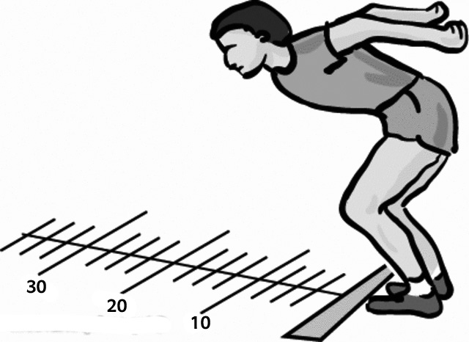
- Chalk
- Draw a starting line.
- Draw other lines from the starting line at different distances from the start.
- Give each distance a number with the easiest distance being 10 points then 20, 30, 40, 50 and so on.
How to Play
- Divide the class into 2 teams.
- When a child answers the question correctly, have that child come to the front and stand at the beginning line with their toes NOT crossing the line.
- Have them jump as far as they can from a standing position.
- Give points to that child's team depending on how far they jumped.
Questions for Review Game
- What is the name of the event that Jesus said will be celebrated? (Passover)
- Jesus said that during the time of the Passover, what else would happen? (The Son of Man will be handed over to be crucified.)
- Who was plotting Jesus' murder? (The teachers of the religious law and the leading priests)
- Satan entered into whom? (Judas Iscariot)
- Who was Judas Iscariot? (One of the twelve disciples)
- What did Judas Iscariot do? (He went to the leading priests to discuss the best ways to betray Jesus.)
- What did the religious leaders of the law and leading priests promise Judas? (A nice reward)
- What two disciples went into Jerusalem when Jesus asked them to? (Peter and John)
- When John and Peter found the house to have Passover in, did they make Jesus set everything up? (No, John and Peter set everything up so that Jesus did not have to do anything.)
- What is the truth for today? ( A true disciple of Jesus resists Satan. )
- In the Bible story, who did not resist Satan? (Judas Iscariot)
- In the Bible story, who listened to what Jesus told them to do? (Peter and John)
Song
Memory Verse
Materials and Preparations
- Put a bookmark in Luke 22:3-4
- Write memory verse on the blackboard.
Luke 22:3-4 Then Satan entered Judas, called Iscariot, one of the twelve. And Judas went to the chief priests and the officers of the temple guard and discussed with them how he might betray Jesus.
Teach and Explain
Our memory verse is in the Gospel of Luke. That is in the New Testament, a part of the Bible.
- Read the verse from your Bible.
- Read the verse by yourself as you point to the words.
- Read the verse with the children as you point to the words.
- Explain the verse:
- Our memory verse comes from today’s Bible story.
- As you read the verse, circle the words shown below. Explain each of these words.
- Satan entered Judas: Satan entered Judas, and he ended up helping in arresting Jesus. Judas could have not allowed Satan to enter him, if he set his mind onto the Lord. Judas allowed Satan to take control of his mind, and his heart.
- Chief Priests: The Chief Priests were also called, Sadducees. They did not like what Jesus was teaching, and they wanted him to be arrested. Throughout Jesus' life, they had been trying to plot Jesus' death.
- Temple Guard: The Temple Guards guarded the temple. They too worked with Judas and the Chief Priests on how and when to arrest Jesus.
- Betray: Judas was one of the twelve disciples. Judas turned away from Jesus and the disciples, and began to plan how he would betray Jesus. He no longer followed Jesus' words, and what he was teaching. To betray means to turn your back on somebody or from something.
- Read the verse again by yourself as you point to the words.
- Read the verse again with the children as you point to the words.
Judas allowed Satan to enter him. Because he allowed this, he ended up betraying Jesus. We need to make sure that we always resist Satan. Anything that is against what God wants for us, is following the ways of Satan. Remember, we need to fight temptation, we need to hold onto Jesus and pray to God when we feel tempted.
Remember our truth for the day? Let’s all say it together:
A true disciple of Jesus resists Satan.
Memory Verse Review
Children Repeat the Verse by Playing “Ping Pong”
- Divide the class into 2 teams.
- Team 1 will say the first word of the verse.
- Team 2 will say the second word. The two teams will go back and forth saying one word, until the verse is finished.
- Ask the children the first question.
- When a question is answered correctly, that child chooses which side to start, and how many words each team will say as they go back and forth.
- The verse is said out loud together with the teams taking turns.
- Then the next question is asked.
- When that question is answered correctly, another child chooses which side to start.
- The verse is said aloud again with the teams taking turns.
- Do this until all the questions are asked.
Questions for Memory Verse
- Where in the Bible is today's memory verse found? ( Luke 22:3-4 )
- Who did Satan enter? (Judas)
- What is Judas' other name? (Iscariot)
- Who is Judas? (One of the twelve disciples of Jesus)
- What does Judas agree to do? (Betray Jesus)
- What does it mean to betray? (To turn your back on somebody or from something)
Song
Closing and Homework
- Say the truth together:
A true disciple of Jesus resists Satan.
- Say the memory verse together:
Luke 22:3-4 Then Satan entered Judas, called Iscariot, one of the twelve. And Judas went to the chief priests and the officers of the temple guard and discussed with them how he might betray Jesus.
- Review the homework:
This week, do something right when you feel you want to do something wrong. Next week you will tell about it.
- Give any needed announcements.
Closing Prayer
Thank God that we are able to resist Satan, and can run to Jesus when we are surrounded by temptation.
Ask God that the children will remember to do something right when they feel like they want to do wrong.
Colouring page to colour and take home!

A true disciple of Jesus resists Satan.

Luke 22:3-4 Then Satan entered Judas, called Iscariot, one of the twelve. And Judas went to the chief priests and the officers of the temple guard and discussed with them how he might betray Jesus.
A true disciple of Jesus resists Satan.

Luke 22:3-4 Then Satan entered Judas, called Iscariot, one of the twelve. And Judas went to the chief priests and the officers of the temple guard and discussed with them how he might betray Jesus.

- The Last Supper
The Last Supper
Luke 22:13–40
Lesson Overview
Today’s Truth | A true disciple remembers Jesus' sacrifice.
Objective | KNOW: The children will know that Christ sacrificed his only Son.  DO: The children will take time every day this week to pray and thank God for sending His son, Jesus, to die for us.
Materials | - Quarter 4 Picture book, Bible, chalk  - Copies of the memory verse coloring page for the children to take home.  - Bread and a cup (Or whatever is used in church for Communion)  - Cooking pot with a lid  - Rope, string, or yarn cut into 10 pieces that are all different sizes
Memory Verse | Luke 22:19-20 And he took the bread, gave thanks and broke it, and gave it to them, saying, “This is my body given for you; do this in remembrance of me.” In the same way, after the supper he took the cup, saying, “This cup is the new covenant in my blood, which is poured out for you.”
Homework | Try to take time every day this week to pray and thank God for sending His son, Jesus, to die for us.

Detailed Lesson Plan
Song
Opening
Welcome
- Be sure the children know you are happy to see them!
- Introduce yourself and your helpers.
Sharing Time
- Say the truth from the previous lesson together:
A true disciple of Jesus resists Satan.
- Say the memory verse from the previous lesson together:
Luke 22:3-4 Then Satan entered Judas, called Iscariot, one of the twelve. And Judas went to the chief priests and the officers of the temple guard and discussed with them how he might betray Jesus.
- Review the homework from the previous lesson:
Last week you were to do something right when you felt like you wanted to do something wrong. What did you do?
(Give children time to share.)
Prayer
- Let the children share praises and prayer requests.
- Keep a record of what the children are sharing so you can remember to thank God together for answered prayers.
- Spend time praying together. Let children pray out loud if they volunteer. Do not force anyone to pray out loud.
Song
Words to Discuss
- On the blackboard, write the “Words to Discuss” from the list below.
- Let's discuss some words to help us better understand the Bible story for today.
- Covenant: An agreement.
- Sacrifice: The act of giving up someone or something for God.
- Remembrance: To remember something.
- Simon: Another name for Peter.
Song
Bible Story / Lesson
Materials: Bread and a cup (Or whatever is used in church for Communion)
- Show the objects to the children.
- Have you ever seen these being used in a church service?
(Allow the children to respond.)
- What are they used for?
(Allow the children to respond.)
- Today's Bible story will show how Jesus used these with his disciples for the very first time.
- Today we will be learning that a true disciple remembers Christ's sacrifice.
Introduce Truth
Our truth for today is: A true disciple remembers Jesus' sacrifice.
This reminds me of a true story from the Bible. Remember, in our last lesson, Jesus sent the disciples ahead to prepare for the Passover meal. Jesus and the disciples have gathered together in the room that was prepared for them, and started celebrating the Passover feast together.
Bible Story: Luke 22:13–40
Luke 22:13 They left and found things just as Jesus had told them. So they prepared the Passover.
Picture 43–1
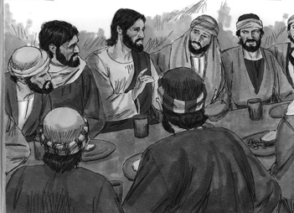
Luke 22:14-16 When the hour came, Jesus and his apostles reclined at the table. And he said to them, “I have eagerly desired to eat this Passover with you before I suffer. For I tell you, I will not eat it again until it finds fulfillment in the kingdom of God.”
Luke 22:17-18 After taking the cup, he gave thanks and said, “Take this and divide it among you. For I tell you I will not drink again of the fruit of the vine until the kingdom of God comes.”
Luke 22:19 And he took bread, gave thanks and broke it, and gave it to them, saying, “This is my body given for you; do this in remembrance of me.”
Luke 22:20-23 In the same way, after the supper he took the cup, saying, “This cup is the new covenant in my blood, which is poured out for you. But the hand of him who is going to betray me is with mine on the table. The Son of Man will go as it has been decreed, but woe to that man who betrays him.” They began to question among themselves which of them it might be who would do this.
Luke 22:24 Also a dispute arose among them as to which of them was considered to be greatest.
Luke 22:25-27 Jesus said to them, “The kings of the Gentiles lord it over them; and those who exercise authority over them call themselves Benefactors. But you are not to be like that. Instead, the greatest among you should be like the youngest, and the one who rules like the one who serves. For who is greater, the one who is at the table or the one who serves? Is it not the one who is at the table? But I am among you as one who serves.
Picture 43–2
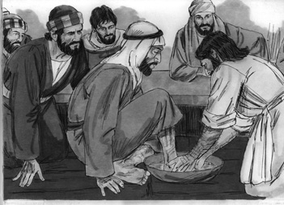
Luke 22:31-32 “Simon, Simon, Satan has asked to sift you as wheat. But I have prayed for you, Simon, that your faith may not fail. And when you have turned back, strengthen your brothers.”
Picture 43–3
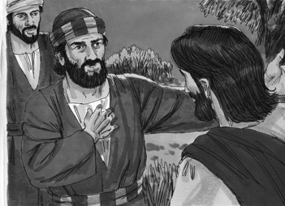
Luke 22:33 But he replied, “Lord, I am ready to go with you to prison and to death.”
Luke 22:34 Jesus answered, “I tell you, Peter, before the rooster crows today, you will deny three times that you know me.”
Luke 22:39-40 Jesus went out as usual to the Mount of Olives, and his disciples followed him. On reaching the place, he said to them, “Pray that you will not fall into temptation.”
Application
As a follower of Jesus, it is very important that we always remember what Jesus did for us. During the Last Supper with the disciples, Jesus took bread to have them remember the sacrifice that he made with his body. Jesus then took the wine, and told the disciples to drink to remember his blood that he poured out for us. By remembering what he has done for us, we learn to live a life that is about God, and not about ourselves.
A true disciple remembers Jesus' sacrifice.
Homework
Try to take time every day this week to pray and thank God for sending His son, Jesus, to die for us.
Prayer / Song
Review Game
Spaghetti Game
Materials
- Cooking pot with a lid
- Rope, string, or yarn cut into 10 pieces that are all different sizes
How to Play
- Put the rope, string, or yarn in the pot with some of it hanging out. Put the lid on the pot over the ropes.
- Divide the children into two teams.
- When someone on the team answers the question correctly, they come to the front and choose one of the ropes. (They never know if they will get a long or short rope.)
- The ropes that each team gets are tied together into one long rope.
- At the end, measure the ropes from the two teams side by side.
- The teams with the longest rope wins.
Questions for Review Game
- What did Jesus say he would not do “until it comes to the fulfillment in the Kingdom of God”? (He would not eat.)
- What did Jesus bless and break into pieces? (Bread)
- What did Jesus say the bread represented? (His body)
- Who were they to remember when eating the bread? (Jesus)
- After the bread, what did Jesus pick up? (A cup of wine)
- What did Jesus say the cup of wine represented? (The blood of Jesus)
- While they were all sitting at the table, what did Jesus say one man would do? (Betray him)
- When the disciples heard this, what did they begin to do? (Ask each other which of them would ever do such a thing)
- Jesus said that those who are the greatest should do what? (Take the lowest rank)
- Jesus said that those who are the leader should be more like what? (Servants)
- Who did Jesus tell that when the rooster crows, they will deny him three times? (Peter)
- As Jesus went to the Mount of Olives, what did he say the disciples should pray about? (They should pray to not be overcome by temptation.)
Song
Memory Verse
Materials and Preparations
- Put a bookmark in Luke 22:19-20
- Write memory verse on the blackboard.
Luke 22:19-20 And he took the bread, gave thanks and broke it, and gave it to them, saying, “This is my body given for you; do this in remembrance of me.” In the same way, after the supper he took the cup, saying, “This cup is the new covenant in my blood, which is poured out for you.”
Teach and Explain
Our memory verse is in the Gospel of Luke. That is in the New Testament, a part of the Bible.
- Read the verse from your Bible.
- Read the verse by yourself as you point to the words.
- Read the verse with the children as you point to the words.
- Explain the verse:
- Our memory verse comes from today’s Bible story.
- As you read the verse, circle the words shown below. Explain each of these words.
- This is my body: Jesus was saying that the bread was like his body. Jesus gave up his body so that we can be saved from sin.
- In remembrance of me: During Communion when we take the bread and the cup, we do it all in remembrance of Jesus. We are remembering that Jesus gave up his body and his blood was spilled so that we can be free from sin.
- New covenant in my blood: “A new agreement in his blood.” By the act of Jesus dying, we are free from sin. We no longer are chained to sin. We are set free! Because of the new covenant-or agreement, we are free.
- Poured out for you: Jesus died and poured out his blood for US. He loved us so much, he sacrificed himself so that we can be free in Christ.
- Read the verse again by yourself as you point to the words.
- Read the verse again with the children as you point to the words.
Next time when you are doing Communion, really think about everything Jesus did for you. Because of his death, you are free, and you can have eternal life!
Remember our truth for the day? Let’s all say it together:
A true disciple remembers Jesus' sacrifice.
Memory Verse Review
Children Repeat the Verse by Playing “Ping Pong”
- Divide the class into 2 teams.
- Team 1 will say the first word of the verse.
- Team 2 will say the second word. The two teams will go back and forth saying one word, until the verse is finished.
- Ask the children the first question.
- When a question is answered correctly, that child chooses which side to start, and how many words each team will say as they go back and forth.
- The verse is said out loud together with the teams taking turns.
- Then the next question is asked.
- When that question is answered correctly, another child chooses which side to start.
- The verse is said aloud again with the teams taking turns.
- Do this until all the questions are asked.
Questions for Memory Verse
- Where in the Bible is today's memory verse found? ( Luke 22:19-20 )
- Who took the bread and cup and spoke these words? (Jesus)
- What does the bread represent? (Jesus' body)
- What does the cup represent? (Jesus' blood)
- What is a covenant? (An agreement)
- What should we always remember and thank God for? (Jesus dying for us/Jesus' sacrifice)
Song
Closing and Homework
- Say the truth together:
A true disciple remembers Jesus' sacrifice.
- Say the memory verse together:
Luke 22:19-20 And he took the bread, gave thanks and broke it, and gave it to them, saying, “This is my body given for you; do this in remembrance of me.” In the same way, after the supper he took the cup, saying, “This cup is the new covenant in my blood, which is poured out for you.”
- Review the homework:
Try to take time every day this week to pray and thank God for sending His son, Jesus, to die for us.
- Give any needed announcements.
Closing Prayer
Thank God that He died on the cross for our sins.
Ask God that the children will remember the sacrifice that Christ did for us all.
Colouring page to colour and take home!
A true disciple remembers Jesus' sacrifice.

Luke 22:19-20 And he took the bread, gave thanks and broke it, and gave it to them, saying, “This is my body given for you; do this in remembrance of me.” In the same way, after the supper he took the cup, saying, “This cup is the new covenant in my blood, which is poured out for you.”
A true disciple remembers Jesus' sacrifice.

Luke 22:19-20 And he took the bread, gave thanks and broke it, and gave it to them, saying, “This is my body given for you; do this in remembrance of me.” In the same way, after the supper he took the cup, saying, “This cup is the new covenant in my blood, which is poured out for you.”

- Jesus is Arrested
Jesus is Arrested
Luke 22:39–55
Lesson Overview
Today’s Truth | A true disciple of Jesus submits to God's will.
Objective | KNOW: The children will know that we are to submit to God's will.  DO: The children will learn that if something hard comes into their lives, they will learn to ask God to decide for them. They will tell God that they are submitting to his will.
Materials | - Quarter 4 Picture book, Bible, chalk  - Copies of the memory verse coloring page for the children to take home.  - 5-10 different sized containers or cups (You can also use shoes or hats/caps)  - 5-10 strips of paper (One for each container). Write different amounts of points on each. (Have numbers as low as 1 and numbers as high as 100.)  - 2 bottle caps, stones, or other small things to throw
Memory Verse | Luke 22:42 Father, if you are willing, take this cup from me; yet not my will, but yours be done.
Homework | This week, when you have something hard come into your life, ask God to help you decide on what to do. Tell God that you are submitting to his will.

Detailed Lesson Plan
Song
Opening
Welcome
- Be sure the children know you are happy to see them!
- Introduce yourself and your helpers.
Sharing Time
- Say the truth from the previous lesson together:
A true disciple remembers Jesus' sacrifice.
- Say the memory verse from the previous lesson together:
Luke 22:19-20 And he took the bread, gave thanks and broke it, and gave it to them, saying, “This is my body given for you; do this in remembrance of me.” In the same way, after the supper he took the cup, saying, “This cup is the new covenant in my blood, which is poured out for you.”
- Review the homework from the previous lesson:
You were to spend time every day thanking God for sending his son, Jesus, and for dying on the cross for us. Did you do that?
(Give children time to share.)
Prayer
- Let the children share praises and prayer requests.
- Keep a record of what the children are sharing so you can remember to thank God together for answered prayers.
- Spend time praying together. Let children pray out loud if they volunteer. Do not force anyone to pray out loud.
Song
Words to Discuss
- On the blackboard, write the “Words to Discuss” from the list below.
- Let's discuss some words to help us better understand the Bible story for today.
- Temptation: Being drawn into doing something you know you should not do.
- Chief Priests: Teachers who were in charge in the temples.
- Rebellion: To go against authority.
Song
Bible Story / Lesson
When we pray God answers “Yes”, “No”, or “Wait”.
When Jesus prayed did God always answer “Yes”?
Today we will be learning that a true disciple submits to God's will.
Introduce Truth
Our truth for today is: A true disciple of Jesus submits to God's will.
This reminds me of a true story from the Bible.
Bible Story: Luke 22:39–55
Luke 22:39-40 Jesus went out as usual to the Mount of Olives, and his disciples followed him. On reaching the place, he said to them, “Pray that you will not fall into temptation.”
Luke 22:41-44 He withdrew about a stone’s throw beyond them, knelt down and prayed, “Father, if you are willing, take this cup from me; yet not my will, but yours be done.” An angel from heaven appeared to him and strengthened him. And being in anguish, he prayed more earnestly, and his sweat was like drops of blood falling to the ground.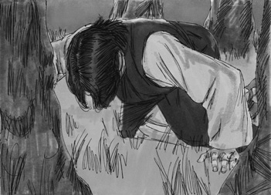
Picture 44–1

Luke 22:45-46 When he rose from prayer and went back to the disciples, he found them asleep, exhausted from sorrow. “Why are you sleeping?” he asked them. “Get up and pray so that you will not fall into temptation.”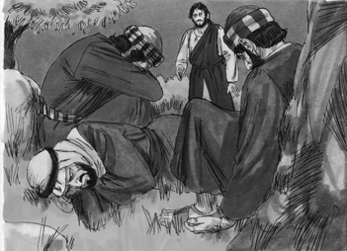
Picture 44–2

Luke 22:47-48 While he was still speaking a crowd came up, and the man who was called Judas, one of the Twelve, was leading them. He approached Jesus to kiss him, but Jesus asked him, “Judas, are you betraying the Son of Man with a kiss?”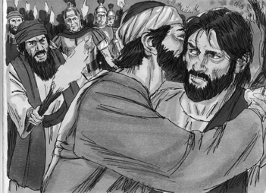
Picture 44–3

Luke 22:49-50 When Jesus’ followers saw what was going to happen, they said, “Lord, should we strike with our swords?” And one of them struck the servant of the high priest, cutting off his right ear.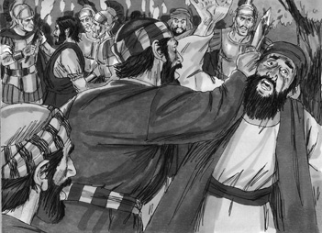
Picture 44–4

Luke 22:51 But Jesus answered, “No more of this!” And he touched the man’s ear and healed him.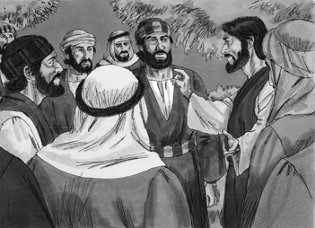
Picture 44–5

Luke 22:52-53 Then Jesus said to the chief priests, the officers of the temple guard, and the elders, who had come for him, “Am I leading a rebellion, that you have come with swords and clubs? Every day I was with you in the temple courts, and you did not lay a hand on me. But this is your hour — when darkness reigns.”
Luke 22:54-55 Then seizing him, they led him away and took him into the house of the high priest. Peter followed at a distance. But when they had kindled a fire in the middle of the courtyard and had sat down together, Peter sat down with them.
Application
When hard things happen, you need to submit to God's will. Let Jesus decide. Like we learned in the story, Jesus submitted to God's will. Jesus did not fight God. We did not see him run away when he was being arrested. Jesus allowed the men to take him, because it was God's will. Jesus was doing this all for us, so that we can be saved.
A true disciple of Jesus submits to God's will.
Homework
This week, when you have something hard come into your life, ask God to help you decide on what to do. Tell God that you are submitting to his will.
Prayer / Song
Review Game
Throw Bottle Caps into Containers
Materials
- Draw a line for the children to stand behind.
- Arrange 5-10 different sized containers or cups (you can also use shoes or hats/caps) into a group a distance from the line.
- Put one small paper with points written on it inside each container.
- Collect 2 bottle caps, stones, or other small things to throw and set them on the line that you drew for the children to stand behind.
How to Play
- Divide the class into 2 teams.
- The first team tries to answer the first question. The teacher can use this time to explain what the children do not seem to understand.
- The child on the team that answers the question correctly comes to the front and stands behind the line. If the child only gets part of the question right, the teacher can fill in the rest.
- The child then tries to throw the bottle cap into the group of containers. Wherever the bottle cap enters, the points on the paper inside that container are what the team has.
- Record the points. The team with the most points wins.
- Be sure to clap for both sides. No name-calling. Encourage good sportsmanship.
Questions for Review Game
- What did Jesus pray and ask God to take away? (His suffering)
- At the end of Jesus' prayer, what did he say? (He wanted what was God's will, not his own.)
- Who appeared and strengthened Jesus? (An angel)
- What was Jesus' sweat dripping like? (Drops of blood)
- When Jesus went back to his disciples, what did he find them doing? (Sleeping)
- What did Jesus tell the disciples to get up and start doing? (Start praying, otherwise they would fall under temptation)
- As Jesus was saying this, who approached Jesus and the disciples? (A mob came around them all.)
- Who was leading the mob? (Judas Iscariot)
- What did Judas do as he approached Jesus? (He kissed Jesus on the cheek.)
- As Jesus was being arrested, what did one of the disciples do to protect Jesus? (One of the disciples slashed off the ear of the servant of the high priest.)
- What did Jesus do to the servant who got his ear cut off? (He touched the place where the ear had been and healed it.)
- What is the truth for today? ( A true disciple of Jesus submits to God's will. )
Song
Memory Verse
Materials and Preparations
- Put a bookmark in Luke 22:42
- Write memory verse on the blackboard.
Luke 22:42 Father, if you are willing, take this cup from me; yet not my will, but yours be done.
Teach and Explain
Our memory verse is in the Gospel of Luke. That is in the New Testament, a part of the Bible.
- Read the verse from your Bible.
- Read the verse by yourself as you point to the words.
- Read the verse with the children as you point to the words.
- Explain the verse:
- Our memory verse comes from today’s Bible story.
- As you read the verse, circle the words shown below. Explain each of these words.
- Take this cup from me: Jesus is asking God to take away burden of dying on the cross for us. He is asking God if there is another way for it to happen.
- Not my will, but yours: Jesus did not want to die, he did not want to suffer, but because it was God's will, he did not fight. Jesus knew that is was God's will to allow his death, so Jesus did not fight.
- Read the verse again by yourself as you point to the words.
- Read the verse again with the children as you point to the words.
Sometimes we run when God wants us to do something. Can you imagine if Jesus ran away from God's will? We would never be free from our sins if Jesus did not listen to God's will. We too need to always listen and allow God to direct us where he wants us.
Remember our truth for the day? Let’s say it together:
A true disciple of Jesus submits to God's will.
Memory Verse Review
Children Repeat the Verse by Playing “Ping Pong”
- Divide the class into 2 teams.
- Team 1 will say the first word of the verse.
- Team 2 will say the second word. The two teams will go back and forth saying one word, until the verse is finished.
- Ask the children the first question.
- When a question is answered correctly, that child chooses which side to start, and how many words each team will say as they go back and forth.
- The verse is said out loud together with the teams taking turns.
- Then the next question is asked.
- When that question is answered correctly, another child chooses which side to start.
- The verse is said aloud again with the teams taking turns.
- Do this until all the questions are asked.
Questions for Memory Verse
- Where in the Bible is today's memory verse found? ( Luke 22:42 )
- Who is speaking the words here in this verse? (Jesus)
- What is Jesus doing while he says these words? (He is praying to God.)
- What does Jesus mean when he says “take this cup from me”? (He is asking God to not make him suffer and die.)
- At the end of this prayer, what does Jesus agree to do? (He agrees to do whatever God wants him to do.)
Song
Closing and Homework
- Say the truth together:
A true disciple of Jesus submits to God's will.
- Say the memory verse together:
Luke 22:42 Father, if you are willing, take this cup from me; yet not my will, but yours be done.
- Review the homework:
This week, when you have something hard come into your life, ask God to help you decide on what to do. Tell God that you are submitting to his will.
Closing Prayer
Thank God that He is always the one in control, and that we can go to Him when we are worried, upset, sad, or concerned about things.
Ask God that the children will remember to submit to God's will. Even if it is something they thought they would never be asked to do, that they would follow His will.
Colouring page to colour and take home!

A true disciple of Jesus submits to God's will.

Luke 22:42 Father, if you are willing, take this cup from me; yet not my will, but yours be done.
A true disciple of Jesus submits to God's will.

Luke 22:42 Father, if you are willing, take this cup from me; yet not my will, but yours be done.

- The Birth of John the Baptizer
Peter Denies Jesus
Luke 22:54–62
Lesson Overview
Today’s Truth | A true disciple of Jesus has a sorry heart when they sin.
Objective | KNOW: The children will learn to be sorry when they sin.  DO: The children will find the sin in their life and spend time confessing that sin to God. They will tell Him how truly sorry they are, and they need his help to stop doing that sin.
Materials | - Quarter 4 Picture book, Bible, chalk  - Copies of the memory verse coloring page for the children to take home.  - Tic Tac Toe/Long Line – You can use chalk and blackboard, paper and pen, or a stick and dirt
Memory Verse | Luke 22:61-62 The Lord turned and looked straight at Peter. Then Peter remembered the word the Lord had spoken to him: “Before the rooster crows today, you will disown me three times.” And he went outside and wept bitterly.
Homework | This week, find a sin in your life and spend time confessing that sin to God. Tell Him you are truly sorry, and that you need His help to stop doing that sin.

Detailed Lesson Plan
Song
Opening
Welcome
- Be sure the children know you are happy to see them!
- Introduce yourself and your helpers.
Sharing Time
- Say the truth from the previous lesson together:
A true disciple of Jesus submits to God's will.
- Say the memory verse from the previous lesson together:
Luke 22:42 Father, if you are willing, take this cup from me; yet not my will, but yours be done.
- Review the homework from the previous lesson:
The homework was to ask God to help you decide something difficult that has come into your life. What did you ask God to help you with? Did you submit to God's will?
(Give children time to share.)
Prayer
- Let the children share praises and prayer requests.
- Keep a record of what the children are sharing so you can remember to thank God together for answered prayers.
- Spend time praying together. Let children pray out loud if they volunteer. Do not force anyone to pray out loud.
Song
Words to Discuss
- On the blackboard, write the “Words to Discuss” from the list below.
- Let's discuss some words to help us better understand the Bible story for today.
- Galilean: Someone from Galilee.
- Disown/Deny: To refuse being connected to someone.
- High Priest: Someone who holds position as leader.
Song
Bible Story / Lesson
Today we will be learning that a true disciple of Jesus has a sorry heart when they sin.
Introduce Truth
Our truth for today is: A true disciple of Jesus has a sorry heart when they sin.
This reminds me of a true story from the Bible.
Bible Story: Luke 22:54–62
Luke 22:54-55 Then seizing him, they led him away and took him into the house of the high priest. Peter followed at a distance. But when they had kindled a fire in the middle of the courtyard and had sat down together, Peter sat down with them.
Picture 45–1
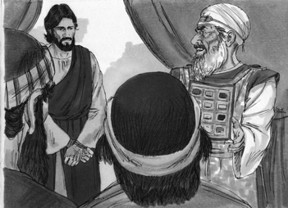

Luke 22:56 A servant girl saw him seated there in the firelight. She looked closely at him and said, “This man was with him.”
Picture 45–2
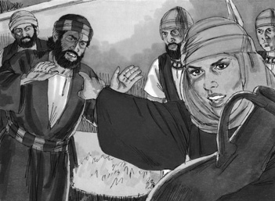
Luke 22:57 But he denied it. “Woman, I don’t know him,” he said.
Luke 22:58 A little later someone else saw him and said, “You also are one of them.” “Man, I am not!” Peter replied.
Luke 22:59 About an hour later another asserted, “Certainly this fellow was with him, for he is a Galilean.”
Luke 22:60 Peter replied, “Man, I don’t know what you’re talking about!” Just as he was speaking, the rooster crowed.
Luke 22:61-62 The Lord turned and looked straight at Peter. Then Peter remembered the word the Lord had spoken to him: “Before the rooster crows today, you will disown me three times.” And he went outside and wept bitterly.
Picture 45–3
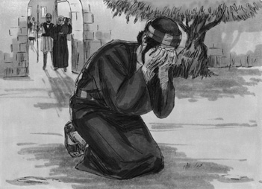

Application
Peter was a disciple of Jesus. He followed Jesus in his heart, mind, and in his actions. Peter ended up sinning and denied knowing Christ three times. Peter sinned, yet he asked God for forgiveness. As followers of Jesus we can always ask God for forgiveness when we sin. When we sin, we need to come to God with a sorry heart and ask him to forgive us. And he promises to always forgive us.
A true disciple of Jesus has a sorry heart when they sin.
Homework
This week, find a sin in your life and spend time confessing that sin to God. Tell Him you are truly sorry, and that you need His help to stop doing that sin.
Prayer / Song
Review Game
Tic-Tac-Toe/Long Line
Materials

- Draw on the blackboard, on the dirt, or on a paper a game board of two horizontal lines crossing two vertical lines.
- One team marks the X's, one team marks the O's using chalk, marker, pen, or a stick.
How to Play
- Divide the class into 2 teams.
- The first team tries to answer the first question. The teacher can use this time to explain what the children do not seem to understand.
- The child on the team that answers the question correctly comes to the front and marks and X (for team 1) or an O (for team 2) in one of the spaces on the Tic-Tac-Toe board.
- The first team to get three X's or O's in a row in any direction wins.
- Be sure to clap for both sides. No name-calling. Encourage good sportsmanship.
Questions for Review Game
- Which disciple followed far behind as Jesus was arrested? (Peter)
- A servant girl noticed Peter, what did she say? (“This man is one of Jesus' followers!”)
- Another person noticed Peter and said the same thing. How did Peter respond? (He said that he was not a follower of Jesus.)
- What happened after Peter denied being a follower of Jesus to the third person? (A rooster crowed.)
- What did Peter remember Jesus had told him? (That he would deny Jesus three times.)
- When did Jesus tell this to Peter? (During the Passover meal.)
- After Peter remembered what Jesus had told him and what he had done, what did he do? (He left the courtyard and cried bitterly.)
- What is the truth for today? ( A true disciple of Jesus has a sorry heart when they sin. )
Song
Memory Verse
Materials and Preparations
- Put a bookmark in Luke 22:61-62
- Write memory verse on the blackboard.
Luke 22:61-62 The Lord turned and looked straight at Peter. Then Peter remembered the word the Lord had spoken to him: “Before the rooster crows today, you will disown me three times.” And he went outside and wept bitterly.
Teach and Explain
Our memory verse is in the Gospel of Luke. That is in the New Testament, a part of the Bible.
- Read the verse from your Bible.
- Read the verse by yourself as you point to the words.
- Read the verse with the children as you point to the words.
- Explain the verse:
- Our memory verse comes from today’s Bible story.
- As you read the verse, circle the words shown below. Explain each of these words.
- Before the rooster crows today: A rooster usually crows right before the sun rises. Peter would deny knowing Jesus three times before the sun would rise.
- Disown: Peter was going to disown Jesus, by claiming to not be one of his followers.
- Read the verse again by yourself as you point to the words.
- Read the verse again with the children as you point to the words.
Remember our truth for the day? Let’s all say it together:
A true disciple of Jesus has a sorry heart when they sin.
Memory Verse Review
Children Repeat the Verse by Playing “Ping Pong”
- Divide the class into 2 teams.
- Team 1 will say the first word of the verse.
- Team 2 will say the second word. The two teams will go back and forth saying one word, until the verse is finished.
- Ask the children the first question.
- When a question is answered correctly, that child chooses which side to start, and how many words each team will say as they go back and forth.
- The verse is said out loud together with the teams taking turns.
- Then the next question is asked.
- When that question is answered correctly, another child chooses which side to start.
- The verse is said aloud again with the teams taking turns.
- Do this until all the questions are asked.
Questions for Memory Verse
- Where in the Bible is today's memory verse found? ( Luke 22:61-62 )
- What had Jesus told Peter that he would do? (Disown Jesus three times before the rooster crows)
- In what way did Peter deny Jesus? (Peter denied that he knew and followed Jesus.)
- What did Peter do when he heard the rooster crow? (He remembered what Jesus said and wept bitterly.)
- Why did Peter weep? (He was sorry for what he had done wrong.)
Song
Closing and Homework
- Say the truth together:
A true disciple of Jesus has a sorry heart when they sin.
- Say the memory verse together:
Luke 22:61-62 The Lord turned and looked straight at Peter. Then Peter remembered the word the Lord had spoken to him: “Before the rooster crows today, you will disown me three times.” And he went outside and wept bitterly.
- Review the homework:
This week, find a sin in your life and spend time confessing that sin to God. Tell Him you are truly sorry, and that you need His help to stop doing that sin.
- Give any needed announcements.
Closing Prayer
Thank God that He forgives us from all the bad things that we do.
Ask God that the children will remember to spend time confessing a sin to God. Pray that they would be truly sorry.
Colouring page to colour and take home!

A true disciple of Jesus has a sorry heart when they sin.

Luke 22:61-62 The Lord turned and looked straight at Peter. Then Peter remembered the word the Lord had spoken to him: “Before the rooster crows today, you will disown me three times.” And he went outside and wept bitterly.
A true disciple of Jesus has a sorry heart when they sin.

Luke 22:61-62 The Lord turned and looked straight at Peter. Then Peter remembered the word the Lord had spoken to him: “Before the rooster crows today, you will disown me three times.” And he went outside and wept bitterly.

- Review Lesson
Review Lesson
Lessons 40-45
NOTE: It is important to review the lessons previously taught to help the children remember what they have learned. It is also important to make the review lessons exciting and fun! Turn the whole lesson into a game. If you have time, have the children act out their favourite stories while you read it from the “Picture Book”.
Materials
- Quarter 4 Picture book, Bible, chalk
- 5-10 different sized containers or cups (You can also use shoes or hats/caps)
- 5-10 strips of paper (One for each container). Write different amounts of points on each. (Have numbers as low as 1 and numbers as high as 100.)
- 2 bottle caps, stones, or other small things to throw
Opening
Song
Welcome
- Be sure the children know you are happy to see them!
- Introduce yourself and your helpers.
Sharing Time
- Say the truth from the previous lesson together:
A true disciple of Jesus has a sorry heart when they sin.
- Say the memory verse from the previous lesson together:
Luke 22:61-62 The Lord turned and looked straight at Peter. Then Peter remembered the word the Lord had spoken to him: “Before the rooster crows today, you will disown me three times.” And he went outside and wept bitterly.
- Review the homework from the previous lesson:
Did you think of a sin in your life and spend time confessing that sin to God? Were you able to tell Him you are truly sorry, and that you need His help to stop doing that sin?
(Give children time to share.)
Prayer
- Let the children share praises and prayer requests.
- Keep a record of what the children are sharing so you can remember to thank God together for answered prayers.
- Spend time praying together. Let children pray out loud if they volunteer. Do not force anyone to pray out loud.
Song
Today we are going to do another review lesson. We are going to review all the words, truths, stories and memory verses that we have had up to this point. We are going to start with a game right now!
Review Game
Throw Bottle Caps into Containers
Materials
- Draw a line for the children to stand behind.
- Arrange 5-10 different sized containers or cups (you can also use shoes or hats/caps) into a group a distance from the line.
- Put one small paper with points written on it inside each container.
- Collect 2 bottle caps, stones, or other small things to throw and set them on the line that you drew for the children to stand behind.
How to Play
- Divide the class into 2 teams.
- The first team tries to answer the first question. The teacher can use this time to explain what the children do not seem to understand.
- The child on the team that answers the question correctly comes to the front and stands behind the line. If the child only gets part of the question right, the teacher can fill in the rest.
- The child then tries to throw the bottle cap into the group of containers. Wherever the bottle cap enters, the points on the paper inside that container are what the team has.
- Record the points. The team with the most points wins.
- Be sure to clap for both sides. No name-calling. Encourage good sportsmanship.

NOTE: It is important to remember that this is a review. Teach the key points, but DO NOT teach the entire story again.
Lesson 40
Jesus Enters Jerusalem and Clears the Temple
In Lesson 40 Jesus went into Jerusalem with his disciples. He sent his disciples to get a colt, and he rode the colt into Jerusalem, and the crowds of people spread out their coats on the road ahead of him, because they knew he was their king. They were waving palm branches and shouting, “Bless the King who comes in the name of the Lord! Peace in heaven and glory in the highest heaven!” Jesus arrived at the temple, where merchants were selling things, but the temple was for worship. Jesus drove them out. After that, Jesus kept teaching at the temple, and many people came to hear him.
The truth of this lesson is: A true disciple makes Jesus their King.
Questions for Review
- Why did the people spread out their coats on the road before Jesus? (They knew he was the King.)
- What else did the people do to show they knew Jesus was the king? (They waved palm branches / They shouted, “Bless the King who comes in the name of the Lord!”)
- Who should be the King of our lives? (Jesus)
- When Jesus entered into the temple, who did he drive out? (All of the merchants)
- Why did Jesus drive out all of the merchants who were in the temple? (They were selling in the temple, and not worshiping.)
Lesson 41
The Widow's Gift
Remember that Jesus was teaching in the temple every day? In Lesson 41, we learned about a woman who came to the temple and put her money in the collection box. Rich people put in their money to support the temple, and this poor widow only had 2 pennies, but she put them both in. Jesus said she had given more than the rest of them, because she gave all she had. Jesus also said that soon all this will be demolished, and their land will be taken over by Gentiles, but they should not worry and they should stand firm until the end and trust his words, because his words would never pass away.
The truth of this lesson is: A true disciple of Jesus gives what they have with all their heart.
Questions for Review
- Why was Jesus so pleased about the poor widow, and not with the wealthy? (She put in all that she had.)
- What was the memory verse for this lesson? ( Luke 21:3-4 “I tell you the truth,” he said, “this poor widow has put in more than all the others. All these people gave their gifts out of their wealth; but she out of her poverty put in all she had to live.” )
- No matter the size of the gift, in what way does Jesus want us to give? (Jesus wants us to give with our whole heart, holding nothing back.)
- What is the truth from this lesson? ( A true disciple of Jesus gives what they have with all their heart. )
Lesson 42
The Passover Approaches
Lesson 42 was about Jesus and his disciples preparing for the Passover. At the same time, the priests and the religious leaders were plotting to kill Jesus, and Jesus' own disciple, Judas Iscariot, betrayed Jesus and chose to help them. When the disciples were getting ready to celebrate Passover, Jesus told Peter and John to go into Jerusalem, and they did what Jesus said. They saw a man carrying water, and they asked him where the Teacher could have the Passover meal. This man let them use the upstairs room of his house. That same night, Judas went to betray Jesus.
The truth of this lesson is: A true disciple of Jesus resists Satan.
Questions for Review
- Which disciples listened to Jesus and did what he said? (Peter and John)
- What was the memory verse for this lesson? ( Luke 22:3-4 Then Satan entered Judas, called Iscariot, one of the twelve. And Judas went to the chief priests and the officers of the temple guard and discussed with them how he might betray Jesus. )
- What is the truth from this lesson? ( A true disciple of Jesus resists Satan. )
- In the Bible story, who did not resist Satan? (Judas Iscariot)
- What is one way we can resist Satan? (Accept any acceptable answer like: Read the Bible, pray, follow God's teaching)
- What is another way we can resist Satan? (See answers to 5.)
Lesson 43
The Last Supper
In Lesson 43, Jesus and his disciples shared the Passover meal together. Jesus took some bread, thanked God for it, and then broke it, saying, “This is my body, given for you. Do this in rememberance of me.” Then he took wine and said, “This wine is the token of God's new covenant to save you-an agreement sealed with the blood I will pour out for you.” Then he told them that one of them would betray him. He also said that the greatest should become the lowest, just like Jesus who has made himself a servant. Jesus also prayed for the disciples that their faith would be strong, and Peter told Jesus he was ready to die with Jesus, but Jesus told Peter that by the time the rooster cries in the morning, Peter will deny Jesus three times.
The truth of this lesson is: A true disciple remembers Jesus' sacrifice.
Questions for Review
- What did Jesus say the bread represented? (His body)
- What did Jesus say the cup of wine represented? (The blood of Jesus)
- Why did Jesus say we should break the bread and drink the wine? (To remember him.)
- What is the truth from this lesson? ( A true disciple remembers Jesus' sacrifice. )
- What did Jesus pray for the disciples? (That their faith would be strong.)
Lesson 44
Jesus is Arrested
In Lesson 44, after the Passover meal, Jesus and his disciples went to the Mount of Olives to pray. He told his disciples to pray so that they would not be overcome by temptation. Jesus prayed to God that if it was God's will, that God would take the suffering away from him, but he also prayed, “Yet I want your will, not mine.” When he went back to the disciples, they were asleep; they had not kept praying. A group came with Judas to arrest Jesus, and the disciples were ready to fight, but Jesus told them not to. He knew this was God's plan. They took Jesus to the high priest's house, and Peter followed, but stayed outside in the courtyard.
The truth of this lesson is: A true disciple of Jesus submits to God's will.
Questions for Review
- At the end of Jesus' prayer, what did he say? (He wanted what was God's will, not his own.)
- Why didn't Jesus fight? (He knew it was God's plan.)
- What does it mean to submit to God's will? (To do what God wants you to do)
- What was the memory verse from this lesson? ( Luke 22:42 Father, if you are willing, take this cup from me; yet not my will, but yours be done. )
Lesson 45
Peter Denies Jesus
Remember that Peter followed behind Jesus, and he was waiting in the courtyard outside the high priest's house. In Lesson 45, we learned what Peter did there. A servant girl saw him and said he was one of Jesus' followers, but he denied it. Two other people said they knew he was one of Jesus' followers, and both times, he said, “No, it was not me.” After the third time, he heard the rooster crow and he remembered what Jesus had told him, and he began to cry.
The truth of this lesson is: A true disciple of Jesus has a sorry heart when they sin.
Questions for Review
- What did Peter remember that Jesus said to him? (He would deny Jesus three times before the rooster crows.)
- After Peter remembered this, what did he do? (He cried.)
- What is the truth from this lesson? ( A true disciple of Jesus has a sorry heart when they sin. )
- Why should we be sad when we sin? (Accept any acceptable answer like: We have hurt God, Sin displeases God, Sin separates us from God.)
Closing and Homework
Homework
This week spend time everyday praying to God asking him to help you be a true disciple for Him. Remember that Jesus is our example, and tell God you want to submit to His will not our own. Be sure to remember Christ's sacrifice and thank him.
- Give any needed announcements.
Closing Prayer
Thank God for giving us his words so that we can know how we should live.
Ask God that he would help the children to spend time reading their memory verses everyday and praying. Pray that the lives of the children would be changed.


- Jesus's Trial
Jesus's Trial
Luke 22:63–23:25
Lesson Overview
Today’s Truth | Jesus was wrongly judged, but he did not fight.
Objective | KNOW: The children will learn that Jesus was wrongly judged.  DO: The children will respond calmly to any accusations.
Materials | - Quarter 4 Picture book, Bible, chalk  - Copies of the memory verse coloring page for the children to take home.  - Piece of candy or pen  - Ball (Make a ball by tying wrappen (plastic bag) into knots many times, or fill an old sock with scrap material.)  - A drum, shaker, or anything to make music with.
Memory Verse | Luke 23:9-10 So Herod questioned him at considerable length; Jesus gave him no answer.The chief priests and the experts in the law were there, vehemently accusing him.
Homework | This week, if you are being accused of something you did not do, respond calmly.

Detailed Lesson Plan
Song
Opening
Welcome
- Be sure the children know you are happy to see them!
- Introduce yourself and your helpers.
Sharing Time
- Does anyone remember a truth from any of our previous lessons?
(Give children time to share.)
- Does anyone remember a memory verse from any of our previous lessons?
(Give children time to share.)
Prayer
- Let the children share praises and prayer requests.
- Keep a record of what the children are sharing so you can remember to thank God together for answered prayers.
- Spend time praying together. Let children pray out loud if they volunteer. Do not force anyone to pray out loud.
Song
Words to Discuss
- On the blackboard, write the “Words to Discuss” from the list below.
- Let's discuss some words to help us better understand the Bible story for today.
- Sanhedrin: Jewish Council of elders who meet in Jerusalem to perform both administrative and judiciary functions.
- Jurisdiction: An area or a country in which a particular system of laws has authority.
- Royal: Connected with, or belonging to the king or queen of a country.
- Revolt: Protesting against authority.
- Insurrection: A situation in which a large group of people try to take political control of their own country with violence.
Song
Bible Story / Lesson
Object Lesson: Sketch
Materials: Piece of candy or pen
- Have two friends with something small on the table near them. (Piece of candy, pen)
- As the two friends greet one another the table is pushed and the object falls off the table.
- One friend accuses the other of taking the object off the table.
- The friend that is accused reacts by yelling and fighting back.
- Have the children act out the sketch again, but this time the friend that is accused remains calm and offers to help look for the object. They both look for the object together.
- Which reaction is more pleasing to God?
(Allow the children to respond.)
- Today we will be learning that Jesus was wrongly judged and he did not fight.
Introduce Truth
Our truth for today is: Jesus was wrongly judged, but he did not fight.
This reminds me of a true story from the Bible. Jesus was arrested in the Garden of Gethsemane.
Bible Story: Luke 22:63–23:25
Luke 22:54 Then seizing him, they led him away and took him into the house of the high priest. Peter followed at a distance.
Picture 47–1
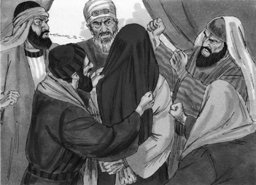
Luke 22:63-65 The men who were guarding Jesus began mocking and beating him. They blindfolded him and demanded, “Prophesy! Who hit you?” And they said many other insulting things to him.
Luke 22:66-69 At daybreak the council of the elders of the people, both the chief priests and teachers of the law, met together, and Jesus was led before them. “If you are the Christ,” they said, “tell us.” Jesus answered, “If I tell you, you will not believe me, and if I asked you, you would not answer. But from now on, the Son of Man will be seated at the right hand of the mighty God.”
Luke 22:70 They all asked, “Are you then the Son of God?” He replied, “You are right in saying I am.”
Luke 22:71 Then they said, “Why do we need any more testimony? We have heard it from his own lips.”
Luke 23:1-2 Then the whole assembly rose and led him off to Pilate. And they began to accuse him, saying, “We have found this man subverting our nation. He opposes payment of taxes to Caesar and claims to be Christ, a king.”
Picture 47–2
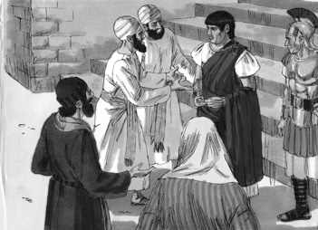
Luke 23:3 So Pilate asked Jesus, “Are you the king of the Jews?” “Yes, it is as you say,” Jesus replied.
Luke 23:4 Then Pilate announced to the chief priests and the crowd, “I find no basis for a charge against this man.”
Luke 23:5 But they insisted, “He stirs up the people all over Judea by his teaching. He started in Galilee and has come all the way here.”
Luke 23:6-7 On hearing this, Pilate asked if the man was a Galilean. When he learned that Jesus was under Herod’s jurisdiction, he sent him to Herod, who was also in Jerusalem at that time.
Luke 23:8-12 When Herod saw Jesus, he was greatly pleased, because for a long time he had been wanting to see him. From what he had heard about him, he hoped to see him perform some miracle. He plied him with many questions, but Jesus gave him no answer. The chief priests and the teachers of the law were standing there, vehemently accusing him. Then Herod and his soldiers ridiculed and mocked him. Dressing him in an elegant robe, they sent him back to Pilate. That day Herod and Pilate became friends — before this they had been enemies.
Picture 47–3
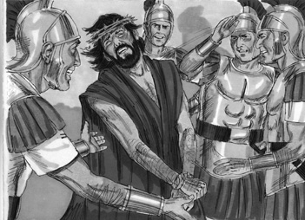
Luke 23:13-16 Pilate called together the chief priests, the rulers and the people, and said to them, “You brought me this man as one who was inciting the people to rebellion. I have examined him in your presence and have found no basis for your charges against him. Neither has Herod, for he sent him back to us; as you can see, he has done nothing to deserve death. Therefore, I will punish him and then release him.”
47–4
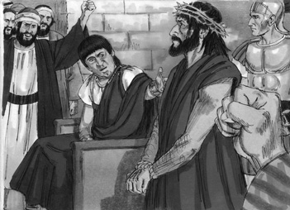
Luke 23:18-19 With one voice they cried out, “Away with this man! Release Barabbas to us!” (Barabbas had been thrown into prison for an insurrection in the city, and for murder.)
Luke 23:20-21 Wanting to release Jesus, Pilate appealed to them again. But they kept shouting, “Crucify him! Crucify him!”
Luke 23:22 For the third time he spoke to them: “Why? What crime has this man committed? I have found in him no grounds for the death penalty. Therefore I will have him punished and then release him.”
Luke 23:23-25 But with loud shouts they insistently demanded that he be crucified, and their shouts prevailed. So Pilate decided to grant their demand. He released the man who had been thrown into prison for insurrection and murder, the one they asked for, and surrendered Jesus to their will.
Application
To accusations, we need to respond calmly. We may be accused of things we never did. As followers of Jesus, we need to respond the way Jesus did. Remember, we always need to respond calmly to accusations.
Jesus was wrongly judged, but he did not fight.
Homework
This week, if you are being accused of something you did not do, respond calmly.
Prayer / Song
Review Game
Team Hot Potato
Materials
- Ball (Make a ball by tying wrappen (plastic bag) into knots many times, or fill an old sock with scrap material.)
- A drum, shaker, or anything to make music with.
How to Play
- Divide the class into 2 teams. Pick 3 volunteers from each team.
- The 6 children will stand in a circle at the front of the room.
- The children will pass the ball from person to person in the circle as quickly as possible.
- Have a drummer not face the children and drum for a short time.
- When the drummer stops, the student holding the ball answers a question. If the answer is correct, that team gets a point.
- The drummer then starts to play again and the game continues.
- After playing 2 or 3 times, you can change the children in the circle. Have the chidren at the front sit down. Then, pick 3 different voluteers from each team.
- Continue playing the game.
- Record the points. The team with the most points wins.
- Be sure to clap for both sides. No name-calling. Encourage good sportsmanship.
Questions for Review Game
- Where was Jesus arrested? (Gethsemane)
- After Jesus was beaten by the guards, who was he first taken to? (The leading priests and teachers of the religious law)
- What did Jesus say when the leading priests and the teachers of the religious law asked him if he was really the Messiah? (Jesus said that if he told them, they would not believe him. He then said that soon he would be sitting at God's right hand.)
- The high priests and religious leaders were so upset about his answer, they sent him to a second person. Whom did they send Jesus to? (Pilate)
- When the people took Jesus over to Pilate, they were saying that he was leading the people to ruin by telling them not to pay their taxes to the Roman Government and by claiming that he was what? (The Messiah, a king)
- When Pilate asked Jesus if he was the King of the Jews, what did Jesus say? (“Yes, it is as you say.”)
- What did Pilate decide after he found this out? (There was nothing wrong with Jesus, he was innocent.)
- To whom did Pilate send Jesus? (Herod)
- When Herod received Jesus, what did he and the soldiers do to Jesus? (They put a royal robe on him and sent him back to Pilate.)
- What happened between Pilate and Herod that day? (Pilate and Herod became friends.)
- What was the name of the prisoner that the people wanted to exchange Jesus for, so that he could be persecuted? (Barabbas)
- As the people grew louder and louder, what did Pilate decide to do with Jesus? (Sentence Jesus to death)
Song
Memory Verse
Materials and Preparations
- Put a bookmark in Luke 23:9-10
- Write memory verse on the blackboard.
Luke 23:9-10 So Herod questioned him at considerable length; Jesus gave him no answer.The chief priests and the experts in the law were there, vehemently accusing him.
Teach and Explain
Our memory verse is in the Gospel of Luke. That is in the New Testament, a part of the Bible.
- Read the verse from your Bible.
- Read the verse by yourself as you point to the words.
- Read the verse with the children as you point to the words.
- Explain the verse:
- Our memory verse comes from today’s Bible story.
- As you read the verse, circle the words shown below. Explain each of these words.
- Plied: Means to do something over and over. Herod asked Jesus many questions over and over again, trying to get Jesus to answer him.
- Vehemently accusing: The chief priests and the teachers of the law were accusing Jesus with a lot of emotion. They did not like Jesus, and they were giving him a hard time.
- Read the verse again by yourself as you point to the words.
- Read the verse again with the children as you point to the words.
Jesus never got angry or upset with those who were accusing him, and who were mean to him. We need to have that same mindset when we are accused of things we did not do, or when people say mean things to us. We need to remember to act how Jesus did, and not fight with those who wrongly accuse us, or who are mean.
Remember our truth for the day? Let’s all say it together:
Jesus was wrongly judged, but he did not fight.
Memory Verse Review
Children Repeat the Verse by Playing “Rhythm”
- Using hands and feet, have the teacher create a rhythm for the children to follow.
- Say the memory verse while following the rhythm.
- The child who answers questions correctly, gets to come up to the front of the class and lead.
Questions for Memory Verse
- Where in the Bible is today's memory verse found? ( Luke 23:9-10 )
- In this verse, who asked Jesus many questions? (Herod)
- What did Jesus do when Herod asked these questions? (Jesus gave no answer.)
- What were the chief priests and teachers of the law doing? (They were accusing Jesus.)
- What is the truth for today? ( Jesus was wrongly judged, but he did not fight. )
Song
Closing and Homework
- Say the truth together:
Jesus was wrongly judged, but he did not fight.
- Say the memory verse together:
Luke 23:9-10 So Herod questioned him at considerable length; Jesus gave him no answer.The chief priests and the experts in the law were there, vehemently accusing him.
- Review the homework:
This week, if you are being accused of something you did not do, respond calmly.
- Give any needed announcements.
Closing Prayer
Thank God that we can go to God when others accuse us of something we did not do. We can ask for His help to react calmly.
Ask God that the children will remember to respond calmly to any accusations.
Colouring page to colour and take home!

Jesus was wrongly judged, but he did not fight.

Luke 23:9-10 So Herod questioned him at considerable length; Jesus gave him no answer.The chief priests and the experts in the law were there, vehemently accusing him.
Jesus was wrongly judged, but he did not fight.

Luke 23:9-10 So Herod questioned him at considerable length; Jesus gave him no answer.The chief priests and the experts in the law were there, vehemently accusing him.

- The Crucifixion
The Crucifixion
Luke 23:24–27 Luke 23:32–49
Lesson Overview
Today’s Truth | Jesus suffered and died for us.
Objective | KNOW: The children will know that Jesus went through pain and suffering for us.  DO: The children will thank Jesus for what he has done for us.
Materials | - Quarter 4 Picture book, Bible, chalk  - Copies of the memory verse coloring page for the children to take home.  - Bottle cap or some other small object to hide
Memory Verse | Luke 23:46-47 Jesus called out with a loud voice, “Father, into your hands I commit my spirit.” When he had said this, he breathed his last. The centurion, seeing what had happened, praised God and said, “Surely this was a righteous man.”
Homework | Thank Jesus for what he has done.

Detailed Lesson Plan
Song
Opening
Welcome
- Be sure the children know you are happy to see them!
- Introduce yourself and your helpers.
Sharing Time
- Say the truth from the previous lesson together:
Jesus was wrongly judged, but he did not fight.
- Say the memory verse from the previous lesson together:
Luke 23:9-10 So Herod questioned him at considerable length; Jesus gave him no answer. The chief priests and the experts in the law were there, vehemently accusing him.
- Review the homework from the previous lesson:
For the homework you were to respond calmly when being accused of something you did not do. Did you do this?
(Give children time to share.)
Prayer
- Let the children share praises and prayer requests.
- Keep a record of what the children are sharing so you can remember to thank God together for answered prayers.
- Spend time praying together. Let children pray out loud if they volunteer. Do not force anyone to pray out loud.
Song
Words to Discuss
- On the blackboard, write the “Words to Discuss” from the list below.
- Let's discuss some words to help us better understand the Bible story for today.
- Cross: Two large pieces of wood that “cross” over one another. It was an instrument used for crucifixions.
- Crucify: To put someone to death by tying their hands and feet, and nailing them to a cross.
- Casting Lots: A game of chance that is played by using stones or sticks.
- Centurion: Commander of the Roman Army.
Song
Bible Story / Lesson
Today we will be learning that Jesus suffered and died for us.
Introduce Truth
Our truth for today is: Jesus suffered and died for us.
This reminds me of a true story from the Bible.
Bible Story: Luke 23:24–27 Luke 23:32–49
Luke 23:24-25 So Pilate decided to grant their demand. He released the man who had been thrown into prison for insurrection and murder, the one they asked for, and surrendered Jesus to their will.
Picture 48–1
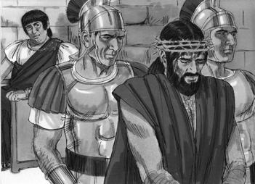
Luke 23:26-27 As they led him away, they seized Simon from Cyrene, who was on his way in from the country, and put the cross on him and made him carry it behind Jesus. A large number of people followed him, including women who mourned and wailed for him.
Luke 23:32-34 Two other men, both criminals, were also led out with him to be executed. When they came to the place called the Skull, there they crucified him, along with the criminals — one on his right, the other on his left. Jesus said, “Father, forgive them, for they do not know what they are doing.” And they divided up his clothes by casting lots.
Picture 48–2
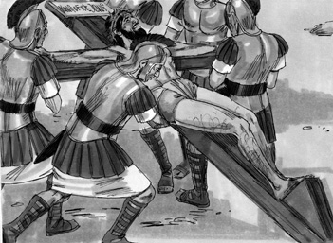
Luke 23:35 The people stood watching, and the rulers even sneered at him. They said, “He saved others; let him save himself if he is the Christ of God, the Chosen One.”
Luke 23:36-37 The soldiers also came up and mocked him. They offered him wine vinegar and said, “If you are the king of the Jews, save yourself.”
Luke 23:38 There was a written notice above him, which read: THIS IS THE KING OF THE JEWS.
Luke 23:39 One of the criminals who hung there hurled insults at him: “Aren’t you the Christ? Save yourself and us!”
Luke 23:40-41 But the other criminal rebuked him. “Don’t you fear God,” he said, “since you are under the same sentence? We are punished justly, for we are getting what our deeds deserve. But this man has done nothing wrong.”
Luke 23:42 Then he said, “Jesus, remember me when you come into your kingdom.”
Luke 23:43 Jesus answered him, “I tell you the truth, today you will be with me in paradise.”
Luke 23:44-46 It was now about the sixth hour, and darkness came over the whole land until the ninth hour, for the sun stopped shining. And the curtain of the temple was torn in two. Jesus called out with a loud voice, “Father, into your hands I commit my spirit.” When he had said this, he breathed his last.
Picture 48–3
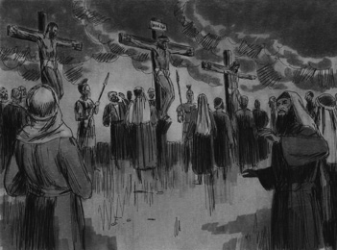
Luke 23:47 The centurion, seeing what had happened, praised God and said, “Surely this was a righteous man.”
Luke 23:48-49 When all the people who had gathered to witness this sight saw what took place, they beat their breasts and went away. But all those who knew him, including the women who had followed him from Galilee, stood at a distance, watching these things.
Picture 48–4
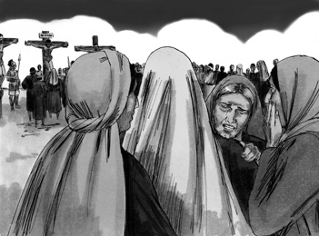

Application
Why did this have to happen? Because of his love for us, Jesus accepted to suffer and die for us. Jesus took the punishment for our sins. Because of that, we are set free from our sins. We need to thank him for what he did for us.
Jesus suffered and died for us.
Homework
This week: Thank Jesus for what he has done.
Prayer / Song
Review Game
Hide the Bottle Cap
Materials
- Bottle cap or some other small object to hide
How to Play
- Divide the class into 2 teams.
- One child from each team is selected and leaves the room.
- The teacher or a child will hide the bottle cap. A part of the object must be seen.
- The two children return. They will then start searching for the object.
- The teams shout “hot” when someone is close to the object and “cold” when they are far away.
- The child who finds the object first, answers a review question, and wins points.
- The team with the most points wins the game.
- Be sure to clap for both sides. No name-calling. Encourage good sportsmanship.
Questions for Review Game
- To allow Jesus to be crucified, what did Pilate do? (Released a prisoner convicted of murder)
- As Jesus was walking to be crucified, who carried Jesus' cross behind him? (Simon from Cyrene)
- How many other criminals were led behind Jesus, who also were walking to be crucified? (Two)
- What was the name of the place where Jesus was crucified? (Skull Hill)
- What did Jesus say as the men below were sneering at him? (“Father, forgive them, for they do not know what they are doing.”)
- As the soldiers were offering Jesus wine and vinegar, what did they say to him? (“If you are the king of the Jews, save yourself.”)
- What was the sign hanging above Jesus as he was on the cross? (THIS IS THE KING OF THE JEWS)
- Did both of the criminals hanging next to Jesus mock him? (No, one of the criminals insulted Jesus, while the other one claimed Jesus was the King.)
- What did Jesus say to the criminal who supported him? (He would go to heaven.)
- What happened from the sixth to the ninth hour? (The sun stopped shining, and the curtain of the temple was torn into two.)
- What did Jesus say before he died? (“Father, into your hands I commit my spirit.”)
- What did the centurion say after Jesus had passed away? (“Surely this was a righteous man.”)
Song
Memory Verse
Materials and Preparations
- Put a bookmark in Luke 23:46-47
- Write memory verse on the blackboard.
Luke 23:46-47 Jesus called out with a loud voice, “Father, into your hands I commit my spirit.” When he had said this, he breathed his last. The centurion, seeing what had happened, praised God and said, “Surely this was a righteous man.”
Teach and Explain
Our memory verse is in the Gospel of Luke. That is in the New Testament, a part of the Bible.
- Read the verse from your Bible.
- Read the verse by yourself as you point to the words.
- Read the verse with the children as you point to the words.
- Explain the verse:
- Our memory verse comes from today’s Bible story.
- As you read the verse, circle the words shown below. Explain each of these words.
- Commit: Jesus is giving his spirit to God. He is hanging on the cross, ready to die.
- Centurion: Seeing everything that had happened, the centurion praised God and he knew that Jesus was who he said he was, which was a righteous man.
- Righteous man: Jesus was a righteous man, meaning that he followed God's commands. He was a sinless man, who was true to what he taught.
- Read the verse again by yourself as you point to the words.
- Read the verse again with the children as you point to the words.
Remember our truth for the day? Let’s all say it together:
Jesus suffered and died for us.
Memory Verse Review
Children Repeat the Verse by Playing “Rhythm”
- Using hands and feet, have the teacher create a rhythm for the children to follow.
- Say the memory verse while following the rhythm.
- The child who answers questions correctly, gets to come up to the front of the class and lead.
Questions for Memory Verse
- Where in the Bible is today's memory verse found? ( Luke 23:46-47 )
- What was the last thing Jesus said before he died? (“Father into your hands I commit my spirit.”)
- What did the centurion do? (He praised God.)
- Who did the centurion call a righteous man? (Jesus)
- What is the truth for today? ( Jesus suffered and died for us. )
Song
Closing and Homework
- Say the truth together:
Jesus suffered and died for us.
- Say the memory verse together:
Luke 23:46-47 Jesus called out with a loud voice, “Father, into your hands I commit my spirit.” When he had said this, he breathed his last. The centurion, seeing what had happened, praised God and said, “Surely this was a righteous man.”
- Review the homework:
Remember to thank Jesus for what he has done.
- Give any needed announcements.
Closing Prayer
Thank God that He sent His one and only son to die for us.
Ask God that the children will remember to thank Jesus for what he did for us.
Colouring page to colour and take home!

Jesus suffered and died for us.

Luke 23:46-47 Jesus called out with a loud voice, “Father, into your hands I commit my spirit.” When he had said this, he breathed his last. The centurion, seeing what had happened, praised God and said, “Surely this was a righteous man.”
Jesus suffered and died for us.

Luke 23:46-47 Jesus called out with a loud voice, “Father, into your hands I commit my spirit.” When he had said this, he breathed his last. The centurion, seeing what had happened, praised God and said, “Surely this was a righteous man.”

- Jesus Lives Again!
Jesus Lives Again!
Luke 23:50–24:12
Lesson Overview
Today’s Truth | All of Jesus' words are true.
Objective | KNOW: The children will know that all of Jesus' words are true, and we are to believe them all.  DO: The children will believe and listen to all of Jesus' words. They will trust that God will take care of them in the future.
Materials | - Quarter 4 Picture book, Bible, chalk  - Copies of the memory verse coloring page for the children to take home.  - Six tall containers (Water containers, anything that can fall over)  - Sand, dirt, small rocks, or water (Anything that can fill just the bottom of the tall containers)  - A guava, or a round heavy object that can be rolled
Memory Verse | Luke 24:6-7 He is not here; he has risen! Remember how he told you, while he was still with you in Galilee: “The Son of Man must be delivered into the hands of sinful men, be crucified and on the third day be raised again.”
Homework | Believe Jesus' words. Trust that God will take care of you in the future.  Super homework: Find a promise in the Bible and bring it back next week to share.

Detailed Lesson Plan
Song
Opening
Welcome
- Be sure the children know you are happy to see them!
- Introduce yourself and your helpers.
Sharing Time
- Say the truth from the previous lesson together:
Jesus suffered and died for us.
- Say the memory verse from the previous lesson together:
Luke 23:46-47 Jesus called out with a loud voice, “Father, into your hands I commit my spirit.” When he had said this, he breathed his last. The centurion, seeing what had happened, praised God and said, “Surely this was a righteous man.”
- Review the homework from the previous lesson:
You were to thank Jesus for doing what he did for us. Did you do that?
(Give children time to share.)
Prayer
- Let the children share praises and prayer requests.
- Keep a record of what the children are sharing so you can remember to thank God together for answered prayers.
- Spend time praying together. Let children pray out loud if they volunteer. Do not force anyone to pray out loud.
Song
Words to Discuss
- On the blackboard, write the “Words to Discuss” from the list below.
- Let's discuss some words to help us better understand the Bible story for today.
- Tomb: A place that is used to store the dead.
- Preparation Day: The day before the Sabbath.
- Sabbath: A Jewish Holiday where they do not do any work.
- Crucify: To put someone to death by tying their hands and feet, and nailing them to a cross.
- The Eleven: Because Judas left the disciples, they are now only eleven.
Song
Bible Story / Lesson
Object Lesson: “Whisper down the line”
- Arrange the children in a line.
- Choose a phrase that is not common.
- Whisper the phrase into the child at the end of each line.
- The child then whispers the message they heard to the child sitting next to them.
- They can only whisper it one time.
- The children continue to whisper it to their neighbour until it reaches to the end of the line. The child at the end of the row should stand up and when the teacher calls on them, they share what they heard to the entire class.
- Did the message change at all?
(Allow the children to respond.)
- Even though some of these messages have changed, Jesus' words to us never change.
- Today we will be learning that all of Jesus' words are true.
Introduce Truth
Our truth for today is: All of Jesus' words are true.
This reminds me of a true story from the Bible.
Bible Story: Luke 23:50–24:12
[ Thus Jesus died, nailed to a cross between two robbers. ]
Luke 23:50-54 Now there was a man named Joseph, a member of the Council, a good and upright man, who had not consented to their decision and action. He came from the Judean town of Arimathea and he was waiting for the kingdom of God. Going to Pilate, he asked for Jesus’ body. Then he took it down, wrapped it in linen cloth and placed it in a tomb cut in the rock, one in which no one had yet been laid. It was Preparation Day, and the Sabbath was about to begin.
Picture 49–1
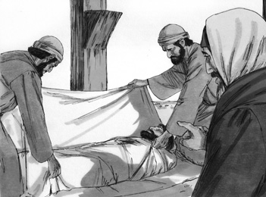
Luke 23:55-56 The women who had come with Jesus from Galilee followed Joseph and saw the tomb and how his body was laid in it. Then they went home and prepared spices and perfumes. But they rested on the Sabbath in obedience to the commandment.
Luke 24:1-8 On the first day of the week, very early in the morning, the women took the spices they had prepared and went to the tomb. They found the stone rolled away from the tomb, but when they entered, they did not find the body of the Lord Jesus. While they were wondering about this, suddenly two men in clothes that gleamed like lightning stood beside them. In their fright the women bowed down with their faces to the ground, but the men said to them, “Why do you look for the living among the dead? He is not here; he has risen! Remember how he told you, while he was still with you in Galilee: ‘The Son of Man must be delivered into the hands of sinful men, be crucified and on the third day be raised again.’” Then they remembered his words.
Picture 49–2
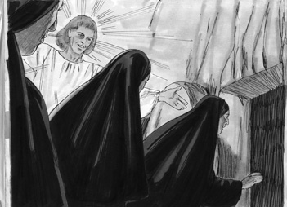
Luke 24:9-11 When they came back from the tomb, they told all these things to the Eleven and to all the others. It was Mary Magdalene, Joanna, Mary the mother of James, and the others with them who told this to the apostles. But they did not believe the women, because their words seemed to them like nonsense.
Picture 49–3
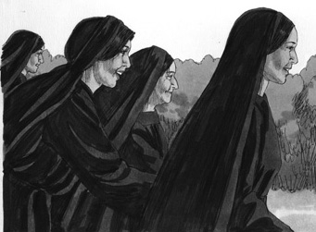

Luke 24:12 Peter, however, got up and ran to the tomb. Bending over, he saw the strips of linen lying by themselves, and he went away, wondering to himself what had happened.
Picture 49-4
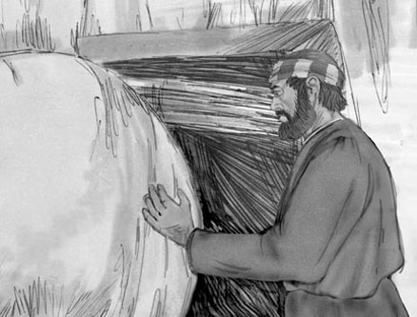

Application
Jesus proved that his words are true. Who can predict their own death and resurrection, and then actually rise from the dead? No one has ever done what Jesus did! By doing this, Jesus proved that everything he had done and said was true. Therefore, we can trust his words and we should obey his commands.
All of Jesus' words are true.
Homework
This week: Believe Jesus' words. Trust that God will take care of you in the future.
Super homework: Find a promise in the Bible and bring it back next week to share.
Prayer / Song
Review Game
Bowling with Bottles and Green Guavas

Materials
- Six tall containers (Water containers, anything that can fall over)
- Sand, dirt, small rocks, or water (Anything that can fill just the bottom of the tall containers)
- A guava, or a round heavy object that can be rolled
- Draw a line on the floor for the children to stand behind.
How to Play
- Set up tall containers to look like a flat triangle. (See picture.)
- Fill the bottles 1/4 to 1/2 with sand, dirt, small rocks, or water to add weight.
- Divide the class into 2 teams.
- The first team tries to answer the first question. The teacher can use this time to explain what the children don’t seem to understand.
- The student on that team that answers the question correctly comes to the front and stands behind the line. If the child only gets part of the question right, the teacher can fill in the rest. That child can also ask for help from another child on his/her team. Help the child to have success.
- The student then rolls the guava on the ground to try to knock over all six containers.
- However many containers that are knocked over is how many points that team gets (1-6 points.)
- Record the points. The team with the most points wins.
- Be sure to clap for both sides. No name-calling. Encourage good sportsmanship.
- Be sure to put the containers back in the flat triangle position after every student rolls the guava.
Questions for Review Game
- What was the name of the man from Arimathea who was a good and upright man? (Joseph)
- When Joseph went to Pilate, what did he ask him for? (Jesus' body)
- What did Joseph do to Jesus' body? (He wrapped it in linen and placed it in a tomb cut in the rock.)
- After the Sabbath two women went to the tomb, what happened? (They found the stone rolled away, and they did not find Jesus' body.)
- While the women were wondering what happened to Jesus, who appeared to them? (Two men in clothes that gleamed like lightning)
- When the women saw these two men, what did they do? (They bowed down with their faces to the ground.)
- What did the men say to the women? (“Why do you look for the living among the dead? He is not here; he has risen!”)
- What did the women do after they left the empty tomb? (They ran to the now eleven disciples, and shared with them the good news.)
- Did they believe the women? (No, they all thought their words were nonsense.)
- Who ended up running to the tomb after hearing the news? (Peter)
- What did he do there? (Peter walked around the tomb, looking at everything, wondering to himself what had happened.)
- What is the truth for today? ( All of Jesus' words are true. )
Song
Memory Verse
Materials and Preparations
- Put a bookmark in Luke 24:6-7
- Write memory verse on the blackboard.
Luke 24:6-7 He is not here; he has risen! Remember how he told you, while he was still with you in Galilee: “The Son of Man must be delivered into the hands of sinful men, be crucified and on the third day be raised again.”
Teach and Explain
Can you imagine going to visit the grave where one of your family members, or friends is burried and finding it empty!?! How would you react to that?
- Read the verse from your Bible.
- Read the verse by yourself as you point to the words.
- Read the verse with the children as you point to the words.
- Explain the verse:
- Our memory verse comes from today’s Bible story.
- As you read the verse, circle the words shown below. Explain each of these words.
- Son of Man: When we hear people say, “Son of Man” they are talking about Jesus. He is the Son of Man. Because of his death, we are saved.
- Delivered: The Son of Man must be “delivered” into the hands of sinful men, meaning that Jesus must be crucified so that sinful men can be free.
- Raised again: Jesus will rise from the dead on the third day.
- Read the verse again by yourself as you point to the words.
- Read the verse again with the children as you point to the words.
Remember our truth for the day? Let’s all say it together:
All of Jesus' words are true.
Memory Verse Review
Children Repeat the Verse by Playing “Rhythm”
- Using hands and feet, have the teacher create a rhythm for the children to follow.
- Say the memory verse while following the rhythm.
- The child who answers questions correctly, gets to come up to the front of the class and lead.
Questions for Memory Verse
- Where in the Bible is today's memory verse found? ( Luke 24:6-7 )
- Who is speaking the words of these verses? (The men in bright clothes at Jesus' tomb)
- Who are the men speaking these words to? (The women who went to Jesus' tomb)
- Who are they talking about when they say the “Son of Man”? (Jesus)
- Why is Jesus' body not there in the tomb? (Because He is risen! He is alive!)
Song
Closing and Homework
- Say the truth together:
All of Jesus' words are true.
- Say the memory verse together:
Luke 24:6-7 He is not here; he has risen! Remember how he told you, while he was still with you in Galilee: “The Son of Man must be delivered into the hands of sinful men, be crucified and on the third day be raised again.”
- Review the homework:
Believe Jesus' words. Trust that God will take care of you in the future.
- Super homework:
Find a promise in the Bible and bring it back next week to share.
- Give any needed announcements.
Closing Prayer
Thank God that He is alive and that all of Jesus' words are true.
Ask God to help the children believe Jesus' words, and trust Him to take care of them.
Colouring page to colour and take home!
All of Jesus' words are true.

Luke 24:6-7 He is not here; he has risen! Remember how he told you, while he was still with you in Galilee: “The Son of Man must be delivered into the hands of sinful men, be crucified and on the third day be raised again.”
All of Jesus' words are true.

Luke 24:6-7 He is not here; he has risen! Remember how he told you, while he was still with you in Galilee: “The Son of Man must be delivered into the hands of sinful men, be crucified and on the third day be raised again.”

- On the Road to Emmaus
On the Road to Emmaus
Luke 24:10–35
Lesson Overview
Today’s Truth | Jesus helps us know the truth.
Objective | KNOW: The children will know that Jesus walks and talks with us.  DO: The children will pray and ask God to help them with their fears and doubts that they may have.
Materials | - Quarter 4 Picture book, Bible, chalk  - Copies of the memory verse coloring page for the children to take home.  - A list of different animals that children could act out (giraffe, elephant, dog, cat, bird, etc.)
Memory Verse | Luke 24:27 And beginning with Moses and all the Prophets, he explained to them what was said in all the Scriptures concerning himself.
Homework | This week, if you have any fears or doubts, pray and ask God to help you know the truth that he can overcome them.

Detailed Lesson Plan
Song
Opening
Welcome
- Be sure the children know you are happy to see them!
- Introduce yourself and your helpers.
Sharing Time
- Say the truth from the previous lesson together:
All of Jesus' words are true.
- Say the memory verse from the previous lesson together:
Luke 24:6-7 He is not here; he has risen! Remember how he told you, while he was still with you in Galilee: “The Son of Man must be delivered into the hands of sinful men, be crucified and on the third day be raised again.”
- Review the homework from the previous lesson:
You were to believe Jesus' words. Did you trust that God would take care of your future? Did you do the super homework? What promise did you find in the Bible?
(Give children time to share.)
Prayer
- Let the children share praises and prayer requests.
- Keep a record of what the children are sharing so you can remember to thank God together for answered prayers.
- Spend time praying together. Let children pray out loud if they volunteer. Do not force anyone to pray out loud.
Song
Words to Discuss
- On the blackboard, write the “Words to Discuss” from the list below.
- Let's discuss some words to help us better understand the Bible story for today.
- Prophet: A man or woman God uses as His messenger.
- Angels: Spiritual beings created by God to serve and worship Him. Often used by God as His messengers.
- Redeem: To pay a debt and set free.
Song
Bible Story / Lesson
Today we will be learning that Jesus helps us know the truth.
Introduce Truth
Our truth for today is: Jesus helps us know the truth.
This reminds me of a true story from the Bible.
Bible Story: Luke 24:10–35
Luke 24:10-11 It was Mary Magdalene, Joanna, Mary the mother of James, and the others with them who told this to the apostles. But they did not believe the women, because their words seemed to them like nonsense.
Luke 24:13-16 Now that same day two of them were going to a village called Emmaus, about seven miles from Jerusalem. They were talking with each other about everything that had happened. As they talked and discussed these things with each other, Jesus himself came up and walked along with them; but they were kept from recognizing him.
Picture 50–1
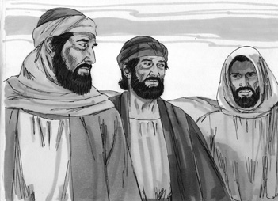

Luke 24:17-18 He asked them, “What are you discussing together as you walk along?” They stood still, their faces downcast. One of them, named Cleopas, asked him, “Are you only a visitor to Jerusalem and do not know the things that have happened there in these days?”
Picture 50-2
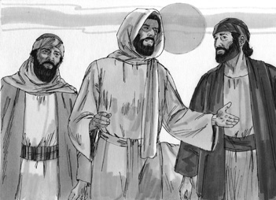
Luke 24:19-24 “What things?” he asked. “About Jesus of Nazareth,” they replied. “He was a prophet, powerful in word and deed before God and all the people. The chief priests and our rulers handed him over to be sentenced to death, and they crucified him; but we had hoped that he was the one who was going to redeem Israel. And what is more, it is the third day since all this took place. In addition, some of our women amazed us. They went to the tomb early this morning but didn’t find his body. They came and told us that they had seen a vision of angels, who said he was alive. Then some of our companions went to the tomb and found it just as the women had said, but him they did not see.”
Luke 24:25-27 He said to them, “How foolish you are, and how slow of heart to believe all that the prophets have spoken! Did not the Christ have to suffer these things and then enter his glory?” And beginning with Moses and all the Prophets, he explained to them what was said in all the Scriptures concerning himself.
Luke 24:28-29 As they approached the village to which they were going, Jesus acted as if he were going farther. But they urged him strongly, “Stay with us, for it is nearly evening; the day is almost over.” So he went in to stay with them.
Luke 24:30-32 When he was at the table with them, he took bread, gave thanks, broke it and began to give it to them. Then their eyes were opened and they recognized him, and he disappeared from their sight. They asked each other, “Were not our hearts burning within us while he talked with us on the road and opened the Scriptures to us?”
Picture 50–3
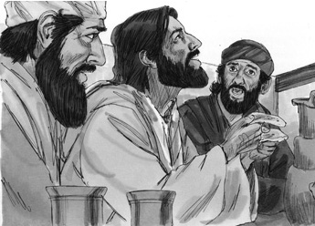
Luke 24:33-35 They got up and returned at once to Jerusalem. There they found the Eleven and those with them, assembled together and saying, “It is true! The Lord has risen and has appeared to Simon.” Then the two told what had happened on the way, and how Jesus was recognized by them when he broke the bread.
Application
Just as Jesus demonstrated with the two friends on the road to Emmaus, Jesus also walks with us and talks with us today. He helps us to know the truth as we read the Bible and pray. He promises to be with us always and he will help us when we have fears or doubts. We can share these fears and doubts with Jesus and ask him to help us overcome them. We can ask him to help us know and remember the truth that he is here with us.
Jesus helps us know the truth.
Homework
This week, if you have any fears or doubts, pray and ask God to help you know the truth that he can overcome them.
Prayer / Song
Review Game
Animal Drama
Materials
- A list of different animals that children could act out (giraffe, elephant, dog, cat, bird, etc.)
How to Play
- Divide the class into 2 teams.
- The first team tries to answer the first question. The teacher can use this time to explain what the children do not seem to understand.
- The child on the team that answers the question correctly comes to the front.
- The teacher whispers what animal they should act out. The child then acts/behaves like that animal.
- The child's team has three times to guess what the animal is. If they are correct, they get points. If they are wrong, the other team gets one chance to try to guess.
- Be sure to clap for both sides. No name-calling. Encourage good sportsmanship.
Questions for Review Game
- What was the name of the road that the two followers of Jesus were walking on? (The road to Emmaus)
- As the two men were walking, who appeared to them? (Jesus)
- Who did these two men think they had met as they were walking? (Some stranger they did not know, and they certainly did not recognize him as Jesus.)
- What did Jesus ask the men? (“What are you talking about?”)
- What did the men say after Jesus asked what they were talking about? (“Do you not know what has happened in Jerusalem these past days?” Then they told him about the death of Jesus.)
- Did these two men believe Jesus had risen from the dead? (No.)
- What did Jesus say to them? (“Foolish men, why are you so slow to believe all that the prophets have spoken? Wasn't it necessary that the Christ suffer these things and enter into his glory?”)
- When they came to Emmaus, what did the men ask Jesus to do? (Stay with them)
- While the men were eating, what happened? (They recognized Jesus.)
- As they recognized Jesus, what did the disciples say? (“The Lord really has risen!”)
Song
Memory Verse
Materials and Preparations
- Put a bookmark in Luke 24:27
- Write memory verse on the blackboard.
Luke 24:27 And beginning with Moses and all the Prophets, he explained to them what was said in all the Scriptures concerning himself.
Teach and Explain
Our memory verse is in the Gospel of Luke. That is in the New Testament, a part of the Bible.
- Read the verse from your Bible.
- Read the verse by yourself as you point to the words.
- Read the verse with the children as you point to the words.
- Explain the verse:
- Our memory verse comes from today’s Bible story.
- As you read the verse, circle the words shown below. Explain each of these words.
- Moses: Was an early leader of the Hebrews. He brought the Hebrew people out from Egypt. He also has talked with God. In this verse, Jesus opened up their minds so that they would understand the Scriptures from the beginning with Moses.
- Prophets: These were all the teachers who taught about the will of God. You will find them in the Old Testament and the New Testament.
- Scriptures: Jesus opened up their minds so that they would see that the death and resurrection of Jesus had been already known. In the Old Testament with Moses and all the other prophets, they all knew the coming of Jesus.
- Read the verse again by yourself as you point to the words.
- Read the verse again with the children as you point to the words.
The men did not believe that Jesus had raised from the dead. We can see that all through New and Old Testament, they all knew about the death and resurrection of Jesus. We can be sure that all of Jesus' words are true. He says what he will do, and it will happen. When we read Scripture, Jesus helps and has helped us understand the truth in the Bible.
Remember our truth for the day? Let’s all say it together:
Jesus helps us know the truth.
Memory Verse Review
Children Repeat the Verse by Playing “Rhythm”
- Using hands and feet, have the teacher create a rhythm for the children to follow.
- Say the memory verse while following the rhythm.
- The child who answers questions correctly, gets to come up to the front of the class and lead.
Questions for Memory Verse
- Where in the Bible is today's memory verse found? ( Luke 24:27 )
- In this verse, who is explaining the Scriptures about himself? (Jesus)
- Who is Jesus explaining these Scriptures to? (The men walking on the road to Emmaus)
- Why does Jesus need to explain these things to them? (They do not believe that Jesus is risen/alive.)
- What is the truth for today? ( Jesus helps us know the truth. )
Song
Closing and Homework
- Say the truth together:
Jesus helps us know the truth.
- Say the memory verse together:
Luke 24:27 And beginning with Moses and all the Prophets, he explained to them what was said in all the Scriptures concerning himself.
- Review the homework:
This week, if you have any fears or doubts, pray and ask God to help you know the truth that he can overcome them.
Closing Prayer
Thank God that He has risen from the dead!
Ask God that the children will remember to pray and ask God to them face any fears or doubts that they may have.
Colouring page to colour and take home!

Jesus helps us know the truth.

Luke 24:27 And beginning with Moses and all the Prophets, he explained to them what was said in all the Scriptures concerning himself.
Jesus helps us know the truth.

Luke 24:27 And beginning with Moses and all the Prophets, he explained to them what was said in all the Scriptures concerning himself.

- Jesus Appears to Believers and Returns to Heaven
Jesus Appears to Believers and Returns to Heaven
Luke 24:35–53
Lesson Overview
Today’s Truth | Jesus is truly alive!
Objective | KNOW: The children will know that Jesus has risen from the dead, and is truly alive!  DO: The children will tell a friend or family member that Jesus is alive, and that he is the only one to protect us, not traditional practices or spirits.
Materials | - Quarter 4 Picture book, Bible, chalk  - Copies of the memory verse coloring page for the children to take home.  - Bottle cap or some other small object to hide
Memory Verse | Luke 24:39 Look at my hands and my feet. It is I myself! Touch me and see; a ghost does not have flesh and bones, as you see I have.
Homework | The most important homework you can have is to be sure you believe and have asked to receive Jesus' gift of forgiveness and eternal life. Then, be sure to tell a friend, or family member that Jesus is alive and that he is the only one who can protect us - not traditional practices, or spirits, or ancestors.

Detailed Lesson Plan
Song
Opening
Welcome
- Be sure the children know you are happy to see them!
- Introduce yourself and your helpers.
Sharing Time
- Say the truth from the previous lesson together:
Jesus helps us know the truth.
- Say the memory verse from the previous lesson together:
Luke 24:27 And beginning with Moses and all the Prophets, he explained to them what was said in all the Scriptures concerning himself.
- Review the homework from the previous lesson:
For the homework you were to pray and ask God to help you overcome any doubts and fears. What did you pray and ask God to help you with?
(Give children time to share.)
Prayer
- Let the children share praises and prayer requests.
- Keep a record of what the children are sharing so you can remember to thank God together for answered prayers.
- Spend time praying together. Let children pray out loud if they volunteer. Do not force anyone to pray out loud.
Song
Words to Discuss
- On the blackboard, write the “Words to Discuss” from the list below.
- Let's discuss some words to help us better understand the Bible story for today.
- Ghost: A dead person who appears to be living.
- Law of Moses: Laws that God gave to Moses for the Israelites to follow.
- Psalms: A book in the Old Testament.
- Witnesses: People who see an event.
Song
Bible Story / Lesson
Today we will be learning that Jesus is truly alive!
Introduce Truth
Our truth for today is: Jesus is truly alive!
This reminds me of a true story from the Bible.
Bible Story: Luke 24:35–53
Luke 24:35 Then the two told what had happened on the way, and how Jesus was recognized by them when he broke the bread.
Picture 51–1
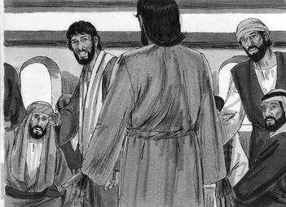
Luke 24:36 While they were still talking about this, Jesus himself stood among them and said to them, “Peace be with you.”
Luke 24:37-39 They were startled and frightened, thinking they saw a ghost. He said to them, “Why are you troubled, and why do doubts rise in your minds? Look at my hands and my feet. It is I myself! Touch me and see; a ghost does not have flesh and bones, as you see I have.”
Luke 24:40 When he had said this, he showed them his hands and feet.
Luke 24:41-43 And while they still did not believe it because of joy and amazement, he asked them, “Do you have anything here to eat?” They gave him a piece of broiled fish, and he took it and ate it in their presence.
Picture 51–2
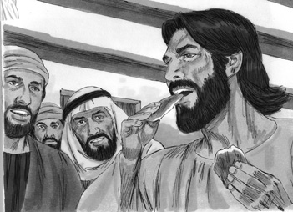
Luke 24:44 He said to them, “This is what I told you while I was still with you: Everything must be fulfilled that is written about me in the Law of Moses, the Prophets and the Psalms.”
Luke 24:45-49 Then he opened their minds so they could understand the Scriptures. He told them, “This is what is written: The Christ will suffer and rise from the dead on the third day, and repentance and forgiveness of sins will be preached in his name to all nations, beginning at Jerusalem. You are witnesses of these things. I am going to send you what my Father has promised; but stay in the city until you have been clothed with power from on high.”
Picture 51–3
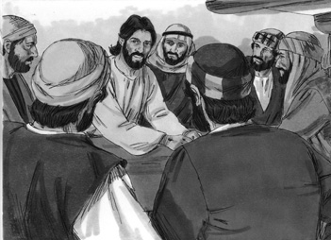
Luke 24:50-53 When he had led them out to the vicinity of Bethany, he lifted up his hands and blessed them. While he was blessing them, he left them and was taken up into heaven. Then they worshiped him and returned to Jerusalem with great joy. And they stayed continually at the temple, praising God.
Picture 51–4
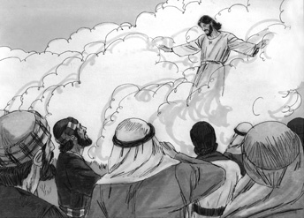

Application
Jesus rose from the dead. Many people are afraid to die. We know that there is life after death. The question is, “Where will we be after we die.” We will either be with God, or in hell separated from God . None of our living, or departed relatives can change that for us. It is a decision each of us must make while we are still alive: either we believe in Jesus and accept his gift forgiveness of our sin and eternal life with God, or we don't. When we believe in Jesus, we will be with him in heaven forever when we die! We can praise God knowing that Jesus is still alive today and we can have confidence where we will be, too! Jesus is in heaven waiting for us.
If we have relatives and friends who are not followers of Jesus, tell them the truth about Jesus and pray for them. Jesus is our one true hope.
Jesus is truly alive!
Homework
This week: The most important homework you can have is to be sure you believe and have asked to receive Jesus' gift of forgiveness and eternal life. Then, be sure to tell a friend, or family member that Jesus is alive and that he is the only one who can protect us - not traditional practices, or spirits, or ancestors.
Prayer / Song
Review Game
Hide the Bottle Cap
Materials
- Bottle cap or some other small object to hide
How to Play
- Divide the class into 2 teams.
- One child from each team is selected and leaves the room.
- The teacher or a child will hide the bottle cap. A part of the object must be seen.
- The two children return. They will then start searching for the object.
- The teams shout “hot” when someone is close to the object and “cold” when they are far away.
- The child who finds the object first, answers a review question, and wins points.
- The team with the most points wins the game.
- Be sure to clap for both sides. No name-calling. Encourage good sportsmanship.
Questions for Review Game
- As the two men were sharing to the group about seeing Jesus on the road, what happened? (Jesus suddenly appeared among them.)
- What did Jesus say to them? (“Peace be with you.”)
- How did everyone react when they saw Jesus? (They were terribly frightened.)
- What did they think Jesus was? (A ghost)
- To make the people believe that he was not a ghost, what did Jesus tell them to do? (Touch his hands and feet, to prove that he was human.)
- How did they respond to Jesus after he told them to touch him and see that it was truly him? (They were still doubting.)
- What did Jesus ask them for? (Something to eat)
- What happened as Jesus began to talk to the people? (He opened their minds to help them understand the Scriptures.)
- What did Jesus say is given to all who turn to him? (Jesus said, “There is forgiveness of sins for all who turn to me.”)
- What did Jesus give to the people and to all of us? (The Holy Spirit)
- What happened to Jesus after he led the people to Bethany? (He was taken up to heaven.)
- What is the truth for today? ( Jesus is truly alive! )
Song
Memory Verse
Materials and Preparations
- Put a bookmark in Luke 24:39
- Write memory verse on the blackboard.
Luke 24:39 Look at my hands and my feet. It is I myself! Touch me and see; a ghost does not have flesh and bones, as you see I have.
Teach and Explain
Our memory verse is in the Gospel of Luke. That is in the New Testament, a part of the Bible.
- Read the verse from your Bible.
- Read the verse by yourself as you point to the words.
- Read the verse with the children as you point to the words.
- Explain the verse:
- Our memory verse comes from today’s Bible story.
- As you read the verse, circle the words shown below. Explain each of these words.
- Ghost: The disciples were having a hard time believing that Jesus was human again. They thought he was a ghost. Jesus told his disciples to look at his hands and feet, they can see the marks from when he was crucified.
- Flesh and bones: Jesus was human, meaning that he had skin and bones. Again, the disciples did not believe that Jesus was human, but Jesus made sure to let the disciples know that he is like them, human.
- Read the verse again by yourself as you point to the words.
- Read the verse again with the children as you point to the words.
Jesus rose from the dead. Many people are afraid to die. We know that there is life after death. The question is, “Where will we be after we die.” We will either be with God, or in hell separated from God . None of our living, or departed relatives can change that for us. It is a decision each of us must make while we are still alive: either we believe in Jesus and accept his gift forgiveness of our sin and eternal life with God, or we don't. When we believe in Jesus, we will be with him in heaven forever when we die! We can praise God knowing that Jesus is still alive today and we can have confidence where we will be, too! Jesus is in heaven waiting for us.
Remember our truth for the day? Let’s all say it together:
Jesus is truly alive!
Memory Verse Review
Children Repeat the Verse by Playing “Rhythm”
- Using hands and feet, have the teacher create a rhythm for the children to follow.
- Say the memory verse while following the rhythm.
- The child who answers questions correctly, gets to come up to the front of the class and lead.
Questions for Memory Verse
- Where in the Bible is today's memory verse found? ( Luke 24:39 )
- Who is speaking the words of this verse? (Jesus)
- Who is Jesus speaking to? (The disciples)
- When the disciples look at Jesus' hands and feet, what will they see? (The marks that show Jesus was crucified)
- Why does Jesus want the disciples to touch him? (He wants them to know for sure that he is alive.)
Song
Closing and Homework
- Say the truth together:
Jesus is truly alive!
- Say the memory verse together:
Luke 24:39 Look at my hands and my feet. It is I myself! Touch me and see; a ghost does not have flesh and bones, as you see I have.
- Review the homework:
The most important homework you can have is to be sure you believe and have asked to receive Jesus' gift of forgiveness and eternal life. Then, be sure to tell a friend, or family member that Jesus is alive and that he is the only one who can protect us - not traditional practices, or spirits, or ancestors.
- Give any needed announcements.
Closing Prayer
Thank God that He is truly alive!
Ask God that the children will remember to tell someone that Jesus is alive!
Colouring page to colour and take home!

Jesus is truly alive!

Luke 24:39 Look at my hands and my feet. It is I myself! Touch me and see; a ghost does not have flesh and bones, as you see I have.
Jesus is truly alive!

Luke 24:39 Look at my hands and my feet. It is I myself! Touch me and see; a ghost does not have flesh and bones, as you see I have.

- Review Lesson
Review Lesson
Lessons 47-51
NOTE: It is important to review the lessons previously taught to help the children remember what they have learned. It is also important to make the review lessons exciting and fun! Turn the whole lesson into a game. If you have time, have the children act out their favourite stories while you read it from the “Picture Book”.
Materials
- Quarter 4 Picture book, Bible, chalk
- As this is the last lesson, it would be good to provide treats and have a party to celebrate one year of learning Luke.
- Bottle cap or some other small object to hide
Opening
Song
Welcome
- Be sure the children know you are happy to see them!
- Introduce yourself and your helpers.
Sharing Time
- Say the truth from the previous lesson together:
Jesus is truly alive!
- Say the memory verse from the previous lesson together:
Luke 24:39 Look at my hands and my feet. It is I myself! Touch me and see; a ghost does not have flesh and bones, as you see I have.
- Review the homework from the previous lesson:
Did you tell a friend or family member that Jesus is alive and that he is the only one that can protect us, not traditional practices or spirits?
(Give children time to share.)
Prayer
- Let the children share praises and prayer requests.
- Keep a record of what the children are sharing so you can remember to thank God together for answered prayers.
- Spend time praying together. Let children pray out loud if they volunteer. Do not force anyone to pray out loud.
Song
Today we are going to do another review lesson. We are going to review all the words, truths, stories and memory verses that we have had up to this point. We are going to start with a game right now!
Review Game
Hide the Bottle Cap
Materials
- Bottle cap or some other small object to hide
How to Play
- Divide the class into 2 teams.
- One child from each team is selected and leaves the room.
- The teacher or a child will hide the bottle cap. A part of the object must be seen.
- The two children return. They will then start searching for the object.
- The teams shout “hot” when someone is close to the object and “cold” when they are far away.
- The child who finds the object first, answers a review question, and wins points.
- The team with the most points wins the game.
- Be sure to clap for both sides. No name-calling. Encourage good sportsmanship.

NOTE: It is important to remember that this is a review. Teach the key points, but DO NOT teach the entire story again.
Lesson 47
Jesus's Trial
Remember that Jesus was arrested, beaten, mocked, and taken to trial in Lesson 47. The religious leaders asked him if he was the Messiah, and he told them it was true, that he is the Son of God. This angered them and they took him to the Roman Governor named Pilate. Pilate saw that Jesus had done nothing wrong, but the Jewish leaders were so angry, so Pilate sent him to another Roman ruler named Herod, but he also found nothing wrong, and sent him back to Pilate. Pilate told the crowd that Jesus would be beaten but set free, because he has not done anything to deserve the death penalty. There was a mighty roar from the crowd, and they demanded that Jesus should die. Pilate knew that Jesus had done nothing wrong, but the crowd kept yelling, “Kill him!” so Pilate finally agreed to let them kill him.
The truth of this lesson is: Jesus was wrongly judged, but he did not fight.
Questions for Review
- What did the religious leaders do with Jesus? (Took him to Pilate, the Roman Governor)
- How did Jesus act when he was accused? (He was calm.)
- What did Pilate decide about Jesus? (He hadn't done anything wrong.)
- As the people shouted louder and louder, what did Pilate decide to do with Jesus? (Pilate decided to sentence Jesus to death.)
- What is the truth from this lesson? ( Jesus was wrongly judged, but he did not fight. )
Lesson 48
The Crucifixion
Lesson 48 was a very sad story about the death of Jesus. Pilate chose to give in to the religious leaders and he gave Jesus to be crucified, which means death on a cross. They beat him and walked him up to Skull Hill with his cross. It was carried by a man named Simon. Two criminals were going to be killed also. They soldiers nailed Jesus to a cross, and Jesus said, “Father, forgive them, for they do not know what they are doing.” The soldiers and the people were mocking Jesus and put a sign above his head that said, “This is the King of the Jews”. One of the prisoners also insulted Jesus, bot the other prisoner asked Jesus for forgiveness. Jesus said that man would be in paradise with him. At the sixth hour, darkness came over the whole land until the ninth hour, and the curtain of the temple was torn in two. Jesus called out with a loud voice, “Father, into your hands I commit my spirit.” After he said this, he died. The crowd was happy, but the people who knew Jesus were sad. This story also makes us sad because we know that Jesus died for us, to forgive our sins.
The truth of this lesson is: Jesus suffered and died for us.
Questions for Review
- What kind of death did Jesus suffer? (Crucifixion – Death on a cross)
- Is crucifixion a quick and painless death? (No, it is long and painful.)
- What did Jesus say as the men below were sneering at him? (“Father, forgive them, for they do not know what they are doing.”)
- What happened from the sixth to the ninth hour? (The sun stopped shining, and the curtain of the temple was torn into two.)
- Why did Jesus go through all that pain? (For us, to forgive our sins)
- What is the truth from this lesson? ( Jesus suffered and died for us. )
Lesson 49
Jesus Lives Again!
In Lesson 49, we learned that after Jesus died a man named Joseph took Jesus' body, wrapped it in cloth, and placed it in a tomb. There were women who came from Galilee with Jesus, and they prepared perfumes and spices, and went on the third day to the tomb. When they arrived the stone was rolled away and Jesus was not there. Then two men in bright clothes appeared and told the women that he had risen from the dead, just like he told them he would. The women told the apostles, and they did not believe, but Peter went to the tomb to see and saw the cloths, but no Jesus.
The truth of this lesson is: All of Jesus' words are true.
Questions for Review
- After the Sabbath two women went to the tomb, what happened? (They found the stone rolled away, and they did not find Jesus' body.)
- While the women were wondering what happened to Jesus, who appeared to them? (Two men in bright clothes)
- How had Jesus prepared his followers to know that he would suffer, die and rise from the dead? (Jesus prepared his followers by telling them it would happen, but they did not understand.)
- What did the apostles say when the women told them what happened at the tomb? (The apostles did not believe the women and thought they were talking nonsense.)
- What is the truth from this lesson? ( All of Jesus' words are true. )
Lesson 50
On the Road to Emmaus
In Lesson 50, after the women told the apostles that Jesus' body was not there, two of the apostles were walking on the road to Emmaus. Remember that Jesus came and was walking beside them! They were talking about what the women had told them, and Jesus asked who they were talking about. They told him what had happened, but Jesus saw that they didn't understand it all. So he began talking about the Scriptures, about how it was necessary for Christ to suffer and die. They asked him to stay and eat with them, and as they ate, they realized it was Jesus! They said, “The Lord has really risen!” and they told the other disciples!
The truth of this lesson is: Jesus helps us know the truth.
Questions for Review
- Why did the two men not realize it was Jesus who was walking and talking with them? (Because they did not understand and believe all of what the Prophets before had spoken.)
- Why were these disciples discussing what had happened to Jesus? (Because they did not understand what was happening, or even that Jesus had told them all these things were going to happen to him.)
- What did Jesus talk about to help them understand what happened? (The Scriptures)
- As they recognized Jesus, what did the disciples say? (“The Lord really has risen!”)
- How can we know the truth? (By listening to Jesus' words/By reading scripture.)
Lesson 51
Jesus Appears to Believers and Returns to Heaven
When the two men went to tell the story to the others, Jesus also appeared to the disciples. They were frightened, and Jesus showed them his hands and feet, but they still doubted. He told them, “When I was with you before, I told you that everything written about me by Moses and the Prophets and in the Psalms must all come true.” Their minds were opened and they understood. He told them the Messiah must die and rise again on the third day. He also told them to take this message and tell everyone about the forgiveness of sins through Jesus Christ. Soon they would have the Holy Spirit to guide them. Then Jesus was taken up to heaven.
The truth of this lesson is: Jesus is truly alive!
Questions for Review
- What did Jesus promise to all who turn to him? (Jesus promised forgiveness of sins to all who turn to him.)
- Who did Jesus say he would give to guide them? (The Holy Spirit)
- If we accept Jesus, who also will guide us? (The Holy Spirit)
- What is the truth from this lesson? ( Jesus is truly alive! )
- How does it make you feel that Jesus is alive? (Accept any acceptable answers.)
Closing and Homework
- Homework
This week spend time everyday praying to God, giving thanks to him for sending Jesus to suffer and die on the cross for our sins. Also thank him for sending the Holy Spirit to guide and help us. Tell someone you know about the good news of Jesus!
- Give any needed announcements.
Closing Prayer
Thank God for giving us his words so that we can know how we should live.
Ask God to help the children to spend time reading their memory verses everyday and praying. Pray that the lives of the children would be changed.

