
A True Disciple of Jesus is Generous
A True Disciple of Jesus is Generous
A True Disciple of Jesus is Generous
Luke 6:30-31
Lesson Overview
Today’s Truth | A true disciple of Jesus is generous.  A true disciple of Jesus is generous.
Objective | KNOW: The children will learn about how to be generous.  DO: The children this week will be kind and patient with others.
Materials | - Quarter 2 Picture book, Bible, chalk  - Copies of the memory verse coloring page for the children to take home.  - Cooking pot with a lid  - Rope, string, or yarn cut into 10 pieces that are all different sizes
Memory Verse | Luke 6:30-31 Give to everyone who asks you, and do not ask for your possessions back from the person who takes them away. Treat others in the same way that you would want them to treat you.  Luke 6:30-31 Give to everyone who asks you, and do not ask for your possessions back from the person who takes them away. Treat others in the same way that you would want them to treat you.
Homework | Who can you be generous to this week? Who can you treat with kindness? Who in your family, friends, and schoolmates can you show patience to? Think of these people, then pray and ask God to help you.  Who can you be generous to this week? Who can you treat with kindness? Who in your family, friends, and schoolmates can you show patience to? Think of these people, then pray and ask God to help you.

Detailed Lesson Plan
Song
Opening
Welcome
- Be sure the children know you are happy to see them!
- Introduce yourself and your helpers.
Sharing Time
- Say the truth from the previous lesson together:
True disciples of Jesus love their enemies.
True disciples of Jesus love their enemies.
- Say the memory verse from the previous lesson together:
Luke 6:27-28 But I tell you who hear me: Love your enemies, do good to those who hate you, bless those who curse you, pray for those who mistreat you.
Luke 6:27-28 But I tell you who hear me: Love your enemies, do good to those who hate you, bless those who curse you, pray for those who mistreat you.
- Review the homework from the previous lesson:
You were to show love to someone who you do not get along with. Did you say something kind to them? Did you do something for that person? What did you do?
You were to show love to someone who you do not get along with. Did you say something kind to them? Did you do something for that person? What did you do?
(Give children time to share.)
Prayer
- Let the children share praises and prayer requests.
- Keep a record of what the children are sharing so you can remember to thank God together for answered prayers.
- Spend time praying together. Let children pray out loud if they volunteer. Do not force anyone to pray out loud.
Song
Words to Discuss
- On the blackboard, write the “Words to Discuss” from the list below.
- Let's discuss some words to help us better understand the Bible story for today.
Let's discuss some words to help us better understand the Bible story for today.
- Disciple: Someone who follows Jesus and lives by His teachings.
Disciple: Someone who follows Jesus and lives by His teachings.
- Generous: Willing to give or to serve.
Generous: Willing to give or to serve.
- Demand: To urgently insist.
Demand: To urgently insist.
Song
Bible Story / Lesson
Today we will be learning that a true disciple of Jesus is generous.
Today we will be learning that a true disciple of Jesus is generous.
Introduce Truth
In our last lesson, we learned that a true follower of Jesus loves everyone, even his enemies. This week, we will learn another truth about those who are true followers of Jesus.
In our last lesson, we learned that a true follower of Jesus loves everyone, even his enemies. This week, we will learn another truth about those who are true followers of Jesus.
Our truth for today is: A true disciple of Jesus is generous.
Our truth for today is: A true disciple of Jesus is generous.
This reminds me of a story from the village.
This reminds me of a story from the village.
Bible Story: A story from a village
In one village not too far from here, I heard a story about some people who showed us what it means to be generous. The time of the year to prepare for planting had come. Everyone had spent all the money they had to buy seed, so they could plant their crops and have enough food for the next year.
In one village not too far from here, I heard a story about some people who showed us what it means to be generous. The time of the year to prepare for planting had come. Everyone had spent all the money they had to buy seed, so they could plant their crops and have enough food for the next year.
One day, a very bad thing happened to the Nfor family. Their cookhouse caught fire while they were away from the compound. The whole cookhouse and barn burned down, including all of their seed that they bought to plant.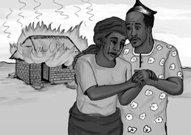
Picture 16–1

Ma Nfor was crying and asked her husband, “What will we do? We have no seed to plant. We have no money to buy more seed. We will not have food next year! We will starve! What can we do?”
Pa Nfor told his wife not to worry, he would go to see Elder Mbe, who was elder of their church. Elder Mbe would know what to do. They were fellow Christians, and went to church together. Certainly Pa Mbe would know how to solve their problem.
One day, a very bad thing happened to the Nfor family. Their cookhouse caught fire while they were away from the compound. The whole cookhouse and barn burned down, including all of their seed that they bought to plant.
Ma Nfor was crying and asked her husband, “What will we do? We have no seed to plant. We have no money to buy more seed. We will not have food next year! We will starve! What can we do?”
Pa Nfor told his wife not to worry, he would go to see Elder Mbe, who was elder of their church. Elder Mbe would know what to do. They were fellow Christians, and went to church together. Certainly Pa Mbe would know how to solve their problem.
Pa went to see Elder Mbe and told him of his family's situation and his need. Elder Mbe said, “We will pray for you, my brother. You too should remember to pray. You should have faith, God will help you. As for me, I can do nothing. I only have enough seed for my family's needs.”
Picture 16–2

Pa went to see Elder Mbe and told him of his family's situation and his need. Elder Mbe said, “We will pray for you, my brother. You too should remember to pray. You should have faith, God will help you. As for me, I can do nothing. I only have enough seed for my family's needs.”
Pa Nfor went away sad and discouraged. He thought that of anyone he knew, Elder Mbe would understand his situation and help him. He wondered what he would do. He asked God, “What will happen to me and my family?”
Picture 16–3

Pa Nfor went away sad and discouraged. He thought that of anyone he knew, Elder Mbe would understand his situation and help him. He wondered what he would do. He asked God, “What will happen to me and my family?”
Upon reaching his compound, he met Pa Akem waiting for him to return. He had also brought a bag of seed corn with him. Pa Akem said, “I heard about your loss. I know that you lost all of your seed, and you don't have any more money to buy seed. Jesus said that his true followers are generous, so I knew that I must come to help you.”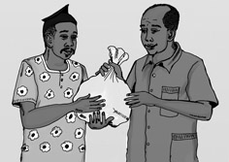
Picture 16–4

Pa Nfor said, “I don't understand, how can you give me a bag of your seed when you only have enough to feed your family? Your family will not have enough.”
Pa Aken said, “True followers of Jesus treat others as they want to be treated. If I were in need, I would hope others would come to help me too. I believe that with God's help, we will all have enough to eat next year.”
The two families joined together singing, dancing, and praising God.
Upon reaching his compound, he met Pa Akem waiting for him to return. He had also brought a bag of seed corn with him. Pa Akem said, “I heard about your loss. I know that you lost all of your seed, and you don't have any more money to buy seed. Jesus said that his true followers are generous, so I knew that I must come to help you.”
Pa Nfor said, “I don't understand, how can you give me a bag of your seed when you only have enough to feed your family? Your family will not have enough.”
Pa Aken said, “True followers of Jesus treat others as they want to be treated. If I were in need, I would hope others would come to help me too. I believe that with God's help, we will all have enough to eat next year.”
The two families joined together singing, dancing, and praising God.
Application
Jesus tells us that we should be generous and share with those in need around us. Just like in the story, the Nfor family were going to have no food because of the fire. The Akem family saw that there was a family in need, so they helped them out. This is a good example as to how we are to be. Jesus tells us to treat others the way we want to be treated. Being generous, kind, and patient with others is how we can show that we are true followers of Jesus.
Jesus tells us that we should be generous and share with those in need around us. Just like in the story, the Nfor family were going to have no food because of the fire. The Akem family saw that there was a family in need, so they helped them out. This is a good example as to how we are to be. Jesus tells us to treat others the way we want to be treated. Being generous, kind, and patient with others is how we can show that we are true followers of Jesus.
A true disciple of Jesus is generous.
A true disciple of Jesus is generous.
Homework
Who can you be generous to this week? Who can you treat with kindness? Who in your family, friends, and schoolmates can you show patience to? Think of these people, then pray and ask God to help you.
Who can you be generous to this week? Who can you treat with kindness? Who in your family, friends, and schoolmates can you show patience to? Think of these people, then pray and ask God to help you.
Prayer / Song
Review Game
Spaghetti Game
Materials
- Cooking pot with a lid
- Rope, string, or yarn cut into 10 pieces that are all different sizes
How to Play
- Put the rope, string, or yarn in the pot with some of it hanging out. Put the lid on the pot over the ropes.
- Divide the children into two teams.
- When someone on the team answers the question correctly, they come to the front and choose one of the ropes. (They never know if they will get a long or short rope.)
- The ropes that each team gets are tied together into one long rope.
- At the end, measure the ropes from the two teams side by side.
- The teams with the longest rope wins.
Questions for Review Game
- Is the story we had today from the Bible? (No, it is from a village.)
Is the story we had today from the Bible? (No, it is from a village.)
- What did Jesus say his true followers will do when people ask for help? (They are generous and give to those who ask.)
What did Jesus say his true followers will do when people ask for help? (They are generous and give to those who ask.)
- How does Jesus want his true followers to treat other people? (In the same way that they want to be treated.)
How does Jesus want his true followers to treat other people? (In the same way that they want to be treated.)
- What do you think it means to treat others like we want to be treated? (Give the children time to give examples. Be sure to mention being honest, patient, helpful, and kind.)
What do you think it means to treat others like we want to be treated? (Give the children time to give examples. Be sure to mention being honest, patient, helpful, and kind.)
- What happened to the Nfor family? (Their cookhouse burned down with all of their seed for planting inside.)
What happened to the Nfor family? (Their cookhouse burned down with all of their seed for planting inside.)
- Why was Ma Nfor crying and afraid? (They had no money to buy more seed, so they would not have food to harvest and feed themselves.)
Why was Ma Nfor crying and afraid? (They had no money to buy more seed, so they would not have food to harvest and feed themselves.)
- Who did Pa Nfor go to for help first? (Elder Mbe from the church)
Who did Pa Nfor go to for help first? (Elder Mbe from the church)
- Did Elder Mbe help the Nfor family? (It is good that Elder Mbe promised to pray for the Nfor family, but he did not try to think of how he could help them with their physical needs.)
Did Elder Mbe help the Nfor family? (It is good that Elder Mbe promised to pray for the Nfor family, but he did not try to think of how he could help them with their physical needs.)
- Who did Pa Nfor meet at his compound? (Pa Akem)
Who did Pa Nfor meet at his compound? (Pa Akem)
- What did Pa Akem have to give to Pa Nfor? (A bag of his family's seed)
What did Pa Akem have to give to Pa Nfor? (A bag of his family's seed)
- Was Pa Akem sacrificing to help the Nfor family? (Yes, Pa Akem was giving from his own family's seed they would use for planting. Pa Akem's family might not have enough food from their harvest.)
Was Pa Akem sacrificing to help the Nfor family? (Yes, Pa Akem was giving from his own family's seed they would use for planting. Pa Akem's family might not have enough food from their harvest.)
- Why did Pa Akem give Pa Nfor a bag of his seed? (Pa Akem knew that Jesus wants his true followers to be generous and treat others like they want to be treated. If Pa Akem knew they had the same problem, he would want people to help him so his family would not be hungry.)
Why did Pa Akem give Pa Nfor a bag of his seed? (Pa Akem knew that Jesus wants his true followers to be generous and treat others like they want to be treated. If Pa Akem knew they had the same problem, he would want people to help him so his family would not be hungry.)
Song
Memory Verse
Materials and Preparations
- Put a bookmark in Luke 6:30-31
- Write memory verse on the blackboard.
Luke 6:30-31 Give to everyone who asks you, and do not ask for your possessions back from the person who takes them away. Treat others in the same way that you would want them to treat you.
Luke 6:30-31 Give to everyone who asks you, and do not ask for your possessions back from the person who takes them away. Treat others in the same way that you would want them to treat you.
Teach and Explain
Our memory verse is in the Gospel of Luke. That is in the New Testament, a part of the Bible.
Our memory verse is in the Gospel of Luke. That is in the New Testament, a part of the Bible.
- Read the verse from your Bible.
- Read the verse by yourself as you point to the words.
- Read the verse with the children as you point to the words.
- Explain the verse:
- Our memory verse comes from today’s Bible story.
Our memory verse comes from today’s Bible story.
- As you read the verse, circle the words shown below. Explain each of these words.
- Everyone: Jesus wants us to be generous with people. If someone asks us for something, Jesus wants us to give it to them whether they are friends, family, or strangers.
Everyone: Jesus wants us to be generous with people. If someone asks us for something, Jesus wants us to give it to them whether they are friends, family, or strangers.
- Takes: Jesus is talking about people who take things from us without our permission.
Takes: Jesus is talking about people who take things from us without our permission.
- Demand: To demand something to be returned to you means that you will not forgive someone unless they give back what was taken from you. Jesus wants us to forgive people who wrong us, whether they ever give back what they took, or not.
Demand: To demand something to be returned to you means that you will not forgive someone unless they give back what was taken from you. Jesus wants us to forgive people who wrong us, whether they ever give back what they took, or not.
- Others: This means ALL people: strangers, family, friends, neighbors-anyone! Jesus is telling us how to treat ALL the people around us. Whether we like them or not.
Others: This means ALL people: strangers, family, friends, neighbors-anyone! Jesus is telling us how to treat ALL the people around us. Whether we like them or not.
- Read the verse again by yourself as you point to the words.
- Read the verse again with the children as you point to the words.
Jesus tells us to think about how we want to be treated by other people. This is how we are to treat others. Do you want to be treated nicely, or badly? I am sure you want people to be nice to you. Jesus says that is how you should treat all other people.
Jesus tells us to think about how we want to be treated by other people. This is how we are to treat others. Do you want to be treated nicely, or badly? I am sure you want people to be nice to you. Jesus says that is how you should treat all other people.
Remember our truth for the day? Let’s all say it together:
Remember our truth for the day? Let’s all say it together:
A true disciple of Jesus is generous.
A true disciple of Jesus is generous.
Memory Verse Review
Children Repeat the Verse by Using Movements
- Talk about different movements with our bodies: Your hands on your head, standing on one foot, jumping up and down, touching your toes....
- Ask the children the first question.
- When a question is answered correctly, that child chooses one of the movements listed above or chooses their own movement.
- The verse is said out loud together while doing the movement.
- Then the next question is asked.
- When that question is answered correctly, another child chooses one of the movements.
- The verse is said aloud again while doing the movement.
- Do this until all the questions are asked.
Questions for Memory Verse
- Where is today's memory verse found? ( Luke 6:30-31 )
Where is today's memory verse found? ( Luke 6:30-31 )
- How does Jesus want us to treat others? (In the same way we want to be treated)
How does Jesus want us to treat others? (In the same way we want to be treated)
- If someone takes something from us, what does Jesus tell us NOT to do? (Demand things taken from us to be given back)
If someone takes something from us, what does Jesus tell us NOT to do? (Demand things taken from us to be given back)
- What does Jesus want us to to do when people ask for something from us? (We should give it to them.)
What does Jesus want us to to do when people ask for something from us? (We should give it to them.)
- If we like it when people help us, should we help others? (Yes)
If we like it when people help us, should we help others? (Yes)
- If we like it when people are honest with us, should we be honest with them? (Yes)
If we like it when people are honest with us, should we be honest with them? (Yes)
- Should we be kind to only people we like? (No. Jesus tells us to treat ALL people with kindness, whether we like them or not.)
Should we be kind to only people we like? (No. Jesus tells us to treat ALL people with kindness, whether we like them or not.)
- What should we do to people who do wrong against us and then ask for forgiveness? (We should forgive those who do wrong against us because, that is how we want to be treated.)
What should we do to people who do wrong against us and then ask for forgiveness? (We should forgive those who do wrong against us because, that is how we want to be treated.)
Song
Closing and Homework
- Say the truth together:
A true disciple of Jesus is generous.
A true disciple of Jesus is generous.
- Say the memory verse together:
Luke 6:30-31 Give to everyone who asks you, and do not ask for your possessions back from the person who takes them away. Treat others in the same way that you would want them to treat you.
Luke 6:30-31 Give to everyone who asks you, and do not ask for your possessions back from the person who takes them away. Treat others in the same way that you would want them to treat you.
- Review the homework:
Who can you be generous to this week? Who can you treat with kindness? Who in your family, friends, and schoolmates can you show patience to? Think of these people, then pray and ask God to help you.
Who can you be generous to this week? Who can you treat with kindness? Who in your family, friends, and schoolmates can you show patience to? Think of these people, then pray and ask God to help you.
- Give any needed announcements.
Closing Prayer
Thank God that we are children of God, and that we can go to Him if we come to any troubles.
Ask God that the children will remember to treat others with kindness and generosity.
Colouring page to colour and take home!

A true disciple of Jesus is generous.
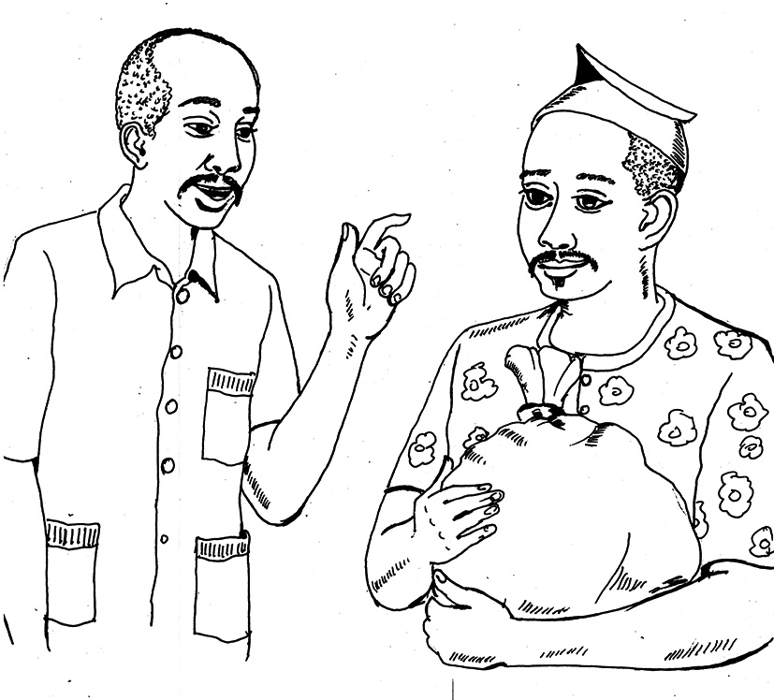
Luke 6:30-31 Give to everyone who asks you, and do not ask for your possessions back from the person who takes them away. Treat others in the same way that you would want them to treat you.
A true disciple of Jesus is generous.
Luke 6:30-31 Give to everyone who asks you, and do not ask for your possessions back from the person who takes them away. Treat others in the same way that you would want them to treat you.

