
The Wise Man and the Foolish Man
The Wise Man and the Foolish Man
The Wise Man and the Foolish Man
Luke 6:46-49
Lesson Overview
Today’s Truth | A true disciple of Jesus does what the Bible teaches.  A true disciple of Jesus does what the Bible teaches.
Objective | KNOW: The children will know that to be a true disciple, we must follow what the Bible teaches.  DO: This week, the children will take time every day to read, or listen to God's Word every day, and then do what it says you should do.
Materials | - Quarter 2 Picture book, Bible, chalk  - Copies of the memory verse coloring page for the children to take home.  - A small bucket of sand and a large rock  - Cooking pot with a lid  - Rope, string, or yarn cut into 10 pieces that are all different sizes
Memory Verse | Luke 6:47-48 I will show you what he is like who comes to me and hears my words and puts them into practice. He is like a man building a house, who dug down deep and laid the foundation on rock. When the floodwaters rise and break against the house, it stands firm because it is well built.  Luke 6:47-48 I will show you what he is like who comes to me and hears my words and puts them into practice. He is like a man building a house, who dug down deep and laid the foundation on rock. When the floodwaters rise and break against the house, it stands firm because it is well built.
Homework | This week, make sure you take time to read, or listen to God's Word every day, and then do what it says you should do.  This week, make sure you take time to read, or listen to God's Word every day, and then do what it says you should do.

Detailed Lesson Plan
Song
Opening
Welcome
- Be sure the children know you are happy to see them!
- Introduce yourself and your helpers.
Sharing Time
- Say the truth from the previous lesson together:
A true disciple of Jesus bears good fruit.
A true disciple of Jesus bears good fruit.
- Say the memory verse from the previous lesson together:
Luke 6:43 No good tree bears bad fruit, nor does a bad tree bear good fruit.
Luke 6:43 No good tree bears bad fruit, nor does a bad tree bear good fruit.
- Review the homework from the previous lesson:
For homework you were to make good decisions so that you could bear good fruit. Did you make good choices?
For homework you were to make good decisions so that you could bear good fruit. Did you make good choices?
(Give children time to share.)
Prayer
- Let the children share praises and prayer requests.
- Keep a record of what the children are sharing so you can remember to thank God together for answered prayers.
- Spend time praying together. Let children pray out loud if they volunteer. Do not force anyone to pray out loud.
Song
Words to Discuss
- On the blackboard, write the “Words to Discuss” from the list below.
- Let's discuss some words to help us better understand the Bible story for today.
Let's discuss some words to help us better understand the Bible story for today.
- Foolish: Not having good sense or good judgment.
Foolish: Not having good sense or good judgment.
- Wise: Showing common knowledge.
Wise: Showing common knowledge.
- Rock: Material forming the surface of the earth.
Rock: Material forming the surface of the earth.
- Sand: Loose material, usually formed from rocks and other materials.
Sand: Loose material, usually formed from rocks and other materials.
- Flood: An overflow of water onto a land that is normally dry.
Flood: An overflow of water onto a land that is normally dry.
Song
Bible Story / Lesson
Materials: A small bucket of sand and a large rock
- Have the children put their fist in the sand. What happens? (The sand moves around and a hole is left where the person's fist when in.)
- Now have the children put their fist into the rock. What happens? (It hurts if you hit the rock hard because the rock doesn't shift. The rock stays hard.)
Introduce Truth
Our truth for today is: A true disciple of Jesus does what the Bible teaches.
Our truth for today is: A true disciple of Jesus does what the Bible teaches.
This reminds me of a true story from the Bible.
This reminds me of a true story from the Bible.
Bible Story: Luke 6:46-49
[ One day, Jesus was teaching to a large crowd of people from all around. ]
Luke 6:46-47 “Why do you call me, ‘Lord, Lord,’ and do not do what I say? I will show you what he is like who comes to me and hears my words and puts them into practice.
[ One day, Jesus was teaching to a large crowd of people from all around. ]
Luke 6:46-47 “Why do you call me, ‘Lord, Lord,’ and do not do what I say? I will show you what he is like who comes to me and hears my words and puts them into practice.
Luke 6:48 He is like a man building a house, who dug down deep and laid the foundation on rock. When a flood came, the torrent struck that house but could not shake it, because it was well built.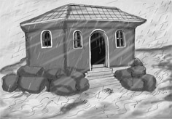
Picture 18–1

Luke 6:48 He is like a man building a house, who dug down deep and laid the foundation on rock. When a flood came, the torrent struck that house but could not shake it, because it was well built.

Luke 6:49 But the one who hears the Word and does not follow, is like a man building a house on a weak foundation. The second a storm hits, the house collapses, and it is no more.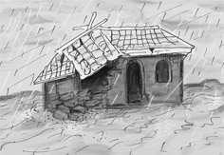
Picture 18–2

Luke 6:49 But the one who hears the Word and does not follow, is like a man building a house on a weak foundation. The second a storm hits, the house collapses, and it is no more.

Skit
Have the children act this story out. Have one volunteer be the wise man. The child acting as the wise man chooses two friends to be in his house. They face each other and hold each others hands up in the air (to form the house.) The child who is acting as the wise man enters the “house” made by his friends' arms and bodies, and crouches down. Then, when the teacher gives the command, the rest of the children make storm noises.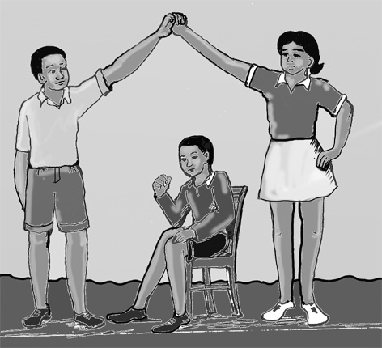

Discuss with the children that if they hear the teachings of the Bible and do what it says, they are like the wise man. When the difficulties of life come their way, they will not be shaken in their faith, but they will be able to stand strong.
Have the children act this story out. Have one volunteer be the wise man. The child acting as the wise man chooses two friends to be in his house. They face each other and hold each others hands up in the air (to form the house.) The child who is acting as the wise man enters the “house” made by his friends' arms and bodies, and crouches down. Then, when the teacher gives the command, the rest of the children make storm noises.
Discuss with the children that if they hear the teachings of the Bible and do what it says, they are like the wise man. When the difficulties of life come their way, they will not be shaken in their faith, but they will be able to stand strong.
Next, Have a different volunteer act out being the foolish man. The child acting as the foolish man chooses two different friends to be his house. They face each other and hold each others hands up in the air. The child who is acting as the foolish man enters the “house” made by his friends' arms and bodies, and crouches down. Then, when the teacher gives the command, the rest of the children make storm noises again, like they did for the wise man.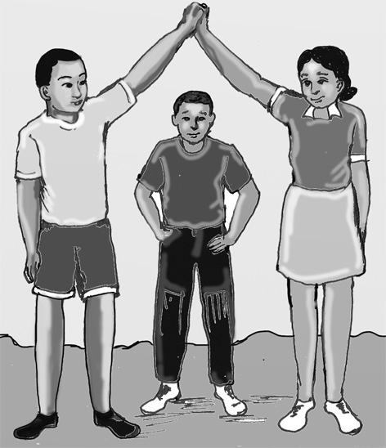

Next, Have a different volunteer act out being the foolish man. The child acting as the foolish man chooses two different friends to be his house. They face each other and hold each others hands up in the air. The child who is acting as the foolish man enters the “house” made by his friends' arms and bodies, and crouches down. Then, when the teacher gives the command, the rest of the children make storm noises again, like they did for the wise man.
This time, when the storm noises are made, the children that are the “house” for the foolish man fall to the ground, and the foolish man yells and runs away.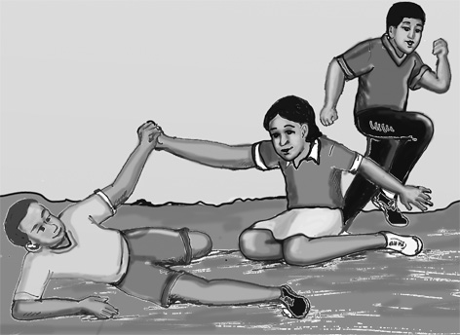

Discuss with the children that if they hear the teachings of the Bible and don't do what it says, then they are like the foolish man who builds his house on the sand. When the difficulties of life come their way, they will not be able to stand strong, they will be swept away by the world.
This time, when the storm noises are made, the children that are the “house” for the foolish man fall to the ground, and the foolish man yells and runs away.
Discuss with the children that if they hear the teachings of the Bible and don't do what it says, then they are like the foolish man who builds his house on the sand. When the difficulties of life come their way, they will not be able to stand strong, they will be swept away by the world.
Application
After hearing the story, and acting out the story, how do we live a life that is firm and strong?
After hearing the story, and acting out the story, how do we live a life that is firm and strong?
To have a strong foundation in Jesus, we need to read the Bible, and follow what it teaches us. By doing this, we become wise.
To have a strong foundation in Jesus, we need to read the Bible, and follow what it teaches us. By doing this, we become wise.
We must resist sin, all the things we think, do, or say that displeases God, and stand firm in our faith in the Lord. We need to be strong and firm so that we can resist any temptation of sin that comes in our way.
We must resist sin, all the things we think, do, or say that displeases God, and stand firm in our faith in the Lord. We need to be strong and firm so that we can resist any temptation of sin that comes in our way.
A true disciple of Jesus does what the Bible teaches.
A true disciple of Jesus does what the Bible teaches.
Homework
This week, make sure you take time to read, or listen to God's Word every day, and then do what it says you should do.
This week, make sure you take time to read, or listen to God's Word every day, and then do what it says you should do.
Prayer / Song
Review Game
Spaghetti Game
Materials
- Cooking pot with a lid
- Rope, string, or yarn cut into 10 pieces that are all different sizes
How to Play
- Put the rope, string, or yarn in the pot with some of it hanging out. Put the lid on the pot over the ropes.
- Divide the children into two teams.
- When someone on the team answers the question correctly, they come to the front and choose one of the ropes. (They never know if they will get a long or short rope.)
- The ropes that each team gets are tied together into one long rope.
- At the end, measure the ropes from the two teams side by side.
- The teams with the longest rope wins.
Questions for Review Game
- What does the wise man do? (Builds his house on a rock)
What does the wise man do? (Builds his house on a rock)
- What happens to his house when a storm comes and the flood waters hit against it? (The house still stands.)
What happens to his house when a storm comes and the flood waters hit against it? (The house still stands.)
- Who is the wise man? (The person who reads the Bible and follows what it says)
Who is the wise man? (The person who reads the Bible and follows what it says)
- What does the foolish man do? (Builds his house on the sand)
What does the foolish man do? (Builds his house on the sand)
- What happens to the foolish man's house when the storm comes and the flood waters hit against it? (It is completely destroyed.)
What happens to the foolish man's house when the storm comes and the flood waters hit against it? (It is completely destroyed.)
- Who is like the foolish man? (The person who reads the Bible and does NOT do what it says)
Who is like the foolish man? (The person who reads the Bible and does NOT do what it says)
- A true follower of Jesus should be like which man? (The wise man)
A true follower of Jesus should be like which man? (The wise man)
- What should a true follower of Jesus do? (Listen to the teachings of the Bible and do what it says)
What should a true follower of Jesus do? (Listen to the teachings of the Bible and do what it says)
Song
Memory Verse
Materials and Preparations
- Put a bookmark in Luke 6:47-48
- Write memory verse on the blackboard.
Luke 6:47-48 I will show you what he is like who comes to me and hears my words and puts them into practice. He is like a man building a house, who dug down deep and laid the foundation on rock. When the floodwaters rise and break against the house, it stands firm because it is well built.
Luke 6:47-48 I will show you what he is like who comes to me and hears my words and puts them into practice. He is like a man building a house, who dug down deep and laid the foundation on rock. When the floodwaters rise and break against the house, it stands firm because it is well built.
Teach and Explain
Our memory verse is in the Gospel of Luke. That is in the New Testament, a part of the Bible.
Our memory verse is in the Gospel of Luke. That is in the New Testament, a part of the Bible.
- Read the verse from your Bible.
- Read the verse by yourself as you point to the words.
- Read the verse with the children as you point to the words.
- Explain the verse:
- Our memory verse comes from today’s Bible story.
Our memory verse comes from today’s Bible story.
- As you read the verse, circle the words shown below. Explain each of these words.
- Who comes to me: Refers to a sinner who comes to Jesus to have their sins forgiven. To become a follower of Jesus we must first some and pray to Jesus. We should not turn away from Jesus.
Who comes to me: Refers to a sinner who comes to Jesus to have their sins forgiven. To become a follower of Jesus we must first some and pray to Jesus. We should not turn away from Jesus.
- Hears my word: Refers to a person who has heard what Jesus said in the Bible or has heard a lesson from the Bible.
Hears my word: Refers to a person who has heard what Jesus said in the Bible or has heard a lesson from the Bible.
- Practice: It is not enough to hear the words of Jesus or a lesson from the Bible, we need to put those words into action. We must practice doing those actions over and over again.
Practice: It is not enough to hear the words of Jesus or a lesson from the Bible, we need to put those words into action. We must practice doing those actions over and over again.
- Read the verse again by yourself as you point to the words.
- Read the verse again with the children as you point to the words.
God's Word, the Bible, teaches us how we can live in a way that pleases God. It teaches us how to be wise. Jesus tells us clearly how to be wise:
- Come to Jesus by praying and asking Him to help you.
- Hear his teachings by reading, or listening to God's Word, the Bible.
- Do what you hear.
God's Word, the Bible, teaches us how we can live in a way that pleases God. It teaches us how to be wise. Jesus tells us clearly how to be wise:
- Come to Jesus by praying and asking Him to help you.
- Hear his teachings by reading, or listening to God's Word, the Bible.
- Do what you hear.
If God's Word says you SHOULD NOT do something, then don't do it. Can you tell me something that God's Word tells us not to do? (Do not steal, do not tell lies, do not fight, do not be bitter against people.)
If God's Word says you SHOULD NOT do something, then don't do it. Can you tell me something that God's Word tells us not to do? (Do not steal, do not tell lies, do not fight, do not be bitter against people.)
If God's Word says you SHOULD do something, then do it! Can you tell me something that God's Word tell us TO DO? (Be generous, tell the truth, respect and obey my parents, be helpful, be kind, and be forgiving.)
If God's Word says you SHOULD do something, then do it! Can you tell me something that God's Word tell us TO DO? (Be generous, tell the truth, respect and obey my parents, be helpful, be kind, and be forgiving.)
Do you take time to read, or to listen to God's Word every day? That is where you can learn to be wise and to live in the way that pleases God. This week, make sure you take time every day to read, or to listen to God's Word every day, and then do what it says you should do.
Do you take time to read, or to listen to God's Word every day? That is where you can learn to be wise and to live in the way that pleases God. This week, make sure you take time every day to read, or to listen to God's Word every day, and then do what it says you should do.
Remember our truth for the day? Let’s all say it together:
Remember our truth for the day? Let’s all say it together:
A true disciple of Jesus does what the Bible teaches.
A true disciple of Jesus does what the Bible teaches.
Memory Verse Review
Children Repeat the Verse by Using Movements
- Talk about different movements with our bodies: Your hands on your head, standing on one foot, jumping up and down, touching your toes....
- Ask the children the first question.
- When a question is answered correctly, that child chooses one of the movements listed above or chooses their own movement.
- The verse is said out loud together while doing the movement.
- Then the next question is asked.
- When that question is answered correctly, another child chooses one of the movements.
- The verse is said aloud again while doing the movement.
- Do this until all the questions are asked.
Questions for Memory Verse
- Where is today's memory verse found? ( Luke 6:47-48 )
Where is today's memory verse found? ( Luke 6:47-48 )
- Where can you go to learn how to be strong and firm in the Lord? (The Bible)
Where can you go to learn how to be strong and firm in the Lord? (The Bible)
- In the Bible verse, where did the man dig his foundation? (On rock)
In the Bible verse, where did the man dig his foundation? (On rock)
- Name one out of the three ways how the Bible teaches us how to be wise? (Come to Jesus by praying and asking him to help you, hear his teachings by reading, or listening to God's Word, the Bible, and by doing what you hear.)
Name one out of the three ways how the Bible teaches us how to be wise? (Come to Jesus by praying and asking him to help you, hear his teachings by reading, or listening to God's Word, the Bible, and by doing what you hear.)
- Name another way how the Bible teaches us to be wise? (See answers to 4.)
Name another way how the Bible teaches us to be wise? (See answers to 4.)
- Name another way how the Bible teaches us to be wise? (See answers to 4.)
Name another way how the Bible teaches us to be wise? (See answers to 4.)
Song
Closing and Homework
- Say the truth together:
A true disciple of Jesus does what the Bible teaches.
A true disciple of Jesus does what the Bible teaches.
- Say the memory verse together:
Luke 6:47-48 I will show you what he is like who comes to me and hears my words and puts them into practice. He is like a man building a house, who dug down deep and laid the foundation on rock. When the floodwaters rise and break against the house, it stands firm because it is well built.
Luke 6:47-48 I will show you what he is like who comes to me and hears my words and puts them into practice. He is like a man building a house, who dug down deep and laid the foundation on rock. When the floodwaters rise and break against the house, it stands firm because it is well built.
- Review the homework:
This week, make sure you take time to read, or listen to God's Word every day, and then do what it says you should do.
This week, make sure you take time to read, or listen to God's Word every day, and then do what it says you should do.
- Give any needed announcements.
Closing Prayer
Thank God that we are able to go to the Bible to learn how to live like a true follower of Jesus.
Ask God that the children will remember to read the Bible every day, and that they will follow what the Bible says.
Colouring page to colour and take home!

A true disciple of Jesus does what the Bible teaches.

Luke 6:47-48 I will show you what he is like who comes to me and hears my words and puts them into practice. He is like a man building a house, who dug down deep and laid the foundation on rock. When the floodwaters rise and break against the house, it stands firm because it is well built.

A true disciple of Jesus does what the Bible teaches.

Luke 6:47-48 I will show you what he is like who comes to me and hears my words and puts them into practice. He is like a man building a house, who dug down deep and laid the foundation on rock. When the floodwaters rise and break against the house, it stands firm because it is well built.

