Lessons from Acts
Teacher’s Guide – Quarter 4
Based on “Lessons from Acts,” 2nd edition, 2021
Chris Jackson

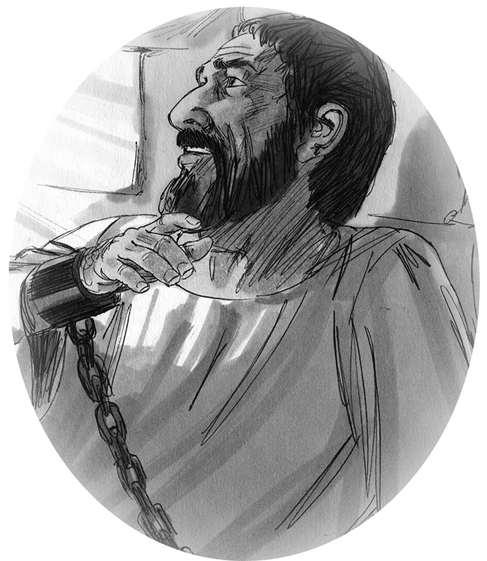

Publisher
Publisher address
City, Region
Country

Year of publication

Language: | Name of language
Spoken in: | insert division, region, country information.
ISO 639-3 language code: | Insert language code
Title in English: | Lessons from Acts Teacher’s Guide – Quarter 4
Translated by: | Insert names of translators

Adapted from the original work, “Lessons from Acts, 2nd Edition,” copyright Chris Jackson, licensed under a Creative Commons Attribution-NonCommercial-ShareAlike 4.0 International License (CC-BY-NC-SA). Edited by Annette Beyer, Sulee Kindle.

Scripture text: | Title of New Testament, or Book of Acts in translated language  © Scripture copyright year Scripture copyright holder.  All rights reserved.

English Scripture text: the NET Bible® http://netbible.com copyright ©1996, 2019 used with permission from Biblical Studies Press, L.L.C. All rights reserved

Bible illustrations by Jim Padgett, courtesy of Sweet Publishing, Fr. Worth (Texas); licensed for use under the Creative Commons BY-SA. https://creativecommons.org/licenses/by-sa/3.0/

Coloring page illustrations by Ariel Ayotte.
(for copyright questions concerning illustrations, contact Chris Jackson: chris_jackson@sil.org.)

Year of publication Publisher
This work is licensed under the Creative Commons Attribution-NonCommercial-ShareAlike 4.0 International License. To view a copy of this license, visit http://creativecommons.org/licenses/by-nc-sa/4.0/deed.en_US.

Quarter 4 Table of Contents
No. | Title | Truth | Story
40 | Jesus encourages Paul in a dream  Jesus encourages Paul in a dream | The Holy Spirit helps us when we face problems.  The Holy Spirit helps us when we face problems. | Acts 18:9–17
41 | False miracle workers  False miracle workers | A true follower of Jesus does not practice sorcery, or witchcraft.  A true follower of Jesus does not practice sorcery, or witchcraft. | Acts 19:1  Acts 19:11–20
42 | Riot in Ephesus  Riot in Ephesus | The Good News of Jesus breaks down false gods and evil businesses.  The Good News of Jesus breaks down false gods and evil businesses. | Acts 19:21–41
43 | Paul prepares to leave for Jerusalem  Paul prepares to leave for Jerusalem | A true follower of Jesus serves God faithfully no matter what happens.  A true follower of Jesus serves God faithfully no matter what happens. | Acts 20:16–38
44 | Paul is arrested in Jerusalem  Paul is arrested in Jerusalem | When we obey God, the Holy Spirit helps us face any situation.  When we obey God, the Holy Spirit helps us face any situation. | Acts 21:10–40
45 | Paul testifies in Jerusalem  Paul testifies in Jerusalem | No matter the situation, tell everyone about Jesus.  No matter the situation, tell everyone about Jesus. | Acts 22:1-5  Acts 22:14–15  Acts 22:21–30
46 | Review Lesson  Review Lesson | Lessons 40-45  Lessons 40-45
47 | God protects Paul’s life  God protects Paul’s life | The Holy Spirit leads and protects Jesus-followers who obey God.  The Holy Spirit leads and protects Jesus-followers who obey God. | Acts 23
48 | Paul’s trial before Felix  Paul’s trial before Felix | True Jesus-followers live so they have nothing to hide.  True Jesus-followers live so they have nothing to hide. | Acts 24
49 | Paul testifies to King Agrippa  Paul testifies to King Agrippa | True Jesus-followers want ALL people to accept Jesus.  True Jesus-followers want ALL people to accept Jesus. | Acts 25-26
50 | Paul is shipwrecked  Paul is shipwrecked | The Holy Spirit helps us encourage others when facing problems.  The Holy Spirit helps us encourage others when facing problems. | Acts 27
51 | Paul in Rome  Paul in Rome | No matter where God sends you, tell others about Jesus.  No matter where God sends you, tell others about Jesus. | Acts 28:15–31
52 | Review Lesson  Review Lesson | Lessons 47-51  Lessons 47-51

