
The Twelve Apostles
The Twelve Apostles
The Twelve Apostles
Luke 6:12-16
Lesson Overview
Today’s Truth | A true disciple of Jesus follows him and his teachings.  A true disciple of Jesus follows him and his teachings.
Objective | KNOW: The children will learn how to be a true follower of Jesus.  DO: The children will show that they are true disciples of Jesus.
Materials | - Quarter 2 Picture book, Bible, chalk  - Copies of the memory verse coloring page for the children to take home.  - Cooking pot with a lid  - Rope, string, or yarn cut into 10 pieces that are all different sizes
Memory Verse | Luke 6:13 When morning came, he called his disciples to him and chose twelve of them, whom he also designated apostles.  Luke 6:13 When morning came, he called his disciples to him and chose twelve of them, whom he also designated apostles.
Homework | What can you do this week to show that you are a disciple of Jesus?  What can you do this week to show that you are a disciple of Jesus?

Detailed Lesson Plan
Song
Opening
Welcome
- Be sure the children know you are happy to see them!
- Introduce yourself and your helpers.
Sharing Time
- Do you remember any truths from the last lessons?
Do you remember any truths from the last lessons?
(Give children time to share.)
- What truth have you continued to do even though it is not homework?
What truth have you continued to do even though it is not homework?
(Give children time to share.)
- It is important to follow these truths, even if they are not homework. All of the truths are the way we should be living.
It is important to follow these truths, even if they are not homework. All of the truths are the way we should be living.
Prayer
- Let the children share praises and prayer requests.
- Keep a record of what the children are sharing so you can remember to thank God together for answered prayers.
- Spend time praying together. Let children pray out loud if they volunteer. Do not force anyone to pray out loud.
Song
Words to Discuss
- On the blackboard, write the “Words to Discuss” from the list below.
- Let's discuss some words to help us better understand the Bible story for today.
Let's discuss some words to help us better understand the Bible story for today.
- Disciple: Someone who follows Jesus and lives by His teachings.
Disciple: Someone who follows Jesus and lives by His teachings.
- Mountainside: The part of the mountain that begins to slope up.
Mountainside: The part of the mountain that begins to slope up.
- Apostles: Twelve men who were chosen by Jesus to be his chief disciples to carry his teachings to others.
Apostles: Twelve men who were chosen by Jesus to be his chief disciples to carry his teachings to others.
- Traitor: Someone who gives up a friend to the enemy because they want some benefit from it.
Traitor: Someone who gives up a friend to the enemy because they want some benefit from it.
Song
Bible Story / Lesson
Game: Follow Me
- Ask children to stand up and copy your movements. Start out simple. Raise your right hand, raise your left hand, etc.
- Add more and more difficult maneuvers using facial expressions and sounds. Enjoy the confusion as it becomes harder and harder to copy your actions. (The point is not to trick the children into making mistakes, but to make it humorous and difficult to follow.)
- Was it easy or hard to imitate the teacher?
Was it easy or hard to imitate the teacher?
- What made it easier?
What made it easier?
- What made it more difficult?
What made it more difficult?
- Today we will be learning that we are true disciples of Jesus if we follow him and his teachings.
Today we will be learning that we are true disciples of Jesus if we follow him and his teachings.
Introduce Truth
Our truth for today is: A true disciple of Jesus follows him and his teachings.
Our truth for today is: A true disciple of Jesus follows him and his teachings.
This reminds me of a true story from the Bible.
This reminds me of a true story from the Bible.
Bible Story: Luke 6:12-16
[ As Jesus went around preaching, the people who followed him and lived by his teachings were called “disciples.” ]
[ As Jesus went around preaching, the people who followed him and lived by his teachings were called “disciples.” ]
Luke 6:12 One day, Jesus left the group of people that were following him and he went up the mountainside to pray. He spent the whole night praying because he was about to make a very important decision.
Picture 14–1
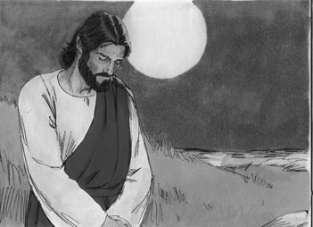
Luke 6:12 One day, Jesus left the group of people that were following him and he went up the mountainside to pray. He spent the whole night praying because he was about to make a very important decision.
Luke 6:13-16 When morning came, he called his disciples to him and chose twelve of them, whom he also designated apostles: Simon (whom he named Peter), his brother Andrew, James, John, Philip, Bartholomew, Matthew, Thomas, James son of Alphaeus, Simon who was called the Zealot, Judas son of James, and Judas Iscariot, who became a traitor.
Picture 14–2
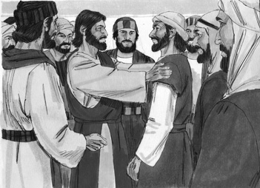
[ These twelve men were the closest to Jesus and went everywhere with him. Two of them men wrote about their time spent with Jesus. They are in the books of the Bible called “Matthew” and “John”. Later on, Peter wrote two letters to the new followers of Jesus in two books of the Bible called First and Second Peter. All of these men abandoned Jesus at one time, or another because they were afraid. ]
Luke 6:13-16 When morning came, he called his disciples to him and chose twelve of them, whom he also designated apostles: Simon (whom he named Peter), his brother Andrew, James, John, Philip, Bartholomew, Matthew, Thomas, James son of Alphaeus, Simon who was called the Zealot, Judas son of James, and Judas Iscariot, who became a traitor.
[ These twelve men were the closest to Jesus and went everywhere with him. Two of them men wrote about their time spent with Jesus. They are in the books of the Bible called “Matthew” and “John”. Later on, Peter wrote two letters to the new followers of Jesus in two books of the Bible called First and Second Peter. All of these men abandoned Jesus at one time, or another because they were afraid. ]
[ In the end, most of these men returned to follow Jesus. Some even ended up being killed because they chose to follow Jesus. ]
Picture 14–3
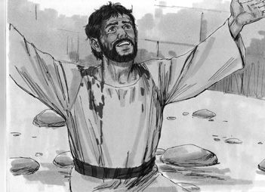
[ In the end, most of these men returned to follow Jesus. Some even ended up being killed because they chose to follow Jesus. ]

[ We can learn how to be disciples, or followers of Jesus by obeying his teachings, imitating him, and learning about how his disciples learned to follow Jesus. ]
Picture 14–4
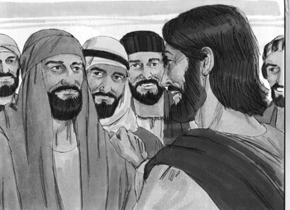
[ We can learn how to be disciples, or followers of Jesus by obeying his teachings, imitating him, and learning about how his disciples learned to follow Jesus. ]

Application
We can all be disciples for Jesus. One thing that we need to remember is that it will not be easy. To be a disciple for Christ we need to remember to resist Satan, and the temptation that he brings. We need to always remember to obey Jesus' teachings, and live the way that He lived. Jesus lived a life for others, he always showed love and compassion to everyone, even to those who were his enemies.
We can all be disciples for Jesus. One thing that we need to remember is that it will not be easy. To be a disciple for Christ we need to remember to resist Satan, and the temptation that he brings. We need to always remember to obey Jesus' teachings, and live the way that He lived. Jesus lived a life for others, he always showed love and compassion to everyone, even to those who were his enemies.
A true disciple of Jesus follows him and his teachings.
A true disciple of Jesus follows him and his teachings.
Homework
What can you do this week to show that you are a disciple of Jesus?
What can you do this week to show that you are a disciple of Jesus?
Prayer / Song
Review Game
Spaghetti Game
Materials
- Cooking pot with a lid
- Rope, string, or yarn cut into 10 pieces that are all different sizes
How to Play
- Put the rope, string, or yarn in the pot with some of it hanging out. Put the lid on the pot over the ropes.
- Divide the children into two teams.
- When someone on the team answers the question correctly, they come to the front and choose one of the ropes. (They never know if they will get a long or short rope.)
- The ropes that each team gets are tied together into one long rope.
- At the end, measure the ropes from the two teams side by side.
- The teams with the longest rope wins.
Questions for Review Game
- What are disciples? (People that follow Jesus and live by his teachings)
What are disciples? (People that follow Jesus and live by his teachings)
- What did Jesus do on the mountainside? (Prayed)
What did Jesus do on the mountainside? (Prayed)
- How long did Jesus stay on the mountainside? (A whole night)
How long did Jesus stay on the mountainside? (A whole night)
- Why was Jesus praying? (He had an important decision to make)
Why was Jesus praying? (He had an important decision to make)
- What was the important decision he was making? (Choosing 12 men to be his chief disciples)
What was the important decision he was making? (Choosing 12 men to be his chief disciples)
- What did Jesus call those twelve men? (Jesus called the twelve men his apostles.)
What did Jesus call those twelve men? (Jesus called the twelve men his apostles.)
- What was the Apostles' job? (Carry the teachings of Jesus to others)
What was the Apostles' job? (Carry the teachings of Jesus to others)
- What is the new name that Jesus gave Simon? (Jesus gave Simon the name Peter.)
What is the new name that Jesus gave Simon? (Jesus gave Simon the name Peter.)
- How can we be disciples of Jesus? (By following his teachings, and by trying to imitate him in the way we live.)
How can we be disciples of Jesus? (By following his teachings, and by trying to imitate him in the way we live.)
- What happened to many of the apostles? (Many of the apostles were killed for being followers of Jesus.)
What happened to many of the apostles? (Many of the apostles were killed for being followers of Jesus.)
Song
Memory Verse
Materials and Preparations
- Put a bookmark in Luke 6:13
- Write memory verse on the blackboard.
Luke 6:13 When morning came, he called his disciples to him and chose twelve of them, whom he also designated apostles.
Luke 6:13 When morning came, he called his disciples to him and chose twelve of them, whom he also designated apostles.
Teach and Explain
Our memory verse is in the Gospel of Luke. That is in the New Testament, a part of the Bible.
Our memory verse is in the Gospel of Luke. That is in the New Testament, a part of the Bible.
- Read the verse from your Bible.
- Read the verse by yourself as you point to the words.
- Read the verse with the children as you point to the words.
- Explain the verse:
Our memory verse comes from today’s Bible story.
Our memory verse comes from today’s Bible story.
- As you read the verse, circle the words shown below. Explain each of these words.
- Morning: Jesus had been praying all night because he had a very important decision to make. He had the decision in the morning.
Morning: Jesus had been praying all night because he had a very important decision to make. He had the decision in the morning.
- Disciple: Jesus had many disciples following him wherever he went. A disciple is someone who follows the teachings of Jesus.
Disciple: Jesus had many disciples following him wherever he went. A disciple is someone who follows the teachings of Jesus.
- Twelve: Jesus chose twelve men to be his chief disciples. Let's count to twelve together.
Twelve: Jesus chose twelve men to be his chief disciples. Let's count to twelve together.
- Apostles: Jesus called the special twelve men he chose apostles. They are special because they followed the teachings of Jesus and took His teachings to others.
Apostles: Jesus called the special twelve men he chose apostles. They are special because they followed the teachings of Jesus and took His teachings to others.
- Read the verse again by yourself as you point to the words.
- Read the verse again with the children as you point to the words.
Remember our truth for the day? Let’s all say it together:
Remember our truth for the day? Let’s all say it together:
A true disciple of Jesus follows him and his teachings.
A true disciple of Jesus follows him and his teachings.
Memory Verse Review
Children Repeat the Verse by Using Movements
- Talk about different movements with our bodies: Your hands on your head, standing on one foot, jumping up and down, touching your toes....
- Ask the children the first question.
- When a question is answered correctly, that child chooses one of the movements listed above or chooses their own movement.
- The verse is said out loud together while doing the movement.
- Then the next question is asked.
- When that question is answered correctly, another child chooses one of the movements.
- The verse is said aloud again while doing the movement.
- Do this until all the questions are asked.
Questions for Memory Verse
- Where is today's memory verse found? ( Luke 6:13 )
Where is today's memory verse found? ( Luke 6:13 )
- What had Jesus been doing all night before he made his big decision? (Praying)
What had Jesus been doing all night before he made his big decision? (Praying)
- What is a disciple? (Someone who follows the teachings of Jesus)
What is a disciple? (Someone who follows the teachings of Jesus)
- How many men did Jesus choose? (12)
How many men did Jesus choose? (12)
- Who can count to twelve? (Have them count to twelve.)
Who can count to twelve? (Have them count to twelve.)
- What is an apostle? (A special disciple that Jesus chose to take his teachings to others)
What is an apostle? (A special disciple that Jesus chose to take his teachings to others)
Song
Closing and Homework
- Say the truth together:
A true disciple of Jesus follows him and his teachings.
A true disciple of Jesus follows him and his teachings.
- Say the memory verse together:
Luke 6:13 When morning came, he called his disciples to him and chose twelve of them, whom he also designated apostles.
Luke 6:13 When morning came, he called his disciples to him and chose twelve of them, whom he also designated apostles.
- Review the homework:
What can you do this week to show that you are a disciple of Jesus?
What can you do this week to show that you are a disciple of Jesus?
- Give any needed announcements.
Closing Prayer
Thank God that we are called to be disciples of Jesus.
Ask God that the children will remember to think of a way to show that they are a disciple of Jesus.
Colouring page to colour and take home!

A true disciple of Jesus follows him and his teachings.
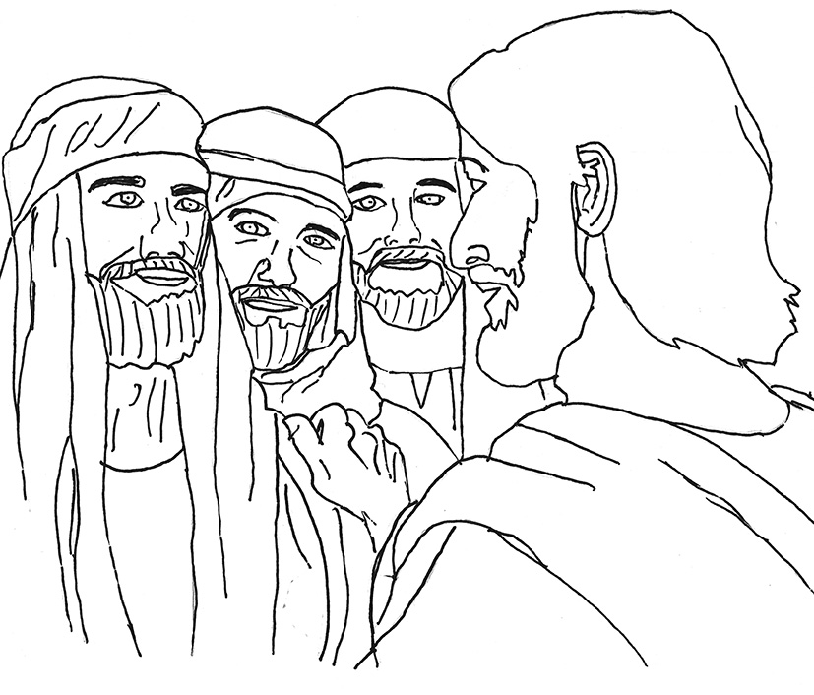

Luke 6:13 When morning came, he called his disciples to him and chose twelve of them, whom he also designated apostles.

A true disciple of Jesus follows him and his teachings.

Luke 6:13 When morning came, he called his disciples to him and chose twelve of them, whom he also designated apostles.

