
A True Disciple of Jesus Bears Good Fruit
A True Disciple of Jesus Bears Good Fruit
A True Disciple of Jesus Bears Good Fruit
Luke 6:43-44
Lesson Overview
Today’s Truth | A true disciple of Jesus bears good fruit.  A true disciple of Jesus bears good fruit.
Objective | KNOW: The children will know how to bear good fruit.  DO: The children will pray and ask God to help them make good choices, so that they could bear good fruit.
Materials | - Quarter 2 Picture book, Bible, chalk  - Copies of the memory verse coloring page for the children to take home.  - 5-10 different sized containers or cups (You can also use shoes or hats/caps)  - 5-10 strips of paper (One for each container). Write different amounts of points on each. (Have numbers as low as 1 and numbers as high as 100.)  - 2 bottle caps, stones, or other small things to throw
Memory Verse | Luke 6:43 No good tree bears bad fruit, nor does a bad tree bear good fruit.  Luke 6:43 No good tree bears bad fruit, nor does a bad tree bear good fruit.
Homework | This week, pray every day and ask Jesus to help you make good choices. That will help you grow into a good tree that bears good fruit.  This week, pray every day and ask Jesus to help you make good choices. That will help you grow into a good tree that bears good fruit.

Detailed Lesson Plan
Song
Opening
Welcome
- Be sure the children know you are happy to see them!
- Introduce yourself and your helpers.
Sharing Time
- Say the truth from the previous lesson together:
A true disciple of Jesus is generous.
A true disciple of Jesus is generous.
- Say the memory verse from the previous lesson together:
Luke 6:30-31 Give to everyone who asks you, and do not ask for your possessions back from the person who takes them away. Treat others in the same way that you would want them to treat you.
Luke 6:30-31 Give to everyone who asks you, and do not ask for your possessions back from the person who takes them away. Treat others in the same way that you would want them to treat you.
- Review the homework from the previous lesson:
The homework was to be generous to someone in your family, in your group of friends, or a schoolmate. Did you ask God to help you to be kind to them? Who was it? What did you do or say to them?
The homework was to be generous to someone in your family, in your group of friends, or a schoolmate. Did you ask God to help you to be kind to them? Who was it? What did you do or say to them?
(Give children time to share.)
Prayer
- Let the children share praises and prayer requests.
- Keep a record of what the children are sharing so you can remember to thank God together for answered prayers.
- Spend time praying together. Let children pray out loud if they volunteer. Do not force anyone to pray out loud.
Song
Words to Discuss
- On the blackboard, write the “Words to Discuss” from the list below.
- Let's discuss some words to help us better understand the Bible story for today.
Let's discuss some words to help us better understand the Bible story for today.
- Good Fruit: You make good fruit by doing good actions: being honest, being kind, being generous and helpful.
Good Fruit: You make good fruit by doing good actions: being honest, being kind, being generous and helpful.
- Bad Fruit: Anything that goes against what God stands for, actions and things we do that are bad.
Bad Fruit: Anything that goes against what God stands for, actions and things we do that are bad.
- Recognized: To notice or bring attention to.
Recognized: To notice or bring attention to.
Song
Bible Story / Lesson
Today we will be learning about how a true disciple of Jesus bears good fruit.
Today we will be learning about how a true disciple of Jesus bears good fruit.
Introduce Truth
Our truth for today is: A true disciple of Jesus bears good fruit.
Our truth for today is: A true disciple of Jesus bears good fruit.
We've been learning what Jesus taught about how his true followers would live. We learned that they love all people, even their enemies. We also learned that a true follower of Jesus is generous and shares with others. This week, Jesus teaches us that his true followers bear good fruit. What do you think it means to “bear good fruit”? Let me tell you a story that will help us understand.
We've been learning what Jesus taught about how his true followers would live. We learned that they love all people, even their enemies. We also learned that a true follower of Jesus is generous and shares with others. This week, Jesus teaches us that his true followers bear good fruit. What do you think it means to “bear good fruit”? Let me tell you a story that will help us understand.
Bible Story: A story from a village
I want to tell you about two brothers, Ngum and Tata. Ngum was nine years old; Tata was eight years old. One day, their mother sent them to carry firewood.
I want to tell you about two brothers, Ngum and Tata. Ngum was nine years old; Tata was eight years old. One day, their mother sent them to carry firewood.
On their way back, they saw their friends rushing to Ma Nungu's compound. They decided to follow. Ma Nungu was holding her weekly Bible Club. The boys decided to stay and see what it was like. They left their firewood outside the compound door.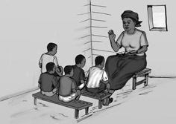
Picture 17–1

Ma Nungu led the club. They sang songs, played a game, and then they listened to a story about bearing good and bad fruit. At the end, Ma Nungu asked if those who were bearing bad fruit wanted to have their sins forgiven so that they could have eternal life, and start to bear good fruit. Both Ngum and Tata put up their hands and prayed with Ma.
On their way back, they saw their friends rushing to Ma Nungu's compound. They decided to follow. Ma Nungu was holding her weekly Bible Club. The boys decided to stay and see what it was like. They left their firewood outside the compound door.
Ma Nungu led the club. They sang songs, played a game, and then they listened to a story about bearing good and bad fruit. At the end, Ma Nungu asked if those who were bearing bad fruit wanted to have their sins forgiven so that they could have eternal life, and start to bear good fruit. Both Ngum and Tata put up their hands and prayed with Ma.
It was getting late, so Ngum and Tata needed to rush home. They left Ma Nungu's compound, but found that their firewood had been taken! It was too late to find more, so they just had to go home.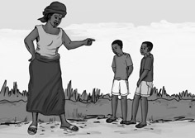
Picture 17–2

Once they reached the house, their mother was angry. She asked, “Where have you been? Where is your firewood?” Ngum spoke first, he said, “Big boys met us on the way and took our firewood. There was nothing we could do!” Tata said, “That is not true! We stopped at Ma Nungu's compound. She was having a Bible Club for children. It was great, and we prayed to have our sins forgiven!” Ngum looked angrily at Tata.
It was getting late, so Ngum and Tata needed to rush home. They left Ma Nungu's compound, but found that their firewood had been taken! It was too late to find more, so they just had to go home.
Once they reached the house, their mother was angry. She asked, “Where have you been? Where is your firewood?” Ngum spoke first, he said, “Big boys met us on the way and took our firewood. There was nothing we could do!” Tata said, “That is not true! We stopped at Ma Nungu's compound. She was having a Bible Club for children. It was great, and we prayed to have our sins forgiven!” Ngum looked angrily at Tata.
The next day, Ngum was still angry. His mother was not happy with him. She told him that he would have to go collect the firewood alone for having lied to her. Tata went along with Ngum to help. Even though he had told the truth, he still knew he was also to blame for the firewood not reaching the house. Ngum ran ahead, not wanting to walk with Tata. Along the way, Ngum met his small sister. He was so angry, he decided to beat her. Tata saw this, and ran to protect his sister from Ngum. Tata started shouting for someone to come help them. Ngum ran off. Tata comforted his small sister, and shared some groundnuts that he had in his pocket.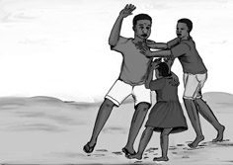
Picture 17–3

The next day, Ngum was still angry. His mother was not happy with him. She told him that he would have to go collect the firewood alone for having lied to her. Tata went along with Ngum to help. Even though he had told the truth, he still knew he was also to blame for the firewood not reaching the house. Ngum ran ahead, not wanting to walk with Tata. Along the way, Ngum met his small sister. He was so angry, he decided to beat her. Tata saw this, and ran to protect his sister from Ngum. Tata started shouting for someone to come help them. Ngum ran off. Tata comforted his small sister, and shared some groundnuts that he had in his pocket.
A week later, things had calmed down. Ngum and Tata were now playing together again. Ngum was no longer angry. As they were working around the house, they found their mother's handbag on the ground, money had fallen out of it. Ngum said, “Look, let's take the money. I really want to buy some sweets. Mama said I couldn't, but now I can!” Tata said, “No, it is not right for us to take that money, that is stealing. Don't you remember that we prayed to have our sins forgiven?” Ngum just looked at Tata, snatched up the money, and ran off. 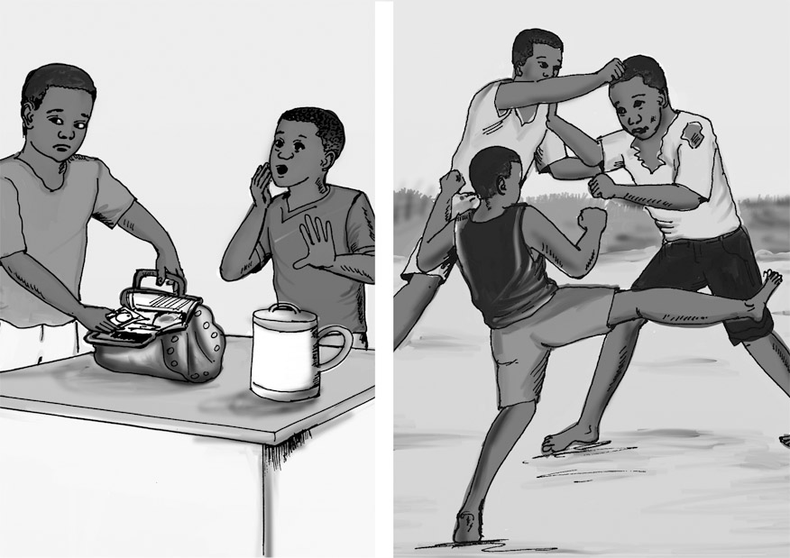
Picture 17–4

A week later, things had calmed down. Ngum and Tata were now playing together again. Ngum was no longer angry. As they were working around the house, they found their mother's handbag on the ground, money had fallen out of it. Ngum said, “Look, let's take the money. I really want to buy some sweets. Mama said I couldn't, but now I can!” Tata said, “No, it is not right for us to take that money, that is stealing. Don't you remember that we prayed to have our sins forgiven?” Ngum just looked at Tata, snatched up the money, and ran off.
Ngum went to buy the sweets with his mother's money. On the way home, some other boys saw him enjoying his sweets and asked him to share. He said, “No, they are mine! I don't want to share, and I don't have to share!” The boys said he was selfish. Ngum became angry and started fighting with them.
Once Ngum reached the house, his mother saw how his clothes were torn and he was covered in dirt. She asked him, “What happened?” He told her, “The boys in the village attacked me!” “Why?” She asked. Ngum said he didn't know. His mother then said, “Tata told me you took money from my handbag, and went to buy sweets. Did the boys try to take the sweets you bought?” Ngum's head sank, and he said, “Yes Mama, I took your money and bought sweets. The boys asked me to share, but I didn't want to. So, the boys said that I was selfish. That made me angry, so I attacked them.”
Ngum went to buy the sweets with his mother's money. On the way home, some other boys saw him enjoying his sweets and asked him to share. He said, “No, they are mine! I don't want to share, and I don't have to share!” The boys said he was selfish. Ngum became angry and started fighting with them.
Once Ngum reached the house, his mother saw how his clothes were torn and he was covered in dirt. She asked him, “What happened?” He told her, “The boys in the village attacked me!” “Why?” She asked. Ngum said he didn't know. His mother then said, “Tata told me you took money from my handbag, and went to buy sweets. Did the boys try to take the sweets you bought?” Ngum's head sank, and he said, “Yes Mama, I took your money and bought sweets. The boys asked me to share, but I didn't want to. So, the boys said that I was selfish. That made me angry, so I attacked them.”
That night as Ngum and Tata were getting ready to sleep, Ngum started to cry. “Why do I keep doing all these wrong things? I prayed the same prayer you prayed that day at Ma Nungu's compound. You are different, but I keep getting into trouble!” Tata replied that when he prayed to have Jesus forgive his sins and to live in his life, he was not just saying some special words. He prayed and believed with his whole heart, then he asked Jesus every day to help him do what is right. Tata and Ngum prayed together. This time, Ngum prayed and believed with his whole heart.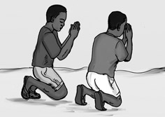
Picture 17–5

That night as Ngum and Tata were getting ready to sleep, Ngum started to cry. “Why do I keep doing all these wrong things? I prayed the same prayer you prayed that day at Ma Nungu's compound. You are different, but I keep getting into trouble!” Tata replied that when he prayed to have Jesus forgive his sins and to live in his life, he was not just saying some special words. He prayed and believed with his whole heart, then he asked Jesus every day to help him do what is right. Tata and Ngum prayed together. This time, Ngum prayed and believed with his whole heart.
Application
Even though you may have already asked Jesus into your heart, are you really following him? To be a true disciple of Jesus, you believe with all of your heart. If you believe with all of your heart, and you are reading your Bible, it will show in your life. Stealing, lying, are things that Jesus does not want us to do. If we truly follow Jesus, we will want to do what is right, we will want to live like Jesus. Did Jesus steal, fight, and hurt others? No, he lived by the Spirit, which is to show love to everyone. We are to live like Jesus.
Even though you may have already asked Jesus into your heart, are you really following him? To be a true disciple of Jesus, you believe with all of your heart. If you believe with all of your heart, and you are reading your Bible, it will show in your life. Stealing, lying, are things that Jesus does not want us to do. If we truly follow Jesus, we will want to do what is right, we will want to live like Jesus. Did Jesus steal, fight, and hurt others? No, he lived by the Spirit, which is to show love to everyone. We are to live like Jesus.
A true disciple of Jesus bears good fruit.
A true disciple of Jesus bears good fruit.
Homework
This week, pray every day and ask Jesus to help you make good choices. That will help you grow into a good tree that bears good fruit.
This week, pray every day and ask Jesus to help you make good choices. That will help you grow into a good tree that bears good fruit.
Prayer / Song
Review Game
Throw Bottle Caps into Containers
Materials
- Draw a line for the children to stand behind.
- Arrange 5-10 different sized containers or cups (you can also use shoes or hats/caps) into a group a distance from the line.
- Put one small paper with points written on it inside each container.
- Collect 2 bottle caps, stones, or other small things to throw and set them on the line that you drew for the children to stand behind.
How to Play
- Divide the class into 2 teams.
- The first team tries to answer the first question. The teacher can use this time to explain what the children do not seem to understand.
- The child on the team that answers the question correctly comes to the front and stands behind the line. If the child only gets part of the question right, the teacher can fill in the rest.
- The child then tries to throw the bottle cap into the group of containers. Wherever the bottle cap enters, the points on the paper inside that container are what the team has.
- Record the points. The team with the most points wins.
- Be sure to clap for both sides. No name-calling. Encourage good sportsmanship.
Questions for Review Game
- What is one way we have learned how a true follower of Jesus lives? ( True disciples of Jesus love their enemies. )
What is one way we have learned how a true follower of Jesus lives? ( True disciples of Jesus love their enemies. )
- What is another way we have learned how a true follower of Jesus lives? ( A true disciple of Jesus is generous. )
What is another way we have learned how a true follower of Jesus lives? ( A true disciple of Jesus is generous. )
- What did we learn today how a true follower of Jesus lives? ( A true disciple of Jesus bears good fruit. )
What did we learn today how a true follower of Jesus lives? ( A true disciple of Jesus bears good fruit. )
- What does it mean to bear good fruit? (Do good things)
What does it mean to bear good fruit? (Do good things)
- Who in the story today bore good fruit? (Tata)
Who in the story today bore good fruit? (Tata)
- What were some of the good actions that Tata did to show he was a follower of Jesus? (Tata told the truth, even though it was hard.)
What were some of the good actions that Tata did to show he was a follower of Jesus? (Tata told the truth, even though it was hard.)
- What is another action that Tata did to show he was a true follower of Jesus? (Tata also helped his brother.)
What is another action that Tata did to show he was a true follower of Jesus? (Tata also helped his brother.)
- What is another good action that Tata did to show that he was a follower of Jesus? (Another action that Tata did to show he was a true follower of Jesus, was he protected his younger sister.)
What is another good action that Tata did to show that he was a follower of Jesus? (Another action that Tata did to show he was a true follower of Jesus, was he protected his younger sister.)
- What is another good action that Tata did to show he was a follower of Jesus? (He did not steal from his mother's purse.)
What is another good action that Tata did to show he was a follower of Jesus? (He did not steal from his mother's purse.)
- Why was it hard for Ngum to do good things? (He did not pray with his whole heart to have Jesus in his life. He did not ask Jesus every day to help him make good decisions.)
Why was it hard for Ngum to do good things? (He did not pray with his whole heart to have Jesus in his life. He did not ask Jesus every day to help him make good decisions.)
Song
Memory Verse
Materials and Preparations
- Put a bookmark in Luke 6:43
- Write memory verse on the blackboard.
Luke 6:43 No good tree bears bad fruit, nor does a bad tree bear good fruit.
Luke 6:43 No good tree bears bad fruit, nor does a bad tree bear good fruit.
Teach and Explain
Our memory verse is in the Gospel of Luke. That is in the New Testament, a part of the Bible.
Our memory verse is in the Gospel of Luke. That is in the New Testament, a part of the Bible.
- Read the verse from your Bible.
- Read the verse by yourself as you point to the words.
- Read the verse with the children as you point to the words.
- Explain the verse:
- Our memory verse comes from today’s Bible story.
Our memory verse comes from today’s Bible story.
- As you read the verse, circle the words shown below. Explain each of these words.
- Bad Fruit: What kind of fruit would you expect from a good mango tree? You would expect good mangoes, right? Of course! You wouldn't expect to get bad fruit from that tree.
Bad Fruit: What kind of fruit would you expect from a good mango tree? You would expect good mangoes, right? Of course! You wouldn't expect to get bad fruit from that tree.
- Good Fruit: If you had a bad mango tree, you would be surprised to harvest a good fruit from that tree. Wouldn't you?
Good Fruit: If you had a bad mango tree, you would be surprised to harvest a good fruit from that tree. Wouldn't you?
- Fruit: We can tell what a tree is by its fruit. Mango trees give mangoes for fruit. Guava trees give guavas. We can also tell if a tree is good or bad by its quality of fruit we harvest from it. If a tree only gives bad fruit, it is not a good tree.
Fruit: We can tell what a tree is by its fruit. Mango trees give mangoes for fruit. Guava trees give guavas. We can also tell if a tree is good or bad by its quality of fruit we harvest from it. If a tree only gives bad fruit, it is not a good tree.
- Read the verse again by yourself as you point to the words.
- Read the verse again with the children as you point to the words.
In the same way, people will know that we are followers of Jesus by our good fruit. This means that people will know us by our good actions: being honest, being kind, being generous and helpful. Jesus reminds us that our speech and our actions show our true beliefs.
In the same way, people will know that we are followers of Jesus by our good fruit. This means that people will know us by our good actions: being honest, being kind, being generous and helpful. Jesus reminds us that our speech and our actions show our true beliefs.
Remember our truth for the day? Let’s all say it together:
Remember our truth for the day? Let’s all say it together:
A true disciple of Jesus bears good fruit.
A true disciple of Jesus bears good fruit.
Memory Verse Review
Children Repeat the Verse by Using Movements
- Talk about different movements with our bodies: Your hands on your head, standing on one foot, jumping up and down, touching your toes....
- Ask the children the first question.
- When a question is answered correctly, that child chooses one of the movements listed above or chooses their own movement.
- The verse is said out loud together while doing the movement.
- Then the next question is asked.
- When that question is answered correctly, another child chooses one of the movements.
- The verse is said aloud again while doing the movement.
- Do this until all the questions are asked.
Questions for Memory Verse
- What kind of fruit will a good tree produce? (Good fruit)
What kind of fruit will a good tree produce? (Good fruit)
- What is another way we have learned how a true follower of Jesus lives? ( A true disciple of Jesus is generous. )
What is another way we have learned how a true follower of Jesus lives? ( A true disciple of Jesus is generous. )
- What did we learn today how a true follower of Jesus lives? ( A true disciple of Jesus bears good fruit. )
What did we learn today how a true follower of Jesus lives? ( A true disciple of Jesus bears good fruit. )
- What does it mean to bear good fruit? (Do good things)
What does it mean to bear good fruit? (Do good things)
- What does good fruit look like in the life of a follower of Jesus? (Give examples of being honest, helpful, generous, kind, praying, and studying the Bible to know how God wants us to live, etc.)
What does good fruit look like in the life of a follower of Jesus? (Give examples of being honest, helpful, generous, kind, praying, and studying the Bible to know how God wants us to live, etc.)
Song
Closing and Homework
- Say the truth together:
A true disciple of Jesus bears good fruit.
A true disciple of Jesus bears good fruit.
- Say the memory verse together:
Luke 6:43 No good tree bears bad fruit, nor does a bad tree bear good fruit.
Luke 6:43 No good tree bears bad fruit, nor does a bad tree bear good fruit.
- Review the homework:
This week, pray every day and ask Jesus to help you make good choices. That will help you grow into a good tree that bears good fruit.
This week, pray every day and ask Jesus to help you make good choices. That will help you grow into a good tree that bears good fruit.
- Give any needed announcements.
Closing Prayer
Thank God that we are able to bear good fruit.
Ask God that the children will be in prayer every day this week, and ask God to help them bear good fruit.
Colouring page to colour and take home!

A true disciple of Jesus bears good fruit.

Luke 6:43 No good tree bears bad fruit, nor does a bad tree bear good fruit.

A true disciple of Jesus bears good fruit.

Luke 6:43 No good tree bears bad fruit, nor does a bad tree bear good fruit.

