**Doctor Consultation System**

Peter Mbugua Ndungu

SC211/0826/2017

Dr. Mariga

A project report submitted in partial fulfillment of the requirements for the award of Bachelor of Business Information Technology at the School of Computing and information Technology, Murang’a University of Technology

**SYSTEM ANALYSIS**

System analysis is a process of gathering and interpreting facts, diagnosing problems and the information about the Hospital Appointment System to recommend improvements on the system. It is a problem-solving activity that requires intensive communication between the system users and system developers. System analysis or study is an important phase of any system development process. The system is studied to the minutest detail and analyzed. The system analyst plays the role of the interrogator and dwells deep into the working of the present system. The system is viewed as a whole and the input to the system are identified. The outputs from the organizations are traced to the various processes. System analysis is concerned with becoming aware of the problem, identifying the relevant and decisional variables, analyzing and synthesizing the various factors and determining an optimal or at least a satisfactory solution or program of action. A detailed study of the process must be made by various techniques like interviews, questionnaires etc. The data collected by these sources must be scrutinized to arrive to a conclusion. The conclusion is an understanding of how the system functions. This system is called the existing system. Now the existing system is subjected to close study and problem areas are identified. The designer now functions as a problem solver and tries to sort out the difficulties that the enterprise faces. The solutions are given as proposals. The proposal is then weighed with the existing system analytically and the best one is selected. The proposal is presented to the user for an endorsement by the user. The proposal is reviewed on user request and suitable changes are made. This is loop that ends as soon as the user is satisfied with proposal. Preliminary study is the process of gathering and interpreting facts, using the information for further studies on the system. Preliminary study is problem solving activity that requires intensive communication between the system users and system developers. It does various feasibility studies. In these studies, a rough figure of the system activities can be obtained, from which the decision about the strategies to be followed for effective system study and analysis can be taken.

Existing System of Hospital Appointment System:

In the existing system the exams are done only manually but in proposed system we have to computerize the exams using this application.

• Lack of security of data.

• More man power.

• Time consuming.

• Consumes large volume of pare work.

• Needs manual calculations.

• No direct role for the higher officials

Proposed System of Hospital Appointment System:

The aim of proposed system is to develop a system of improved facilities. The proposed system can overcome all the limitations of the existing system. The system provides proper security and reduces the manual work.

* Security of data.
* Ensure data accuracies.
* Proper control of the higher officials.
* Minimize manual data entry.
* Minimum time needed for the various processing.
* Greater efficiency.
* Better service.
* User friendliness and interactive.
* Minimum time required.

**SYSTEM DESIGN**

n this phase, a logical system is built which fulfils the given requirements. Design phase of software development deals with transforming the client’s requirements into a logically working system. Normally, design is performed in the following in the following two steps:

1. **Primary Design Phase**: In this phase, the system is designed at block level. The blocks are created on the basis of analysis done in the problem identification phase. Different blocks are created for different functions emphasis is put on minimizing the information flow between blocks. Thus, all activities which require more interaction are kept in one block.

2. **Secondary Design Phase**: In the secondary phase the detailed design of every block is performed.

Use Case diagram

Use-case diagrams describe the high-level functions and scope of a system. These diagrams also identify the interactions between the system and its actors. ... Use-case diagrams illustrate and define the context and requirements of either an entire system or the important parts of the system.

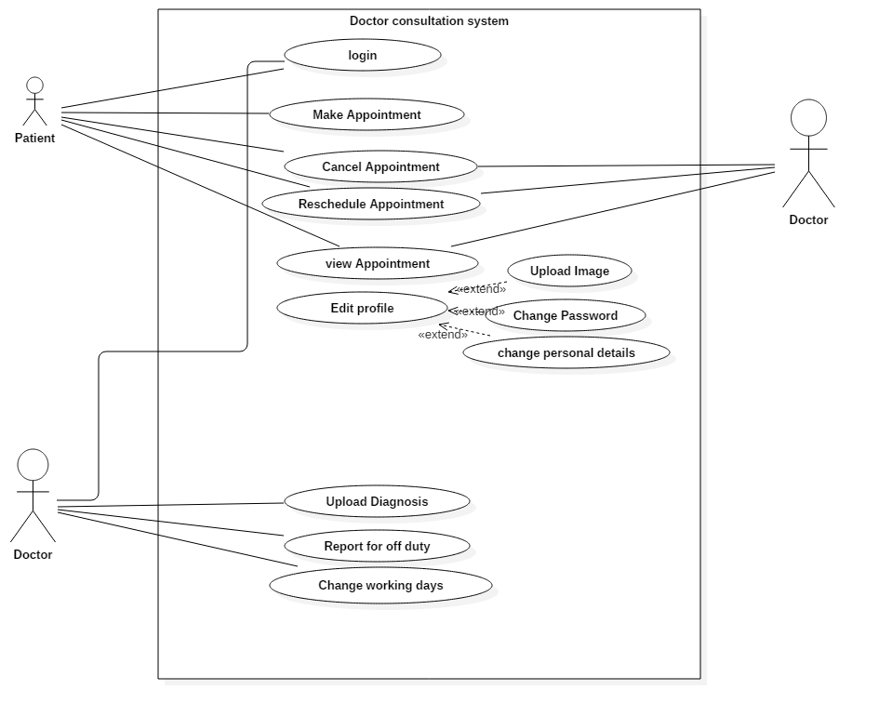

Class diagram

Used to model the objects that make up the system, to display the relationships between the objects, and to describe what those objects do and the services that they provide.

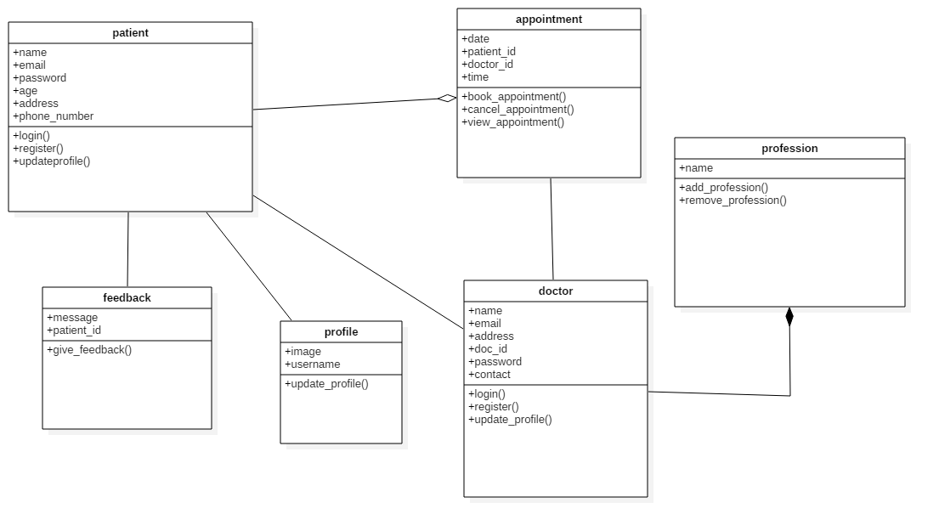

ER – Diagram

An entity relationship diagram (ERD) shows the relationships of entity sets stored in a database. An entity in this context is an object, a component of data. An entity set is a collection of similar entities. These entities can have attributes that define its properties.

By defining the entities, their attributes, and showing the relationships between them, an ER diagram illustrates the logical structure of databases.

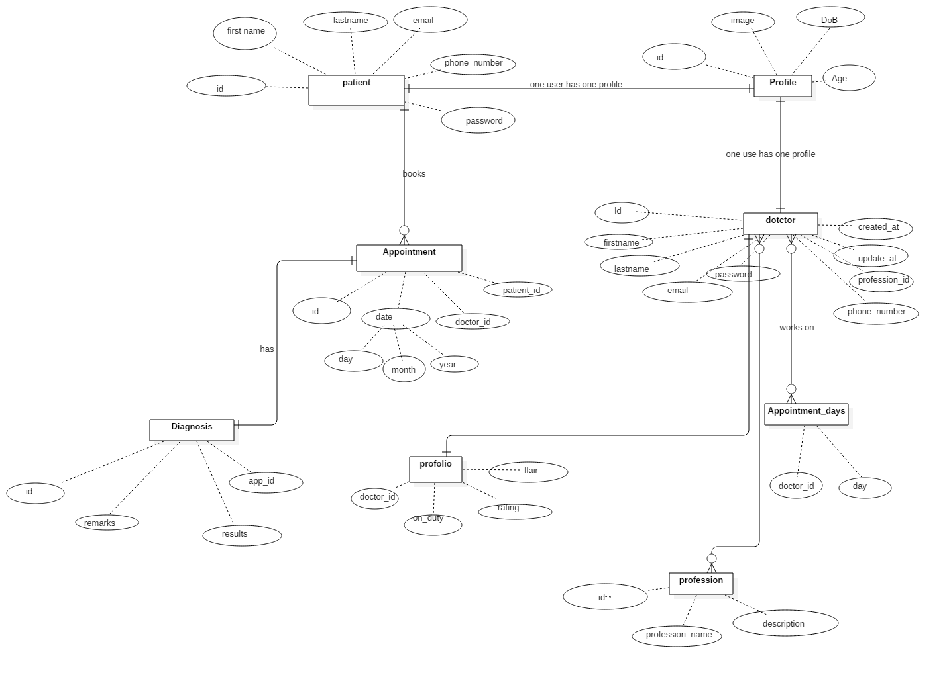

System Development

The development stage is the part actual code is written and application building is according to the earlier design documents and outlined specifications.

Product program code is built per the design document specifications. In theory, all of the prior planning and outlined should make the actual development phase relatively straightforward.

Developers will follow any coding guidelines as defined by the organization and utilize different tools such as compilers, debuggers, and interpreters.

The section will contain code and screenshots of various graphical user interface. The website user interface is coded using html to define the elements, CSS to design the layout of elements and beautify the site and JavaScript to make the site interactive. The php is used in the backend to capture user data and store the data in the database.

**Login form**

Form that will enable patient and doctor to log into to the system and perform various activities on the website

The form will have to field that is the username or and the password

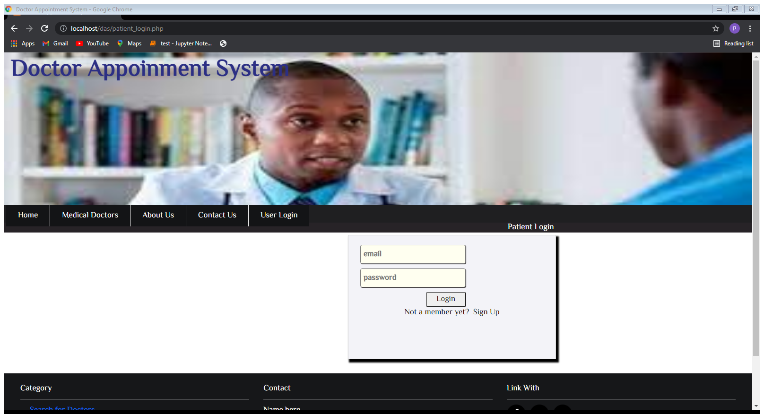

**Patient Registration form**

The form enables new patient users to sign up for an account in the system. The user data obtained is stored in the patient table in the database and used later to authenticate the user into the system

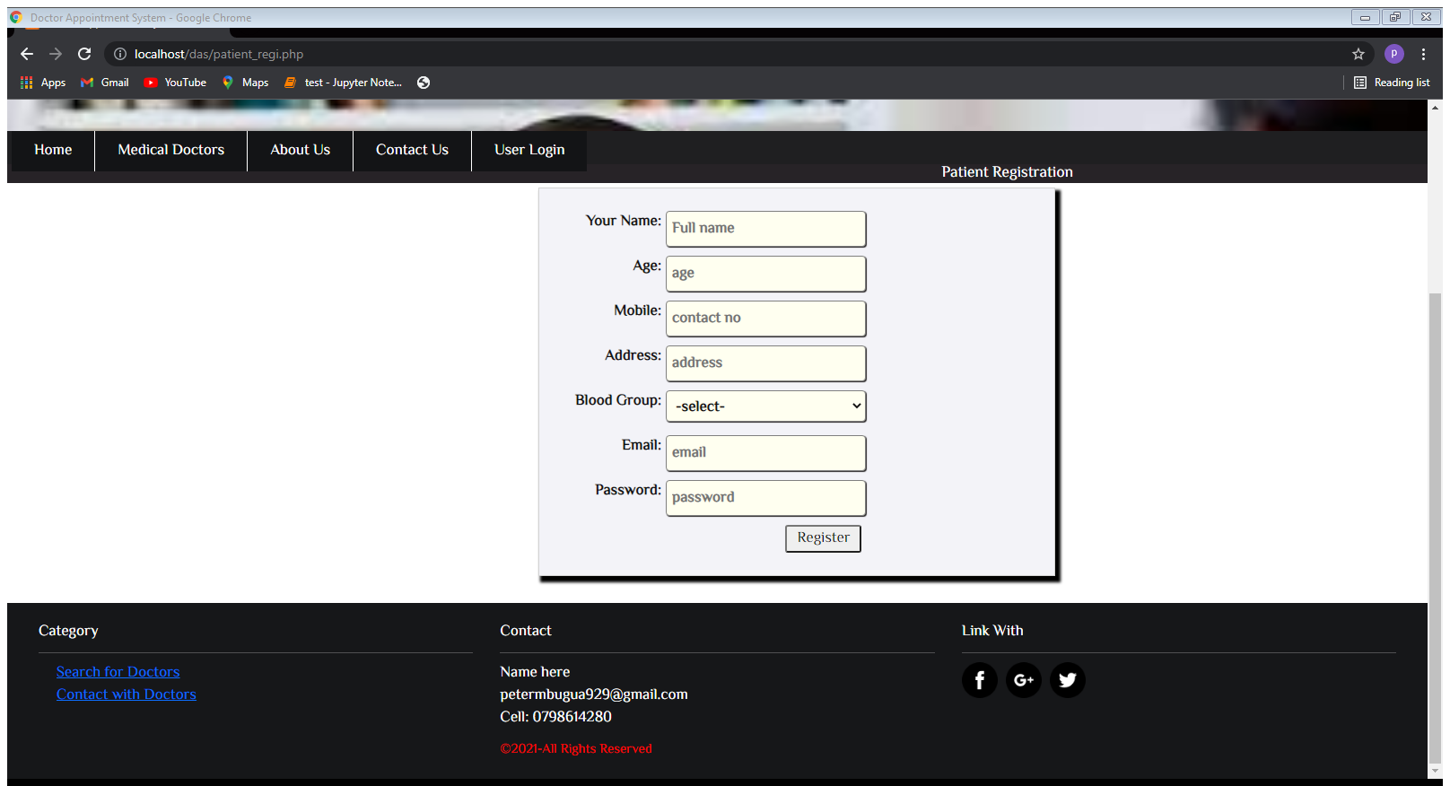

**Doctor Search Form**

Used by logged in user such as patient to search for doctor according to either the location of the clinic or by area that the doctor has specialized in.

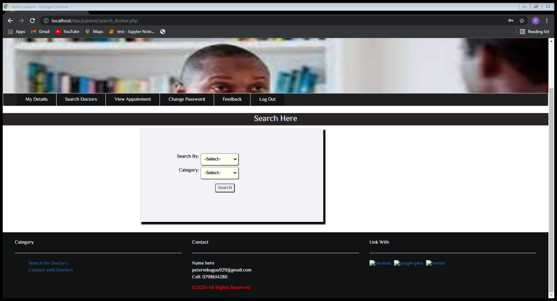

**Medical Doctors Page**

Used to display the top doctors who are the most search doctors and who are also influential people in their craft

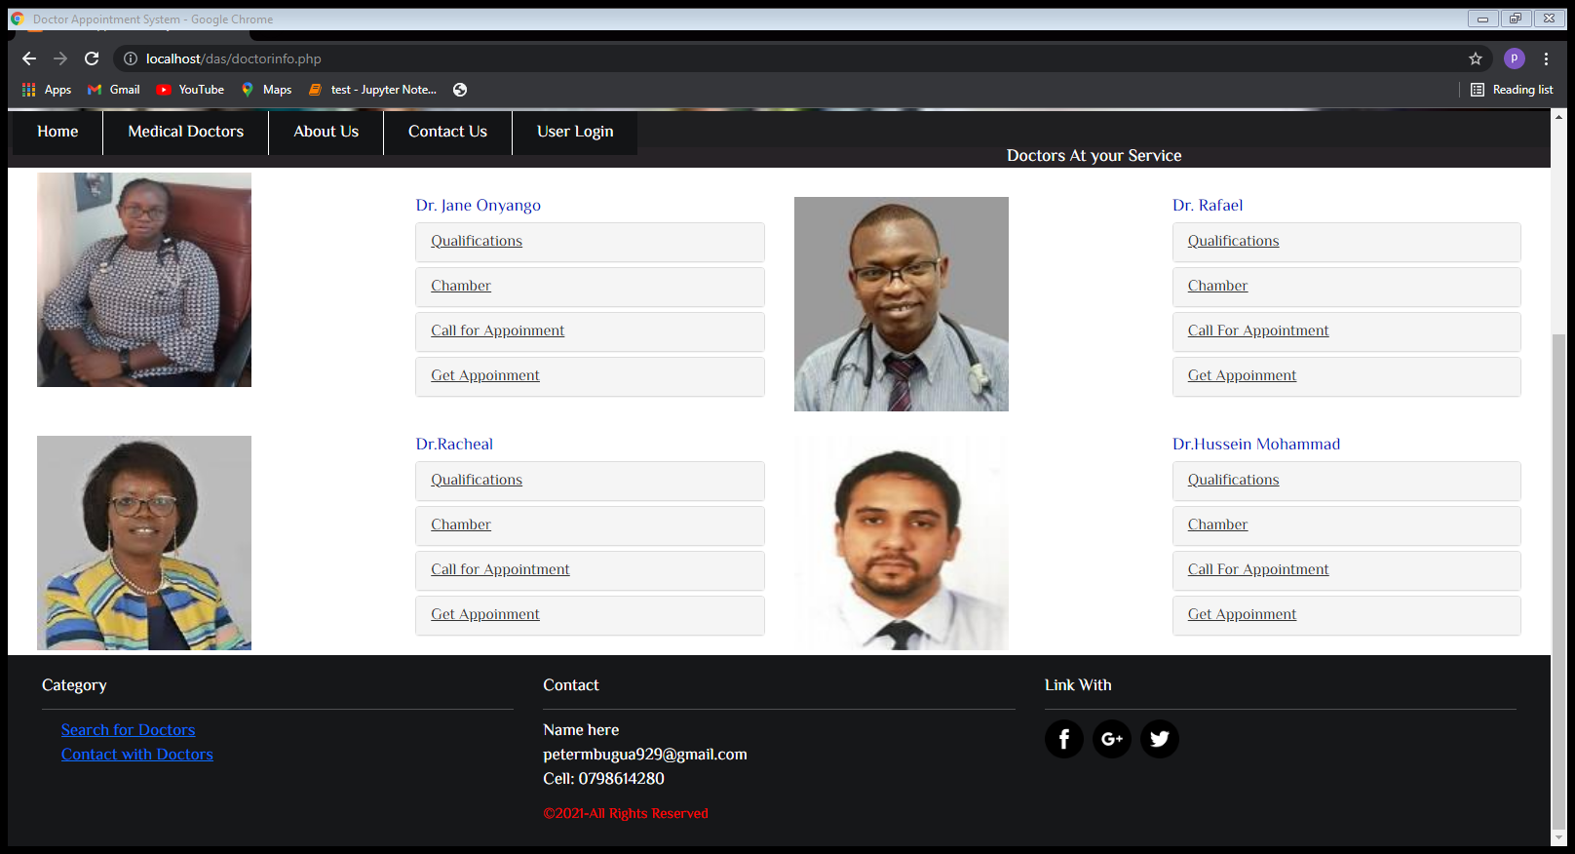

**Doctor’s Profile page**

The page displays a doctor profile which are the doctor personal information and the doctor image that is upload after the doctor has created an account in the system. The page has a title of My details. It also a form where a doctor can edit his or her details and update them requlary.

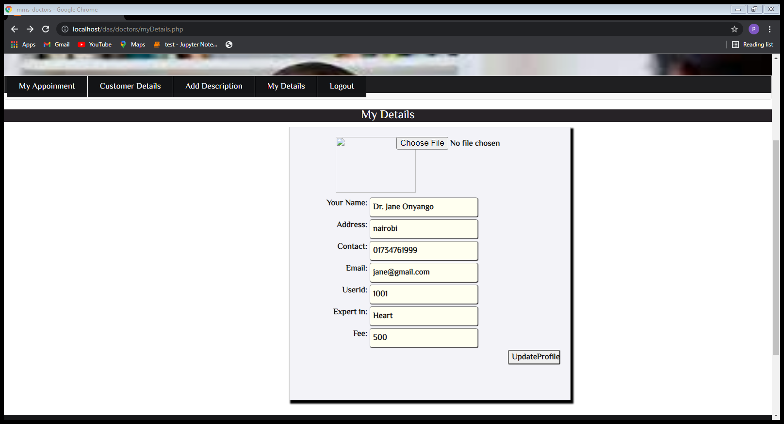

**Doctor Search Result Page**

The webpage contains content of the results from the database after the query matches a certain field or fields in the doctor’s table in the database

