
设计模式与系统架构分析报告


系 （院）： 计算机科学学院
课 程： 设计模式与系统架构
指导教师： 向华
专业班级： 计科11402
姓 名： 邓元坤
学 号： 201403617
设计时间： 2017.6.12 - 2017.6.25
个人gitgub网址:https://github.com/silencereader
代码的链接如下：
https://github.com/YEN-GitHub/PatternDemo/tree/master/src/BehavioralPattern2/ObserverPattern

package BehavioralPattern2.ObserverPattern.demo1;

/**
* Created by yangenneng on 2017-06-14 10:37
* Abstract：抽象观察者角色
*/
public abstract class Observer {

protected String stuName;//学生姓名
protected Subject subject;//哨兵

/*构造函数*/
Observer(String stuName,Subject subject){
this.stuName=stuName;
this.subject=subject;
}

/*改变状态*/
public abstract void update();

public String getStuName() {
return stuName;
}

public void setStuName(String stuName) {
this.stuName = stuName;
}

public Subject getSubject() {
return subject;
}

public void setSubject(Subject subject) {
this.subject = subject;
}

}

package BehavioralPattern2.ObserverPattern.demo1;

import java.util.ArrayList;

/**
* Created by yangenneng on 2017-06-14 10:37
* Abstract：抽象主题角色-即哨兵
*/
public abstract class Subject {

protected String msg="";//通知信息

Subject(String msg){
this.msg=msg;
}

/*存放所有待通知的观察者*/
protected ArrayList<Observer> arrayList=new ArrayList<>();

/*增加被观察者*/
public void addObserver(Observer obj) {arrayList.add(obj);}

/*移除被观察者*/
public void removeObserver(Observer obj){arrayList.remove(obj);}

/*通知函数*/
public abstract void notifyObserver();

public String getMsg() {
return msg;
}

public void setMsg(String msg) {
this.msg = msg;
}

}

package BehavioralPattern2.ObserverPattern.demo1;

/**
* Created by yangenneng on 2017-06-14 11:01
* Abstract：游戏观察者
*/
public class GameObserver extends Observer {

GameObserver(String name,Subject subject){super(name,subject);}

@Override
public void update() {
System.out.println(this.stuName+"切换状态，由游戏状态变为做实验状态");
}

}

package BehavioralPattern2.ObserverPattern.demo1;

/**
* Created by yangenneng on 2017-06-14 11:02
* Abstract：视频观察者
*/
public class VideoObserver extends Observer {

VideoObserver(String name,Subject subject){super(name,subject);}

@Override
public void update() {
System.out.println(this.stuName+"切换状态，由视频状态变为做实验状态");
}
}

package BehavioralPattern2.ObserverPattern.demo1;

/**
* Created by yangenneng on 2017-06-14 11:03
* Abstract：好人哨兵
*/
public class SentrySubject extends Subject{

SentrySubject(String msg) {
super(msg);
}

/*通知函数*/
public void notifyObserver(){
System.out.println(msg);
for (Observer observer:arrayList){
observer.update();
}
}

}

package BehavioralPattern2.ObserverPattern.demo1;

/**
* Created by yangenneng on 2017-06-14 11:06
* Abstract：老师-哨兵
*/
public class TeacherSubject extends Subject{

TeacherSubject(String msg) {
super(msg);
}

/*通知函数*/
public void notifyObserver(){
System.out.println(msg);
for (Observer observer:arrayList){
observer.update();
}
panish();//惩罚
}

/*惩罚学生函数*/
public void panish(){
for (Observer observer:arrayList){
System.out.print(observer.getStuName()+ " ");
}
System.out.println("罚抄观察者模式10遍");
}

}

package BehavioralPattern2.ObserverPattern.demo1;

/**
* Created by yangenneng on 2017-06-14 11:10
* Abstract：客户端测试
*/
public class Client {
public static void main(String[] args) {
Subject subject=new SentrySubject("");

Observer stu1=new GameObserver("张三",subject);
Observer stu2=new VideoObserver("李四",subject);

subject.addObserver(stu1);
subject.addObserver(stu2);

subject.notifyObserver();

System.out.println("-------------------------------------");

subject=new TeacherSubject("高老师来了");

subject.addObserver(stu1);
subject.addObserver(stu2);
subject.notifyObserver();
}
}

任务分析：
观察者有游戏观察者（GameObserver）和视频观察者（VideoObserver）。
观察者中的更新函数（updata）只需输出具体Subject对象的状态和状态改变语句即可。
目标对象(Subject）有哨兵（Sentry）和老师（teacher），一个目标对象可以对应多个和多种观察者对象，
当客服端目标对象状态设置为（"高老师来了"），调用通知函数（notifyObserver）通知所有对应的观察者对象执行更新函数。
其中老师（teacher）的状态还包括一个惩罚（panish）函数，惩罚（panish）函数输出如下“XXX XXX（所有惩罚人的名字）把观察者模式的结构图抄写10遍”
完成状态更新
UML图：
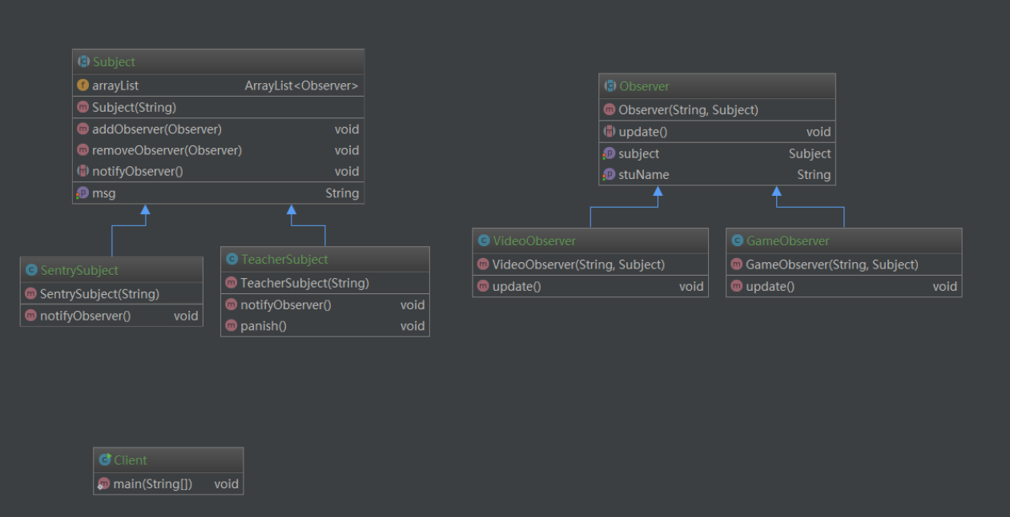

作业二
代码链接：https://github.com/honghailiang/SpringMango
一、相关库文件
根据myeclipse中创建gradle web项目建立完成后（建议使用idea进行，本系列也已用idea进行分析），在build.gradle中添加下面库文件
- apply plugin: 'java'
- apply plugin: 'war'

- sourceCompatibility = 1.5
- version = '1.0'
- jar {
- manifest {
- attributes 'Implementation-Title': 'Gradle Quickstart',
- 'Implementation-Version': version
- }
- }

- repositories {
- jcenter()
- mavenCentral()
- }

- dependencies {
- compile group: 'commons-collections', name: 'commons-collections', version: '3.2'
- testCompile group: 'junit', name: 'junit', version: '4.+'

- //servlet
- providedCompile group: 'javax.servlet', name: 'javax.servlet-api', version: '3.1.0' //在配置apply plugin: 'war'才可用
- runtime("jstl:jstl:1.2")

- //spring
- def springVersion = "4.3.2.RELEASE";
- compile "org.springframework:spring-context:$springVersion"
- compile "org.springframework:spring-core:$springVersion"
- compile "org.springframework:spring-webmvc:$springVersion"

- //sitemesh
- compile "org.sitemesh:sitemesh:3.0.0"

- //log4j2
- def log4j_version = "2.2";
- compile "org.apache.logging.log4j:log4j-api:$log4j_version"
- compile "org.apache.logging.log4j:log4j-core:$log4j_version"
- compile "org.apache.logging.log4j:log4j-slf4j-impl:$log4j_version"

- }

- test {
- systemProperties 'property': 'value'
- }

- uploadArchives {
- repositories {
- flatDir {
- dirs 'repos'
- }
- }
- }

二、虽然spring从3.1版本后可以采用Java配置的方式配置springMVC（具体可参见《spring实战第四版》）。但本文还是采用传统的web.xml配置方式

- <?xml version="1.0" encoding="UTF-8"?>
- <web-app xmlns:xsi="http://www.w3.org/2001/XMLSchema-instance" xmlns="http://java.sun.com/xml/ns/javaee" xsi:schemaLocation="http://java.sun.com/xml/ns/javaee http://java.sun.com/xml/ns/javaee/web-app_3_0.xsd" id="WebApp_ID" version="3.0">
- <display-name>SpringMango</display-name>
- <!--==================== LISTENER Spring容器====================-->
- <context-param>
- <param-name>contextConfigLocation</param-name>
- <param-value>classpath*:applicationContext-*.xml</param-value>
- </context-param>
- <listener>
- <listener-class>org.springframework.web.context.ContextLoaderListener</listener-class>
- </listener>

- <!-- 防止内存泄漏 -->
- <listener>
- <listener-class>org.springframework.web.util.IntrospectorCleanupListener</listener-class>
- </listener>

- <!--==================== SERVLET Spring MVC====================-->
- <servlet>
- <servlet-name>Mango</servlet-name>
- <servlet-class>
- org.springframework.web.servlet.DispatcherServlet
- </servlet-class>
- <load-on-startup>1</load-on-startup>
- </servlet>
- <servlet-mapping>
- <servlet-name>Mango</servlet-name>
- <url-pattern>/</url-pattern>
- </servlet-mapping>

- <!--START 设置字符编码过滤器-->
- <filter>
- <description>字符集过滤器</description>
- <filter-name>encodingFilter</filter-name>
- <filter-class>org.springframework.web.filter.CharacterEncodingFilter</filter-class>
- <init-param>
- <description>字符集编码</description>
- <param-name>encoding</param-name>
- <param-value>UTF-8</param-value>
- </init-param>
- </filter>
- <filter-mapping>
- <filter-name>encodingFilter</filter-name>
- <url-pattern>/*</url-pattern>
- </filter-mapping>
- <!--END 设置字符编码过滤器-->

- <!--sitemesh装饰器-->
- <filter>
- <filter-name>sitemesh</filter-name>
- <filter-class>
- org.sitemesh.config.ConfigurableSiteMeshFilter
- </filter-class>
- <init-param>
- <param-name>ignore</param-name>
- <param-value>true</param-value>
- </init-param>
- <init-param>
- <param-name>encoding</param-name>
- <param-value>GBK</param-value>
- </init-param>
- </filter>
- <filter-mapping>
- <filter-name>sitemesh</filter-name>
- <url-pattern>/*</url-pattern>
- </filter-mapping>

- </web-app>
DispatcherServlet配置文件采用默认从/WEB-INF/下Mango-servlet.xml加载的方式，也可以通过contextConfigLocation指定xml文件路径：
- <servlet>
- <servlet-name>Mango</servlet-name>
- <servlet-class>
- org.springframework.web.servlet.DispatcherServlet
- </servlet-class>
- <init-param>
- <param-name>contextConfigLocation</param-name>
- <param-value>classpath*:Mango-servlet.xml</param-value>
- </init-param>
- <load-on-startup>1</load-on-startup>
- </servlet>
三、servlet配置文件：Mango-servlet.xml
- <?xml version="1.0" encoding="UTF-8"?>
- <beans xmlns="http://www.springframework.org/schema/beans"
- xmlns:xsi="http://www.w3.org/2001/XMLSchema-instance"
- xmlns:context="http://www.springframework.org/schema/context"
- xmlns:mvc="http://www.springframework.org/schema/mvc"
- xsi:schemaLocation="http://www.springframework.org/schema/beans
- http://www.springframework.org/schema/beans/spring-beans.xsd
- http://www.springframework.org/schema/context
- http://www.springframework.org/schema/context/spring-context.xsd
- http://www.springframework.org/schema/mvc
- http://www.springframework.org/schema/mvc/spring-mvc.xsd">

- <!-- 扫描web包，应用Spring的注解 -->
- <mvc:annotation-driven/>
- <context:component-scan base-package="com.mango.jtt.controller"/>

- <!-- jsp视图 -->
- <bean id="viewResolver" class="org.springframework.web.servlet.view.InternalResourceViewResolver">
- <property name="viewClass" value="org.springframework.web.servlet.view.JstlView" />
- <property name="prefix" value="/WEB-INF/views/jsp/"/>
- <property name="suffix" value=".jsp"/>
- </bean>

- <!-- 静态资源不走controller -->
- <mvc:resources mapping="/resources/**" location="/resources/" />
- <!-- or <mvc:default-servlet-handler/> 与上面mvc:resources标签选其一即可,这里如果配置，必须配置<mvc:annotation-driven/>其他controller才可正常工作-->

- </beans>

通过<mvc:annotation-driven/>启用springMVC的注解配置，该标签注册了多个特性：包括JSR-303校验支持，信息转换以及对域格式化的支持。
<context:component-scan/>标签时查找对应支持的注解类并注册到容器中的bean
<mvc:resources/>标签配置静态资源文件不需要走控制器，直接映射到mapping下，该标签3.0.4及以后才有
四、controller
- /**
- *
- */
- package com.mango.jtt.controller;

- import org.springframework.stereotype.Controller;
- import org.springframework.web.bind.annotation.RequestMapping;

- /**
- * @author HHL
- *
- * @date 2016年11月22日
- */
- @Controller
- public class PageController {

- /**
- * 首页 映射/和/index路径
- *
- * @return
- * @throws Exception
- */
- @RequestMapping({ "/", "/index" })
- public String index() throws Exception {
- return "index";
- }

- }

五、index.jsp
采用了sitemesh装饰器
- <%@ page language="java" pageEncoding="UTF-8" contentType="text/html;charset=UTF-8"%>
- <%@ include file="../includes/taglibs.jsp"%>
- <!DOCTYPE html>
- <html>
- <head>
- <title>Mango-Index</title>
- <meta name="menu" content="home" />
- </head>

- <body>

- <h1>欢迎光临!</h1>

- <div style="text-align:center"><img src="<c:url value='/resources/images/team.jpg'/>" /></div>

- </body>
- </html>
装饰器sitemesh3.xml
- <?xml version="1.0" encoding="UTF-8"?>
- <sitemesh>
- <mapping path="/" decorator="/WEB-INF/views/decorators/default.jsp" />
- <mapping path="/index" decorator="/WEB-INF/views/decorators/default.jsp" />
- </sitemesh>
default.jsp
- <%@ page language="java" pageEncoding="UTF-8" contentType="text/html;charset=UTF-8"%>
- <%@ include file="../includes/taglibs.jsp"%>
- <!doctype html>
- <html>
- <head>
- <title><sitemesh:write property='title' /></title>
- <meta http-equiv="Content-Type" content="text/html; charset=GBK"/>
- <link rel="stylesheet" type="text/css" href="<c:url value='/resources/css/style.css'/>" />
- <sitemesh:write property='head' />
- <script type="text/javascript" src="<c:url value='/resources/js/jquery.js'/>"></script>
- </head>
- <div id="page">
- <div id="header">
- <jsp:include page="../includes/header.jsp"/>
- </div>
- <div id="content">
- <ul id="tabmenu">
- <li><a href="<c:url value='/'/>" class="current">首页</a></li>
- </ul>
- <div id="tabcontent">
- <sitemesh:write property='body'></sitemesh:write>
- </div>
- </div>
- <div id="footer">
- <jsp:include page="../includes/footer.jsp"/>
- </div>
- </div>
- </body>
- </html>
log4j2.xml
- <?xml version="1.0" encoding="UTF-8"?>
- <Configuration status="WARN">
- <Appenders>
- <Console name="Console" target="SYSTEM_OUT">
- <PatternLayout pattern="%d{YYYY-MM-dd HH:mm:ss.SSS} [%t] %-5level %l %msg%n"/>
- </Console>

- <RollingFile name="test_logger" filename="${sys:catalina.home}/logs/test_logger.log"
- filepattern="${sys:catalina.home}/logs/test_logger.%d{yyyy-MM-dd-HH}.log">
- <PatternLayout pattern="%d{YYYY-MM-dd HH:mm:ss.SSS} %5p [%t] %c(%F:%L) - %msg%n" />
- <Policies>
- <!-- 文件大小配置 -->
- <SizeBasedTriggeringPolicy size="100 KB"/>
- </Policies>
- <!-- 共存log文件数量 -->
- <DefaultRolloverStrategy max="20"/>
- </RollingFile>

- </Appenders>

- <Loggers>
- <Root level="info">
- <AppenderRef ref="Console"/>
- </Root>
- <!-- springMVC log配置 -->
- <Logger name="org.springframework.web" level="info" additivity="false">
- <AppenderRef ref="Console"/>
- </Logger>
- <!-- log文件配置 -->
- <Logger name="test_logger" level="info" additivity="true">
- <AppenderRef ref="test_logger"/>
- </Logger>
- </Loggers>
- </Configuration>
这里配置全局异常处理APPWideExceptionHandler.java
- /**
- *
- */
- package com.mango.jtt.controller;

- import org.springframework.web.bind.annotation.ControllerAdvice;
- import org.springframework.web.bind.annotation.ExceptionHandler;

- /**
- * 全局异常处理器
- *
- * @author HHL
- *
- * @date 2016年11月23日
- */
- @ControllerAdvice
- public class APPWideExceptionHandler {

- @ExceptionHandler(Exception.class)
- public String exceptionHandler(){
- return "errorPage/404";
- }
- }
Jsp
<h2>Sorry, that page doesn't exist!</h2>
运行效果如下：
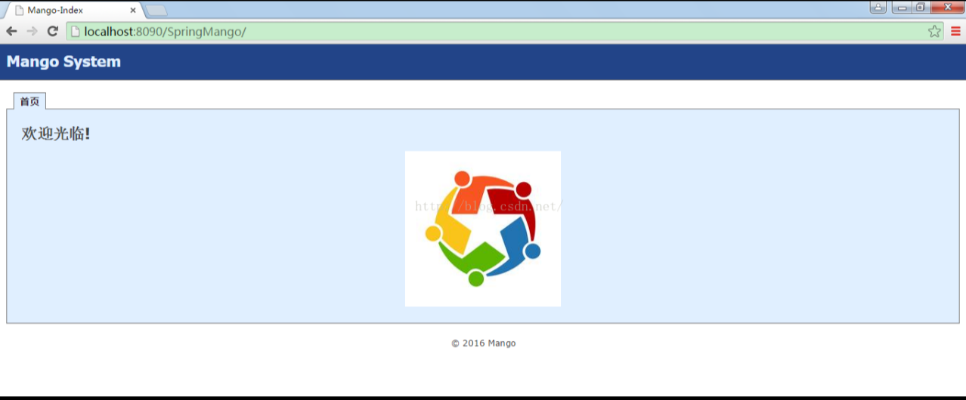

springMVC框架图
