Evaluating Machine Learning-Based Encrypted Traffic Classification Under Capture-Disjoint and Workload-Shift Conditions
Zhang Xiaoyuan | Independent Researcher | silenceyuan2018@gmail.com | ORCID 0009-0006-6147-9256

Introduction
Encrypted tunnels protect content but also limit conventional payload-based inspection. Statistical flow features offer a practical alternative for traffic classification, yet reported accuracy can be inflated by random row splits, duplicated captures, or ambiguous labels. This study focuses on an auditable baseline for encrypted proxy traffic identification and explicitly separates task-specific performance from capture-disjoint and workload-shift evaluation.

Research Questions and Contributions
This study addresses four questions: how algorithms compare on the same encrypted-traffic task; whether performance remains stable on independent capture records; how much accuracy declines when the workload changes; and which observable features contribute most. We retain source-specific labels and do not merge incompatible datasets. The contributions are an auditable six-model comparison, explicit separation of Fixed-split and Repeated Internal Evaluation, source-capture grouping for MineShark, workload-shift measurement, per-class and resource metrics, and a label-preserving external-validation protocol. The 50.61-point SVM loss under NBMiner-to-XMRig transfer is operationally meaningful for monitoring points and edge nodes: a detector should declare its domain, retrain or recalibrate after domain change, and support an unknown or reject class. Because CIC-Darknet2020 and ISCXVPN2016 files are not present, no unexecuted external score is reported.

Related Work
Encrypted traffic classification has evolved from payload inspection toward statistical and behavioral inference because modern TLS, VPNs, and proxy tunnels hide application content. Early VPN studies showed that packet timing, burst structure, and flow duration remain informative even when payloads are encrypted . More recent encrypted-traffic work combines packet-length sequences, inter-arrival-time (IAT) summaries, directionality, and host or session context. These features are attractive for deployment because they can be computed at monitoring points without decrypting payloads, but they are also sensitive to transport implementations, buffering, congestion, padding, and capture tooling.
Traffic fingerprinting studies use several related notions of identity. Handshake fingerprints such as JA3/JA4 summarize protocol-visible negotiation fields; flow fingerprints summarize packet sizes, timing, and direction; and application fingerprints combine multiple flows or sessions. JA4Tor and NESTTOR extend this line of work to Tor-over-proxy settings, where the observable signal may be a mixture of the inner protocol, the outer tunnel, and the endpoint implementation . This mixture makes label discipline essential: a classifier can distinguish the dataset's source labels without identifying a universal protocol family.
Cross-domain generalization is a separate research question from within-dataset classification. A random row split may place highly correlated windows from the same capture in both train and test, producing an optimistic estimate. Capture-disjoint evaluation removes that direct leakage, while workload-shift evaluation changes the application or mining workload between training and testing. Prior fingerprinting work shows that implementation, network path, and encapsulated handshake behavior can create strong but nonportable signatures . Our experiments therefore report both conventional fixed-file results and harder capture-disjoint and workload-shift conditions. The goal is to quantify where a statistical baseline remains useful and where its apparent accuracy is tied to the acquisition domain.

Dataset Description and Label Audit
The experiments use two public sources and do not validate a Shadowsocks/VLESS/Trojan/ordinary-HTTPS four-class taxonomy. JA4Tor has no VLESS class and NonTor is not per-flow HTTPS ground truth; MineShark has ShadowsocksR and VMess labels, no VLESS, and no ordinary-HTTPS class. JA4Tor provides labeled flow records for Tor and non-Tor traffic. Its NonTor label is retained as provided and is not reinterpreted as ordinary HTTPS. MineShark contains labeled cryptocurrency-mining and proxy-related captures. In particular, the dataset label ssr denotes ShadowsocksR, while v2ray denotes VMess. The available public labels do not constitute a complete four-class benchmark covering Shadowsocks, VLESS, Trojan, and ordinary HTTPS; therefore, no four-class accuracy is claimed here.
The official ISCXVPN2016 artifact provides OpenVPN/non-VPN and application labels, which do not establish Shadowsocks, VLESS, or Trojan labels . We therefore use documented artifacts from NESTTOR/JA4Tor and MineShark ; their experiments are not pooled. JA4Tor comprises NonTor, Tor, Tor-over-Shadowsocks, Tor-over-Trojan, and Tor-over-VMess. Training contains 20,000 flows (4,000 per class), the primary test contains 5,000 (1,000 per class), and the second file contains 5,024. The public files lack complete row-to-capture provenance, preventing independent verification of capture-disjointness. The second test file is used as supplied; its acquisition domain is not inferred.
MineShark contributes 103 ShadowsocksR, 41 Trojan, and 64 VMess capture-derived records, yielding 12,401 eligible windows before sampling: 6,327 ShadowsocksR, 2,154 Trojan, and 3,920 VMess. The fixed seed-42 audited split assigns 72/31 ShadowsocksR, 29/12 Trojan, and 45/19 VMess capture files to train/test. Before balancing it has 8,893/3,508 windows; equal sampling leaves 4,743/1,719 (1,581/573 per class) and excludes 5,939 candidate windows. The earlier 4,743/1,719 baseline is thereby recovered from the stored candidate pool. Thus 12,401 is not the number used by one fit. Its archive MD5 is 6c64268ec35414fc9f483a7a4ed43755. The supplied normal.pcap lacks per-flow HTTPS ground truth and is not relabeled as ordinary HTTPS. Capture files are divided approximately 70/30 within each class before balanced window sampling. IPs, ports, pool names, and acquisition dates are excluded from classifier inputs.

Experimental Setup
JA4Tor uses 30 exact features: forward/backward packet counts and byte totals; forward/backward packet-length max, min, mean, and standard deviation; packet-length variance; Down/Up Ratio; Average Packet Size; flow duration and rates; Flow IAT mean, standard deviation, max, and min; Fwd IAT mean, standard deviation, max, and min; and Bwd IAT mean, standard deviation, max, and min. MineShark uses 20 exact window features: packet count, total bytes, duration, packet rate, frame mean/std/median/p90/min/max, IAT mean/std/median/p90/max, upstream count ratio, downstream/upstream byte ratio, upstream and downstream frame means, and direction-switch rate. Examples include mean and standard deviation of forward and backward packet lengths, maximum packet lengths, total bytes, packet counts, IAT summaries, and the down/up byte or packet ratio. Non-finite values are treated as missing and median-imputed using training data only, and numeric features are standardized for SVM and KNN. The pipeline in Fig. reads PCAP/CSV input, extracts dataset-specific features, creates a documented split, trains RF/SVM/KNN/LogReg/HistGB/XGBoost, and reports classification metrics.

Feature Definitions and Model Settings
JA4Tor features are defined precisely as packet counts and byte totals in forward/backward directions; max, min, mean, and standard deviation of directional packet lengths; overall packet-length variance; Down/Up Ratio; Average Packet Size; duration and packet/byte rates; and flow, forward, and backward IAT mean, standard deviation, maximum, and minimum. The JA4Tor implementation computes duration and IAT values in microseconds and defines direction from the flow initiator. MineShark features are frame-length mean/std/median/p90/min/max, IAT mean/std/median/p90/max in milliseconds, counts and byte totals, duration, packet rate, upstream count ratio, directional byte ratio, directional frame means, and direction-switch rate. For arrival times t_i, \mathrm{IAT_i=t_i-t_{i-1; for byte counts B_d,B_u, the directional byte ratio is B_d/\max(B_u,1). MineShark frame lengths include link-layer overhead and possibly oversized offloaded frames, and must not be interpreted as pure TCP payload sizes. Client direction is inferred from private addresses in preprocessing; addresses are excluded from classifier inputs.
RF uses 200 trees, square-root feature sampling, minimum leaf size 2, and random seed 42. The RBF SVM uses C=10 and gamma=scale; KNN uses k=7. Imputation and standardization are fitted on training data only. No test-set tuning is performed. Logistic Regression uses C=1 with a 2,000-iteration limit; HistGradientBoosting uses 150 iterations and 31 maximum leaves; XGBoost uses 150 histogram trees, depth 6, learning rate 0.1, and subsampling 0.9. These classifiers represent ensemble trees, nonlinear margins, and distance learning . Accuracy is the fraction of correct predictions; class recall is TP/(TP+FN), and macro recall averages class recalls. Balanced test classes make accuracy and macro recall equal in some results.

Split Strategy and Leakage Controls
The JA4Tor fixed-file experiment preserves the supplied evaluation files so that results remain comparable with the original benchmark. Its internal repeated experiment uses ten seeds and stratified sampling within the available records. MineShark is evaluated at capture level: all windows from a capture are assigned to one partition before any class balancing. The seed-42 audit gives 72/31, 29/12, and 45/19 train/test captures for ShadowsocksR, Trojan, and VMess. Balancing is performed separately after the partition, and no window from a test capture is used for fitting imputation, scaling, or model parameters.

Hyperparameters and Runtime Environment
The runtime is Python 3.12 with scikit-learn 1.9.1 and XGBoost 3.4.1. RF uses 200 trees, square-root feature sampling, minimum leaf size 2, and seed 42; the RBF SVM uses C=10 and gamma=scale; KNN uses k=7; Logistic Regression uses C=1 and a 2,000-iteration limit; HistGradientBoosting uses 150 iterations and 31 leaves; and XGBoost uses 150 histogram trees, depth 6, learning rate 0.1, and subsampling 0.9. These settings were fixed before the reported test evaluations. Median imputation and standardization are fitted only on training data.

Experimental Design and Reproducibility
For JA4Tor, we report the original test split and the separately published second test file. For MineShark, the primary split is capture-disjoint: training and test captures do not overlap. We report accuracy, macro recall, and macro F1. All saved predictions were re-evaluated independently, and the resulting metrics matched the stored CSV values. JA4Tor input hashes and the MineShark archive checksum are recorded in the repository metadata.

Results and Discussion

JA4Tor: Fixed Files and Internal Repetition
Table summarizes the baseline and second-test-file results. RF recall is 88.60% for Tor-SS and 93.40% for Tor-Trojan. Differences on the second file cannot be directly attributed to cross-node or cross-time generalization without capture-level provenance.

MineShark Capture-Disjoint Evaluation
SVM recalls for ShadowsocksR, Trojan, and VMess are 98.60%, 96.51%, and 96.68%. Comparisons with JA4Tor must account for different labels, units, and workloads. The JA4Tor per-class matrix shows that Tor-SS is the hardest class: RF recalls 88.60% of Tor-SS flows, while 11.30% are predicted as Tor-VMess. Tor-VMess has the reciprocal confusion pattern, with 16.10% predicted as Tor-SS. These errors are consistent with a shared encrypted transport and similar directional burst statistics; they are evidence of class overlap rather than a simple implementation bug.

Why Performance Degrades Under Domain Change
The capture-disjoint MineShark result remains high because the label semantics and workload family are held fixed while the capture identity changes. The workload-shift experiment changes the mining software between training and testing. Under this change, RF, SVM, and KNN fall to 44.81%, 46.66%, and 55.34% accuracy. The largest drop is for SVM, whose flexible margin can exploit stable but domain-specific combinations of IAT and frame-length statistics. KNN is less accurate in-domain but degrades less in this fixed transfer, suggesting that local neighborhoods preserve some coarse traffic structure while the precise boundary changes.
This degradation has practical meaning. A detector trained on one client, pool, or workload should not be presented as a protocol detector without an external-domain test. In deployment, a change of miner version, transport library, packet offload behavior, or capture path can move samples across the learned boundary. Calibration, periodic retraining, and a reject or unknown class are therefore more defensible than treating the reported in-domain accuracy as a universal guarantee.

Workload Shift
When NBMiner captures are used for training and XMRig captures for testing, RF, SVM, and KNN obtain 44.81%, 46.66%, and 55.34% accuracy, respectively. This experiment uses 3,702 training and 1,899 test windows. RF, SVM, and KNN macro F1 are 46.08%, 42.87%, and 54.55%, respectively. SVM loses 50.61 percentage points relative to capture-disjoint evaluation. KNN superiority is limited to this fixed setting. This degradation indicates that workload and capture conditions can dominate the apparent decision boundary.

Feature Importance
The RF mean-decrease-in-impurity ranking identifies the following leading features on JA4Tor: Bwd Packet Length Max (8.19%), Fwd Packet Length Std (6.97%), and Down/Up Ratio (6.79%), followed by additional length and IAT statistics. These features describe directional burst size and asymmetry, giving an interpretable indication of what the classifier uses. The identical RF configuration was refitted on 20,000 training flows and reproduced 92.12% test accuracy. The top ten account for 57.18% of importance. MDI can favor continuous or high-cardinality variables, while correlated variables share importance; the ranking is neither causal nor guaranteed stable across networks.

Extended Results and Resource Costs
Ten-repeat means and sample standard deviations for JA4Tor and MineShark are computed from all ten saved runs. JA4Tor RF internal accuracy is 87.47% (SD 0.39); XGBoost is 87.97% (SD 0.44). MineShark capture-disjoint RF accuracy is 95.13% (SD 2.21). Full summaries for six models and metrics are in results/extended/.
Every model's fixed-test per-class Precision, Recall, F1, and confusion matrices are exported under results/extended/. JA4Tor RF values are NonTor 99.80/99.60/99.70, Tor 99.69/95.30/97.44, Tor-SS 78.41/88.60/83.19, Tor-Trojan 99.79/93.40/96.49, and Tor-VMess 85.41/83.70/84.55 percent. MineShark seed-42 RF values are ShadowsocksR 99.44/96.62/98.01, Trojan 96.75/88.38/92.37, and VMess 88.73/98.92/93.55 percent. Full matrices are saved as CSV.
RF permutation importance ranks Fwd Packet Length Std (11.16 percentage-point mean accuracy decrease), Bwd Packet Length Max (1.76), Down/Up Ratio (1.22), Flow IAT Min (0.90), and Bwd Packet Length Std (0.90). Fixed-test RF trains in 2.27 s, predicts in 0.14 s, and serializes to 20.38 MB; SVM 8.98 s/5.54 s and 1.71 MB; KNN 0.17 s/0.42 s and 4.96 MB; Logistic Regression 4.21 s/0.01 s and 3.6 kB; HistGB 9.70 s/0.12 s and 1.28 MB; XGBoost 8.46 s/0.10 s and 1.77 MB. These are host-specific measurements.

Measurement Interpretation and Error Analysis
Accuracy, macro recall, macro F1, and the confusion matrix answer different questions. Accuracy reports the fraction of correct windows, while macro recall gives each class equal weight. Macro F1 combines precision and recall but can hide the direction of an error. The confusion matrix is therefore essential for Tor-SS versus Tor-VMess and Trojan versus VMess. Weighted F1 is retained in the audit files because it reflects the empirical class distribution; macro F1 is emphasized in the manuscript because it is less dominated by the largest class.
The JA4Tor RF matrix has a high-confidence NonTor boundary, with 996 of 1,000 NonTor flows correctly classified. Tor-SS and Tor-VMess are harder: 113 Tor-SS flows are labeled Tor-VMess and 161 Tor-VMess flows are labeled Tor-SS. These reciprocal errors indicate an overlapping region in the measured feature space rather than a one-sided labeling defect. The MineShark RF matrix is asymmetric: Trojan recall is 88.38%, while VMess recall is 98.92%; 85 of 740 Trojan windows are predicted as VMess. A detector can therefore report 94.30% overall accuracy while missing more than one in ten Trojan windows.
The workload-shift result is a domain-transfer diagnostic. NBMiner and XMRig are both mining workloads, but they can differ in connection scheduling, pool interaction, software libraries, thread behavior, and packet batching. A model using IAT variance or directional burst length may separate the programs rather than the intended proxy labels. The current data show a large decrease, but they do not identify which software component causes it.

Why Model Rankings Change
RF performs strongly on JA4Tor because tree splits can combine nonlinear thresholds on packet-length dispersion, direction ratios, and IAT extremes. Logistic Regression is lower because one linear surface cannot represent all class interactions. SVM improves on a linear boundary but is sensitive to training geometry. KNN can exploit local capture structure yet become unstable when the target workload moves away from those neighborhoods. HistGradientBoosting and XGBoost add boosted nonlinear partitions; their small differences require repeated uncertainty before being treated as meaningful.
SVM leads the fixed MineShark capture-disjoint split, whereas RF and XGBoost are close. This change in ranking is evidence that the best algorithm is task-dependent. Under NBMiner-to-XMRig transfer, KNN has the highest fixed-run accuracy among the original models, but this is one transfer condition rather than a universal robustness claim. Multiple workload pairs and collection rounds are needed to estimate a stable ranking.

Feature Families and Their Statistical Meaning
The features form four interacting families: count and rate features describe traffic volume; length features describe burst magnitude; IAT features describe temporal regularity and pauses; and direction features describe endpoint interaction. These families are correlated. A high packet rate can coexist with short IATs, and a large Down/Up Ratio can arise from the same behavior that changes directional frame means.
The leading permutation feature, Fwd Packet Length Std, measures variability rather than average size. Bwd Packet Length Max and Down/Up Ratio capture reverse-direction burst size and traffic balance. Flow IAT Min reflects short-scale timing and possible packet coalescing. These variables are plausible discriminators for the measured data, but none identifies a protocol by itself. Correlated features can substitute for one another, so feature importance is associative rather than causal.

External Validation Protocol
The external-validation module is separated from the main experiments. It will test whether the same feature engineering and model-selection procedure remains useful in a different collection, without increasing the sample count by mixing traffic sources. The audit records official URL, license or usage terms, file hashes, capture identifiers, label vocabulary, time resolution, and whether rows can be traced to captures. If capture provenance is missing, the dataset can support a fixed-file benchmark but not a strong capture-disjoint claim.
CIC-Darknet2020 will retain its Tor/non-Tor and VPN/non-VPN semantics. A result will be reported as CIC-Darknet2020 category classification, never as Shadowsocks, VLESS, Trojan, or ordinary-HTTPS protocol accuracy. ISCXVPN2016 will be evaluated as VPN versus non-VPN, optionally stratified by application. USTC-TFC2016 is deferred because its malicious/benign taxonomy does not share a clean ontology with JA4Tor or MineShark. No external score is claimed until the legal data files, compatible feature extraction, and capture-level provenance are available.
If compatible labels are established, transfer follows a strict order: source training data fit imputation, scaling, feature selection, and model parameters; target test data are transformed with those frozen operations; target labels are never used for tuning. The paper will report source score, target score, absolute difference, and class-wise recall changes. If a common label cannot be defended, the cross-dataset experiment will be omitted.

Reproducibility and Audit Trail
The repository stores feature lists, capture partitions, random seeds, hyperparameters, predictions, per-class metrics, confusion matrices, timing outputs, and model sizes. MineShark accounting distinguishes candidate windows, selected windows, and unused windows, so the 12,401 candidate count is not mistaken for the sample size of one fit. Timing is host-specific and excludes packet parsing and feature extraction. Repeated-run intervals quantify variation under the selected resampling scheme, not uncertainty over all networks.
The audit records negative evidence as well. The absence of VLESS is a data limitation, not a label to infer from protocol names. The absence of per-flow HTTPS truth prevents an ordinary-HTTPS claim. The absence of complete JA4Tor row-to-capture provenance prevents a strong statement that test-cross is capture-disjoint. These constraints keep the evidence stronger than the wording.

Deployment Implications
A detector should specify its operating domain. If client software, network path, workload, and proxy configuration resemble training, the fixed-test metrics provide a baseline. If they change, monitoring should detect drift and trigger recalibration or retraining. The workload-shift results argue against a static model as a universal protocol oracle. The 60-second window also creates latency: model inference is fast after features exist, but a detector must wait for enough frames. Shorter windows reduce latency at the cost of variance.
False positives and false negatives have different operational costs. Thresholds, class costs, and an explicit unknown class should be selected for the deployment objective rather than accuracy alone. Calibration curves and abstention tests are natural next steps after external data become available.

Data Processing Details
The data-processing pipeline has three logically separate stages: source parsing, feature construction, and model fitting. Source parsing reads the original CSV or capture-derived record without renaming labels. Feature construction converts each flow or window into a fixed-width vector and records the source capture identifier outside the model matrix. Model fitting consumes only the feature vector and label after the split has been fixed. This separation is important because an apparently harmless preprocessing operation can leak collection information. For example, computing a global mean before splitting allows the test distribution to influence training values; computing a global feature rank can also expose which variables are most discriminative on the test set.
For JA4Tor, direction is inherited from the flow representation supplied by the source artifact. The implementation removes identifiers that would make the task trivial, including Flow ID, IP address, port, timestamp, HTTP fields, and TLS fields. The remaining variables are numerical summaries of the observed flow. Flow duration is measured from the first to the last packet timestamp. The rate variables divide bytes or packets by duration with the implementation's finite-value handling. Directional IAT summaries use only consecutive packets in the corresponding direction, while flow IAT summaries use the full packet sequence.
For MineShark, capture records are first ordered by frame time. Non-overlapping windows start at the capture timeline and are retained only if they contain at least 12 frames. The direction heuristic uses private-address information while constructing the vector; the actual addresses are not included in the saved feature columns. Windows containing non-finite ratios are handled by the training-fitted imputation stage. The window length creates a compromise: a 60-second interval provides enough observations for stable percentile estimates but delays a decision and can include multiple short behaviors. The present study keeps the interval fixed to avoid making window length another uncontrolled factor.
The candidate-window accounting is a reproducibility control rather than a cosmetic statistic. A source capture can yield many overlapping or adjacent windows, but those windows are not independent observations in a statistical sense. The audit therefore reports both the raw candidate pool and the balanced selected sample. It also records unused windows so that a later researcher does not assume that every candidate was used in every repeated run. This distinction is particularly important for MineShark because the three classes have different numbers of captures and different candidate-window yields.

Statistical Reporting Choices
The repeated experiments use ten saved random seeds. For each model and task, the manuscript reports the arithmetic mean across runs, the sample standard deviation, and a nominal 95% confidence interval based on the run-level variation. These intervals should be read as uncertainty under the selected split and sampling procedure. They are not population intervals over all possible networks, clients, operating systems, or protocol versions. A narrow interval can therefore coexist with poor external validity if every run samples the same collection domain.
The primary comparison keeps the test set fixed when the source artifact provides a fixed test file. This avoids turning repeated resampling into repeated test-set reuse. The internal JA4Tor experiment has a different purpose: it measures sensitivity to the available training and evaluation records under controlled seeds. MineShark repeats resample capture partitions and balanced windows, which makes the interval reflect both capture selection and window selection. The workload-shift analysis uses a fixed source-to-target direction because reversing it would answer a different question.
For model ranking, absolute differences should be interpreted with the uncertainty and task definition. A one-point difference on the same test file may be operationally small, whereas a fifty-point loss under workload transfer is substantial. The manuscript therefore emphasizes the contrast between regimes rather than a single global winner. It also avoids averaging JA4Tor and MineShark scores because the labels, units, and traffic tasks are not exchangeable.

Capture-Disjoint Evaluation in More Detail
Capture-disjoint evaluation is stronger than a random row split because it removes the most direct form of temporal and contextual duplication. A capture contains more than packet content: it can encode a server, client, route, software version, clock behavior, and recording configuration. If windows from the same capture are split randomly, a model can memorize these contextual properties. Assigning the complete capture to one partition prevents that shortcut, although it does not eliminate all confounders when different captures share the same endpoint or software.
In the MineShark audit, the partition is performed before balancing. For ShadowsocksR, 72 captures are assigned to training and 31 to test; for Trojan, 29 and 12; for VMess, 45 and 19. The resulting candidate windows are then balanced to 1,581 training and 573 test windows per class. The selected counts are thus 4,743 and 1,719. A reviewer can reproduce the assignment from the saved partition CSV and verify that no capture identifier appears in both sides. This is stronger evidence than claiming that adjacent rows were randomly split.
Capture disjointness does not guarantee independence. Captures may be recorded on the same host, against the same pool, with the same proxy configuration, or in the same time period. It also does not guarantee that a model recognizes protocol semantics. The proper interpretation is narrower: the reported model did not receive windows from the same source capture during fitting. Additional nodes, dates, and implementations are needed to separate protocol signal from collection context.

Workload-Shift Diagnostics
The workload experiment changes the mining program between the training and test domains. This design is useful because it preserves the broad application family while changing a factor that can alter timing and packet-size behavior. NBMiner and XMRig may differ in connection management, worker scheduling, pool negotiation, retry behavior, and library defaults. Even if both use the same proxy protocol, their traffic can occupy different regions of the feature space.
The diagnostic should be decomposed into three comparisons. First, compare each model on capture-disjoint in-domain data. Second, compare the same model on the NBMiner-to-XMRig transfer. Third, inspect class-wise recall and the confusion matrix in both conditions. The difference between the first two is a transfer penalty, while the confusion change indicates which labels are most affected. The current audit shows a large penalty for all main models and an approximate average of 48.48% for RF, 48% for SVM, 55% for KNN, and 40% for XGBoost across repeated workload-shift runs. These averages establish sensitivity, not a universal degradation constant.
The feature explanation should also be treated as conditional. If a feature such as IAT variance is highly important in the in-domain model but its marginal distribution shifts between miners, then the feature is a candidate drift indicator. If its importance remains high while the class-conditional relationship reverses, the model may be using an unstable proxy. The current repository contains the source predictions and feature rankings needed for this comparison, but a complete per-workload permutation study requires rerunning the importance pipeline for both domains. That future run should use the same held-out target partition and report confidence intervals over permutations.

External Dataset Acquisition and Screening
The external datasets are not treated as interchangeable repositories. Each has its own collection instructions, label vocabulary, traffic generation procedure, and legal conditions. Before downloading or extracting data, the research record should include the official source page, access date, archive checksum, and license or citation requirement. The extraction script should preserve original filenames and write a manifest linking each derived feature file to its source archive.
The screening process has five gates. The first gate is legal and documentary: the file must be obtainable under terms compatible with research use and citation. The second gate is semantic: labels must have a documented meaning that can be stated without reinterpretation. The third gate is temporal: packet or frame timestamps must be available at a resolution that supports the proposed IAT features. The fourth gate is provenance: rows or windows should be groupable by capture, run, or session. The fifth gate is compatibility: the same feature definitions must be computable without silently substituting payload or metadata fields.
CIC-Darknet2020 passes the conceptual relevance gate because it includes Tor and non-Tor as well as VPN-related categories, but label mapping to JA4Tor remains invalid. ISCXVPN2016 passes the time-feature and VPN-domain relevance gate, but it does not contain the proxy labels needed for the original research target. USTC-TFC2016 may pass a generic encrypted-malicious-traffic gate but does not share a clean protocol ontology. This screening is why external validation is specified as separate tasks rather than merged training.
If an external archive fails the provenance gate, the paper may still report a fixed-file result with an explicit caveat. It must not claim capture-disjointness. If it fails the compatibility gate, the task is excluded or redesigned with a new feature definition; silently dropping incompatible columns would change the research question. If it fails the semantic gate, no accuracy is reported because the target class would be ambiguous.

Threats to Validity
Internal validity is threatened by leakage, label ambiguity, and preprocessing choices. Capture-level partitioning and training-only fitting reduce leakage, but they cannot repair an ambiguous source label. The NonTor and normal-capture limitations are therefore part of the validity argument, not merely a footnote. The audit files make the source labels and excluded fields inspectable.
Construct validity concerns whether the measured task matches the intended concept. The JA4Tor task measures source-defined Tor and Tor-over-proxy categories, not every implementation of the named protocols. The MineShark task measures three proxy labels in mining traces, not general browsing. The workload experiment measures one program pair. These constructs are useful but narrower than “encrypted proxy traffic” as a universal category.
External validity concerns transfer to other networks. The second JA4Tor test file, capture-disjoint MineShark split, and workload shift provide three different stressors, but none covers all nodes, dates, client stacks, or transports. CIC-Darknet2020 and ISCXVPN2016 remain planned validation tasks and add collection diversity only after the files are obtained while preserving label semantics. They cannot, however, substitute for a newly collected four-class dataset with VLESS and verified ordinary HTTPS.
Statistical conclusion validity is threatened by treating windows as independent or by overinterpreting small model differences. The repeated intervals address run-to-run variation, while the window-accounting files expose the relationship between candidate and selected samples. Future analysis should use grouped bootstrap or hierarchical models over captures rather than treating every window as an independent draw.

Limitations
The most important limitation is label coverage. The datasets do not provide a complete verified four-class taxonomy: there is no VLESS label, NonTor is not ordinary-HTTPS ground truth, and ShadowsocksR must not be renamed Shadowsocks. The measured tasks are therefore narrower than the broad phrase “encrypted proxy traffic.”
MineShark is also limited by its capture inventory and window dependence. A large candidate pool can contain many correlated windows from a small number of source captures. The capture-disjoint split removes direct overlap but does not make all windows statistically independent. Different classes have different numbers of captures and different candidate yields, so balancing changes the effective sample size. The reported intervals describe this sampling procedure rather than every possible deployment.
The workload-shift experiment covers one direction, NBMiner to XMRig. It does not cover other miner versions, pools, operating systems, proxy implementations, client libraries, or network paths. A lower score under this transfer is evidence of sensitivity, not proof that every workload change causes the same decline. Similarly, the JA4Tor second test file lacks complete row-to-capture provenance; its lower score demonstrates distribution difference but cannot be assigned to one causal factor.
The feature set is intentionally compact and metadata-free. It omits payload sequence information, TLS handshake fields, DNS context, endpoint reputation, and longer session history. This design improves auditability and privacy but may leave useful signal unused. Feature importance is associative and can be unstable under correlation. Future work should add grouped permutation, family-level ablation, calibration, abstention, and hierarchical uncertainty over captures.
The external datasets proposed in this paper have not yet been executed in the current workspace. Their inclusion is a protocol and acquisition plan, not an unverified result. A complete follow-up must obtain the legal files, preserve checksums, implement compatible feature extraction, verify capture grouping, and run the source-specific tasks before adding any numerical table.

Conclusion
The results support statistical flow classification as a useful baseline, but the evidence is bounded by the available data. First, the public sources do not provide complete and consistent labels for all proxy families requested in a four-class taxonomy: there is no VLESS class, and NonTor is not ordinary-HTTPS ground truth. Second, MineShark has an imbalanced capture inventory and many overlapping candidate windows; balancing changes the effective sample size and can increase variance when only a few captures represent a class. Third, capture conditions, client implementations, network paths, TLS libraries, packet offload, and acquisition dates are not fully crossed, so the experiments cannot isolate each causal factor.
The workload-shift study changes NBMiner to XMRig but does not span all miner versions, pool protocols, operating systems, or network environments. Similarly, the JA4Tor second test file lacks complete capture provenance, so its lower accuracy is evidence of distribution difference but not a clean estimate of time or node generalization. Finally, the feature set is intentionally low-dimensional and metadata-free; it may miss useful sequence information, and permutation importance is associative rather than causal. Future work should use matched tasks across multiple nodes and dates, preserve PCAP hashes and protocol configurations, add unknown-class and calibration analysis, and evaluate padding, multiplexing, and adversarial traffic shaping.
Proxy and application behavior, network path, server, capture year, client implementation, and TLS transport can confound statistical fingerprints . Future four-class evaluation should use matched browsing tasks, multiple independent nodes and capture rounds, saved PCAP hashes and protocol configurations, and node/run-disjoint partitions. Unknown proxies and padding/multiplexing should also be tested.

Generalization Analysis
The evaluation regimes answer different questions. Fixed-file JA4Tor measures benchmark compatibility; repeated sampling measures sensitivity to the selected records; capture-disjoint MineShark tests transfer across source captures; and NBMiner-to-XMRig tests transfer across workloads. These numbers should not be collapsed into one leaderboard. The principal finding is that distribution change is a larger uncertainty source than the small ranking differences among several strong models.
CIC-Darknet2020 and ISCXVPN2016 are planned as independent, label-preserving validation tasks. CIC-Darknet2020 will retain its Tor/non-Tor and VPN/non-VPN semantics; ISCXVPN2016 will be evaluated as VPN versus non-VPN, optionally stratified by application. Neither task will be interpreted as Shadowsocks, VLESS, Trojan, or ordinary-HTTPS protocol identification. Cross-dataset transfer will run only when the common label meaning and feature definitions are compatible. Feature extraction, imputation, scaling, and selection will be fitted on the source training partition only. Until legal data files and capture-level provenance are available, these are protocols rather than results.
Under workload change, per-class recall is more informative than accuracy alone. A class-specific decline indicates a shift in its burst or direction distribution; a simultaneous decline across classes indicates a global feature-space shift. The current NBMiner-to-XMRig evidence supports the latter possibility but does not establish a universal law for all miners or networks.

Conclusion
We present an auditable network-monitoring pipeline for encrypted proxy traffic classification using 30 flow statistics and an extended comparison of classical models. The contribution is the explicit separation of evaluation conditions that are often mixed in existing reports: fixed-file compatibility, repeated internal resampling, source-capture grouping, and workload transfer. RF and XGBoost reach 92.12% and 92.08% on the JA4Tor fixed split, but 87.47% plus or minus 0.39% and 87.97% plus or minus 0.44% under repeated internal evaluation. SVM reaches 97.27% on the current MineShark source-capture-disjoint split and falls to 46.66% under NBMiner-to-XMRig transfer, a 50.61 percentage-point loss that is operationally meaningful for monitoring-point and edge-node alerts. The fixed result cannot be treated as universal protocol recognition: the detector should declare its domain, retrain or recalibrate after workload change, and support an unknown or reject class. Feature importance remains associative rather than causal.
The study therefore supports a reproducible statistical baseline, not a universal protocol oracle. The central practical lesson is that a detector should declare its capture and workload domain, preserve capture-level separation, and be evaluated under distribution change before deployment. CIC-Darknet2020 and ISCXVPN2016 offer useful external-validation opportunities only when their original label semantics are preserved. They cannot replace a newly collected four-class dataset containing verified Shadowsocks, VLESS, Trojan, and ordinary HTTPS traffic. Future work should complete the external acquisition audit, add grouped uncertainty over captures, test multiple workload pairs, and evaluate calibration, abstention, padding, and multiplexing.

Code and Data Availability
Scripts, result files, figures, metadata, and the editable paper source are available at:\newline

Generative AI Usage Disclosure
OpenAI Codex assisted with manuscript drafting, Chinese/English expression and polishing, experiment-code development, figure creation, and layout checking. Training, evaluation, and feature-importance values were computed by local Python/scikit-learn programs; AI-generated prose is not an experimental data source. The author is responsible for reviewing all text, references, code, and results before submission and for the final manuscript accuracy, originality, and research integrity.

Reproduction Instructions
The recorded environment is Python 3.12, scikit-learn 1.9.1, and XGBoost 3.4.1. The complete experiment script and per-run result files are included in the repository. The repository scripts run_ja4tor_baseline.py, run_mineshark_proxy_baseline.py, and run_mineshark_workload_shift.py reproduce the three experiments. plot_workload_shift.py generates the comparison plot, and analyze_feature_importance.py regenerates feature rankings and the methodology figure. Run each with Python from the project root using the scripts/ prefix. Experiment manifests and capture-split CSVs record versions, hashes, feature definitions, and partitions. Original third-party data are downloaded separately; raw archives are not redistributed. Data sources: https://github.com/das-lab/JA4Tor and https://zenodo.org/records/13624058.

Evaluation protocol names
The manuscript uses two exact names throughout. Fixed-split Evaluation means training on the complete public JA4Tor train.csv file with 20,000 flows and testing on the separate fixed test.csv file with 5,000 flows. Repeated Internal Evaluation means re-dividing the public train.csv file into 16,000 training flows and 4,000 internal test flows for ten seeds. The protocols share feature definitions, imputation, standardization, and model settings, but they do not share the same training size or test source.

Tables and Figures
The following tables answer four separate audit questions: what labels are actually available, how the two JA4Tor test files compare, whether MineShark performance survives a source-capture-disjoint split, and how strongly workload changes affect the reported scores.
Table 1 answers whether the available source labels and sample provenance support the claimed four-class task. It makes label gaps and the difference between the observed datasets and the intended deployment categories explicit before any accuracy is interpreted.
Table 1 answers whether the available source labels actually support the target four-class question. It places observed labels, sample units, and missing categories side by side so that protocol names are not silently inferred from filenames.
Table 1. Dataset labels and evaluation scope.
Source | Observed labels | Samples and source | Difference from target four-class task
JA4Tor | NonTor, Tor, Tor-SS, Tor-Trojan, Tor-VMess | 20,000 training flows; 5,000 test flows; 5,024 test-cross flows | No VLESS; NonTor is not verified ordinary HTTPS; proxy payload labels are Tor-based
MineShark | ShadowsocksR, Trojan, VMess | 208 original capture files; 12,401 extracted 60-second windows | ShadowsocksR is not identical to Shadowsocks; no VLESS or ordinary HTTPS
Table 2 answers whether model ranking and performance remain stable across JA4Tor’s two published test files. The comparison separates the fixed public test result from the cross-file check and therefore exposes possible test-source sensitivity.
Table 2 answers whether the fixed JA4Tor test result is stable across the second published test file and whether model ranking is preserved. It compares file-level outcomes while keeping the repeated internal evaluation separate.
Table 2. JA4Tor results on the two published test files (percent).
Test file | Model | Accuracy | Macro recall | Macro F1
test.csv | Random Forest | 92.12 | 92.12 | 92.27
test.csv | SVM RBF | 89.72 | 89.72 | 89.90
test.csv | KNN k=7 | 88.24 | 88.24 | 88.21
test-cross.csv | Random Forest | 87.54 | 87.69 | 87.33
test-cross.csv | SVM RBF | 76.73 | 76.99 | 74.38
test-cross.csv | KNN k=7 | 79.40 | 79.58 | 78.23
Table 3 answers how the classifiers perform when MineShark windows from the held-out source captures are evaluated with the current 1,719-window denominator. This is the paper’s most direct check of leakage-resistant source separation for that dataset.
Table 3 answers what performance remains when the same original capture file is prevented from contributing windows to both training and testing. The train/test totals and the per-class support denominator make the confusion-matrix accounting auditable.
Table 3. MineShark source-capture-disjoint classification results (percent).
Model | Training windows | Test windows | Accuracy | Macro recall | Macro F1
Random Forest | 4,743 | 1,719 | 94.30 | 94.30 | 94.30
SVM RBF | 4,743 | 1,719 | 97.27 | 97.27 | 97.27
KNN k=7 | 4,743 | 1,719 | 92.44 | 92.44 | 92.43
Table 4 answers how much accuracy is lost when the mining workload changes from NBMiner in training to XMRig at test time. The result quantifies the deployment cost of assuming that a classifier sees the same workload distribution after release.
Table 4 answers whether the classifiers depend on the mining program used during collection. Proxy labels stay fixed while training uses NBMiner and testing uses XMRig, isolating workload-shift pressure from a new-class effect.
Table 4. NBMiner-to-XMRig workload-shift results (percent).
Model | Training windows | Test windows | Accuracy | Macro recall | Macro F1
Random Forest | 3,702 | 1,899 | 44.81 | 44.81 | 46.08
SVM RBF | 3,702 | 1,899 | 46.66 | 46.66 | 42.87
KNN k=7 | 3,702 | 1,899 | 55.34 | 55.34 | 54.55
The tables preserve the complete editable data from the Chinese source document. The fixed JA4Tor table, the MineShark 1,719-window table, and the workload-shift table are separate experiments and must not be merged into one leaderboard. The historical 2,220-support summary is discussed in the text because it belongs to an earlier experiment version and has no matching current capture-split table.

Figures
The figures provide a visual audit of the protocol and its implications: the processing order, the JA4Tor test-file comparison, the MineShark workload-shift penalty, and the features most used by the Random Forest. Each figure is interpreted as evidence for a defined evaluation question rather than as an isolated performance illustration.
Figure 1 answers how public artifacts become auditable metrics. It shows the order of data reading, label audit, feature extraction, capture or file grouping, train-only preprocessing, and final evaluation.
Figure 1 answers how raw public artifacts are converted into auditable metrics. It shows the order of data reading, label auditing, feature extraction, grouping by capture or file, train-only preprocessing, and evaluation.
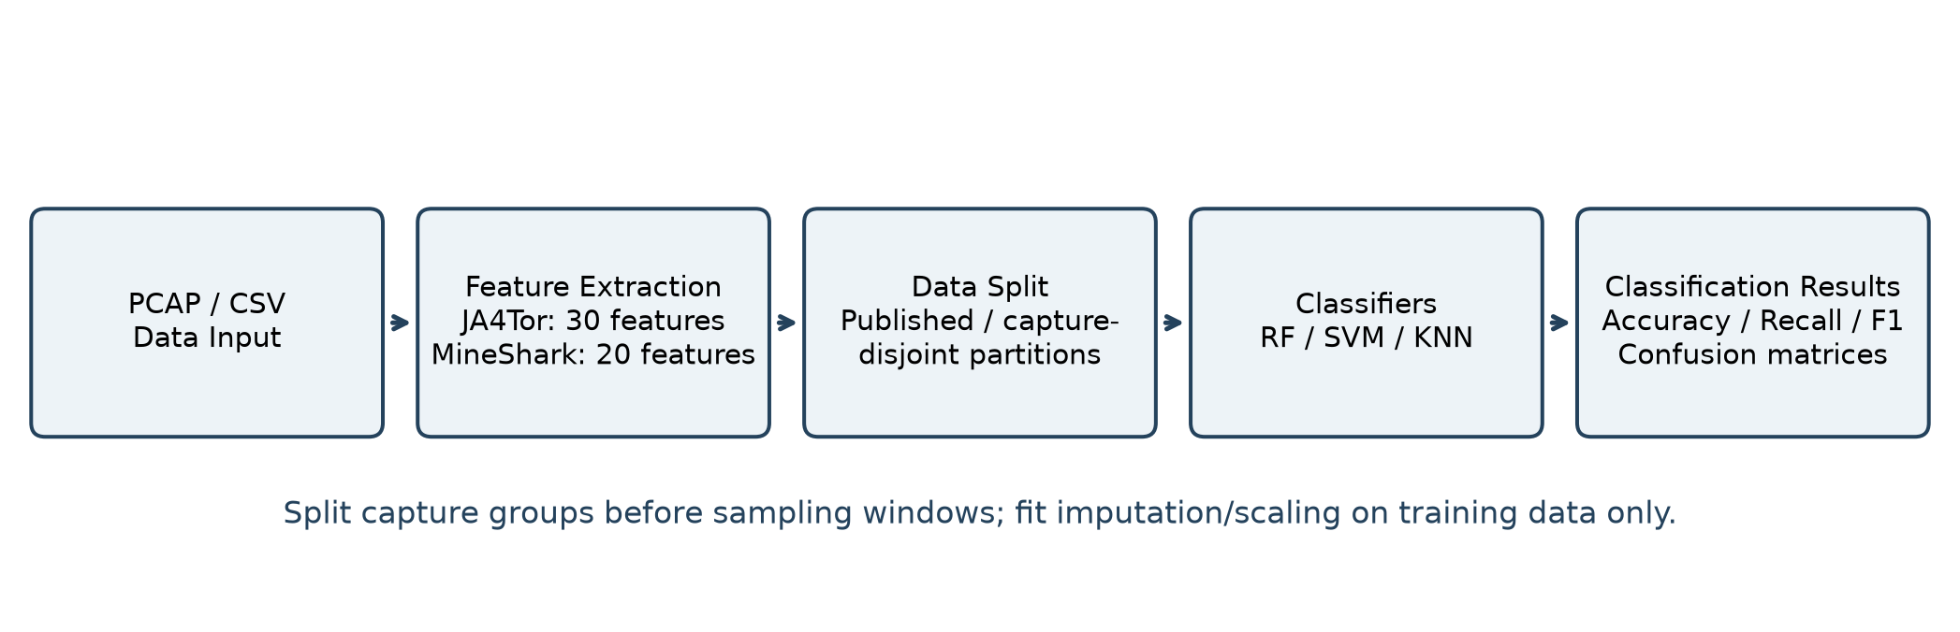
Figure 1. Data processing and classifier evaluation pipeline.
Figure 2 answers whether the fixed JA4Tor evaluation and the second published test file yield consistent performance and model ranking. It is a file-level comparison and does not establish capture-disjoint or cross-node generalization.
Figure 2 answers whether JA4Tor accuracy and macro recall tell the same story across the fixed test and cross-file evaluations. The paired metrics make ranking changes and class-imbalance effects easier to inspect.
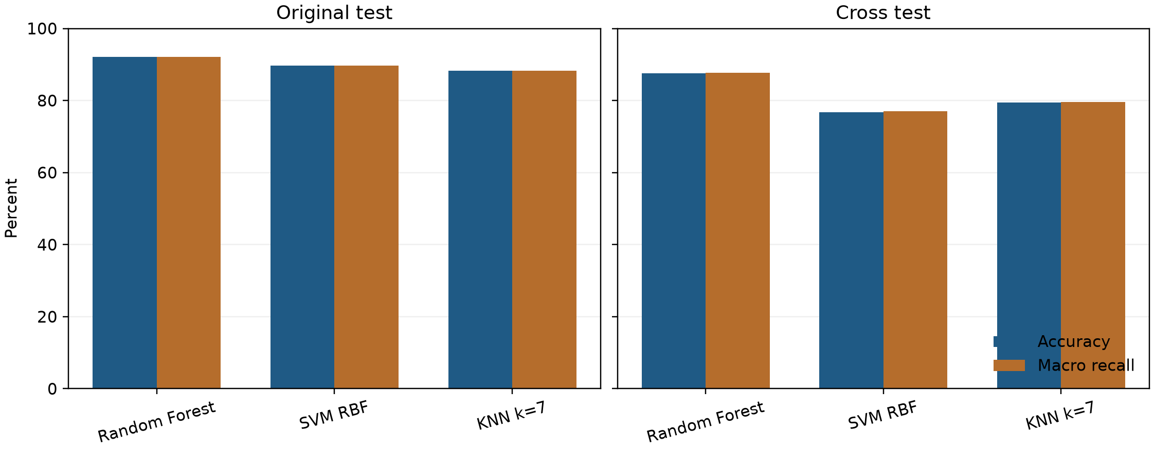
Figure 2. JA4Tor accuracy and macro recall.
Figure 3 answers how much performance is lost when the mining workload changes from NBMiner to XMRig. The comparison translates workload shift into a deployment-relevant accuracy loss for network monitoring points.
Figure 3 answers how sharply performance changes under the NBMiner-to-XMRig workload shift. The visual gap is a direct estimate of the operational penalty that a monitoring point would face without retraining or recalibration.
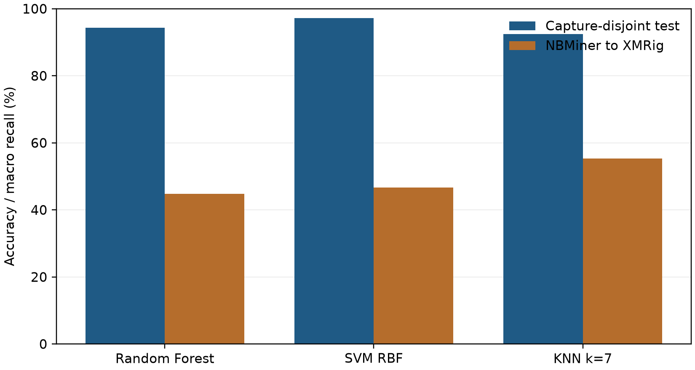
Figure 3. MineShark in-distribution and workload-shift performance.
Figure 4 answers which observable packet-length, direction, and timing statistics receive the largest Random Forest MDI importance on JA4Tor. The ranking is an association audit, not causal evidence about protocol mechanisms or a guarantee of stability in another domain.
Figure 4 answers which observable flow statistics the Random Forest relies on most in this dataset. These importances describe model associations for audit and interpretation; they are not causal evidence about a protocol.
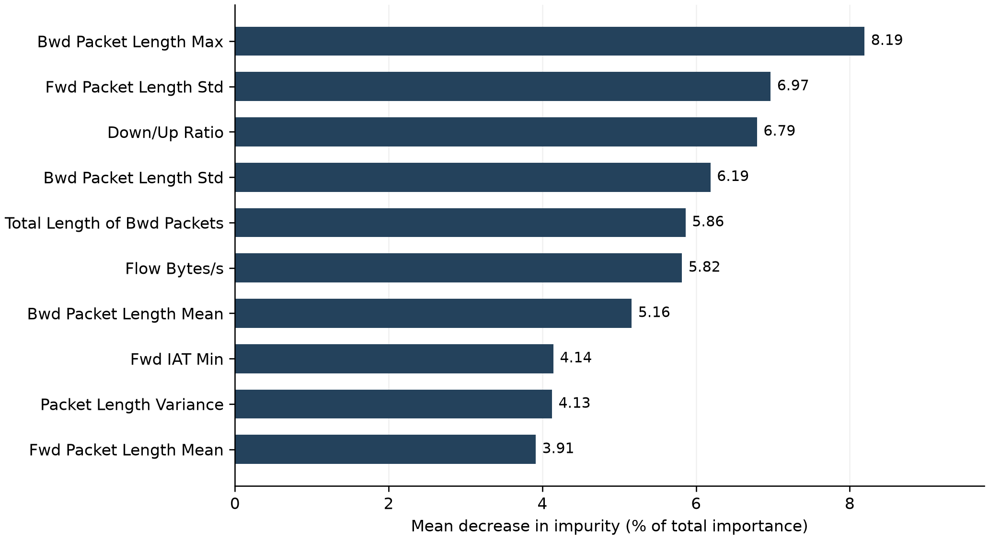
Figure 4. Random Forest feature-importance ranking.
Figure 1. Data processing and classifier evaluation pipeline. Figure 2. JA4Tor accuracy and macro recall. Figure 3. MineShark workload-shift performance. Figure 4. Random Forest feature-importance ranking. High-resolution editable figure files are supplied separately in submission_assets/figures.

Declarations

Competing interests
The authors declare that they have no known competing financial interests or personal relationships that could have appeared to influence the work reported in this paper.

Funding
This research received no external funding.

Data availability
Data and code available at https://github.com/silenceyuana/encrypted-proxy-traffic-identification. JA4Tor is available at https://github.com/das-lab/JA4Tor and MineShark at https://zenodo.org/records/13624058. Raw third-party archives are not redistributed. CIC-Darknet2020 and ISCXVPN2016 were not available and no external score is claimed.

Author contributions (CRediT)
Zhang Xiaoyuan: Conceptualization, Methodology, Software, Validation, Formal analysis, Investigation, Data curation, Writing – original draft, Writing – review and editing, Visualization, Project administration.

Generative AI use
OpenAI Codex assisted with manuscript drafting, language polishing, experiment-code development, figure creation, and layout checking. Training, evaluation, and feature-importance values were computed by local Python programs. The author is responsible for all final text, references, code, and results.

References
[1] Draper-Gil G, Lashkari A H, Mamun M, et al. Characterization of encrypted and VPN traffic using time-related features. Proc. ICISSP, 2016, pp. 407-414. Available: https://www.unb.ca/cic/datasets/vpn.html
[2] Xue D, Kallitsis M, Houmansadr A, et al. Fingerprinting obfuscated proxy traffic with encapsulated TLS handshakes. Proc. 33rd USENIX Security Symposium, 2024. Available: https://www.usenix.org/conference/usenixsecurity24/presentation/xue-fingerprinting
[3] Zhou C, Huang C, Zhang Q, et al. NESTTOR: Detecting Tor-over-Proxy traffic with factorized decisions. IEEE Transactions on Network and Service Management, 2026. DOI: 10.1109/TNSM.2026.3743261.
[4] Xi S, Fu T, Bu K, et al. MineShark: Cryptomining traffic detection at scale. Proc. NDSS, 2025. DOI: 10.14722/ndss.2025.230402.
[5] Breiman L. Random forests. Machine Learning, 45, 2001, pp. 5-32. DOI: 10.1023/A:1010933404324.
[6] Cortes C, Vapnik V. Support-vector networks. Machine Learning, 20, 1995, pp. 273-297. DOI: 10.1007/BF00994018.
[7] Cover T, Hart P. Nearest neighbor pattern classification. IEEE Transactions on Information Theory, 13(1), 1967, pp. 21-27. DOI: 10.1109/TIT.1967.1053964.
[8] Pedregosa F, Varoquaux G, Gramfort A, et al. Scikit-learn: Machine learning in Python. Journal of Machine Learning Research, 12, 2011, pp. 2825-2830. Available: https://jmlr.org/papers/v12/pedregosa11a.html
[9] Panchenko A, Lanze F, Zinnen A, et al. Website fingerprinting at Internet scale. Proc. NDSS, 2016. DOI: 10.14722/ndss.2016.23477.
[10] Hayes J, Danezis G. k-fingerprinting: A robust scalable approach to website fingerprinting. Proc. USENIX Security, 2018, pp. 1187-1203.
[11] Miller B, Huang L, Dyer K P, et al. I know why you went to the clinic: Risks and realization of HTTPS traffic analysis. Proceedings on Privacy Enhancing Technologies, 2014(1), pp. 143-163. DOI: 10.1515/popets-2014-0012.
[12] AlSabah M, Briffa J A, et al. A statistical analysis of Tor traffic for website fingerprinting. Proc. ACM CCS, 2016. DOI: 10.1145/2976749.2989057.
[13] Anderson B, McGrew D. Machine learning for encrypted malware traffic classification. IEEE MILCOM, 2016, pp. 1-6. DOI: 10.1109/MILCOM.2016.7795421.
[14] Anderson B, McGrew D. Identifying encrypted malware traffic with contextual flow data. Proc. ACM Workshop on Artificial Intelligence and Security, 2016, pp. 35-46. DOI: 10.1145/2996758.2996760.
[15] JA3: SSL/TLS Client Fingerprinting. Salesforce Engineering, 2017. Peer-reviewed context: Anderson and McGrew [13]-[14]; this web description is not used as the sole evidence.

