**1.How to compare two json have same property without order?**

*// Define a function called compareJson that takes two JSON strings as input.function compareJson(jsonStr1, jsonStr2) {*

function compareJson(jsonStr1, jsonStr2) {

*// Parse the first JSON string into a JavaScript object and store it in obj1.*

const obj1 = JSON.parse(jsonStr1);

*// Parse the second JSON string into a JavaScript object and store it in obj2.*

const obj2 = JSON.parse(jsonStr2);

*// Convert the properties of obj1 into a sorted JSON string and store it in sorted JsonStr1.*

*// The `Object.keys(obj1).sort()` part sorts the keys of obj1 in alphabetical order.*

const sortedJsonStr1 = JSON.stringify(obj1, Object.keys(obj1).sort());

*// Convert the properties of obj2 into a sorted JSON string and store it in sortedJsonStr2.*

*// The `Object.keys(obj2).sort()` part sorts the keys of obj2 in alphabetical order.*

const sortedJsonStr2 = JSON.stringify(obj2, Object.keys(obj2).sort());

*// Compare the two sorted JSON strings for equality and store the result in the `result` variable.*

const result = sortedJsonStr1 === sortedJsonStr2;

*// Return the result of the comparison.*

*return* result;

}

let jsonStr1 = '{"name": "Person 1", "age": 5}';

let jsonStr2 = '{"age": 5, "name": "Person 1"}';

*// Call the compareJson function with the example JSON strings.*

const result = compareJson(jsonStr1, jsonStr2);

*// Check if the result is true or false and log the appropriate message.*

*if* (result) {

console.log("The JSON objects are equal.");

} *else* {

console.log("The JSON objects are not equal.");

}

***2.Display all country flag : https://restcountries.com/v3.1/all***

*const xhr = new XMLHttpRequest();*

*xhr.open("GET", "https://restcountries.com/v3.1/all");*

*xhr.responseType = "json";*

*xhr.send();*

*xhr.onload = () => {*

*const responseData = xhr.response;*

*if (Array.isArray(responseData)) {*

*responseData.forEach((item, index) => {*

*// Check if the item has a flag property*

*if (item.hasOwnProperty("flag")) {*

*const flag = item.flag;*

*console.log(`Flag at index ${index}:`, flag);*

*}*

*});*

*} else {*

*console.log("Response is not an array:", responseData);*

*}*

*};*

**Result :**

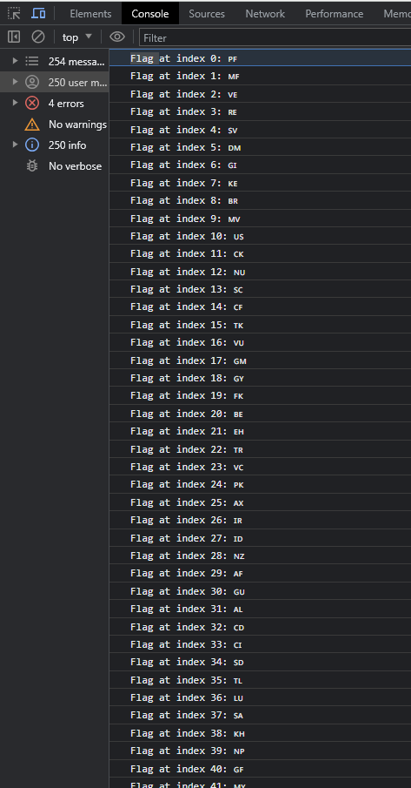

**3.Display country name, region,subregion,population**

**const xhr = new XMLHttpRequest();**

**xhr.open("GET", "https://restcountries.com/v3.1/all");**

**xhr.responseType = "json";**

**xhr.send();**

**xhr.onload = () => {**

**const responseData = xhr.response;**

***if* (Array.isArray(responseData)) {**

**const extractedData = responseData**

**.map((item, index) => {**

***// Check if the item has the required properties***

***if* (**

**item.hasOwnProperty("name") &&**

**item.hasOwnProperty("region") &&**

**item.hasOwnProperty("subregion") &&**

**item.hasOwnProperty("population")**

**) {**

**const name = item.name.common;**

**const region = item.region;**

**const subregion = item.subregion;**

**const population = item.population;**

***return* {**

**index,**

**name,**

**region,**

**subregion,**

**population,**

**};**

**}**

**})**

**.filter(Boolean); *// Filter out items where the required properties were not found***

***// Convert the extracted data array to a JSON object***

**const result = JSON.stringify(extractedData, null, 2);**

**console.log(result);**

**} *else* {**

**console.log("Response is not an array:", responseData);**

**}**

**};**

**Result:**

