User Manual - HVAS
Hybrid Video Analysis System (HVAS) + Municipal Urban Business System (MUBS)

Document Control
Field | Value
Project | Hybrid Video Analysis System (HVAS) + Municipal Urban Business System (MUBS)
Portfolio section | 04-Development-and-Quality-Assurance
Version | 1.1
Date | 2026-05-06
Status | Final portfolio version - deployment guidance expanded
Source basis | System source code, frontend screens, backend API routes, docker-compose.yml, requirements.txt, frontend/package.json, and .env.example.

1. Target Users
This manual is for operators or assessors using the HVAS web portal to configure video sources, monitor AI events, review evidence, and generate common-space reports.
2. Deployment and Initial Setup
This section describes a clean Windows deployment path for HVAS. The steps assume the operator starts from the project root and uses Docker Desktop for MongoDB and MinIO, Python for the Flask backend, and Node.js/npm for the Vue dashboard.
2.1 Download and Install Prerequisites
Component | Where to Get It | Installation Notes | Verification
Docker Desktop | https://www.docker.com/products/docker-desktop/ | Install Docker Desktop for Windows. Enable WSL 2/virtualization if the installer prompts for it. Start Docker Desktop before running infrastructure commands. | docker --version  docker compose version
Python | https://www.python.org/downloads/windows/ | Install a project-compatible Python version. Select Add python.exe to PATH during installation, then reopen the terminal. | python --version  pip --version
Node.js and npm | https://nodejs.org/ | Install the LTS release if npm is not already available. The Vue dashboard and upload service use npm scripts from frontend/package.json. | node --version  npm --version
Git or project archive | Existing repository or delivered zip package | Use Git clone or extract the delivered archive. Open PowerShell in the project root before running the following commands. | dir docker-compose.yml  dir .env.example
2.2 Install Project Dependencies
Run the backend dependency installation from the project root:
Step | PowerShell Command | Purpose
Create virtual environment | python -m venv venv | Keeps project Python packages isolated.
Activate virtual environment | .\venv\Scripts\activate | Ensures pip installs into the project environment.
Upgrade pip | python -m pip install --upgrade pip | Reduces dependency installation failures.
Install backend packages | pip install -r requirements.txt | Installs Flask, OpenCV, Ultralytics YOLO, MongoDB, MinIO, requests, dotenv, and watchdog dependencies.
Optional CUDA torch | pip install torch torchvision --index-url https://download.pytorch.org/whl/cu121 | Use only when the deployment machine has a compatible NVIDIA GPU and CUDA runtime.
Install frontend packages | cd frontend  npm install  cd .. | Installs Vue, Vite, axios, three/globe.gl, Express, MongoDB driver, and multer.
2.3 Configure .env from .env.example
Create a local .env file from the template and fill in deployment-specific API keys and secrets. Do not commit .env to source control.
Step | PowerShell Command or Setting | Notes
Copy template | Copy-Item .env.example .env | Use the template as the starting point for all local configuration.
Set webhook secret | WEBHOOK_SECRET=<strong-shared-secret> | Required when ENABLE_WEBHOOKS=true. The receiving MUBS/webhook system must use the same HMAC secret.
Set Qwen report key | QWEN_REPORT_API_KEY=<your DashScope key> | Required for LLM-based common-space reports. QWEN_REPORT_API_URL defaults to the DashScope OpenAI-compatible endpoint in .env.example.
Set Qwen-VL key if used | QWEN_VL_API_KEY=<your DashScope key> | Needed when smoke/fire secondary verification or visual common-space analysis depends on Qwen-VL environment configuration.
Choose inference device | YOLO_DEVICE=cuda or YOLO_DEVICE=cpu | Use cuda only after confirming torch.cuda.is_available() on the deployment machine.
Review RTSP sampling | RTSP_SAMPLE_INTERVAL=0.5 | Default legacy sampling interval. The backend also supports PARKING_RTSP_SAMPLE_INTERVAL, SMOKE_RTSP_SAMPLE_INTERVAL, and COMMON_SPACE_RTSP_SAMPLE_INTERVAL for task-level overrides.
Review queue limits | STREAM_EXECUTOR_MAX_QUEUE=24  SMOKE_DETECTION_MAX_QUEUE=8  SMOKE_VERIFICATION_MAX_QUEUE=12  COMMON_SPACE_MAX_QUEUE=4 | Keep backpressure enabled for multi-stream deployments to avoid unbounded queue growth.
- Docker Compose provides default local MongoDB and MinIO settings: MONGO_URI=mongodb://localhost:27017, MONGO_DB_NAME=video_analysis_db, MINIO_ENDPOINT=localhost:9000, MINIO_ACCESS_KEY=minioadmin, MINIO_SECRET_KEY=minioadmin, and MINIO_BUCKET=video-events.
- For production or shared demos, replace default MinIO credentials and WEBHOOK_SECRET with non-default values, then restart the affected services.
2.4 Start Infrastructure with Docker Desktop
Step | PowerShell Command | Expected Result
Start Docker Desktop | Open Docker Desktop from Windows Start Menu | Docker engine is running.
Start MongoDB and MinIO | docker compose up -d | Containers named mongo and minio are created or restarted.
Check container status | docker compose ps | MongoDB exposes 27017. MinIO exposes API 9000 and console 9001.
Open MinIO console if needed | http://localhost:9001 | Login with configured MinIO credentials. Local defaults are minioadmin / minioadmin.
2.5 Start HVAS Services
Service | Command | URL or Output
Backend Flask API | python -m backend.main | http://localhost:5000
Frontend dashboard | cd frontend  npm run dev | http://localhost:5173
Upload/proxy service | cd frontend  npm run start-server | http://localhost:8080
The delivered batch launcher can also be used after dependencies are installed: run the project-root one-click launcher, then verify each service window remains open without errors.
2.6 Post-Deployment Verification
Check | Command or UI Action | Pass Criteria
Backend health | Invoke-RestMethod http://localhost:5000/api/health | status is ok or degraded only when optional services are intentionally unavailable; mongodb and minio should be connected for a full deployment.
Dashboard access | Open http://localhost:5173 | Dashboard, Stream Manager, Events, Globe, and Reports pages load.
RTSP stream setup | Add a stream in Stream Manager | The stream appears as running and /api/streams returns the configured camera_id and task list.
Event persistence | Trigger a test event, then open Events List | New event card appears and the event image is reachable from MinIO.
Report generation | Open Reports and run common-space generation | Rule-based reports work; LLM-based reports require QWEN_REPORT_API_KEY.
2.7 Shutdown and Restart
- Stop backend and frontend terminals with Ctrl+C.
- Stop infrastructure with docker compose down when local data should be preserved in Docker volumes.
- After changing .env, restart the backend so python-dotenv reloads the updated settings.

3. Main Workflows
Workflow | Steps / Expected Behaviour
Open dashboard | Navigate to /dashboard to view high-level event statistics and recent events.
Upload video | Open /upload, select a video file and submit it for local-video processing where configured.
Manage stream | Open /streams, add an RTSP/local source, assign camera metadata and select detection tasks.
Monitor events | Open /events to filter events by time, type, camera or status and view event details.
Respond to alert popup | When a smoke/fire alert appears, open the event detail and confirm evidence image and status.
View location map | Open /globe to inspect geospatial event visualisation if location data is present.
Generate report | Open /reports to generate or view common-space usage reports.

4. Screenshot Evidence Fields
- final runtime screenshot of Dashboard
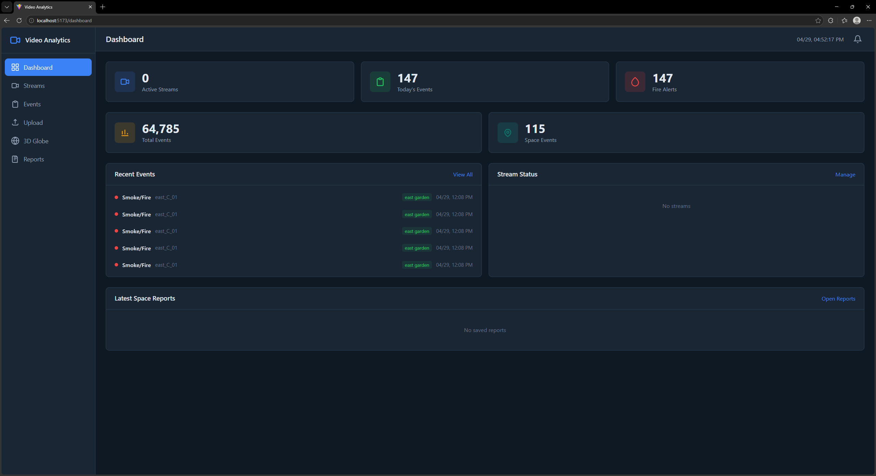
- final runtime screenshot of Video upload page
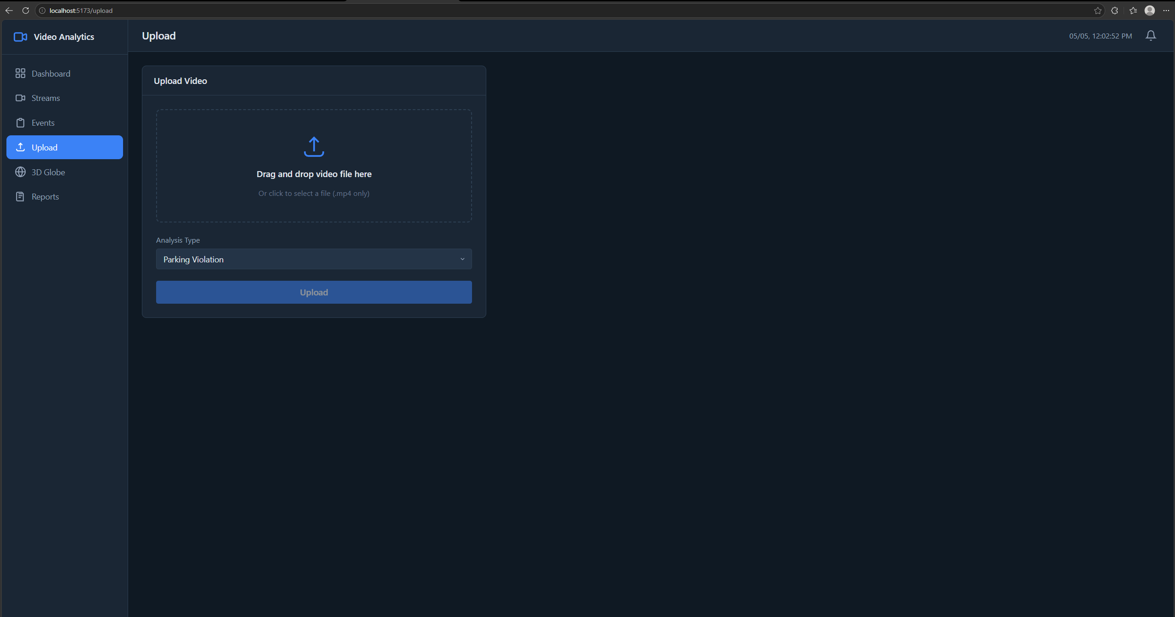
- final runtime screenshot of Stream manager
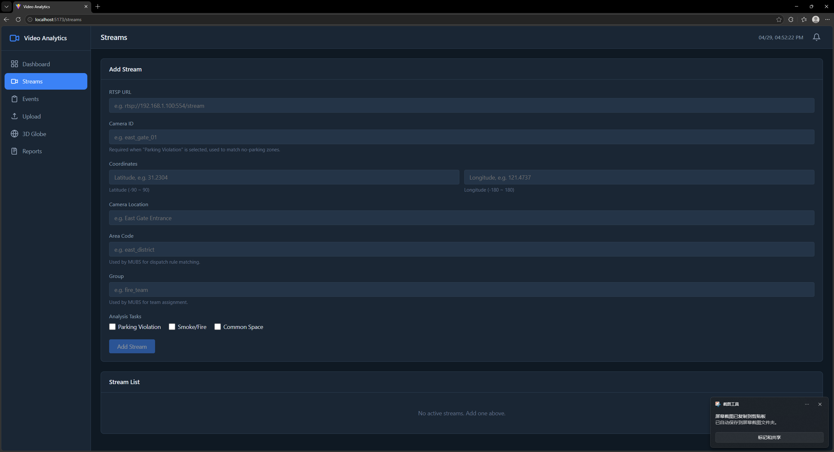
- final runtime screenshot of Event list with evidence image
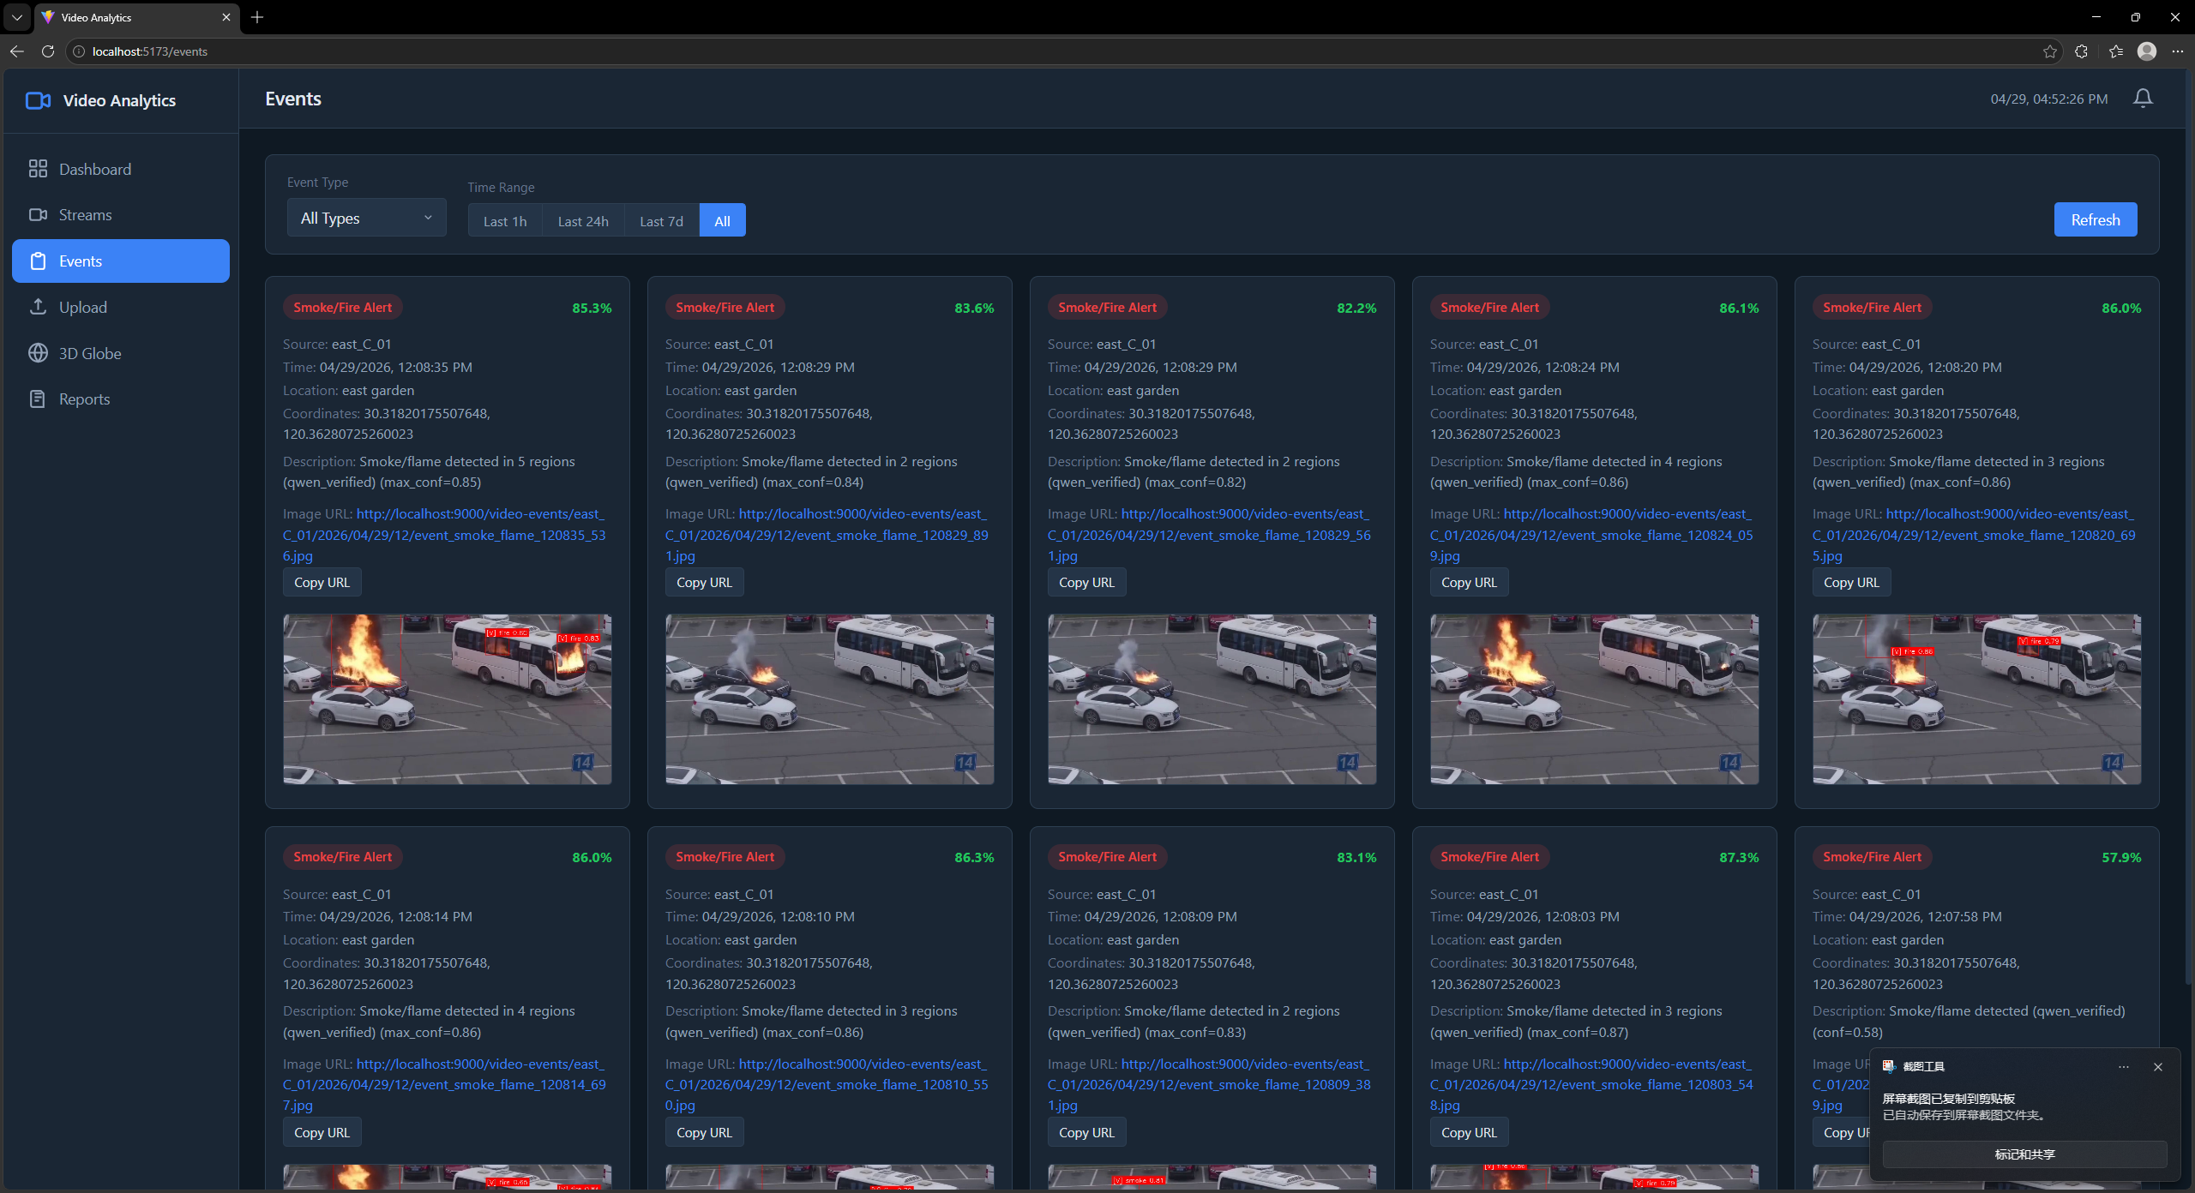
- final runtime screenshot of Globe view
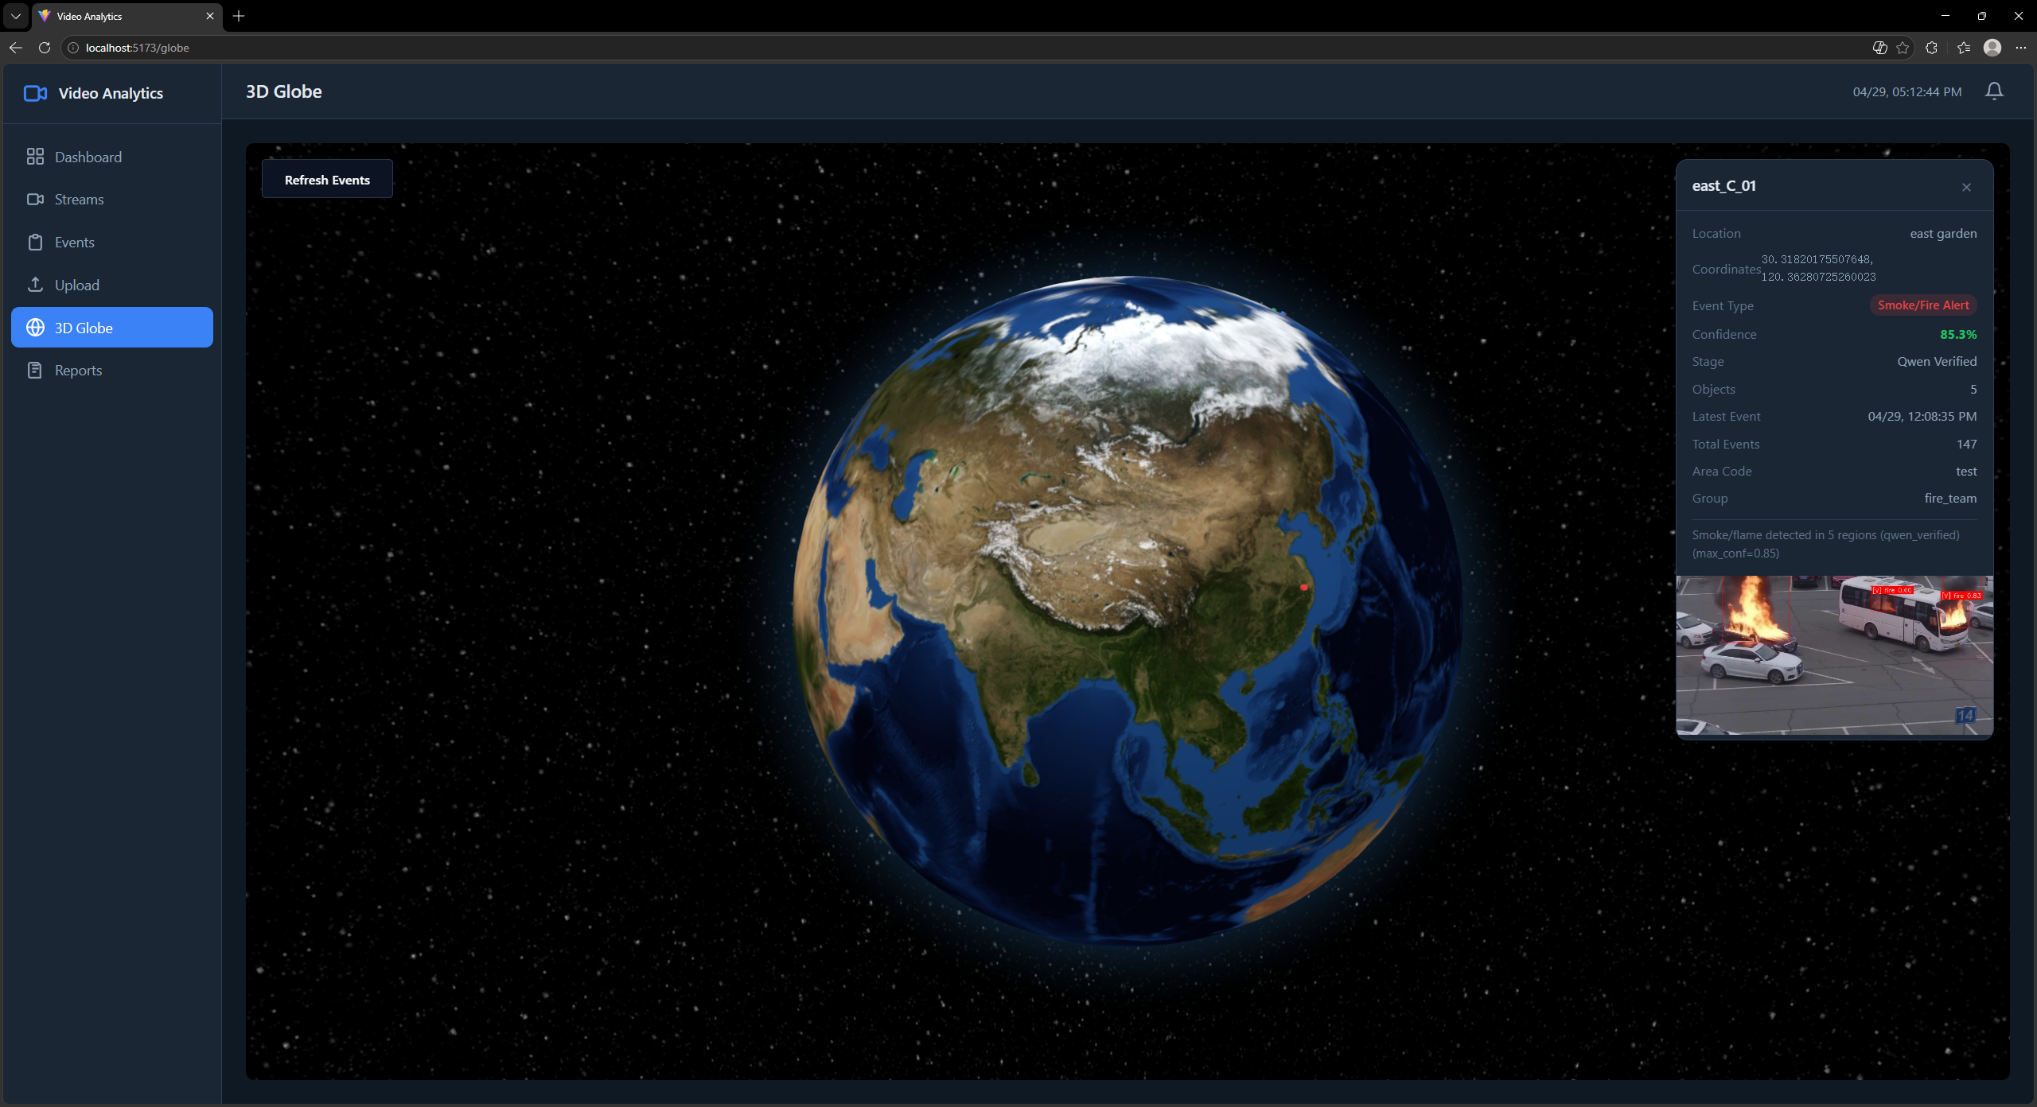
- final runtime screenshot of Common-space report page
Based-on rules:
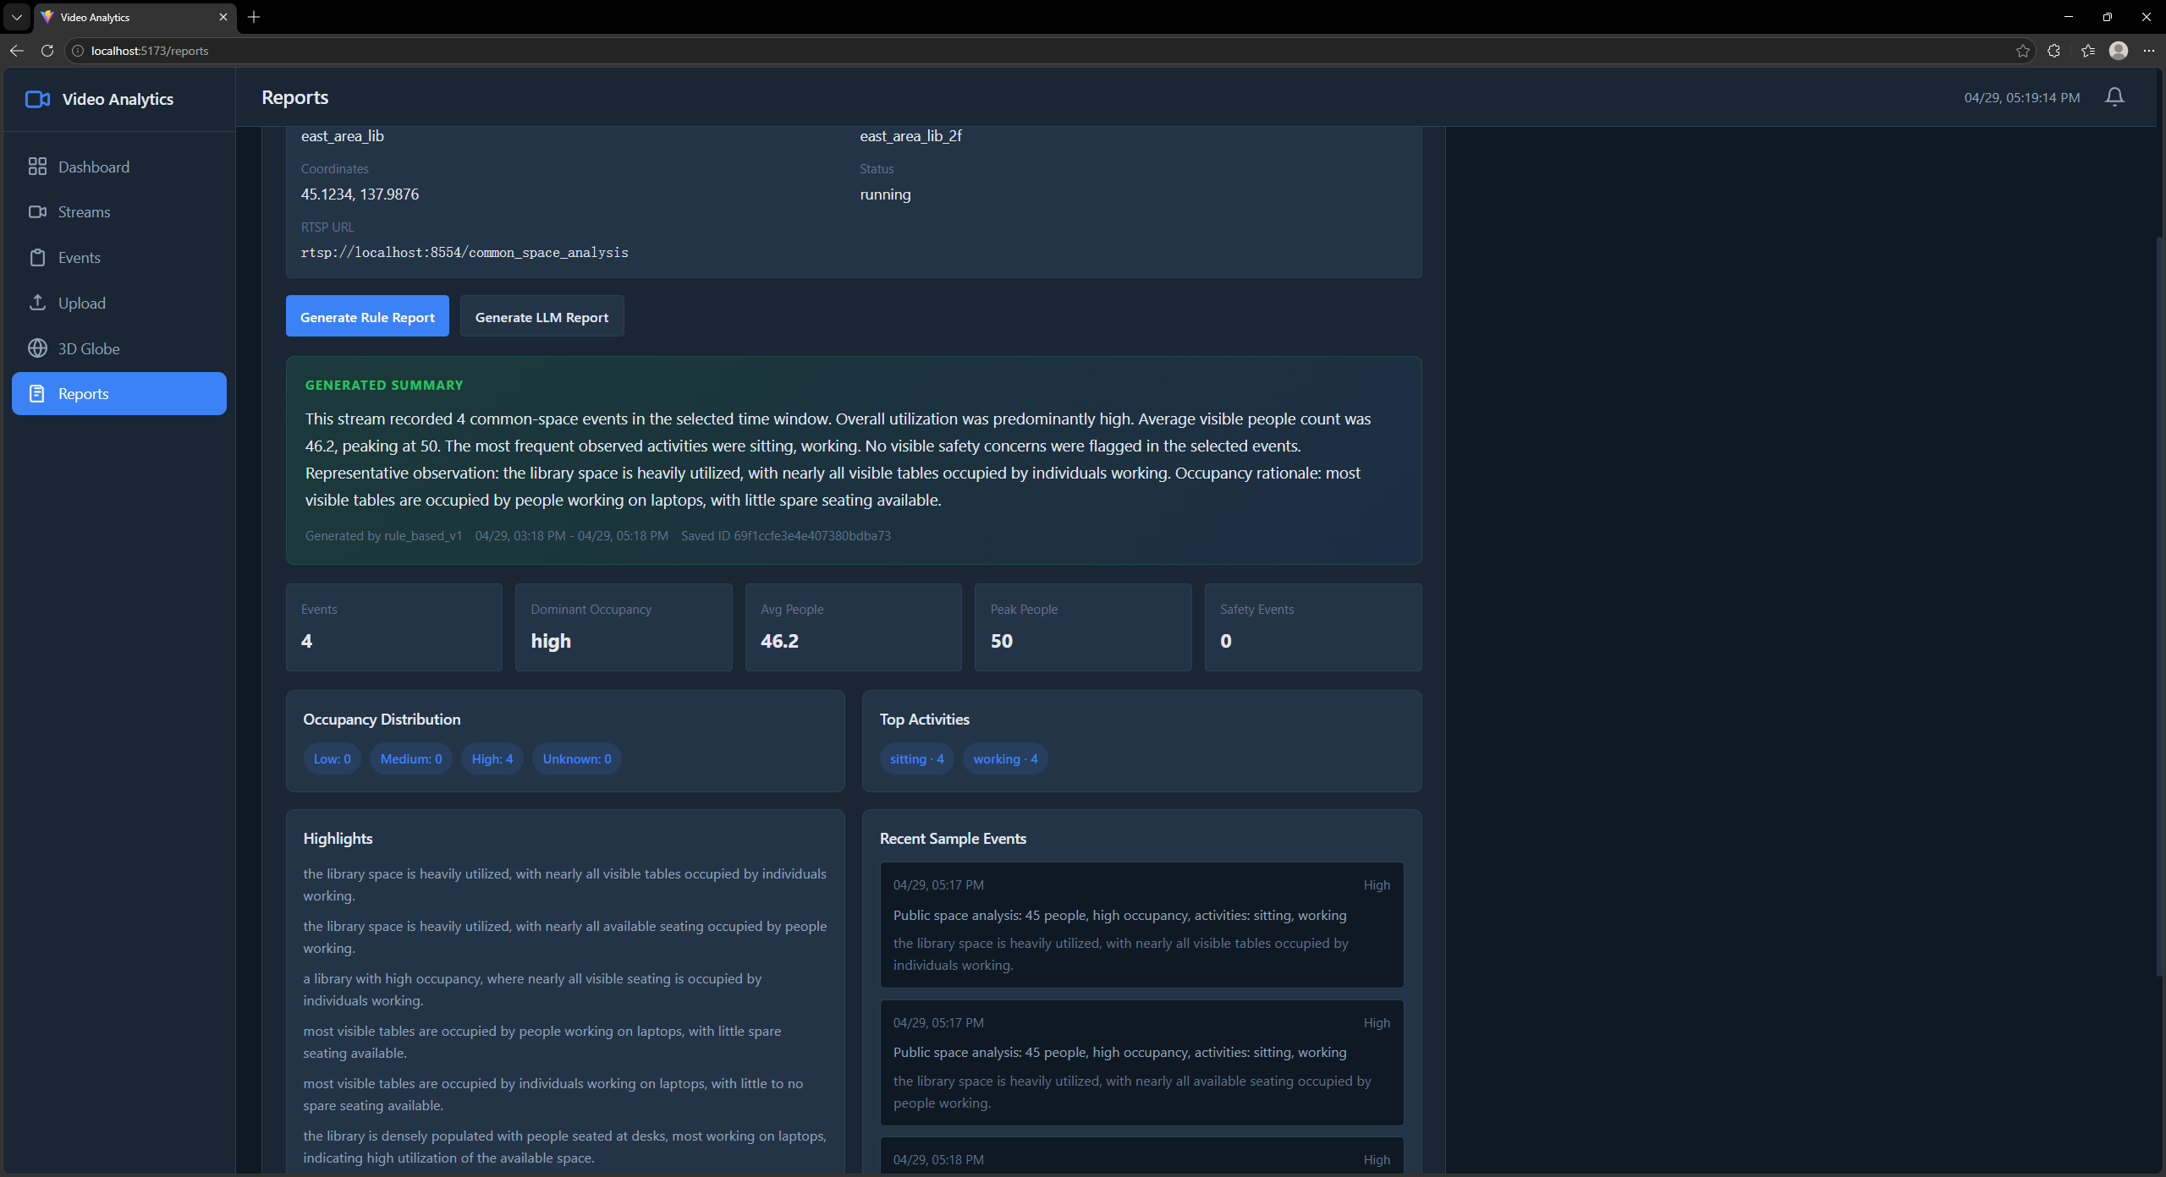
Based-on LLM:
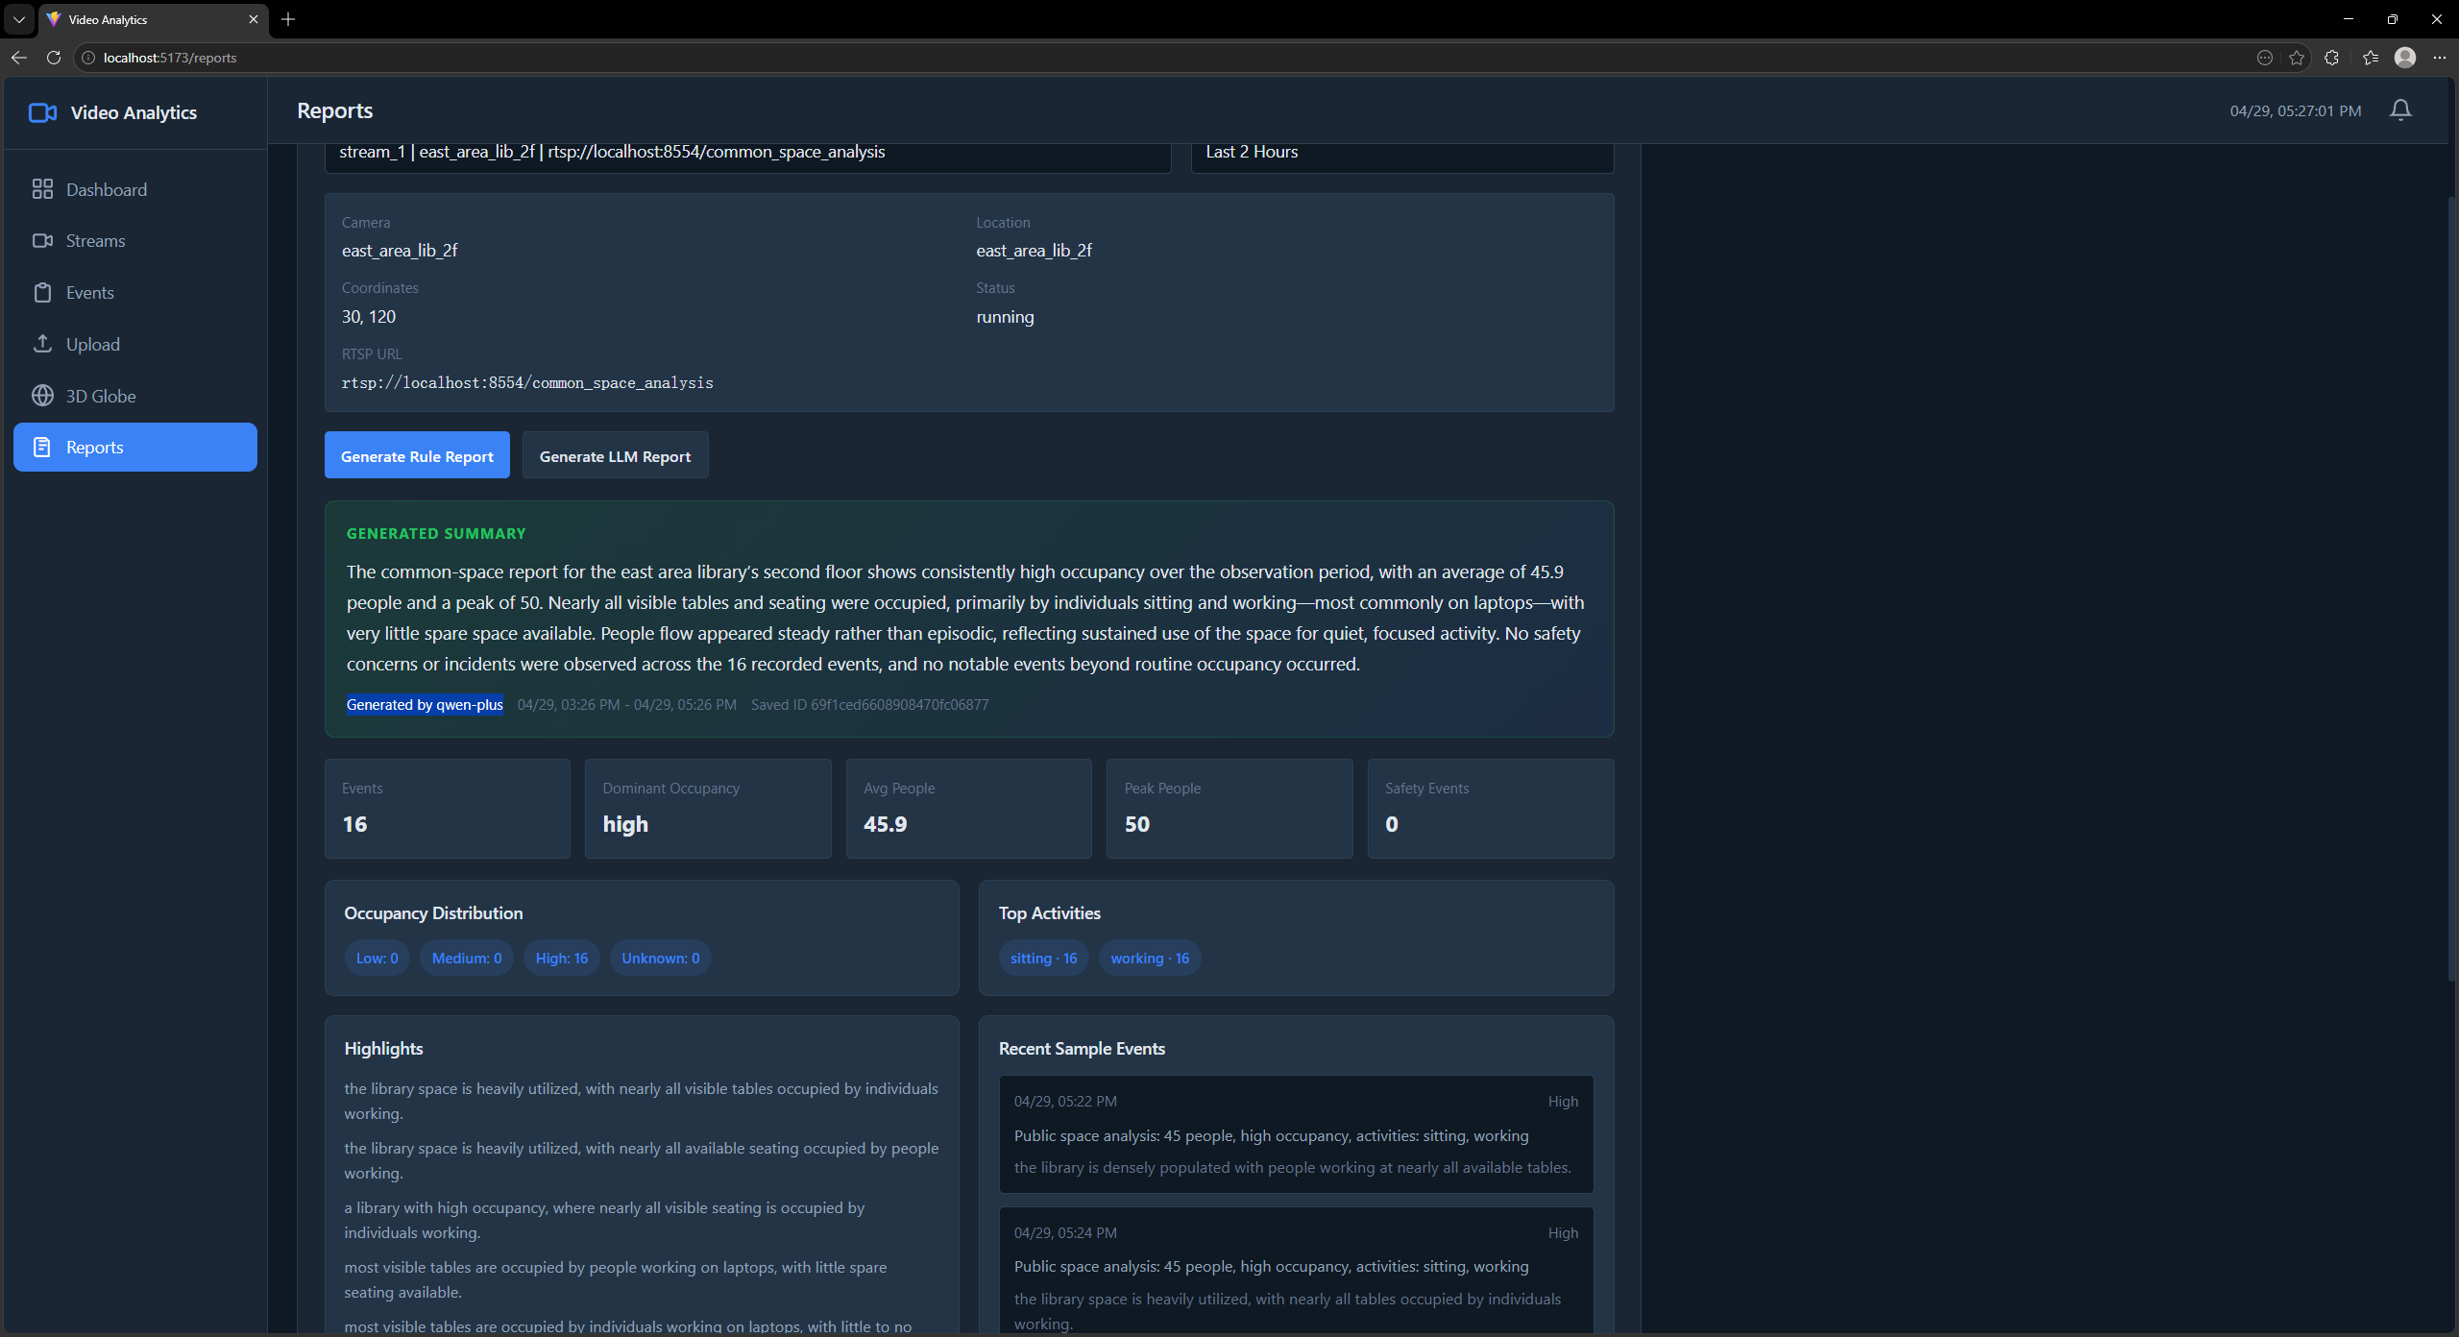

5. Troubleshooting for Users
Problem | Likely Action
No events appear | Check whether backend, MongoDB, MinIO and video stream are running.
No evidence image loads | Check MinIO bucket, public/read policy and image_url in MongoDB.
Stream preview unavailable | Check RTSP URL, camera accessibility and backend logs.
Report generation fails | Check Qwen/LLM configuration and common-space events in database.
Docker command fails or MongoDB/MinIO stay disconnected | Cause: Docker Desktop is not running, the Docker engine is still starting, or ports 27017/9000/9001 are occupied.  Action: Start Docker Desktop, wait until it reports that the engine is running, then execute docker compose up -d and docker compose ps from the project root.
python or pip is not recognized | Cause: Python was installed without PATH registration, or the terminal was opened before installation completed.  Action: Reopen the terminal, run python --version and pip --version, or reinstall Python from python.org and select Add python.exe to PATH.
Backend starts but /api/health returns degraded | Cause: The backend is reachable, but MongoDB or MinIO cannot be reached.  Action: Confirm docker compose ps shows mongo and minio as running, then check MONGO_URI, MINIO_ENDPOINT, MINIO_ACCESS_KEY, and MINIO_SECRET_KEY in .env.
Qwen report generation or vision verification is unavailable | Cause: The relevant Qwen API key, endpoint, or model name is empty or incorrect.  Action: Copy .env.example to .env, set QWEN_REPORT_API_KEY for reports and QWEN_VL_API_KEY if Qwen-VL verification is used, then restart the backend.
Webhook receiver rejects HVAS events | Cause: The HMAC secret configured in HVAS does not match the secret configured in the receiving system.  Action: Set WEBHOOK_SECRET to a shared production value in .env and configure the same value in the receiver before registering webhooks.

