Practice work №3
Simple queries in SQL
Objectives: To learn how to create simple queries using DDL.
Suppose we have the following entity-relationship model, showing the results of the students exams passing in different subjects:

The relational database model for it has the following view:

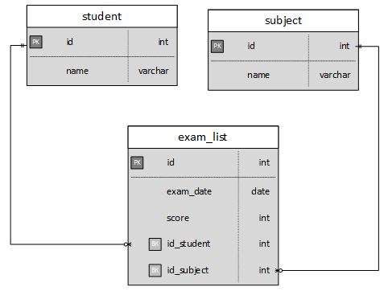
Task: Realize in SQL scripts for the following tasks. Display your own screenshots of the performed tasks.
1) Create the database and connect to it
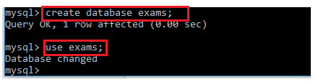
2) Create the tables specified in a relational DB taking into account data types and constraints
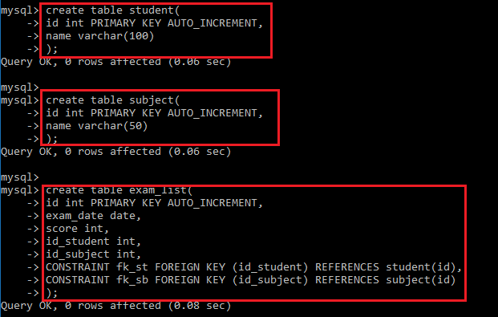
3) Let's assume that we decided to change the table Student and create an additional field with the student's address. Modify the Student table and include the address field. Look what happened with the table.
ALTER TABLE <table name> ADD <field_name> <field_type>;
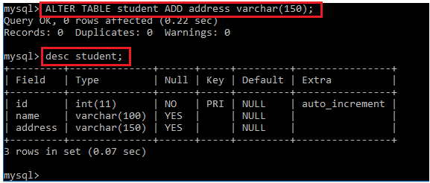
4) Fill in the tables Student (at least 10 entries, one of which must include your name), Subject (minimum of 5 entries, one of which include "Database management systems") and Exam_list (minimum 20 entries).
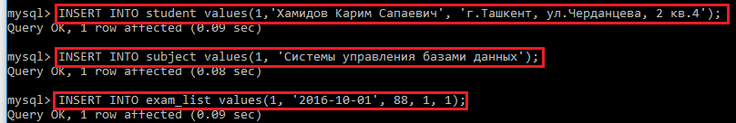
5) Once all queries are executed, refer to the tables and read all records from them.
