**ASSIGNMENT – 1**

Write queries to execute following DDL commands:

1. Create: a structure of table at least 5 columns (Roll no, Name, Course, Address, Contact no)
2. Alter:
3. Change the size of a particular column
4. Add new column (Gender)
5. Remove a column from a table
6. Drop: destroy the table along with its data

1.

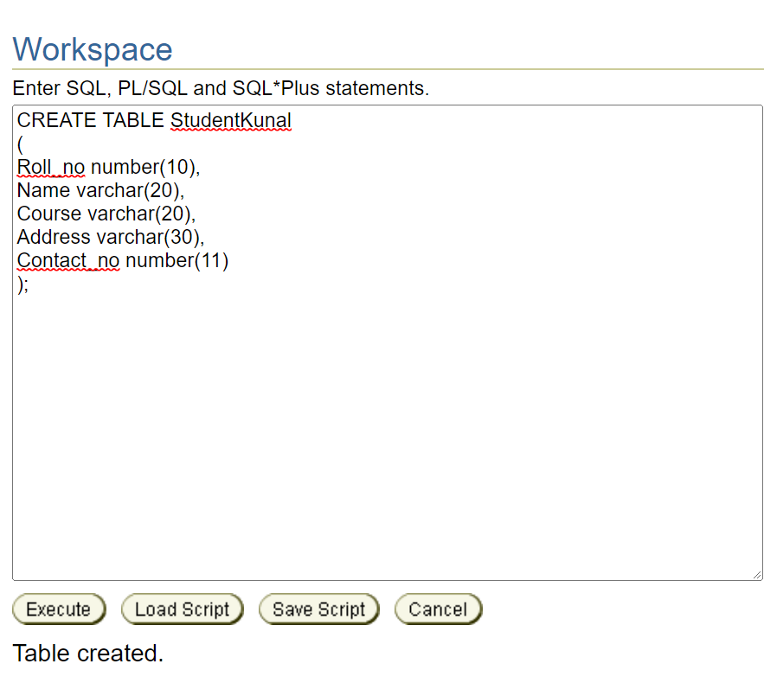

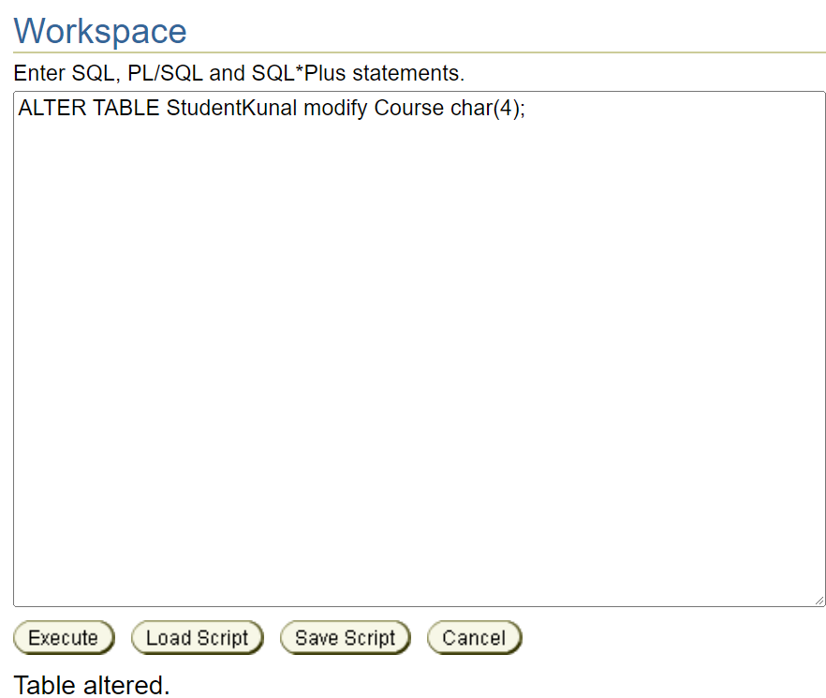

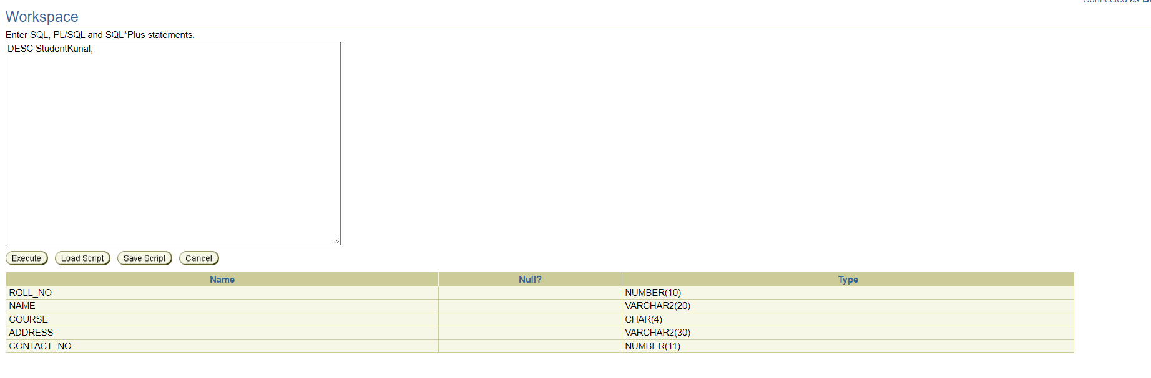

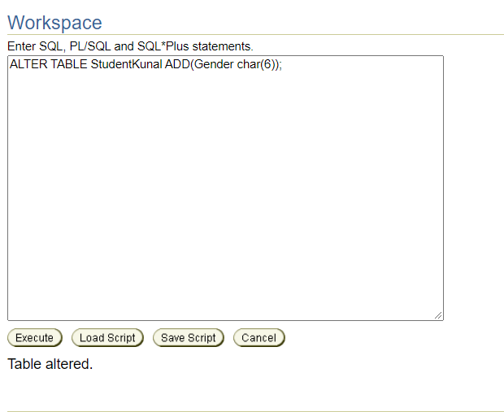

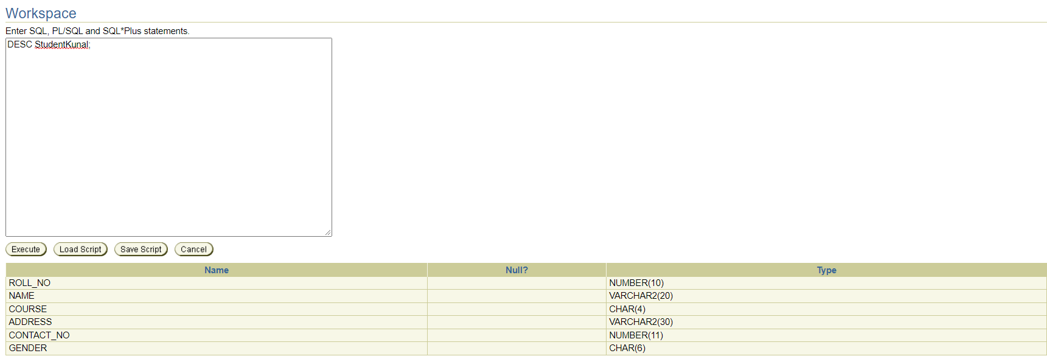

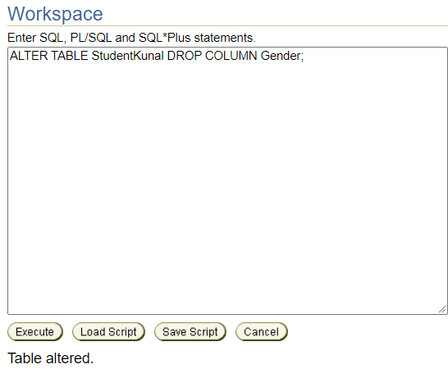

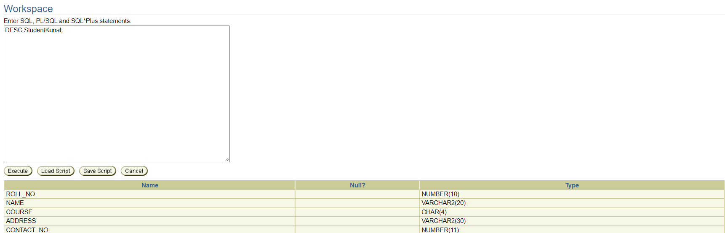

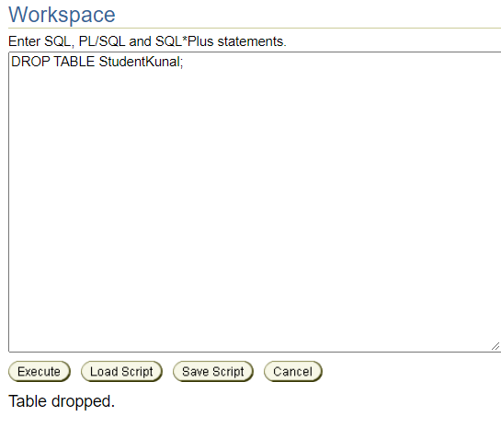

ASSIGNMENT – 2

Write queries to execute following DML commands:

1. Insert: 5 records in the table
2. Update: modify data in single and multiple columns in a table
3. Delete: delete selective and all records from a table