# **TASK 4**

🔰Hello Everyone this is my another blog on my task 4.

Today I successfully completed MLOps Task-4.

Task Description 📄

🔅 Task 4.1 📌 Create image by yourself Using Python Code .

🔅 Task 4.2 📌 Take 2 image crop some part of both image and swap it .

🔅 Task 4.3 📌 Take 2 image and combine it to form single image. For example collage .

# Creating Image using Python Code

***So the first thing we have to do is import cv2 and numpy . And then we will create photo1 and store it in ‘30.jpg’ file***

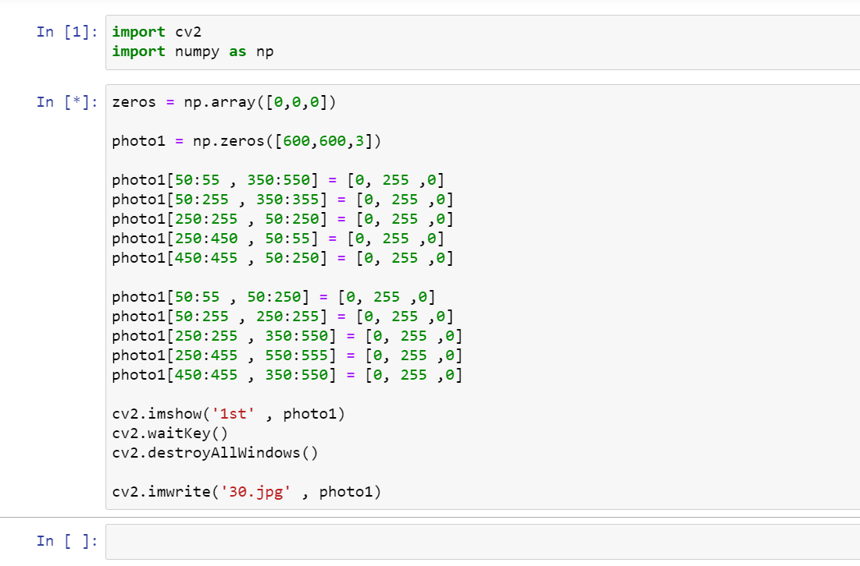

# OUTPUT

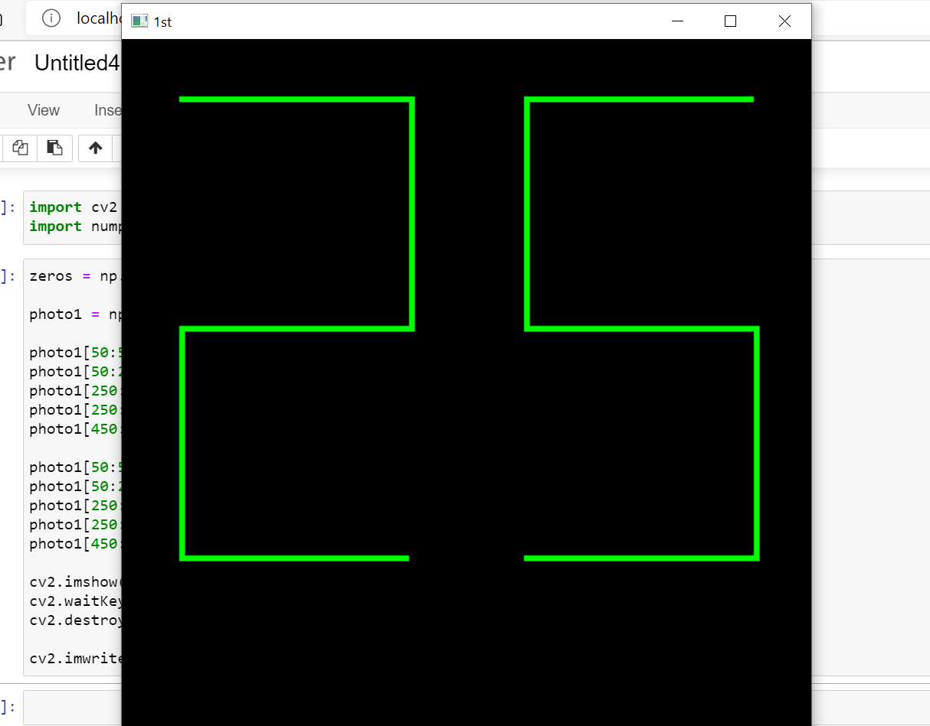

***Now we will create photo2 using python code and store it in ‘40.jpg’ file***

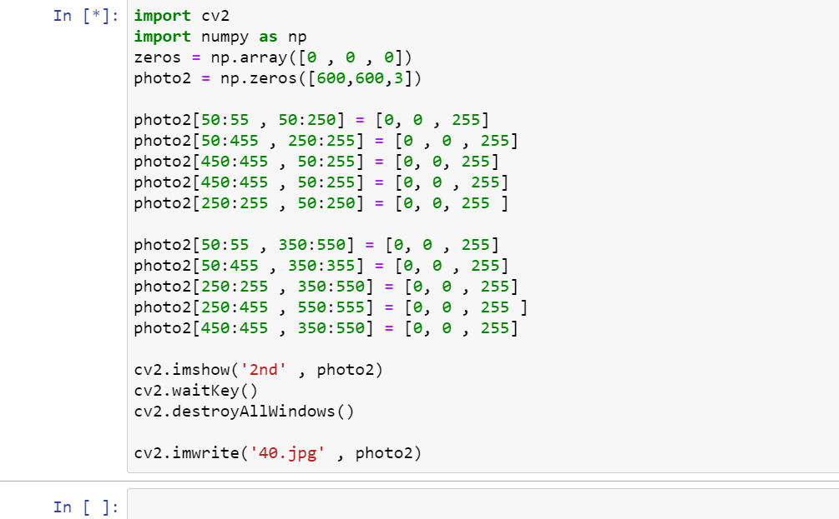

# OUTPUT

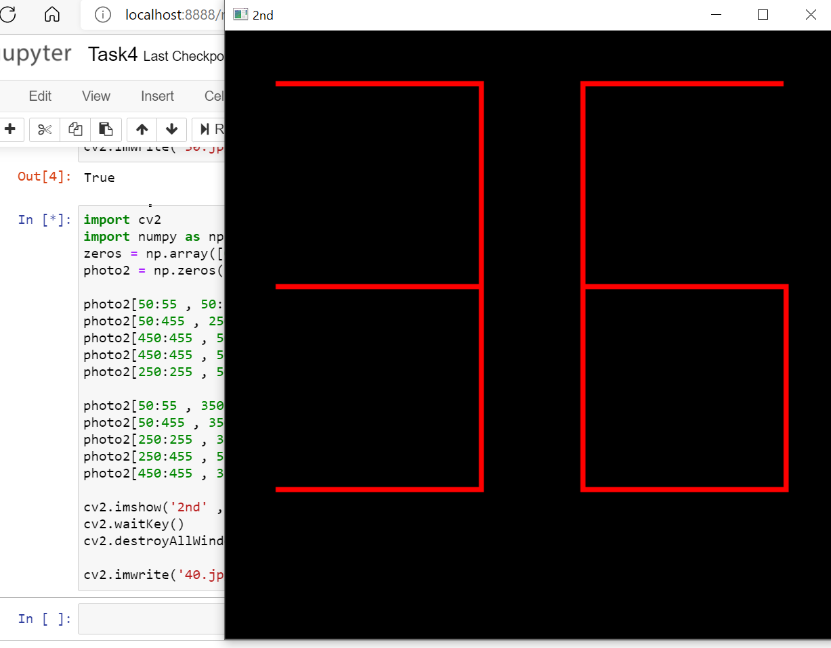

***Now we will swap some parts of both the images***

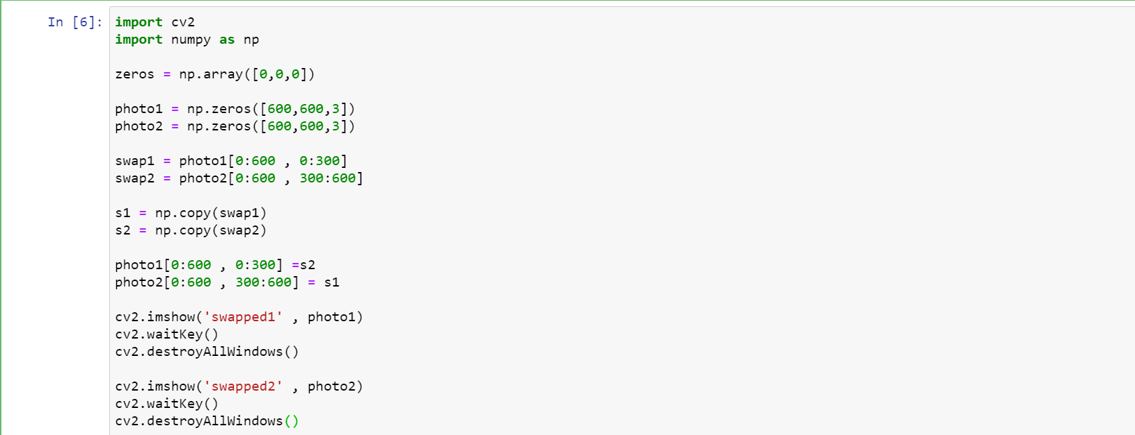

# OUTPUT

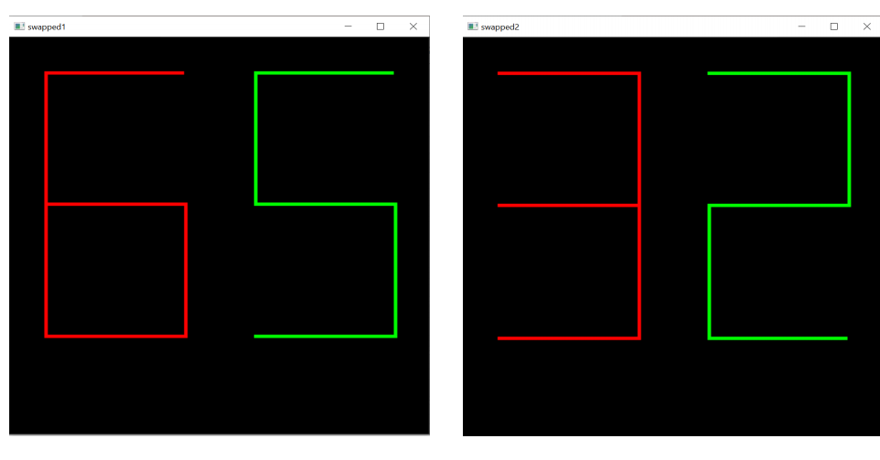

***Now we will combine both the images to form a single image***

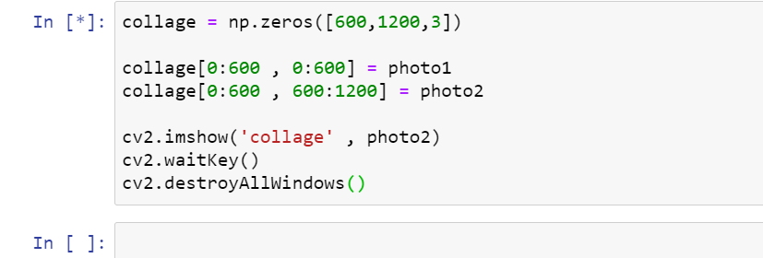

# OUTPUT

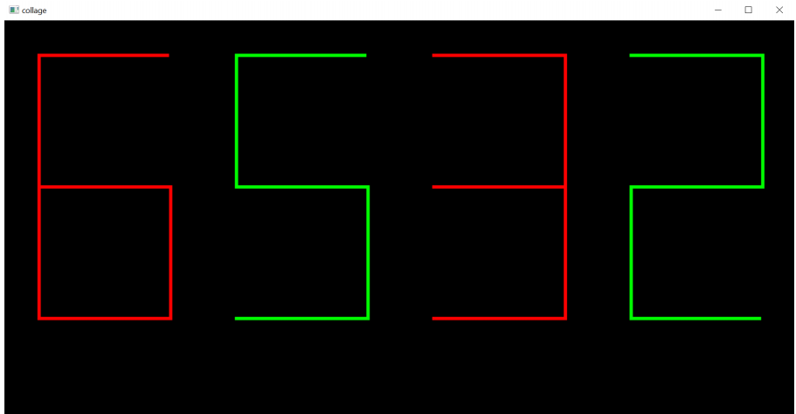

# So now I have completed all the mentioned tasks ……